Zachary Thompson

Part1:
Code:
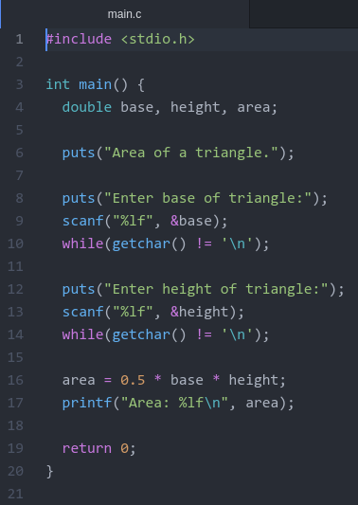
Output:
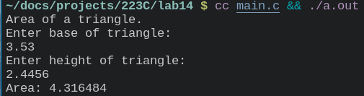
Part 2:
Code:
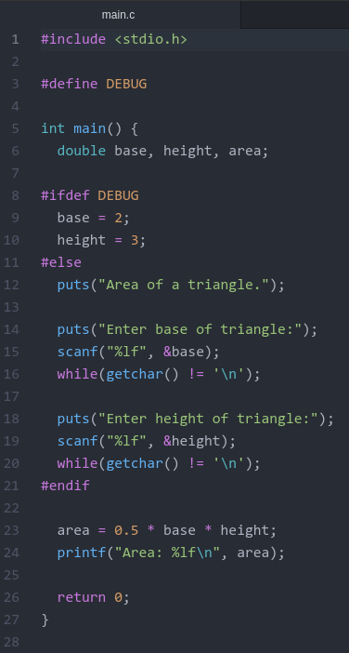
Output:

If DEBUG is defined:

If DEBUG is not defined:
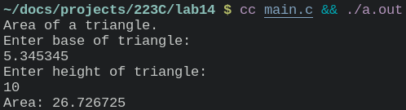
Part 3:
Code:
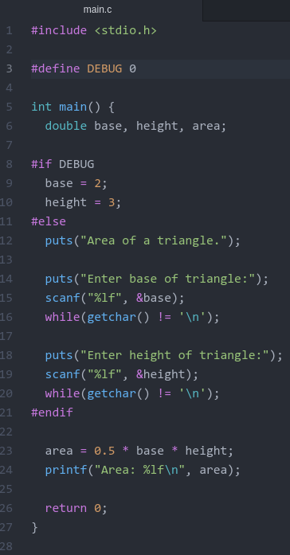
Output:
If DEBUG is 1:

If DEBUG is 0:
