Zachary Thompson
- The role of the continue statements is to prevent the printing of numbers not divisible by 2, 3, 5, and 7.
- Replacing the continue statement after the if statement that checks if a number is divisible by 3 results in the program only printing 499 because 500 is divisible by 2 and 498 is divisibly by 3. Since it is divisible by 3, it exits the loop, so 499 is the only number printed.

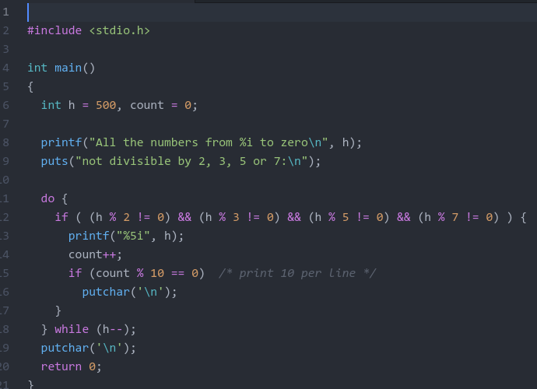
- -2 = 1110
- -5 = 1011
- 2 = 0010
- 1
- -2
- -7
- -8

