Zachary Thompson
Lab 19
Code:
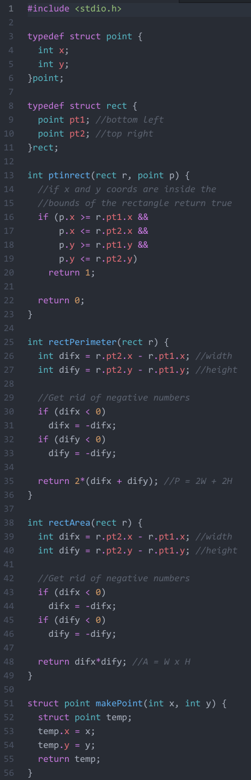
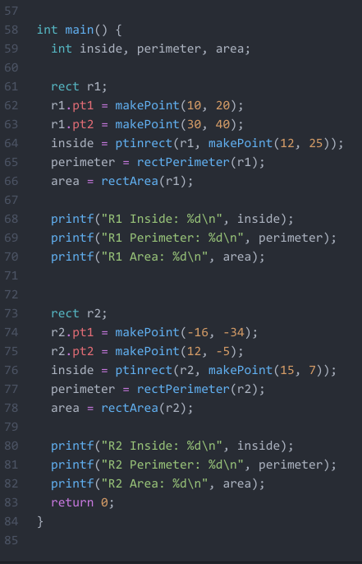
Sample Output:
