Zachary Thompson
Lab 22
Code:
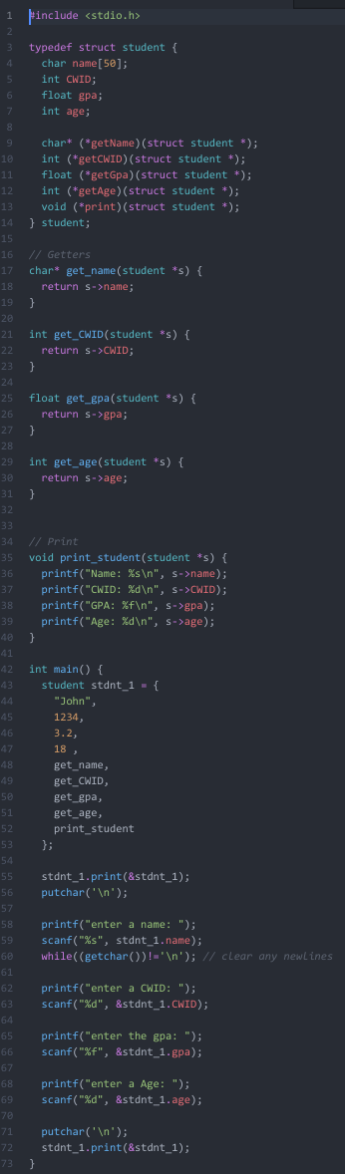
Sample Output:
