Name:__________________________ Date:_________

Class worksheet: Alg2H

Polynomials: Factors, roots, zeros

(book chapter 11)

|  |
| --- |
| Example polynomial: $$P\left(x\right)= x^{5}-9x^{4}+31x^{3}-53x^{2}+48x-18$$ |
| Degree of polynomial: ____ Leading Coefficient: ____  End behavior: ________________________ |
| Factoring: $$P\left(x\right)=\left(x-1\right)⋅(x^{4}-8x^{3}+23x^{2}-30x+18)$$ |
| Factor Theorem: |

|  |
| --- |
| Roots:  Fundamental theorem of Algebra. |
| Complex roots |

Back to our polynomial:

$$P\left(x\right)= x^{5}-9x^{4}+31x^{3}-53x^{2}+48x-18$$

End behavior:

Factoring:

Roots:

1. ____________ 4. ___________

2. _____________ 5. ___________

3. _____________

y-intercept: __________________________

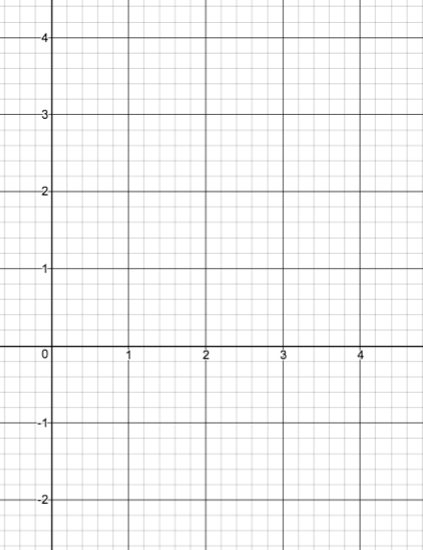Plotting: