Unit 12: Inverse functions

**I.** Given the function:

$$f\left(x\right)=2-\sqrt{x+5}$$

1. Indicate in the table a few key values for (x,y).
2. Plot the function on the axes below.
3. **Table Method:** Fill in the table below based on the table you filled for f(x).
4. Mark these points on the graph.
5. **Graph Method:** Graph the line y=x as dotted line.

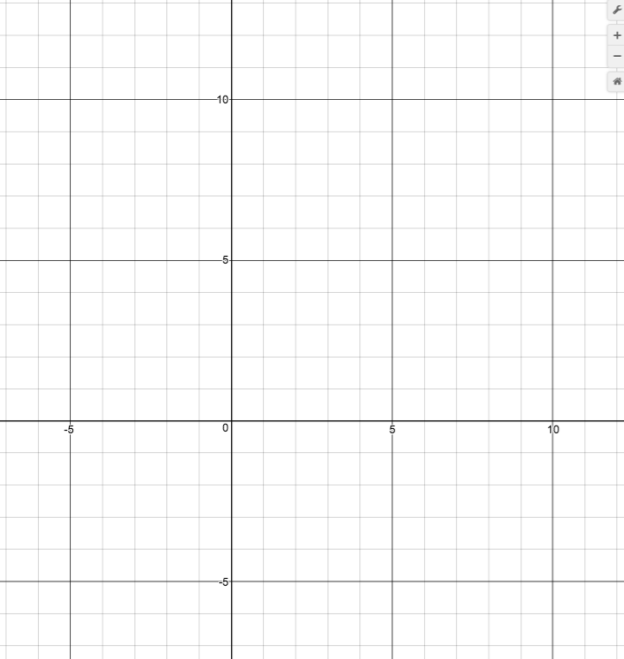

$$f^{-1}\left(x\right)$$

$$f\left(x\right)$$

|  |  |
| --- | --- |
| $$x$$ (in) | $$y$$ (out) |
|  |  |
|  |  |
|  |  |
|  |  |
|  |  |

|  |  |
| --- | --- |
| (in) $$x$$ | (out) $$y$$ |
|  |  |
|  |  |
|  |  |
|  |  |
|  |  |

**Algebraic method**

$$f\left(x\right)=2-\sqrt{x+5}$$

1. Using swapping x 🡨🡪 y method, find the formula for the inverse function.