**Exploration: Graphs of quadratic equations**

**No-Desmos**

**I. Create a table of values, and then graph the function**

 for .

|  |  |
| --- | --- |
|  |  |
| -3 |  |
| -2 |  |
| -1 |  |
| 0 |  |
| 1 |  |
| 2 |  |
| 3 |  |

1. Where does the function intercept the y-axis?
   1. Can you obtain this from the quadratic function equation?
2. Where does the function intercept the x-axis?
   1. Can you find these using algebraic process?
3. What is the axis-of-symmetry?
   1. Can you see it from the graph? Table?
   2. Write the y-coordinate of the lowest point on the graph of f(x)

**II. Create a table of values, and then graph the function**

for



|  |  |
| --- | --- |
| x | f(x) |
| -3 |  |
| -2 |  |
| -1 |  |
| 0 |  |
| 1 |  |
| 2 |  |
| 3 |  |
| 4 |  |
| 5 |  |

1. For what x value(s) is f(x) equal to zero?
2. What is the axis of symmetry?
3. What is the minimum value of f(x)?

**III. Create a table of values, and then graph the function**

 for

|  |  |
| --- | --- |
| x | g(x) |
| -5 |  |
| -4 |  |
| -3 |  |
| -2 |  |
| -1 |  |
| 0 |  |
| 1 |  |
| 2 |  |
| 3 |  |

1. What is the y-intercept of the function?
2. How and why is this graph different compared to the previous two?

**IV. Create a table of values, and then graph the function**

for

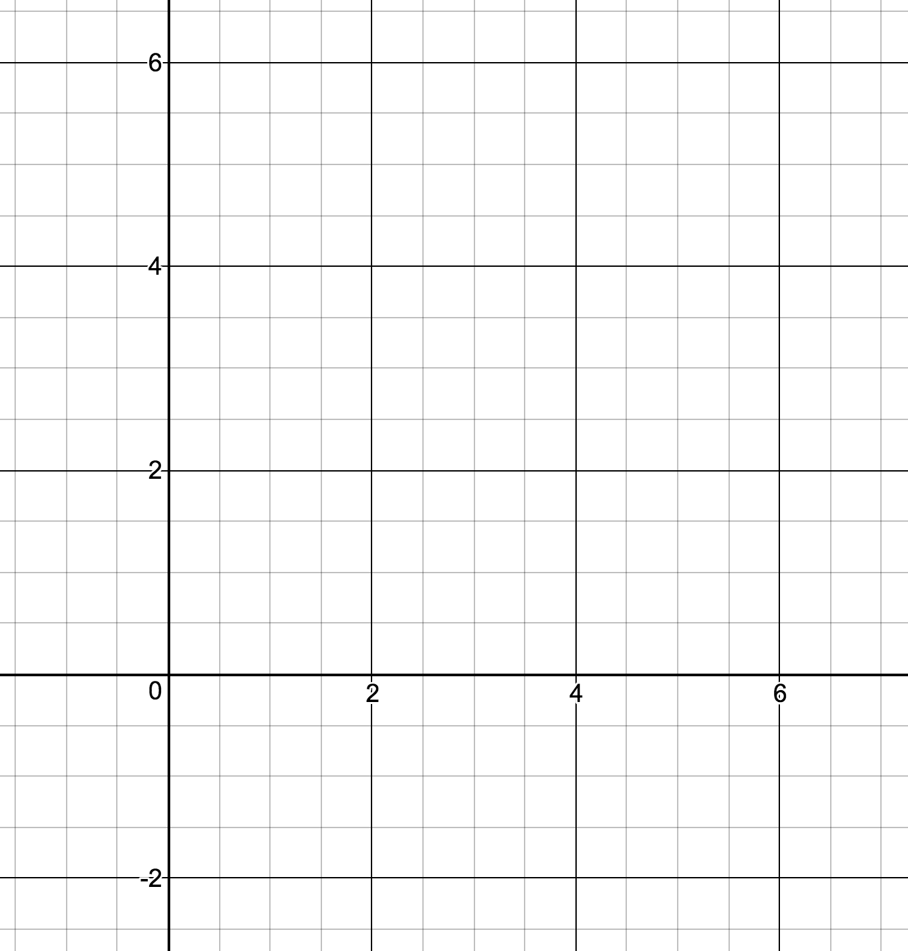

|  |  |
| --- | --- |
| x | m(x) |
| -1 |  |
| 0 |  |
| 1 |  |
| 2 |  |
| 3 |  |
| 4 |  |
| 5 |  |
| 6 |  |
| 7 |  |

1. What is the y-intercept of the function?
2. What are the x-intercepts of the function?

**V. Draw the function q(x) on the same axes. Use different colors.**

for

|  |  |  |  |  |  |
| --- | --- | --- | --- | --- | --- |
| x | 1 | 2 | 3 | 4 | 5 |
| q(x) |  |  |  |  |  |

**VI. Create a table of values, and then graph the function**

for

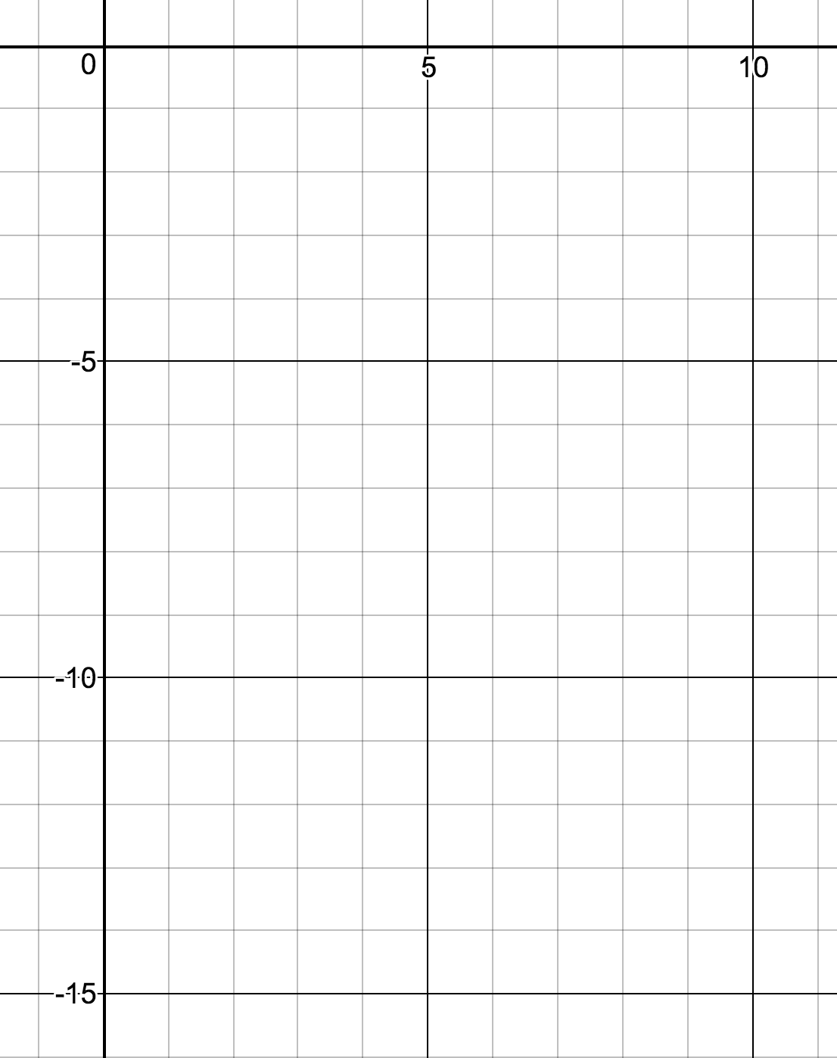

|  |  |
| --- | --- |
| x | h(x) |
| -1 |  |
| 0 |  |
| 1 |  |
| 2 |  |
| 3 |  |
| 4 |  |
| 5 |  |
| 6 |  |
| 7 |  |
| 8 |  |

1. What is the y-intercept of the function?
2. What are the x-intercepts of the function?

**VII. Look back at the last 3 examples. Any insights and observations?**

=== End ===