**Fun Multiple Graphs**

I. For each of the below graphs (A-through-E), fill in the below table.

You CAN use your calculator to verify your graphs and results.

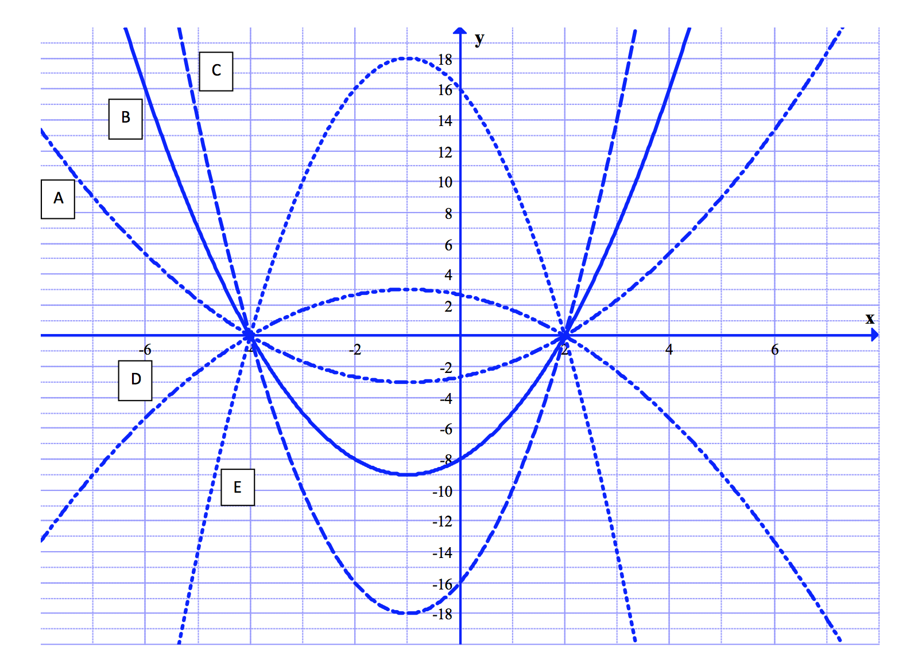

|  |  |  |  |  |  |
| --- | --- | --- | --- | --- | --- |
| Graph | Zeros | Vertex | Write as $$a{\left(x-h\right)}^{2}+k$$ | Write as factored form $$a(x-x_{1})(x-x_{2})$$ | y-intercept  (Calculate) |
| A |  |  |  |  |  |
| B |  |  |  |  |  |
| C |  |  |  |  |  |
| D |  |  |  |  |  |
| E |  |  |  |  |  |

I. For each of the below graphs (A-through-D), fill in the below table.

You CAN use your calculator to verify your graphs and results.

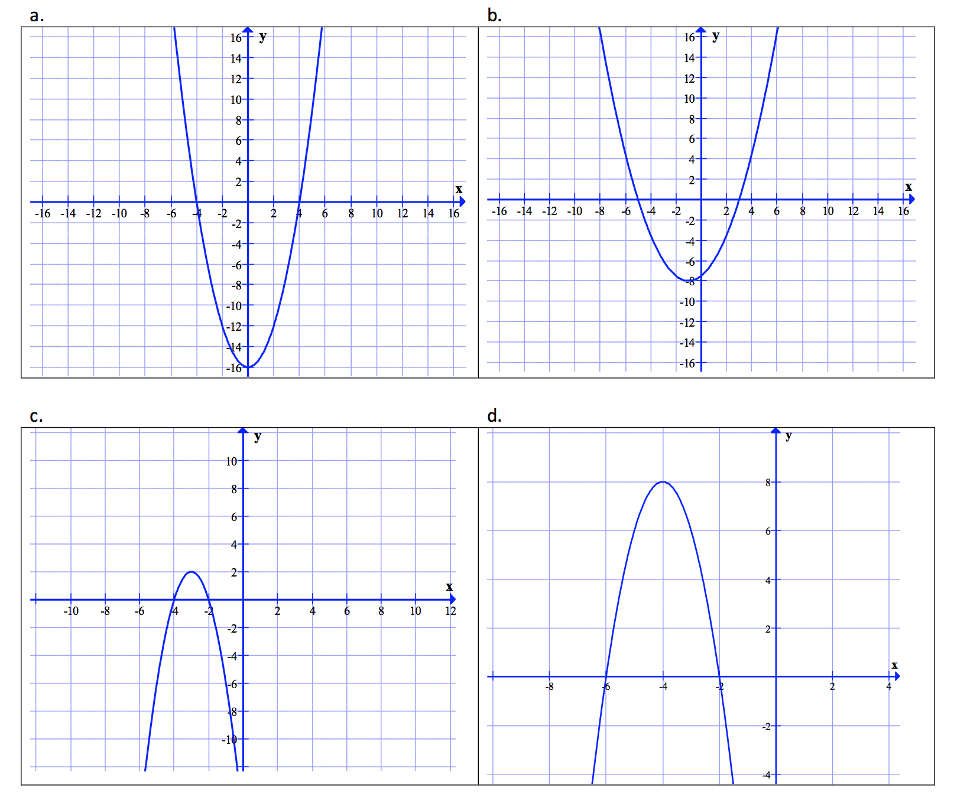

|  |  |  |  |  |  |
| --- | --- | --- | --- | --- | --- |
| Graph | Zeros | Vertex | Write as $$a{\left(x-h\right)}^{2}+k$$ | Write as factored form $$a(x-x_{1})(x-x_{2})$$ | y-intercept  (Calculate) |
| A |  |  |  |  |  |
| B |  |  |  |  |  |
| C |  |  |  |  |  |
| D |  |  |  |  |  |

=== End ===