Name:__________________________ Date:_________

Class/Home worksheet: Alg2H

Vertex form

(book chapter 9, page 404 and onward)

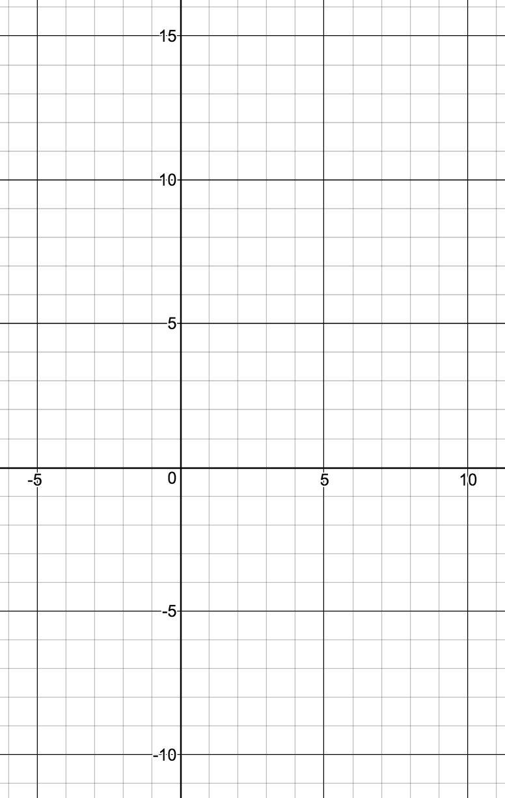Writing quadratic expression as a function:

|  |
| --- |
| Standard form:  Useful for: |
| Factored form:  Useful for: |
| Vertex form:  Useful for: |

|  |
| --- |
| Vertex form |
| The rule of h |
| The rule of k |
| The rule of a |

Question:

Given the function

$$f\left(x\right)=(2x+2)(x-3)$$

1. Write in standard form
2. Solve $f\left(x\right)=0$ for x (using the quadratic equation)
3. Write in Vertex form. What is the vertex?

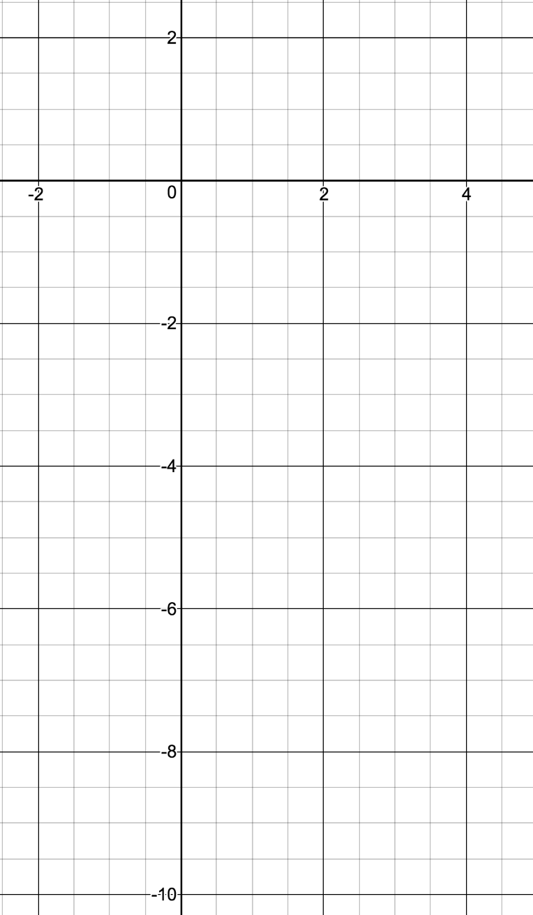

1. What is the Y-intercept?
2. What is the X-intercept?
3. Write in factored form
4. Plot the function.

General process of moving from one form to another

Standard form:

Factored form

Vertex form

Using the following function:

$f\left(x\right)= 2(x-1)(x+2)$

Standard form:

Vertex form:

Y-intercept:

X-intercept:

Vertex:

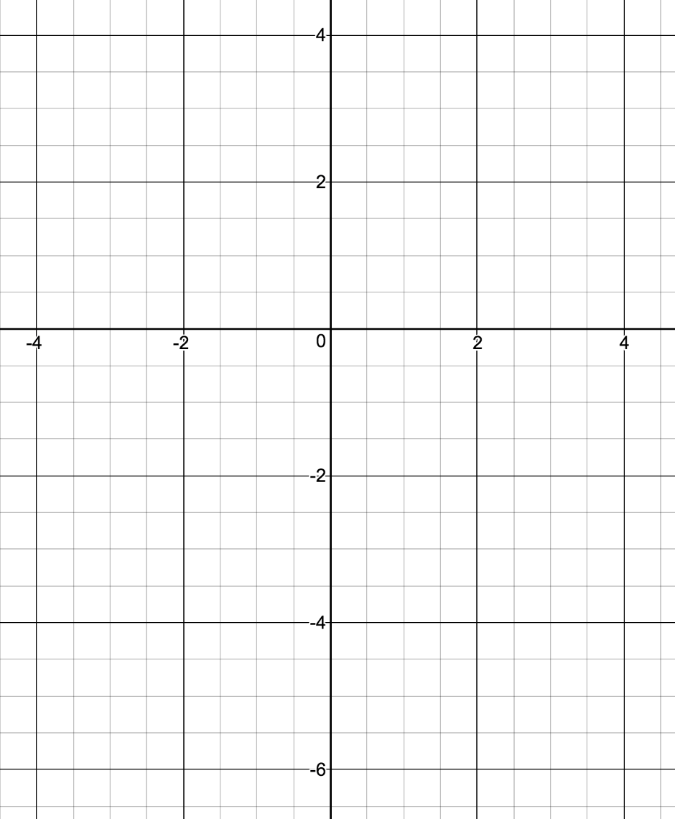

Plot (free hand), and compare: