Defuse the Bomb

A CSC 102 Project

Team: The Deadly Denotators

BOMB DEFUSAL MANUAL

Version 1

Verification Code: 0xFLAPJACK

**The Game**

This project is based on the game **Keep Talking and Nobody Explodes**[1], a cooperative bomb defusing party game. As the game designers put it, “You’re alone in a room with a bomb. Your friends, the 'Experts', have the manual needed to defuse it. But there’s a catch: the Experts can’t see the bomb, so everyone will need to talk it out – fast! Put your puzzle-solving and communication skills to the test as you and your friends race to defuse bombs quickly before time runs out!”

Their version is a software game. Our version takes the idea and realizes it as a physical device with buttons, switches, and more! Although our version can be played just like theirs, players can interact with both the bomb and this document at the same time (i.e., players can both defuse the bomb and serve as the “Experts”, using this document to help disarm the phases).

The backend of our version of the game is a Raspberry Pi[2] computer that combines a typical computer with the ability to interact with the outside world through sensors. The underlying software is written in Python[3] and is the result of a final group-based project in CSC 102 (The Science of Computing II) in the Computer Science Program at the University of Tampa.

**Defusing Bombs**

The bomb will “explode” when its countdown reaches 0:00 or when too many strikes have occurred. You defuse the bomb by disarming all of its “phases” before the countdown expires.

**Phases**

The bomb has four phases, each of which must be disarmed to defuse the bomb. The phases can be disarmed in any order. Once a phase is disarmed, it becomes inactive and changing it doesn't affect the bomb. Instructions for disarming the phases are provided in this document.

**Strikes**

A strike will occur when a mistake is made disarming the bomb. Get too many strikes and the bomb will “explode.” The bomb will begin with 3 strikes.

**Information**

A different version of the bomb is randomly presented each time it is “booted”. There are 6,720 unique versions of the bomb with a whopping 1,176,000 possible variations!

Disarming some phases will require specific information about the bomb. Pay close attention to the “bootup” text on the bomb's screen.

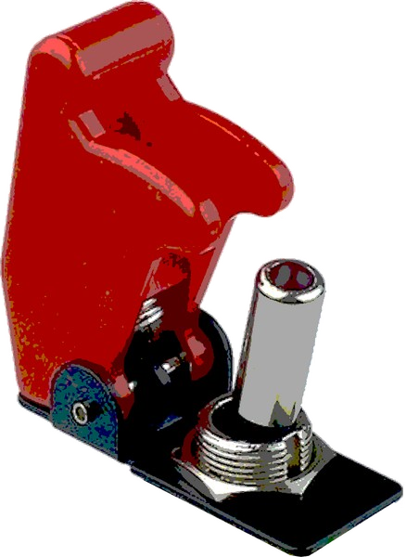**The Toggles**

The bomb’s serial number will be used to determine the correct positions of the toggle

switches.

You need to find the target value by finding the sum of all numeric digits in the bomb’s serial number. Then, you must convert this sum into a 4-digit number in binary. Switch the toggles into their correct position to represent the binary value.

To convert a number to binary from decimal, you can use the table below. Place a 1 in the appropriate power of 2 represented by the column of the table so that when added together create, they equal to the sum of the number. A 0 will be placed in any column that did not receive a 1. The left most digit (in our case toggle) of the binary number is known as the most significant bit, or MSB. The right most digit is known as the least significant but, or LSB.

|  |  |  |  |
| --- | --- | --- | --- |
| $$2^{3}$$ | $$2^{2}$$ | $$2^{1}$$ | $$2^{0}$$ |
| 8 | 4 | 2 | 1 |
|  |  |  |  |

|  |  |  |  |
| --- | --- | --- | --- |
| MSB |  |  | LSB |
|  |  |  |  |

The left most toggle will represent the most significant bit (MSB). The right most toggle will represent the least significant bit (LSB). The LED on the toggle switch illuminates when representing a binary 1.

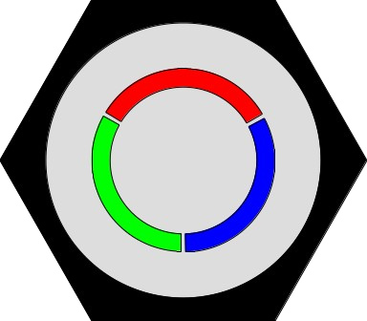**The Button**

You will need to defuse the button at some point to defuse the bomb. Pressing it

Is the easy part, releasing it not so much. The button has an illuminated ring around

it that can either be red, green, or blue. Release the button by following the instructions in the table below.

|  |  |
| --- | --- |
| Button Color | Button Instructions |
| Red | Release the button at any time. |
| Green | Release the button when the first numeric digit of the bomb’s serial number appears in the seconds section of the countdown timer. |
| Blue | Release the button when the last numeric digit of the bomb’s serial number appears in the seconds section of the countdown timer. |

**The Keypad**

Information regarding the keypad is displayed on the bomb during boot-

up. To find the passphrase, the keyword must first be decrypted with a key

using an alphabetic substitution cipher and then finding the corresponding

word in the table located on the right.

|  |  |
| --- | --- |
| **KEYWORDS** | **PASSPHRASES** |
| JUNGLE | ROCKET |
| SADDLE | DAMAGE |
| SWEATY | ORANGE |
| COWARD | MARVEL |
| PUZZLE | LEGEND |
| HOLLOW | SALUTE |
| GUITAR | SILVER |
| SORROW | RATTLE |
| SNOOZE | SHELTER |
| PUPPET | SPIRIT |
| WIZARD | SPHERE |
| TURTLE | VELVET |
| LIZARD | ROCKET |
| TEMPLE | WINDOW |
| MEADOW  HARBOR | SPIRIT  TARGET |

A substitution cipher with a key represents a rotation of the alphabet. For a key of 5, the alphabet is shifted five places so that A becomes F, B becomes G, and so on. The word ABC becomes FGH.

To correctly enter the passphrase, you need to enter its numeric combination on the keypad. To do so, press each button on the keypad with the required letter only once.

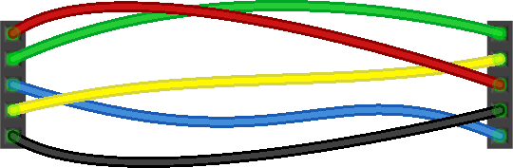**The Wires**

|  |  |
| --- | --- |
| Button Color | “Cut” Instructions |
| Red | The first three letters in the serial number represent the wires that must stay connected. The remaining wires must be “cut.” |
| Green | “Cut” the wires labeled B and D |
| Blue | “Cut” the wires labeled A and E |

To find what wires need to be “cut” you need to look at the color of the button,

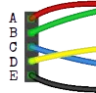or sometimes the bomb’s serial number. The wires are labeled below:

Note that the color of the wires on the bomb might be different.

“Cut” the wires based on the color of the button found on the bomb and compare with the table below.

1. <https://keeptalkinggame.com/>
2. <https://www.raspberrypi.com/>
3. <https://www.python.org/>