Naïve Bayes – Project 1
Zachary Weiss
Student ID: 1201217619

Abstract—This project covered the Naïve Bayes method of classifying digits 0 and 1.

Introduction
In this paper I will discuss what was completed during the work on a Naïve Bayes Classifier. Python, Jupiter Notebook, MNIST data set, and NumPy, and SciPy libraries were used during the completion of this project.

Tasks
We initially extracted 10,000 training datasets 5,000 for each handwritten 0 and 1 respectively for the training set. We also extracted 980 handwritten zeros and 1,135 handwritten ones for our test data set.
In task 1, completion of feature extraction was implemented from the training data set. For each image of handwritten digits, brightness averages and standard deviation on each image were calculated.
In task 2, parameter calculations were completed using the results from task 1. From the average brightness and standard deviation, mean and variance were calculated.
Table Head | Parameters
Table Head | Digit 0 | Digit 1
Mean (Ave Brightness) | 44.194659949 | 19.407065051
Variance (Ave. Brightness) | 114.689917342 | 31.4895261975
Mean (Standard Deviation) | 87.4189676075 | 61.4115611832
Variance (Standard Deviation) | 100.735082148 | 82.2415746334

Task 3 began the Naïve Bayes classification. Inputs to this function were the results from the previous two tasks. Initially, extraction of the test zero and test one digits were done using the same function from task 1. Then brightness and standard deviation from the extracted test data as feature 1 and feature 2, respectively. Next, iteration over every data point from the extracted features were conducted, 4 probability density functions were created. The first probability density function had inputs from the test feature 1, along with a distribution based on the zero digit train mean and variance, while the second contained input from the test feature 2, along with the mean and variance of the train digit zero standard deviation. The next two were similar to the previously mention probability density functions, but contained the mean and variance from digit one instead (both average brightness mean and variance, and standard deviation mean and variance).
In Task 4, scoring of the Naïve Bayes Classifier. Scoring is as follows:

Table Head | Parameters
Table Head | Digit 0 | Digit 1
Accuracy | 91.73469387755102% | 92.33480176211454%

Equations
For the probability density functions, since standard deviation was the inputs, squaring gave the variance according to the function.
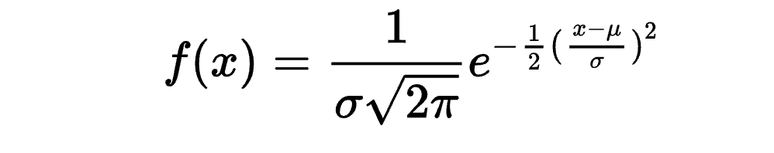

Conclusion
This was a very interesting project. I know better understand how the Naïve Bayes Classifier works.

