K-Means – Project 2
Zachary Weiss
Student ID: 1201217619

Abstract—This project covered K-Means Strategies for unsupervised classification.

Introduction
In this paper I will discuss what was completed during the work on a K-Means Clustering. Python, Jupiter Notebook, a random [x,y] data set, and NumPy library were used during the completion of this project.
A K-Means Classifier is used to partition n data values into k clusters where the data values belong to the cluster with the nearest mean, or centroid.

Tasks
Strategy I. Random Initial Centroids
In the first strategy, we pick some random k points to be the values for the centroids. We then run the K-Means algorithm.
The algorithm has essentially two steps. The first step is to initialize the centroids, and the second step is to classify each data point by finding the nearest centroid to the data point. Then, after all data points are classified, we recalculate the centroids (means) for each cluster. We continue this algorithm until the algorithm converges. Then, we calculate the objective function to see the loss value for each k value. As the number of centroids, k, increases we can see the loss value decrease (Figure 1 & 2, two separate randomly selected initial centroids)
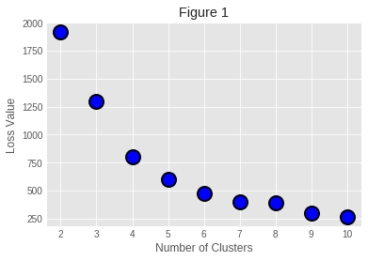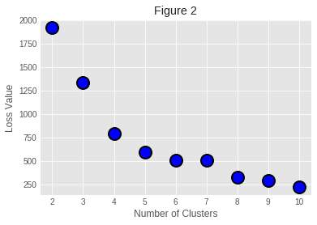
Initial Given Centroids (k=3)
X | Y
1.69565649 | 7.68082458
4.43990951 | 3.70495907
4.34489155 | 3.99726667

Final Centroids (k=3)
X | Y
2.561464 | 6.088613
5.477400 | 2.254981
6.497250 | 7.522973
Initial Given Centroids (k=5) |  | Initial Given Centroids (k=5)
X | X | X | Y
2.95147442 | 7.76615605 | 7.016428 | 8.441691
1.92561853 | 2.73857632 | 2.746674 | 2.123703
2.3085098 | 7.39324133 | 2.464488 | 7.093933
2.7845243 | 6.61847158 | 5.079971 | 5.613513
7.30246332 | 3.16580577 | 7.094433 | 2.420127
Loss : 1294.727 and 630.334166911 Respectively

Strategy II. One Random Centroid, others calculated by max average distance
In the second strategy, instead of using k random data points as the initial centroids, we use only one random data point for
the first k value. We then calculate the next k-1 centroids by find the max average distance from the previously selected centroids. After this, we run the K-Means algorithm to find the final centroids similar to strategy 1, and calculated the loss function.
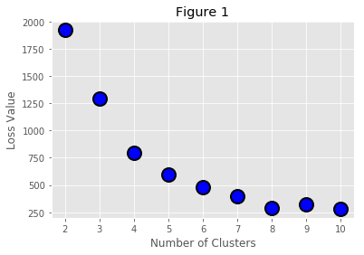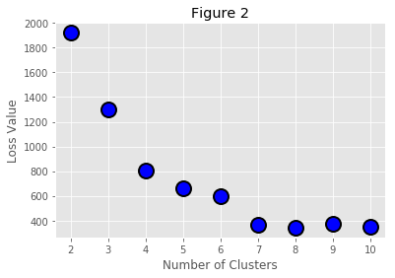
Initial Centroids | X | Y
K =4 | 3.06996954 | 5.97020551
K = 6 | 7.80003043 | 1.90963115

After K-Means Algorithm (K=4)
X | Y
3.253767 | 2.537811
6.856583 | 73661434
7.283653 | 2.380279
3.153427 | 6.912921

After K-Means Algorithm (K=6)
X | Y
7.414192 | 2.321691
5.464277 | 6.837714
3.145061 | 0.907707
7.756483 | 8.556689
2.563338 | 6.978225
3.495567 | 3.566112

Loss: 792.724460873 and 476.118751676 Repsectively

Equations
Objective Function: ∑i=1 k​∑x∈Di​​∣∣x−μi​∣∣²

Conclusion
The K-Means algorithm seems to be an effective algorithm for clustering data points. It appears that using the distance trick in strategy 2, creates a smaller initial loss as compared with strategy 1. When using a K-Means Algorithm for a small k value, it should be noted that the distance trick is a more effective approach.

