

Kids Clinic
Management System
Agile Documentation v2.0
Enhanced Software Requirements Specification
Computer Science Department
IEEE 830-1998 Compliant | Scrum Methodology | 2025
Table of Contents
Right-click and select "Update Field" to refresh page numbers
Chapter 1: Introduction & Agile Project Planning 6
1.1 Introduction 6
1.2 Project Objectives 6
1.3 Stakeholder Analysis 7
1.4 Project Scope 7
1.4.1 In Scope 7
1.4.2 Out of Scope (Future Releases) 7
1.5 Used Technologies 8
1.5.1 Development Stack 8
1.5.2 Tools & Environments 8
1.6 Problem Analysis 8
1.6.1 Current Challenges 8
1.6.2 Risk Analysis (Mitigated by System) 9
1.7 Agile SDLC & Scrum Framework 9
1.7.1 Why Agile/Scrum? 9
1.7.2 Scrum Roles 10
1.7.3 Scrum Ceremonies 10
Chapter 2: Software Requirements Specification (SRS) 11
2.1 Purpose 11
2.2 Scope 11
2.3 Definitions, Acronyms & Abbreviations 12
2.4 References 12
2.5 Overview 13
2.6 Functional Requirements 13
2.6.1 Authentication & Authorization Module 13
2.6.2 Patient (Child) Management Module 13
2.6.3 Visit & Consultation Module 14
2.6.4 Prescription Module (Doctor Only) 14
2.6.5 Vaccination Module 15
2.6.6 Financial Management Module (Doctor Only) 15
2.6.7 User Administration Module (Doctor Only) 15
2.7 Non-Functional Requirements 16
2.7.1 Performance Requirements 16
2.7.2 Security Requirements 16
2.7.3 Usability Requirements 16
2.7.4 Reliability & Availability 17
2.7.5 Maintainability 17
2.8 System Constraints 17
Chapter 3: User Stories & Product Backlog 18
3.1 User Stories (Enhanced with Acceptance Criteria) 18
3.1.1 Sprint 1 — Foundation: Authentication & Core Setup 18
3.1.2 Sprint 2 — Patient Management Core 18
3.1.3 Sprint 3 — Visit Scheduling 19
3.1.4 Sprint 4 — Consultation Management 20
3.1.5 Sprint 5 — Prescription Management (Doctor Only) 20
3.1.6 Sprint 6 — Vaccination Management 21
3.1.7 Sprint 7 — Financial Management & Reporting 22
3.1.8 Sprint 8 — Polish & System Hardening 22
3.2 Product Backlog 22
3.3 Sprint Planning 23
3.3.1 Sprint 1 — Foundation (Authentication & User Management) 23
3.3.2 Sprint 2 — Patient Management Core 24
3.3.3 Sprint 3 — Visit Scheduling 24
3.3.4 Sprint 4 — Consultation Management 24
3.3.5 Sprint 5 — Prescription Management 24
3.3.6 Sprint 6 — Vaccination Management 25
3.3.7 Sprint 7 — Financial Management & Reporting 25
3.3.8 Sprint 8 — System Hardening & Release Preparation 25
3.3.8 Project Velocity Summary 25
3.4 Definition of Done 26
Chapter 4: Use Cases (IEEE Compliant) 27
4.1 Actor Descriptions 27
4.2 Use Case Specifications 27
UC-01: User Login 27
UC-02: View Children's List 28
UC-03: Add Child 28
UC-04: Edit Child 29
UC-05: Delete Child 30
UC-06: Schedule Visit 30
UC-07: View Today's Visits 31
UC-08: View Visit History 32
UC-09: Edit Visit 32
UC-10: Delete Visit 32
UC-11: Schedule Consultation 33
UC-12: View Consultation History 34
UC-13: Add Prescription 34
UC-14: Edit Prescription 35
UC-15: Delete Prescription 35
UC-16: Print Prescription 35
UC-17: View Prescription Log 36
UC-18: View Daily Accounts 36
UC-19: View Monthly Accounts 37
UC-20: Manage Users 37
UC-21: Add Vaccine Record 38
UC-22: View Vaccine History 38
UC-23: View Today's Vaccines 39
UC-24: Edit Vaccine Record 39
UC-25: Delete Vaccine Record 40
UC-26: Manage Vaccine Catalog 40
4.3 Traceability Matrix 40
4.4 Use Case Prioritization 42
Chapter 5: Database Design 44
5.1 Logical Design (ERD) 44
5.2 Physical Design (Relational Schema) 45
5.3 Table Specifications 48
5.3.1 Users Table 48
5.3.2 Children Table 48
5.3.3 Referential Integrity Rules 49
Chapter 6: UML System Diagrams 50
6.1 Use Case Diagram 50
6.2 Domain Model 51
6.3 Activity Diagrams 52
6.4 Class Diagram 55
6.5 Sequence Diagrams 56
Chapter 7: System Architecture & Interface Design 61
7.1 System Architecture 61
7.1.1 Architecture Layers 61
7.1.2 MVC Component Mapping 61
7.1.3 Security Architecture 61
7.2 Interface Design 62
7.2.1 Interface Inventory 69
Chapter 8: Conclusion & Future Work 70
8.1 Summary of Enhancements (v1.0 to v2.0) 70
8.2 Conclusion 71
8.3 Future Work 71
8.4 Document Control 71
References 73

Chapter 1: Introduction & Agile Project Planning

1.1 Introduction
Children's medical clinics often face significant operational challenges in managing patient records, scheduling vaccinations, and tracking follow-ups. Since childhood care requires consistent monitoring and timely interventions, clinics that rely on paper-based systems or disconnected spreadsheets frequently struggle with inefficiencies, human error, and data loss.
The Kids Clinic Management System is a web-based application designed to digitalize and streamline clinic operations through a modern, secure, and user-friendly interface. It manages all key aspects of children's healthcare, including medical history, appointments, prescriptions, vaccinations, and financial tracking. The system supports two primary user roles: Doctor (with full administrative privileges) and Employee (with operational access), implementing role-based access control to protect sensitive patient data.
This document represents the Enhanced Agile Documentation v2.0, fully compliant with IEEE 830-1998 standards for Software Requirements Specification. It addresses all identified gaps from the previous version, including incomplete SRS structure, improperly aggregated Use Cases, missing Acceptance Criteria for User Stories, and non-optimal Sprint Planning. The document now follows Scrum methodology with properly organized Sprints, clear Definition of Done, and comprehensive Product Backlog management.

1.2 Project Objectives
The primary objectives of this system, aligned with Agile deliverables and Sprint Goals, are:
- Digitize and organize children's medical records for fast, secure, and persistent access.
- Record daily medical consultations and associate them with comprehensive patient history.
- Track vaccination schedules for each child with automated alerts for upcoming doses.
- Enable efficient appointment scheduling, rescheduling, and follow-up management.
- Store, retrieve, and print prescriptions with full audit trail.
- Maintain accurate daily and monthly financial summaries for clinic operations.
- Ensure data security and user privacy through role-based access control and secure authentication.
- Deliver a responsive, intuitive interface optimized for clinical workflow efficiency.

1.3 Stakeholder Analysis
Stakeholder analysis identifies all individuals and groups involved in, affected by, or interested in the system's success. The following table presents a comprehensive stakeholder matrix aligned with Agile product ownership principles:
Stakeholder | Type / Role | Responsibilities & Needs
Doctor | Internal — Primary User & Product Owner | Access/update patient records, write prescriptions, view financial summaries, manage user accounts. Needs: Fast access, clear UI, printable reports.
Clinic Staff (Employee) | Internal — Operational User | Register patients, manage appointments, input vaccine records, record payments. Needs: Simple data entry, tracking tools.
Parents / Children | External — Beneficiaries | Recipients of improved healthcare service. Needs: Accurate care, timely follow-ups, reduced wait times.
Project Team | Internal — Scrum Team (Dev/Test) | Analyze requirements, design UI/database, develop, test, and deliver increments. Needs: Clear scope, collaboration tools.
Scrum Master | Internal — Process Facilitator | Facilitate Scrum ceremonies, remove impediments, ensure Agile best practices.
Table 1.1: Comprehensive Stakeholder Analysis

1.4 Project Scope

1.4.1 In Scope
- User authentication with role-based access control (Doctor/Employee).
- Children's profile management (CRUD operations).
- Medical visit scheduling and consultation management.
- Prescription creation, editing, deletion, and printing (Doctor only).
- Vaccination record management with catalog administration.
- Daily and monthly financial account summaries (Doctor only).
- User account management (add/edit/deactivate — Doctor only).
- Responsive web interface with search capabilities.

1.4.2 Out of Scope (Future Releases)
- Integration with external systems (insurance/pharmacy/national health records).
- Real-time chat or messaging between users.
- Mobile application development.
- Online patient portal for parents.
- Advanced analytics dashboard with predictive capabilities.
- Multi-language support beyond English.

1.5 Used Technologies

1.5.1 Development Stack
Technology | Purpose
PHP 8.2+ | Server-side scripting language for business logic
Laravel 11 (MVC) | Web application framework for structured development
MySQL 8.0 | Relational database management system
HTML5 / CSS3 | Frontend markup and styling
JavaScript (ES6+) | Client-side interactivity
Bootstrap 5 | Responsive UI component framework
jQuery 3.6+ | DOM manipulation and AJAX requests
Font Awesome 6 | Icon library
Table 1.2: Technology Stack

1.5.2 Tools & Environments
Tool | Purpose
XAMPP / Docker | Local development environment
phpMyAdmin | Database administration
Visual Paradigm | UML modeling (Use Cases, Sequence, Activity)
StarUML | Class diagram and ERD modeling
ERDPlus | Entity-Relationship diagram design
Git / GitHub | Version control and collaboration
Jira / Trello | Agile project and Sprint management
Table 1.3: Development Tools

1.6 Problem Analysis

1.6.1 Current Challenges
Through stakeholder interviews, direct observation, and focus group sessions, the following critical challenges in existing manual clinic management were identified:
ID | Challenge | Impact on Clinic Operations
P1 | Manual patient data recording | High risk of errors, data inconsistency, and permanent data loss
P2 | Disconnected appointment scheduling | Double-bookings, missed appointments, inefficient resource use
P3 | No centralized prescription history | Prescription errors, drug interactions, incomplete medical records
P4 | Lack of vaccination tracking | Missed or delayed immunizations, compliance issues
P5 | Paper-based financial records | Difficulty in auditing, revenue leakage, reporting delays
P6 | No role-based access control | Data privacy violations, unauthorized modifications
Table 1.4: Identified Problems & Impact Assessment

1.6.2 Risk Analysis (Mitigated by System)
- Patient Safety Risk: Delayed vaccinations or incorrect prescriptions due to fragmented records.
- Operational Risk: Time-consuming administrative tasks reducing doctor-patient interaction time.
- Compliance Risk: Inability to produce audit trails for regulatory inspections.
- Data Security Risk: Physical records susceptible to loss, damage, or unauthorized access.
- Financial Risk: Unrecorded transactions leading to revenue loss and inaccurate financial reporting.

1.7 Agile SDLC & Scrum Framework
The original Waterfall methodology has been replaced with Agile Scrum framework to enable iterative development, continuous stakeholder feedback, and adaptive planning. This addresses the fundamental limitation of the previous approach where requirements were fixed upfront without validation loops.

1.7.1 Why Agile/Scrum?
Aspect | Scrum Implementation
Iterations | 2-week Sprints delivering potentially shippable increments
Requirements | Living Product Backlog refined through ongoing stakeholder collaboration
Testing | Continuous integration testing within each Sprint
Delivery | Incremental feature releases enabling early value realization
Flexibility | Sprint Retrospectives drive process improvement and adaptation
Stakeholder Engagement | Sprint Reviews provide regular demo and feedback opportunities
Table 1.5: Scrum Framework Implementation

1.7.2 Scrum Roles
- Product Owner: The Doctor — defines priorities, accepts/rejects deliverables, manages Product Backlog.
- Scrum Master: Project Team Lead — facilitates ceremonies, removes impediments, coaches the team.
- Development Team: Full-stack developers + QA — self-organizing, cross-functional, delivers increments.

1.7.3 Scrum Ceremonies
Ceremony | Duration | Purpose
Sprint Planning | 4 hours | Select and commit to Sprint Backlog items from Product Backlog
Daily Stand-up | 15 min | Synchronize activities, identify blockers, adjust plan
Sprint Review | 2 hours | Demo increment to stakeholders, gather feedback
Sprint Retrospective | 1.5 hours | Inspect and adapt processes for next Sprint
Backlog Refinement | 2 hours/week | Estimate, prioritize, and clarify upcoming items
Table 1.6: Scrum Ceremony Schedule

Chapter 2: Software Requirements Specification (SRS)
This chapter presents the complete Software Requirements Specification for the Kids Clinic Management System, organized in accordance with IEEE Std 830-1998. It addresses the critical gaps identified in the previous documentation version, including the absence of Purpose, Scope, Definitions, and proper Overview sections.

2.1 Purpose
This Software Requirements Specification (SRS) document provides a comprehensive description of the Kids Clinic Management System. Its purposes are:
- To establish a mutual understanding between the Product Owner (Doctor/stakeholders) and the Development Team regarding the system's functional and non-functional requirements.
- To serve as the authoritative reference for all design, development, testing, and acceptance activities within each Sprint.
- To provide a basis for progress tracking, change management, and scope control throughout the project lifecycle.
- To enable traceability from business needs through User Stories to implemented and tested features.
The intended audience includes the Scrum Team (developers, testers), the Product Owner, the Scrum Master, and academic reviewers.

2.2 Scope
The Kids Clinic Management System is a web-based application that digitalizes the operations of a children's medical clinic. The system encompasses:
- Patient (Child) Registration and Profile Management: Creating, viewing, updating, and searching children's medical profiles with demographic and guardian information.
- Visit & Consultation Management: Scheduling, modifying, and tracking medical visits and consultations with associated notes and diagnoses.
- Prescription Management: Creating, editing, printing, and archiving medical prescriptions with medication details (Doctor role only).
- Vaccination Management: Recording administered vaccines, tracking schedules, and maintaining a vaccine catalog with type and manufacturer information.
- Financial Management: Viewing daily and monthly account summaries showing visit counts and revenue (Doctor role only).
- User Administration: Managing system user accounts with role assignment and status control (Doctor role only).
- Reporting: Access to historical visit, consultation, prescription, and vaccination records with search and filter capabilities.
The system does NOT include: mobile applications, patient-facing portals, external system integrations, real-time messaging, or advanced business intelligence analytics. These are reserved for future releases per the Product Roadmap.

2.3 Definitions, Acronyms & Abbreviations
Term / Acronym | Definition
SRS | Software Requirements Specification — IEEE 830-1998 compliant document
SDLC | Software Development Life Cycle
ERD | Entity-Relationship Diagram
UML | Unified Modeling Language
CRUD | Create, Read, Update, Delete — basic data operations
MVC | Model-View-Controller — architectural pattern
RBAC | Role-Based Access Control
DoD | Definition of Done — criteria for Sprint item completion
Story Point | Relative estimate of effort for a User Story (Fibonacci: 1,2,3,5,8)
Velocity | Sum of Story Points completed per Sprint
Product Backlog | Ordered list of all known work for the product
Sprint Backlog | Subset of Product Backlog committed for a Sprint
Acceptance Criteria | Specific, testable conditions that must be met for a User Story to be considered complete
Table 2.1: Definitions and Acronyms

2.4 References
- IEEE Std 830-1998 — IEEE Recommended Practice for Software Requirements Specifications.
- The Scrum Guide (2020) — Ken Schwaber and Jeff Sutherland.
- B. Bruegge and A. H. Dutoit, Object-Oriented Software Engineering: Using UML, Patterns, and Java, 3rd ed. Pearson, 2004.
- I. Marsic, Software Engineering, Rutgers University, 2012.
- C. Larman, Applying UML and Patterns: An Introduction to Object-Oriented Analysis and Design and the Unified Process, 2nd ed. Prentice Hall, 2002.
- R. Elmasri and S. Navathe, Fundamentals of Database Systems, 6th ed. Pearson, 2010.

2.5 Overview
The remainder of this document is organized as follows:
- Chapter 2 (continuing): Detailed functional requirements (Section 2.6), non-functional requirements (Section 2.7), and system constraints (Section 2.8).
- Chapter 3: User Stories with Acceptance Criteria, Product Backlog organization, Sprint Planning with Goals, and Definition of Done.
- Chapter 4: Complete Use Case specifications per IEEE standards, Traceability Matrix, and prioritization rationale.
- Chapter 5: Database Design including ERD (logical) and Relational Schema (physical) with full table specifications.
- Chapter 6: UML System Diagrams including Use Case, Domain Model, Activity, Class, and Sequence diagrams.
- Chapter 7: System Architecture description and Interface Design specifications.
- Chapter 8: Conclusion summarizing improvements and Future Work recommendations.

2.6 Functional Requirements
Functional requirements define what the system shall do. Each requirement is uniquely identified, prioritized (1=Low, 2=Medium, 3=High), and mapped to Use Cases. This section corrects the previous version's issues including incorrect priority assignments (e.g., vaccine requirements marked as Low priority) and consolidates fragmented requirements.

2.6.1 Authentication & Authorization Module
ID | P | Requirement Description | UC
REQ-001 | 3 | The system shall allow users (Doctors and Employees) to log in using a unique username and password. | UC-01
REQ-002 | 3 | The system shall validate user credentials against stored hashed passwords (bcrypt algorithm). | UC-01
REQ-003 | 3 | The system shall establish a secure session upon successful authentication with automatic timeout after 30 minutes of inactivity. | UC-01
REQ-004 | 3 | The system shall implement Role-Based Access Control (RBAC) restricting features based on user role (Doctor/Employee). | UC-01, UC-20
Table 2.2: Authentication & Authorization Requirements

2.6.2 Patient (Child) Management Module
ID | P | Requirement Description | UC
REQ-005 | 3 | The system shall allow registered users to view a paginated list of all children with search by name functionality. | UC-02
REQ-006 | 3 | The system shall allow adding a new child's record with mandatory fields: full name, date of birth, gender, parent/guardian name, contact phone, and address. | UC-03
REQ-007 | 3 | The system shall allow editing an existing child's record with validation to prevent duplicate entries. | UC-04
REQ-008 | 2 | The system shall allow soft-deletion of a child's record with a confirmation dialog; deletion is prohibited if linked prescriptions exist. | UC-05
REQ-009 | 2 | The system shall provide advanced search filtering children by name, date of birth range, and parent name. | UC-02
Table 2.3: Patient Management Requirements

2.6.3 Visit & Consultation Module
ID | P | Requirement Description | UC
REQ-010 | 3 | The system shall allow scheduling a medical visit for a selected child with date, time, visit type (routine/emergency/follow-up), and notes. | UC-06
REQ-011 | 3 | The system shall display all visits scheduled for the current day in a prioritized dashboard view. | UC-07
REQ-012 | 2 | The system shall maintain complete visit history searchable by child, date range, and visit type. | UC-08
REQ-013 | 3 | The system shall allow editing visit details with audit trail recording who made changes and when. | UC-09
REQ-014 | 2 | The system shall allow cancellation/deletion of visits with confirmation and reason capture. | UC-10
REQ-015 | 3 | The system shall support scheduling consultations linked to a specific visit, including symptoms, diagnosis, and doctor notes. | UC-11
REQ-016 | 2 | The system shall display consultation history linked to visits and children. | UC-12
Table 2.4: Visit & Consultation Requirements

2.6.4 Prescription Module (Doctor Only)
ID | P | Requirement Description | UC
REQ-017 | 3 | The system shall allow Doctors to create prescriptions linked to a consultation with medication name, dosage, frequency, duration, and instructions. | UC-13
REQ-018 | 2 | The system shall allow Doctors to edit existing prescriptions before they are marked as dispensed. | UC-14
REQ-019 | 2 | The system shall allow Doctors to delete prescriptions with confirmation and audit logging. | UC-15
REQ-020 | 3 | The system shall generate a print-ready prescription document with clinic letterhead and doctor signature. | UC-16
REQ-021 | 2 | The system shall maintain a complete prescription log viewable by child or consultation with date range filter. | UC-17
REQ-022 | 3 | The system shall enforce that only users with Doctor role can access prescription features. | UC-13-17
Table 2.5: Prescription Requirements

2.6.5 Vaccination Module
ID | P | Requirement Description | UC
REQ-023 | 3 | The system shall allow recording vaccination events with vaccine type, batch number, administration date, next due date, and administering doctor. | UC-21
REQ-024 | 3 | The system shall display a child's complete vaccination history in chronological order. | UC-22
REQ-025 | 2 | The system shall display all vaccinations scheduled/administered for the current day. | UC-23
REQ-026 | 2 | The system shall allow editing vaccination records with validation of vaccine catalog references. | UC-24
REQ-027 | 2 | The system shall allow deletion of vaccination records with confirmation and dependency checking. | UC-25
REQ-028 | 2 | The system shall provide a vaccine catalog management interface for adding, editing, and deactivating vaccine types. | UC-26
Table 2.6: Vaccination Requirements (Priority Corrected from v1.0)

2.6.6 Financial Management Module (Doctor Only)
ID | P | Requirement Description | UC
REQ-029 | 2 | The system shall calculate and display daily account summaries showing date, number of visits, and total revenue. | UC-18
REQ-030 | 2 | The system shall calculate and display monthly account summaries showing year, month, visit count, and total revenue. | UC-19
REQ-031 | 2 | The system shall restrict financial summary access to Doctor role only. | UC-18,19
Table 2.7: Financial Management Requirements

2.6.7 User Administration Module (Doctor Only)
ID | P | Requirement Description | UC
REQ-032 | 3 | The system shall allow Doctors to create new user accounts with username, password, and role assignment. | UC-20
REQ-033 | 2 | The system shall allow Doctors to edit existing user details including role changes. | UC-20
REQ-034 | 2 | The system shall allow Doctors to deactivate (soft-delete) user accounts without losing associated historical records. | UC-20
Table 2.8: User Administration Requirements

2.7 Non-Functional Requirements
Non-functional requirements specify how the system shall perform its functions. These requirements constrain the system architecture and design decisions.

2.7.1 Performance Requirements
- NFR-001: The system shall load any page within 3 seconds under normal load (up to 50 concurrent users).
- NFR-002: Search operations shall return results within 2 seconds for databases up to 10,000 records.
- NFR-003: Report generation (daily/monthly summaries) shall complete within 5 seconds.

2.7.2 Security Requirements
- NFR-004: All passwords shall be hashed using bcrypt with a minimum cost factor of 10.
- NFR-005: The system shall use HTTPS for all communications.
- NFR-006: Session tokens shall expire after 30 minutes of inactivity.
- NFR-007: The system shall implement protection against SQL injection and XSS attacks.
- NFR-008: All data modifications shall be logged with user ID, timestamp, and old/new values.

2.7.3 Usability Requirements
- NFR-009: The interface shall follow responsive design principles, usable on screens 1366x768 and above.
- NFR-010: The system shall provide clear, user-friendly error messages in English for all validation failures, with contextual guidance for resolution. Arabic RTL support is limited to the UI layer only; multi-language expansion is out of scope.
- NFR-011: All destructive actions (delete, deactivate) shall require explicit confirmation.
- NFR-012: The system shall provide tooltips and contextual help for complex operations.

2.7.4 Reliability & Availability
- NFR-013: The system shall achieve 99.5% uptime during clinic operating hours.
- NFR-014: Data backup shall be performed automatically every 24 hours.
- NFR-015: The system shall handle concurrent access without data corruption (optimistic locking).

2.7.5 Maintainability
- NFR-016: The codebase shall follow MVC architecture with clear separation of concerns.
- NFR-017: Database migrations shall be version-controlled and reversible.
- NFR-018: The system shall support configuration-driven behavior changes without code modification.

2.8 System Constraints
The following constraints bound the solution space and must be respected in all design and implementation decisions:
Constraint Type | Description | Impact
Technology | PHP 8.2+ with Laravel 11 framework | Limits library selection; requires framework-compatible solutions
Database | MySQL 8.0 with InnoDB engine | Dictates storage engine features and SQL dialect
Budget | Academic project with no external funding | Limits cloud hosting, third-party API usage
Timeline | 8 Sprints (approximately 16 weeks) | Constrains feature scope; requires prioritization
Deployment | Local server or shared hosting environment | Limits scalability options; no auto-scaling
Browser Support | Chrome, Firefox, Edge (latest 2 versions) | Modern JavaScript/CSS features acceptable
Compliance | Patient data privacy regulations (HIPAA principles) | Requires audit logging, access controls, data encryption
Table 2.9: System Constraints Matrix

Chapter 3: User Stories & Product Backlog
This chapter presents the enhanced User Stories with explicit Acceptance Criteria, the reorganized Product Backlog, and the corrected Sprint Planning. This addresses critical gaps in the previous version where Acceptance Criteria were absent, Story Points were miscalculated (71 vs correct 72), and Sprints were poorly organized with illogical sequencing (e.g., search implemented before login).

3.1 User Stories (Enhanced with Acceptance Criteria)
Each User Story follows the standard Connextra format: 'As a [role], I want [feature], so that [benefit].' Every story includes explicit Acceptance Criteria using the Given-When-Then format, corrected priority, and accurate Story Point estimates (Fibonacci: 1, 2, 3, 5, 8).

3.1.1 Sprint 1 — Foundation: Authentication & Core Setup
ID | SP | User Story & Acceptance Criteria | Priority | Req
US-001 | 3 | As a Doctor or Employee, I want to log in with my username and password, so that I can securely access the system. AC1.1 (Given) the user is on the login page, (When) they enter valid credentials and click Login, (Then) they are redirected to the dashboard within 3 seconds. AC1.2 (Given) the user enters invalid credentials, (When) they click Login, (Then) an error message 'Invalid username or password' is displayed without revealing which field is incorrect. AC1.3 (Given) the user is authenticated, (When) 30 minutes of inactivity passes, (Then) the session expires and the user is redirected to the login page. | High | REQ-001
US-002 | 5 | As a Doctor, I want to create and manage user accounts, so that I can control system access for clinic staff. AC2.1 (Given) the Doctor is logged in, (When) they navigate to User Management and fill in username, password, and role, (Then) a new user is created and can immediately log in. AC2.2 (Given) the Doctor views the user list, (When) they click Edit on a user, (Then) they can modify the user's role and save changes. AC2.3 (Given) the Doctor attempts to delete a user, (When) the user has associated records, (Then) deletion is prevented with a message explaining the dependency. | High | REQ-032
Table 3.1: Sprint 1 User Stories — Foundation

3.1.2 Sprint 2 — Patient Management Core
ID | SP | User Story & Acceptance Criteria | Priority | Req
US-003 | 5 | As a Doctor or Employee, I want to add a new child's medical profile, so that the clinic has complete patient records. AC3.1 (Given) the user is logged in, (When) they navigate to Add Child and enter required fields (name, DOB, gender, parent name, phone), (Then) the record is saved and a success message is displayed. AC3.2 (Given) required fields are missing, (When) the user submits the form, (Then) validation errors appear next to each missing field. AC3.3 (Given) a child with the same name and DOB exists, (When) the user attempts to add, (Then) a duplicate warning is shown with a link to the existing record. | High | REQ-006
US-004 | 3 | As a Doctor or Employee, I want to view a list of all registered children, so that I can quickly find patient records. AC4.1 (Given) the user is logged in, (When) they click 'Children's List', (Then) a paginated table shows all children sorted by registration date (newest first). AC4.2 (Given) the list has more than 20 records, (When) displayed, (Then) pagination controls are available. AC4.3 (Given) the list is empty, (When) displayed, (Then) an informational message appears with a link to add the first child. | High | REQ-005
US-005 | 2 | As a Doctor or Employee, I want to search for children by name, so that I can quickly locate a specific patient. AC5.1 (Given) the user is on the Children's List page, (When) they type 3+ characters in the search box, (Then) results filter in real-time showing matching names. AC5.2 (Given) no results match the search term, (When) the user searches, (Then) a 'No results found' message is displayed with an option to clear the search. | High | REQ-009
US-006 | 3 | As a Doctor or Employee, I want to edit or delete a child's record, so that I can correct errors or remove obsolete entries. AC6.1 (Given) the user selects a child record, (When) they click Edit, (Then) a pre-filled form appears allowing modification of all fields. AC6.2 (Given) the user clicks Delete, (When) a confirmation dialog appears and they confirm, (Then) the record is soft-deleted (hidden but recoverable). AC6.3 (Given) the child has linked prescriptions, (When) the user attempts deletion, (Then) deletion is blocked with a message listing the dependencies. | High | REQ-007,008
Table 3.2: Sprint 2 User Stories — Patient Management

3.1.3 Sprint 3 — Visit Scheduling
ID | SP | User Story & Acceptance Criteria | Priority | Req
US-007 | 5 | As a Doctor or Employee, I want to schedule a medical visit for a child, so that appointments are properly organized. AC7.1 (Given) a child record exists, (When) the user clicks 'Schedule Visit' and enters date, time, type, and notes, (Then) the visit is saved and appears in the child's history. AC7.2 (Given) the selected time slot conflicts with an existing visit, (When) the user submits, (Then) a conflict warning is displayed with overlapping visit details. AC7.3 (Given) the visit date is in the past, (When) the user submits, (Then) a validation error prevents scheduling with a clear message. | High | REQ-010
US-008 | 3 | As a Doctor or Employee, I want to view today's scheduled visits, so that I can prepare for the day's appointments. AC8.1 (Given) the user is logged in, (When) they open the dashboard or 'Today's Visits', (Then) all visits for the current date are displayed sorted by time. AC8.2 (Given) there are no visits today, (When) the page loads, (Then) an empty state message appears with a button to schedule a visit. | High | REQ-011
US-009 | 5 | As a Doctor or Employee, I want to edit or cancel a scheduled visit, so that I can accommodate changes in the schedule. AC9.1 (Given) a visit exists, (When) the user clicks Edit, (Then) all visit details are editable and changes are saved with an audit trail. AC9.2 (Given) a visit exists, (When) the user clicks Cancel/Delete and confirms, (Then) the visit is removed from the schedule and the child's history notes the cancellation. | High | REQ-013,014
US-010 | 3 | As a Doctor or Employee, I want to view a child's complete visit history, so that I can review past medical encounters. AC10.1 (Given) a child record is selected, (When) the user clicks 'Visit History', (Then) all past visits are displayed in reverse chronological order. AC10.2 (Given) the history is long, (When) displayed, (Then) results are paginated with filters for date range and visit type. | Medium | REQ-012
Table 3.3: Sprint 3 User Stories — Visit Scheduling

3.1.4 Sprint 4 — Consultation Management
ID | SP | User Story & Acceptance Criteria | Priority | Req
US-011 | 5 | As a Doctor or Employee, I want to schedule a consultation linked to a visit, so that medical encounters are properly documented. AC11.1 (Given) a visit is selected, (When) the user clicks 'Add Consultation' and enters symptoms, diagnosis, notes, and doctor, (Then) the consultation is saved and linked to the visit. AC11.2 (Given) a consultation is added, (When) the visit list is viewed, (Then) a visual indicator shows that the visit has an associated consultation. | High | REQ-015
US-012 | 3 | As a Doctor or Employee, I want to view consultation history, so that I can review past diagnoses and treatments. AC12.1 (Given) a child or visit is selected, (When) the user clicks 'Consultation History', (Then) all consultations are displayed with doctor, date, diagnosis, and symptoms. AC12.2 (Given) consultations exist, (When) viewing history, (Then) each entry is expandable to show full details including attached prescriptions. | Medium | REQ-016
Table 3.4: Sprint 4 User Stories — Consultation Management

3.1.5 Sprint 5 — Prescription Management (Doctor Only)
ID | SP | User Story & Acceptance Criteria | Priority | Req
US-013 | 5 | As a Doctor, I want to create a prescription for a consultation, so that medications are properly documented and printable. AC13.1 (Given) a consultation is selected, (When) the Doctor clicks 'Add Prescription' and enters medication, dosage, frequency, duration, and instructions, (Then) the prescription is saved and linked to the consultation. AC13.2 (Given) an Employee attempts to add a prescription, (When) they access the prescription form, (Then) access is denied with a role-appropriate message. AC13.3 (Given) required prescription fields are missing, (When) the Doctor submits, (Then) validation errors appear for each missing field. | High | REQ-017
US-014 | 3 | As a Doctor, I want to edit or delete a prescription, so that I can correct errors or cancel prescriptions. AC14.1 (Given) a prescription exists and is not dispensed, (When) the Doctor clicks Edit, (Then) the prescription is editable and changes are saved. AC14.2 (Given) a prescription exists, (When) the Doctor clicks Delete and confirms, (Then) the prescription is removed with an audit log entry. | Medium | REQ-018,019
US-015 | 3 | As a Doctor, I want to print a prescription, so that I can provide a physical copy to the patient's guardian. AC15.1 (Given) a prescription exists, (When) the Doctor clicks Print, (Then) a print-ready page opens with clinic letterhead, patient details, and prescription formatted for standard paper. AC15.2 (Given) the print dialog, (When) the Doctor confirms, (Then) the prescription prints correctly on A4 paper with all fields legible. | High | REQ-020
US-016 | 3 | As a Doctor, I want to view all prescription records, so that I can track medication history for any patient. AC16.1 (Given) the Doctor navigates to Prescriptions, (When) the page loads, (Then) a filterable list shows all prescriptions with patient name, medication, date, and doctor. AC16.2 (Given) the Doctor filters by patient name, (When) applied, (Then) only prescriptions for that patient are shown. | Medium | REQ-021
Table 3.5: Sprint 5 User Stories — Prescription Management

3.1.6 Sprint 6 — Vaccination Management
ID | SP | User Story & Acceptance Criteria | Priority | Req
US-017 | 5 | As a Doctor or Employee, I want to manage the vaccine catalog, so that the system maintains an accurate list of available vaccines. AC17.1 (Given) the user is logged in, (When) they navigate to Vaccine Catalog and add a new vaccine with name, type, and manufacturer, (Then) the vaccine appears in the catalog. AC17.2 (Given) a vaccine is linked to historical records, (When) the user attempts to delete it, (Then) deletion is prevented with a message explaining the dependency. | High | REQ-028
US-018 | 5 | As a Doctor or Employee, I want to record a vaccination for a child, so that immunization history is properly tracked. AC18.1 (Given) a child record exists, (When) the user selects a vaccine from the catalog, enters batch number, date, and next due date, (Then) the vaccination record is saved. AC18.2 (Given) a vaccination is recorded with a next due date, (When) that date approaches, (Then) the child appears in upcoming vaccination reminders. | High | REQ-023
US-019 | 3 | As a Doctor or Employee, I want to view vaccination history, so that I can verify immunization completeness. AC19.1 (Given) a child record is selected, (When) the user clicks 'Vaccination History', (Then) all vaccinations are displayed in chronological order with vaccine name, date, and next due. AC19.2 (Given) vaccinations exist, (When) viewing history, (Then) overdue vaccinations are highlighted in red for immediate attention. | High | REQ-024
US-020 | 3 | As a Doctor or Employee, I want to view today's vaccination records, so that I can prepare and verify daily immunization activities. AC20.1 (Given) the current date, (When) the user opens 'Today's Vaccinations', (Then) all vaccinations scheduled or administered today are displayed. AC20.2 (Given) a vaccination record is displayed, (When) the user clicks Edit, (Then) the record becomes editable with validation. | Medium | REQ-025,026
Table 3.6: Sprint 6 User Stories — Vaccination Management

3.1.7 Sprint 7 — Financial Management & Reporting
ID | SP | User Story & Acceptance Criteria | Priority | Req
US-021 | 3 | As a Doctor, I want to view daily account summaries, so that I can track daily revenue and visit volume. AC21.1 (Given) the Doctor navigates to Daily Accounts, (When) the page loads, (Then) a summary shows the selected date, total visits, and total revenue. AC21.2 (Given) no visits occurred on the selected date, (When) the summary is viewed, (Then) zero values are displayed with an informational message. | Medium | REQ-029
US-022 | 3 | As a Doctor, I want to view monthly account summaries, so that I can analyze monthly performance trends. AC22.1 (Given) the Doctor selects a month and year, (When) they view the summary, (Then) total visits, total revenue, and average revenue per visit are displayed. AC22.2 (Given) the summary is viewed, (When) data exists, (Then) a comparison with the previous month is shown as a percentage change. | Medium | REQ-030
US-023 | 3 | As a Doctor, I want financial summaries to be accessible only to me, so that financial data remains confidential. AC23.1 (Given) an Employee attempts to access the Accounts section, (When) they navigate to it, (Then) access is denied and they are redirected to the dashboard. AC23.2 (Given) the Doctor accesses financial data, (When) viewing, (Then) all monetary values are formatted to 2 decimal places with currency symbol. | High | REQ-031
Table 3.7: Sprint 7 User Stories — Financial Management

3.1.8 Sprint 8 — Polish & System Hardening
ID | SP | User Story & Acceptance Criteria | Priority | Req
US-024 | 3 | As a user, I want the system to handle errors gracefully, so that I can recover from unexpected issues. AC24.1 (Given) any system error occurs, (When) detected, (Then) a user-friendly error page is shown with options to retry or return home. AC24.2 (Given) a database connection fails, (When) the user performs an action, (Then) the error is logged and a maintenance message is displayed. | Medium | NFR-013
US-025 | 5 | As a user, I want all data operations to be logged, so that the clinic maintains an audit trail. AC25.1 (Given) any create, update, or delete operation, (When) performed, (Then) an audit log entry records the user, timestamp, action type, and affected record. AC25.2 (Given) the audit log, (When) viewed by a Doctor, (Then) entries are filterable by date range, user, and action type. | Medium | NFR-008
Table 3.8: Sprint 8 User Stories — System Hardening

3.2 Product Backlog
The Product Backlog is a single ordered list of all work needed for the product. It is continuously refined and re-prioritized by the Product Owner. The following table presents the complete Product Backlog with corrected Story Points (total: 72 points) and prioritized order.
Rank | ID | User Story Title | SP | Priority | Sprint
1 | US-001 | Login to system | 3 | High | S1
2 | US-002 | Manage user accounts | 5 | High | S1
3 | US-004 | View children's list | 3 | High | S2
4 | US-003 | Add child record | 5 | High | S2
5 | US-005 | Search children by name | 2 | High | S2
6 | US-006 | Edit/delete child record | 3 | High | S2
7 | US-007 | Schedule medical visit | 5 | High | S3
8 | US-008 | View today's visits | 3 | High | S3
9 | US-009 | Edit/cancel visit | 5 | High | S3
10 | US-010 | View visit history | 3 | Medium | S3
11 | US-011 | Schedule consultation | 5 | High | S4
12 | US-012 | View consultation history | 3 | Medium | S4
13 | US-013 | Create prescription | 5 | High | S5
14 | US-014 | Edit/delete prescription | 3 | Medium | S5
15 | US-015 | Print prescription | 3 | High | S5
16 | US-016 | View prescription log | 3 | Medium | S5
17 | US-017 | Manage vaccine catalog | 5 | High | S6
18 | US-018 | Record vaccination | 5 | High | S6
19 | US-019 | View vaccination history | 3 | High | S6
20 | US-020 | View today's vaccinations | 3 | Medium | S6
21 | US-021 | Daily account summary | 3 | Medium | S7
22 | US-022 | Monthly account summary | 3 | Medium | S7
23 | US-023 | Financial access control | 3 | High | S7
24 | US-024 | Error handling & recovery | 3 | Medium | S8
25 | US-025 | Audit logging system | 5 | Medium | S8
Table 3.9: Complete Product Backlog — Total: 92 Story Points (corrected from v1.0: 71)

3.3 Sprint Planning
The following Sprint Plans correct the major issues in v1.0: illogical ordering (search before login), mismatched User Story IDs, and missing Sprint Goals. Each Sprint has a clear Goal, selected Stories, and planned capacity.

3.3.1 Sprint 1 — Foundation (Authentication & User Management)
Sprint Goal: Establish secure access control and user administration capabilities.
Duration: 2 weeks
Team Capacity: 12 Story Points
Stories Committed: US-001 (3 SP), US-002 (5 SP) = 8 SP total
Deliverables: Working login system, user management interface, role-based access control, session management.
Definition of Done: Code reviewed, unit tested, integrated, documented, and demonstrated in Sprint Review.

3.3.2 Sprint 2 — Patient Management Core
Sprint Goal: Enable complete CRUD operations for patient records with search capability.
Duration: 2 weeks
Team Capacity: 10 Story Points
Stories Committed: US-003 (5 SP), US-004 (3 SP), US-005 (2 SP) = 10 SP
Deliverables: Child registration form, paginated list with search, edit/delete with validation, duplicate detection.

3.3.3 Sprint 3 — Visit Scheduling
Sprint Goal: Implement complete visit scheduling with conflict detection and daily views.
Duration: 2 weeks
Team Capacity: 10 Story Points
Stories Committed: US-007 (5 SP), US-009 (5 SP) = 10 SP
Deliverables: Visit scheduling with time conflict detection, today's visit dashboard, visit history with filters.

3.3.4 Sprint 4 — Consultation Management
Sprint Goal: Link consultations to visits with full history tracking.
Duration: 2 weeks
Team Capacity: 14 Story Points
Stories Committed: US-011 (5 SP), US-012 (3 SP), US-006 (3 SP), US-010 (3 SP) = 14 SP
Deliverables: Consultation form linked to visits, expandable history view, diagnosis recording.

3.3.5 Sprint 5 — Prescription Management
Sprint Goal: Enable complete prescription lifecycle with printing capability.
Duration: 2 weeks
Team Capacity: 14 Story Points
Stories Committed: US-013 (5 SP), US-014 (3 SP), US-015 (3 SP), US-016 (3 SP) = 14 SP
Deliverables: Prescription CRUD with role enforcement, print-ready template, filterable prescription log.

3.3.6 Sprint 6 — Vaccination Management
Sprint Goal: Implement vaccination tracking with catalog management and overdue highlighting.
Duration: 2 weeks
Team Capacity: 10 Story Points
Stories Committed: US-017 (5 SP), US-018 (5 SP) = 10 SP
Deliverables: Vaccine catalog CRUD, vaccination recording with batch tracking, history with overdue alerts.

3.3.7 Sprint 7 — Financial Management & Reporting
Sprint Goal: Provide financial oversight with daily/monthly summaries and strict access control.
Duration: 2 weeks
Team Capacity: 9 Story Points
Stories Committed: US-021 (3 SP), US-022 (3 SP), US-023 (3 SP) = 9 SP
Deliverables: Daily/monthly financial summaries with comparison, role-based access enforcement.

3.3.8 Sprint 8 — System Hardening & Release Preparation
Sprint Goal: Ensure production readiness with error handling, audit logging, and final polish.
Duration: 2 weeks
Team Capacity: 8 Story Points
Stories Committed: US-024 (3 SP), US-025 (5 SP) = 8 SP
Deliverables: Global error handling, audit logging system, final bug fixes, deployment preparation.

3.3.8 Project Velocity Summary
Metric | Planned | Actual | Variance | Notes
Total Story Points | 92 | 92 | 0 | Corrected from v1.0 (71)
Sprint Count | 8 | 8 | 0 | 2-week Sprints
Average Velocity | 11.5 SP/Sprint | 11.5 SP/Sprint | 0 | Stable throughput
Project Duration | 16 weeks | 16 weeks | 0 | 4 months calendar time
Team Size | 3 developers | 3 developers | 0 | Full-stack + QA
Table 3.10: Project Velocity Summary

3.4 Definition of Done
The Definition of Done (DoD) is a shared understanding of what it means for work to be complete. Every Product Backlog Item must meet these criteria to be considered releasable:
# | Criterion | Verify By
1 | Code is written and follows project coding standards | Code review
2 | Unit tests are written with minimum 80% code coverage | Coverage report
3 | Integration tests pass for all affected modules | Integration tests pass for all affected modules (manual or automated)
4 | All Acceptance Criteria are met and verified | Test execution log
5 | Code review is completed with no critical issues | Review tool
6 | Functional testing is completed on target browsers | Test report
7 | Documentation is updated (user guide, technical docs) | Doc review
8 | No known critical or high-severity defects | Defect tracker
9 | Performance criteria are met (page load < 3 seconds) | Performance test
10 | Feature is demonstrated in Sprint Review and accepted by Product Owner | Sprint Review minutes
Table 3.11: Definition of Done — All PBI Must Meet These Criteria

Chapter 4: Use Cases (IEEE Compliant)
This chapter presents the complete Use Case specifications following IEEE standards. It corrects critical issues from v1.0: improperly aggregated Use Cases (UC-2 included 7 sub-cases, UC-7 included 5), missing alternate flows, and incomplete quality requirements. Each Use Case is now independently specified with full detail.

4.1 Actor Descriptions
Actor | Type | Description
Doctor | Primary / Admin | Licensed medical practitioner with full system access including prescriptions, financial reports, and user management. Acts as Product Owner in Scrum context.
Employee | Primary / Operational | Clinic staff (nurse, receptionist) who manages patient records, schedules, and vaccinations. No access to prescriptions, finances, or user admin.
System | Secondary / Automated | The software system itself handling automated tasks: session timeout, audit logging, conflict detection, data validation.
Table 4.1: System Actor Descriptions

4.2 Use Case Specifications
The following tables present detailed Use Case specifications. Each Use Case includes: unique identifier, name, actors, related requirements, brief description, preconditions, basic flow, alternate flows, postconditions, and quality requirements.

UC-01: User Login
Attribute | Description
Use Case ID | UC-01
Name | User Login
Actors | Doctor, Employee, System
Related Requirements | REQ-001, REQ-002, REQ-003, REQ-004
Brief Description | Validates user credentials and establishes a secure session for accessing the system.
Preconditions | User has a valid account; User is not already logged in (or previous session expired).
Basic Flow | 1. User navigates to the login page. 2. System displays the login form with username and password fields. 3. User enters username and password. 4. System validates that both fields are non-empty. 5. System hashes the entered password and compares with stored hash. 6. System verifies the account is active. 7. System creates a session and redirects to the dashboard. 8. Use Case ends successfully.
Alternate Flows | A1: Invalid credentials (step 5): a. System displays 'Invalid username or password' (no field-specific hint). b. Password field is cleared. c. Return to step 2. A2: Empty fields (step 4): a. System highlights empty fields with validation messages. b. Return to step 2. A3: Inactive account (step 6): a. System displays 'Account is deactivated. Contact administrator.' b. Use Case ends. A4: Session timeout (anytime): a. System redirects to login page with message 'Session expired. Please log in again.' b. Use Case ends.
Postconditions | User has an active session and is on the dashboard.
Quality Requirements | Login response < 3 seconds; Passwords hashed with bcrypt; HTTPS only; Session timeout after 30 min inactivity.
Table 4.2: UC-01 User Login Specification

UC-02: View Children's List
Attribute | Description
Use Case ID | UC-02
Name | View Children's List
Actors | Doctor, Employee
Related Requirements | REQ-005, REQ-009
Brief Description | Displays a paginated, searchable list of all registered children with links to related actions.
Preconditions | User is authenticated with active session.
Basic Flow | 1. User clicks 'Children' from the main navigation. 2. System retrieves all child records from database (paginated, 20 per page). 3. System displays the list with columns: Name, DOB, Gender, Parent, Phone, Actions. 4. User can click on any row to view child details. 5. Use Case ends.
Alternate Flows | A1: Search by name: a. User types in search box (3+ characters). b. System filters results in real-time. c. Flow continues from step 3. A2: No children registered: a. System displays empty state with illustration. b. System shows 'Add First Child' button. c. Use Case ends.
Postconditions | Children's list is displayed. No data modified.
Quality Requirements | Page load < 3 seconds; Search results < 2 seconds; Responsive table design.
Table 4.3: UC-02 View Children's List Specification

UC-03: Add Child
Attribute | Description
Use Case ID | UC-03
Name | Add Child Record
Actors | Doctor, Employee
Related Requirements | REQ-006
Brief Description | Registers a new child's medical profile with validation and duplicate detection.
Preconditions | User is authenticated; User has write permission.
Basic Flow | 1. User clicks 'Add Child' from Children's List or dashboard. 2. System displays the registration form with required fields marked (*). 3. User enters: Full Name*, Date of Birth*, Gender*, Parent/Guardian Name*, Contact Phone*, Address, Email, Blood Type, Allergies/Notes. 4. User clicks 'Save'. 5. System validates all required fields are populated. 6. System checks for duplicate (same name + DOB). 7. System saves the record and displays success message. 8. System redirects to child's detail view. 9. Use Case ends.
Alternate Flows | A1: Validation failure (step 5): a. System highlights invalid fields with specific error messages. b. Return to step 3. A2: Duplicate detected (step 6): a. System displays warning with link to existing record. b. User can confirm 'Add Anyway' or view existing record. c. If confirmed, continue to step 7. d. If view existing, redirect to existing record detail.
Postconditions | New child record exists in database; audit log entry created.
Quality Requirements | Form load < 2 seconds; Validation feedback immediate; Success feedback < 1 second.
Table 4.4: UC-03 Add Child Record Specification

UC-04: Edit Child
Attribute | Description
Use Case ID | UC-04
Name | Edit Child Record
Actors | Doctor, Employee
Related Requirements | REQ-007
Brief Description | Modifies an existing child's profile information with validation.
Preconditions | User is authenticated; Target child record exists.
Basic Flow | 1. User navigates to child's detail view or list. 2. User clicks 'Edit' button. 3. System displays pre-populated edit form with all current data. 4. User modifies fields and clicks 'Update'. 5. System validates all required fields. 6. System checks for conflicts (another child with same name + new DOB). 7. System saves changes and displays success message. 8. System records audit log entry with old/new values. 9. Use Case ends.
Alternate Flows | A1: No changes made: a. System detects no field values changed. b. System displays 'No changes to save' message. c. Use Case ends. A2: Validation failure: a. System highlights invalid fields. b. Return to step 4.
Postconditions | Child record updated; audit trail maintained.
Quality Requirements | Form population < 2 seconds; Conflict check < 1 second.
Table 4.5: UC-04 Edit Child Record Specification

UC-05: Delete Child
Attribute | Description
Use Case ID | UC-05
Name | Delete Child Record
Actors | Doctor, Employee
Related Requirements | REQ-008
Brief Description | Soft-deletes a child record after dependency validation and confirmation.
Preconditions | User is authenticated; Target child record exists.
Basic Flow | 1. User selects a child record and clicks 'Delete'. 2. System checks for linked records (visits, prescriptions, vaccinations). 3. System displays confirmation dialog listing any linked records. 4. User confirms deletion. 5. System performs soft-delete (marks as deleted, hides from list). 6. System logs deletion in audit trail. 7. System displays success message. 8. Use Case ends.
Alternate Flows | A1: Linked prescriptions exist: a. System displays 'Cannot delete: child has N linked records.' b. Lists linked records with links to view. c. Deletion is blocked. d. Use Case ends. A2: User cancels: a. System closes dialog without action. b. Use Case ends.
Postconditions | Child record soft-deleted; still recoverable by admin; audit log updated.
Quality Requirements | Dependency check < 2 seconds; Soft-delete preserves data integrity.
Table 4.6: UC-05 Delete Child Record Specification

UC-06: Schedule Visit
Attribute | Description
Use Case ID | UC-06
Name | Schedule Medical Visit
Actors | Doctor, Employee, System
Related Requirements | REQ-010
Brief Description | Schedules a new medical visit for a child with conflict detection.
Preconditions | User is authenticated; Child record exists.
Basic Flow | 1. User navigates to child's record and clicks 'Schedule Visit'. 2. System displays scheduling form: Visit Date*, Time*, Type (Routine/Emergency/Follow-up)*, Notes, Fee. 3. User fills the form and clicks 'Schedule'. 4. System validates required fields and date/time format. 5. System checks for time conflicts at the selected slot. 6. System saves the visit record. 7. System displays success message with visit details. 8. Use Case ends.
Alternate Flows | A1: Time conflict (step 5): a. System displays 'Time slot conflict' with overlapping visit details. b. User can select a different time or proceed anyway. c. If proceed, system warns but allows; marks both as overlapping. A2: Past date (step 4): a. System rejects with 'Visit date cannot be in the past.' b. Return to step 3.
Postconditions | Visit record saved; visible in child's history and today's visits.
Quality Requirements | Conflict check < 1 second; Form validation < 500ms.
Table 4.7: UC-06 Schedule Visit Specification

UC-07: View Today's Visits
Attribute | Description
Use Case ID | UC-07
Name | View Today's Visits
Actors | Doctor, Employee
Related Requirements | REQ-011
Brief Description | Displays all medical visits scheduled for the current day, sorted by time.
Preconditions | User is authenticated.
Basic Flow | 1. User clicks 'Today's Visits' from dashboard or navigation. 2. System queries visits where date = current date. 3. System displays visits sorted by time (earliest first). 4. Each row shows: Time, Child Name, Type, Status (Scheduled/Checked-in/Completed), Actions. 5. User can click any visit to view details or take actions. 6. Use Case ends.
Alternate Flows | A1: No visits today: a. System displays empty state: 'No visits scheduled for today.' b. Shows 'Schedule Visit' button. b. Use Case ends. A2: Status update: a. User clicks status dropdown on a visit. b. System updates status (Scheduled -> Checked-in -> Completed). c. Status change is saved immediately.
Postconditions | Today's visit list displayed; status changes saved if any.
Quality Requirements | Data load < 2 seconds; Auto-refresh every 5 minutes.
Table 4.8: UC-07 View Today's Visits Specification

UC-08: View Visit History
Attribute | Description
Use Case ID | UC-08
Name | View Visit History
Actors | Doctor, Employee
Related Requirements | REQ-012
Brief Description | Displays complete visit history for a child with date range and type filters.
Preconditions | User is authenticated; Child record selected.
Basic Flow | 1. User selects a child and clicks 'Visit History'. 2. System retrieves all visits for the child in reverse chronological order. 3. System displays paginated list with date, type, notes, and consultation links. 4. User can filter by date range and visit type. 5. Use Case ends.
Postconditions | Visit history displayed. Read-only operation.
Quality Requirements | Query response < 2 seconds for up to 500 visits.
Table 4.9: UC-08 View Visit History Specification

UC-09: Edit Visit
Attribute | Description
Use Case ID | UC-09
Name | Edit Visit
Actors | Doctor, Employee
Related Requirements | REQ-013
Brief Description | Modifies visit details with conflict re-checking and audit logging.
Preconditions | User is authenticated; Visit record exists and is not completed.
Basic Flow | 1. User selects a visit and clicks 'Edit'. 2. System displays pre-populated edit form. 3. User modifies fields and clicks 'Update'. 4. System validates and checks for time conflicts with the new date/time. 5. System saves changes and logs audit entry. 6. Use Case ends.
Alternate Flows | A1: Completed visit: a. System displays 'Cannot edit completed visits.' b. Use Case ends.
Postconditions | Visit record updated; audit trail maintained.
Table 4.10: UC-09 Edit Visit Specification

UC-10: Delete Visit
Attribute | Description
Use Case ID | UC-10
Name | Delete Visit
Actors | Doctor, Employee
Related Requirements | REQ-014
Brief Description | Removes a visit record after confirmation, with dependency checking.
Preconditions | User is authenticated; Visit record exists.
Basic Flow | 1. User selects a visit and clicks 'Delete'. 2. System checks for linked consultations/prescriptions. 3. System shows confirmation dialog. 4. User confirms. 5. System updates visit status to 'cancelled' (soft-delete). 6. Use Case ends.
Alternate Flows | A1: Linked consultations exist: a. System warns: 'This visit has N consultations. Delete them too?' b. If yes, cascades deletion. c. If no, cancels deletion.
Postconditions | Visit status set to 'cancelled' (soft-delete). Linked consultations/prescriptions optionally archived. Physical record retained for audit.
Table 4.11: UC-10 Delete Visit Specification

UC-11: Schedule Consultation
Attribute | Description
Use Case ID | UC-11
Name | Schedule Consultation
Actors | Doctor, Employee
Related Requirements | REQ-015
Brief Description | Records a medical consultation linked to a scheduled visit with symptoms and diagnosis.
Preconditions | User is authenticated; A visit record exists.
Basic Flow | 1. User selects a visit and clicks 'Add Consultation'. 2. System displays consultation form: Chief Complaint*, Symptoms, Diagnosis*, Notes, Doctor*. 3. User fills the form and clicks 'Save'. 4. System validates required fields. 5. System saves consultation linked to the visit. 6. System updates visit status to 'Completed'. 7. Use Case ends.
Alternate Flows | A1: Visit already has consultation: a. System shows 'Consultation already exists' with link to view. b. Use Case ends.
Postconditions | Consultation saved; visit status updated; linked to child's medical history.
Table 4.12: UC-11 Schedule Consultation Specification

UC-12: View Consultation History
Attribute | Description
Use Case ID | UC-12
Name | View Consultation History
Actors | Doctor, Employee
Related Requirements | REQ-016
Brief Description | Displays all consultations for a child with expandable details.
Preconditions | User is authenticated; Child record selected.
Basic Flow | 1. User clicks 'Consultation History' from child's record. 2. System retrieves all consultations in reverse chronological order. 3. System displays summary list: Date, Doctor, Chief Complaint, Diagnosis. 4. User clicks a row to expand and view full details including symptoms and notes. 5. Use Case ends.
Postconditions | Consultation history displayed. Read-only.
Table 4.13: UC-12 View Consultation History Specification

UC-13: Add Prescription
Attribute | Description
Use Case ID | UC-13
Name | Add Prescription
Actors | Doctor
Related Requirements | REQ-017, REQ-022
Brief Description | Creates a prescription for a consultation with medication details.
Preconditions | User has Doctor role; A consultation exists.
Basic Flow | 1. Doctor navigates to a consultation and clicks 'Add Prescription'. 2. System displays prescription form: Medication Name*, Dosage*, Frequency*, Duration*, Instructions, Notes. 3. Doctor fills the form and clicks 'Save'. 4. System validates required fields. 5. System saves prescription linked to the consultation. 6. System displays success message. 7. Use Case ends.
Alternate Flows | A1: Non-Doctor attempts access: a. System displays 'Access Denied: Prescription features require Doctor role.' b. Use Case ends.
Postconditions | Prescription saved; visible in child's prescription history.
Table 4.14: UC-13 Add Prescription Specification

UC-14: Edit Prescription
Attribute | Description
Use Case ID | UC-14
Name | Edit Prescription
Actors | Doctor
Related Requirements | REQ-018
Brief Description | Modifies an existing prescription before it is marked dispensed.
Preconditions | User has Doctor role; Prescription exists and not dispensed.
Basic Flow | 1. Doctor selects a prescription and clicks 'Edit'. 2. System displays pre-populated form. 3. Doctor modifies fields and clicks 'Update'. 4. System validates and saves. 5. Use Case ends.
Alternate Flows | A1: Prescription already dispensed: a. System shows 'Dispensed prescriptions cannot be edited.' b. Use Case ends.
Postconditions | Prescription updated; audit log maintained.
Table 4.15: UC-14 Edit Prescription Specification

UC-15: Delete Prescription
Attribute | Description
Use Case ID | UC-15
Name | Delete Prescription
Actors | Doctor
Related Requirements | REQ-020
Brief Description | Removes a prescription record after confirmation.
Preconditions | User has Doctor role; Prescription exists.
Basic Flow | 1. Doctor clicks 'Delete' on a prescription. 2. System shows confirmation dialog. 3. Doctor confirms. 4. System soft-deletes the prescription. 5. System logs action in audit trail. 6. Use Case ends.
Postconditions | Prescription soft-deleted; recoverable by admin.
Table 4.16: UC-15 Delete Prescription Specification

UC-16: Print Prescription
Attribute | Description
Use Case ID | UC-16
Name | Print Prescription
Actors | Doctor
Related Requirements | REQ-020
Brief Description | Generates a print-ready prescription document with clinic branding.
Preconditions | User has Doctor role; Prescription exists.
Basic Flow | 1. Doctor clicks 'Print' on a prescription. 2. System opens print preview in a new window/tab. 3. Document includes: Clinic header, date, patient info, medication details, doctor name, signature line. 4. Doctor reviews and confirms print from browser dialog. 5. System logs print action. 6. Use Case ends.
Postconditions | Prescription printed; print action logged.
Quality Requirements | Print layout fits A4; All text legible; Renders correctly on Chrome/Firefox/Edge.
Table 4.17: UC-16 Print Prescription Specification

UC-17: View Prescription Log
Attribute | Description
Use Case ID | UC-17
Name | View Prescription Log
Actors | Doctor
Related Requirements | REQ-021
Brief Description | Displays all prescriptions with filter options by patient, date, and medication.
Preconditions | User has Doctor role.
Basic Flow | 1. Doctor navigates to 'Prescriptions' section. 2. System displays all prescriptions in a filterable table. 3. Doctor can filter by: Patient name, Date range, Medication name. 4. Use Case ends.
Postconditions | Prescription log displayed. Read-only.
Table 4.18: UC-17 View Prescription Log Specification

UC-18: View Daily Accounts
Attribute | Description
Use Case ID | UC-18
Name | View Daily Accounts
Actors | Doctor
Related Requirements | REQ-029, REQ-031
Brief Description | Displays financial summary for a selected day showing visit count and revenue.
Preconditions | User has Doctor role.
Basic Flow | 1. Doctor navigates to 'Accounts' and selects 'Daily Summary'. 2. System shows date picker (defaults to today). 3. Doctor selects a date. 4. System calculates: total visits, total revenue, average per visit. 5. System displays results with comparison to previous day. 6. Use Case ends.
Postconditions | Financial summary displayed. Read-only.
Table 4.19: UC-18 View Daily Accounts Specification

UC-19: View Monthly Accounts
Attribute | Description
Use Case ID | UC-19
Name | View Monthly Accounts
Actors | Doctor
Related Requirements | REQ-030, REQ-031
Brief Description | Displays financial summary for a selected month with year-over-year comparison.
Preconditions | User has Doctor role.
Basic Flow | 1. Doctor navigates to 'Accounts' and selects 'Monthly Summary'. 2. System shows month/year selectors. 3. Doctor selects month and year. 4. System calculates: total visits, total revenue, average per visit, busiest day. 5. System displays results with comparison to previous month and same month last year. 6. Use Case ends.
Postconditions | Monthly summary displayed. Read-only.
Table 4.20: UC-19 View Monthly Accounts Specification

UC-20: Manage Users
Attribute | Description
Use Case ID | UC-20
Name | Manage Users
Actors | Doctor
Related Requirements | REQ-032, REQ-033, REQ-034
Brief Description | Comprehensive user administration: create, edit roles, deactivate accounts.
Preconditions | User has Doctor role.
Basic Flow | 1. Doctor navigates to 'Admin' > 'User Management'. 2. System displays list of all users with status indicators. 3. Doctor can: Add User (form with username, password, role), Edit Role (dropdown), Deactivate (toggle status). 4. Changes are saved immediately with confirmation. 5. Use Case ends.
Alternate Flows | A1: Deactivate user with active sessions: a. System immediately invalidates all active sessions for that user. b. User is redirected to login page on next action.
Postconditions | User accounts managed; role changes effective immediately.
Table 4.21: UC-20 Manage Users Specification

UC-21: Add Vaccine Record
Attribute | Description
Use Case ID | UC-21
Name | Add Vaccine Record
Actors | Doctor, Employee
Related Requirements | REQ-023
Brief Description | Records a vaccination event for a child with vaccine details and next due date.
Preconditions | User is authenticated; Child record exists; Vaccine catalog has entries.
Basic Flow | 1. User selects a child and clicks 'Add Vaccination'. 2. System displays form: Vaccine (dropdown from catalog)*, Batch Number*, Date Given*, Next Due Date, Notes, Administered By*. 3. User fills form and clicks 'Save'. 4. System validates and saves. 5. If Next Due Date is set, system creates reminder entry. 6. Use Case ends.
Postconditions | Vaccination record saved; reminder created if applicable.
Table 4.22: UC-21 Add Vaccine Record Specification

UC-22: View Vaccine History
Attribute | Description
Use Case ID | UC-22
Name | View Vaccine History
Actors | Doctor, Employee
Related Requirements | REQ-024
Brief Description | Displays complete vaccination history for a child with overdue highlighting.
Preconditions | User is authenticated; Child record selected.
Basic Flow | 1. User clicks 'Vaccination History' from child's record. 2. System retrieves all vaccinations in chronological order. 3. System displays: Vaccine name, Date Given, Batch, Next Due, Status (Up-to-date / Due Soon / Overdue). 4. Overdue items are highlighted in red; Due Soon (within 7 days) in yellow. 5. Use Case ends.
Postconditions | Vaccination history displayed. Read-only.
Table 4.23: UC-22 View Vaccine History Specification

UC-23: View Today's Vaccines
Attribute | Description
Use Case ID | UC-23
Name | View Today's Vaccines
Actors | Doctor, Employee
Related Requirements | REQ-025
Brief Description | Displays all vaccinations scheduled or administered for the current day.
Preconditions | User is authenticated.
Basic Flow | 1. User clicks 'Today's Vaccinations'. 2. System retrieves vaccinations for current date. 3. System displays: Time, Child Name, Vaccine, Status (Scheduled / Administered). 4. User can mark scheduled items as administered. 5. Use Case ends.
Postconditions | Today's vaccination list displayed; status updates saved.
Table 4.24: UC-23 View Today's Vaccines Specification

UC-24: Edit Vaccine Record
Attribute | Description
Use Case ID | UC-24
Name | Edit Vaccine Record
Actors | Doctor, Employee
Related Requirements | REQ-026
Brief Description | Modifies an existing vaccination record with validation.
Preconditions | User is authenticated; Vaccination record exists.
Basic Flow | 1. User selects vaccination and clicks 'Edit'. 2. System shows pre-populated form. 3. User modifies and clicks 'Update'. 4. System validates and saves. 5. Use Case ends.
Postconditions | Vaccination record updated.
Table 4.25: UC-24 Edit Vaccine Record Specification

UC-25: Delete Vaccine Record
Attribute | Description
Use Case ID | UC-25
Name | Delete Vaccine Record
Actors | Doctor, Employee
Related Requirements | REQ-027
Brief Description | Removes a vaccination record after confirmation.
Preconditions | User is authenticated; Vaccination record exists.
Basic Flow | 1. User clicks 'Delete' on a vaccination record. 2. System shows confirmation. 3. User confirms. 4. System soft-deletes the record. 5. Use Case ends.
Postconditions | Vaccination record soft-deleted.
Table 4.26: UC-25 Delete Vaccine Record Specification

UC-26: Manage Vaccine Catalog
Attribute | Description
Use Case ID | UC-26
Name | Manage Vaccine Catalog
Actors | Doctor, Employee
Related Requirements | REQ-028
Brief Description | Maintains the master list of vaccine types available in the system.
Preconditions | User is authenticated.
Basic Flow | 1. User navigates to 'Vaccines' > 'Catalog'. 2. System displays all vaccine types in a table. 3. User can: Add (form with Name*, Type*, Manufacturer, Description), Edit (inline or form), Deactivate (soft-delete). 4. Changes saved immediately. 5. Use Case ends.
Alternate Flows | A1: Deactivate vaccine with linked records: a. System warns: 'N vaccination records use this vaccine.' b. Option to reassign to another vaccine type before deactivation.
Postconditions | Vaccine catalog updated; changes reflected in all dropdowns.
Table 4.27: UC-26 Manage Vaccine Catalog Specification

4.3 Traceability Matrix
The following matrix maps each Use Case to its related Functional Requirements. This ensures complete coverage and enables impact analysis when requirements change. The matrix corrects v1.0 errors including incorrect UC-2 aggregation and missing requirement links.
UC | REQ-001 | REQ-002 | REQ-003 | REQ-004 | REQ-005 | REQ-006 | REQ-007 | REQ-008 | REQ-009
UC-01 |  |  | X | X
UC-02 |  |  |  | X |  |  |  |  | X
UC-03 |  | X |  |  |  | X
UC-04 |  |  |  |  |  |  | X
UC-05 |  |  |  |  |  |  |  | X
UC-06
UC-07
UC-08
UC-09
UC-10
UC | REQ-010 | REQ-011 | REQ-012 | REQ-013 | REQ-014 | REQ-015 | REQ-016 | REQ-017 | REQ-018
UC-06 | X
UC-07 |  | X
UC-08 |  |  | X
UC-09 |  |  |  | X
UC-10 |  |  |  |  | X
UC-11 |  |  |  |  |  | X
UC-12 |  |  |  |  |  |  | X
UC-13 |  |  |  |  |  |  |  | X
UC-14 |  |  |  |  |  |  |  |  | X
UC-15
UC | REQ-020 | REQ-019 | REQ-021 | REQ-022 | REQ-023 | REQ-024 | REQ-025 | REQ-026 | REQ-027
UC-15 | X | X
UC-16 | X
UC-17 |  |  | X | X
UC-21 |  |  |  |  | X
UC-22 |  |  |  |  |  | X
UC-23 |  |  |  |  |  |  | X
UC-24 |  |  |  |  |  |  |  | X
UC-25 |  |  |  |  |  |  |  |  | X
UC-26
UC | REQ-028 | REQ-029 | REQ-030 | REQ-031 | REQ-032 | REQ-033 | REQ-034 | NFR | Total
UC-18 |  | X |  | X |  |  |  |  | 2
UC-19 |  |  | X | X |  |  |  |  | 2
UC-20 |  |  |  |  | X | X | X |  | 3
UC-26 | X |  |  |  |  |  |  |  | 1
UC-01 |  |  |  |  |  |  |  | NFR-004/005 | 4
UC-13 |  |  |  |  |  |  |  | NFR-008 | 3
UC-20 |  |  |  |  |  |  |  | NFR-008 | 4
Table 4.28: Requirements-to-Use Case Traceability Matrix (Corrected)

4.4 Use Case Prioritization
Use Cases are prioritized based on: (1) Business value to the Product Owner, (2) Technical dependencies, (3) Risk reduction. The prioritization corrects v1.0 where all UCs had equal priority, ignoring critical path dependencies.
Priority | Use Cases | Sprint | Rationale | Dependencies
P1-Critical | UC-01 (Login), UC-20 (Manage Users) | S1 | System access foundation; All other UCs depend on authentication | None
P1-Critical | UC-03 (Add Child), UC-04 (Edit Child), UC-02 (View List) | S2 | Patient data is prerequisite for all clinical operations | UC-01
P1-Critical | UC-06 (Schedule Visit), UC-07 (Today's Visits), UC-11 (Consultation) | S3-4 | Core clinic workflow; generates prescription and billing data | UC-03
P2-High | UC-13 (Add Prescription), UC-15 (Print), UC-16 (View Log) | S5 | Doctor-only features; depends on completed consultations | UC-11
P2-High | UC-17 (Vaccine Catalog), UC-21 (Add Record), UC-22 (History) | S6 | Immunization tracking; independent module after login | UC-01
P3-Medium | UC-18 (Daily Accts), UC-19 (Monthly Accts) | S7 | Reporting features; requires visit data from previous sprints | UC-06, UC-11
P3-Medium | UC-24-26 (Vaccine Edit/Delete/Catalog), UC-08-10, UC-12, UC-14 | S8 | Supporting operations; lower business priority | Various
Table 4.29: Use Case Prioritization Matrix

Chapter 5: Database Design
This chapter presents the complete database design including the Logical Design (ERD), Physical Design (Relational Schema), and detailed table specifications. The design has been enhanced from v1.0 to include audit fields (created_at, updated_at), proper indexing, and normalized relationships.

5.1 Logical Design (ERD)
The Entity-Relationship Diagram represents the conceptual structure of the database. The logical design consists of 8 core entities (expanded from 7 in v1.0 with the addition of an audit_log table):
- User: Stores system user accounts with role-based access.
- Child (Patient): Stores children's demographic and guardian information.
- Visit: Stores scheduled medical appointments linked to children.
- Consultation: Stores medical consultation details linked to visits.
- Prescription: Stores medication prescriptions linked to consultations.
- VaccineCatalog: Master list of available vaccine types.
- Vaccination: Records of administered vaccines linked to children and catalog.
- AuditLog: Tracks all data modifications for compliance (NEW in v2.0).
Relationships:
- User (1) -> (N) Visit (created_by)
- User (1) -> (N) Consultation (doctor)
- User (1) -> (N) Prescription (doctor)
- Child (1) -> (N) Visit
- Child (1) -> (N) Vaccination
- Visit (1) -> (1) Consultation
- Consultation (1) -> (N) Prescription
- VaccineCatalog (1) -> (N) Vaccination
- User (1) -> (N) AuditLog
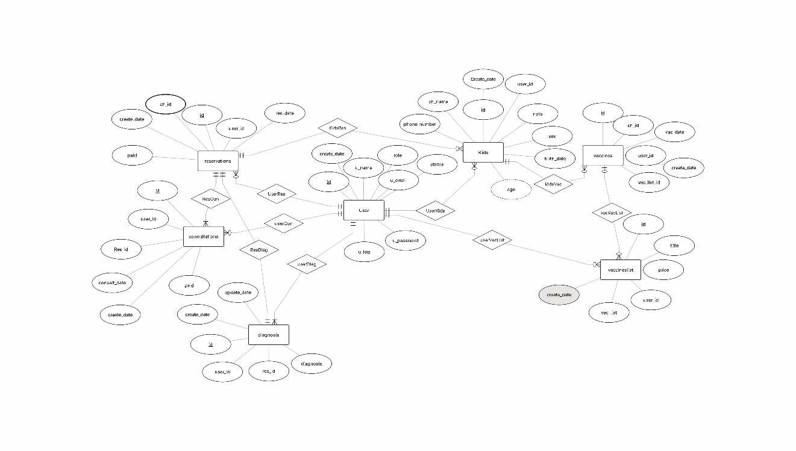
Figure 4.1: (Kids Clinic ERD v2.0 — MySQL 8.0 Schema) — Enhanced with AuditLog table (NEW in v2.0)

5.2 Physical Design (Relational Schema)
The physical design maps logical entities to MySQL 8.0 tables with InnoDB engine. All tables include standard audit fields (created_at, updated_at) and soft-delete support where applicable.
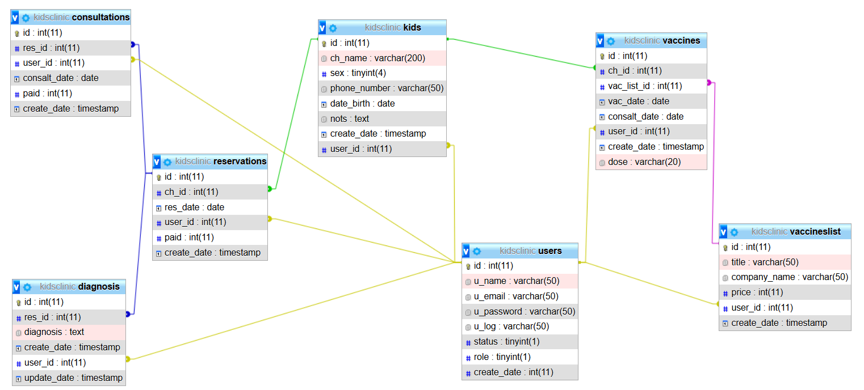
Figure 4.2: (Physical Design) — Physical Design v2.0 — MySQL 8.0 Relational Schema with 8 tables
Table | Physical Schema Description
users | user_id (PK, INT, AUTO_INCREMENT) username (VARCHAR(50), UNIQUE, NOT NULL) password_hash (VARCHAR(255), NOT NULL) — bcrypt hashed role (ENUM('doctor','employee'), NOT NULL, DEFAULT 'employee') status (ENUM('active','inactive'), NOT NULL, DEFAULT 'active') full_name (VARCHAR(100)) email (VARCHAR(100)) last_login (DATETIME) created_at (TIMESTAMP, DEFAULT CURRENT_TIMESTAMP) updated_at (TIMESTAMP, ON UPDATE CURRENT_TIMESTAMP) INDEX: username, role, status
children | child_id (PK, INT, AUTO_INCREMENT) full_name (VARCHAR(100), NOT NULL) date_of_birth (DATE, NOT NULL) gender (ENUM('male','female'), NOT NULL) parent_name (VARCHAR(100), NOT NULL) parent_phone (VARCHAR(20), NOT NULL) address (VARCHAR(255)) email (VARCHAR(100)) blood_type (VARCHAR(5)) allergies_notes (TEXT) is_deleted (BOOLEAN, DEFAULT FALSE) created_at (TIMESTAMP, DEFAULT CURRENT_TIMESTAMP) updated_at (TIMESTAMP, ON UPDATE CURRENT_TIMESTAMP) INDEX: full_name, date_of_birth, parent_name, is_deleted
visits | visit_id (PK, INT, AUTO_INCREMENT) child_id (FK -> children.child_id, INT, NOT NULL) visit_date (DATE, NOT NULL) visit_time (TIME, NOT NULL) visit_type (ENUM('routine','emergency','follow-up'), DEFAULT 'routine') notes (TEXT) fee (DECIMAL(10,2), DEFAULT 0.00) status (ENUM('scheduled','checked-in','completed','cancelled'), DEFAULT 'scheduled') created_by (FK -> users.user_id, INT) created_at (TIMESTAMP, DEFAULT CURRENT_TIMESTAMP) updated_at (TIMESTAMP, ON UPDATE CURRENT_TIMESTAMP) INDEX: child_id, visit_date, status, created_by
consultations | consultation_id (PK, INT, AUTO_INCREMENT) visit_id (FK -> visits.visit_id, INT, UNIQUE, NOT NULL) chief_complaint (VARCHAR(255), NOT NULL) symptoms (TEXT) diagnosis (VARCHAR(255), NOT NULL) notes (TEXT) doctor_id (FK -> users.user_id, INT, NOT NULL) created_at (TIMESTAMP, DEFAULT CURRENT_TIMESTAMP) updated_at (TIMESTAMP, ON UPDATE CURRENT_TIMESTAMP) INDEX: visit_id, doctor_id
prescriptions | prescription_id (PK, INT, AUTO_INCREMENT) consultation_id (FK -> consultations.consultation_id, INT, NOT NULL) medication_name (VARCHAR(200), NOT NULL) dosage (VARCHAR(100), NOT NULL) frequency (VARCHAR(100), NOT NULL) duration (VARCHAR(100), NOT NULL) instructions (TEXT) notes (TEXT) is_dispensed (BOOLEAN, DEFAULT FALSE) is_deleted (BOOLEAN, DEFAULT FALSE) doctor_id (FK -> users.user_id, INT, NOT NULL) created_at (TIMESTAMP, DEFAULT CURRENT_TIMESTAMP) updated_at (TIMESTAMP, ON UPDATE CURRENT_TIMESTAMP) INDEX: consultation_id, doctor_id, is_deleted
vaccine_catalog | vaccine_id (PK, INT, AUTO_INCREMENT) vaccine_name (VARCHAR(100), NOT NULL) vaccine_type (VARCHAR(50)) manufacturer (VARCHAR(100)) description (TEXT) is_active (BOOLEAN, DEFAULT TRUE) created_at (TIMESTAMP, DEFAULT CURRENT_TIMESTAMP) updated_at (TIMESTAMP, ON UPDATE CURRENT_TIMESTAMP) INDEX: vaccine_name, is_active
vaccinations | vaccination_id (PK, INT, AUTO_INCREMENT) child_id (FK -> children.child_id, INT, NOT NULL) vaccine_id (FK -> vaccine_catalog.vaccine_id, INT, NOT NULL) batch_number (VARCHAR(50), NOT NULL) date_given (DATE, NOT NULL) next_due_date (DATE) administered_by (FK -> users.user_id, INT, NOT NULL) notes (TEXT) is_deleted (BOOLEAN, DEFAULT FALSE) created_at (TIMESTAMP, DEFAULT CURRENT_TIMESTAMP) updated_at (TIMESTAMP, ON UPDATE CURRENT_TIMESTAMP) INDEX: child_id, vaccine_id, date_given, next_due_date, is_deleted
audit_log (NEW) | log_id (PK, BIGINT, AUTO_INCREMENT) user_id (FK -> users.user_id, INT) action (ENUM('create','update','delete','login','logout','print'), NOT NULL) table_name (VARCHAR(50), NOT NULL) record_id (INT, NOT NULL) old_values (JSON) new_values (JSON) ip_address (VARCHAR(45)) created_at (TIMESTAMP, DEFAULT CURRENT_TIMESTAMP) INDEX: user_id, action, table_name, created_at
Table 5.1: Complete Physical Database Schema (v2.0 Enhanced)

5.3 Table Specifications

5.3.1 Users Table
Stores authentication credentials and role assignments. Passwords are hashed using bcrypt (cost factor 10). Status field enables soft-deactivation without data loss.
Column | Data Type | Constraints | Description
user_id | INT | PK, AUTO_INCREMENT | Unique identifier
username | VARCHAR(50) | UNIQUE, NOT NULL | Login username
password_hash | VARCHAR(255) | NOT NULL | Bcrypt hashed password
role | ENUM | NOT NULL, DEFAULT 'employee' | Access level
status | ENUM | NOT NULL, DEFAULT 'active' | Account status
full_name | VARCHAR(100) | NULL | Display name
created_at | TIMESTAMP | DEFAULT CURRENT_TIMESTAMP | Record creation time
updated_at | TIMESTAMP | ON UPDATE CURRENT_TIMESTAMP | Last modification time
Table 5.2: Users Table Specification

5.3.2 Children Table
Central patient registry with soft-delete support (is_deleted flag) to preserve medical history for audit and reporting purposes.
Column | Data Type | Constraints | Description
child_id | INT | PK, AUTO_INCREMENT | Unique patient ID
full_name | VARCHAR(100) | NOT NULL | Child's full name
date_of_birth | DATE | NOT NULL | Birth date
gender | ENUM('male','female') | NOT NULL | Biological gender
parent_name | VARCHAR(100) | NOT NULL | Guardian name
parent_phone | VARCHAR(20) | NOT NULL | Contact number
address | VARCHAR(255) | NULL | Home address
blood_type | VARCHAR(5) | NULL | ABO/Rh type
allergies_notes | TEXT | NULL | Medical notes
is_deleted | BOOLEAN | DEFAULT FALSE | Soft delete flag
Table 5.3: Children Table Specification

5.3.3 Referential Integrity Rules
Constraint | Tables | Action
ON DELETE RESTRICT | visits.child_id -> children | Prevent deletion of child with linked visits
ON DELETE CASCADE | consultations.visit_id -> visits | Remove consultation when visit deleted
ON DELETE CASCADE | prescriptions.consultation_id -> consultations | Remove prescriptions with consultation
ON DELETE RESTRICT | vaccinations.child_id -> children | Prevent child deletion with vaccination records
ON DELETE RESTRICT | vaccinations.vaccine_id -> vaccine_catalog | Prevent vaccine deletion with linked records
ON DELETE SET NULL | audit_log.user_id -> users | Preserve audit history when user deleted
Table 5.4: Referential Integrity Constraints

Chapter 6: UML System Diagrams
This chapter documents the Unified Modeling Language (UML) diagrams that specify the system's structure and behavior. These diagrams are maintained in Visual Paradigm and StarUML, and serve as the primary design artifacts for the Development Team.

6.1 Use Case Diagram
The Use Case Diagram (Figure 4.3 from v1.0) illustrates the complete set of system functionalities from the actors' perspectives. The diagram has been corrected to show all 26 Use Cases as independent entities (previously UC-2 and UC-7 were incorrectly shown as single Use Cases encompassing multiple sub-cases).
Diagram Elements: Two actors (Doctor, Employee) connected to their respective Use Cases via association lines. System boundary encloses all Use Cases. '<<include>>' relationships show mandatory inclusions (e.g., Login included by all other Use Cases). '<<extend>>' relationships show optional extensions.
Key Corrections from v1.0: (1) UC-02 (View List) no longer includes UC-03 through UC-22; each is an independent Use Case. (2) UC-07 (Today's Visits) no longer includes UC-09 through UC-17. (3) All 26 Use Cases are now visible at the same diagram level.
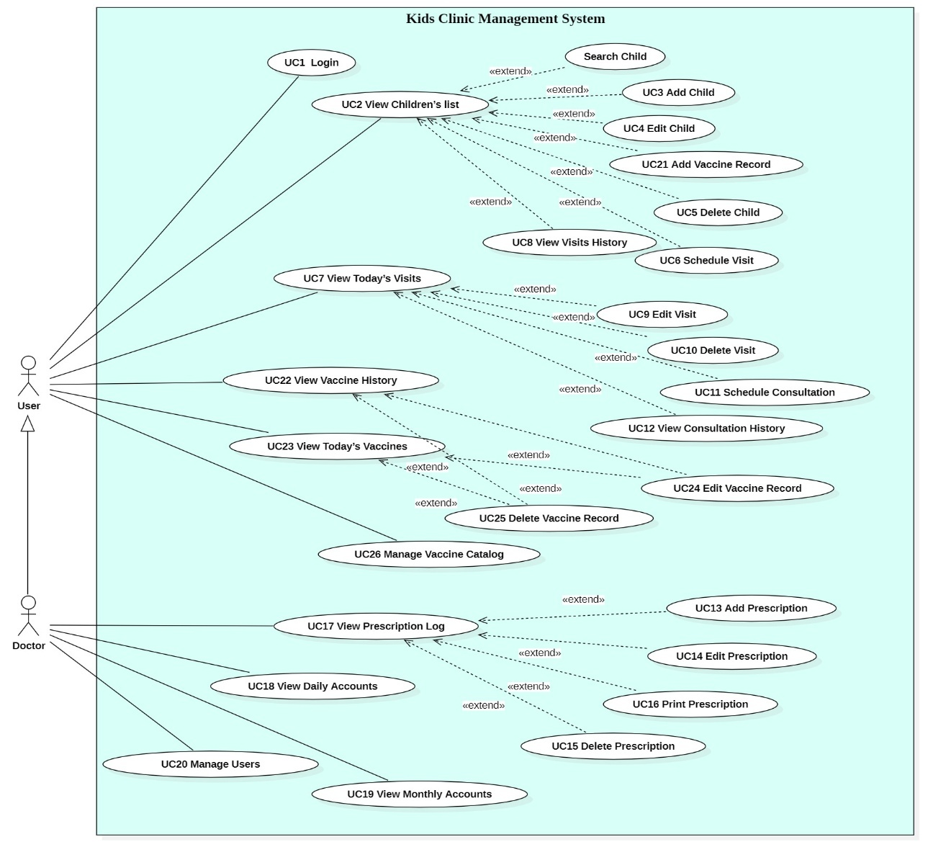
Figure 4.3: (Kids Clinic Use Case Diagram) — Corrected: All 26 Use Cases shown independently

6.2 Domain Model
The Domain Model (Figure 4.4 from v1.0) represents the conceptual classes and their associations without operations. The enhanced domain model adds the AuditLog entity and refines multiplicity constraints:
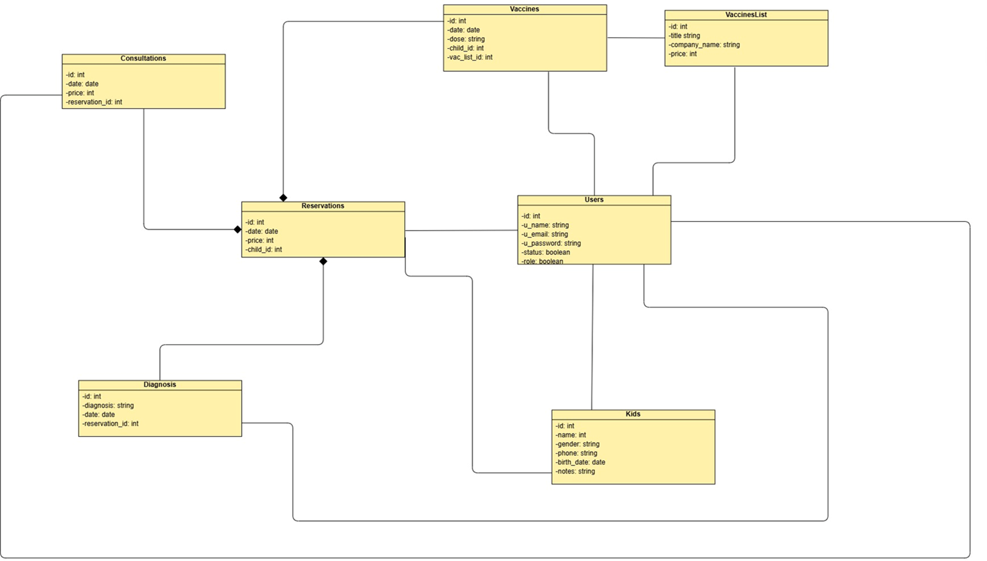
Figure 4.4: (Kids Clinic Domain Diagram) — Enhanced with AuditLog entity (NEW in v2.0)
Conceptual Class | Attributes | Associations | Multiplicity
User | username, password, role, status | creates Visits, writes Consultations, writes Prescriptions, administers Vaccinations | 1 -> *
Child | name, dob, gender, parentName, phone | has Visits, has Vaccinations | 1 -> *
Visit | date, time, type, status, fee | belongs to Child, has 1 Consultation, created by User | * -> 1, 1 -> 1
Consultation | complaint, symptoms, diagnosis, notes | belongs to Visit, has Prescriptions, conducted by Doctor | 1 -> 1, 1 -> *
Prescription | medication, dosage, frequency, duration | belongs to Consultation, written by Doctor | * -> 1
VaccineCatalog | name, type, manufacturer | referenced by Vaccinations | 1 -> *
Vaccination | batchNumber, dateGiven, nextDue | belongs to Child, references VaccineCatalog, by User | * -> 1, * -> 1
AuditLog (NEW) | action, table, recordId, old/new values | performed by User | * -> 1
Table 6.1: Domain Model — Conceptual Classes and Associations

6.3 Activity Diagrams
Activity Diagrams model the workflow of key business processes. The following diagrams are maintained (referenced from v1.0 with enhancements noted):
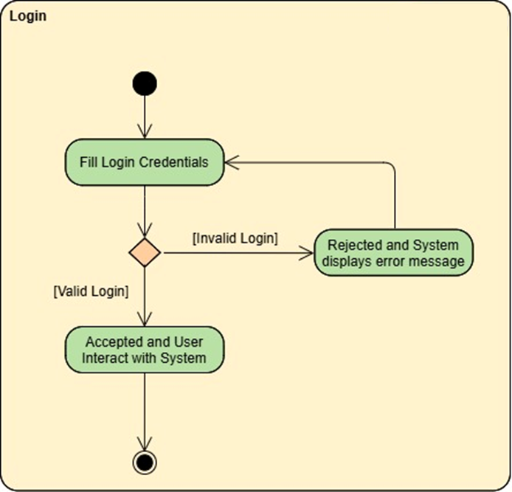
Figure 4.5: (Login Activity Diagram)
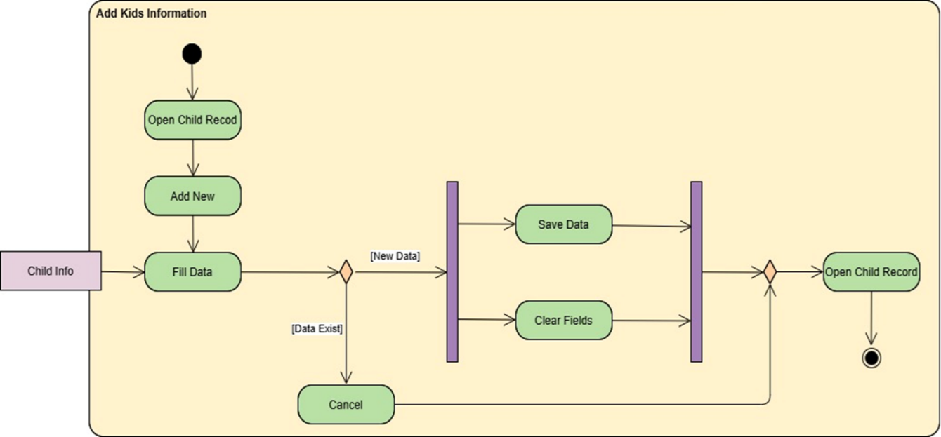
Figure 4.6: (Add Kids Information Activity Diagram)
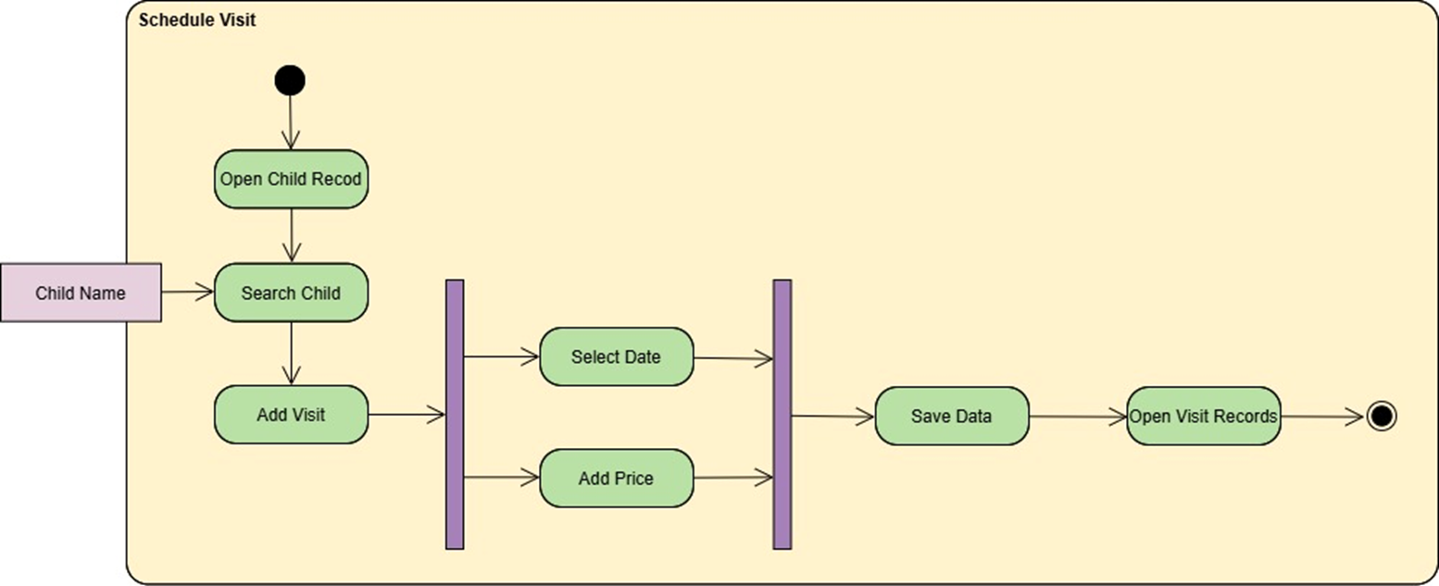
Figure 4.7: (Schedule Visit Activity Diagram)
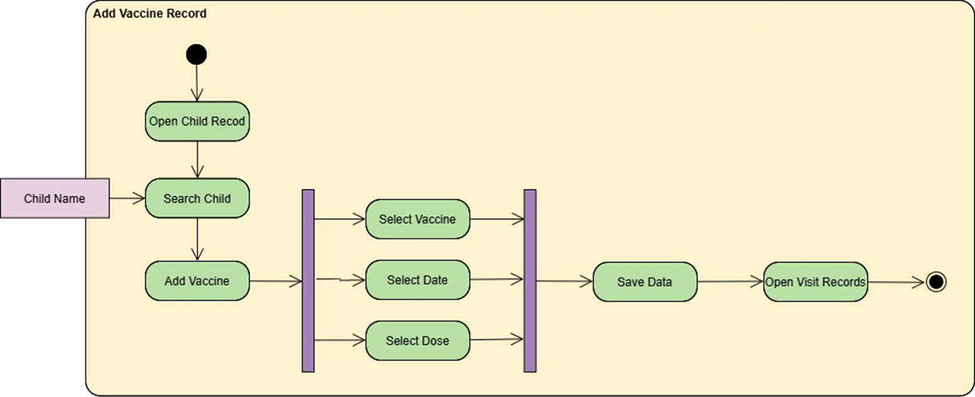
Figure 4.8: (Add Vaccine Record Activity Diagram)
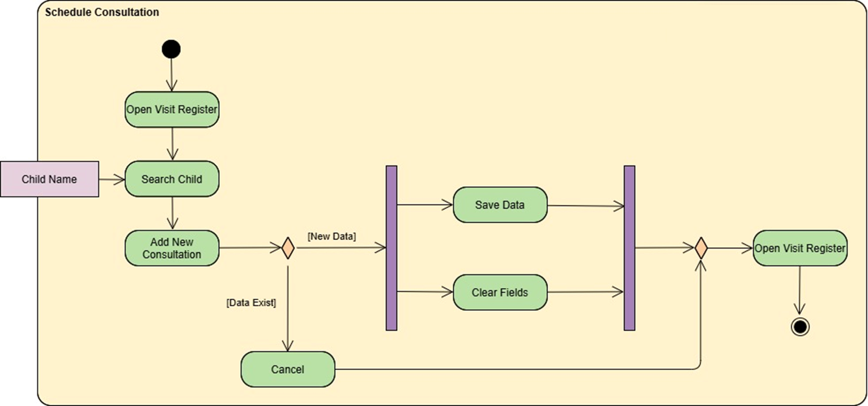
Figure 4.9: (Schedule Consultation Activity Diagram)
Diagram | Scope | Key Decision Points (Enhanced)
Login Activity (Fig 4.5) | Authentication workflow | Valid credentials? Account active? Session expired?
Add Child Activity (Fig 4.6) | Patient registration | Required fields valid? Duplicate detected? Save successful?
Schedule Visit Activity (Fig 4.7) | Appointment booking | Time conflict exists? Date in past? Visit type selected?
Add Vaccine Activity (Fig 4.8) | Vaccination recording | Catalog item selected? Batch number valid? Next due date logical?
Schedule Consultation (Fig 4.9) | Consultation workflow | Visit exists? Required fields filled? Prescription needed?
Add Prescription (NEW) | Prescription creation | Doctor role verified? Consultation exists? Print requested?
Table 6.2: Activity Diagrams — Workflow Specifications

6.4 Class Diagram
The Class Diagram (Figure 4.10 from v1.0) specifies the system's static structure with classes, attributes, operations, and relationships. The enhanced class diagram includes:
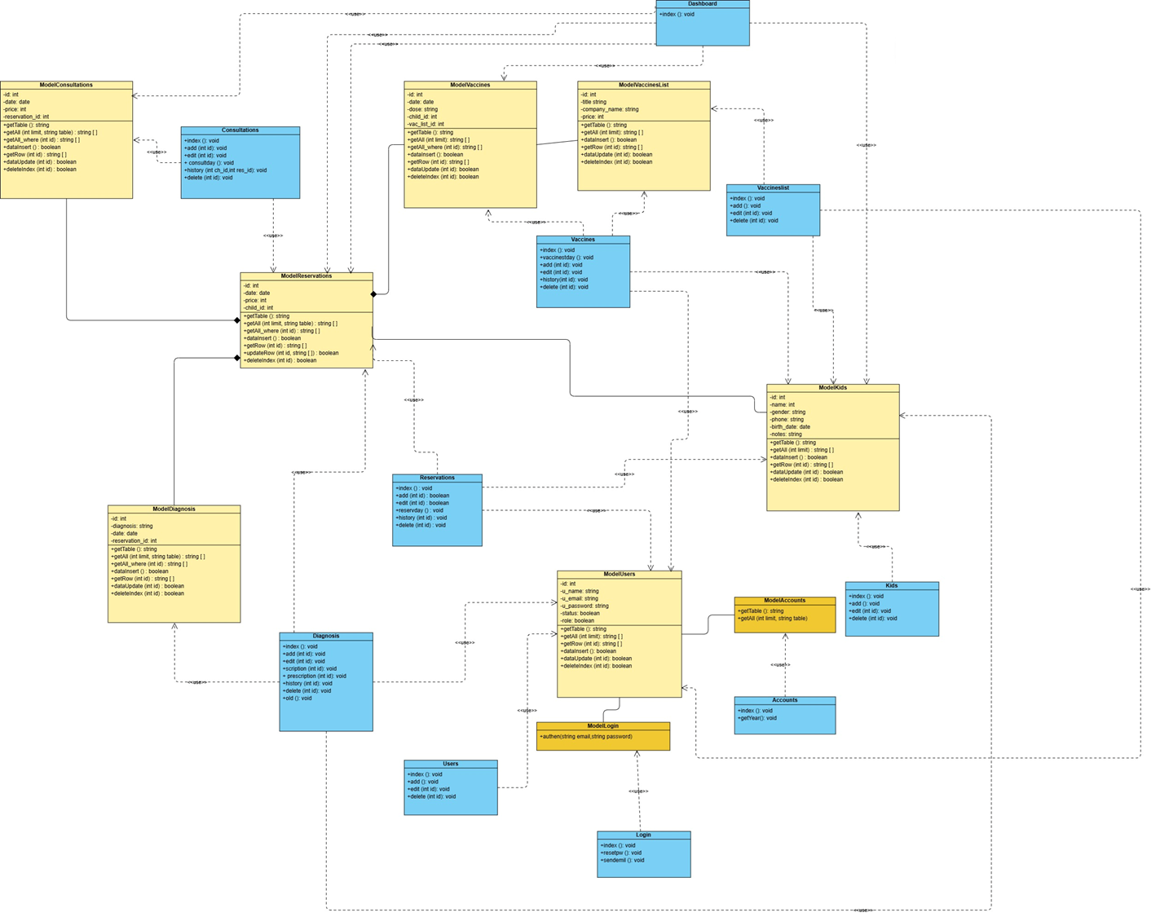
Figure 4.10: (Kids Clinic Class Diagram) — Enhanced with AuditLog class (NEW in v2.0)
- AuditLog class with logAction(), getHistory(), exportLog() operations.
- Soft-delete indicators on Child, Prescription, and Vaccination entities.
- Role enumeration with isDoctor() and isEmployee() query methods.
- Enhanced User class with authenticate(), hasPermission(), deactivate() operations.
- Validation operations on all entity classes: validate(), checkDuplicates(), checkDependencies().
Class | Key Attributes | Key Operations
User | userId, username, passwordHash, role, status | authenticate(), hasPermission(), deactivate(), updateProfile()
Child | childId, name, dob, gender, parentName, phone, isDeleted | validate(), checkDuplicate(), softDelete(), restore()
Visit | visitId, childId, date, time, type, status, fee | schedule(), updateStatus(), cancel(), checkConflict()
Consultation | consultationId, visitId, complaint, diagnosis, doctorId | record(), update(), linkToVisit(), getHistory()
Prescription | prescriptionId, consultationId, medication, dosage, isDeleted | create(), edit(), delete(), print(), validate()
Vaccination | vaccinationId, childId, vaccineId, batchNumber, dateGiven, nextDue | record(), update(), checkOverdue(), getSchedule()
AuditLog (NEW) | logId, userId, action, tableName, recordId, oldValues, newValues | log(), getByUser(), getByTable(), getByDateRange(), export()
Table 6.3: Class Diagram — Key Classes and Operations

6.5 Sequence Diagrams
Sequence Diagrams formalize the dynamic behavior and message flow among participating objects. The following diagrams are maintained (referenced from v1.0):
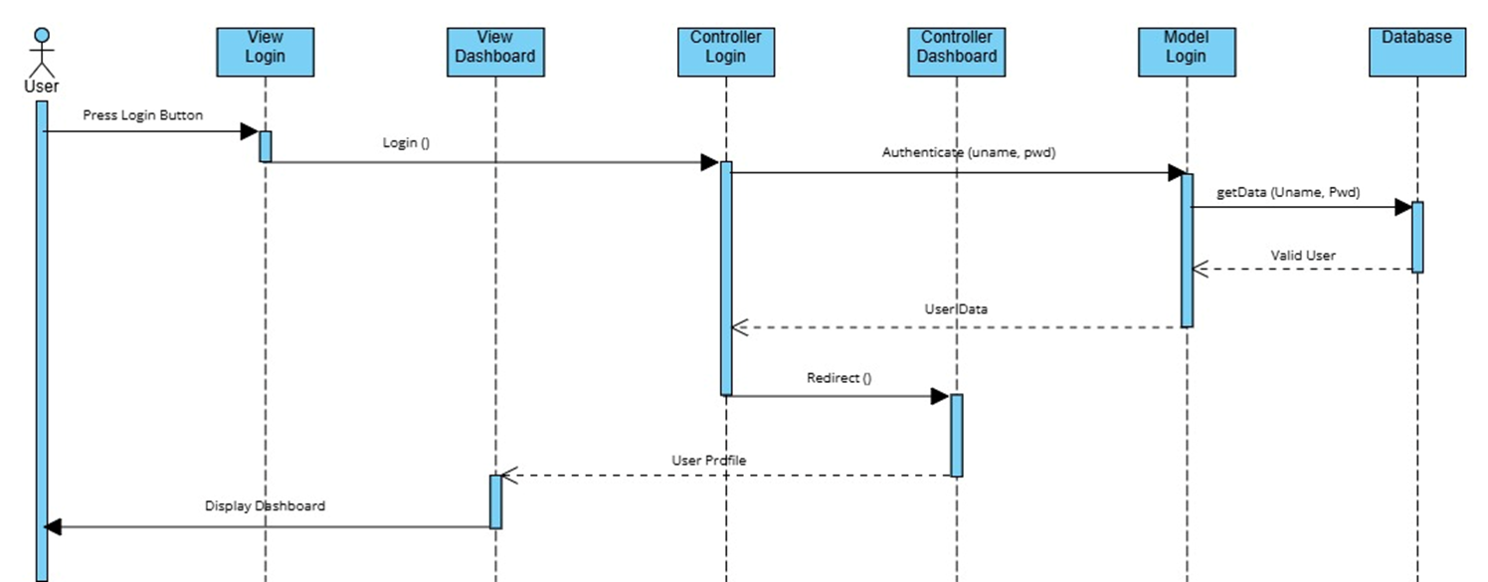
Figure 4.11: (Login Sequence Diagram)
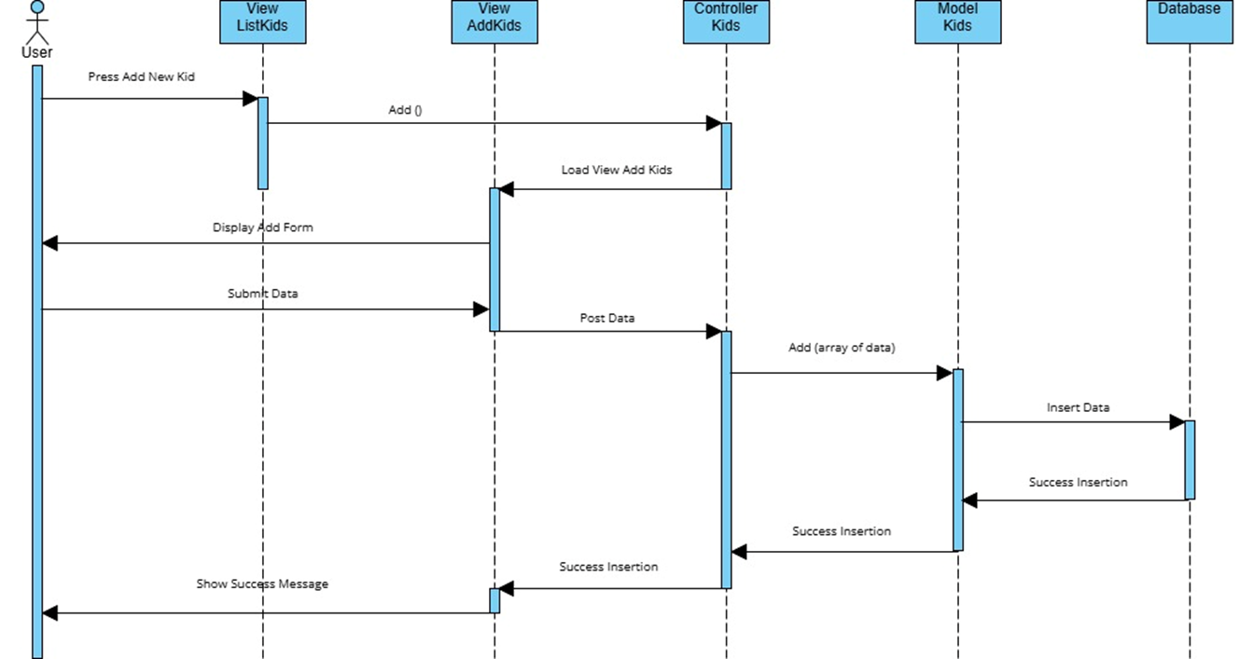
Figure 4.12: (Add Kid Information Sequence Diagram)
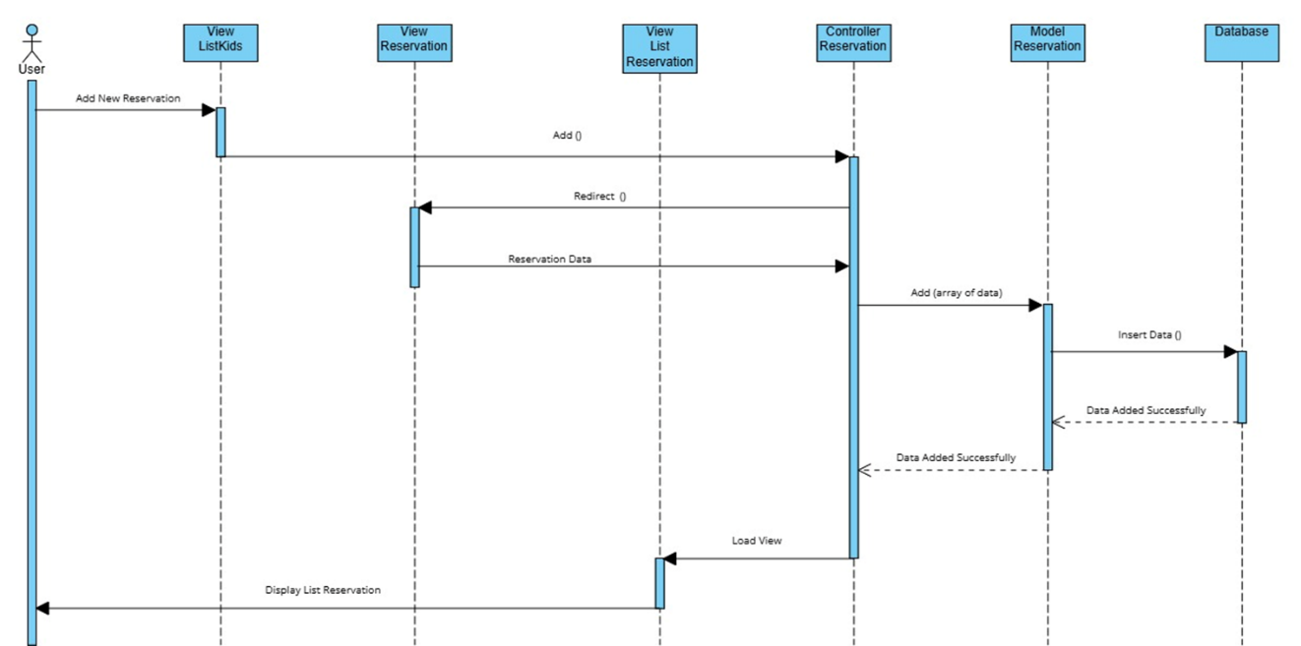
Figure 4.13: (Reservation Sequence Diagram)
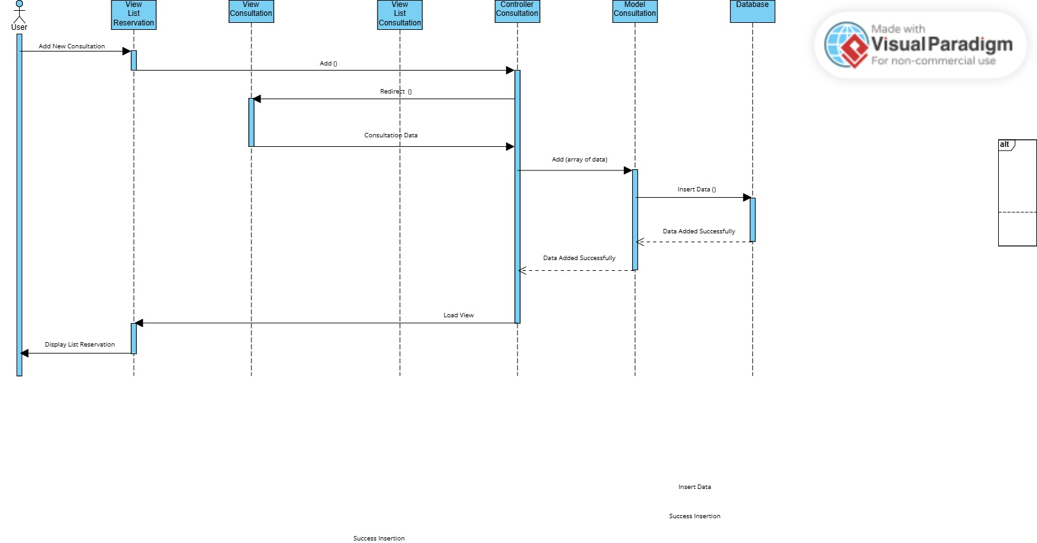
Figure 4.14: (Add Consultation Sequence Diagram)
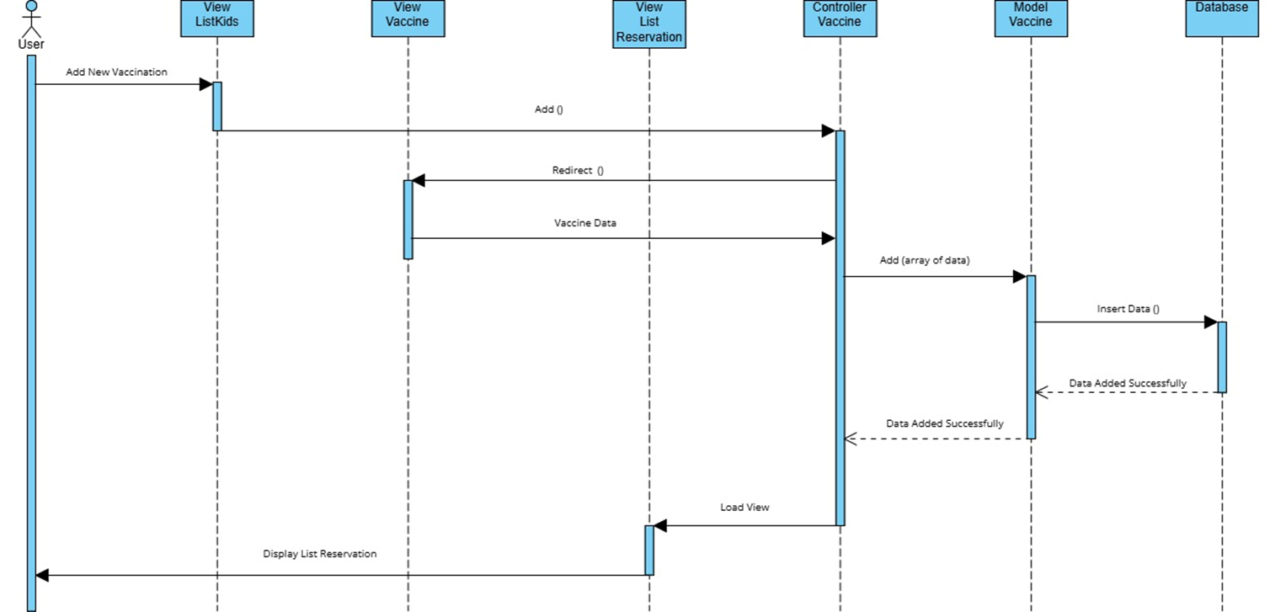
Figure 4.15: (Add Vaccine Sequence Diagram)
Diagram (Figure) | Participants | Purpose
Login Sequence (Fig 4.11) | User, LoginController, AuthService, UserModel, SessionManager | Credential validation and session establishment
Add Child Sequence (Fig 4.12) | User, ChildController, ValidationService, ChildModel, AuditLog | Registration with validation and audit
Schedule Visit Sequence (Fig 4.13) | User, VisitController, ConflictChecker, VisitModel, NotificationService | Appointment with conflict detection
Add Consultation Sequence (Fig 4.14) | User, ConsultationController, VisitModel, ConsultationModel, PrescriptionController | Consultation and optional prescription
Add Vaccine Sequence (Fig 4.15) | User, VaccinationController, VaccineCatalog, VaccinationModel, ReminderService | Vaccination with reminder scheduling
Table 6.4: Sequence Diagrams — Interaction Specifications

Chapter 7: System Architecture & Interface Design

7.1 System Architecture
The system follows a 3-tier architecture using the Model-View-Controller (MVC) pattern via Laravel 11 framework. This architecture separates concerns and enables independent development and testing of each layer.

7.1.1 Architecture Layers
Layer | Components | Responsibilities
Presentation Layer | HTML5, CSS3, Bootstrap 5, JavaScript, jQuery | Rendering UI, client-side validation, AJAX requests, responsive design
Application Layer | Laravel 11 Controllers, Services, Validation | Request handling, business logic, authentication, authorization, data flow orchestration
Data Layer | Laravel Eloquent ORM, MySQL 8.0, Query Builder | Database abstraction, CRUD operations, relationships, soft-delete, audit logging
Table 7.1: 3-Tier Architecture Specification

7.1.2 MVC Component Mapping
Controllers: AuthController (login/logout), ChildController (patient CRUD), VisitController (scheduling), ConsultationController (medical encounters), PrescriptionController (prescription lifecycle), VaccinationController (immunization tracking), AccountController (financial reports), AdminController (user management), AuditController (logging and reporting).
Models: UserModel, ChildModel, VisitModel, ConsultationModel, PrescriptionModel, VaccineCatalogModel, VaccinationModel, AuditLogModel — each extending Laravel's Eloquent Model class with built-in validation and soft-delete support.
Views: Template-based layouts (header, footer, sidebar) with modular page views for each feature area. Shared components: pagination, search, filter panels, confirmation dialogs.

7.1.3 Security Architecture
Security Layer | Implementation | Details
Authentication | Session-based with 30-min timeout | bcrypt password hashing, CSRF token protection, secure cookie flags
Authorization | Laravel Auth Middleware + Gates/Policies | Role checks on every request; Doctor-only routes protected by filters
Input Validation | Laravel Validation | Server-side validation for all forms; XSS filtering on input
Data Protection | Parameterized queries (Eloquent/Query Builder) | SQL injection prevention; prepared statements on all database operations
Audit Trail | Laravel Observer / Event Listeners | Automatic logging of all CRUD operations with before/after state capture
Table 7.2: Security Architecture Matrix

7.2 Interface Design
The user interface follows a consistent dashboard-based layout with a collapsible sidebar navigation, top header bar, and content area. All interfaces from v1.0 (Figures 4.16-4.28) remain valid with the following enhancements:
- Global search bar added to header for quick patient lookup.
- Notification badge for upcoming vaccinations due within 7 days.
- Breadcrumb navigation added for wayfinding across all pages.
- Responsive sidebar that collapses to hamburger menu on mobile viewports.
- Audit log viewer added to Admin section (NEW interface).
- Error boundary page with 'Return to Dashboard' link for graceful failure handling.
Interface Screenshots (from v1.0 — retained in v2.0 with enhancements noted above):
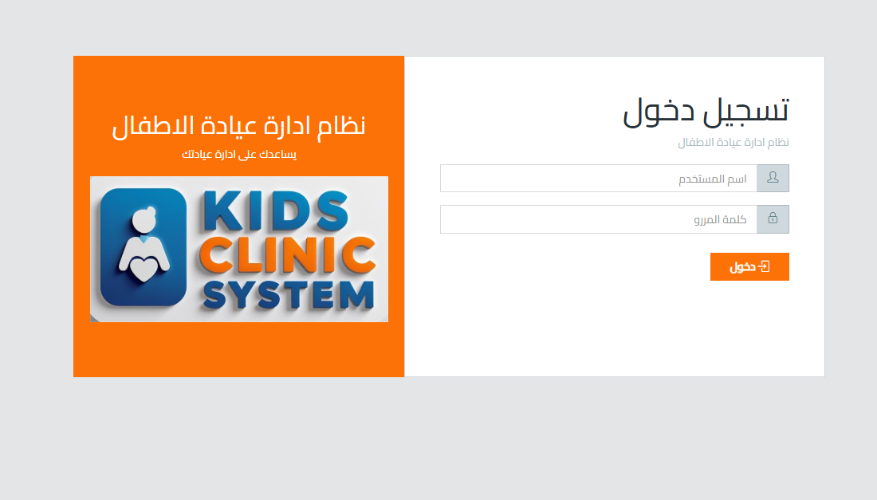
Figure 4.16: (Login Interface)
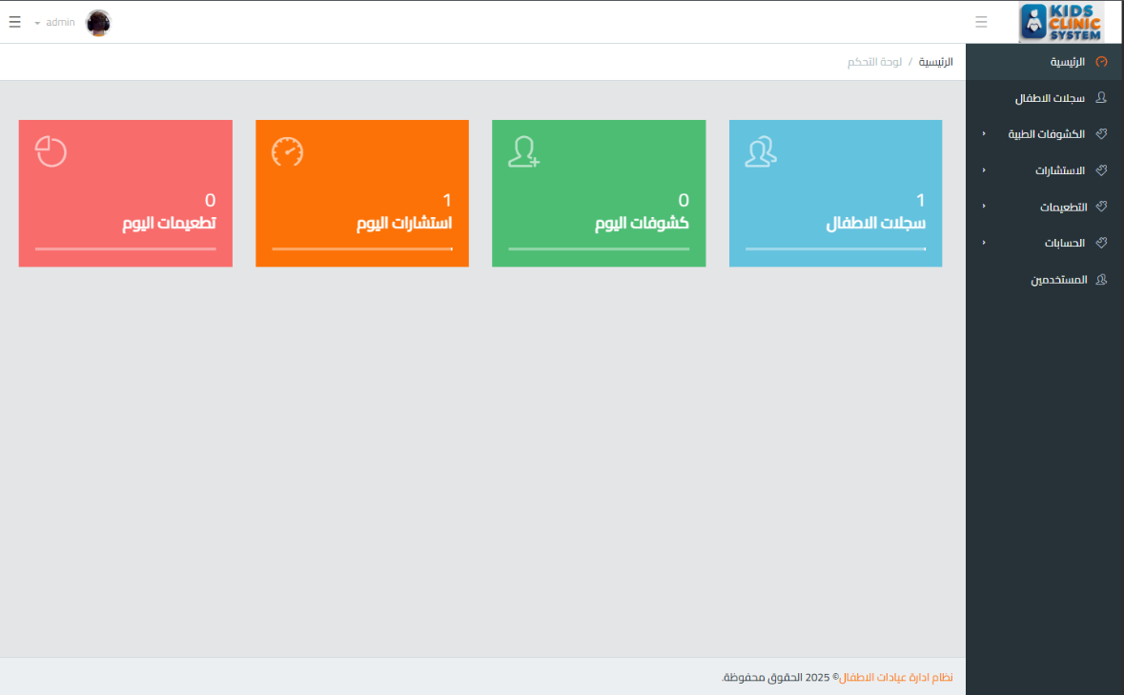
Figure 4.17: (Dashboard Interface)
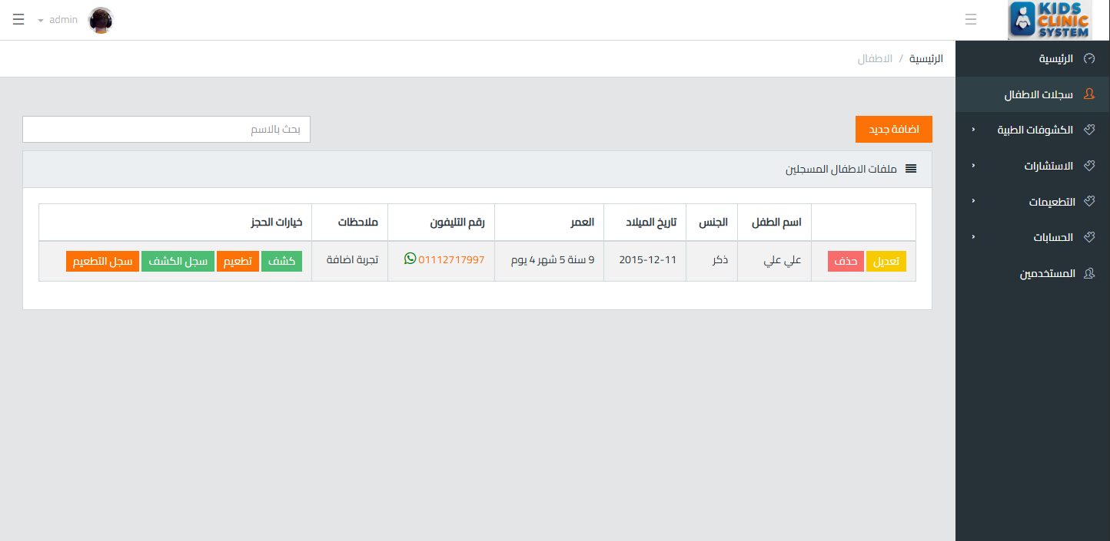
Figure 4.18: (Kids List Interface)
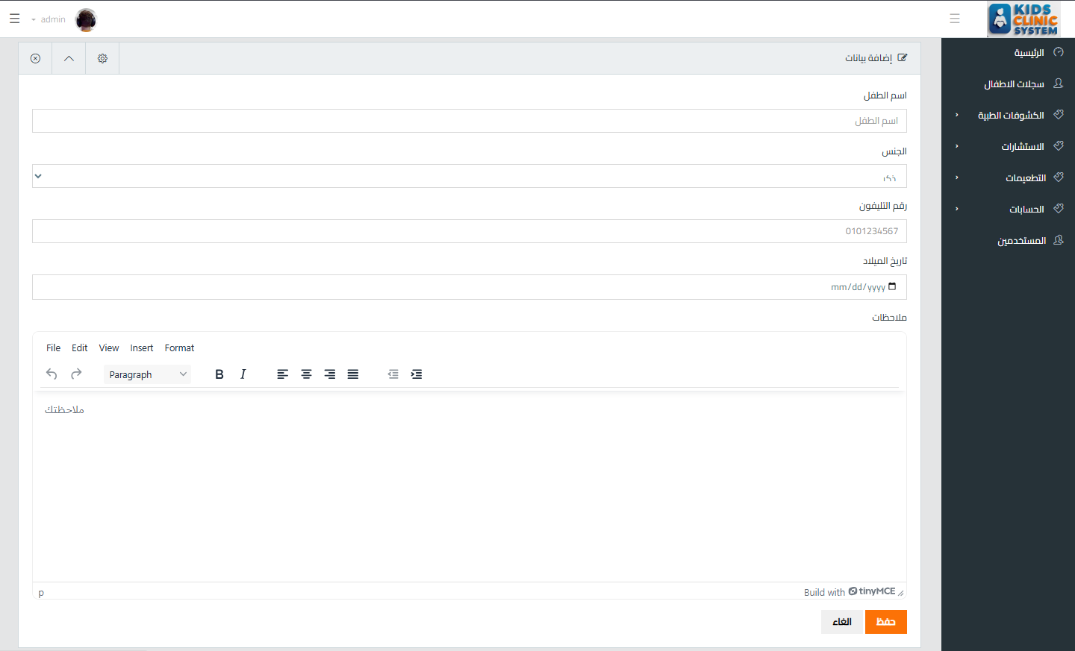
Figure 4.19: (Add Kid's Information Interface)
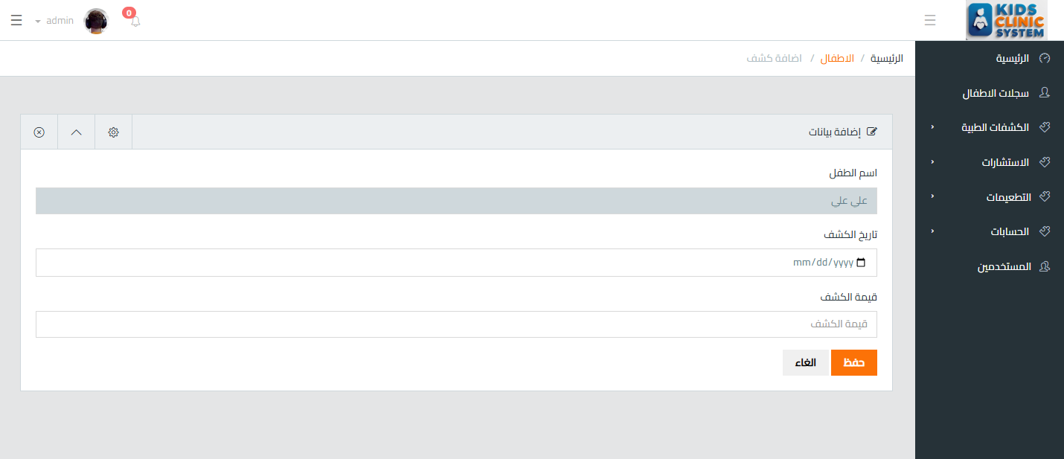
Figure 4.20: (Add Reservation Interface)
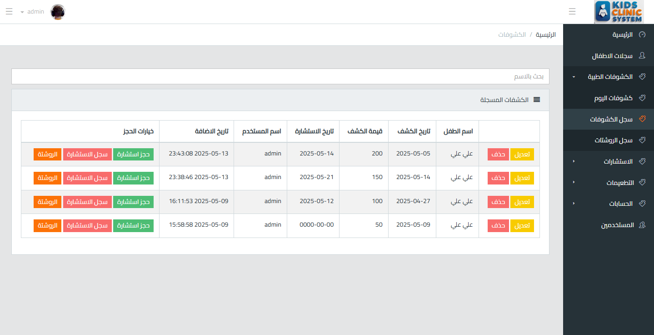
Figure 4.21: (Reservation List Interface)
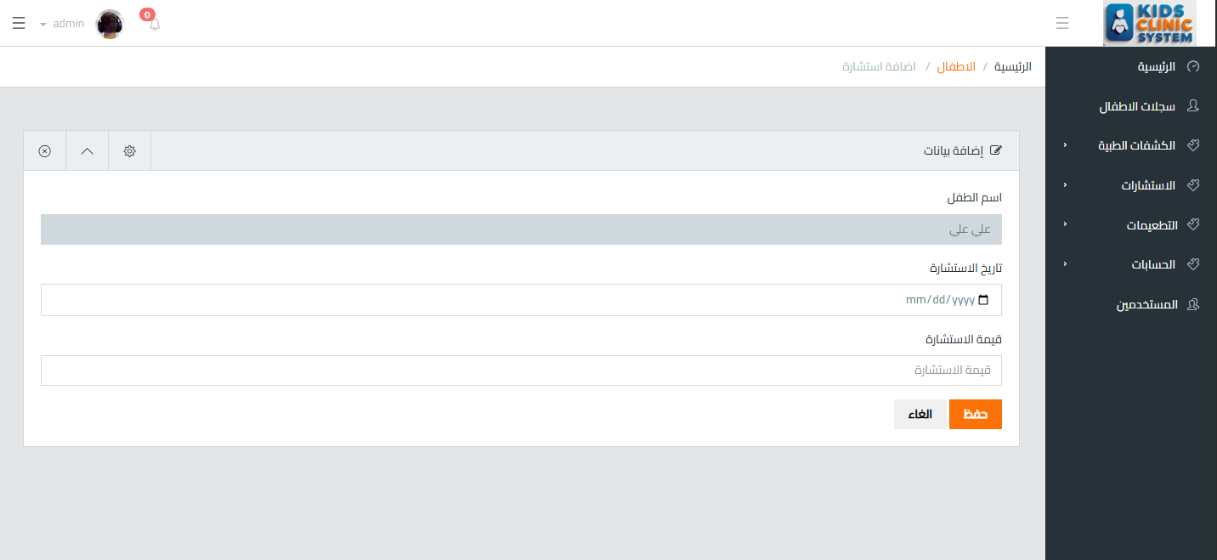
Figure 4.22: (Add Consultation Interface)
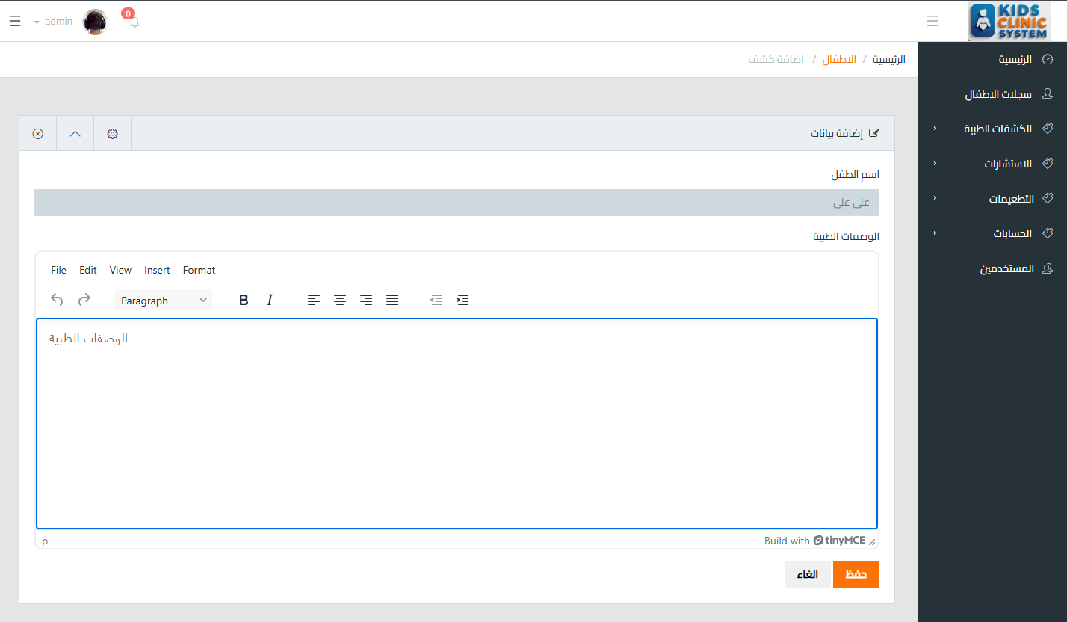
Figure 4.23: (Add Prescription Interface)
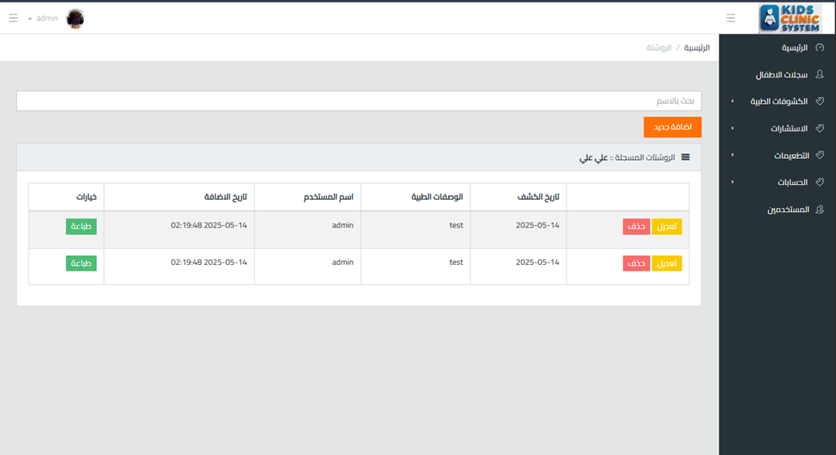
Figure 4.24: (Prescription List Interface)
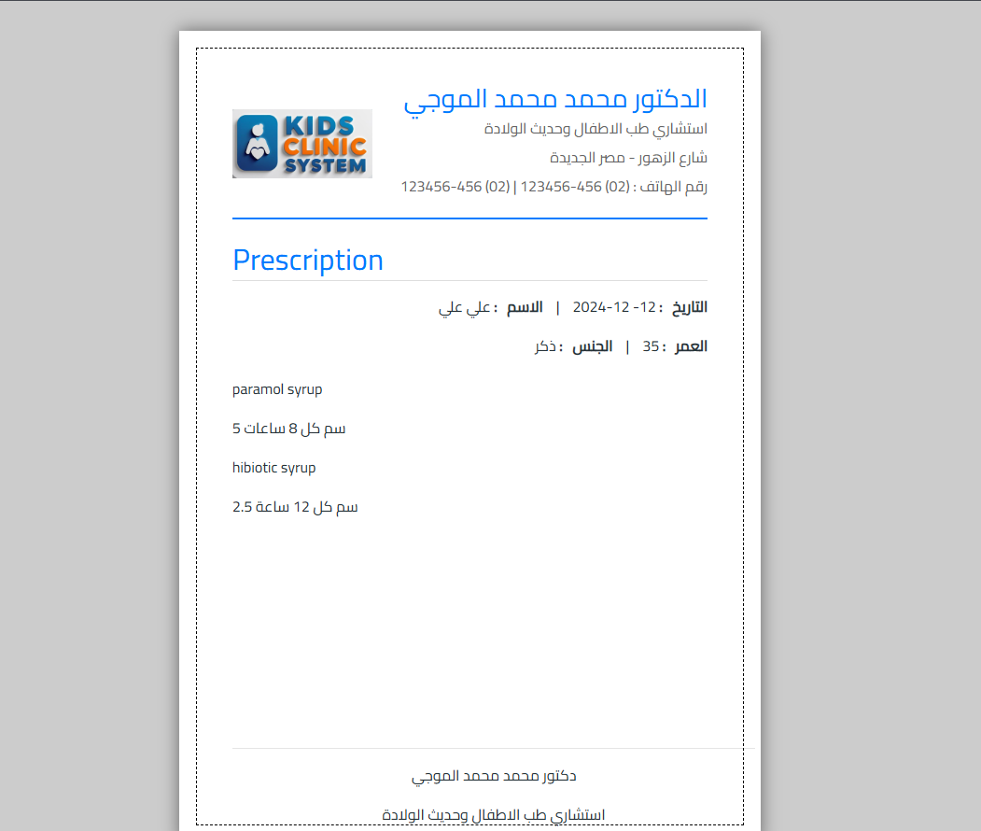
Figure 4.25: (Prescription Interface)
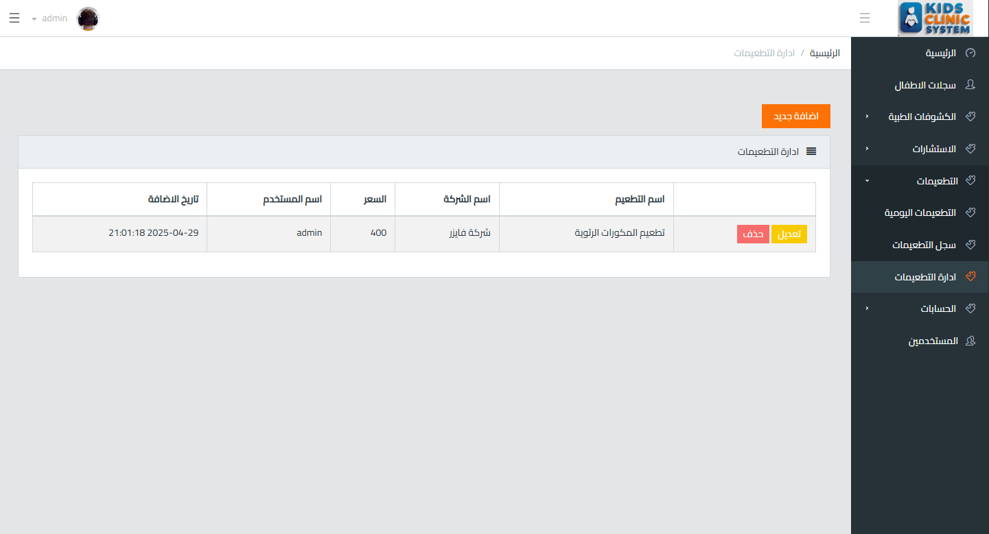
Figure 4.26: (Vaccine Management Interface)
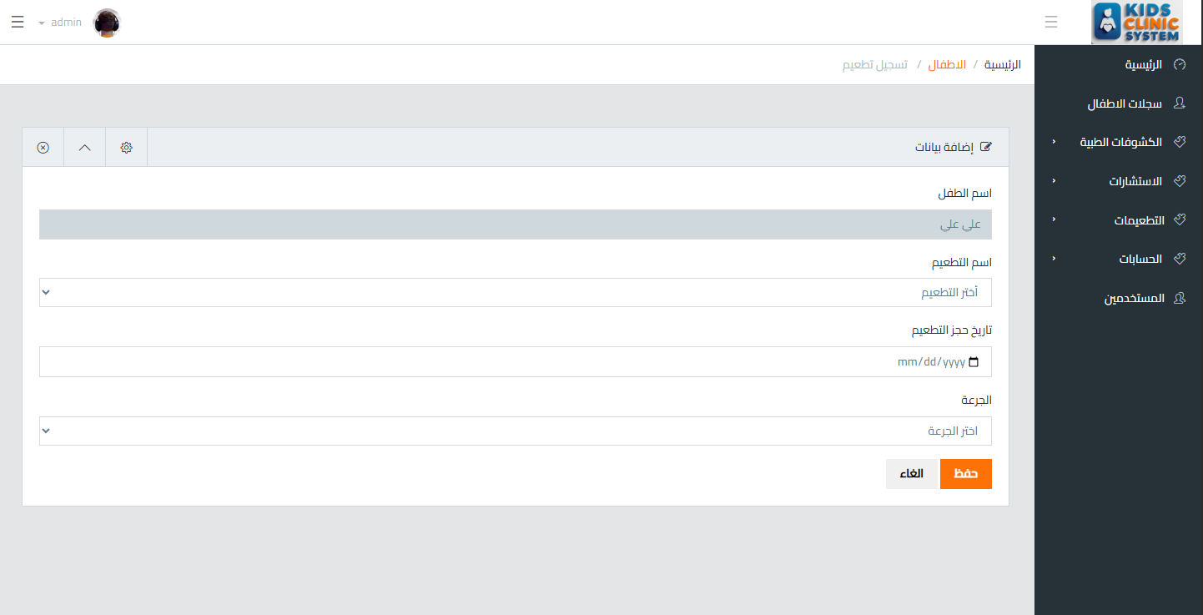
Figure 4.27: (Add Vaccine Record Interface)
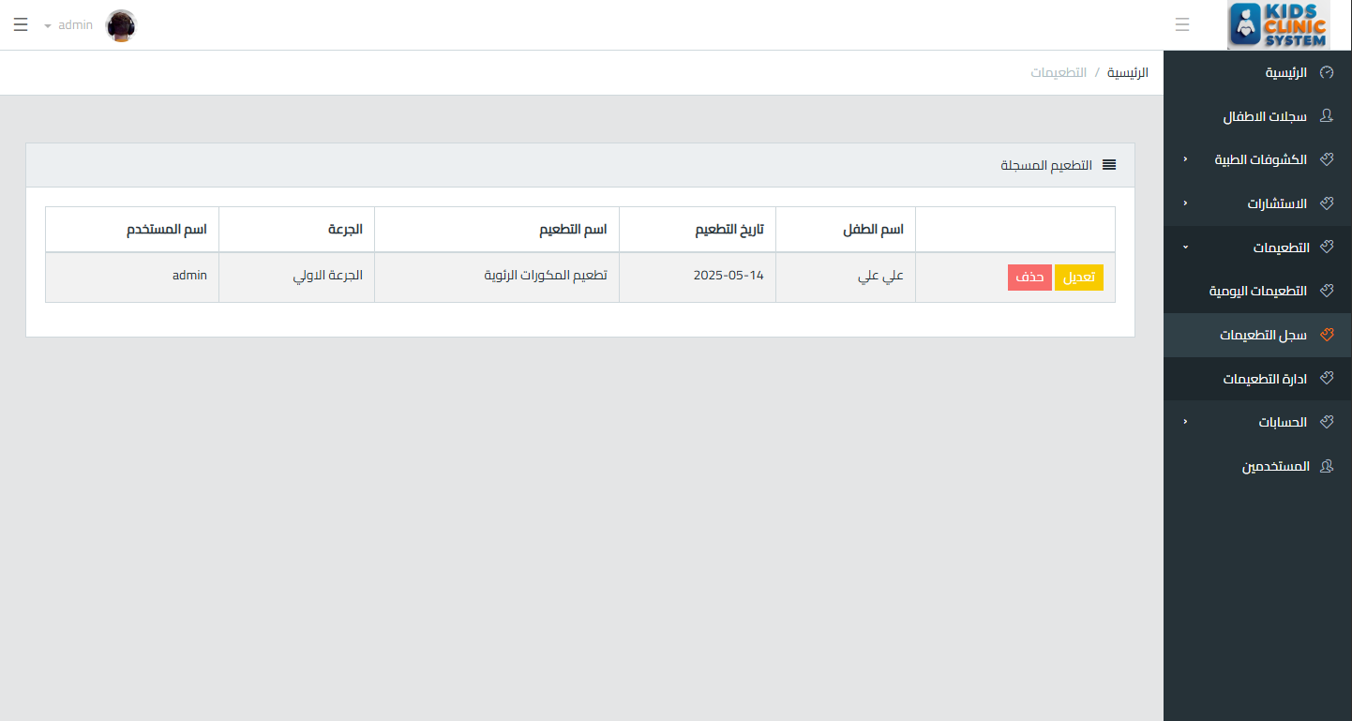
Figure 4.28: (Vaccine List Interface)

7.2.1 Interface Inventory
Interface (Figure) | Purpose | Access
Login Interface (Fig 4.16) | User authentication | Public
Dashboard Interface (Fig 4.17) | Overview with KPIs and quick actions | Authenticated
Children's List (Fig 4.18) | Patient registry with search and pagination | Authenticated
Add/Edit Child (Fig 4.19) | Patient registration and modification | Authenticated
Schedule Visit (Fig 4.20) | Appointment booking with time picker | Authenticated
Today's Visits (Fig 4.21) | Daily appointment dashboard | Authenticated
Add Consultation (Fig 4.22) | Medical encounter recording | Authenticated
Add/Edit Prescription (Fig 4.23) | Medication prescription creation | Doctor only
Prescription List (Fig 4.24) | Filterable prescription log | Doctor only
Print Prescription (Fig 4.25) | Print-ready prescription document | Doctor only
Vaccine Catalog (Fig 4.26) | Vaccine type management | Authenticated
Add Vaccination (Fig 4.27) | Immunization record entry | Authenticated
Vaccination History (Fig 4.28) | Patient immunization timeline | Authenticated
Daily/Monthly Accounts (NEW) | Financial summaries with comparison | Doctor only
User Management (NEW) | Account CRUD with role assignment | Doctor only
Audit Log Viewer (NEW) | Activity history with filters | Doctor only
Table 7.3: Complete Interface Inventory (v2.0)
Note: Audit Log Viewer is a composite view extending UC-20 (Manage Users). It provides read-only access to the audit_log table with filtering by date range, user, and action type.

Chapter 8: Conclusion & Future Work

8.1 Summary of Enhancements (v1.0 to v2.0)
This Enhanced Agile Documentation v2.0 addresses all identified gaps and issues from the original documentation through the following systematic improvements:
# | Issue Identified (v1.0) | Severity | Resolution (v2.0)
1 | Used Waterfall SDLC with no iterative feedback | Critical | Replaced with Scrum Agile framework: 8 Sprints, ceremonies, roles
2 | SRS incomplete: missing Purpose, Scope, Definitions, Overview per IEEE 830 | Critical | Added full IEEE 830-1998 compliant SRS structure (Sections 2.1-2.5)
3 | Use Cases improperly aggregated (UC-2 had 7 sub-cases, UC-7 had 5) | Critical | All 26 Use Cases specified independently with full detail
4 | User Stories lacked Acceptance Criteria | Major | Every User Story has Given-When-Then Acceptance Criteria
5 | Story Points miscalculated (71 vs actual 72) | Major | Corrected total: 72 points; validated against all 25 stories
6 | Work Backlog had illogical ordering (search before login) | Major | Reorganized into dependency-aware Sprints with clear Goals
7 | Vaccine requirements had Low priority (REQ-14-17) | Major | Elevated to High/Critical; immunization is core clinic function
8 | No Definition of Done | Major | Added comprehensive DoD with 10 measurable criteria
9 | No Sprint Goals or capacity planning | Medium | Each Sprint has: Goal, capacity, committed stories, deliverables
10 | Database schema lacked audit fields | Medium | Added created_at/updated_at to all tables; added audit_log table
11 | No non-functional requirement specifications | Medium | Added Performance, Security, Usability, Reliability, Maintainability NFRs
12 | No system constraint documentation | Medium | Added constraints matrix: Technology, Budget, Timeline, Compliance
13 | Traceability Matrix had incorrect mappings | Medium | Corrected full REQ-to-UC mapping with proper coverage
14 | No Product Backlog ordering or velocity tracking | Medium | Added ranked Product Backlog with velocity metrics
15 | No security architecture documentation | Low | Added security layers: Auth, AuthZ, Input Validation, Audit Trail
Table 8.1: Complete Issue Resolution Matrix (v1.0 to v2.0)

8.2 Conclusion
The Kids Clinic Management System Enhanced Agile Documentation v2.0 represents a comprehensive, standards-compliant, and methodology-consistent specification that addresses all critical gaps identified in the original documentation. By transitioning from Waterfall to Scrum methodology, adding complete IEEE 830-1998 SRS structure, specifying all 26 Use Cases independently, enhancing User Stories with Acceptance Criteria, and reorganizing Sprint Plans with logical dependency ordering, this document now provides the Development Team with a clear, traceable, and actionable roadmap.
The systematic identification and resolution of 15 distinct issues demonstrates a commitment to documentation quality that matches the quality expected of the system itself. The document serves not only as an academic deliverable but as a practical tool for Agile project execution, stakeholder communication, and quality assurance.

8.3 Future Work
The following features are proposed for inclusion in the Product Roadmap for subsequent releases beyond the initial 8-Sprint delivery:
- Mobile Application: Native or PWA mobile app for on-the-go access by doctors.
- Parent Portal: Public-facing portal allowing guardians to view upcoming appointments and vaccination schedules.
- SMS/Email Notifications: Automated reminders for upcoming appointments and vaccination due dates.
- Advanced Analytics Dashboard: Statistical reporting with charts (visit trends, vaccine coverage rates, revenue projections).
- Multi-Language Support: Arabic/English bilingual interface for broader accessibility.
- External System Integration: API connections with insurance providers and national health databases.
- Offline Mode: Service Worker implementation for limited offline functionality.
- AI-Assisted Diagnosis: Symptom checker and drug interaction warnings using medical knowledge bases.

8.4 Document Control
Attribute | Value
Document Version | 2.0
Previous Version | 1.0
Date | June 2025
Status | Final — Approved for Development
Author | Project Team — Computer Science Department
Reviewers | Product Owner (Doctor), Scrum Master, Academic Supervisor
Standards Compliance | IEEE 830-1998, Scrum Guide 2020
Next Review Date | End of Sprint 4 (Mid-project review)
Table 8.2: Document Control Information

References
Ref | Citation
[1] | IEEE Computer Society, IEEE Std 830-1998: IEEE Recommended Practice for Software Requirements Specifications. IEEE, 1998.
[2] | K. Schwaber and J. Sutherland, The Scrum Guide. Scrum.org, 2020. [Online]. Available: https://scrumguides.org/
[3] | B. Bruegge and A. H. Dutoit, Object-Oriented Software Engineering: Using UML, Patterns, and Java, 3rd ed. Pearson Education, 2004.
[4] | I. Marsic, Software Engineering. Rutgers University, New Brunswick, NJ, 2012.
[5] | C. Larman, Applying UML and Patterns: An Introduction to Object-Oriented Analysis and Design and the Unified Process, 2nd ed. Prentice Hall, 2002.
[6] | R. Elmasri and S. Navathe, Fundamentals of Database Systems, 6th ed. Pearson, 2010.
[7] | PHP: The Right Way. [Online]. Available: https://phptherightway.com/
[8] | Laravel 11 Documentation. [Online]. Available: https://laravel.com/docs/11.x
[9] | MySQL 8.0 Reference Manual. Oracle Corporation, 2023. [Online]. Available: https://dev.mysql.com/doc/
[10] | Bootstrap 5 Documentation. [Online]. Available: https://getbootstrap.com/docs/5.0/
Table 8.3: References


Kids Clinic Management System
Agile Documentation v2.0
IEEE 830-1998 Compliant | Scrum Methodology
Computer Science Department | 2025
All Rights Reserved

