Turkey Used-Car Sales Drivers 2020
12 Nov 2026
By Zack Wong

1. Background & Summary
Analysis of 49,534 used-car listings in Turkey (Jan–Sep 2020, 51 duplicates removed) to find which cars to push. 1 listing = 1 sale / 1 customer (assumed; no customer count in the data). Prices in TL.
Summary:
- Hyundai Accent leads with 3,424 sales (6.9%); ranks #2–#9 are within 1pt of each other. Fiat, Renault, Opel and Ford = 54% of volume.
- Model years 2012, 2011, 2013 are 26.6% of sales; 45% of cars sit in the 100k–200k KM band.
- İstanbul is 25.7% of sales; top 3 provinces = 41%. Top district: Çankaya (Ankara) (931).
- White is 30% of colours (26% blank); stock White, then Grey and Black.
- Aug is the peak month, but Jul–Aug = 91% of rows, a scrape artifact. YoY is not possible (2020 only).

2. Method
- Remove 51 exact duplicate rows; parse Price (TL) and Km (6 corrupt Km values set to Unknown).
- Derive Series = brand + first model token (e.g. Fiat Egea); Model = model year.
- Map Turkish colours to English using the reference table; blanks = Unknown.
- KM bands: <50k new-ish, 50–100k low-mid, 100–200k average, >200k used.
- Count rows (1 row = 1 sale) by series, model year, month, province and district.

3. Findings

3.1 Hyundai Accent is the clear #1 car; ranks #2–#9 are effectively tied
Hyundai Accent has 3,424 sales vs 2,497 for #2.
Rank | Car (brand + series) | Sales | Share | Median price
1 | Hyundai Accent | 3,424 | 6.9% | 69,750
2 | Opel Corsa | 2,497 | 5.0% | 76,500
3 | Ford Focus | 2,496 | 5.0% | 117,000
4 | Opel Astra | 2,495 | 5.0% | 107,500
5 | Renault Fluence | 2,494 | 5.0% | 111,000
6 | Fiat Linea | 2,494 | 5.0% | 73,500
7 | Ford Fiesta | 2,446 | 4.9% | 80,000
8 | Renault Megane | 2,445 | 4.9% | 81,500
9 | Honda Civic | 2,398 | 4.8% | 120,625
10 | Fiat Egea | 2,131 | 4.3% | 119,250
Root cause: Audi, BMW, Mercedes and most series sit at ~2,500 rows each, which suggests the data collection was capped per series.

3.2 Model years 2011–2013 and 2015–2016 drive the most sales
2012 is the top year with 4,940 sales (10.0%).
Rank | Model year | Sales | Share | Median KM
1 | 2012 | 4,940 | 10.0% | 149,803
2 | 2011 | 4,384 | 8.9% | 162,000
3 | 2013 | 3,869 | 7.8% | 135,000
4 | 2016 | 3,770 | 7.6% | 90,244
5 | 2015 | 3,739 | 7.5% | 104,000
6 | 2017 | 3,066 | 6.2% | 67,000
7 | 2014 | 2,958 | 6.0% | 123,000
8 | 2010 | 2,634 | 5.3% | 169,000
9 | 2008 | 2,099 | 4.2% | 200,000
10 | 2004 | 1,986 | 4.0% | 214,100
Root cause: Cars aged 4–9 years at listing time match the 100k–200k KM sweet spot (45% of sales).

3.3 İstanbul and Ankara generate over a third of sales
İstanbul has 12,728 sales (25.7%); Ankara has 4,713.
Rank | Province | Sales | Share | Median price
1 | İstanbul | 12,728 | 25.7% | 105,000
2 | Ankara | 4,713 | 9.5% | 94,750
3 | İzmir | 2,777 | 5.6% | 90,750
4 | Antalya | 2,208 | 4.5% | 96,750
5 | Bursa | 1,885 | 3.8% | 95,000
6 | Gaziantep | 1,377 | 2.8% | 85,000
7 | Kocaeli | 1,316 | 2.7% | 89,500
8 | Konya | 1,278 | 2.6% | 90,000
9 | Adana | 1,260 | 2.5% | 90,000
10 | Hatay | 1,146 | 2.3% | 85,825
Root cause: Population concentration; the top 10 provinces hold a majority of listings.

3.4 Demand is spread thinly across districts; Çankaya (Ankara) leads
No district exceeds 1.9% of sales; 4 of the top 10 are in İstanbul.
Rank | District (Province) | Sales | Share | Median price
1 | Çankaya (Ankara) | 931 | 1.9% | 115,000
2 | Bağcılar (İstanbul) | 885 | 1.8% | 115,000
3 | Esenyurt (İstanbul) | 843 | 1.7% | 108,000
4 | Osmangazi (Bursa) | 752 | 1.5% | 97,000
5 | Ataşehir (İstanbul) | 746 | 1.5% | 124,675
6 | Pendik (İstanbul) | 725 | 1.5% | 95,250
7 | Şehitkamil (Gaziantep) | 713 | 1.4% | 96,000
8 | Keçiören (Ankara) | 682 | 1.4% | 88,000
9 | Muratpaşa (Antalya) | 610 | 1.2% | 107,625
10 | Yenimahalle (Ankara) | 609 | 1.2% | 97,000
Root cause: Large, dense districts dominate; no single local hotspot.

3.5 Monthly volume peaks in Aug, driven by the scrape window, not demand
Aug has 34,777 listings vs 10,274 in Jul. Sep covers 1–3 Sep only.
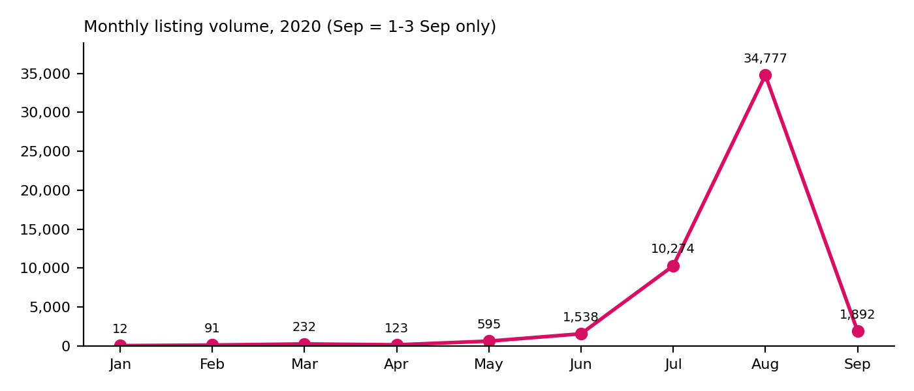
Month | Sales | MoM change | MoM %
Jan | 12 | – | –
Feb | 91 | +79 | 658%
Mar | 232 | +141 | 155%
Apr | 123 | -109 | -47%
May | 595 | +472 | 384%
Jun | 1,538 | +943 | 158%
Jul | 10,274 | +8,736 | 568%
Aug | 34,777 | +24,503 | 238%
Sep | 1,892 | -32,885 | -95%
Root cause: The file is a snapshot of active listings (~3 Sep); Jan–Jun hold only older, still-live listings. YoY is not possible with 2020 only.

3.6 White, 100k–200k KM cars dominate the mix
KM band | Sales | Share | Median price
New-ish (<50k) | 4,828 | 9.7% | 145,000
Low-mid (50k-100k) | 8,812 | 17.8% | 125,000
Average (100k-200k) | 22,173 | 44.8% | 91,000
Used (>200k) | 13,715 | 27.7% | 60,000

Colour | Sales | Share
White | 14,936 | 30.2%
Unknown | 12,889 | 26.0%
Grey | 8,641 | 17.4%
Black | 4,942 | 10.0%
Red | 2,059 | 4.2%
Silver | 1,928 | 3.9%
Root cause: Colour is blank on 26% of rows; White (30%) is the dominant stated colour.

4. Recommendations & Action Items
- Push Hyundai Accent, Opel Corsa, Ford Focus, Opel Astra, Renault Fluence, focused on model years 2012–2013 with 100k–200k KM.
- Target İstanbul, Ankara, İzmir first; use Çankaya, Bağcılar and Esenyurt for local targeting.
- Stock White first, then Grey and Black.
- Get a better dataset before time-based planning:
  - Full-year data (2019 and 2020) for real YoY and seasonality.
  - Confirmed sales and customer counts instead of listings.
  - Uncapped extract per series to validate ranks #2–#9.

5. Reference
Working file: CarSales_Analysis.xlsx (tables and native charts per question).
Series derivation (Python):
series = brand + ' ' + first token after brand (BMW: two tokens; 'Mercedes - Benz' and 'Alfa Romeo' handled as brands)
df.drop_duplicates().groupby('Series').size().sort_values(ascending=False).head(10)

