Exchange Matching Engine - Performance & Scalability Report

Overview
This report summarizes the performance and scalability testing of our exchange matching engine. We designed the tests to simulate realistic high-load conditions and analyze how the engine behaves as concurrency increases. Our focus was on understanding the tradeoffs between thread-level parallelism and hardware (core) scaling.

Test Setup
- Test Script: Python-based multithreaded client sending XML orders over TCP sockets
- Server Environment:
  - Dockerized C++ trading engine
  - PostgreSQL database (Docker container)
  - Internal Docker network for server-DB communication
- Metrics Collected:
  - Throughput (TPS - transactions per second)
  - Average latency per request
- Scaling Dimensions:
  - Logical concurrency: by increasing the number of client threads
  - Physical concurrency: by running the engine on 1, 2, and 4 CPU cores via taskset

Results Summary

Logical Scaling (Threads on Fixed Core Set)
Threads | Avg TPS | Efficiency per Thread
1 | 37,644 | 100%
2 | 39,074 | ~52%
4 | 28,256 | ~19%
8 | 22,798 | ~15%
16 | 18,244 | ~7%

Hardware Scaling (Fixed Threads = 4)
CPU Cores | Avg TPS | Observations
1 | 3,538 | Baseline
2 | 7,160 | Roughly 2x gain
4 | 11,000–12,000 | Close to linear scaling

Experimental Throughput Graph
- While increase the number of threads

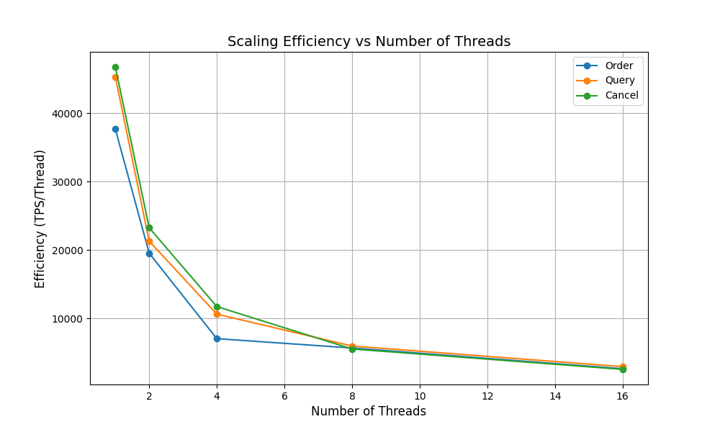

Scaling Efficiency

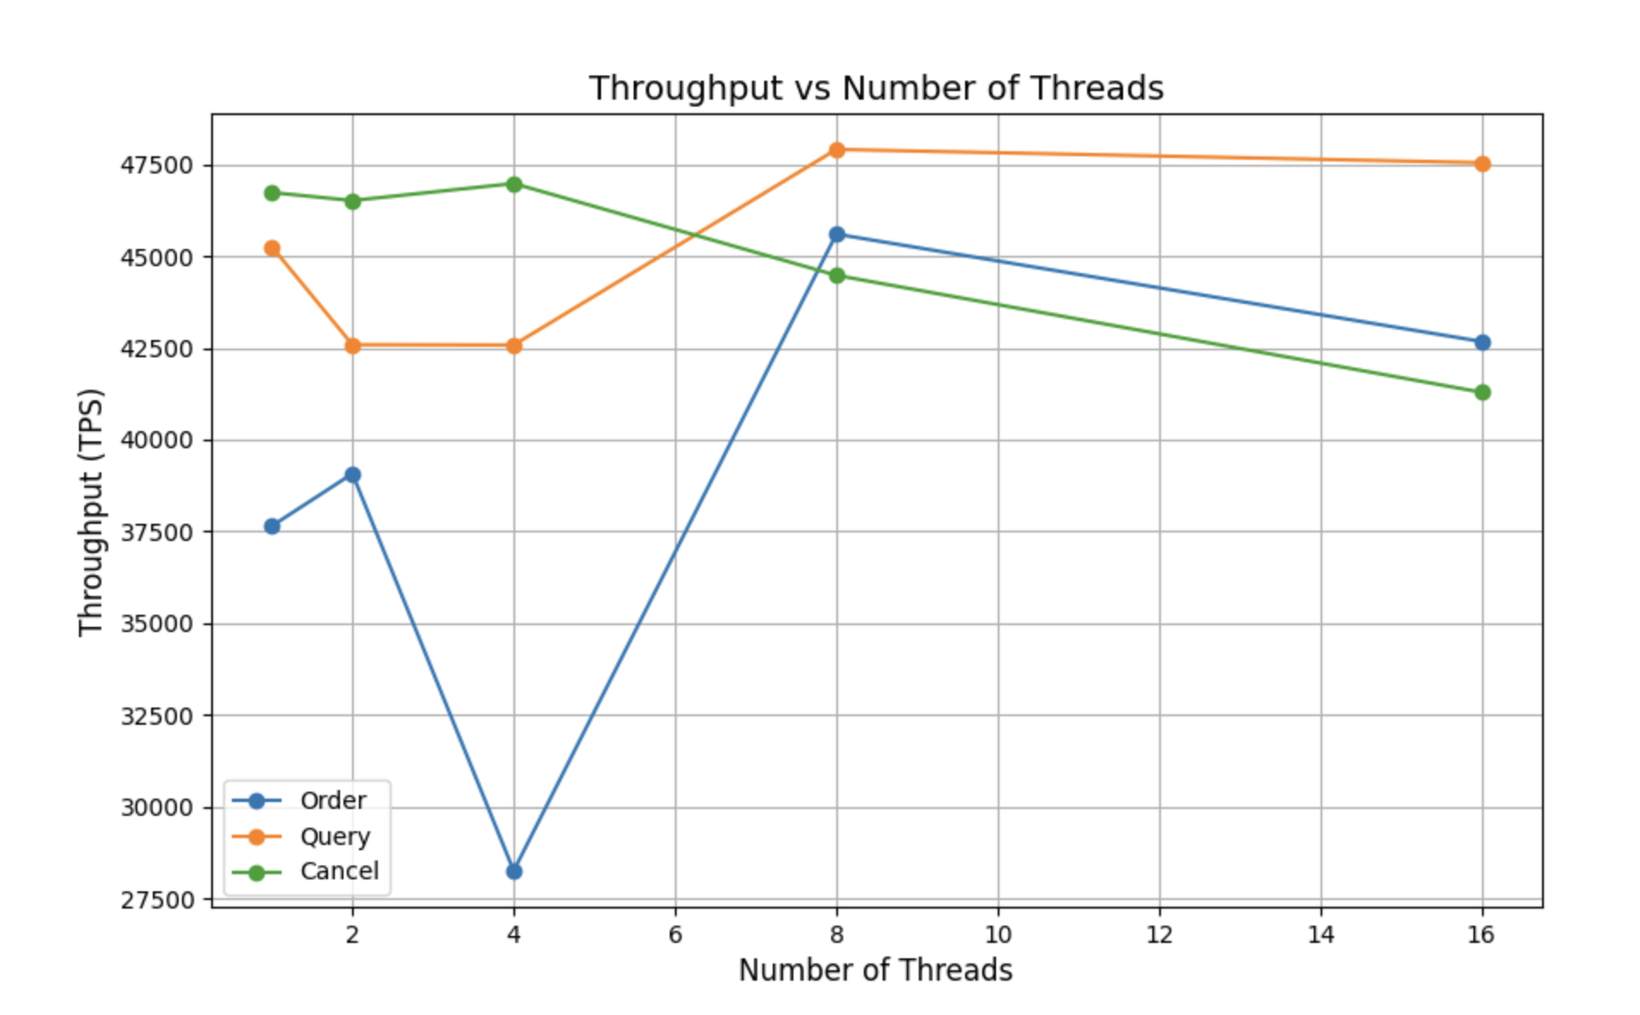

Throughput

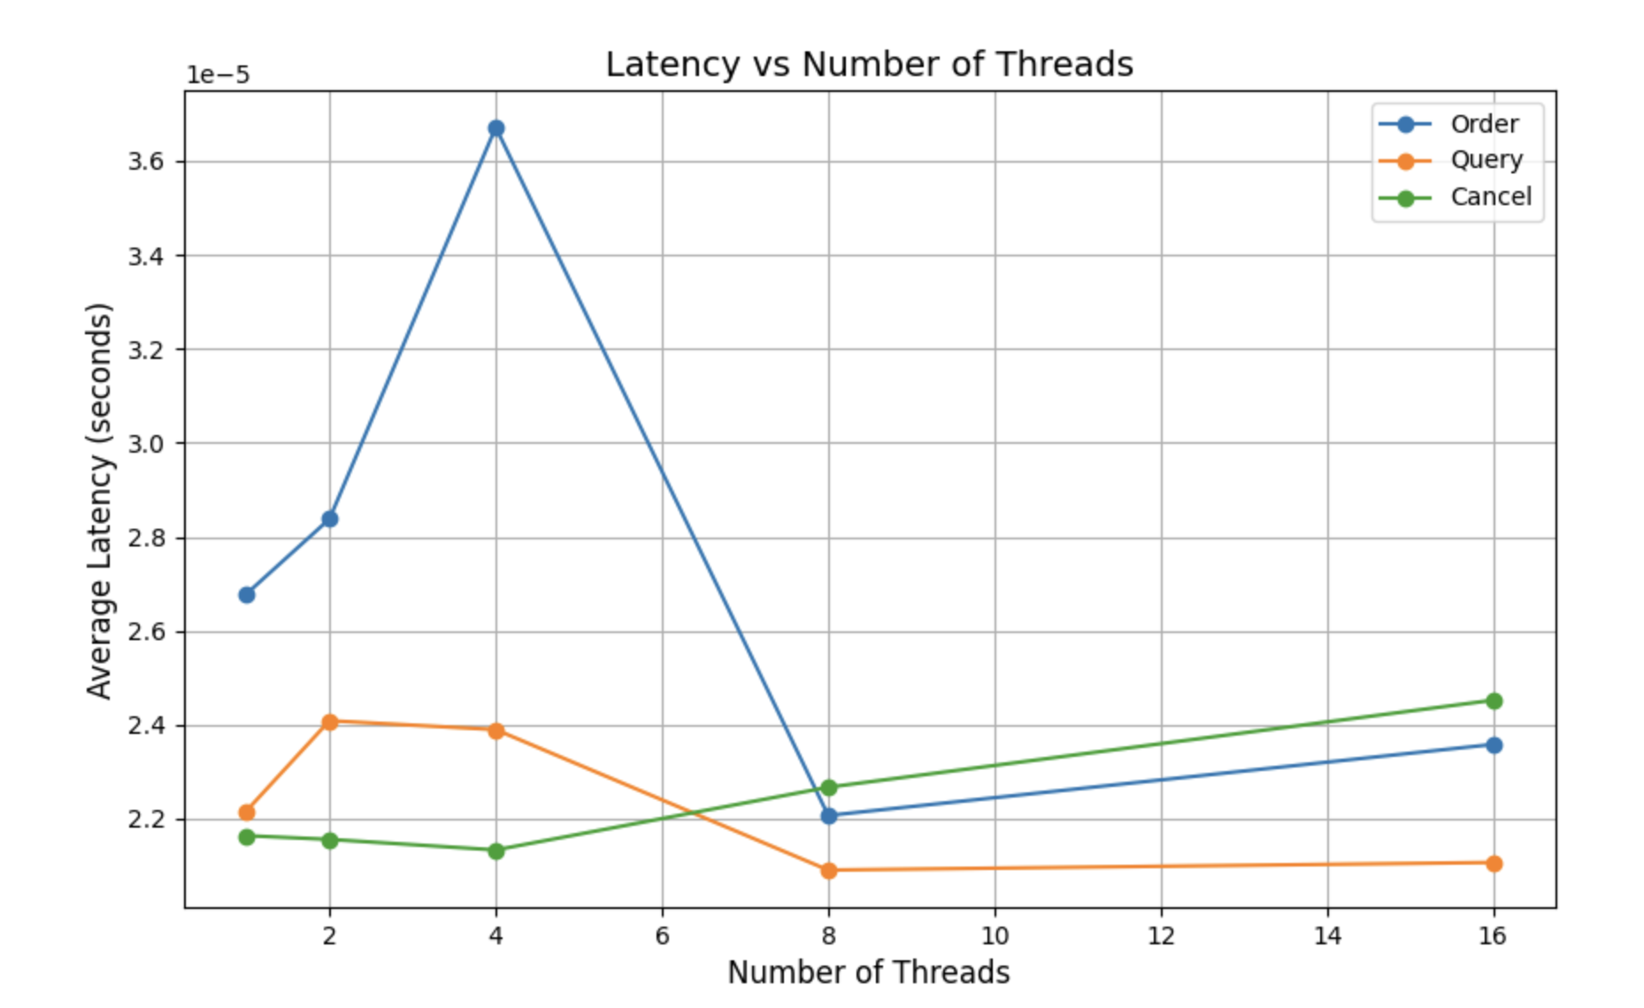

Latency

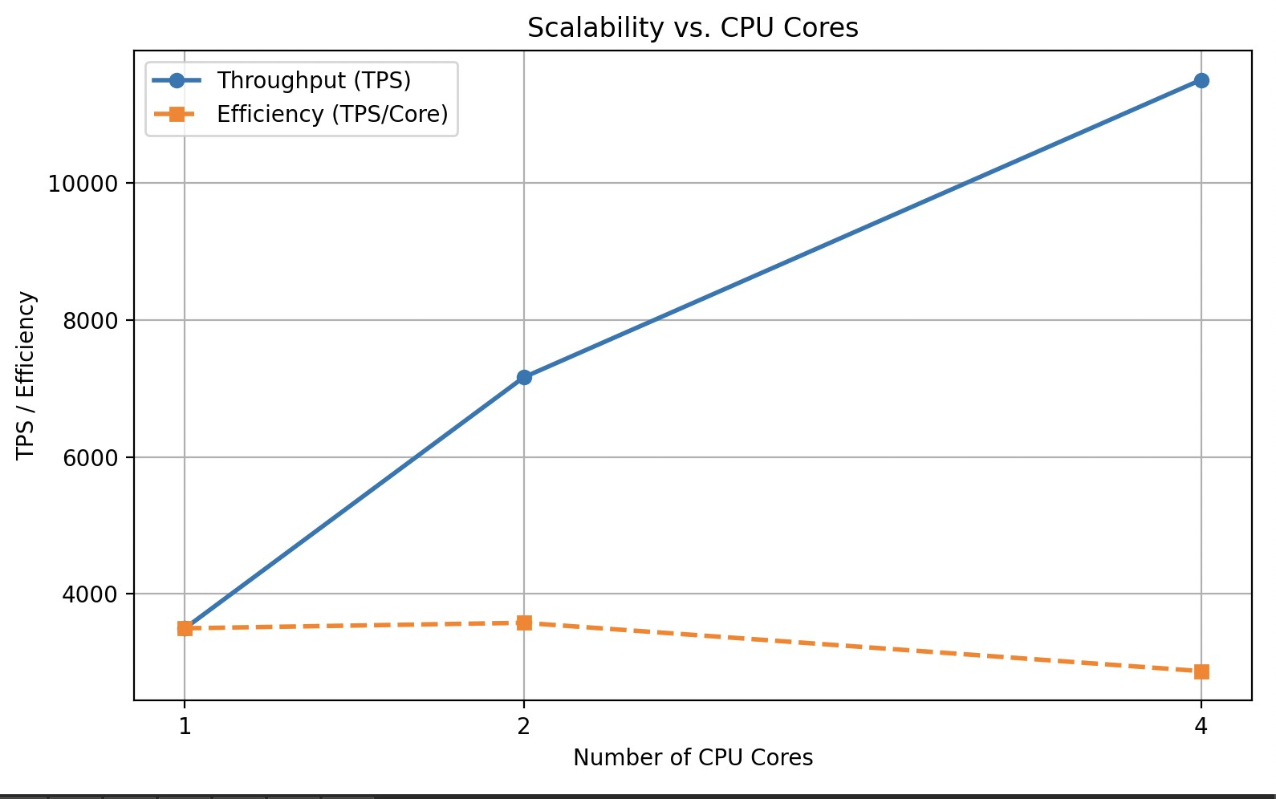

Throughput while CPU Cores increase

Observations & Interpretation
- Thread-Based Scaling: Beyond 4 threads, performance gains taper off. This is due to internal locking, increased context switching, and limited ability to parallelize critical sections like order matching.
- Core-Based Scaling: When spreading the engine over more physical cores using taskset, we observed near-linear throughput improvements, confirming the design leverages multi-core hardware well.

Architectural Factors

Why Order Handling Scales Worse
Order placement involves multiple shared resources:
- Balance validation and updates
- Position adjustment
- Order book insertion
- Matching and trade execution
- DB writes
These introduce lock contention and serial dependencies.
On the other hand, QUERY and CANCEL operations:
- Are mostly read-only
- Require simpler state changes
- Hold locks for shorter durations

Locking & Logging Model
To support concurrency, our engine:
- Uses std::shared_mutex for read/write concurrency
- Employs std::thread and std::condition_variable for an async logger, reducing I/O stalls
- Pins threads to specific cores using pthread_setaffinity_np() (Linux)

Lessons Learned
- Thread ≠ Throughput: More threads don’t always mean better performance. Lock contention is a real limiter.
- Scale with Cores: Spreading the engine over more physical cores (up to 4 in our case) gives consistent gains.
- Simpler Operations Scale Better: QUERY and CANCEL operations performed more consistently under load.
- Profiling is Key: We noticed ORDER operations sometimes dominate DB write time or hold locks longer.

Recommendations
- Sharding: Partitioning order books by symbol can reduce contention.
- Fine-Grained Locks: Lock less and lock smart. Avoid global or coarse locks.
- Thread Pool Tuning: Dynamically adjust thread pool size based on core availability.
- Queue Management: Cap inbound request queue depth to prevent overload during spikes.

Final Thoughts
Our team implemented core-aware logic and a modular engine to maximize scalability. While logical concurrency hits diminishing returns due to internal synchronization, the system scales well with physical hardware. These results give us a solid baseline for further optimization and future production deployment.
This analysis, backed by both raw throughput data and architectural reasoning, provides a realistic picture of where our exchange matching engine performs well and where it needs refinement.

