Zack Campbell

Zcc254

**Lab 7 Report**

The first design of the display colors project had all the methods contained in one big class, DisplayColors. ColorPanel was implemented within the DisplayColors class, but primarily just stored the color of the panel and repainted it when necessary. DisplayColors implements the ChangeListener interface to determine when the sliders change values so as to update the colors accordingly. ColorPanel inherits the JPanel class as it’s primary function.

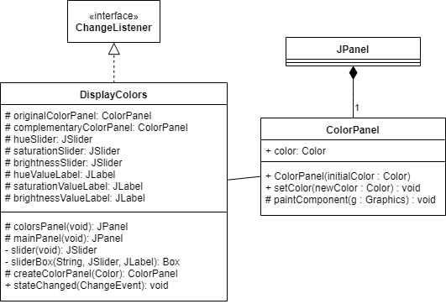

**Part 1 UML Class Diagram**

The second part of the project was to refactor the design into the Observer Design Pattern. The DisplayColors class is the subject and extends the Observable class. The ColorPanel class is the observer and implements the Observer interface while still extending JPanel. The ColorPanel class still contains the same methods as the previous iteration but the various types of colorpanels are now extending the ColorPanel class. In isolating the types of panels as subsets of ColorPanel, they can each implement their own “update()” method according to what that panel should accomplish.

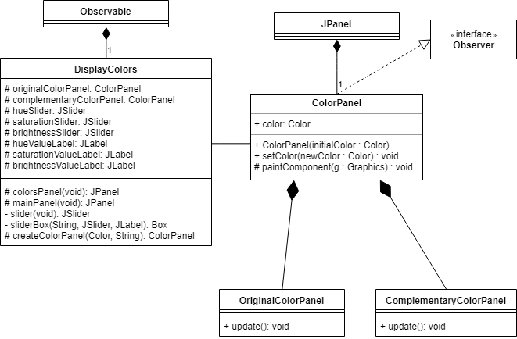

**Part 2 Observer Design Pattern Class Diagram**

The last design pattern is the Model-View-Controller design pattern. In this pattern, the DisplayColors class is the Observer because encompasses the View and Controller aspects of the pattern. Display colors controls the GUI and shows the view. Conversely, the ColorPanel class is the Model because it contains the necessary elements shown on the GUI.

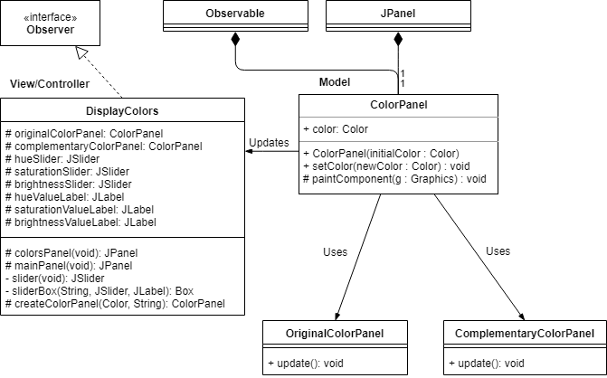

**Part 4 MVC Design Pattern Class Diagram**