Midterm Project Documentation

March 14, 2025

Student - Connor Clawson Professor – Edward Weber

# Premise

The goal of this project is to create and build up a character sheet manager, using the game rules of the pen and paper role playing game Pathfinder. By the end of the semester, the web application should feature fully functional character sheets for player characters and non-player characters.

# Database

Using MySQL, the database is to be tailored to the task of ensuring all values in the many fields of a character sheet are valid, saved, and made available to users.

## Tables

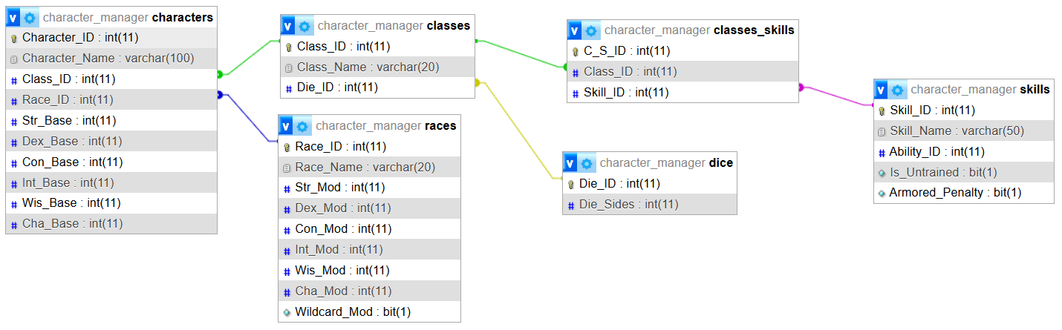

As the project evolves, more tables will be added to the database to achieve the desired functionality. The following tables have been set up with values and relationships:

* CHARACTERS
  + This is the main table that users will interact with.
  + V.1 contains the following:
    - Foreign key constraints to the CLASSES and RACES tables.
    - Base scores for the six core stats: Strength, Dexterity, Constitution, Intelligence, Wisdom, and Charisma.
* CLASSES
  + This holds a fixed list of the 11 core classes in the Pathfinder Core Rulebook (CRB.)
  + V.1 contains the following:
    - Foreign key constraints to the CLASSES_SKILLS and DICE tables.
* RACES
  + This contains the 7 core races playable by players in the CRB.
  + Includes fields for ability score modifiers, used at character creation
* DICE
  + This table lists the size or face count of the dice used in the game. This table is expected to be utilized by other tables in the future.
* SKILLS
  + Contains the complete list of skills useable by characters.
  + V.1 contains the following:
    - Foreign key constraint to the CLASSES_SKILLS table
    - The names and boolean flags for trained/untrained skills and armor check penalties.
* CLASSES_SKILLS
  + This table handles the many-to-many relation between classes and the skills they have access to.
  + Currently, only the class skills for the Barbarian class are stored. The remaining classes will have their skills linked in the near future.
* ABILITIES – not shown in graph above
  + This table holds the names and abbreviations of the 6 ability scores.
  + This table is not yet utilized as of V.1

## Future Tables

Tables for feats, skill stats, and inventory will be forthcoming as the project continues to develop. These will require their own systems and implementation due to how they are structured.

# Visual Presentation

The theming and layout of the paces will be reminiscent of the tables and charts in the core rule book, as well as the print version of the character sheet. For now, a basic monochromatic layout will be used to aid in the design of the wireframe for the system. Character sheet designs are not ready currently.

By the end of the project, every page will feature the imagery, decorations, and stylings typical of a fantasy setting. A mood board is to be assembled to clarify the desired look.

Mockup of the character list.

# Pages

Aside from the main roster and character sheet, there will be pages for adding new sheets to the list. And the character sheet itself will be comprised of multiple pages navigated by a tab bar. The location of this tab bar is yet to be decided.