**Code Structure**

**Tensor Voting:**

main ==> pixel2tensor ==> vote_kernel ==> get_eig ==> main (generate the result)

**Steerable Filter:**

main ==> steerable_filter ==> main (generate the result)

**Steerable Filter with Tensor Voting:**

main ==> steerable_filter ==> steer_tv_kernel ==> main (generate the result)

**Tensor Voting**

1. vote_kernel

|  |  |  |
| --- | --- | --- |
| -1, -1 | 0, -1 | 1, -1 |
| -1, 0 | 0, 0 | 1, 0 |
| -1, 1 | 0, -1 | 1, 1 |

Because I am using a fixed kernel size, I can pre-define the relationships between a targeted pixel and its neighbour. Let’s say I decide to use a 3x3 kernel. The relationship is described as this:

Based on this relationship, I can calculate theta, then get parameters for decay

function and the projection matrix. The SV projection matrix is 2x2 and is calculated as

N’ * N ==> [ -sin2θ, cos2θ ] ’ * [ -sin2θ, cos2θ ].

TV = SV + BV for images, where BV = ∫ SV dθ

It is impractical to integrate for DF, so we only integrate for the projection matrix. The kernel like this: TV = DF * [ N’ * N + ∫ (N’ * N) dθ ]

Then, I stretch it into a matrix. Each p component is a 2x2 projection matrix. How many of them is determined by the kernel size. For a 3x3 kernel, there are 9 projection matrix.

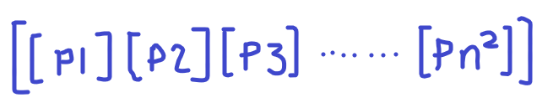

1. pixel2tensor

Two main steps in this function: 1) convert a pixel value into a 2x2 tensor, 2) get a targeted pixel’s neighbour and apply the kernel.

If I decide to use a 3x3 kernel, for each targeted pixel I will get 9 tensors. Then apply the tensor to its according projection matrix, and sum up to become a new tensor. The output is M x N x 2 x 2

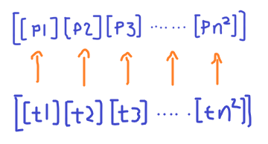

1. get_eig

It takes the output of the pixel2tensor as its input. The outcome is a M x N matrix.

**Steerable Filter with Tensor Voting**

1. steerable_filter

this function can generate two different results

1) steerable filter

2) steerable filter with tensor voting

The 4th and 5th input are for the interpolation function. If they are same number, it refers to use a steerable filter with tensor voting. Otherwise, it refers to use a regular steerable filter. The output of the function is a M x N matrix.

The steerable filter is very straight forward, no need to explain the code. For the steerable filter with tensor voting, I did not use an interpolation function. After applying a Gaussian filter, I use the projection matrix to connect with the [ Gx Gy ]. I did not apply eigen decomposition, but simply sum up the result to generate a M x N matrix. Interestingly, the final result is not much different from the regular tensor voting technique.