# **Module 5 - Assignment 2**

## **Bradley, Zackery**

### **More Data Wrangling**

library(tidyverse)

## -- Attaching packages --------------------------------------- tidyverse 1.3.1 --

## v ggplot2 3.3.5 v purrr 0.3.4  
## v tibble 3.1.2 v dplyr 1.0.7  
## v tidyr 1.1.3 v stringr 1.4.0  
## v readr 1.4.0 v forcats 0.5.1

## -- Conflicts ------------------------------------------ tidyverse_conflicts() --  
## x dplyr::filter() masks stats::filter()  
## x dplyr::lag() masks stats::lag()

library(dplyr)  
library(readr)  
tuition_cost <- read_csv("C:/Users/bradl/OneDrive/Desktop/MODULE 2/Model 5/tuition_cost.csv")

##   
## -- Column specification --------------------------------------------------------  
## cols(  
## name = col_character(),  
## state = col_character(),  
## state_code = col_character(),  
## type = col_character(),  
## degree_length = col_character(),  
## `2017` = col_character(),  
## `2018` = col_character(),  
## `2019` = col_character(),  
## `2020` = col_character()  
## )

### Part 1 - Creating tidy data using tidyr

Tuition <- pivot_longer(tuition_cost,c("2017", "2018", "2019", "2020"),names_to = "year", values_to = "tuition")  
Tuition <- separate(Tuition,tuition, into = c("Instate", "Outstate"),sep = '/', convert = TRUE)

#==Part 2

#==Question 13

### Part 2 - **North Carolina Schools**

Public <- filter(Tuition,state == "North Carolina" & type=="Public" & degree_length == "4 Year")  
ggplot(data = Public, aes(x = year, y= Instate, color= name))+  
geom_point()+  
ggtitle("In State Tuition for North Carolina Schools")+  
labs(x="year", y= "cost in $")+  
theme(legend.title=element_blank())

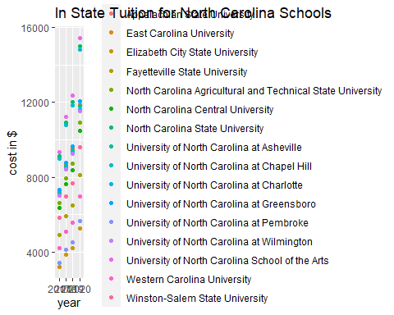

UNC <- filter(Public,grepl("University of North Carolina",name))  
ggplot(data = UNC,mapping = aes(x = year, y = Instate, color=name))+  
geom_point()+  
ggtitle("In State Tuition for UNC Schools")+  
theme(legend.title=element_blank())+  
theme(legend.position="bottom") +  
labs(x="year", y= "cost in $")+  
guides(colour = guide_legend(nrow = 4))

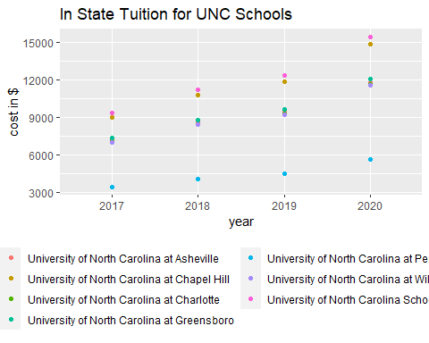 ### **Part 3 -** Additional Universities**

Public1 <- filter(Tuition,state == "Colorado" & type=="Public" & degree_length == "4 Year")  
ggplot(data = Public1, aes(x = year, y= Outstate, color= name))+  
geom_point()+  
ggtitle("Outstate Tuition for Colorado Schools")+  
labs(x="year", y= "cost in $")+  
theme(legend.title=element_blank())

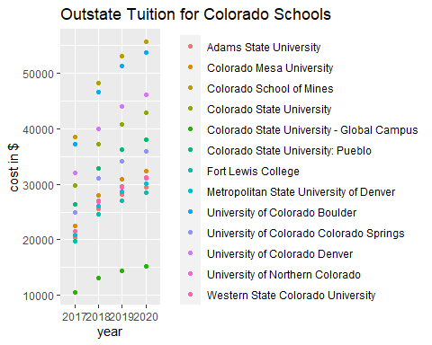

Public2 <- filter(Tuition,state == "South Carolina" & type=="Public" & degree_length == "2 Year")  
ggplot(data = Public2, aes(x = year, y= Outstate, color= name))+  
geom_point()+  
ggtitle("Oustate Tuition for South Carolina Schools")+  
labs(x="year", y= "cost in $")+  
theme(legend.title=element_blank())+  
theme(legend.position="bottom")

