Introduction
CommonsenseQA, focuse on inference of answers through implicit common sense was developed as a dataset that machine learning models could not easily learn through simple memorization of the input texts. (Please find examples in the Discussion section below.) At the time of the publication, the “best baseline is based on BERT-large (Devlin et al., 2018) and obtains 56% accuracy, well below human performance, which is 89%” (Talmor et al., 2018). Since the authors “used the same hyper-parameters as Devlin et al. (2018) for SWAG” (Talmor et al., 2018). It’s unsurprising since Bert-large was the general state-of-the-art model at that time and is still one of the most popuar baseline models. A common problem is that researchers often compare untuned bert models with fine-tuned models like GPT-2 and ALBERT. Thus, we hypothesize that after reimplementation of the original model (in PyTorch), more explicit hyperparameter turning might be helpful in showing a more realistic baseline.

Computational Models
Data
Since the original test data is withheld by the creators for the leaderboard, we have taken the same proportional of data out of the train data as our validation data and used the original validation data as the test data. We have a roughly 8:1:1 ratio among the train, validation, and test datasets.

Embedding
wordpieces are trained separately, such the most frequent words remain together and the less frequent words get split eventually down to characters.

Activation
Gaussian Error Linear Units (GELUs)
https://arxiv.org/abs/1606.08415
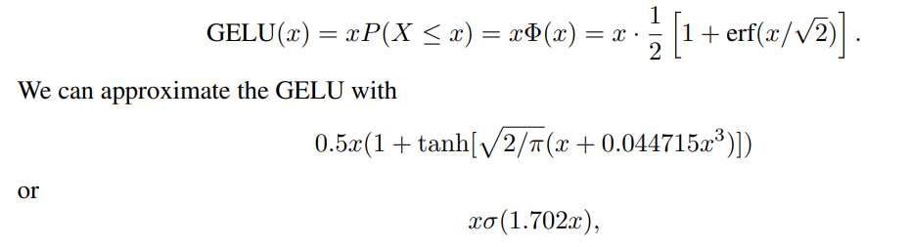

Architecture
We have adapted BERT for choosing an answer among multiple candidates. A detailed descriptioin of the bert model can be found in the original paper (Devlin, 2018). On top of the final layer of BERT, we pool the output (into (batch_size, hidden_size)), add a dropout regularizer, add a linear layer (config.hidden_size, 1), and finally a softmax upon the results of all the 5 choices to select the best answer (num_choices, 1 \in [0, 4] (answer id)).

Hyperparameters
We have decided to tune the following hyperparameters (below are the initial random caurse search ranges):
"lr": tune.loguniform(1e-6, 1e-4),
"batch_size": tune.choice([48, 32, 8]),
"max_seq_length": tune.choice([80, 48]),
"hidden_dropout_prob": tune.choice([.1, .2]),
"hidden_act": tune.choice(["gelu"]),
"architecture": { # BERT or ALBERT
"tokenizer": BertTokenizer,
"model": BertForMultipleChoice,
"pretrained_model_name": "bert-large-uncased"
}

Then we performed fine-tuning upon the best result above to obtain the best hyperparameters.

Experimental Results
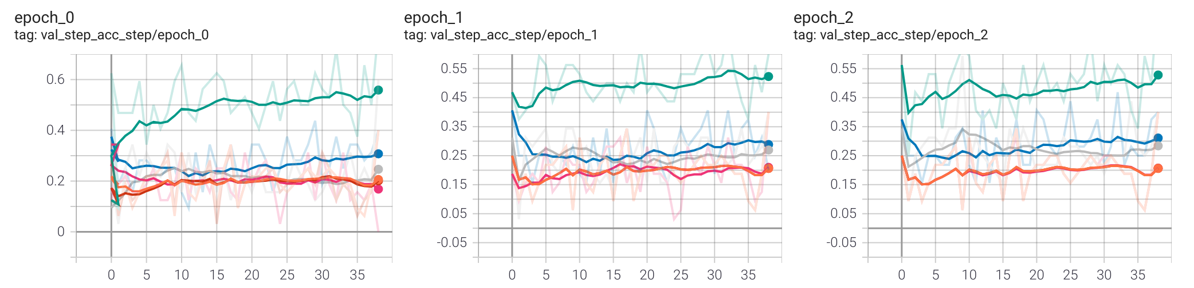
Figure: results of caurse tuning

Fine tuning:
DEFAULT_91eca_00003 | TERMINATED | | 32 | gelu | 0.1 | 1.57513e-05 | 48 | 3 | 1117.16 | 1.27474 | 0.576603

Number of trials: 6/6 (6 TERMINATED)
+---------------------+------------+-------+--------------+--------------+-----------------------+-------------+------------------+--------+------------------+---------+----------+
| Trial name | status | loc | batch_size | hidden_act | hidden_dropout_prob | lr | max_seq_length | iter | total time (s) | loss | acc |
|---------------------+------------+-------+--------------+--------------+-----------------------+-------------+------------------+--------+------------------+---------+----------|
| DEFAULT_91eca_00000 | TERMINATED | | 32 | gelu | 0.1 | 5.61152e-06 | 60 | 3 | 1367.3 | 1.16782 | 0.544712 |
| DEFAULT_91eca_00001 | TERMINATED | | 32 | gelu | 0.1 | 7.96945e-05 | 60 | 3 | 1361.22 | 1.86669 | 0.50016 |
| DEFAULT_91eca_00002 | TERMINATED | | 32 | gelu | 0.1 | 2.91064e-05 | 48 | 3 | 1115.95 | 1.61456 | 0.552244 |
| DEFAULT_91eca_00003 | TERMINATED | | 32 | gelu | 0.1 | 1.57513e-05 | 48 | 3 | 1117.16 | 1.27474 | 0.576603 |
| DEFAULT_91eca_00004 | TERMINATED | | 32 | gelu | 0.1 | 2.05134e-06 | 60 | 3 | 1376.05 | 1.24068 | 0.512179 |
| DEFAULT_91eca_00005 | TERMINATED | | 32 | gelu | 0.1 | 2.05111e-06 | 60 | 3 | 1376.19 | 1.25815 | 0.497756 |
+---------------------+------------+-------+--------------+--------------+-----------------------+-------------+------------------+--------+------------------+---------+----------+

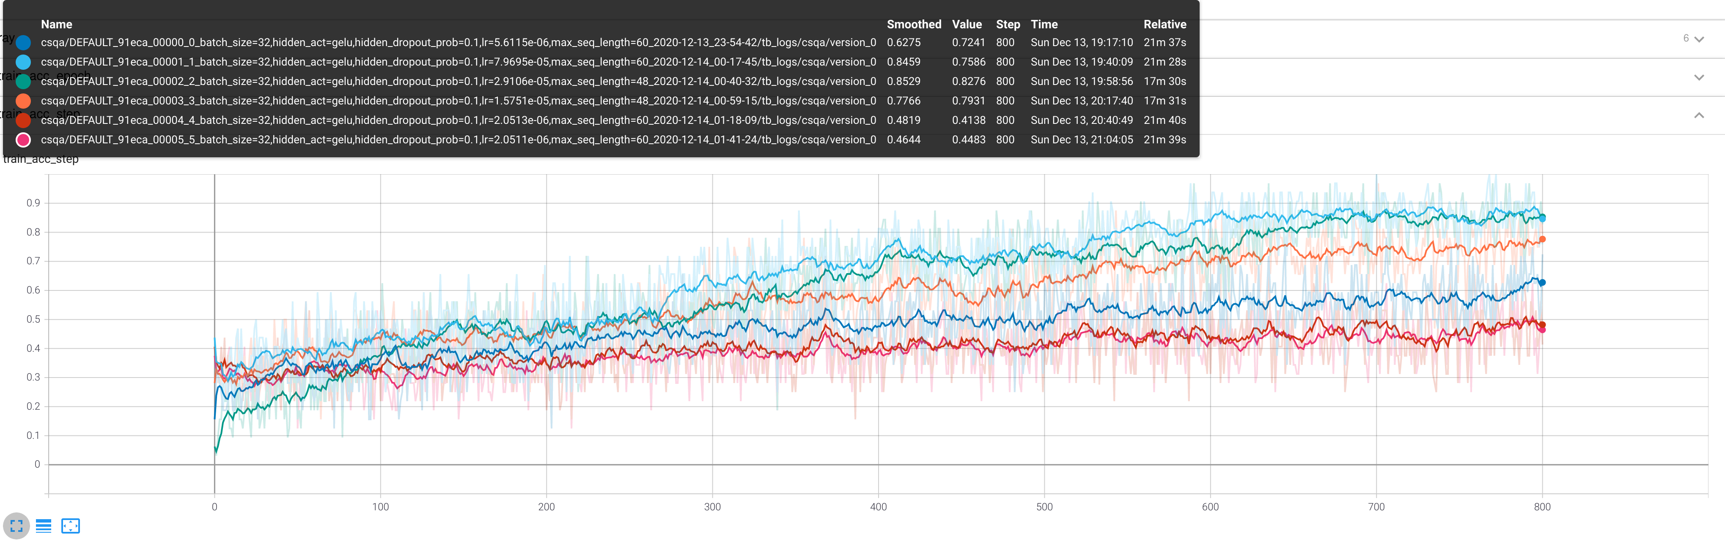

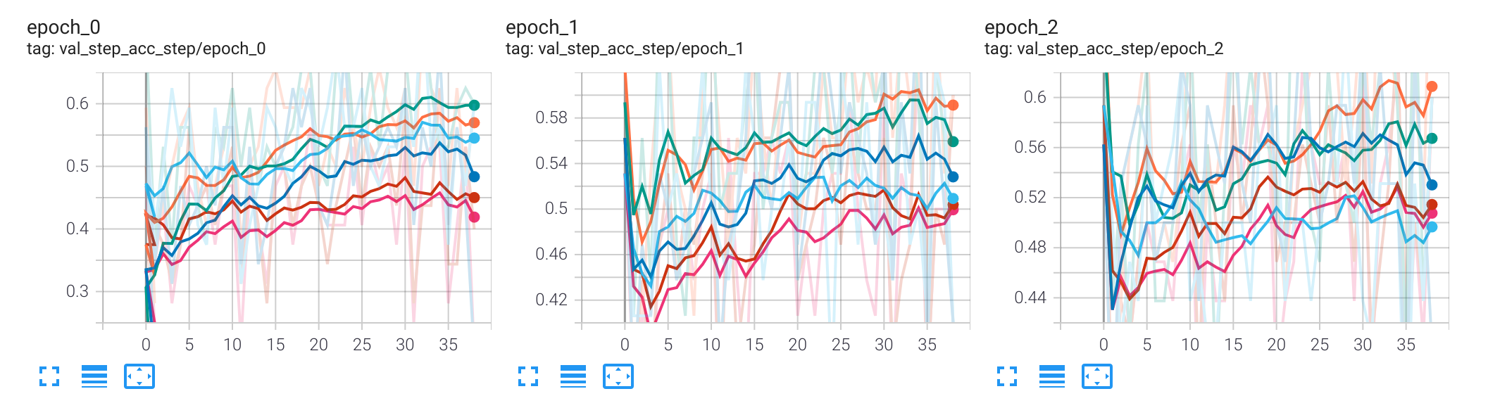
Discussion
The first step of any data science project is to scrutinize the data. Some research has pointed hidden biases of the dataset. Recently, Rajani et al. (2019) has pointed out “in CQA we observed significant
gender disparity and bias with higher proportion of female pronouns used in negative contexts.” For instance the following are some such examples from CQA:

Q: "She was a horrible pet owner, she put a what on her cat?"
AC: wool sweater, get wet, eat vegetables

Q: "The woman was yelling obscenities in public,and while it was entertaining for people passing by,what did her husband feel?"
AC: fulfillment, fatigue, embarrassment
(Cite https://github.com/salesforce/cos-e)

In other words, it’s reasonable to assume that due to the bias in the training data, the model is more likely to give negative answers or make negative decisions when the subjects are women. This kind of bias has inevitably propagated into CoS-E. We advise that these datasets and trained models be used with that in mind. Recently there have been new methods to prevent biases in data and training, this could be an area of future research.

Since we are only reporting on the validation accuracy. I had to split the combined training and validation data into three chucks to include a testing dataset to prevent overfitting to the validation data. I would exepct the actual generalization ability of the model to be equal or slightly lower than the testing accuracy we have obtained when tested on newer data such as the data withheld for the leaderboard. However, the competition in the class uses the full original validation data, providing an incentive for us to not to do a three-way (or cross-validation) and overfit the validation data. With that explict understanding, the code we provide for the competition will strictly be based on this special circumstance of the competition.

This research has given us tremendious insights. First, hyperparameter searching and tuning is time-consuming and costly. For natural language processing, the biggest problem is sequence length. It has a linear relationship with respect to the complexity many of the current state-of-the-art models. When we set the max sequence length to be 80, an ideal choice for our dataset, often our platform Google Colab would barely allow us to conduct training. Luckily, with extremely small parameters such as batch size, we have seen similar performance between BERT-large-uncased (0.579248% on our validation dataset) and BERT-base-uncased. Thus, we performed the fine tuning on BERT-base-uncased.

Rajani, N. F., McCann, B., Xiong, C., & Socher, R. (2019). Explain yourself! leveraging language models for commonsense reasoning. arXiv preprint arXiv:1906.02361.
------------------------------------------------------------------------------------
To do
use concept net to weed out wrong answer choices
ensemble
mention pruning

To explore
https://stackoverflow.com/questions/62452271/understanding-bert-vocab-unusedxxx-tokens#:~:text=Unused%20tokens%20are%20helpful%20if,the%20original%20vocabulary%20of%20BERT.

BertForMultipleChoice(
(bert): BertModel(
(embeddings): BertEmbeddings(
(word_embeddings): Embedding(30522, 768, padding_idx=0)
(position_embeddings): Embedding(512, 768)
(token_type_embeddings): Embedding(2, 768)
(LayerNorm): LayerNorm((768,), eps=1e-12, elementwise_affine=True)
(dropout): Dropout(p=0.1, inplace=False)
)
(encoder): BertEncoder(
(layer): ModuleList(
(0): BertLayer(
(attention): BertAttention(
(self): BertSelfAttention(
(query): Linear(in_features=768, out_features=768, bias=True)
(key): Linear(in_features=768, out_features=768, bias=True)
(value): Linear(in_features=768, out_features=768, bias=True)
(dropout): Dropout(p=0.1, inplace=False)
)
(output): BertSelfOutput(
(dense): Linear(in_features=768, out_features=768, bias=True)
(LayerNorm): LayerNorm((768,), eps=1e-12, elementwise_affine=True)
(dropout): Dropout(p=0.1, inplace=False)
)
)
(intermediate): BertIntermediate(
(dense): Linear(in_features=768, out_features=3072, bias=True)
)
(output): BertOutput(
(dense): Linear(in_features=3072, out_features=768, bias=True)
(LayerNorm): LayerNorm((768,), eps=1e-12, elementwise_affine=True)
(dropout): Dropout(p=0.1, inplace=False)
)
)
(1): BertLayer(
(attention): BertAttention(
(self): BertSelfAttention(
(query): Linear(in_features=768, out_features=768, bias=True)
(key): Linear(in_features=768, out_features=768, bias=True)
(value): Linear(in_features=768, out_features=768, bias=True)
(dropout): Dropout(p=0.1, inplace=False)
)
(output): BertSelfOutput(
(dense): Linear(in_features=768, out_features=768, bias=True)
(LayerNorm): LayerNorm((768,), eps=1e-12, elementwise_affine=True)
(dropout): Dropout(p=0.1, inplace=False)
)
)
(intermediate): BertIntermediate(
(dense): Linear(in_features=768, out_features=3072, bias=True)
)
(output): BertOutput(
(dense): Linear(in_features=3072, out_features=768, bias=True)
(LayerNorm): LayerNorm((768,), eps=1e-12, elementwise_affine=True)
(dropout): Dropout(p=0.1, inplace=False)
)
)
(2): BertLayer(
(attention): BertAttention(
(self): BertSelfAttention(
(query): Linear(in_features=768, out_features=768, bias=True)
(key): Linear(in_features=768, out_features=768, bias=True)
(value): Linear(in_features=768, out_features=768, bias=True)
(dropout): Dropout(p=0.1, inplace=False)
)
(output): BertSelfOutput(
(dense): Linear(in_features=768, out_features=768, bias=True)
(LayerNorm): LayerNorm((768,), eps=1e-12, elementwise_affine=True)
(dropout): Dropout(p=0.1, inplace=False)
)
)
(intermediate): BertIntermediate(
(dense): Linear(in_features=768, out_features=3072, bias=True)
)
(output): BertOutput(
(dense): Linear(in_features=3072, out_features=768, bias=True)
(LayerNorm): LayerNorm((768,), eps=1e-12, elementwise_affine=True)
(dropout): Dropout(p=0.1, inplace=False)
)
)
(3): BertLayer(
(attention): BertAttention(
(self): BertSelfAttention(
(query): Linear(in_features=768, out_features=768, bias=True)
(key): Linear(in_features=768, out_features=768, bias=True)
(value): Linear(in_features=768, out_features=768, bias=True)
(dropout): Dropout(p=0.1, inplace=False)
)
(output): BertSelfOutput(
(dense): Linear(in_features=768, out_features=768, bias=True)
(LayerNorm): LayerNorm((768,), eps=1e-12, elementwise_affine=True)
(dropout): Dropout(p=0.1, inplace=False)
)
)
(intermediate): BertIntermediate(
(dense): Linear(in_features=768, out_features=3072, bias=True)
)
(output): BertOutput(
(dense): Linear(in_features=3072, out_features=768, bias=True)
(LayerNorm): LayerNorm((768,), eps=1e-12, elementwise_affine=True)
(dropout): Dropout(p=0.1, inplace=False)
)
)
(4): BertLayer(
(attention): BertAttention(
(self): BertSelfAttention(
(query): Linear(in_features=768, out_features=768, bias=True)
(key): Linear(in_features=768, out_features=768, bias=True)
(value): Linear(in_features=768, out_features=768, bias=True)
(dropout): Dropout(p=0.1, inplace=False)
)
(output): BertSelfOutput(
(dense): Linear(in_features=768, out_features=768, bias=True)
(LayerNorm): LayerNorm((768,), eps=1e-12, elementwise_affine=True)
(dropout): Dropout(p=0.1, inplace=False)
)
)
(intermediate): BertIntermediate(
(dense): Linear(in_features=768, out_features=3072, bias=True)
)
(output): BertOutput(
(dense): Linear(in_features=3072, out_features=768, bias=True)
(LayerNorm): LayerNorm((768,), eps=1e-12, elementwise_affine=True)
(dropout): Dropout(p=0.1, inplace=False)
)
)
(5): BertLayer(
(attention): BertAttention(
(self): BertSelfAttention(
(query): Linear(in_features=768, out_features=768, bias=True)
(key): Linear(in_features=768, out_features=768, bias=True)
(value): Linear(in_features=768, out_features=768, bias=True)
(dropout): Dropout(p=0.1, inplace=False)
)
(output): BertSelfOutput(
(dense): Linear(in_features=768, out_features=768, bias=True)
(LayerNorm): LayerNorm((768,), eps=1e-12, elementwise_affine=True)
(dropout): Dropout(p=0.1, inplace=False)
)
)
(intermediate): BertIntermediate(
(dense): Linear(in_features=768, out_features=3072, bias=True)
)
(output): BertOutput(
(dense): Linear(in_features=3072, out_features=768, bias=True)
(LayerNorm): LayerNorm((768,), eps=1e-12, elementwise_affine=True)
(dropout): Dropout(p=0.1, inplace=False)
)
)
(6): BertLayer(
(attention): BertAttention(
(self): BertSelfAttention(
(query): Linear(in_features=768, out_features=768, bias=True)
(key): Linear(in_features=768, out_features=768, bias=True)
(value): Linear(in_features=768, out_features=768, bias=True)
(dropout): Dropout(p=0.1, inplace=False)
)
(output): BertSelfOutput(
(dense): Linear(in_features=768, out_features=768, bias=True)
(LayerNorm): LayerNorm((768,), eps=1e-12, elementwise_affine=True)
(dropout): Dropout(p=0.1, inplace=False)
)
)
(intermediate): BertIntermediate(
(dense): Linear(in_features=768, out_features=3072, bias=True)
)
(output): BertOutput(
(dense): Linear(in_features=3072, out_features=768, bias=True)
(LayerNorm): LayerNorm((768,), eps=1e-12, elementwise_affine=True)
(dropout): Dropout(p=0.1, inplace=False)
)
)
(7): BertLayer(
(attention): BertAttention(
(self): BertSelfAttention(
(query): Linear(in_features=768, out_features=768, bias=True)
(key): Linear(in_features=768, out_features=768, bias=True)
(value): Linear(in_features=768, out_features=768, bias=True)
(dropout): Dropout(p=0.1, inplace=False)
)
(output): BertSelfOutput(
(dense): Linear(in_features=768, out_features=768, bias=True)
(LayerNorm): LayerNorm((768,), eps=1e-12, elementwise_affine=True)
(dropout): Dropout(p=0.1, inplace=False)
)
)
(intermediate): BertIntermediate(
(dense): Linear(in_features=768, out_features=3072, bias=True)
)
(output): BertOutput(
(dense): Linear(in_features=3072, out_features=768, bias=True)
(LayerNorm): LayerNorm((768,), eps=1e-12, elementwise_affine=True)
(dropout): Dropout(p=0.1, inplace=False)
)
)
(8): BertLayer(
(attention): BertAttention(
(self): BertSelfAttention(
(query): Linear(in_features=768, out_features=768, bias=True)
(key): Linear(in_features=768, out_features=768, bias=True)
(value): Linear(in_features=768, out_features=768, bias=True)
(dropout): Dropout(p=0.1, inplace=False)
)
(output): BertSelfOutput(
(dense): Linear(in_features=768, out_features=768, bias=True)
(LayerNorm): LayerNorm((768,), eps=1e-12, elementwise_affine=True)
(dropout): Dropout(p=0.1, inplace=False)
)
)
(intermediate): BertIntermediate(
(dense): Linear(in_features=768, out_features=3072, bias=True)
)
(output): BertOutput(
(dense): Linear(in_features=3072, out_features=768, bias=True)
(LayerNorm): LayerNorm((768,), eps=1e-12, elementwise_affine=True)
(dropout): Dropout(p=0.1, inplace=False)
)
)
(9): BertLayer(
(attention): BertAttention(
(self): BertSelfAttention(
(query): Linear(in_features=768, out_features=768, bias=True)
(key): Linear(in_features=768, out_features=768, bias=True)
(value): Linear(in_features=768, out_features=768, bias=True)
(dropout): Dropout(p=0.1, inplace=False)
)
(output): BertSelfOutput(
(dense): Linear(in_features=768, out_features=768, bias=True)
(LayerNorm): LayerNorm((768,), eps=1e-12, elementwise_affine=True)
(dropout): Dropout(p=0.1, inplace=False)
)
)
(intermediate): BertIntermediate(
(dense): Linear(in_features=768, out_features=3072, bias=True)
)
(output): BertOutput(
(dense): Linear(in_features=3072, out_features=768, bias=True)
(LayerNorm): LayerNorm((768,), eps=1e-12, elementwise_affine=True)
(dropout): Dropout(p=0.1, inplace=False)
)
)
(10): BertLayer(
(attention): BertAttention(
(self): BertSelfAttention(
(query): Linear(in_features=768, out_features=768, bias=True)
(key): Linear(in_features=768, out_features=768, bias=True)
(value): Linear(in_features=768, out_features=768, bias=True)
(dropout): Dropout(p=0.1, inplace=False)
)
(output): BertSelfOutput(
(dense): Linear(in_features=768, out_features=768, bias=True)
(LayerNorm): LayerNorm((768,), eps=1e-12, elementwise_affine=True)
(dropout): Dropout(p=0.1, inplace=False)
)
)
(intermediate): BertIntermediate(
(dense): Linear(in_features=768, out_features=3072, bias=True)
)
(output): BertOutput(
(dense): Linear(in_features=3072, out_features=768, bias=True)
(LayerNorm): LayerNorm((768,), eps=1e-12, elementwise_affine=True)
(dropout): Dropout(p=0.1, inplace=False)
)
)
(11): BertLayer(
(attention): BertAttention(
(self): BertSelfAttention(
(query): Linear(in_features=768, out_features=768, bias=True)
(key): Linear(in_features=768, out_features=768, bias=True)
(value): Linear(in_features=768, out_features=768, bias=True)
(dropout): Dropout(p=0.1, inplace=False)
)
(output): BertSelfOutput(
(dense): Linear(in_features=768, out_features=768, bias=True)
(LayerNorm): LayerNorm((768,), eps=1e-12, elementwise_affine=True)
(dropout): Dropout(p=0.1, inplace=False)
)
)
(intermediate): BertIntermediate(
(dense): Linear(in_features=768, out_features=3072, bias=True)
)
(output): BertOutput(
(dense): Linear(in_features=3072, out_features=768, bias=True)
(LayerNorm): LayerNorm((768,), eps=1e-12, elementwise_affine=True)
(dropout): Dropout(p=0.1, inplace=False)
)
)
)
)
(pooler): BertPooler(
(dense): Linear(in_features=768, out_features=768, bias=True)
(activation): Tanh()
)
)
(dropout): Dropout(p=0.1, inplace=False)
(classifier): Linear(in_features=768, out_features=1, bias=True)
)

