PRODUCT · ENGINEERING · AI

Fridge Meal Planner
  - Project documentation and implementation handbook

Implementation reviewed 22 July 2026
React Native · ASP.NET Core · PostgreSQL · AI orchestration

A practical reference that distinguishes the checked-in prototype from the recommended production design.

Document map
- Product and build plan
- Tech stack and architecture
- User flows
- Backend, AI, and API
- Implemented data schema
- Current implementation audit
Status convention: Implemented is present in the repository; Partial exists but is not complete end-to-end; Planned is target design only.

Product and build plan

Product goal
Fridge Meal Planner reduces the planning work that prevents people from cooking at home. It combines expiry-aware fridge inventory, flexible weekly meal planning, recipe suggestions, and a generated shopping list.

Problems and product responses
User problem | Product response | Current status
Meal planning is tedious and repetitive | Visual weekly planner with reusable recipes | Partial
Shopping requires reconciling many recipe ingredients | Generate a weekly list from planned meals minus fridge stock | Implemented, with same-unit subtraction only
Food expires before users decide what to cook | Sort stock by best-before date and recommend matching recipes | Partial
Receipt entry is slow | Scan receipts, extract line items, and let the user verify OCR | Planned
Healthy, affordable home eating needs too much planning | Preference-aware AI plan with user control and drag/drop editing | Planned

Primary users
- University students with changing class and work schedules.
- Busy individuals or households trying to reduce food waste.
- Budget-conscious users who want to cook more often.
- Health-conscious users who need visible weekly structure without rigid plans.

Product principles
- The user, not the model, owns the final plan.
- AI output is a proposal until explicitly accepted.
- Expiry priority is visible and explainable.
- Shopping quantities are derived from verified data.
- Manual correction is always available after OCR or AI inference.
- Safety constraints such as allergens are hard rules, not ranking hints.

MVP scope

Must have
- Account and household boundary.
- Fridge inventory with quantity, unit, source, and expiry type/date.
- Receipt image upload, OCR extraction, review, and confirmed inventory import.
- Recipe catalogue with normalized ingredients and units.
- Expiry-aware recipe suggestions with missing-ingredient explanations.
- Weekly planner with one authoritative entry per household/date/meal slot.
- Generated shopping list using unit conversions and current stock.
- AI plan proposal, review, accept, edit, and regenerate actions.
- Backend validation for every mutation and AI tool call.

Should have
- Prepared-meal batches and schedulable portions.
- Dietary preferences, allergens, time, budget, and nutrition targets.
- Pantry/fridge/freezer locations and storage-aware shelf-life estimates.
- Notifications for soon-to-expire food and weekly planning.

Later
- Barcode lookup, retailer integrations, price comparison, shared live planning, nutrition tracking, and personalization from feedback history.

Delivery plan

Phase 0 — Stabilize the prototype
- Fix mobile/backend route and request mismatches.
- Repair the current backend compile error in AI recipe suggestions.
- Add validation, error details, and integration tests.
- Add uniqueness and positive-value constraints required by current logic.
Exit: the existing fridge, recipe, planner, shopping, conversion, and chat flows run end-to-end against PostgreSQL.

Phase 1 — Identity and reliable inventory
- Add authentication, households, membership, and row-level ownership checks.
- Replace aggregate-only fridge rows with inventory lots and immutable events.
- Add explicit expiry type and confidence.
- Add optimistic concurrency or version columns.
Exit: multi-user data cannot leak across households and stock changes are auditable.

Phase 2 — Receipt OCR
- Upload receipt image to object storage.
- Create asynchronous OCR job and parsed line records.
- Match products/ingredients with confidence scores.
- Require a correction/confirmation screen before inventory writes.
Exit: a user can scan, review, correct, and import a receipt without silent AI writes.

Phase 3 — AI planning and expiry optimization
- Generate structured proposals constrained by availability, allergies, schedule, servings, and expiry urgency.
- Validate proposal IDs, dates, quantities, and authorization on the backend.
- Persist proposal metadata and accept atomically into the meal plan.
- Return reasons, substitutions, and missing items.
Exit: a user can generate and safely accept an explainable weekly plan.

Phase 4 — Shopping and prepared meals
- Convert compatible units before subtracting stock.
- Generate idempotent lists and persist checked state.
- Track cooked batches and portions available for drag/drop scheduling.
Exit: the plan, stock, prepared meals, and shopping list remain consistent.

Phase 5 — Production hardening
- Observability, rate limits, retries, outbox events, backups, and restore test.
- Accessibility, privacy, security, load, and AI evaluation suites.
- Closed beta metrics and iterative ranking improvements.

MVP success measures
- Median weekly planning time under five minutes.
- At least 70% of generated plans accepted with fewer than five edits.
- Reduced self-reported food disposal after four weeks.
- Shopping lists require fewer than two manual quantity corrections per week.
- No accepted plan violates a confirmed allergen exclusion.

Tech stack and architecture

Current implementation
Layer | Technology | Role
Mobile | React Native, Expo, Expo Router, TypeScript | Five-tab prototype for fridge, planner, recipes, shopping, and chat
API | ASP.NET Core controllers, C# net10.0 | Validation, reads/writes, AI tool execution, Swagger, CORS
Data | EF Core, Npgsql, PostgreSQL 16 | Relational persistence, migrations, seed data
AI | OpenRouter chat completions and backend-defined tools | Reads and mutates application data through ToolExecutor
Local infrastructure | Docker Compose | PostgreSQL development service

Recommended target stack
Concern | Recommendation
Mobile | React Native + Expo + TypeScript; TanStack Query for server state; a tested drag/drop library
Backend | ASP.NET Core 10 when stable/LTS-ready, C#, EF Core, FluentValidation, OpenAPI
Database | PostgreSQL with UUID keys for user-owned aggregates, constraints, indexes, and row-level security where appropriate
Authentication | OIDC provider with verified JWTs; household membership enforced in the API
Object storage | S3-compatible storage for receipt images with signed upload/download URLs
Jobs | Background worker plus durable queue for OCR, matching, notifications, and list regeneration
AI | Provider adapter, structured JSON output, backend tool allow-list, evaluation and audit metadata
OCR | Managed OCR/document service initially; preserve raw result and confidence for review
Cache | Add Redis only after measured need; do not make it a source of truth
Observability | OpenTelemetry traces/metrics/logs, error monitoring, correlation IDs
Delivery | Containers, CI checks, managed PostgreSQL, secrets manager, automated migrations with rollback plan

Target component flow
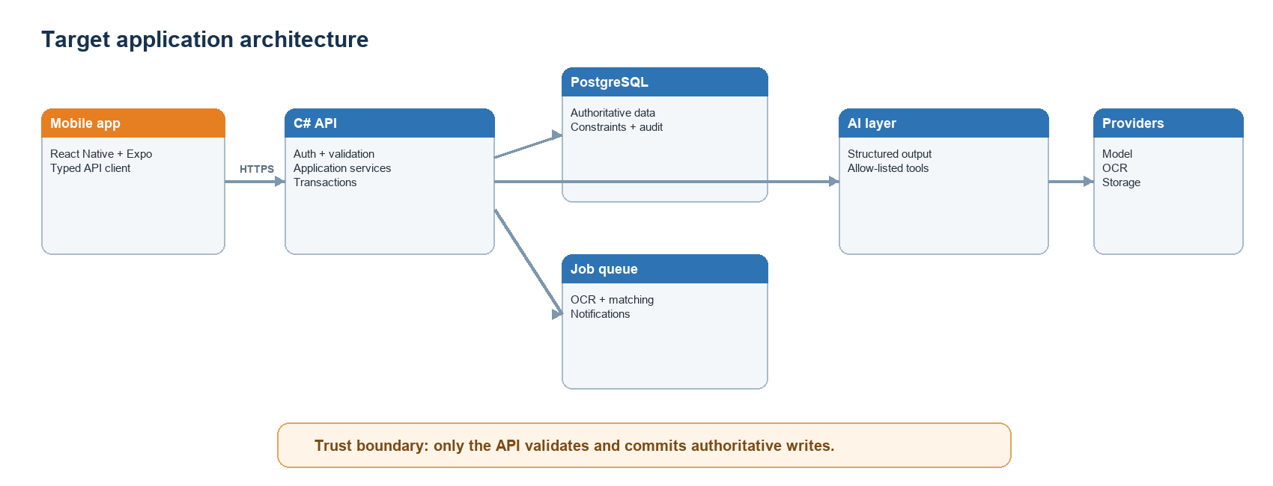
Target architecture
The backend remains the trust boundary. The mobile client and model may request actions, but only authenticated application services validate and commit data.

Why C# instead of a TypeScript backend

Advantages
- Strong compile-time modelling for DTOs, enums, nullable fields, and domain services.
- Mature ASP.NET Core middleware, dependency injection, authentication, validation, OpenAPI, background services, and observability.
- EF Core provides migrations, transactions, concurrency patterns, and good PostgreSQL support.
- High performance and predictable server-side resource use.
- Clear separation from the React Native client can discourage accidental sharing of UI types as database contracts.
- Good fit for a backend responsible for verification, authorization, and transactional writes.

Disadvantages
- The team maintains C# and TypeScript skill sets and cannot directly share runtime validation schemas.
- Preview framework/package versions can create compatibility and tooling risk; prefer stable versions for production.
- Mobile/API contracts require OpenAPI-generated clients or disciplined manual synchronization.
- Cold-start and deployment footprint may be larger than some minimal Node deployments, depending on hosting mode.
- AI SDK examples often appear in Python or TypeScript first, although HTTP and provider adapters make this manageable.

Recommendation
Keep C# for the backend. It matches the requirement for authoritative verification and data writes. Generate the TypeScript mobile client from the backend OpenAPI contract and use stable .NET/EF/Npgsql versions before release.

Backend module boundaries
- Identity: users, households, membership, authorization.
- Inventory: receipt import, ingredient matching, lots, expiry, quantity events.
- Recipes: recipes, normalized requirements, tags, dietary rules.
- Planning: AI proposals, accepted plans, prepared meals, reservations.
- Shopping: required amounts, stock subtraction, rounding, completion.
- AI orchestration: structured outputs, tools, prompt/model versions, evaluation, and audit trail.
- Notifications: expiry and weekly-plan reminders.
Start as a modular monolith. Split services only when scaling or ownership data shows a concrete need.

User flows

Navigation model
The prototype exposes Fridge, Planner, Recipes, Shopping, and Chat tabs. The target product adds onboarding, receipt review, proposal review, and account settings while keeping the five primary destinations.

First-time setup
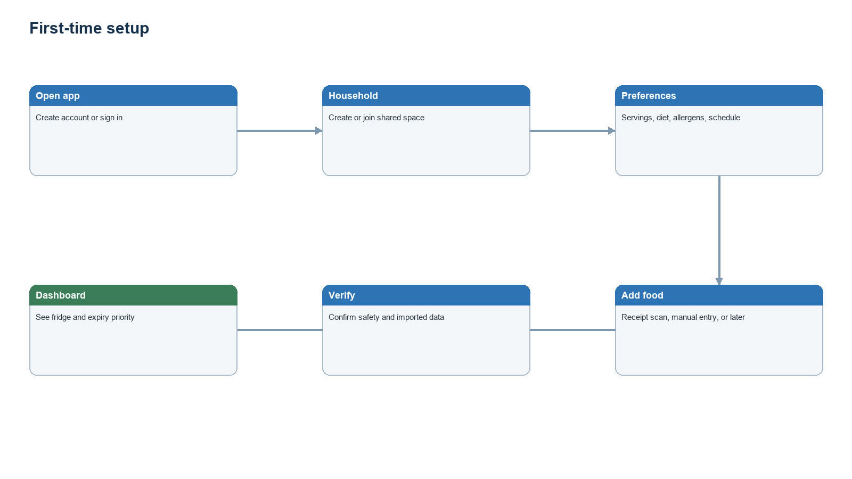
First-time setup
Allergen confirmation is a hard safety step. Optional preferences may be skipped and completed later.

Receipt capture and verification
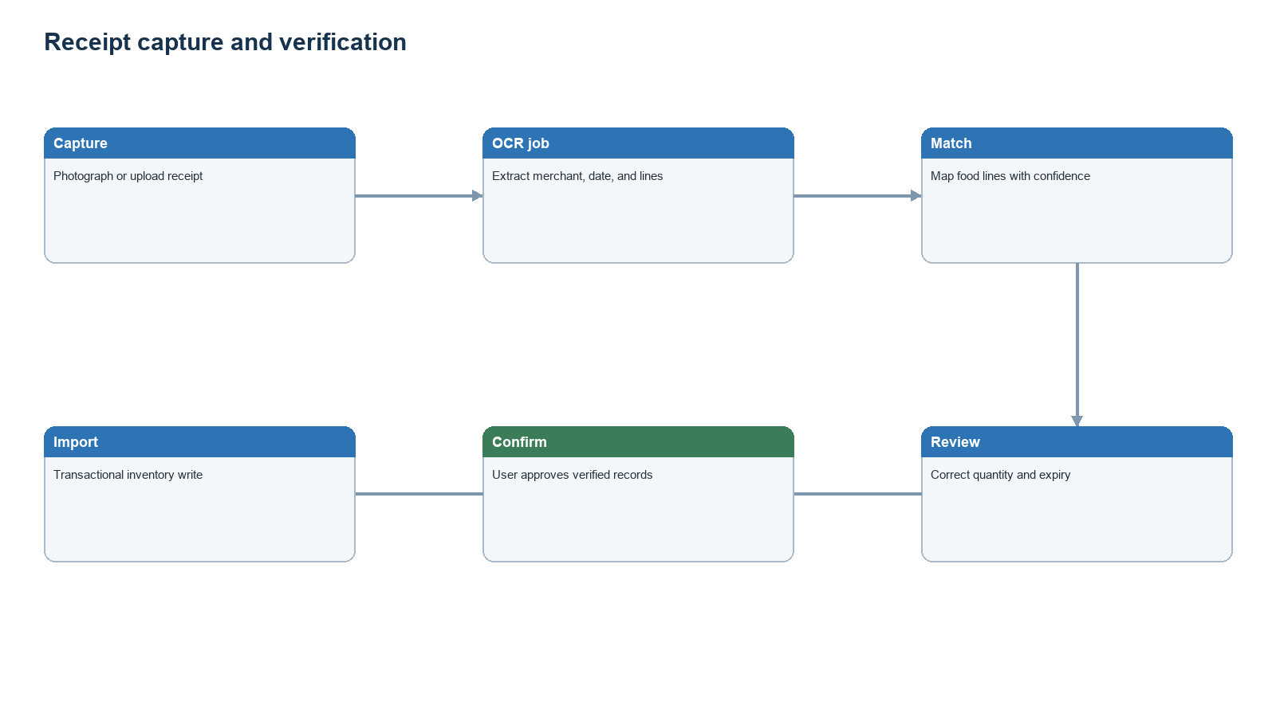
Receipt verification flow
Low-confidence matches must be visible. The system never treats OCR text as authoritative before confirmation.

Fridge and expiry flow
- Open Fridge and view lots ordered by urgency.
- Filter by storage location or category.
- Open an item to correct quantity, unit, expiry type/date, or source.
- Mark an amount used, discarded, or moved.
- Request recipes that prioritize urgent ingredients.
The current prototype implements a simplified version: aggregate rows are sorted by one best-before timestamp and “Use” subtracts one unit.

AI weekly-plan flow
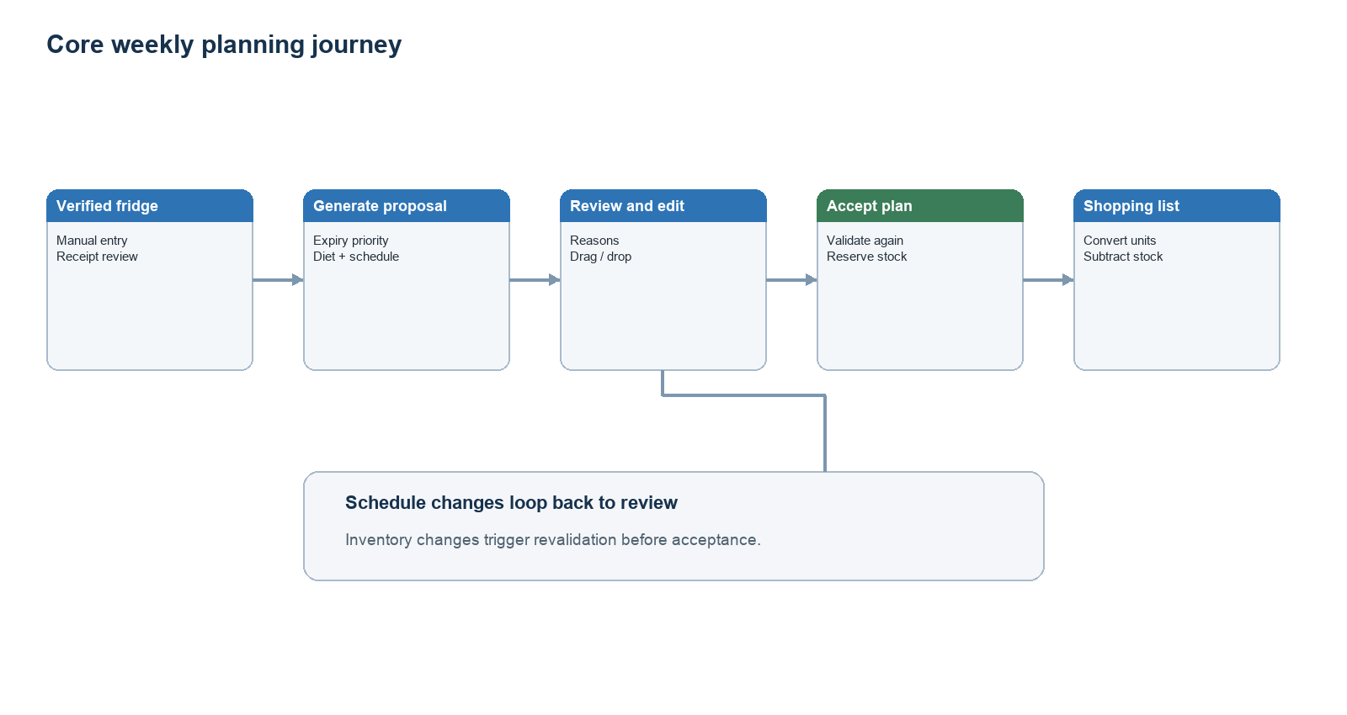
Weekly planning flow
The current AI tool writes random recipe selections directly into MealPlans; proposal review and acceptance are planned safeguards.

Manual planning flow
- Select a day and meal slot.
- Browse recipes or prepared meal portions.
- Review availability, expiry benefit, missing items, cooking time, and servings.
- Drop or assign the meal to the slot.
- Move it when the schedule changes; backend updates the authoritative entry.
- Regenerate the shopping list after meaningful plan changes.
The current prototype uses tap-to-pick instead of drag/drop and supports recipe slots only.

Shopping flow
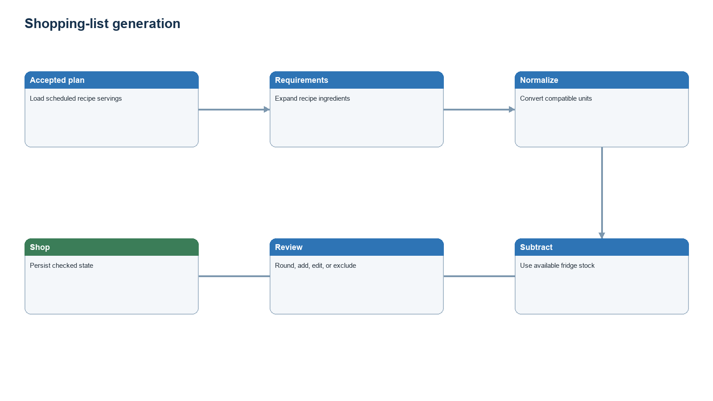
Shopping-list flow
The current backend generates and stores a list, but the mobile checked state is local-only and unit conversion is not used during subtraction.

AI chat flow
- User asks a fridge, expiry, recipe, plan, shopping, or stock-use question.
- Backend sends the question and an allow-listed tool schema to the model.
- The model requests a tool; the backend parses, authorizes, and validates it.
- Read tools return verified data. Write tools run application services and transactions.
- Backend returns a concise explanation of the result.
For sensitive or broad writes, require preview and confirmation. The current chat is stateless and does not persist messages.

Important failure paths
- OCR fails: keep the image/job, allow retry, and offer manual entry.
- Ingredient match is uncertain: require user selection or create a reviewed custom ingredient.
- AI output is invalid: reject it, log structured errors, and retry safely.
- Allergen conflict: block acceptance and explain the conflicting ingredient.
- Inventory changes after proposal: revalidate before acceptance.
- Network failure: retain unsent edits and use idempotency keys on retry.

Backend, AI, and API

Responsibility boundary
The ASP.NET Core backend is the only component allowed to authorize users, validate commands, calculate authoritative quantities, and commit PostgreSQL transactions. Mobile input, OCR output, and model output are untrusted data.

Current API surface
Controller routes use ASP.NET's [Route("api/[controller]")] convention.
Method | Implemented route | Purpose
GET | /api/fridge | List fridge items with ingredient details
POST | /api/fridge | Add or merge stock by ingredient and unit
PATCH | /api/fridge/{id}/use?quantity= | Deduct stock and delete an empty row
DELETE | /api/fridge/{id} | Delete a fridge row
GET | /api/recipes | List recipe summaries
GET | /api/recipes/{id} | Get recipe and requirements
GET | /api/recipes/suggest?ingredients=1,2 | Rank recipes by matched ingredient IDs
GET | /api/mealplan?week=YYYY-MM-DD | Read seven days of meal entries
POST | /api/mealplan | Create a meal entry
PUT | /api/mealplan/{id} | Replace a meal entry
DELETE | /api/mealplan/{id} | Delete a meal entry
POST | /api/shoppinglist/generate?week=&userId= | Generate and store a shopping list
GET | /api/conversions | List unit conversion records
GET | /api/conversions/convert | Convert a quantity
POST | /api/chat | Run stateless AI chat with backend tools

Route matching is normally case-insensitive, but punctuation is significant. The mobile client currently calls /api/shopping-list/generate, while the controller convention produces /api/shoppinglist/generate.

Current AI tools
Tool | Access | Database effect
get_fridge_contents | Read | None
get_expiring_soon | Read | None
suggest_recipes | Read | None
generate_meal_plan | Write | Inserts MealPlans directly
create_shopping_list | Write | Inserts ShoppingLists and items
use_ingredient | Write | Updates or deletes FridgeItems
add_ingredient | Write | May insert Ingredients; inserts/updates FridgeItems

OpenRouter returns tool calls to OpenRouterService; ToolExecutor dispatches them against EF Core. The current request contains only a system prompt and the latest user message, so conversations do not retain history.

Target AI request lifecycle
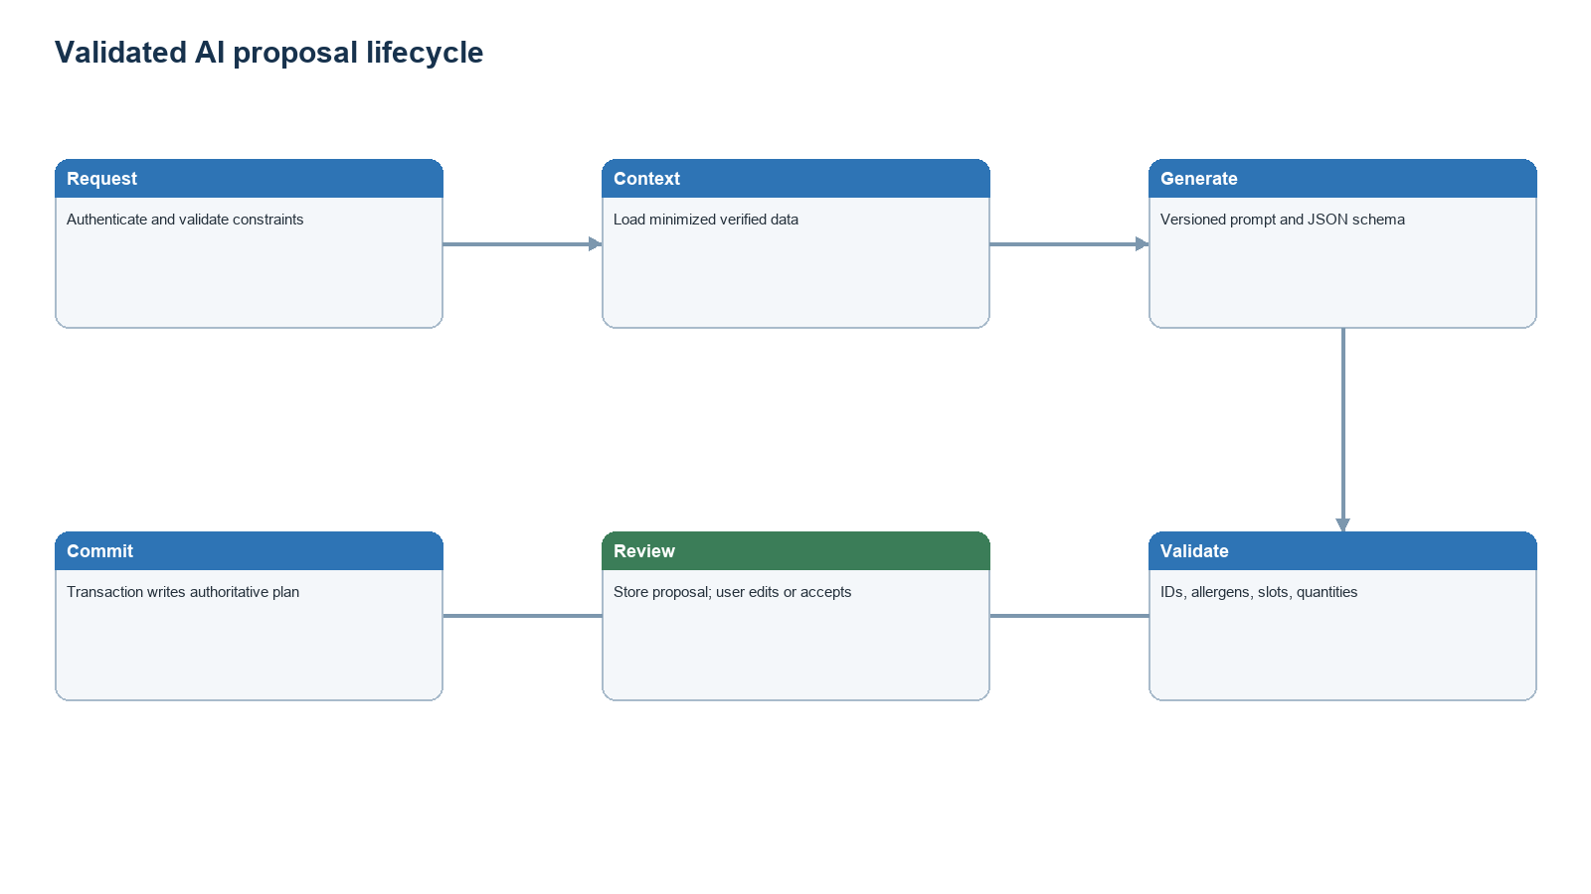
Validated AI lifecycle

Required verification rules
- Authenticate every user and derive the user/household from the token, not a request UserId string.
- Confirm membership and role for every aggregate read/write.
- Reject unknown ingredient, recipe, inventory, proposal, and plan IDs.
- Validate enum values, dates, positive quantities, serving counts, and units.
- Check allergen exclusions deterministically after model generation.
- Re-read inventory and verify proposal version inside the acceptance transaction.
- Make retryable writes idempotent.
- Keep AI suggestions separate from authoritative tables until acceptance.
- Store prompt/model/schema versions and validation failures without retaining unnecessary sensitive content.

Target API groups
- /api/v1/households and /members
- /api/v1/ingredients, /products, and /recipes
- /api/v1/receipts, /lines, /confirm
- /api/v1/inventory/lots and /events
- /api/v1/plan-proposals, /accept, and /meal-plans
- /api/v1/prepared-meals
- /api/v1/shopping-lists and /items/{id}
- /api/v1/assistant/messages for optional persisted conversations
Use OpenAPI-generated TypeScript types/client code so React Native contracts do not drift from C# DTOs.

Reliability and security
- Transactions for receipt confirmation, proposal acceptance, inventory use, and shopping-list replacement.
- Optimistic concurrency tokens for inventory and plans.
- Outbox events for asynchronous notifications and regeneration work.
- Bounded model/tool loops, timeouts, cancellation tokens, and provider retries.
- Rate limits and size limits for chat and uploads.
- Signed object-storage URLs, malware/type checks, retention policies, and redaction of receipt payment identifiers.
- Structured logs with correlation IDs; never log API keys or raw authorization headers.

Fridge Meal Planner — Implemented Data Schema
Status: implementation-aligned Database: PostgreSQL 16 ORM: Entity Framework Core with Npgsql Backend: ASP.NET Core / C# (net10.0) Reviewed: 22 July 2026
This document describes the schema that is implemented in prototype/backend/FridgeMealPlanner. It is derived from the EF Core models, AppDbContext, the InitialCreate migration, controllers, AI tool executor, and the React Native API contract. It intentionally does not describe the larger proposed architecture unless a feature is clearly marked as not yet persisted.

Relational graph
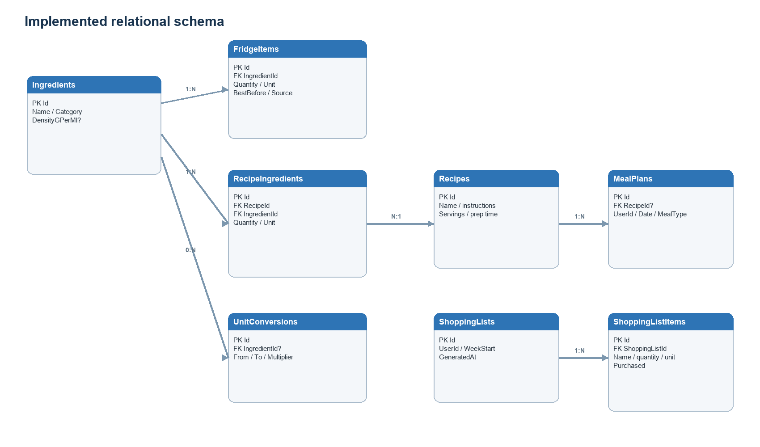
Implemented entity relationship graph
RecipeIngredients is the many-to-many bridge between Recipes and Ingredients. The other implemented relationships are one-to-many. A MealPlan may have no recipe, and a generic UnitConversion has no ingredient.

Tables

Ingredients
Canonical ingredient catalogue used by fridge stock, recipes, conversions, recipe matching, and shopping-list generation.
Column | PostgreSQL type | Null | Constraints / behaviour
Id | integer | No | Primary key; identity by default
Name | varchar(200) | No | Required
Category | varchar(100) | No | Defaults to an empty string in C# for new model instances
DensityGPerMl | numeric(10,4) | Yes | Optional density metadata

The migration seeds 15 ingredients. There is no unique index on Name, so the database can contain duplicates even though the AI add-ingredient tool performs a case-insensitive lookup first.

FridgeItems
Current fridge stock. The application generally treats one row as the aggregate quantity for an ingredient/unit pair.
Column | PostgreSQL type | Null | Constraints / behaviour
Id | integer | No | Primary key; identity by default
IngredientId | integer | No | FK → Ingredients.Id
Quantity | numeric(10,2) | No | Increased when the same ingredient/unit is added
Unit | integer | No | Unit enum
BestBeforeDate | timestamp with time zone | No | Used by expiry sorting and priority badges
AddedAt | timestamp with time zone | No | Set to UTC by application code
Source | integer | No | Source enum

Deleting an ingredient cascades to its fridge items. An index exists on IngredientId. There is no database uniqueness constraint on (IngredientId, Unit), although the controller and AI tool assume at most one matching row. There are also no database checks preventing zero or negative quantities.

Recipes
Recipe metadata and cooking instructions.
Column | PostgreSQL type | Null | Constraints / behaviour
Id | integer | No | Primary key; identity by default
Name | varchar(300) | No | Required
Description | varchar(2000) | No | Required by generated schema
Instructions | varchar(5000) | No | Required by generated schema
Servings | integer | No | No positive-value check
PrepTimeMinutes | integer | No | No non-negative check
ImageUrl | varchar(500) | Yes | Optional image URL

The migration seeds five recipes.

RecipeIngredients
Ingredient requirements for a recipe. This is the implemented recipe-to- ingredient join table and stores the required amount.
Column | PostgreSQL type | Null | Constraints / behaviour
Id | integer | No | Primary key; identity by default
RecipeId | integer | No | FK → Recipes.Id
IngredientId | integer | No | FK → Ingredients.Id
Quantity | numeric(10,2) | No | Required amount per stored recipe
Unit | integer | No | Unit enum

Both foreign keys cascade on delete. Separate indexes exist on RecipeId and IngredientId. There is no unique constraint on (RecipeId, IngredientId), so the same ingredient may be repeated within a recipe. The migration seeds 23 requirements for the five sample recipes.

MealPlans
One scheduled meal entry. The mobile planner creates a row for a date, meal type, user string, and optional recipe.
Column | PostgreSQL type | Null | Constraints / behaviour
Id | integer | No | Primary key; identity by default
UserId | varchar(200) | No | Plain string; not an FK to an identity table
Date | date | No | Calendar date
MealType | integer | No | MealType enum
RecipeId | integer | Yes | FK → Recipes.Id

Deleting a recipe sets RecipeId to null. An index exists on RecipeId. There is no unique constraint on (UserId, Date, MealType), so repeated taps or AI runs can create multiple meals in the same slot. The week GET endpoint does not filter by UserId, while shopping-list generation does.

ShoppingLists
Header for a generated weekly shopping list.
Column | PostgreSQL type | Null | Constraints / behaviour
Id | integer | No | Primary key; identity by default
UserId | varchar(200) | No | Plain string; not an FK
WeekStartDate | date | No | Start of requested seven-day range
GeneratedAt | timestamp with time zone | No | Set to UTC by application code

Every generation creates a new list. There is no unique constraint or status field for choosing the active list for a user/week.

ShoppingListItems
Materialized missing quantities calculated from planned recipes minus fridge stock. The ingredient is stored as display text rather than a foreign key.
Column | PostgreSQL type | Null | Constraints / behaviour
Id | integer | No | Primary key; identity by default
ShoppingListId | integer | No | FK → ShoppingLists.Id
IngredientName | varchar(200) | No | Denormalized ingredient name
Quantity | numeric(10,2) | No | Calculated missing quantity
Unit | integer | No | Unit enum
Purchased | boolean | No | Defaults to false in C#

Deleting a shopping list cascades to its items. An index exists on ShoppingListId. The current mobile checkbox changes local React state only; there is no endpoint that persists Purchased changes.

UnitConversions
Multipliers for generic and ingredient-specific unit conversion.
Column | PostgreSQL type | Null | Constraints / behaviour
Id | integer | No | Primary key; identity by default
FromUnit | integer | No | Unit enum
ToUnit | integer | No | Unit enum
IngredientId | integer | Yes | FK → Ingredients.Id; null means generic
Multiplier | numeric(10,6) | No | Result = input × multiplier

Deleting an ingredient sets IngredientId to null. An index exists on IngredientId. The migration seeds 20 conversions. There is no uniqueness constraint on (FromUnit, ToUnit, IngredientId).

Enum storage
EF Core stores all three enums as PostgreSQL integers. Values are part of the database contract and must not be reordered without a data migration.

Unit
Value | Integer
Grams | 0
Ml | 1
Pieces | 2
Cups | 3
Tbsp | 4
Tsp | 5

Source
Value | Integer
Receipt | 0
Manual | 1

MealType
Value | Integer
Breakfast | 0
Lunch | 1
Dinner | 2
Snack | 3

Foreign keys and delete rules
Child column | Parent column | On delete
FridgeItems.IngredientId | Ingredients.Id | Cascade
RecipeIngredients.RecipeId | Recipes.Id | Cascade
RecipeIngredients.IngredientId | Ingredients.Id | Cascade
MealPlans.RecipeId | Recipes.Id | Set null
ShoppingListItems.ShoppingListId | ShoppingLists.Id | Cascade
UnitConversions.IngredientId | Ingredients.Id | Set null

Implemented write flows

Add or use fridge stock
- The API verifies that an ingredient ID exists for normal mobile requests.
- It looks for an existing FridgeItems row with the same ingredient and unit.
- It adds the quantity and retains the later best-before date, or inserts a new row.
- Using stock subtracts quantity; the row is deleted when quantity reaches zero or less.
The AI tool follows the same merge behaviour and can create a new Ingredients row by name. These steps are application conventions, not database constraints.

Weekly meal planning
The mobile app writes one MealPlans row per chosen recipe slot. The AI tool can create breakfast, lunch, and dinner rows for a requested number of days by randomly selecting stored recipes. AI proposals are not stored separately and there is no accept/reject workflow.

Shopping-list generation
- Load the user's recipe-backed meal plans in the requested seven-day range.
- Sum RecipeIngredients by ingredient ID.
- Subtract fridge stock only when the stored unit exactly matches the recipe unit.
- Insert one ShoppingLists row and its missing ShoppingListItems rows.
The generator currently stores an ingredient name snapshot, not IngredientId, and does not use the available conversion table during this calculation.

Features not persisted in the current implementation
The following product concepts are not represented by the current EF Core schema:
- user accounts, authentication, households, roles, and data ownership;
- receipt image uploads, OCR jobs, parsed receipt lines, and confidence/review state;
- distinct use-by, best-before, and estimated expiry date types;
- inventory lots, storage locations, immutable quantity events, and meal reservations;
- prepared-meal batches and individual portions;
- AI conversations, messages, prompts, model metadata, suggestions, proposals, acceptance, or feedback;
- dietary preferences, allergens, nutrition targets, recipe tags, and cost;
- durable shopping-item completion from the mobile app.
The OpenRouter chat layer is stateless: each request starts a new model conversation, and only tool side effects—fridge items, meal plans, and shopping lists—are written to PostgreSQL.

Implementation risks visible in the schema
These are documentation findings; this schema file does not alter runtime code.
- Add a unique constraint on FridgeItems (IngredientId, Unit) because both write paths assume a single row and use FirstOrDefault/First.
- Add a unique constraint on MealPlans (UserId, Date, MealType) or explicitly support multiple entries per slot in the API and UI.
- Add IngredientId to ShoppingListItems while retaining IngredientName only as an optional snapshot.
- Add check constraints for positive quantities, servings, prep time, and conversion multipliers.
- Make user ownership relational before supporting multiple users; currently fridge and recipe data are global, meal-plan reads are unscoped, and only some generation paths filter the plain UserId string.
- Use UnitConversions when aggregating recipe requirements and fridge stock, and add a uniqueness rule for conversion keys.
- Add a backend update endpoint if ShoppingListItems.Purchased should survive app restarts.

Sources of truth reviewed
- prototype/backend/FridgeMealPlanner/Data/AppDbContext.cs
- prototype/backend/FridgeMealPlanner/Models/*.cs
- prototype/backend/FridgeMealPlanner/Enums/*.cs
- prototype/backend/FridgeMealPlanner/Migrations/20260722044624_InitialCreate.cs
- prototype/backend/FridgeMealPlanner/Controllers/*.cs
- prototype/backend/FridgeMealPlanner/Services/ToolExecutor.cs
- prototype/mobile/services/api.ts
- prototype/mobile/app/*.tsx

Current implementation audit

Capability map
Capability | Status | Evidence / limitation
Fridge list and expiry ordering | Implemented | Mobile sorts bestBeforeDate; backend returns joined ingredient data
Manual fridge entry | Partial | UI collects a name but submits hard-coded ingredientId = 1
Stock use/delete | Implemented | API subtracts quantity and removes empty rows
Receipt OCR | Not implemented | Source.Receipt exists, but no capture, OCR, review, or receipt tables/endpoints
Recipe catalogue/detail | Implemented | Five seeded recipes and normalized requirements
Recipe matching | Partial | API match-count endpoint exists; normal Recipes screen does not invoke it
Manual weekly planner | Partial | Tap-to-select works; no drag/drop, prepared meals, or slot uniqueness
AI weekly planning | Partial | Tool inserts random recipes directly; no constraints, proposal, or acceptance
Shopping generation | Partial | Persists missing same-unit quantities; route mismatch and no conversion/rounding
Shopping completion | Partial | Purchased exists; mobile toggles only local state and no update endpoint exists
Chat | Partial | OpenRouter tools exist; no auth, history, confirmation, or model audit records
Multi-user isolation | Not implemented | Plain UserId; global fridge/recipes; unscoped meal-plan GET

Integration defects to address first
- Backend build: ToolExecutor.SuggestRecipes contains a repeated .Select(e => e.GetInt32()); the second call operates on an int and should be removed.
- Shopping route: the mobile client requests /api/shopping-list/generate but ShoppingListController maps to /api/shoppinglist/generate unless an explicit route is added.
- HTTP method: mobile generateShoppingList uses the generic request helper without method: 'POST', while the controller requires POST.
- Manual ingredient: Fridge UI ignores the entered name and always sends ingredient ID 1. Add ingredient search/create or change the request contract.
- Use response type: deleting the final fridge quantity returns an object without the FridgeItem shape the TypeScript client declares.
- Date input: mobile submits YYYY-MM-DD for a DateTime field. Normalize timezone semantics explicitly instead of relying on serializer defaults.
- User scoping: GET /api/mealplan does not filter UserId; all fridge and recipe records are shared globally.

Data integrity priorities
- Unique FridgeItems (IngredientId, Unit).
- Unique MealPlans (UserId, Date, MealType) if one meal per slot is intended.
- Unique recipe requirement per recipe/ingredient or an explicit sequence key.
- Unique conversion key (FromUnit, ToUnit, IngredientId) with null-safe logic.
- Positive checks for stock, recipe requirements, servings, prep time, and multipliers.
- Relational ingredient reference on shopping items.
- Authentication-backed user/household foreign keys.

Testing priorities
- Compile and migration application in CI.
- API/mobile contract tests from OpenAPI.
- Fridge merge, expiry, use-to-zero, and concurrent-add tests.
- Meal-slot uniqueness and user-isolation tests.
- Unit-conversion and shopping aggregation tests.
- AI tool argument validation, authorization, loop-limit, and confirmation tests.
- OCR fixtures covering low confidence, duplicate lines, discounts, weights, and non-food receipt entries once OCR is implemented.

Recommended next implementation slice
Complete a vertical “verified manual week” before OCR:
- Fix the seven integration defects above.
- Add stable authentication and household ownership.
- Add constraints/migrations and validation.
- Make tap-to-plan, shopping generation, and purchased-state persistence work end-to-end.
- Add integration tests.
This creates a trustworthy foundation for receipt OCR and AI plan proposals.

