**DatingApp**

**BackEnd**

1. SET UP
   1. Using the CLI to create the App

* Commands :

PS C:\MyGitRepos\DatingApp> dotnet --info

new -h (give all info of what can be done with the “new” command)

new list (give list of available templates to create projects)

new sln (create a solution file and if we don’t give the name it will chose the same as the folder name)

ls (check what’s in the folder)

new webapi -n API (create a new project with name API)

sln add API/ (add the project in the API folder)

dotnet run -lp https (to run the app on https server)

dotnet restore (reload the app after adding or removing packages)

dotnet watch run (run the app)

* 1. Extensions to install In VS Code
* Material Icon theme (icons looking better)
* C# (if you want to work with C# on VS code)

Go to extension settings -> enable Async completion

Enable Import completion

Organize imports on format

* C# Extensions from JosCreativ
* 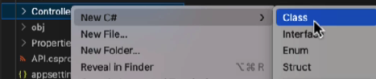
* NuGet gallery (to be able to install NuGet packages)
* In the NuGet gallery find and install
  + Microsoft.EntityFrameworkCore.Design
  + Microsoft.EntityFrameworkCore.Sqlite

1. Install Entity Framework

Check with “dotnet tool list -g” if **EF** is installed and if not In the browser : nuget.org/packages/dotnet-ef -> copy the command “dotnet tool install --global dotnet-ef --version 7.0.1” and use it in terminal to install EF

* 1. VS Code set up

1. File -> Auto Save (enable auto save)
2. TO REFRESH VS CODE : Ctrl+Shift+P -> Ctrl+R (Reload Window)
3. TO Exclude unused folders from solution explorer : bin and obj => File->Preferences->Settings-> exclude-> Add pattern “ **/bin ” ->Ok (same for **/obj)

**Context, Controllers**

1. First Migration

dotnet ef migrations add InitialCreate -o Data/Migrations

1. DataBase

dotnet ef database update

* DB is created, but file can’t be read, to manage that , in extensions -> SQLite (install the first one) -> Ctrl+Shift+P -> SQLite: Open Database

SQLite Explorer -> Users -> New Query [Insert] (to fill the table with data) -> run the query

1. Create Users Controller

* If you want to put _ when inject by default in the constructor -> In the extension “C# Extensions” -> Extension Settings ->

**Source control GIT**

* Has to be in the main folder and in the terminal tap “ git init “ command
* “dotnet new list” to check available templates -> dotnet new gitignore (to create the gitignore file) .
* Add the appsettings.json file in gitignore file, we don’t want to add this file In Git, because will have secret info in it. To do so hover over the file -> Add file to .gitignore
* We want to create the global.json file : dotnet new globaljson
* Stage changes and make first commit
* Create new Repo in GitHub

**FrontEnd**

1. Commands

* **Check version of node.js**

**node** –version

**npm** –version

* **Install Angular CLI and check version**

**npm** install -g @angular/cli@14 **ng** version

* **Create the new Angular app and run it**

**ng** new client **ng** serve

1. Extensions to install

* Angular Language Service

1. VS code set up

* Productivity features

File -> Preferences -> Settings -> write “bracket”

1. Making Http request in angular

* Add  
  Text

  Description automatically generated

Check commit [Add Http request to API](https://github.com/ZackoYo/DatingApp/commit/4f9f9d7580b4a690c1e3530b54ccf03a2c650377) = 4f9f9d7580b4a690c1e3530b54ccf03a2c650377

1. Solve CORS issue

In Program add  above 

Then under  add



Check commit [Fix CORS policy issue](https://github.com/ZackoYo/DatingApp/commit/9b1f78c7d15160fa70c37b3678ac9ff6e155aeb0)

1. Displaying the fetch users in the browser

Have to be careful it’s case sensitive

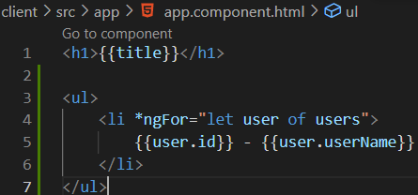

1. Install ngx-bootstrap and bootstrap5

**npm** install [ngx-bootstrap@9.0.0](mailto:ngx-bootstrap@9.0.0) **npm** install bootstrap@5

1. Install font-awesome for fancy icons

**npm** install font-awesome

* **Have to add** styles files in angular.json and remember that the last file overrides those before!!!

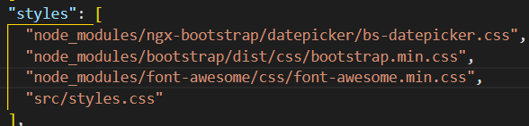

1. Using Https in Angular

Go to C:\MyGitRepos\DatingApp\Resources\StudentAssets\StudentAssets\generateTrustedSSL

Install the certificate and copy the certificate and key files, then go in VS code , on client -> reveal in File Explorer, create folder ssl and paste the files. Then to make Angular use these files go into angular.json file and add this Text

Have to change “http” to “https” in C:\MyGitRepos\DatingApp\API\Program.cs

