Laporan Hasil Pratikum

Algoritma Dan Struktur Data

Jobsheet 1



|  |  |
| --- | --- |
| Nama : | Zacky Rio Orlando |
| NIM : | 244107020086 |
| Kelas : | 1E |

Program Studi D-IV Teknik Informatika

Jurusan Teknologi Informasi

Praktikum

2025

**2. Praktikum**

**2.1 Pemilihan**

Hasil Kode Program

import java.util.Scanner;

public class Pemilihan27 {

public static void main(String[] args) {

Scanner input = new Scanner(System.in);

String nilaiHuruf;

String status;

double tugas,kuis,uts,uas;

System.out.println("Program Menghitung Nilai Akhir");

System.out.println("======================");

System.out.print("Masukkan Nilai Tugas : ");

tugas = input.nextDouble();

System.out.print("Masukkan Nilai Kuis : ");

kuis = input.nextDouble();

System.out.print("Masukkan Nilai UTS : ");

uts = input.nextDouble();

System.out.print("Masukkan Nilai UAS : ");

uas = input.nextDouble();

System.out.println("======================");

if (tugas < 0 || tugas > 100 || kuis < 0 || kuis > 100 || uts < 0 || uts > 100 || uas < 0 || uas > 100) {

System.out.println("Nilai tidak valid");

System.out.println("======================");

System.out.println("======================");

} else {

double nilaiAkhir = (0.2 * tugas) + (0.2 * kuis) + (0.3 * uts) + (0.3 * uas);

if (nilaiAkhir >= 80) {

nilaiHuruf = "A";

} else if (nilaiAkhir >= 73) {

nilaiHuruf = "B+";

} else if (nilaiAkhir >= 65) {

nilaiHuruf = "B";

} else if (nilaiAkhir >= 60) {

nilaiHuruf = "C+";

} else if (nilaiAkhir >= 50) {

nilaiHuruf = "C";

} else if (nilaiAkhir >= 39) {

nilaiHuruf = "D";

} else {

nilaiHuruf = "E";

}

if (nilaiHuruf.equals("A") || nilaiHuruf.equals("B+") || nilaiHuruf.equals("B") || nilaiHuruf.equals("C+") || nilaiHuruf.equals("C")) {

status = "SELAMAT ANDA LULUS";

} else {

status = "ANDA TIDAK LULUS";

}

System.out.println("======================");

System.out.println("Nilai Akhir : " + nilaiAkhir);

System.out.println("Nilai Huruf : " + nilaiHuruf);

System.out.println("======================");

System.out.println("======================");

System.out.println(status);

}

}

}

Hasil Output

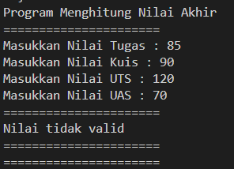

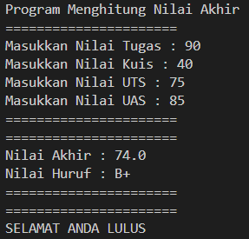

**2.2 Perulangan**

Hasil Kode Program

import java.util.Scanner;

public class Perulangan27 {

public static void main(String[] args) {

Scanner input = new Scanner(System.in);

System.out.print("Masukkan NIM: ");

String nim = input.next();

String duaDigit = nim.substring(nim.length() - 2);

int n = Integer.parseInt(duaDigit);

if (n < 10) {

n += 10;

}

System.out.println("=====================");

System.out.println("n : " + n);

int i = 1;

while (i <= n) {

if (i != 6 && i != 10) {

if (i % 2 == 1) {

System.out.print("* ");

} else {

System.out.print(i + " ");

}

}

i++;

}

}

}

Hasil Output

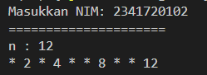

**2.3 Array**

Hasil Kode Program

import java.util.Scanner;

public class Array27 {

public static void main(String[] args) {

Scanner input = new Scanner(System.in);

String[] mataKuliah = {

"MK Pancasila",

"MK Konsep Teknologi Informasi",

"MK Critical Thinking dan Problem Solving",

"MK Matematika Dasar",

"MK Bahasa Inggris",

"MK Dasar Pemrograman",

"MK Praktikum Dasar Pemrograman",

"MK Keselamatan dan Kesehatan Kerja"

};

double[] nilaiAngka = new double[mataKuliah.length];

String[] nilaiHuruf = new String[mataKuliah.length];

double[] bobotNilai = new double[mataKuliah.length];

System.out.println("======================");

System.out.println("Program Menghitung IP Semester");

System.out.println("======================");

for (int i = 0; i < mataKuliah.length; i++) {

System.out.print("Masukkan nilai Angka untuk " + mataKuliah[i] + " : ");

nilaiAngka[i] = input.nextDouble();

if (nilaiAngka[i] >= 80) {

nilaiHuruf[i] = "A";

bobotNilai[i] = 4.00;

} else if (nilaiAngka[i] >= 73) {

nilaiHuruf[i] = "B+";

bobotNilai[i] = 3.50;

} else if (nilaiAngka[i] >= 65) {

nilaiHuruf[i] = "B";

bobotNilai[i] = 3.00;

} else if (nilaiAngka[i] >= 60) {

nilaiHuruf[i] = "C+";

bobotNilai[i] = 2.50;

} else if (nilaiAngka[i] >= 50) {

nilaiHuruf[i] = "C";

bobotNilai[i] = 2.00;

} else if (nilaiAngka[i] >= 39) {

nilaiHuruf[i] = "D";

bobotNilai[i] = 1.00;

} else {

nilaiHuruf[i] = "E";

bobotNilai[i] = 0.00;

}

}

Hasil Output

System.out.println("======================");

System.out.println("Hasil Konversi Nilai");

System.out.println("======================");

System.out.printf("%-40s %-15s %-15s %-15s\n", "MK", "Nilai Angka", "Nilai Huruf", "Bobot Nilai");

double totalBobot = 0;

for (int i = 0; i < mataKuliah.length; i++) {

System.out.printf("%-40s %-15.2f %-15s %-15.2f\n", mataKuliah[i], nilaiAngka[i], nilaiHuruf[i], bobotNilai[i]);

totalBobot += bobotNilai[i];

}

double ip = totalBobot / mataKuliah.length;

System.out.println("======================");

System.out.printf("IP : %.2f\n", ip);

}

}

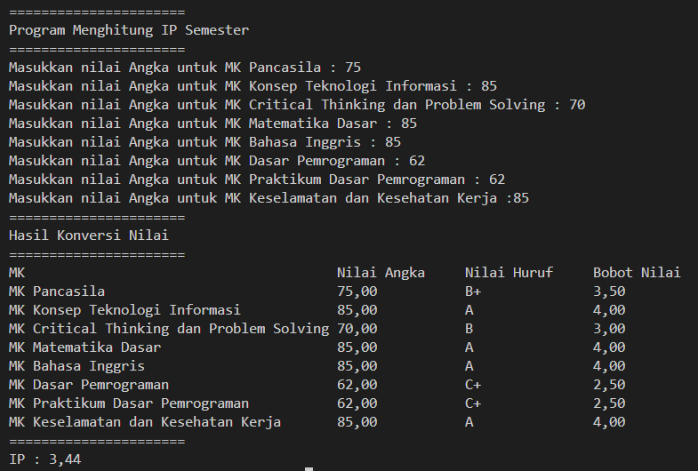

**2.4 Fungsi**

import java.util.Scanner;

public class Fungsi27 {

static int[][] stokBunga;

static int[] hargaBunga = {75000, 50000, 60000, 10000};

static String[] cabang = {"RoyalGarden 1", "RoyalGarden 2", "RoyalGarden 3", "RoyalGarden 4"};

public static void main(String[] args) {

Scanner input = new Scanner(System.in);

stokBunga = new int[cabang.length][4];

System.out.println("=========================");

System.out.println("Input Stok Bunga per Cabang");

System.out.println("=========================");

for (int i = 0; i < cabang.length; i++) {

System.out.println("Cabang: " + cabang[i]);

System.out.print("Aglonema: ");

stokBunga[i][0] = input.nextInt();

System.out.print("Keladi: ");

stokBunga[i][1] = input.nextInt();

System.out.print("Alocasia: ");

stokBunga[i][2] = input.nextInt();

System.out.print("Mawar: ");

stokBunga[i][3] = input.nextInt();

System.out.println();

}

tampilkanPendapatan();

tampilkanTotalStok();

kurangiStokBunga();

tampilkanStokSetelahPengurangan();

input.close();

}

static void tampilkanPendapatan() {

System.out.println("=========================");

System.out.println("Pendapatan setiap cabang jika semua bunga terjual:");

for (int i = 0; i < stokBunga.length; i++) {

int pendapatan = 0;

for (int j = 0; j < stokBunga[i].length; j++) {

pendapatan += stokBunga[i][j] * hargaBunga[j];

}

System.out.println(cabang[i] + " : Rp " + pendapatan);

}

System.out.println();

}

static void tampilkanTotalStok() {

int[] totalStok = new int[4];

for (int i = 0; i < stokBunga.length; i++) {

for (int j = 0; j < stokBunga[i].length; j++) {

totalStok[j] += stokBunga[i][j];

}

}

System.out.println("=========================");

System.out.println("Total stok bunga di semua cabang:");

System.out.println("Aglonema : " + totalStok[0]);

System.out.println("Keladi : " + totalStok[1]);

System.out.println("Alocasia : " + totalStok[2]);

System.out.println("Mawar : " + totalStok[3]);

System.out.println();

}

static void kurangiStokBunga() {

int[] bungaMati = {-1, -2, 0, -5};

for (int i = 0; i < stokBunga.length; i++) {

for (int j = 0; j < stokBunga[i].length; j++) {

stokBunga[i][j] += bungaMati[j];

}

}

}

static void tampilkanStokSetelahPengurangan() {

System.out.println("=========================");

System.out.println("Stok bunga setelah pengurangan karena ada yang mati:");

for (int i = 0; i < stokBunga.length; i++) {

System.out.println(cabang[i] + " - Aglonema: " + stokBunga[i][0] +

", Keladi: " + stokBunga[i][1] +

", Alocasia: " + stokBunga[i][2] +

", Mawar: " + stokBunga[i][3]);

}

}

}

Hasil Output  
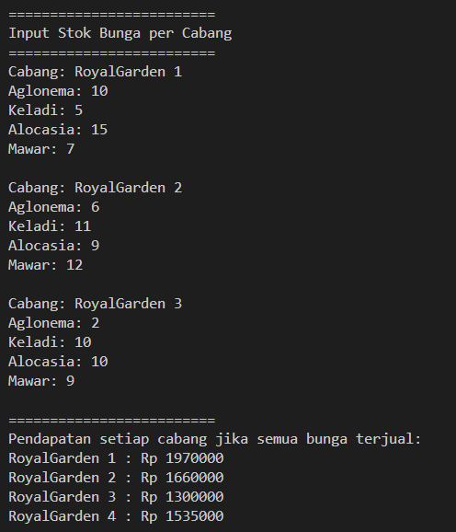

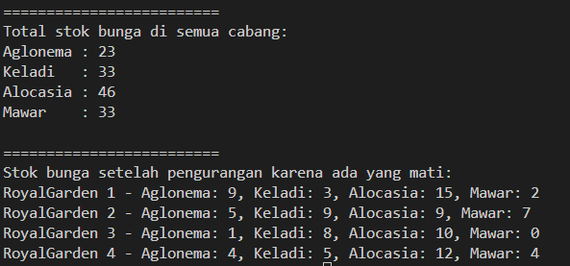

**3. Tugas**

**1. Plat Nomor**

import java.util.Scanner;

public class Tugas127 {

public static void main(String[] args) {

Scanner input = new Scanner(System.in);

char[] platNomor = {'A', 'B', 'D', 'E', 'F', 'G', 'H', 'L', 'N', 'T'};

char[][] kota = {

{'B', 'A', 'N', 'T', 'E', 'N'},

{'J', 'A', 'K', 'A', 'R', 'T', 'A'},

{'B', 'A', 'N', 'D', 'U', 'N', 'G'},

{'C', 'I', 'R', 'E', 'B', 'O', 'N'},

{'B', 'O', 'G', 'O', 'R'},

{'P', 'E', 'K', 'A', 'L', 'O', 'N', 'G', 'A', 'N'},

{'S', 'E', 'M', 'A', 'R', 'A', 'N', 'G'},

{'S', 'U', 'R', 'A', 'B', 'A', 'Y', 'A'},

{'M', 'A', 'L', 'A', 'N', 'G'},

{'T', 'E', 'G', 'A', 'L'}

};

System.out.print("Masukkan kode plat nomor: ");

char kodeInput = Character.toUpperCase(input.next().charAt(0));

boolean ditemukan = false;

for (int i = 0; i < platNomor.length; i++) {

if (platNomor[i] == kodeInput) {

System.out.print("Kota: ");

for (int j = 0; j < kota[i].length; j++) {

System.out.print(kota[i][j] + " ");

}

System.out.println();

ditemukan = true;

break;

}

}

if (!ditemukan) {

System.out.println("Kode plat tidak ditemukan.");

}

}

}

Hasil Output





**2. Kubus**

import java.util.Scanner;

public class Tugas227 {

static double rumusVolume(double s) {

return s * s * s;

}

static double rumusLuasPermukaan(double s) {

return 6 * s * s;

}

static double rumusKeliling(double s) {

return 12 * s;

}

static void menu() {

System.out.println("==============================");

System.out.println("====== Menghitung Kubus ======");

System.out.println("==============================");

System.out.println("1. Hitung Volume Kubus");

System.out.println("2. Hitung Luas Permukaan Kubus");

System.out.println("3. Hitung Keliling Kubus");

System.out.println("4. Keluar");

System.out.println("===========================");

}

public static void main(String[] args) {

Scanner input = new Scanner(System.in);

int pilihan;

do {

menu();

System.out.print("Pilih menu (1-4): ");

pilihan = input.nextInt();

if (pilihan >= 1 && pilihan <= 3) {

System.out.print("Masukkan panjang sisi kubus: ");

double sisi = input.nextDouble();

if (sisi <= 0) {

System.out.println("Panjang sisi harus lebih dari 0!");

} else {

switch (pilihan) {

case 1:

System.out.println("Volume Kubus: " + rumusVolume(sisi));

break;

case 2:

System.out.println("Luas Permukaan Kubus: " + rumusLuasPermukaan(sisi));

break;

case 3:

System.out.println("Keliling Kubus: " + rumusKeliling(sisi));

break;

}

}

} else if (pilihan == 4) {

System.out.println("Terima Kasih");

} else {

System.out.println("Pilihan tidak valid. Silakan pilih lagi.");

}

System.out.println();

} while (pilihan != 4);

}

}

Hasil Output

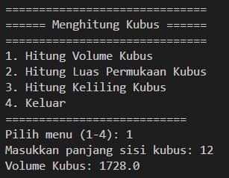

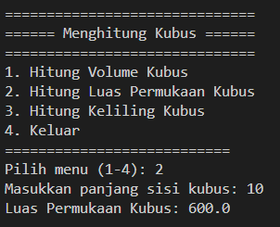

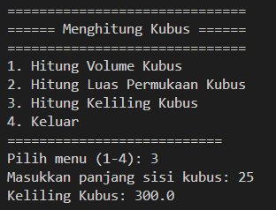

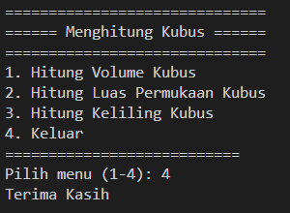

**3. Kuliah**

import java.util.Scanner;

public class Tugas327 {

static Scanner input = new Scanner(System.in);

static String[] namaMataKuliah;

static int[] sks;

static int[] semester;

static String[] hariKuliah;

static int jumlahMK;

public static void main(String[] args) {

inputDataMataKuliah();

menu();

}

static void inputDataMataKuliah() {

System.out.print("Masukkan jumlah mata kuliah: ");

jumlahMK = input.nextInt();

input.nextLine();

namaMataKuliah = new String[jumlahMK];

sks = new int[jumlahMK];

semester = new int[jumlahMK];

hariKuliah = new String[jumlahMK];

for (int i = 0; i < jumlahMK; i++) {

System.out.println("\nMasukkan data mata kuliah ke-" + (i + 1) + ":");

System.out.print("Nama Mata Kuliah: ");

namaMataKuliah[i] = input.nextLine();

System.out.print("SKS: ");

sks[i] = input.nextInt();

System.out.print("Semester: ");

semester[i] = input.nextInt();

input.nextLine();

System.out.print("Hari Kuliah: ");

hariKuliah[i] = input.nextLine();

}

}

static void menu() {

int pilihan;

do {

System.out.println("\n==========================");

System.out.println("======= JADWAL KULIAH ======");

System.out.println("==========================");

System.out.println("1. Tampilkan seluruh jadwal kuliah");

System.out.println("2. Tampilkan jadwal berdasarkan hari");

System.out.println("3. Tampilkan jadwal berdasarkan semester");

System.out.println("4. Cari mata kuliah");

System.out.println("5. Keluar");

System.out.println("==========================");

System.out.print("Pilih menu (1-5): ");

pilihan = input.nextInt();

input.nextLine();

switch (pilihan) {

case 1:

seluruhJadwal();

break;

case 2:

jadwalBerdasarkanHari();

break;

case 3:

jadwalBerdasarkanSemester();

break;

case 4:

cariMataKuliah();

break;

case 5:

System.out.println("Terima kasih");

break;

default:

System.out.println("Pilihan tidak valid! Silakan pilih kembali.");

}

} while (pilihan != 5);

}

static void seluruhJadwal() {

System.out.println("\n===== JADWAL SELURUH MATA KULIAH =====");

for (int i = 0; i < jumlahMK; i++) {

System.out.println(namaMataKuliah[i] + " | " + sks[i] + " SKS | Semester " + semester[i] + " | Hari: " + hariKuliah[i]);

}

}

static void jadwalBerdasarkanHari() {

System.out.print("\nMasukkan hari kuliah yang ingin ditampilkan: ");

String hariCari = input.nextLine();

boolean ditemukan = false;

System.out.println("\n===== JADWAL KULIAH HARI " + hariCari.toUpperCase() + " =====");

for (int i = 0; i < jumlahMK; i++) {

if (hariKuliah[i].equalsIgnoreCase(hariCari)) {

System.out.println(namaMataKuliah[i] + " | " + sks[i] + " SKS | Semester " + semester[i] + " | Hari: " + hariKuliah[i]);

ditemukan = true;

}

}

if (!ditemukan) {

System.out.println("Tidak ada jadwal kuliah pada hari " + hariCari);

}

}

Hasil Output

static void jadwalBerdasarkanSemester() {

System.out.print("\nMasukkan semester yang ingin ditampilkan: ");

int semesterCari = input.nextInt();

boolean ditemukan = false;

System.out.println("\n===== JADWAL KULIAH SEMESTER " + semesterCari + " =====");

for (int i = 0; i < jumlahMK; i++) {

if (semester[i] == semesterCari) {

System.out.println(namaMataKuliah[i] + " | " + sks[i] + " SKS | Semester " + semester[i] + " | Hari: " + hariKuliah[i]);

ditemukan = true;

}

}

if (!ditemukan) {

System.out.println("Tidak ada jadwal kuliah untuk semester " + semesterCari);

}

}

static void cariMataKuliah() {

System.out.print("\nMasukkan nama mata kuliah yang ingin dicari: ");

String namaCari = input.nextLine();

boolean ditemukan = false;

System.out.println("\n===== HASIL PENCARIAN MATA KULIAH =====");

for (int i = 0; i < jumlahMK; i++) {

if (namaMataKuliah[i].equalsIgnoreCase(namaCari)) {

System.out.println("Nama Mata Kuliah: " + namaMataKuliah[i]);

System.out.println("SKS: " + sks[i]);

System.out.println("Semester: " + semester[i]);

System.out.println("Hari Kuliah: " + hariKuliah[i]);

ditemukan = true;

break;

}

}

if (!ditemukan) {

System.out.println("Mata kuliah dengan nama \"" + namaCari + "\" tidak ditemukan.");

}

}

}

