Github Repository

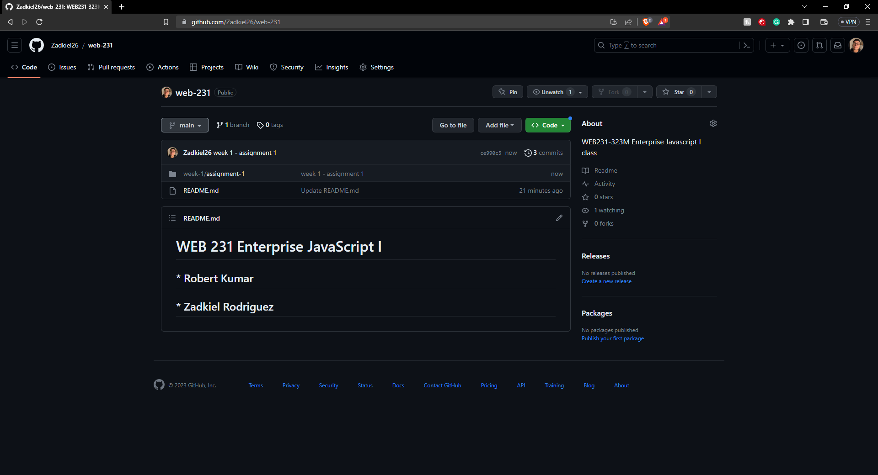

Folder Format (First two weeks)

