**Query to add a new user:**



**Query to update user’s field (email):**

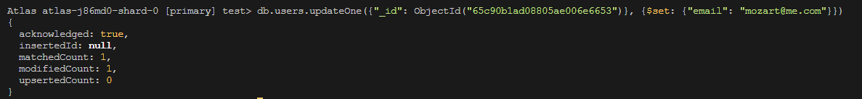

**Query to list all users only showing their firstName, lastName, and email:**

