**Query to show a list of documents in the house collection:**

**Query to show a list of documents in the student’s collection:**

**Query to add a document to the student's collection:**

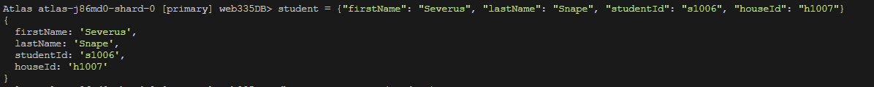

**Query to delete previous document added to the student's collection:**



**Query to show list of students by house:**

**Query to show list of students for house Gryffindor:**

**Query to show list of students for mascot Eagle:**

