GROUP 16 – ClimbOn rock climbing database

Devon Cash, Dakota Zaengle

DATABASE SCREENSHOTS:

Current layout:

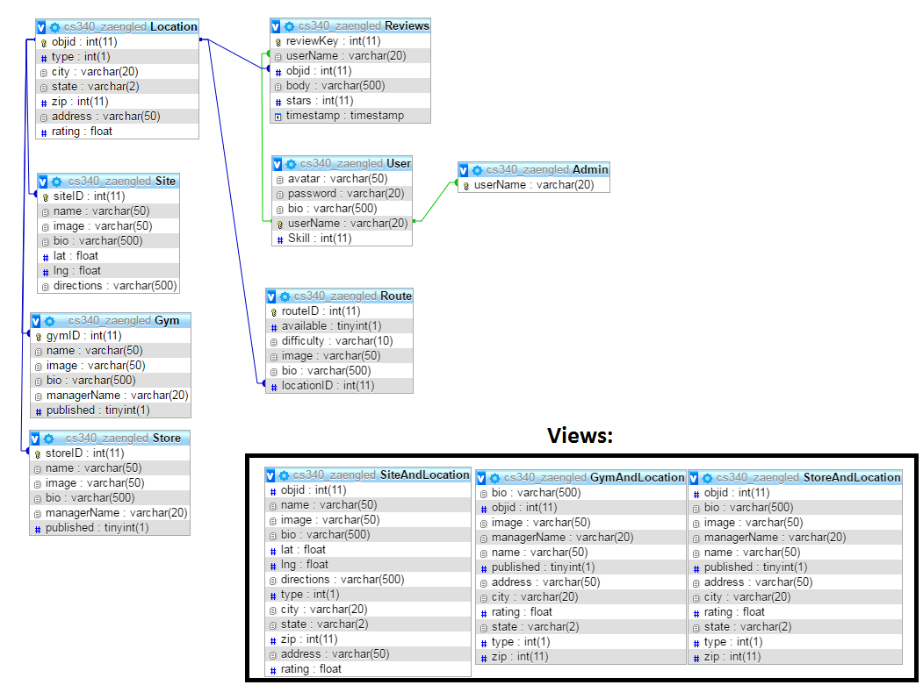

Admin table: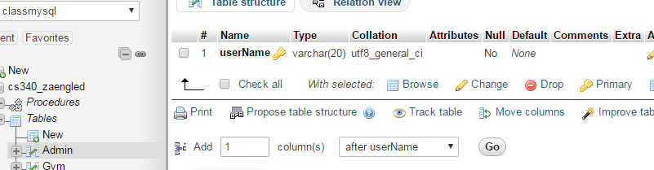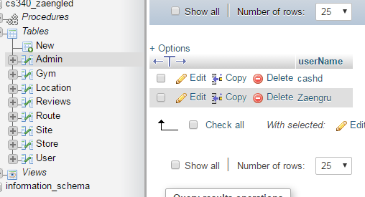

Gym table: 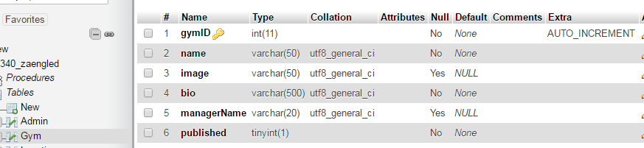

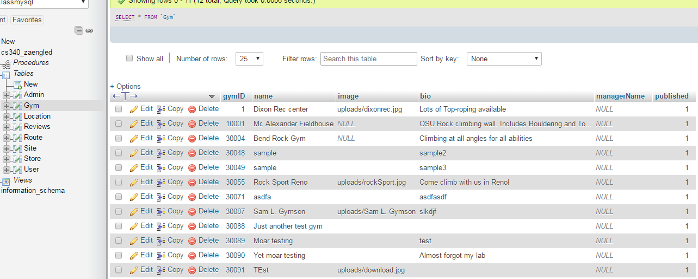

Location table: 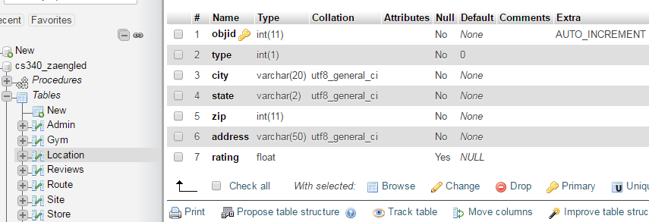

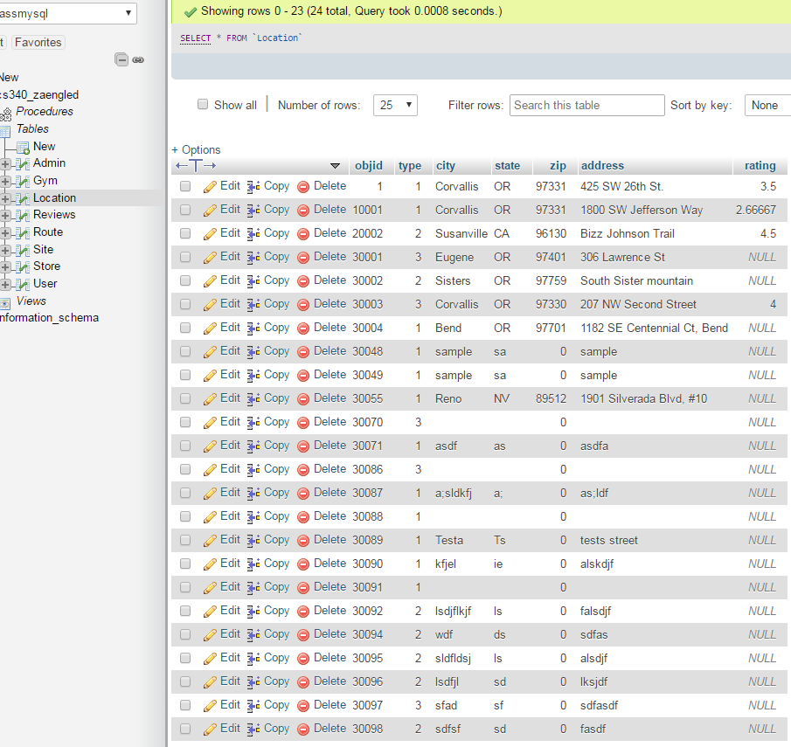

Review table: 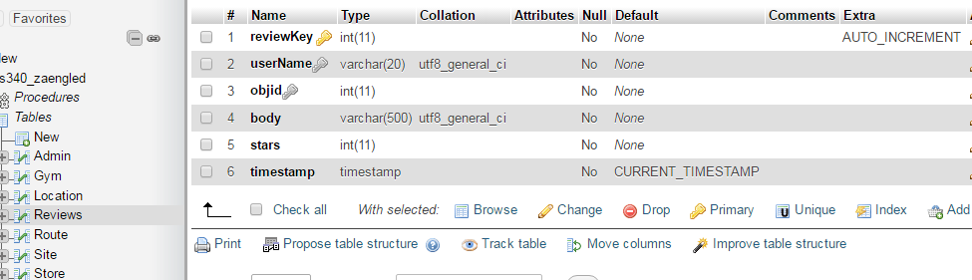

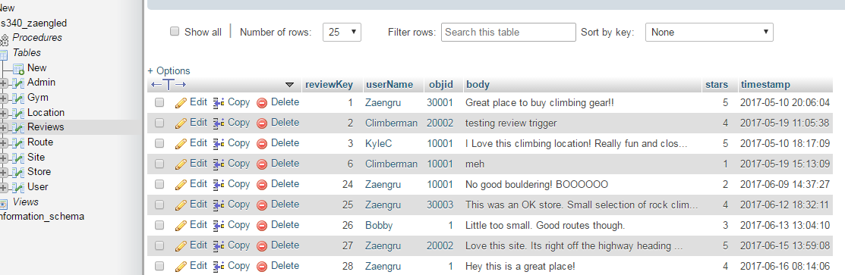

Route table: 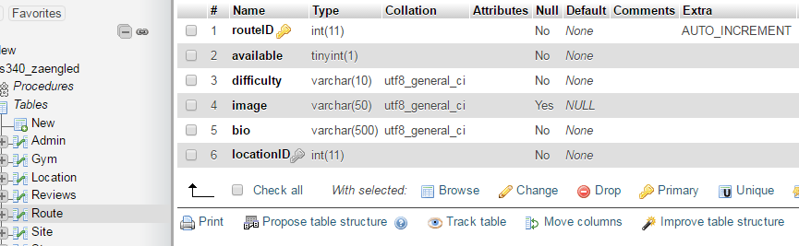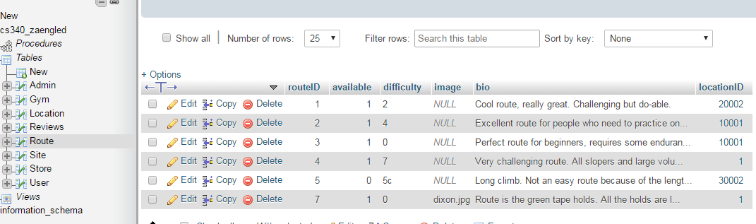

Site table: 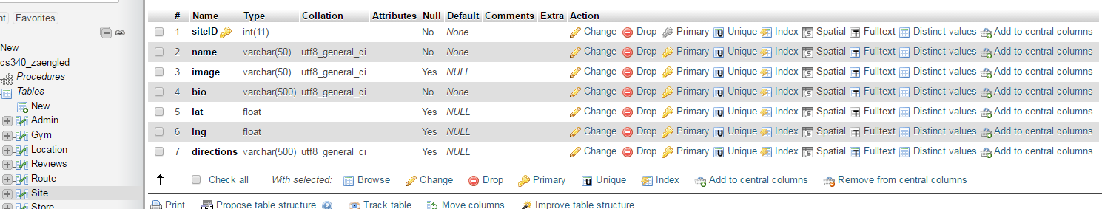

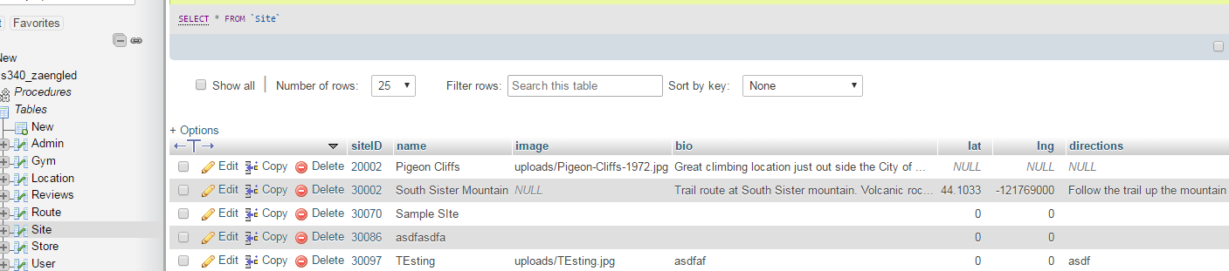

Store table: 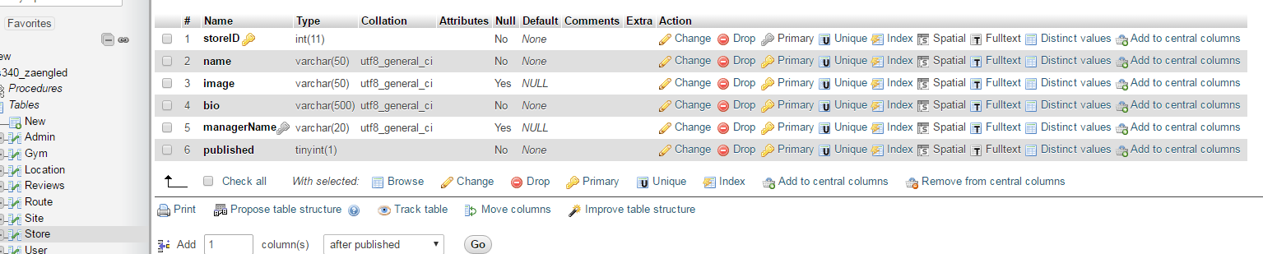

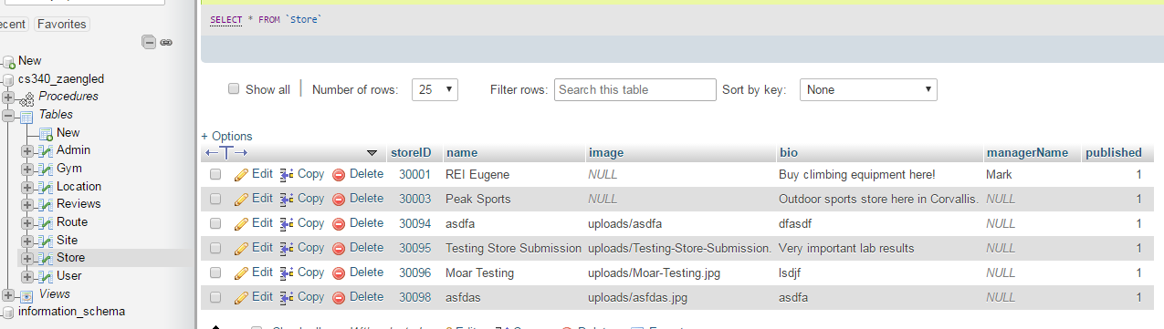

User table: 