Understanding Android Execution
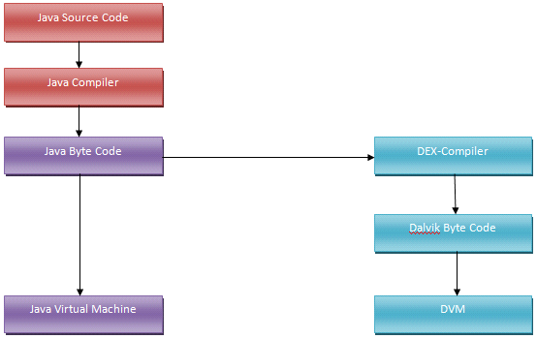

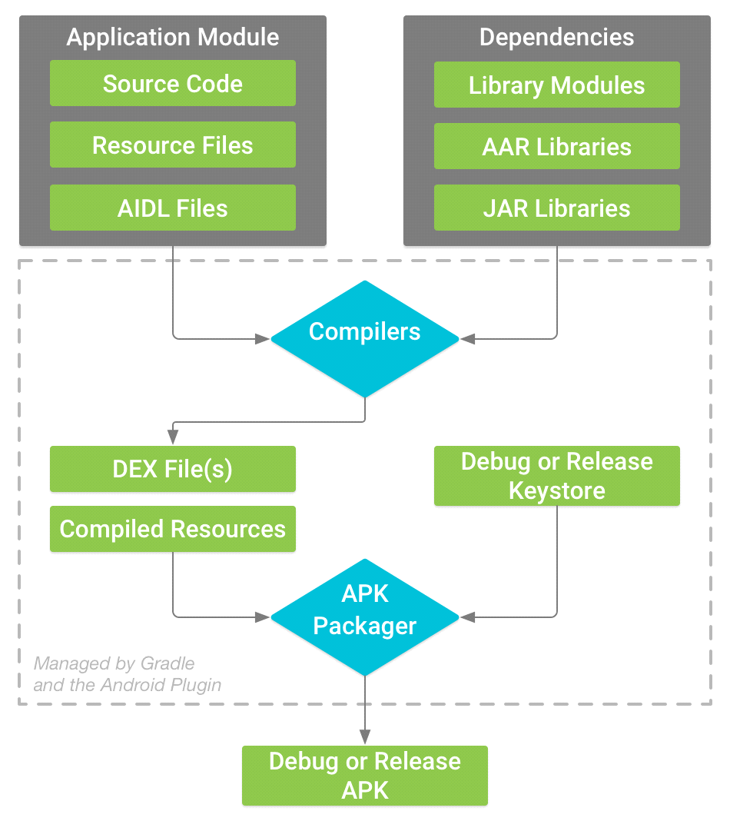

Just Take a look and it is easy to understand:-
1) .java file -- given to -- java compiler -- to generate -- .class file.
2) all .class files -- given to -- dx tool (Compiler) -- to generate single -- dex file
3) dex file -- given to -- dvm (APK Packager) -- to generate -- final machine code.
4) final machine code -- given to -- CPU -- to execute.
Explanation
5) The APK Packager signs your APK using either the debug or release keystore.

Optimisation Techniques:
6)Before generating your final APK, the packager uses the ZIPALIGN TOOL to optimize your app to use less memory when running on a device.
This tool should always be used to align your APK file before distributing it to end-users. The Android build tools can handle this for you. Android Studio automatically aligns your APK
You must use zipalign at one of two specific points in the app-building process :
If you use apksigner, zipalign must only be performed before the APK file has been signed.
If you use jarsigner, zipalign must only be performed after the APK file has been signed.

7) PROGUARD TOOL, It is quite easy to reverse engineer Android applications, so if you want to prevent this from happening, yes, you should use ProGuard for its main function: obfuscation. (Making Code Confusing to decompiling)
//Plz refer : https://developer.android.com/studio/build/shrink-code.html
ProGuard has also two other important functions: shrinking which eliminates unused code and is obviously highly useful and also optimization. Optimization operates with Java bytecode, though, and since Android runs on Dalvik bytecode which is converted from Java bytecode, some optimizations won't work so well. So you should be careful there.
Check :
Shrink Your Code (JAVA & lib) & Resources (Widgets)
To enable code shrinking with ProGuard, add minifyEnabled true to the appropriate build type in your build.gradle file.
Be aware that code shrinking slows down the build time, so you should avoid using it on your debug build if possible. However, it's important that you do enable code shrinking on your final APK used for testing, because it might introduce bugs if you do not sufficiently customize which code to keep.
For example, the following snippet from a build.gradle file enables code shrinking for the release build:
android {
buildTypes {
release {
minifyEnabled true
proguardFiles getDefaultProguardFile('proguard-android.txt'),
'proguard-rules.pro'
}
}
...
}
Note: Android Studio disables ProGuard when using Instant Run. If you need code shrinking for incremental builds, try the experimental Gradle shrinker.
In addition to the minifyEnabled property, the proguardFiles property defines the ProGuard rules:
The getDefaultProguardFile('proguard-android.txt') method gets the default ProGuard settings from the Android SDK tools/proguard/ folder.
Tip: For even more code shrinking, try the proguard-android-optimize.txt file that's in the same location. It includes the same ProGuard rules, but with other optimizations that perform analysis at the bytecode level—inside and across methods—to reduce your APK size further and help it run faster.
The proguard-rules.pro file is where you can add custom ProGuard rules. By default, this file is located at the root of the module (next to the build.gradle file).
To enable resource shrinking, set the shrinkResources property to true in your build.gradle file (alongside minifyEnabled for code shrinking). For example:
android {
...
buildTypes {
release {
shrinkResources true
minifyEnabled true
proguardFiles getDefaultProguardFile('proguard-android.txt'),
'proguard-rules.pro'
}
}
}

