# Android Assignment

Jake Wharton is an enthusiastic reader who loves going to libraries (pun intended) and likes to spend 3-4 hours of his time. He sometimes likes to work from there and also misses being around book racks. For the last 5 months, he has been restricted to stay at home and hasn't been able to visit any libraries.

To help break the monotony of his daily schedule which includes WFH, he decides to visit a library twice a week. There are several different libraries in and around his home locality and he wants to make the best use of it by going to each of those different places.

Let's build a simple app for Jake that allows him to book a seat at the library. The app simply scans a QR code at the library reception. Once the QR code is scanned, a session is created with a “Start time” and an ongoing timer that shows for how long he's been there for.

When Jake has finished his work at the library, he will need to scan the same QR code again at the reception desk to end his active session. He will be presented with details like "End time" and the amount he would need to pay.

The QR code scan gives a JSON string result that contains all the information including pricing details

## Functionalities

* QR code scanner (you're free to use any 3rd party lib for this)
* On app open, show a welcome screen with "Scan Now" button
* On doing a successful scan, start a session and show a timer along with details like location id, price, start time and other info. Add a "End Session" button on the same screen
* When the app is closed and a session is active, show an ongoing notification with a timer and the session details
* To end a session, the “End Session” button has to be clicked to re-scan the same QR code. Once it is successfully scanned, calculate and display the amount to be paid along with total time spent in minutes and “End time”.
* Send the same data to a provided API using POST request (API provided below)
* Show appropriate error messages using a Toast

## Things to keep in mind

* A session has to remain active until the "End Session" button is clicked and the same QR code is scanned
* QR code result could contain invalid data, so do ensure to validate and verify the QR result

## Must have

* Your app should have min SDK as 16 to target low spec devices
* A commonly used architecture in the Android world (MVVM, MVP, etc.)
* A practical and understandable git history. When reading your code, this will help us to understand your thought process by simply following the git history

## Nice to have

* Code in Kotlin
* Usage of RxJava
* OkHttp and Retrofit for networking
* Couple of unit tests

## Samples

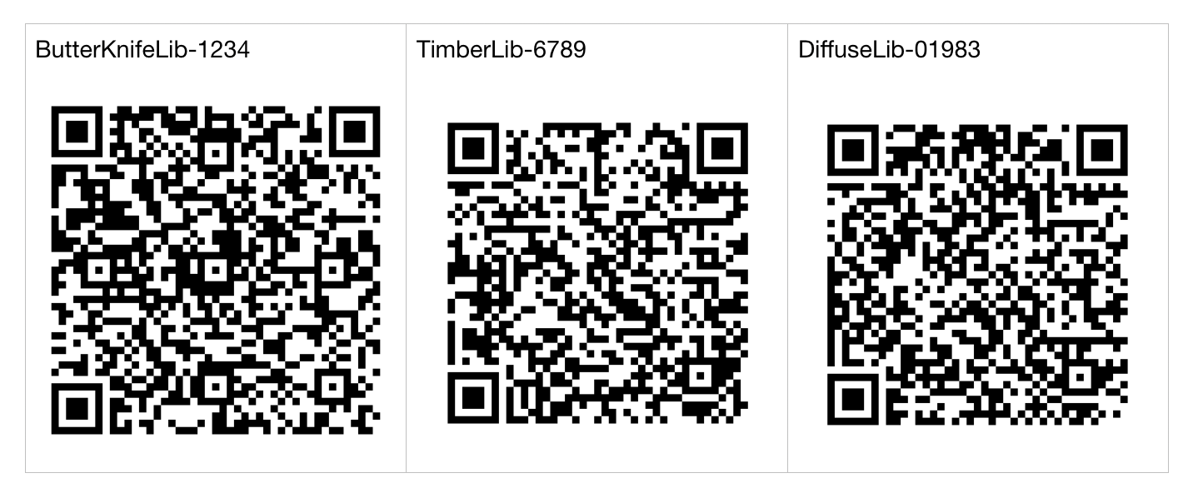

QR code scan result for id **ButterKnifeLib-1234**:

"{\"location_id\":\"ButterKnifeLib-1234\",\"location_details\":\"ButterKnife Lib, 80 Feet Rd, Koramangala 1A Block, Bangalore\",\"price_per_min\":5.50}"

Types:

* "location_id" : String,
* "location_detail" : String,
* "price_per_min" : Float

**POST API - Payload format**

**API:** https://en478jh796m7w.x.pipedream.net/submit-session

{

    "location_id" : "ButterKnifeLib-1234", //string

    "time_spent" : 60 //in minutes //int

    "end_time" : 1599467709991 //timestamp //long

}

## Submit your project

Once you’re done, make a zip archive out of your project **along with the .git folder** and email it to us. Please do not upload to any public repository

Good luck!