



**SITE CENTER**

**1st Semester E-project**

STAR BRAND

**Group Members:**

|  |  |  |  |  |
| --- | --- | --- | --- | --- |
| Name | Design | Development | | Documentation |
| Ahsan Ahmed |  |  | |  |
| Arbaz Awan |  |  | |  |
| Shahroze Khan |  |  | |  |
| Zafar Ullah |  | |  |  |

Contents

Certificate of Completion 3

Acknowledgment: 4

Preface 5

Problem Statement 6

Hardware/ Software Requirements 7

Some Extra Features Used Beside Requirement Specification 7

Site Details 8

USER GUIDE 9

MEMBER DETAILS 9

SCREEN SHOTS 10

SITE MAP 18

Submission Checklist 19

TASK SHEET 20

THE END 21

# 

# Certificate of Completion

**This is to certify that,**

Mr. Ahsan Ahmed

Mr. Arbaz Awan

Mr. Shahroze Khan

Mr. Zafar Ullah

Has successfully Designed and Developed web on

STAR BRAND

During e-project of CPISM (1st Semester)

**APTECH** Worldwide Computer Education,

SITE Centre Karachi.

Issued By: **APTECH SITE** Dated:**11/11/2017**

# Acknowledgment:

Many People Contributed To This Project, And I Would Like To Thank All Of Them. Very Special Thanks To Our Teacher MISS-FAREEHA SIDDIQUI of APTECH for His Expert Advice And Brilliant Suggestion And Always Encourage Us To Do The Best. Indeed Class Fellows Are Very Important And We Would Like To Thank All Of Them For Their Kind Appreciation, Encouragement And Moral Support.

This is our first semester E-Project. We have tried our level best and have derived for a better outlook to come. This project has been developed in Dreamweaver as well as some coding was also made on notepad and sublime. We have been assigned to make a website namely pleasant tours our first semester E-Project. We tried to observe the coding and its outlook on Dreamweaver. We find it easy to utilize the editor.

We earnestly hope that this project will provide all the necessary information required by the user to fulfill his/her inspiration. However suggestions and feedbacks for improvements will be thankfully welcomed & acknowledged.

Thank You

# Preface

This project is the task given to us at end of this course. We have chosen to prepared to this website to invite People attention towards Star Brand which are assets of any country where these monuments are situated.

The Objective of this program is to give a sample project to work on real life projects. These applications help you build a larger more robust application.

The objective is not to teach you JavaScript/Dreamweaver but to provide you with a real life scenario and help you create basic applications using the tools.

# Problem Statement

# Star Organic farm is commenced in the year 1988. Company is involved in trading

# and manufacturing a wide range of Organic Products and spices to the consumers all

# around the global market. Company has wide variety of collection of products lies of

# Nutritious cereals, Pulses, Spices and Condiments, Cooking Oils, Fruit Pulps,

# Agro Products, Oils, Wheat and Wheat Flour, Rice and Rice products and so

# on.

# Requirement Specification:

# The Web site is to be created based on the following requirements.

# 1) The Home Page should be created making use of Sections with a suitable logo

# of STAR BRAND.

# 2) Links such as Home, Products, Contact Us, Query, Show case gallery must be

# included.

# 3) The Products must be properly categorized and details of each product must

# be presented with suitable size image.

# 4) For each information section of the products the enquiry and order link must

# be provided.

# 5) Contact us page must be included.

# 6) Navigation must be made smoother.

# 7) Uniformity in the designing must be maintained in the application.

# 8) Images must be defined with alt attribute defined.

# Hardware/ Software Requirements

**Hardware**

* A minimum computer system that will help you access all the tools in the courses is a Pentium 166 or better
* 64 Megabytes of RAM or better

**Software**

* Notepad/HTML editor
* Dreamweaver
* IE 5.0/ Netscape 6.0

# Some Extra Features Used Beside Requirement Specification

* We Use Jquery to Add Fantastic Functionality and Animation to Project.
* We Use Photoshop to Slicing and Editing the Image Used in this Project.
* We use Javascript to Create Powerful Functionality.

# Site Details

Products:

* Wheat And Wheat Products

You also see the wheat and wheat products Price and Specification.

* Rice and Rice Products

You also see the Rice and Rice Products with Price and Specification.

* Pulses

You also see the Pulses with Price and Specification.

* Spices And Condiments

You also see the Spices and with Price and Specification.

* Others

# It Includes Nutrition Careals and Agro products USER GUIDE

System Requirement

|  |  |  |
| --- | --- | --- |
| No | Items | Description |
| 1 | Operating System | Windows 2006, XP, 7,8,10. |
| 2 | Operating Browser | Preffer use in Google Chrome with screen resolution of 1280 x 800. |
| 3 | Software | Adobe Dreamweaver and Notepad++. |

# MEMBER DETAILS

|  |  |  |
| --- | --- | --- |
| Student No. | Student Name | Role |
| Student 1022712 | Ahsan Ahmed | Member |
| Student 1006788 | Arbaz Awan | Member |
| Student 1024882 | Shahroze Khan | Member |
| Student 1030363 | Zafar Ullah | Member |

# SCREEN SHOTS

**HOME PAGE**

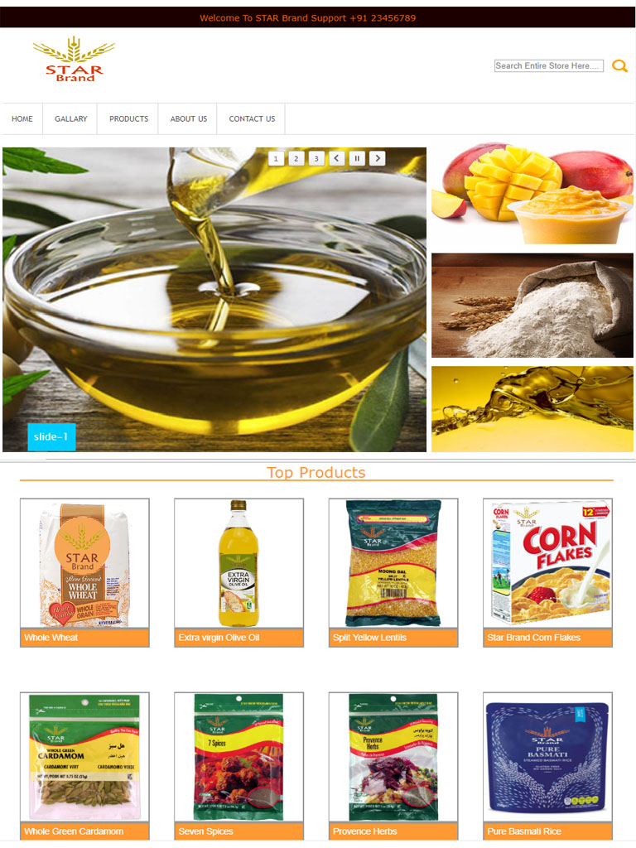

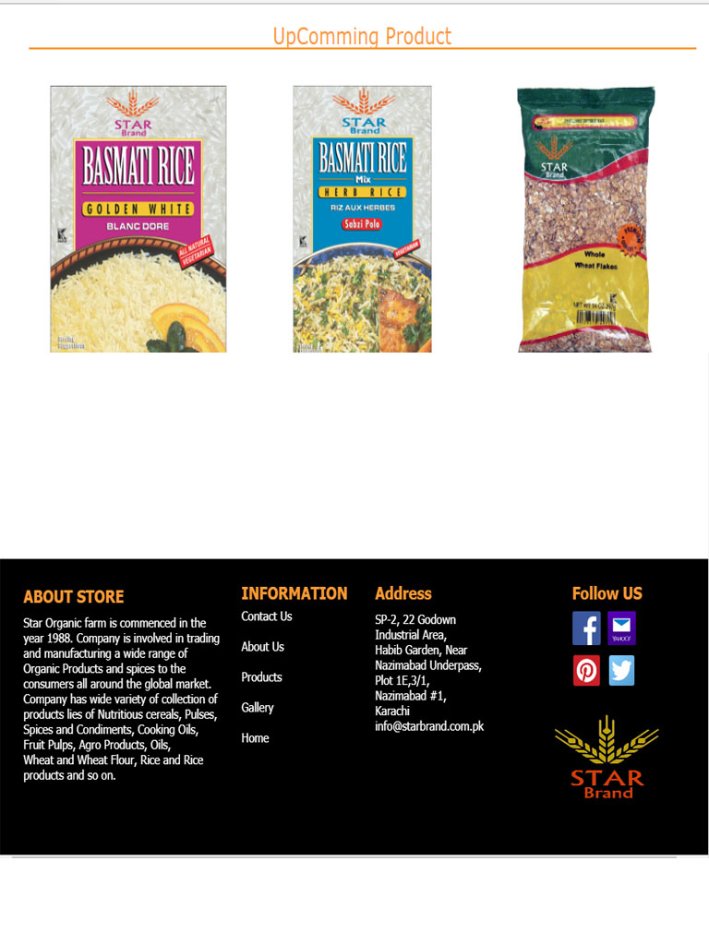

**GALLERY PAGE**

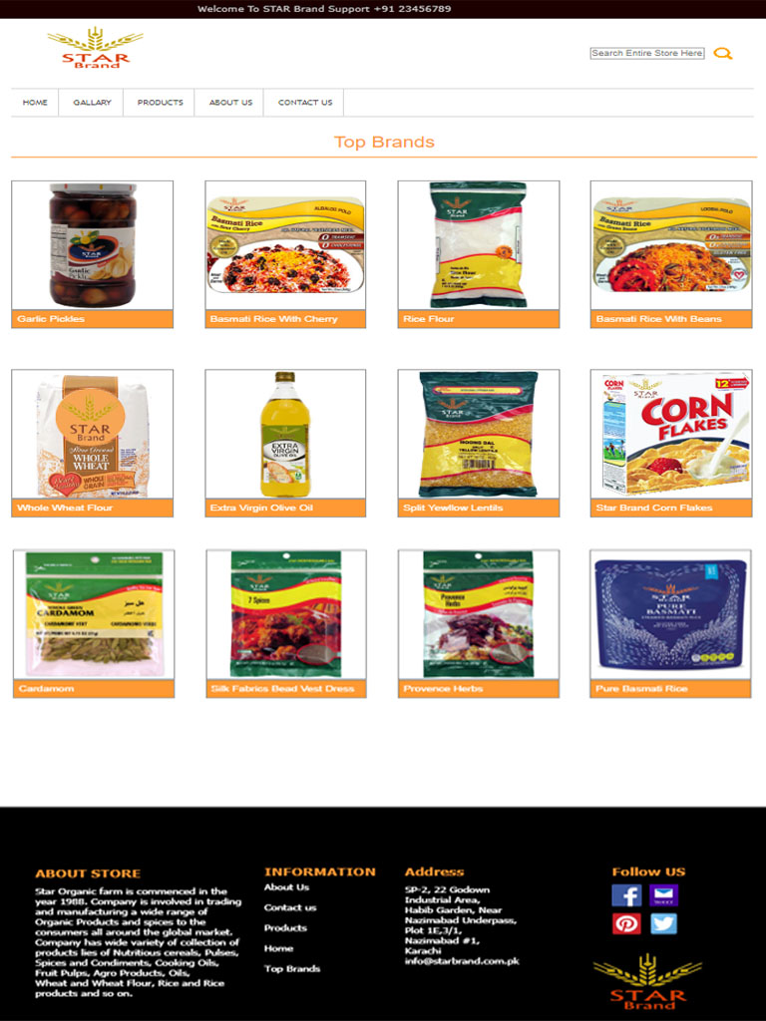

**PRODUCTS PAGE**

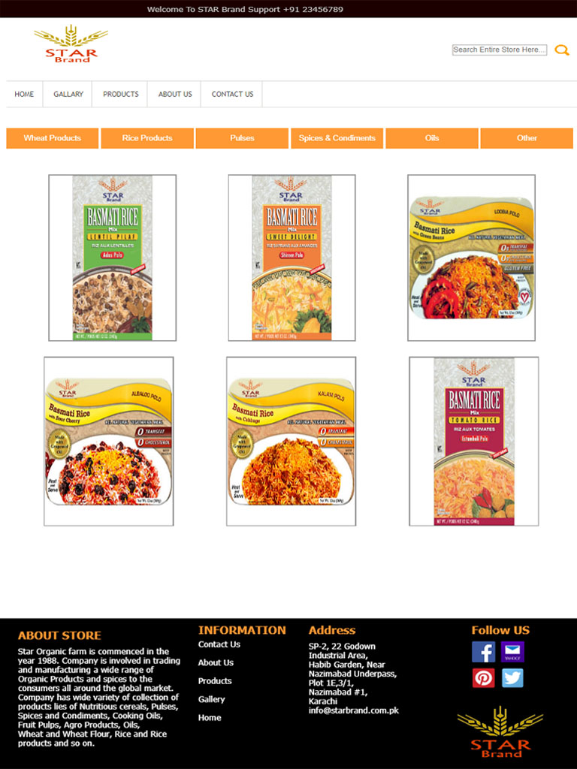

**ABOUT US**

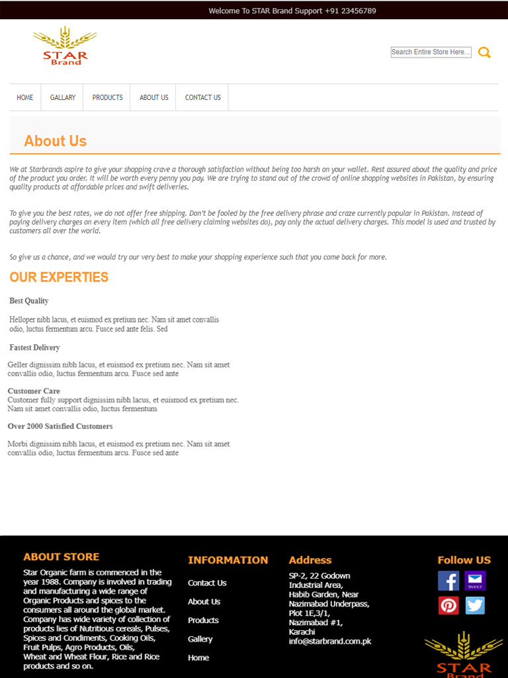

**CONTACT US**

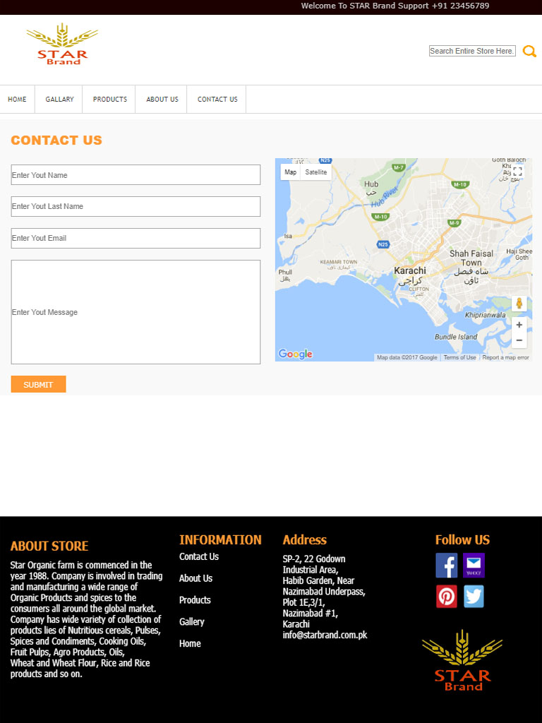

# SITE MAP

# Submission Checklist

|  |  |  |  |
| --- | --- | --- | --- |
| S.NO | LIST OF ITEMS | Remarks | COMMENTS |
| 1. | Do All Pages Linked together | **Yes** | Done |
| 2. | All Hyperlinks working | **Yes** | Done |
| 3. | Site Browser Compatible | **No** | Tested On Chrome, Firefox ,Safari, IE & Opera |
| 4. | Image Slicing | **Yes** | Using Adobe Photoshop, |
| 5. | Feedback Form Included | **Yes** | Included |
| 6. | Project Zip File | Yes | Created using WinRAR |

# TASK SHEET

|  |  |  |  |  |  |
| --- | --- | --- | --- | --- | --- |
| Sr. | Task | Actual Start Date | Actual Days | Team Mate Name | Status |
| 1. | Information Collecting | 12-Nov-2017 | 6 | Ahsan  Arbaz  Shahroze  Zafar | Completed |
| 2. | Making Logo | 18-Nov-2017 | 2 | Ahsan  Arbaz  Shahroze  Zafar | Completed |
| 3. | Making Layout/Pages | 20-Nov-2017 | 8 | Ahsan  Arbaz  Shahroze  Zafar | Completed |
| 4. | Conneting Links | 28-Nov-2017 | 5 | Ahsan  Arbaz  Shahroze  Zafar | Completed |
| 5. | Image Collecting | 03-Dec-2017 | 4 | Ahsan  Arbaz  Shahroze  Zafar | Completed |
| 6. | Website Testing | 7-Dec-2017 | 2 | Ahsan  Arbaz  Shahroze  Zafar | Completed |
| 7. | Documentation | 9-Dec-2017 | 2 | Ahsan  Arbaz  Shahroze  Zafar | Completed |

We Hope That Everyone Satisfied From Us As Our Website And Documentation Concerned Thank You Very Much For Looking It

# THE END