Skill-1
SKILL - 1 :Git Version Control
Task-1,2:
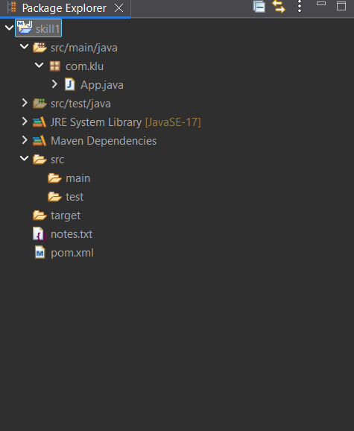

Created a new repository on GitHub, connectelocal repo using the remote URL and push the committed changes.
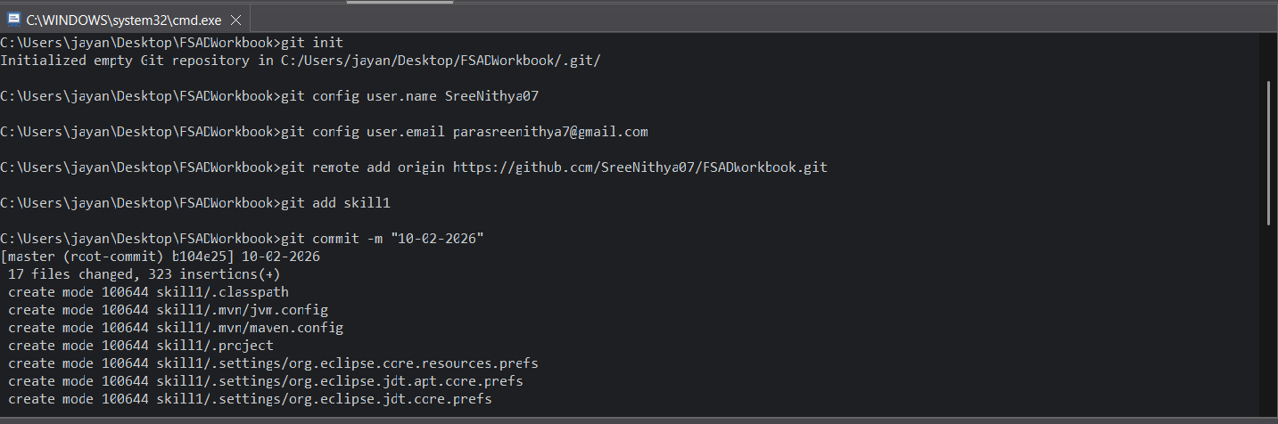
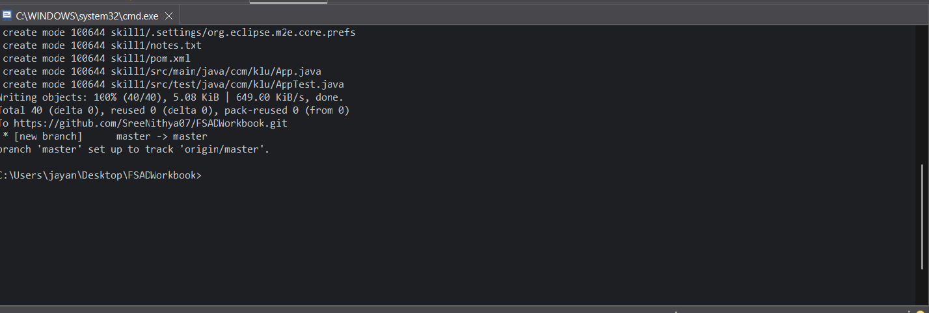
Git repo link:
https://github.com/SreeNithya07/FSADWorkbook/tree/master/skill1
Viva:
1. Why is Git used in development?
Git is used to track changes in source code, manage versions, and enable multiple developers to collaborate efficiently.
2. What information is stored in Git configuration?
Git configuration stores user details (username, email), default editor, and repository behavior settings.
3. What is Maven and why is it used?
Maven is a build automation and dependency management tool used to compile, test, and package Java projects easily.
4. What is the role of the pom.xml file?
pom.xml defines project details, dependencies, plugins, and build configuration for a Maven project.
5. Explain Maven Build Life Cycle.
Maven build life cycle is a sequence of phases (clean, compile, test, package, install, deploy) that control how a project is built and managed.

