29/5/2017 CNG 232 LAB7 (Final)   
Objective:

In this lab we have to build a FSM to control a simple Calculator ALU, we built a datapath to connect our FSM to the ALU and display the output using a 7 segment decoder

7.4.1 MOP Table

|  |  |  |  |  |  |  |  |  |
| --- | --- | --- | --- | --- | --- | --- | --- | --- |
| Instruction  Mnemonic | S0 | S1 | S2 | S3 | | S4 | | |
| NOP (0000) | out_state <= "0000" ;  Input_select <= "000" ;  Load_A <= '0' ;  Load_B <= '0' ;  Cin <= '0' ;  ALUop <= "000" ;  Reset <= '0' ; | out_state <="0001" ;  Input_select <= "100" ;  Load_A <= '0' ;  Load_B <= '0' ;  Cin <= '0' ;  ALUop <= "000" ;  Reset <= '0' ; | out_state <= "0010" ;  Input_select <= "000" ;  Load_A <= '0' ;  Load_B <= '0' ;  Cin <= '0' ;  ALUop <= "000" ;  Reset <= '0' ; | out_state <= "0011" ;  Input_select <= "000" ;  Load_A <= '0' ;  Load_B <= '0' ;  Cin <= '0' ;  ALUop <= "000" ;  Reset <= '0' ; | | out_state <= "0100" ;  Input_select <= "000" ;  Load_A <= '0' ;  Load_B <= '0' ;  Cin <= '0' ;  ALUop <= "000" ;  Reset <= '0' ; | | |
| CLR (0001) | out_state <= "0000" ;  Input_select <= "000" ;  Load_A <= '0' ;  Load_B <= '0' ;  Cin <= '0' ;  ALUop <= "000" ;  Reset <= '0' ; | out_state <= "0001" ;  Input_select <= "100" ;  Load_A <= '0' ;  Load_B <= '0' ;  Cin <= '0' ;  ALUop <= "000" ;  Reset <= '1' ; | out_state <= "0010" ;  Input_select <= "000" ;  Load_A <= '0' ;  Load_B <= '0' ;  Cin <= '0' ;  ALUop <= "000" ;  Reset <= '0' ; | out_state <= "0011" ;  Input_select <= "000" ;  Load_A <= '0' ;  Load_B <= '0' ;  Cin <= '0' ;  ALUop <= "000" ;  Reset <= '0' ; | | out_state <= "0100" ;  Input_select <= "000" ;  Load_A <= '0' ;  Load_B <= '0' ;  Cin <= '0' ;  ALUop <= "000" ;  Reset <= '0' ; | | |
| LOADA (0010) | out_state <= "0000" ;  Input_select <= "000" ;  Load_A <= '0' ;  Load_B <= '0' ;  Cin <= '0' ;  ALUop <= "000" ;  Reset <= '0' ; | out_state <= "0001" ;  Input_select <= "110" ;  Load_A <= '1' ; Load_B <= '0' ;  Cin <= '0' ;  ALUop <= "000" ;  Reset <= '0' ; | out_state <= "0010" ;  Input_select <= "000" ;  Load_A <= '0' ;  Load_B <= '0' ;  Cin <= '0' ;  ALUop <= "000" ;  Reset <= '0' ; | out_state <= "0011" ;  Input_select <= "000" ;  Load_A <= '0' ;  Load_B <= '0' ;  Cin <= '0' ;  ALUop <= "000" ;  Reset <= '0' ; | | out_state <= "0100" ;  Input_select <= "000" ;  Load_A <= '0' ;  Load_B <= '0' ;  Cin <= '0' ;  ALUop <= "000" ;  Reset <= '0' ; | | |
| LOADB (0011) | out_state <= "0000" ;  Input_select <= "000" ;  Load_A <= '0' ;  Load_B <= '0' ;  Cin <= '0' ;  ALUop <= "000" ;  Reset <= '0' ; | out_state <= "0001" ;  Input_select <= "110" ;  Load_A <= '0' ;  Load_B <= '1' ;  Cin <= '0' ;  ALUop <= "000" ;  Reset <= '0' ; | out_state <= "0010" ;  Input_select <= "000" ;  Load_A <= '0' ;  Load_B <= '0' ;  Cin <= '0' ;  ALUop <= "000" ;  Reset <= '0' ; | out_state <= "0011" ;  Input_select <= "000" ;  Load_A <= '0' ;  Load_B <= '0' ;  Cin <= '0' ;  ALUop <= "000" ;  Reset <= '0' ; | | out_state <= "0100" ;  Input_select <= "000" ;  Load_A <= '0' ;  Load_B <= '0' ;  Cin <= '0' ;  ALUop <= "000" ;  Reset <= '0' ; | | |
| BCOPYA(0100) | out_state <= "0000" ;  Input_select <= "000" ;  Load_A <= '0' ;  Load_B <= '0' ;  Cin <= '0' ;  ALUop <= "000" ;  Reset <= '0' ; | out_state<="0001";  Input_select<="100”;  Load_A <= '0' ;  Load_B <= '0' ;  Cin <= '0' ;  ALUop<="000" ;  Reset <= '0' ; | out_state <= "0010" ;  Input_select <= "000" ;  Load_A <= '0' ;  load_B <= '0' ;  Cin <= '0' ;  ALUop <= “000" ;  Reset <= '0' ; | out_state <= "0011" ;  Input_select <= "000" ;  Load_A <= '0' ;  Load_B <= '0' ; Cin <= '0' ;  ALUop <="000" ;  Reset <= '0' ; | | out_state <= "0100" ;  Input_select <= "000" ;  Load_A <= '0' ;  Load_B <= '0' ;  Cin <= '0' ;  ALUop <= "000" ;  Reset <= '0' ; | | |
| ADD2 (0101) | out_state <= "0000";  Input_Select <= "000";  Load_A <= '0';  Load_B <= '0';  Cin <= '0';  ALUop <= "000";  Reset <= '0'; | out_state <= "0001" ;  Input_select <= "000" ;  Load_A <= '0' ;  Load_B <= '0' ;  Cin <= '0' ;  ALUop <= "000" ;  Reset <= '0' ; | out_state <= "0010" ;  Input_select <= "000" ;  Load_A <= '0' ;  Load_B <= '0' ;  Cin <= '0' ;  ALUop <= "000" ;  Reset <= '0' ; | out_state <= "0011" ; Input_select <= "100" ;  Load_A <= '0' ;  Load_B <= '1' ;  Cin <= '0' ;  ALUop <= "001" ;  Reset <= '0' ; | | out_state <= "0100";  Input_Select <= "000";  Load_A <= '0';  Load_B <= '0';  Cin <= '0';  ALUop <= "000";  Reset <= '0'; | | |
| SUB (101) | out_state <= "0000";  Input_Select <= "000";  Load_A <= '0';  Load_B <= '0';  Cin <= '0';  ALUop <= "000";  Reset <= '0'; | out_state <= "0001";  Input_Select <= "000";  Load_A <= '0';  Load_B <= '0';  Cin <= '0';  ALUop <= "000";  Reset <= '0'; | out_state <= "0010";  Input_Select <= "000";  Load_A <= '0';  Load_B <= '0';  Cin <= '0';  ALUop <= "000";  Reset <= '0'; | out_state <= "0011";  Input_Select <= "101";  Load_A <= '0';  Load_B <= '1';  Cin <= '1';  ALUop <= "001";  Reset <= '0'; | | out_state <= "0100" ;  Input_select <= "000" ;  Load_A <= '0' ;  Load_B <= '0' ;  Cin <= '0' ;  ALUop <= "000" ;  Reset <= '0' ; | | |
| ADD21 (0110) | out_state <= "0000" ;  Input_select <= "000" ;  Load_A <= '0' ;  Load_B <= '0' ;  Cin <= '0' ;  ALUop <= "000" ;  Reset <= '0' ; | out_state <= "0001" ;  Input_select <= "000" ;  Load_A <= '0' ;  Load_B <= '0' ;  Cin <= '0' ;  ALUop <= "000" ;  Reset <= '0' ; | out_state <= "0010" ;  Input_select <= "000" ;  Load_A <= '0' ;  Load_B <= '0' ;  Cin <= '0' ;  ALUop <= "000" ;  Reset <= '0' ; | out_state <= "0011" ;  Input_select <= "100" ;  Load_A <= '0' ;  Load_B <= '1' ;  Cin <= '1' ;  ALUop <= "001" ;  Reset <= '0' ; | | out_state <= "0100" ;  Input_select <= "000" ;  Load_A <= '0' ;  Load_B <= '0' ;  Cin <= '0' ;  ALUop <= "000" ;  Reset <= '0' ; | | |
| ADD3 (0111) | out_state <= "0000" ; Input_select <= "000" ;  Load_A <= '0' ;  Load_B <= '0' ;  Cin <= '0' ;  ALUop <= "000" ;  Reset <= '0' ; | out_state <= "0001" ;  Input_select <= "100" ;  Load_A <= '0' ;  Load_B <= '1' ;  Cin <= '0' ;  ALUop <= "001" ;  Reset <= '0' ; | out_state <= "0010" ;  Input_select <= "100" ;  Load_A <= '1' ;  Load_B <= '0' ;  Cin <= '0' ;  ALUop <= "000" ;  Reset <= '0' ; | | out_state <= "0011" ; Input_select <= "110" ;  Load_A <= '0' ;  Load_B <= '1' ;  Cin <= '0' ;  ALUop <= "001" ;  Reset <= '0' ; | | out_state <= "0100" ;  Input_select <= "000" ;  Load_A <= '0' ;  Load_B <= '0' ;  Cin <= '0' ;  ALUop <= "000" ;  Reset <= '0' ; |
| SUB (1000) | out_state <= "0000" ;  Input_select <= "000" ;  Load_A <= '0' ;  Load_B <= '0' ;  Cin <= '0' ;  ALUop <= "000" ;  Reset <= '0' ; | out_state <= "0001" ;  Input_select <= "101" ;  Load_A <= '0' ;  Load_B <= '1' ;  Cin <= '1' ;  ALUop <= "001";  Reset <= '0' ; | out_state <= "0010" ;  Input_select <= "000" ;  Load_A <= '0' ;  Load_B <= '0' ;  Cin <= '0' ;  ALUop <= "000";  Reset <= '0' ; | | out_state <= "0011" ;  Input_select <= "000" ;  Load_A <= '0' ;  Load_B <= '0' ;  Cin <= '0' ;  ALUop <= "000" ;  Reset <= '0' ; | | out_state <= "0100" ;  Input_select <= "000" ;  Load_A <= '0' ;  Load_B <= '0' ;  Cin <= '0' ;  ALUop <= "000" ;  Reset <= '0' ; |
| BINVB (1001) | out_state <= "0000" ;  Input_select <= "000" ;  Load_A <= '0' ;  Load_B <= '0' ;  Cin <= '0' ;  ALUop <= "000" ;  Reset <= '0' ; | out_state <= "0001" ;  Input_select <= "101" ;  Load_A <= '0' ;  Load_B <= '1' ;  Cin <= '0' ;  ALUop <= "000";  Reset <= '0' ; | out_state <= "0010" ;  Input_select <= "000" ;  Load_A <= '0' ;  Load_B <= '0' ;  Cin <= '0' ;  ALUop <= "000";  Reset <= '0' ; | | out_state <= "0011" ;  Input_select <= "000" ;  Load_A <= '0' ;  Load_B <= '0' ;  Cin <= '0' ;  ALUop <= "000" ;  Reset <= '0' ; | | out_state <= "0100" ;  Input_select <= "000" ;  Load_A <= '0' ;  Load_B <= '0' ;  Cin <= '0' ;  ALUop <= "000" ;  Reset <= '0' ; |
| BAND (1010) | out_state <= "0000" ;  Input_select <= "000" ;  Load_A <= '0' ;  Load_B <= '0' ;  Cin <= '0' ;  ALUop <= "000" ;  Reset <= '0' ; | out_state <= "0001" ;  Input_select <= "100" ;  Load_A <= '0' ;  Load_B <= '1' ;  Cin <= '0' ;  ALUop <= "101" ;  Reset <= '0' ; | out_state <= "0010" ;  Input_select <= "000" ;  Load_A <= '0' ;  Load_B <= '0' ;  Cin <= '0' ;  ALUop <= "000" ;  Reset <= '0' ; | | out_state <= "0011" ;  Input_select <= "000" ;  Load_A <= '0' ;  Load_B <= '0' ;  Cin <= '0' ;  ALUop <= "000" ;  Reset <= '0' ; | | out_state <= "0100" ;  Input_select <= "000" ;  Load_A <= '0' ;  Load_B <= '0' ;  Cin <= '0' ;  ALUop <= "000" ;  Reset <= '0' ; |
| BOR (1011) | out_state <= "0000" ;  Input_select <= "000" ;  Load_A <= '0' ;  Load_B <= '0' ;  Cin <= '0' ;  ALUop <= "000" ;  Reset <= '0' ; | out_state <= "0001" ;  Input_select <= "100" ;  Load_A <= '0' ;  Load_B <= '1' ;  Cin <= '0' ;  ALUop <= "100" ;  Reset <= '0' ; | out_state <= "0010" ;  Input_select <= "000" ;  Load_A <= '0' ;  Load_B <= '0' ;  Cin <= '0' ;  ALUop <= "000" ;  Reset <= '0' ; | | out_state <= "0011" ;  Input_select <= "000" ;  Load_A <= '0' ;  Load_B <= '0' ;  Cin <= '0' ;  ALUop <= "000" ;  Reset <= '0' ; | | out_state <= "0100" ;  Input_select <= "000" ;  Load_A <= '0' ;  Load_B <= '0' ;  Cin <= '0' ;  ALUop <= "000" ;  Reset <= '0' ; |
| BXOR (1100) | out_state <= "0000" ;  Input_select <= "000" ;  Load_A <= '0' ;  Load_B <= '0' ;  Cin <= '0' ;  ALUop <= "000" ;  Reset <= '0' ; | out_state <= "0001" ;  Input_select <= "100" ;  Load_A <= '0' ;  Load_B <= '1' ;  Cin <= '0' ;  ALUop <= "110";  Reset <= '0' ; | out_state <= "0010" ;  Input_select <= "000" ;  Load_A <= '0' ;  Load_B <= '0' ;  Cin <= '0' ;  ALUop <= "000";  Reset <= '0' ; | | out_state <= "0011" ;  Input_select <= "000" ;  Load_A <= '0' ;  Load_B <= '0' ;  Cin <= '0' ;  ALUop <= "000" ;  Reset <= '0' ; | | out_state <= "0100" ;  Input_select <= "000" ;  Load_A <= '0' ;  Load_B <= '0' ;  Cin <= '0' ;  ALUop <= "000" ;  Reset <= '0' ; |
| BLSRA (1101) | out_state <= "0000" ;  Input_select <= "000" ;  Load_A <= '0' ;  Load_B <= '0' ;  Cin <= '0' ;  ALUop <= "000" ;  Reset <= '0' ; | out_state <= "0001" ;  Input_select <= "010" ;  Load_A <= '0' ;  Load_B <= '1' ;  Cin <= '0' ;  ALUop <= "000";  Reset <= '0' ; | out_state <= "0010" ;  Input_select <= "000" ;  Load_A <= '0' ;  Load_B <= '0' ;  Cin <= '0' ;  ALUop <= "000";  Reset <= '0' ; | | out_state <= "0011" ;  Input_select <= "000" ;  Load_A <= '0' ;  Load_B <= '0' ;  Cin <= '0' ;  ALUop <= "000" ;  Reset <= '0' ; | | out_state <= "0100" ;  Input_select <= "000" ;  Load_A <= '0' ;  Load_B <= '0' ;  Cin <= '0' ;  ALUop <= "000" ;  Reset <= '0' ; |
| BLSLA (1110) | out_state <= "0000" ;  Input_select <= "000" ;  Load_A <= '0' ;  Load_B <= '0' ;  Cin <= '0' ;  ALUop <= "000" ;  Reset <= '0' ; | out_state <= "0001" ;  Input_select <= "001" ;  Load_A <= '0' ;  Load_B <= '1' ;  Cin <= '0' ;  ALUop <= "000";  Reset <= '0' ; | out_state <= "0010" ; Input_select <= "000" ;  Load_A <= '0' ;  Load_B <= '0' ;  Cin <= '0' ;  ALUop <= "000";  Reset <= '0' ; | | out_state <= "0011" ;  Input_select <= "000" ;  Load_A <= '0' ;  Load_B <= '0' ;  Cin <= '0' ;  ALUop <= "000" ;  Reset <= '0' ; | | out_state <= "0100" ;  Input_select <= "000" ;  Load_A <= '0' ;  Load_B <= '0' ;  Cin <= '0' ;  ALUop <= "000" ;  Reset <= '0' ; |
| BASRA (1111) | out_state <= "0000" ;  Input_select <= "000" ;  Load_A <= '0' ;  Load_B <= '0' ;  Cin <= '0' ;  ALUop <= "000" ;  Reset <= '0' ; | out_state <= "0001" ;  Input_select <= "011" ;  Load_A <= '0' ;  Load_B <= '1' ;  Cin <= '0' ;  ALUop <= "000";  Reset <= '0' ; | out_state <= "0010" ;  Input_select <= "000" ;  Load_A <= '0' ;  Load_B <= '0' ;  Cin <= '0' ;  ALUop <= "000";  Reset <= '0' ; | | out_state <= "0011" ;  Input_select <= "000" ;  Load_A <= '0' ;  Load_B <= '0' ;  Cin <= '0' ;  ALUop <= "000" ;  Reset <= '0' ; | | out_state <= "0100" ;  Input_select <= "000" ;  Load_A <= '0' ;  Load_B <= '0' ;  Cin <= '0' ;  ALUop <= "000" ;  Reset <= '0' ; |

7.4.2 FSM CODE

LIBRARY ieee;

use IEEE.STD_LOGIC_1164.ALL;

ENTITY FSM IS

PORT (

Load_A: OUT STD_LOGIC;

Load_B: OUT STD_LOGIC;

Cin: OUT STD_LOGIC;

ALUop: OUT STD_LOGIC_VECTOR (2 DOWNTO 0);

Input_Select: OUT STD_LOGIC_VECTOR (2 DOWNTO 0);

Reset: OUT STD_LOGIC;

out_state: OUT STD_LOGIC_VECTOR (3 DOWNTO 0);

Clock: IN STD_LOGIC;

RUN : IN STD_LOGIC;

MOP: IN STD_LOGIC_VECTOR (2 DOWNTO 0)

);

END FSM;

ARCHITECTURE Behavior OF FSM IS “In here we specify how many states does our FSM have”

SIGNAL y_present, y_next : STD_LOGIC_VECTOR(4 DOWNTO 0);

CONSTANT S0 : STD_LOGIC_VECTOR(4 DOWNTO 0) := "00001";

CONSTANT S1 : STD_LOGIC_VECTOR(4 DOWNTO 0) := "00010";

CONSTANT S2 : STD_LOGIC_VECTOR(4 DOWNTO 0) := "00100";

CONSTANT S3 : STD_LOGIC_VECTOR(4 DOWNTO 0) := "01000";

CONSTANT S4 : STD_LOGIC_VECTOR(4 DOWNTO 0) := "10000";

BEGIN

PROCESS (RUN, y_present)”In here this will allow us to cycle through our FSM states”

BEGIN

CASE y_present IS

WHEN S0 =>

IF RUN='0' THEN y_next <= S0;

ELSE y_next <= S1;

END IF;

WHEN S1 =>

IF RUN='0' THEN y_next <= S0;

ELSE y_next <= S2;

END IF;

WHEN S2 =>

IF RUN='0' THEN y_next <= S0;

ELSE y_next <= S3;

END IF;

WHEN S3 =>

IF RUN='0' THEN y_next <= S0;

ELSE y_next <= S4;

END IF;

WHEN S4 =>

IF RUN='0' THEN y_next <= S0;

ELSE y_next <= S4;

END IF;

WHEN OTHERS =>

y_next <= S0;

END CASE;

END PROCESS;

PROCESS (Clock, RUN) “In here we define what happens at each state i.e what happens in every MOP”

BEGIN

IF RUN='0' THEN

y_present <= S0;

ELSIF (Clock'EVENT AND Clock='1') THEN

y_present <= y_next;

END IF;

END PROCESS;

PROCESS (y_present, MOP)

BEGIN

Input_select <= "000" ;

Load_A <= '0' ;

Load_B <= '0' ;

Cin <= '0' ;

ALUop <= "000" ;

Reset <= '0' ;

IF MOP = "000" then

IF y_present = S0 then

out_state <= "0000" ;

ELSIF y_present = S1 then

out_state <= "0001" ;

ELSIF y_present = S2 then

out_state <= "0010" ;

ELSIF y_present = S3 then

out_state <= "0011" ;

ELSIF y_present = S4 then

out_state <= "0100" ;

END IF;

ELSIF MOP = "001" then

IF y_present = S0 then

out_state <= "0000" ;

ELSIF y_present = S1 then

out_state <= "0001" ;

ELSIF y_present = S2 then

out_state <= "0010" ;

ELSIF y_present = S3 then

out_state <= "0011" ;

Reset <= '1' ;

ELSIF y_present = S4 then

out_state <= "0100" ;

END IF;

ELSIF MOP = "010" then

IF y_present = S0 then

out_state <= "0000" ;

ELSIF y_present = S1 then

out_state <= "0001" ;

ELSIF y_present = S2 then

out_state <= "0010" ;

ELSIF y_present = S3 then

out_state <= "0011" ;

Input_select <= "110" ;

Load_A <= '1' ;

ELSIF y_present = S4 then

out_state <= "0100" ;

END IF;

ELSIF MOP = "011" then

IF y_present = S0 then

out_state <= "0000" ;

ELSIF y_present = S1 then

out_state <= "0001" ;

ELSIF y_present = S2 then

out_state <= "0010" ;

ELSIF y_present = S3 then

out_state <= "0011" ;

Input_select <= "110" ;

Load_B <= '1' ;

ELSIF y_present = S4 then

out_state <= "0100" ;

END IF;

ELSIF MOP = "100" then

IF y_present = S0 then

out_state <= "0000" ;

ELSIF y_present = S1 then

out_state <= "0001" ;

ELSIF y_present = S2 then

out_state <= "0010" ;

ELSIF y_present = S3 then

out_state <= "0011" ;

Input_select <= "100" ;

Load_B <= '1';

Cin <= '1';

ALUop <= "001";

ELSIF y_present = S4 then

out_state <= "0100" ;

END IF;

ELSIF MOP = "101" then

IF y_present = S0 then

out_state <= "0000" ;

ELSIF y_present = S1 then

out_state <= "0001" ;

ELSIF y_present = S2 then

out_state <= "0010" ;

ELSIF y_present = S3 then

out_state <= "0011" ;

Input_select <= "101" ;

Load_B <= '1';

Cin <= '1';

ALUop <= "001";

ELSIF y_present = S4 then

out_state <= "0100" ;

END IF;

ELSIF MOP = "110" then

IF y_present = S0 then

out_state <= "0000" ;

ELSIF y_present = S1 then

out_state <= "0001" ;

ELSIF y_present = S2 then

out_state <= "0010" ;

ELSIF y_present = S3 then

out_state <= "0011" ;

Input_select <= "101" ;

Load_B <= '1';

ELSIF y_present = S4 then

out_state <= "0100" ;

END IF;

ELSIF MOP = "111" then

IF y_present = S0 then

out_state <= "0000" ;

ELSIF y_present = S1 then

out_state <= "0001" ;

ELSIF y_present = S2 then

out_state <= "0010" ;

ELSIF y_present = S3 then

out_state <= "0011" ;

Input_select <= "100" ;

Load_B <= '1';

ALUop <= "101";

ELSIF y_present = S4 then

out_state <= "0100" ;

END IF;

END IF;

END PROCESS;

END Behavior;

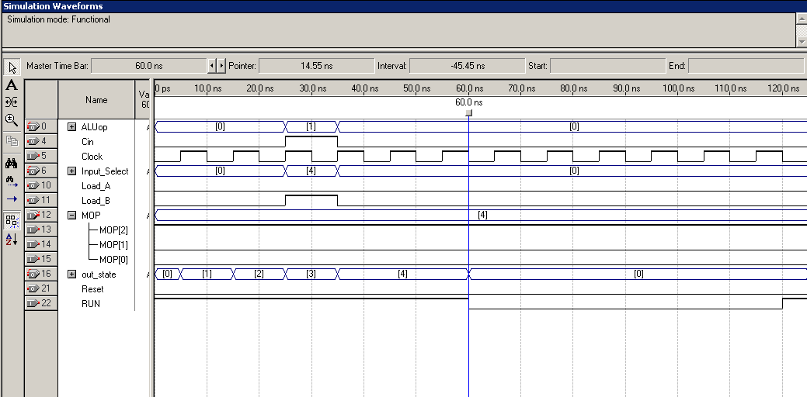

ADD Simulation  
  


BAND Simulation

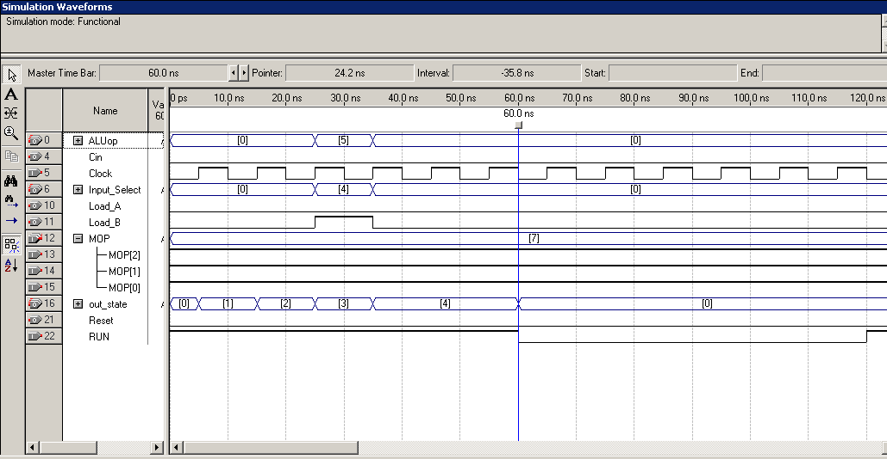  
Same as above with BAND, changes are MOP now is (7) “111” to make BAND operation and ALU_OP is (5) “101”.

7.4.3 Datapath Design

ALU VHDL

library IEEE;

use IEEE.STD_LOGIC_1164.ALL;

use IEEE.STD_LOGIC_ARITH.ALL;

use IEEE.STD_LOGIC_SIGNED.ALL;

entity alu is

Port( Operation: in STD_LOGIC_VECTOR (2 downto 0);

X: in STD_LOGIC_VECTOR (3 downto 0);

Y: in STD_LOGIC_VECTOR (3 downto 0);

Cin: in STD_LOGIC;

Cout: out STD_LOGIC;

Output: out STD_LOGIC_VECTOR (3 downto 0) );

end alu;

architecture Behavioral of alu is

signal Outputt : STD_LOGIC_VECTOR (4 Downto 0) ;

begin

process(Operation, X, Y, Cin)

begin

case Operation is

WHEN "000" => Outputt <= ('0' & X);

Output <= Outputt(3 Downto 0);

Cout <= Outputt(4);

WHEN "001" => Outputt <= ('0' & X) + Y + (Cin);

Output <= Outputt(3 Downto 0);

Cout <= Outputt(4);

WHEN "010" => Outputt <= ('0' & X)- Y - (NOT Cin);

Output <= Outputt(3 Downto 0);

Cout <= Outputt(4);

WHEN "011" => Outputt <= Y- ('0' & X) - (NOT Cin);

Output <= Outputt(3 Downto 0);

Cout <= Outputt(4);

WHEN "100" => Outputt <= ('0' & X) OR Y;

Output <= Outputt(3 Downto 0);

Cout <= Outputt(4);

WHEN "101" => Outputt <= ('0' & X) AND Y;

Output <= Outputt(3 Downto 0);

Cout <= Outputt(4);

WHEN "110" => Outputt <= ('0' & X) XOR Y;

Output <= Outputt(3 Downto 0);

Cout <= Outputt(4);

WHEN OTHERS => Outputt <= ('0' & X) XNOR Y;

Output <= Outputt(3 Downto 0);

Cout <= Outputt(4);

end case;

end process;

end Behavioral;

ALU Simulation  
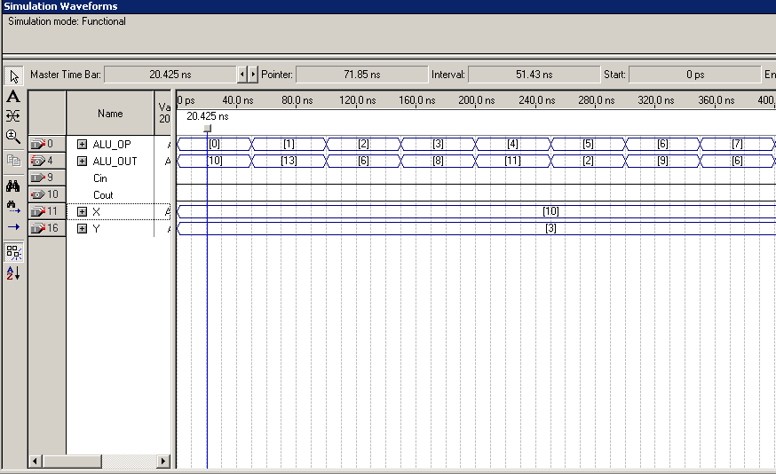

As requested the ALU is going through all operations for numbers 10 and 3.

**Register VHDL**

library IEEE;

use IEEE.STD_LOGIC_1164.ALL;

use IEEE.STD_LOGIC_ARITH.ALL;

use IEEE.STD_LOGIC_UNSIGNED.ALL;

entity registerr is

Port(

Data: in STD_LOGIC_VECTOR (3 downto 0);

load: in STD_LOGIC;

Reset: in STD_LOGIC;

Clk: in STD_LOGIC;

Output: out STD_LOGIC_VECTOR (3 downto 0));

end registerr;

architecture Behavioral of registerr is

begin

process (Clk, load, Reset)

begin

if Clk'event and Clk ='1' then

if Reset = '1' then

Output <= "0000";

elsif Reset = '0' then

if load = '1' then

Output <= Data;

end if;

end if;

end if;

end process;

end Behavioral;

**Register Simulation**  
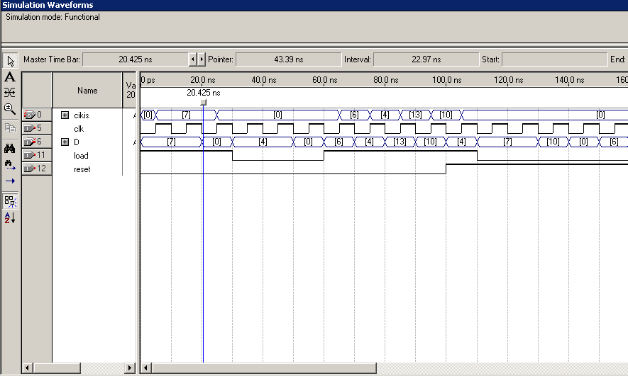

**8x1MUX VHDL**  
  
library IEEE;

use IEEE.STD_LOGIC_1164.ALL;

entity mux8to1 is

Port ( “in here defining 8 inputs and 3 select lines”

s : in STD_LOGIC_VECTOR (2 DOWNTO 0);

w0: in STD_LOGIC_VECTOR (3 DOWNTO 0);

w1: in STD_LOGIC_VECTOR (3 DOWNTO 0);

w2: in STD_LOGIC_VECTOR (3 DOWNTO 0);

w3: in STD_LOGIC_VECTOR (3 DOWNTO 0);

w4: in STD_LOGIC_VECTOR (3 DOWNTO 0);

w5: in STD_LOGIC_VECTOR (3 DOWNTO 0);

w6: in STD_LOGIC_VECTOR (3 DOWNTO 0);

w7: in STD_LOGIC_VECTOR (3 DOWNTO 0);

f : out STD_LOGIC_VECTOR (3 DOWNTO 0));

end mux8to1 ;

architecture Behavior of mux8to1 is “using when command to act as the select lines behavior”

begin

WITH s SELECT

f <= w0 WHEN "000",

w1 WHEN "001",

w2 WHEN "010",

w3 WHEN "011",

w4 WHEN "100",

w5 WHEN "101",

w6 WHEN "110",

w7 WHEN "111";

end Behavior;

**8x1MUX Simulation**

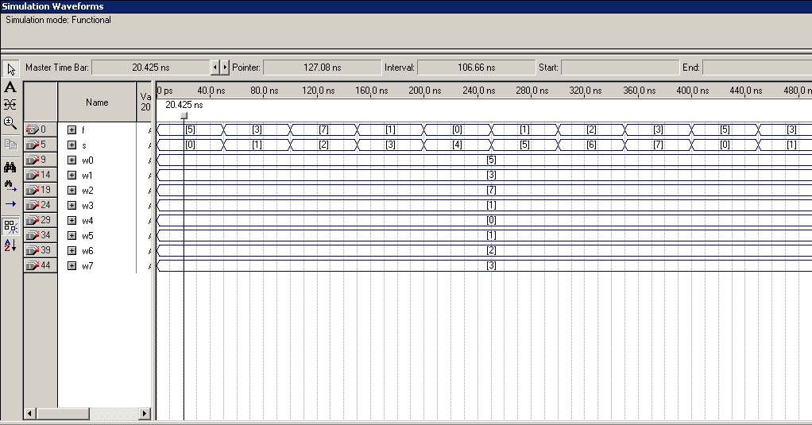

**Datapath Schematic**

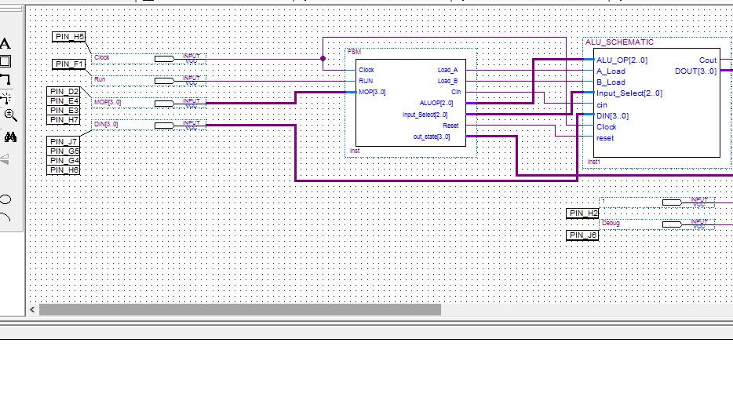  
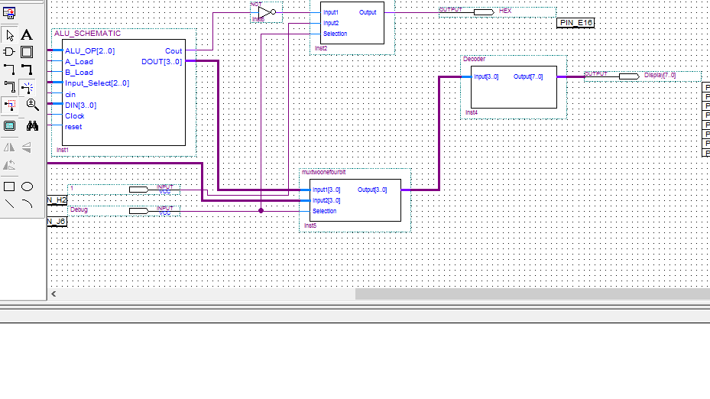

**Datapath Simulation**

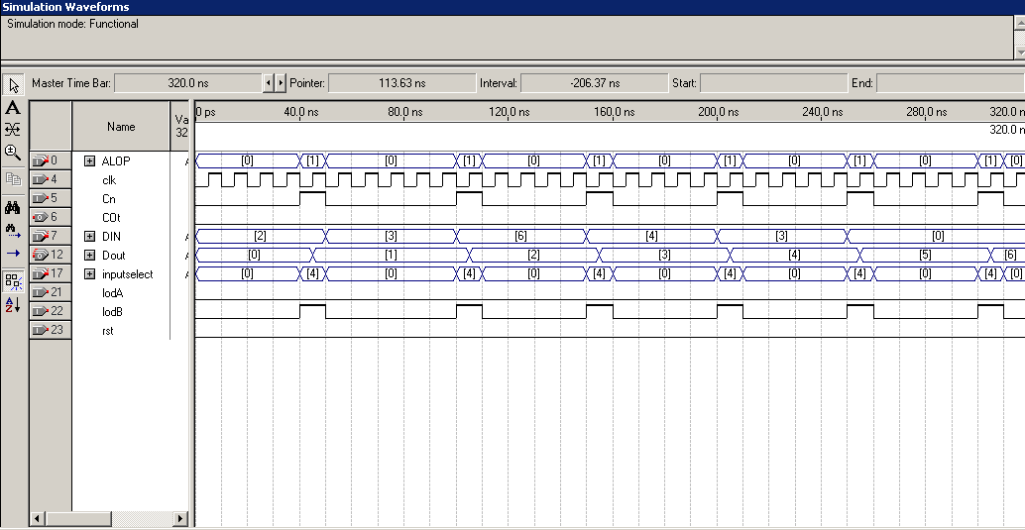

**Datapath Block**

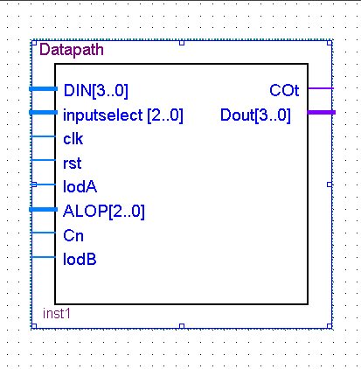

7.4.4 Calculator Simulation

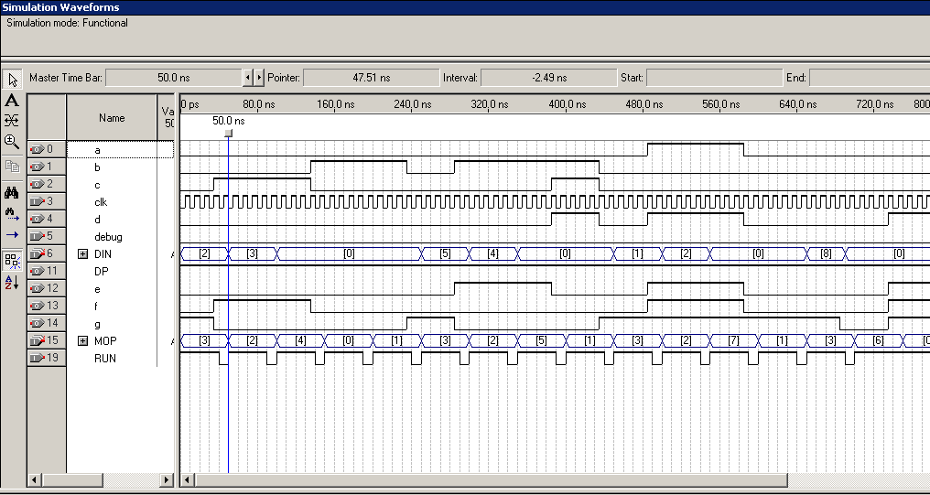

**Conclusion:**

This lab is showing how to connect the knowledge of datapaths and FSM (finite state machines) also including combinational logic (MUX, decoder). So we can design any operation (shift,..) rather than being only a calculator.