Bio: Ishrat Naher Erina is a Health/life Science’s Practitioner and educator by passion and profession. She has dedicated herself working in “Healthy Lifestyle journey without medicine for Disease Management” and “Sex Education & Mental Health”. She believes that health science should be improving the lives of the human being in a very natural but scientific way without making them as a tool of modern business or unethical clinical trial.

Current Work:
- Founder and CEO, Prescription Bangladesh
An educational platform to let people know about thyself scientifically by addressing “Sex Education” (not sexuality education).

Website:
https://www.prescriptionbd.org/
https://bangla.prescriptionbd.org/

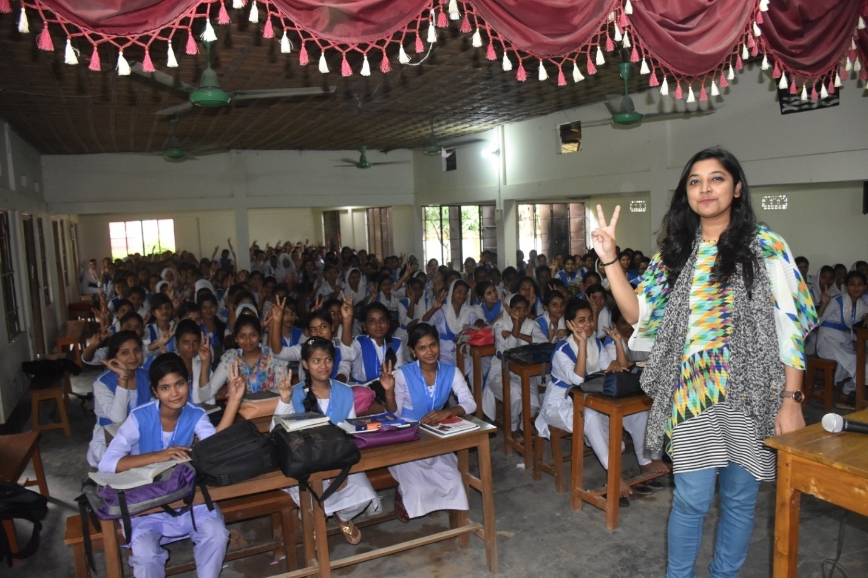

- Family Planning Leader at The Bill & Melinda Gates Institute for Population and Reproductive Health at the Johns Hopkins Bloomberg School of Public Health, USA.
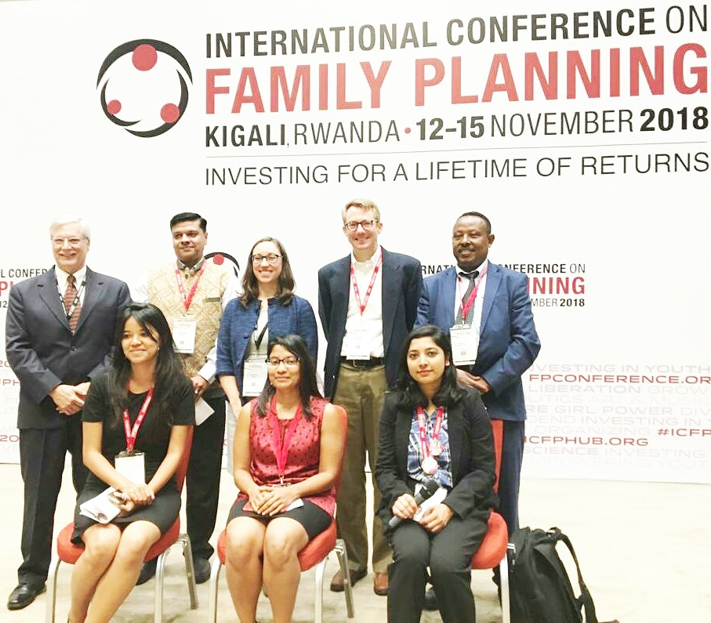

- Award:
Winner at 120 Under 40,Class of 2017.

This program recognizes and highlights the achievements of the next generation of family planning leaders worldwide; it is led by the Bill Gates Institute. Over the course of this multi-year project, 120 young family planning champions have been chosen, 40 in each of the three project years.
Website: https://www.120under40.org/nominee/ishrat-naher-erina

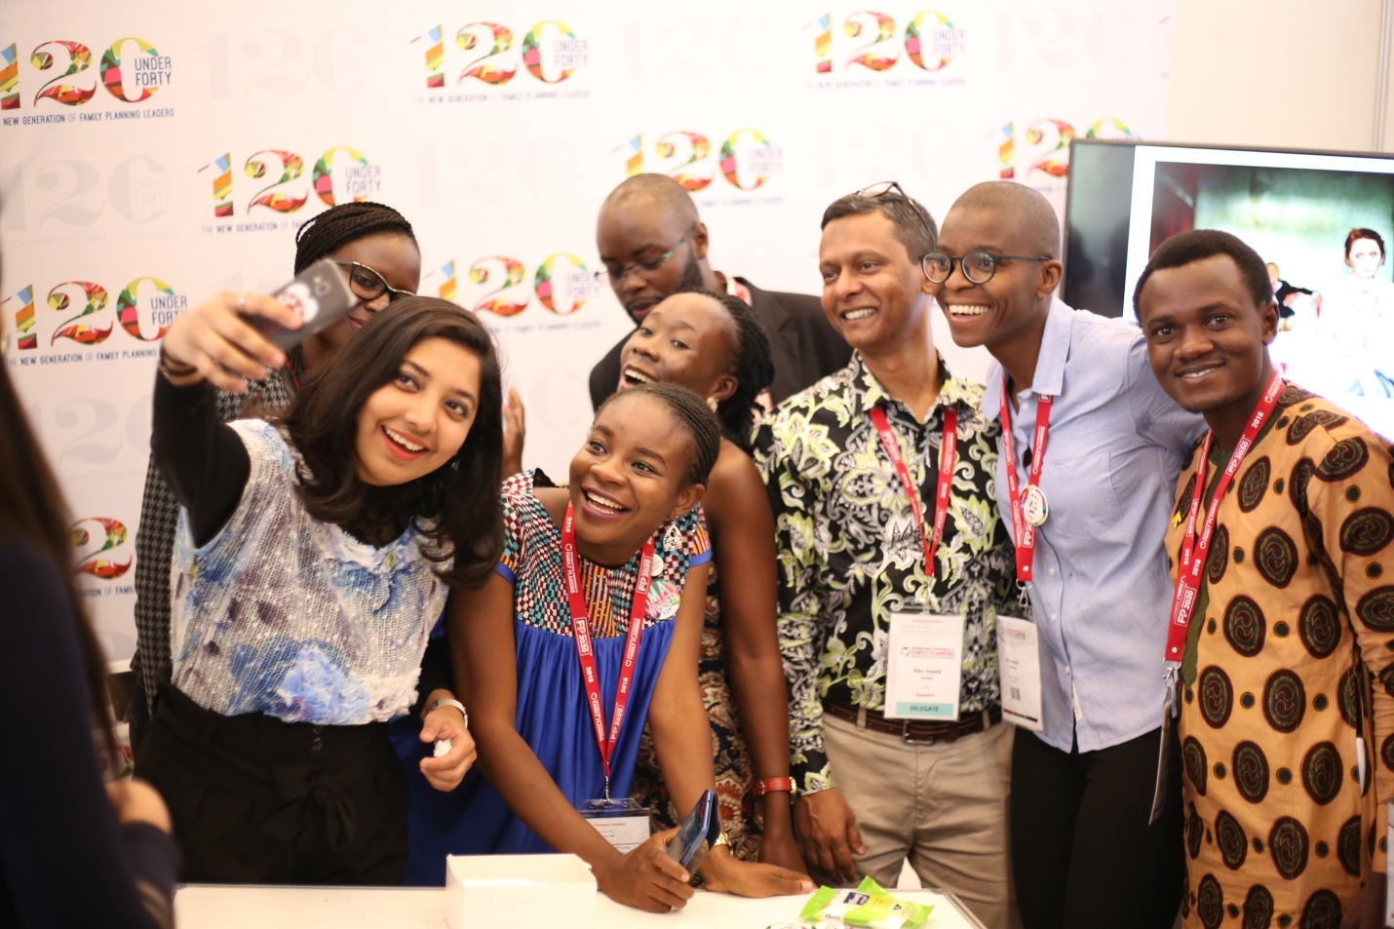

Education:
Post Graduation:
Friedrich Schiller University Jena
Maters in Biochemistry, class of 2019




Internship:
Stress management and aging, at Leibniz Institute on Aging (FLI).

Graduation:
BRAC University
Bachelor of Pharmacy (B. Pharm) with Highest Distinction , Class of 2016.



Internship:
Beximco Pharmaceuticals Ltd (BPL), Bangladesh

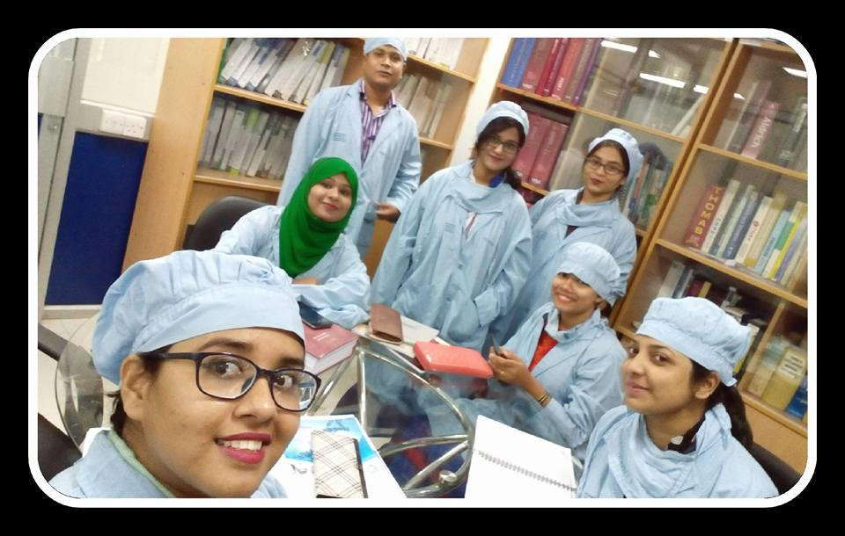

School:
BUDS, Sreemangal ,Moulvibazar.


Conference:
Youth Speaker, on 5th International conference on Family Planning, Rwanda, Africa.
