

American International University-Bangladesh (AIUB)  
**Department of Computer Science  
Faculty of Science &Technology (FST)  
Fall 20_21**

**Section: H  
Group No: 01**

**Topic: Fingerprint based E-Voting System**

A software Engineering project submitted

By

|  |  |  |
| --- | --- | --- |
| Serial No. | Student Name | Student ID |
| 20 | Sultana, Zafrin | 19-39345-1 |
| 36 | Shahriar, B.M. Mahir | 19-40538-1 |
| 37 | Kabir, Md Mahmodul | 19-40642-1 |
| 38 | Niloy, Arindam Shaha | 19-40661-1 |

The project will be Evaluated for the following Course Outcomes

|  |  |
| --- | --- |
| Requirements Analysis (functional, quality, and project requirements) [5Marks] | **Total Marks** |
| System Design (UML, UI/UX design) [5Marks] |  |
| Test and Project Management Planning [5Marks] |
| Submission, Completeness, Spelling, Grammar and Organization [5Marks] |

# PRODUCT AND PROJECT DESCRIPTION

## System Features

# Add candidates by Administrator

**Functional Requirements**

5.1 There will be some specific card for Administrator.

5.2 the software will allow the administrator to add candidate.

5.3 The system will have a option of providing additional information about election issues and rules on the display.

**Priority level:** High.

**Precondition:** The editor shall have valid specific card.

**Cross-reference:** N/A

**Scanning Smart Voter ID Card**

**Functional Requirements**

1.1 The software shall allow user to scan their given Smart Voter ID card.

1.2 If the scanning is successful then user card information and user’s picture will be displayed

1.3 If the ID card has been scanned wrong for more than five times, a warning note will be displayed in the booth managers display.

**Priority level:** High.

**Precondition:** User have Smart Voter ID card.

**Cross-reference:** N/A

**2. Choose Vote candidate**

**Functional Requirements**

2.1 The user will be able to choose vote candidate.

2.2 A display or Logo will indicate the vote candidate and user will be able to scan their fingerprint by a finger print scanner beside from the picture or logo

**Priority level:** High

**Precondition:** User have valid ID card scanning confirmation.

**Cross-reference:** N/A

**3. Scan Finger print**

**Functional Requirements**

3.1 User will be able to scan their fingerprint.

3.2 User will be able to vote their favorite candidate by scanning their finger print beside

from their expected logo or picture

**Priority level:** High

**Precondition:** User shall have proper fingerprint scan.

**Cross-reference:** N/A

**4.Vote Confirmation**

**Functional Requirements**

4.1 The software will show the voted Candidates information and logo to the voter.

4.2 User will be able to see confirmation message.

**Priority level:** High

**Precondition:** User shall have selected their favorite candidate properly.

**Cross-reference:** N/A

**Non-functional Requirement**

**1. warnings:**

1.1 The system will display a warning message and card scanning time to make aware the user about card scan limitation.

1.2 The system will display warning message for unsuccessful fingerprint scanning and ask user for different finger

**Priority level:** High

## System Quality Attributes

1.2.1 **Communication Security:** all communications between the voter and the election server will be encrypted to ensure the privacy of vote and votes information.

**Priority level:** High

1.2.2 **Storage Security:** A copy of vote information will anonymously backup with an encryption process in a storage. If voting machine lost connections with election server storage will save the data and immediate update the data after reconnection.

**Priority level:** High.

1.2.3 **Maintainability**: The system will be well documented and it will be designed to be easier maintenance.

**Priority level:** High.

1.2.4 **Usability**: The system shall be usable by only the Smart Voter ID card holders and specific card holder only can access information modifications.

**Priority level:** High.

1.2.5 **Integrity:** Whenever a change is made to voting device or any activity from voter will recorded in a secure storage and update the voter activity to election server through secure Connection.

**Priority level:** High.

1.2.6 **Interface**: All aspects of the Voting system will have a simple point and click interface using text field, buttons, Id card scanner, fingerprint scanner and all other components of the system with graphical user interface. This interface will be designed to be consistent. The inter face will designed to help accommodate people with disabilities such as color blindness. The system will also have clear and understandable message for every steps and activities for old voters.

**Priority level:** High

## Project Requirements

**Resources**:

01. Computer

02. Visual studio

03. EVM (Electronic voting machine) device

04. Adobe illustrator

05. Photoshop

06. Microprocessor

07. Election Server & database

08. Internet

09. Power Backup

10. Smart Voter ID card Scanner

11. Fingerprint Scanner

12. Backup Storage

13. Presiding Administrator Display

1.3.2 **Operating Environment**: The server should have Java installed on the machine, along with Java’s cryptographic packages. The election server runs on a http server, that is (jsp) enabled. The browsers through which the voters access the server should have minimal support for cookies and encrypted transactions.

1.3.3 **Design/Implementation Constraints**: Even though the system enables voters to poll their vote from any terminal connected to the Internet, the voters should initially contact the election administrator’s office to authenticate themselves and establish their user-ids. This constraint is imposed to ensure that only the genuine person is allowed to vote in the elections. Also, it is assumed that only the election officer with specific ID card has access to the server that hosts the election.

1.3.4 **Assembling/ Setup Time:** The whole system will take 12to 24 hours for being assembled and the system will work 12 hours properly with its backup power and storage.

1.3.5 **Budget**: The system will cost less than 30000-400000 taka for every voting booth according to today’s market price. The cost looks high from certain angles but This system will ensure secure and fair voting. Also save time, reduce illegal voter activity. Moreover, the system will more environment friendly than paper voting system.

# SYSTEM DESIGN SPECIFICATION

## System Design

## Use case diagram: The candidate will apply to the administrator to participate. Then when the voting process will begin the voter will go for vote and first will scan his/her smart NID card to verify as a voter. Then the voter will see the candidate and choose the one he/she prefers. After selecting, the device will ask for fingerprint for authentic verification. Once it’s verified, the vote will be confirmed. After all processes, the administrator will be able to see the result.

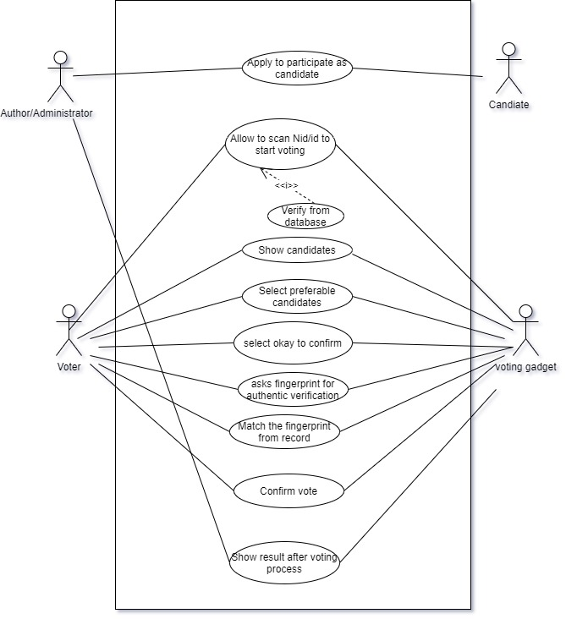

**Class diagram:** There are classes name of candidate, administrator, database, Voter and the voting process. The candidates register to the Administrator. Voter goes for voting process and complete the voting process. The voting device is connected to the database so that id can verify the information of the voter. Once voting is done the th Administrator gets the data and result.

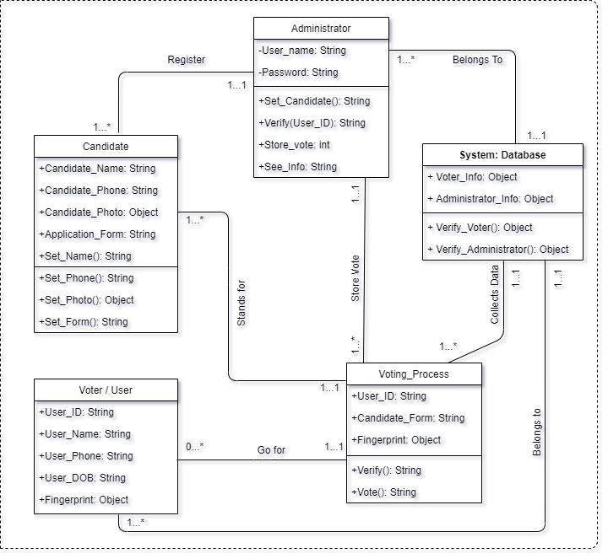

**Sequence diagram:** In this software the voter can verify his identity and confirms his vote through a well secured voting process. Here the voting machine verifies the data of the voter from database server and there are two steps of verification. One will NID smart card and one with Fingerprint.

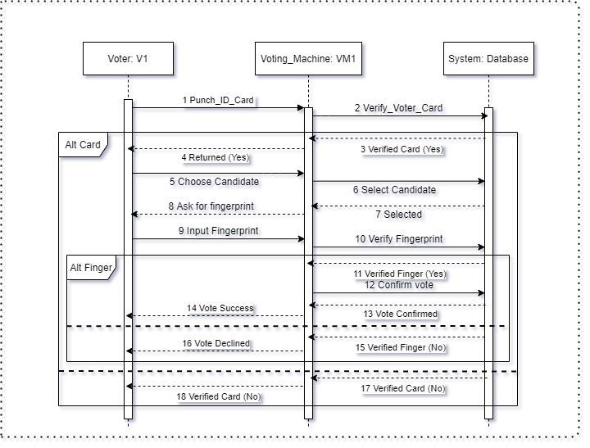

Figure: Sequence Diagram for the System

**Activity Diagram:** In the voting process the voter has to follow some step to confirm his/her vote. First, he/she has to punch the NID smart card to scan. Once it’s verified the voter can select candidate and ask to confirm. To confirm the vote, the voter have to scan his fingerprint which will secure the system more. If the fingerprint doesn’t match with the data for the voter, vote will be cancel and the device will show a deny message.

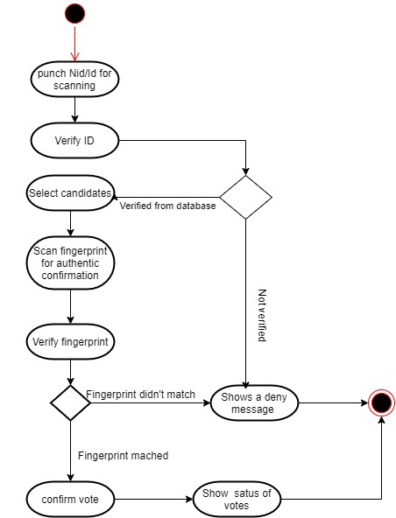

Figure: Sequence Diagram for the System

**Entity-Relationship (E-R) Diagram:**

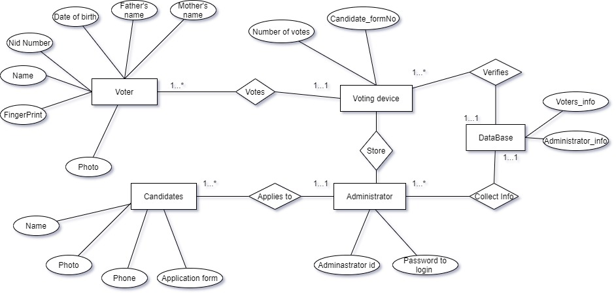

## UI/UX Design

**Interface:** User will start the process from here.

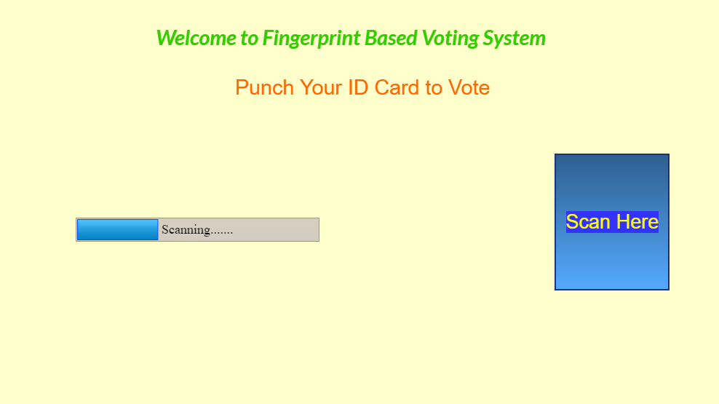

Home Page

Once it’s Scanned and verified, this interface will appear.

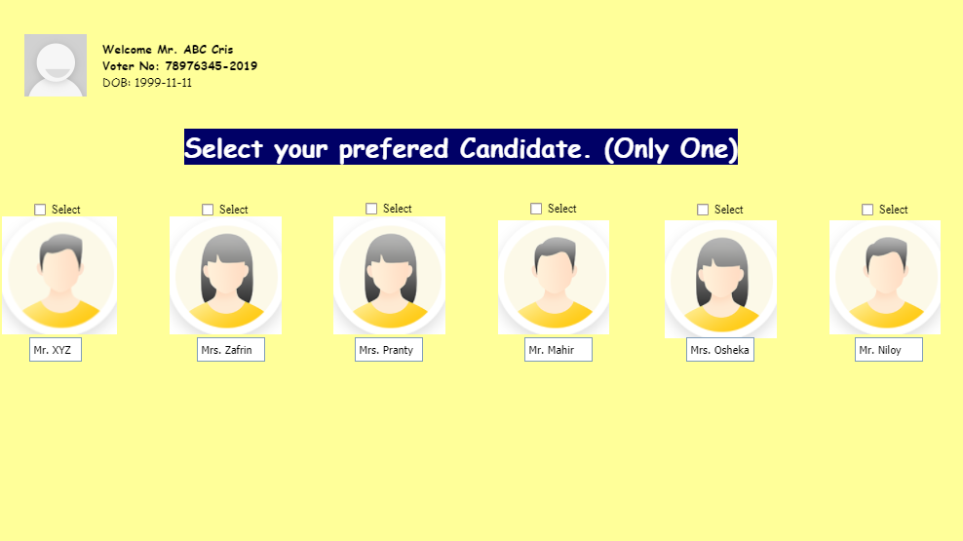

Second Page

Once the voter is done with previous selection, next will appear:

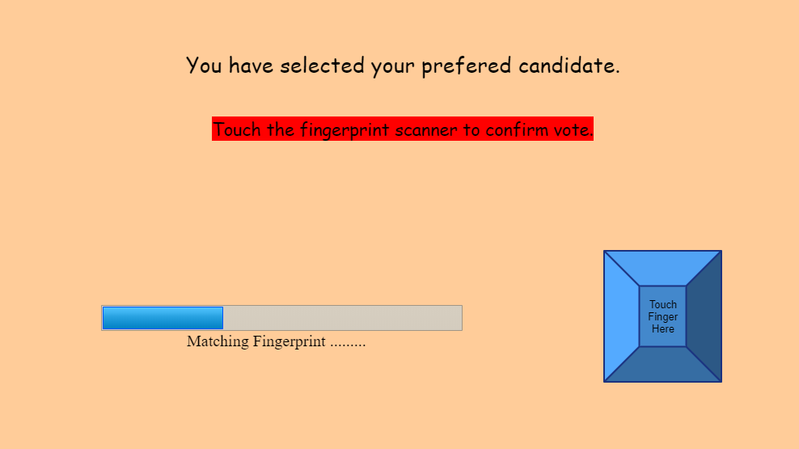Third Page

After verifying Fingerprint, end page will appear:

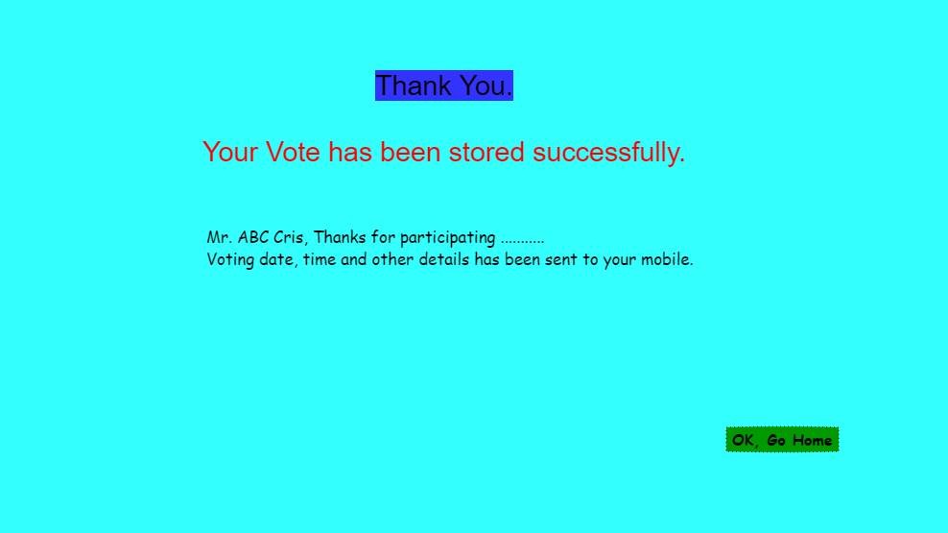

End Page

# SYSTEM TEST PLAN

**Objective:** Perform various techniques for testing using the testing tool: Unit testing, Object oriented testing.

**Tools/ Apparatus:** Manual.

**Procedure:**

1. Select a particular system (Web/ Voting Device)

2. Identified various modules of the system so that they can be tested stand alone.

3. Prepared test cases of testing the selected elements of the identified software.

4. Performed the test according to our generated test case and produce a bug report which will helpful for the system developer to modify the system for improve system’s quality.

**Project Test Planning**

|  |  |  |  |  |  |
| --- | --- | --- | --- | --- | --- |
| Project Name: Fingerprint based E-Voting system | | | Test Designed by: Niloy Shaha | | |
| Test Case ID: AN0001 | | | Test Designed date: 05-12-2020 | | |
| Test Priority: High | | | Test Executed by: Md Mahmodul Kabir | | |
| Module Name: NID card scanner | | | Test Execution date: 15-12-2020 | | |
| Test Title: verification of valid smart NID card. | | |  | | |
| Description: Scan and verify the NID card. | | |
| Precondition (If any): 1. If the NID card is valid.  2. If voting was done with the NID card before. | | | | | |
| Test Steps | Test Data | Expected Results | | Actual  Results | Status  (Pass/Fail) |
| 1.Scan NID card. | Voter NID card No:  Voters name: Niloy Saha | User shows valid  id card. | |  |  |
| Post Condition: The system will allow for further step. | | | | | |

|  |  |  |  |  |  |
| --- | --- | --- | --- | --- | --- |
| Project Name: Fingerprint based E-Voting system | | | Test Designed by: Niloy Shaha | | |
| Test Case ID: AR00200 | | | Test Designed date: 07-10-2020 | | |
| Test Priority: High | | | Test Executed by: Tanmoy Shaha | | |
| Module Name: Candidate selection | | | Test Execution date: 13-10-2020 | | |
| Test Title: to check the candidate selection process | | |  | | |
| Description: test candidate selection page | | |
| Precondition (If any): Voter must have valid NID. | | | | | |
| Test Steps | Test Data | Expected Results | | Actual  Results | Status  (Pass/Fail) |
| 1. See all candidates. 2. Select preferable candidate. | Voter id:  1112233445  Candidate Name: Zafrin | Confirm preferable candidate. | |  |  |
| Post Condition: The system will ask for fingerprint for authentic verification. | | | | | |

|  |  |  |  |  |  |
| --- | --- | --- | --- | --- | --- |
| Project Name: Fingerprint based E-Voting system | | | Test Designed by: Niloy Shaha | | |
| Test Case ID: AR00201 | | | Test Designed date: 15-12-2020 | | |
| Test Priority: High | | | Test Executed by: Shahriar | | |
| Module Name: Fingerprint verification | | | Test Execution date: 13-10-2020 | | |
| Test Title: Verification with valid fingerprint | | |  | | |
| Description: To check UI (User interface) | | |  | | |
| Precondition (If any): voter must select a candidate whom he/she prefers. | | | | | |
| Test Steps | Test Data | Expected Results | | Actual  Results | Status  (Pass/Fail) |
| 1.Allow to scan fingerprint.  2. Verify voter’s fingerprint | Voter NID: 22233456  Fingerprint Data:  23289240923 | Voters fingerprint should be valid. | |  |  |
| Post Condition: Show confirmation message. | | | | | |