CIS 141

# COVER PAGE

INTRODUCTION TO PROGRAMMING

Dondi Hanson

Zach Foutz

UNIT 02 EXERCISE



# TABLE OF CONTENTS

COVER PAGE 1

TABLE OF CONTENTS 2

NARRATIVE 3

DEFINING DIAGRAM 4

HIERARCHY CHART 5

NASSI-SCHNEIDERMAN 6

PROGRAM OUTPUT 7

SOURCE CODE 8

DESK CHECK 9

# NARRATIVE

Although the instructions in the videos were a little confusing, the code itself was simple. Mostly I had trouble adding a zip file to this word document because LibreOffice doesn’t support ActiveX objects.

Does your server automatically scrape the zip files out of the word document? I’m interested in how much of the grading process you’ve automated.

I write PHP daily for work, so I am very familiar with the concepts and coursework covered in this class, but I always look forward to learning something new!

# DEFINING DIAGRAM

|  |  |  |
| --- | --- | --- |
| **INPUT** | **PROCESS** | **OUTPUT** |
| nbr 1 | Prompt for nbr 1 | Total |
| nbr 2 | Get nbr 1 | Tax Rate |
| nbr 3 | Prompt for nbr 2 | Grand Total |
| nbr 4 | Get nbr 2 |  |
| nbr 5 | Prompt for nbr 3 |  |
|  | Get nbr 3 |  |
|  | Prompt for nbr 4 |  |
|  | Get nbr 4 |  |
|  | Prompt for nbr 5 |  |
|  | Get nbr 5 |  |
|  | Calc Total |  |
|  | Calc Grandtotal |  |
|  |  |  |

# HIERARCHY CHART

(not required until unit 6 or 7)

NASSI-SCHNEIDERMAN

|  |
| --- |
| PROMPT FOR INPUT |
| GET INPUT |
| PROMPT FOR INPUT |
| GET INPUT |
| PROMPT FOR INPUT |
| GET INPUT |
| PROMPT FOR INPUT |
| GET INPUT |
| PROMPT FOR INPUT |
| GET INPUT |
| CALC TOTAL |
| CALC GRAND TOTAL |
| DISPLAY RESULT |

# PROGRAM OUTPUT

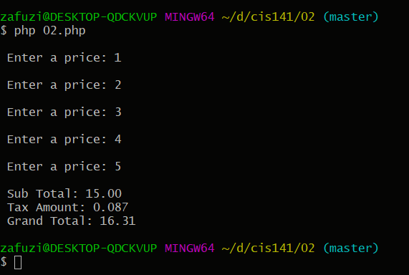

x

# SOURCE CODE

1. <?php
2. $tax_rate = 0.087;
3. $price_001 = 0.0;
4. $price_002 = 0.0;
5. $price_003 = 0.0;
6. $price_004 = 0.0;
7. $price_005 = 0.0;
8. $total = 0.0;
9. $grand_total = 0.0;
10. printf("\n Enter a price: ");
11. fscanf(STDIN, "%f", $price_001);
12. $total += $price_001;
13. printf("\n Enter a price: ");
14. fscanf(STDIN, "%f", $price_002);
15. $total += $price_002;
16. printf("\n Enter a price: ");
17. fscanf(STDIN, "%f", $price_003);
18. $total += $price_003;
19. printf("\n Enter a price: ");
20. fscanf(STDIN, "%f", $price_004);
21. $total += $price_004;
22. printf("\n Enter a price: ");
23. fscanf(STDIN, "%f", $price_005);
24. $total += $price_005;
25. printf("\n Sub Total: %.2f", $total);
26. printf("\n Tax Amount: %.3f", $tax_rate);
27. // round up to get correct grand total
28. printf("\n Grand Total: %.2f\n", round($total + ($total * $tax_rate), 2));
29. ?>



# DESK CHECK