CIS 141

# COVER PAGE

INTRODUCTION TO PROGRAMMING

Dondi Hanson

Zach Foutz

UNIT 3 EXERCISE



# TABLE OF CONTENTS

COVER PAGE 1

TABLE OF CONTENTS 2

NARRATIVE 2

DEFINING DIAGRAM 3

HIERARCHY CHART 4

NASSI-SCHNEIDERMAN 5

PROGRAM OUTPUT 6

SOURCE CODE 7

DESK CHECK 8

# NARRATIVE

The most difficult part about any of these assignments is trying to use Microsoft word to express a programs intention. That aside, I wrote the solution to this problem quickly and only ran into an issue when I forgot what function to use in order to format numbers with commas.

I spent some time formatting the output because I wanted to, beyond that I don’t really have anything else to write here. Instead I will discuss a personal project that I have been working on.

I recently signed up for the tech alpha for Microsoft’s new flight simulator, and while I wait for them to ultimately deny me access, I thought it would be fun to use their old SimConnect SDK to interface with FSX: Steam Edition.

I booted up Visual Studio and built a small application in C++ that simply works as a real-time HUD for what’s happening in game. It was mostly an exercise in learning how to interface with the SDK, and in the future, I plan on use physical switches, rotary encoders, and potentiometers to affect functions in game.

# DEFINING DIAGRAM

|  |  |  |
| --- | --- | --- |
| **INPUT** | **PROCESS** | **OUTPUT** |
| number | Prompt for number | deposit |
|  | Get number |  |
|  | Calculate deposit |  |
|  | Display result |  |
|  |  |  |
|  |  |  |
|  |  |  |
|  |  |  |
|  |  |  |

# HIERARCHY CHART

(not required until unit 6 or 7)

NASSI-SCHNEIDERMAN

Display calculated deposit

P & G LOAN AMOUNT

Loan amount too large, no deposit

Deposit is $1250 + 10% of loan over $25,000

Deposit is 5% of loan amount

Deposit is $5000 + 25% of loan over $50000

F

T

Loan Amount < 250000

Loan Amount < 100000

T

Loan Amount < 50000

F

T

F

# PROGRAM OUTPUT

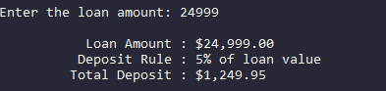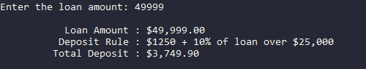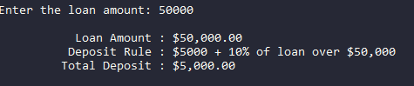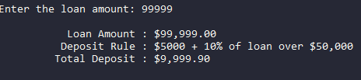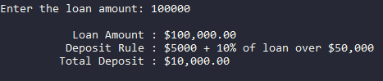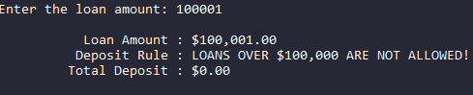

# SOURCE CODE

<?php  
$loan_amt = 0;  
$deposit  = 0;  
$msg      = "";  
printf("\nEnter the loan amount: ");  
fscanf(STDIN, "%f", $loan_amt);  
if ($loan_amt < 25000)  
  {  
    $msg     = "5% of loan value";  
    $deposit = $loan_amt * 0.05;  
  }  
else if ($loan_amt < 50000)  
  {  
    $msg     = "$1250 + 10% of loan over $25,000";  
    $deposit = 1250 + ($loan_amt - 25000) * 0.10;  
  }  
else if ($loan_amt <= 100000)  
  {  
    $msg     = "$5000 + 10% of loan over $50,000";  
    $deposit = 5000 + ($loan_amt - 50000) * 0.10;  
  }  
else  
  {  
    $msg     = "LOANS OVER $100,000 ARE NOT ALLOWED!";  
    $deposit = 0;  
  }  
printf("\n\t   Loan Amount : $%s", number_format($loan_amt, 2, '.', ','));  
printf("\n\t  Deposit Rule : %s", $msg);  
printf("\n\t Total Deposit : $%s\n\n", number_format($deposit, 2, '.', ','));  
?>



# DESK CHECK

INCOMING VALUES 100001

|  |  |  |  |
| --- | --- | --- | --- |
| LINE NUMBER | Loan_amt | deposit | msg |
| 2 | 0 |  |  |
| 3 |  | 0 |  |
| 4 |  |  | “” |
| 6 | 100001 |  |  |
| 24 |  |  | LOANS OVER $100,000 ARE NOT ALLOWED! |
| 25 |  | 0 |  |

7. 100001 < 25000 = false

12. 1000001 < 50000 = false

17. 1000001 < 100000 = false

22. enter else block

MONITOR

Enter the loan amount: 100001

Loan Amount : $100,001.00

Deposit Rule : LOANS OVER $100,000 ARE NOT ALLOWED!

Total Deposit : $0.00