CIS 141

# COVER PAGE

INTRODUCTION TO PROGRAMMING

Dondi Hanson

Zach Foutz

UNIT 5 EXERCISE



# TABLE OF CONTENTS

COVER PAGE 1

TABLE OF CONTENTS 2

NARRATIVE 3

DEFINING DIAGRAHM 4

HIERARCHY CHART 5

NASSI-SCHNEIDERMAN 6

PROGRAM OUTPUT 7

SOURCE CODE 8

DESK CHECK 9

# NARRATIVE

Since this assignment was basically just a repeat of last weeks, I didn’t run into any trouble at all. Didn’t really learn anything new either.

I did find the desk check helpful to actually check the execution of this one since it was a little more complicated and I wanted to make sure I got the logic correct.

It’s mostly just frustrating that we can’t use arrays and associative arrays yet, which I know is next weeks stuff, so yay!

# DEFINING DIAGRAM

|  |  |  |
| --- | --- | --- |
| **INPUT** | **PROCESS** | **OUTPUT** |
| Name | open input file read | summary.txt |
| Gender | open summary file write | Single_men.txt |
| Age | open single men file write | single_women.txt |
| Availability | Open single women file write |  |
|  | Write title to summary |  |
|  | write title to single men |  |
|  | Write headers to single men |  |
|  | Write titles to single women |  |
|  | Write headers to single women |  |
|  | Read first line of input file |  |
|  | Determine gender |  |
|  | Determine availability |  |
|  | Determine age |  |
|  | Write to single men or women if logic is true |  |
|  | Read next line |  |
|  | Repeat until EOF |  |
|  | Write details to summary report |  |
|  | Close files |  |

# HIERARCHY CHART

(not required until unit 6 or 7)

NASSI-SCHNEIDERMA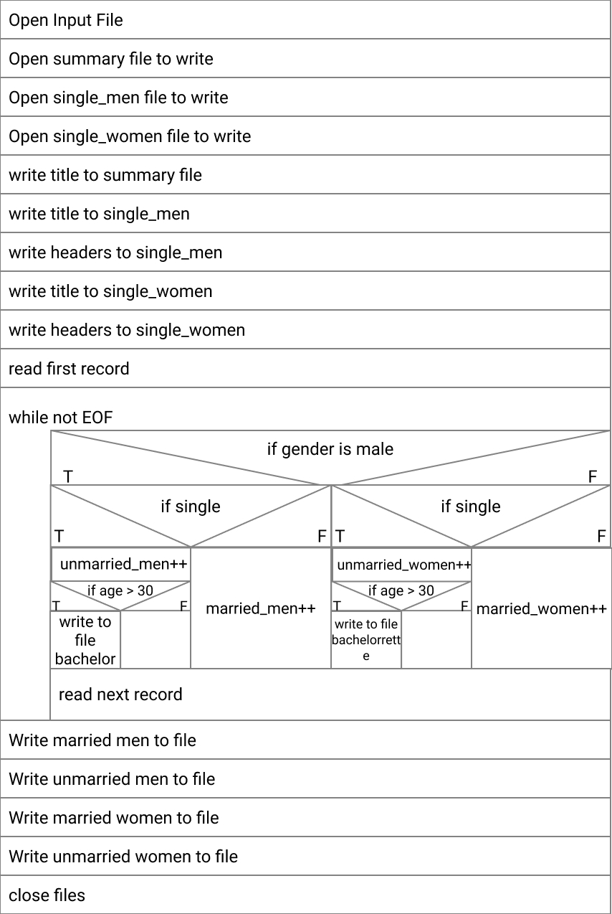

# PROGRAM OUTPUT

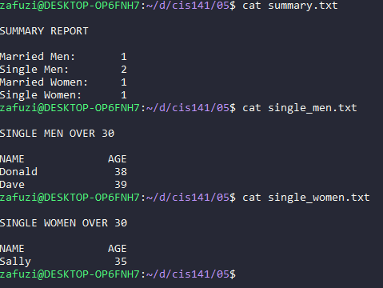

# SOURCE CODE

<?php $input_file = fopen("./students.txt", "r") or die("Unable to read input file\n"); $summary = fopen("./summary.txt", "w") or die("Unable to open summary file for writing\n"); $single_men = fopen("./single_men.txt", "w") or die("Unable to open single men file for writing\n"); $single_women = fopen("./single_women.txt", "w") or die("Unable to open single women file for writing\n"); $format = "%-16s%4d\r\n"; fprintf($summary, "\n%s\r\n\n", "SUMMARY REPORT"); fprintf($single_men, "\n%s\r\n\n", "SINGLE MEN OVER 30"); fprintf($single_men, "%-16s%4s\n", "NAME", "AGE"); fprintf($single_women, "\n%s\r\n\n", "SINGLE WOMEN OVER 30"); fprintf($single_women, "%-16s%4s\n", "NAME", "AGE"); $married_men = 0; $married_women = 0; $unmarried_men = 0; $unmarried_women = 0; $cur_name = ""; $cur_sex = ''; $cur_age = 0; $cur_avail = ''; fscanf($input_file, "%s %c %d %c", $cur_name, $cur_sex, $cur_age, $cur_avail); while( !feof($input_file) ) { if($cur_sex == 'M') { // is male if($cur_avail == 'A') { // is unmarried $unmarried_men++; if( $cur_age > 30 ) { // is over 30 fprintf($single_men, $format, $cur_name, $cur_age); } } else { // is male and married $married_men++; } } else { // is female if($cur_avail == 'A') { // is unmarried $unmarried_women++; if( $cur_age > 30 ) { // is over 30 fprintf($single_women, $format, $cur_name, $cur_age); } } else { // is female and married $married_women++; } } fscanf($input_file, "%s %c %d %c", $cur_name, $cur_sex, $cur_age, $cur_avail); } fprintf($summary, $format, "Married Men: ", $married_men); fprintf($summary, $format, "Single Men: ", $unmarried_men); fprintf($summary, $format, "Married Women: ", $married_women); fprintf($summary, $format, "Single Women: ", $unmarried_women); fclose($input_file); fclose($summary); fclose($single_men); fclose($single_women); ?>



# DESK CHECK

Incoming Data: students.txt

Sally F 35 A

Donald M 38 A

Susan F 22 N

Richard M 21 N

Dave M 39 A

EOF

|  |  |  |  |  |  |  |  |  |
| --- | --- | --- | --- | --- | --- | --- | --- | --- |
| L# | Married men | Unmarried men | Married women | Unmarried women | Cur_name | Cur_sex | Cur_age | Cur_avail |
| 18 | 0 |  |  |  |  |  |  |  |
| 19 |  |  | 0 |  |  |  |  |  |
| 20 |  | 0 |  |  |  |  |  |  |
| 21 |  |  |  | 0 |  |  |  |  |
| 23 |  |  |  |  | “” |  |  |  |
| 24 |  |  |  |  |  | ‘’ |  |  |
| 25 |  |  |  |  |  |  | 0 |  |
| 26 |  |  |  |  |  |  |  | ‘’ |
| 28 |  |  |  |  | Sally | F | 35 | A |
| 32 |  |  |  |  |  |  |  |  |
| 41 |  |  |  | 1 |  |  |  |  |
| 49 |  |  |  |  | Donald | M | 38 | A |
| 32 |  | 1 |  |  |  |  |  |  |
| 49 |  |  |  |  | Susan | F | 22 | N |
| 46 |  |  | 1 |  |  |  |  |  |
| 49 |  |  |  |  | Richard | M | 21 | N |
| 37 | 1 |  |  |  |  |  |  |  |
| 49 |  |  |  |  | Dave | M | 39 | A |
| 32 |  | 2 |  |  |  |  |  |  |
| 49 |  |  |  |  | EOF | EOF | EOF | EOF |

Output Files:

Summary:

Summary Report

Married Men: 1

Single Men: 2

Married Women: 1

Single Women: 1

Single Women:

SINGLE WOMEN OVER 30

NAME AGE

Sally 35

Single Men:

SINGLE MEN OVER 30

NAME AGE

Donald 38

Dave 39

Logic:

**SALLY F 35 A**

29 while !FEOF TRUE

30 ‘F’ == ‘M’ FALSE

40 ‘A’ == ‘A’ TRUE

42 35 > 30 TRUE

**DONALD M 38 A**

29 while !FEOF TRUE

30 ‘M’ == ‘M’ TRUE

31 ‘A’ == ‘A’ TRUE

33 38 > 30 TRUE

**SUSAN F 22 N**

29 while !FEOF TRUE

30 ‘F’ == ‘M’ FALSE

40 ‘N’ == ‘A’ FALSE

**RICHARD M 21 N**

29 while !FEOF TRUE

30 ‘M’ == ‘M’ TRUE

31 ‘N’ == ‘A’ FALSE

**DAVE M 39 A**

29 while !FEOF TRUE

30 ‘M’ == ‘M’ TRUE

31 ‘A’ == ‘A’ TRUE

33 39 > 30 TRUE

29 while !FEOF FALSE