CIS 141

# COVER PAGE

INTRODUCTION TO PROGRAMMING

Dondi Hanson

Zach Foutz

UNIT 1 EXERCISE



# TABLE OF CONTENTS

COVER PAGE 1

TABLE OF CONTENTS 2

NARRATIVE 3

DEFINING DIAGRAHM 4

HIERARCHY CHART 5

NASSI-SCHNEIDERMAN 6

PROGRAM OUTPUT 7

SOURCE CODE 8

DESK CHECK 9

# NARRATIVE

Your narrative is a "program debrief" for the programming problem. This should be one well formed paragraph that speaks to your personal experience when writing the program.

Include such topics as:

* How long in total did you spend on the problem?
* How difficult was the problem to do?
* What pitfalls did you run into?
* What topics did this problem help you to internalize?
* What did you have to learn on your own in order to solve the problem?
* What ways would you change the assignment to make it more meaningful?

For example, a student wrote a program that prompts and gets numbers from the keyboard and outputs the square of the numbers to the screen until 0 is entered and they wrote:

This program was easy for me overall as I had some programming experience prior to taking this class so I am familiar with the concepts. I spent about an hour writing the code and 5 minutes testing it. The only pitfall I ran into was when I first tried to run it, I got an error. It turned out that I had misspelled input as imput while asking for a number to square. This assignment helped me to consider the importance of proper syntax and basic input and output. I thought this problem was a bit on the easy side even for a first program. I would recommend adding an additional element of difficulty.

# DEFINING DIAGRAM

|  |  |  |
| --- | --- | --- |
| **INPUT** | **PROCESS** | **OUTPUT** |
| number | Prompt for number | square |
|  | Get number |  |
|  | Square number |  |
|  | Display result |  |
|  |  |  |
|  |  |  |
|  |  |  |
|  |  |  |
|  |  |  |

# HIERARCHY CHART

# 

(not required until unit 6 or 7)

NASSI-SCHNEIDERMAN

PROMPT FOR INPUT

GET INPUT

WHILE INPUT IS NOT 0

SQUARE THE INPUT

DISPLAY THE SQUARE

PROMPT FOR INPUT

GET INPUT

# PROGRAM OUTPUT

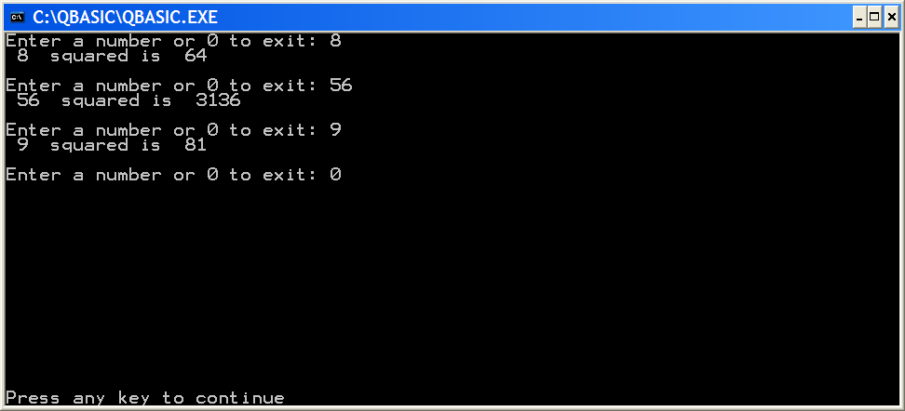

As output was to the screen, Sally did an ALT-PRNT-SCRN reflecting the results of running the application and pasted it into the Word document.

If output was to a file, the results of writing to a file would be pasted here.

In some cases, both might be in order.

# SOURCE CODE

1. ' PROGRAM : squares.bas
2. ' AUTHOR: Sally Sue
3. ' DATE: 15 APR 2005
4. ' VERSION: 1.0
5. Dim num As Integer
6. Dim square As Integer
7. Dim i As Integer
8. Input "Enter a number or 0 to exit: ", num
9. Do While num <> 0
10. square = num * num
11. Print num; " squared is "; square
12. Print ""
13. Input "Enter a number or 0 to exit: ", num

14. Loop

**The source code is formatted to courier new 12 font** ☺

Each new bock of code is indented 2 spaces.

**The source code file is placed in a code.zip folder and then placed in the word document by selecting insert, then object, then create from file, then browse and selecting the file. Make sure the *link to file* is not selected. This inserts the icon you see below that is a zip file embedded in the word document that contains your source code.**



# DESK CHECK

INCOMING VALUES 4 2 0

|  |  |  |
| --- | --- | --- |
| LINE NUMBER | num | square |
| 8 | 4 |  |
| 10 |  | 16 |
| 13 | 2 |  |
| 10 |  | 4 |
| 13 | 0 |  |

9. Do While 4 <> 0 (T)

9. Do While 2 <> 0 (T)

9. Do While 0 <> 0 (F)

MONITOR

Enter a number or 0 to exit: 4

4 squared is 16

Enter a number or 0 to exit: 2

2 squared is 4

Enter a number or 0 to exit: 0