SIMF Control Panel
Operations manual — creating users, configuring the system, and deploying it
Audience | Control Panel administrators and the team deploying the system
Covers | Every Control Panel page, account creation end to end, and the server deployment with its configuration
Screenshots | Captured from the running application, not drawn
Volumes | English and Arabic, published separately

Contents
Contents 2
Signing in for the first time 5
The sign-in screen 5
The forced password change 5
The second factor 6
Recovery codes 7
The dashboard 8
Creating a user by hand 9
Creating an administrator 10
Creating a visitor 13
Creating a partner or staff account 17
Registering a VIP 17
The profile picture 19
Where a picture is set 19
What the system accepts 19
Replacing and removing 20
Changing an account after it exists 21
The approval queues 21
Editing an account 21
Moving an account between types 22
Resetting a lost second factor 22
Withdrawing access 23
Roles and permissions 24
Permission names 24
Creating a role 24
Granting permissions to a role 25
Giving a person a role 25
The guards 26
Deploying to a server 27
The estate 27
The four applications 27
Before the first deployment 27
The order of a deployment 28
The databases 28
The first administrator 28
Every configuration value 29
How a variable name is built 29
How to set one 29
The values that stop a server starting 29
The API 31
The Control Panel 38
The Website 38
The mobile edge 38
The public web application 39
Every host 40
Appendix — what writing this manual found 41
Documents that disagreed with the code — corrected 41
Wording in the product that no longer matched its behaviour — corrected 41
Behaviour worth knowing before it surprises somebody 41
Every page in the Control Panel 43
Overview 43
People 46
Access control 55
Programme 58
Scientific committee 77
Exhibition 80
Engagement 84
Knowledge & AI 86
Content 91
Public relations 98
Gates & arrivals 102
Reference data 106
System 112
Reports 120
Pages reached from inside another page 130

Signing in for the first time
The Control Panel is the operations console for the Saudi International Maritime Forum. Everything in this manual is done from it, so this chapter comes first: it covers the sign-in screen, the password change the system forces on a new account, the second factor, and the recovery codes you are shown exactly once.

The sign-in screen
Open the Control Panel address in a browser. The sign-in page asks for an email address and a password, and offers a language switch and a light/dark switch in the top corner. The language switch changes the whole application, not just this page.
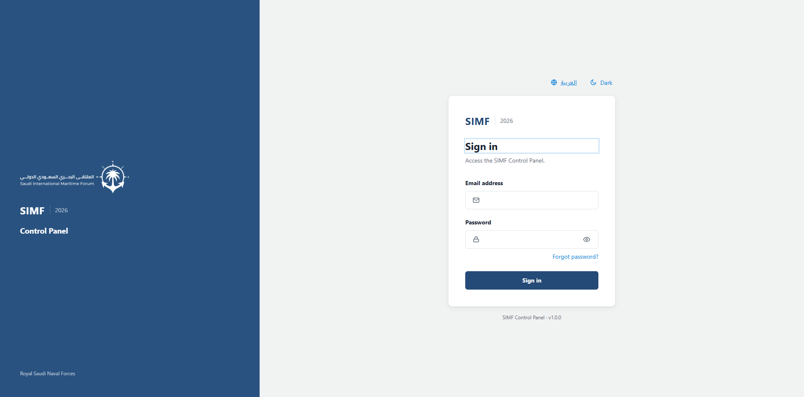
Figure 1 — The sign-in page as it opens.

The forced password change
A newly created account is issued a bootstrap password that the system insists is replaced. On the first sign-in the Control Panel therefore does not go to the dashboard: it opens a dialog over the sign-in page asking for a new password twice. Until that is done the account cannot get in.
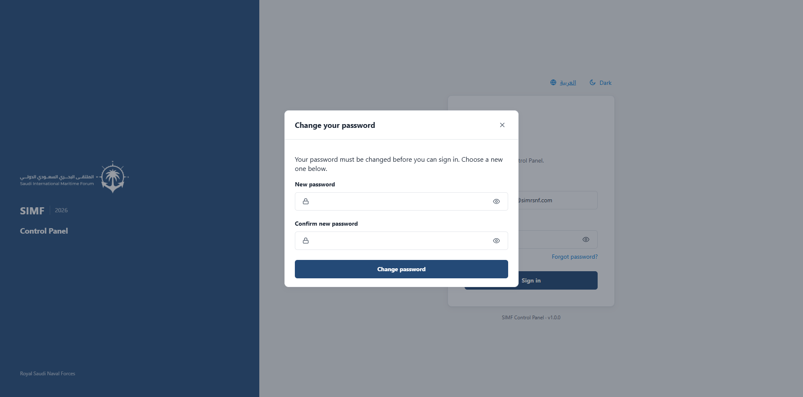
Figure 2 — The password change is a dialog over the sign-in page, not a separate address.
The new password must satisfy the rules the server applies to every password in the system. They are stricter than the length rule most people expect, and the two that surprise operators are the last two:
- Between 8 and 128 characters.
- At least one capital letter, one small letter, one digit and one symbol.
- No character repeated three times in a row — "aa" is allowed, "aaa" is not.
- No run of three characters in sequence within one class — "abc", "123", "cba" and "987" are all rejected.
- Not the account's own email address, and not a commonly used password (leet-speak spellings such as p@ssw0rd are folded back and rejected too).
These rules are enforced in PasswordPolicy.cs and applied by SimfPasswordValidator on every path that sets a password.

The second factor
The Control Panel requires two-factor authentication. After the password the system asks for the six-digit code from an authenticator application. If the account has never paired one, the system shows the pairing screen instead and will not let the account past it — enrolment is mandatory, not optional.
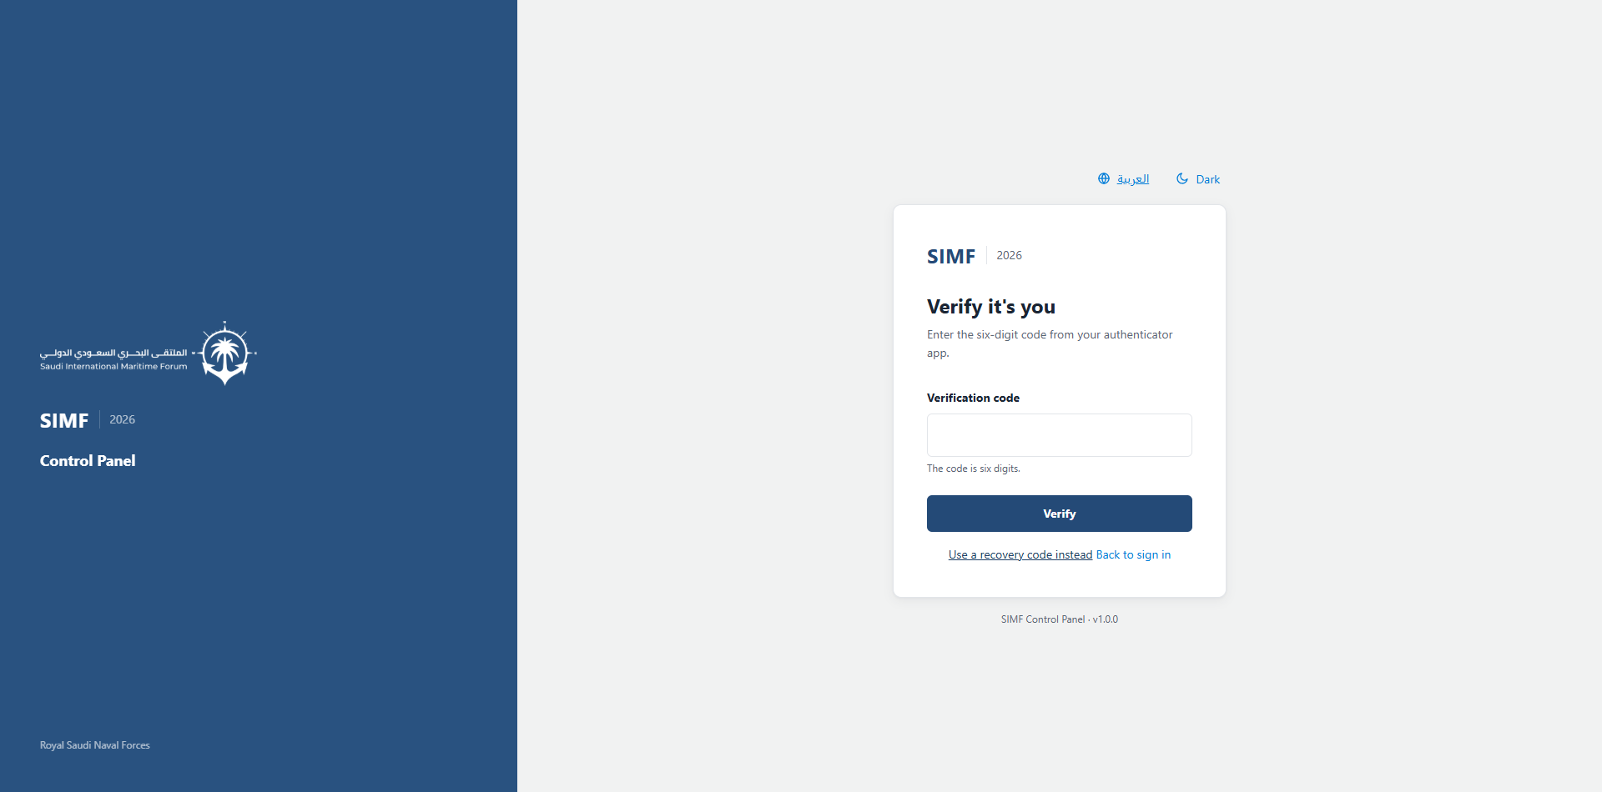
Figure 3 — The second-factor step, after the password has been accepted.
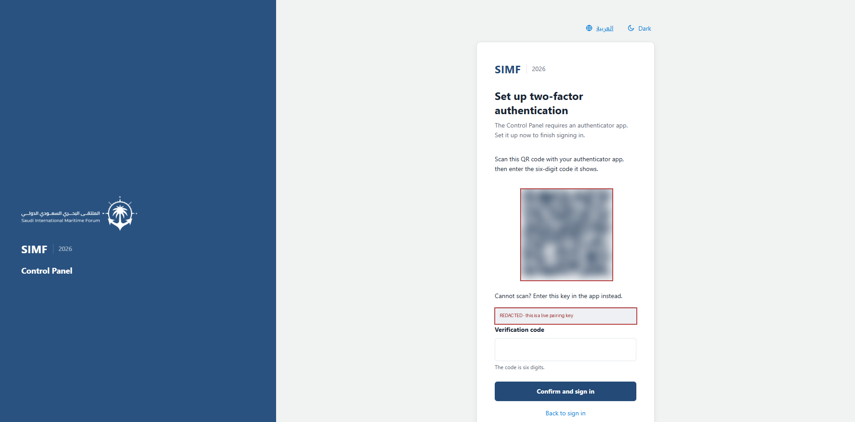
Figure 4 — The pairing screen an account meets when it has no authenticator yet. The QR code and the key beneath it are obscured here: they are a real credential, and a manual should never print one.
The requirement is controlled by IdentityLifecycle:RequireControlPanelTwoFactorEnrolment, which ships as true. It applies to the Control Panel only — the mobile application and the public website are not affected.

Recovery codes
When an account pairs its authenticator the system displays ten single-use recovery codes. They are shown once and never again. Print them or store them somewhere safe: they are what gets the account back in when the phone is lost. If they are lost as well, an administrator must reset the account's second factor from Reset user 2FA, which is covered later in this manual.

The dashboard
A completed sign-in lands on the dashboard: a summary of the event and, down the left, the menu that this manual follows chapter by chapter.
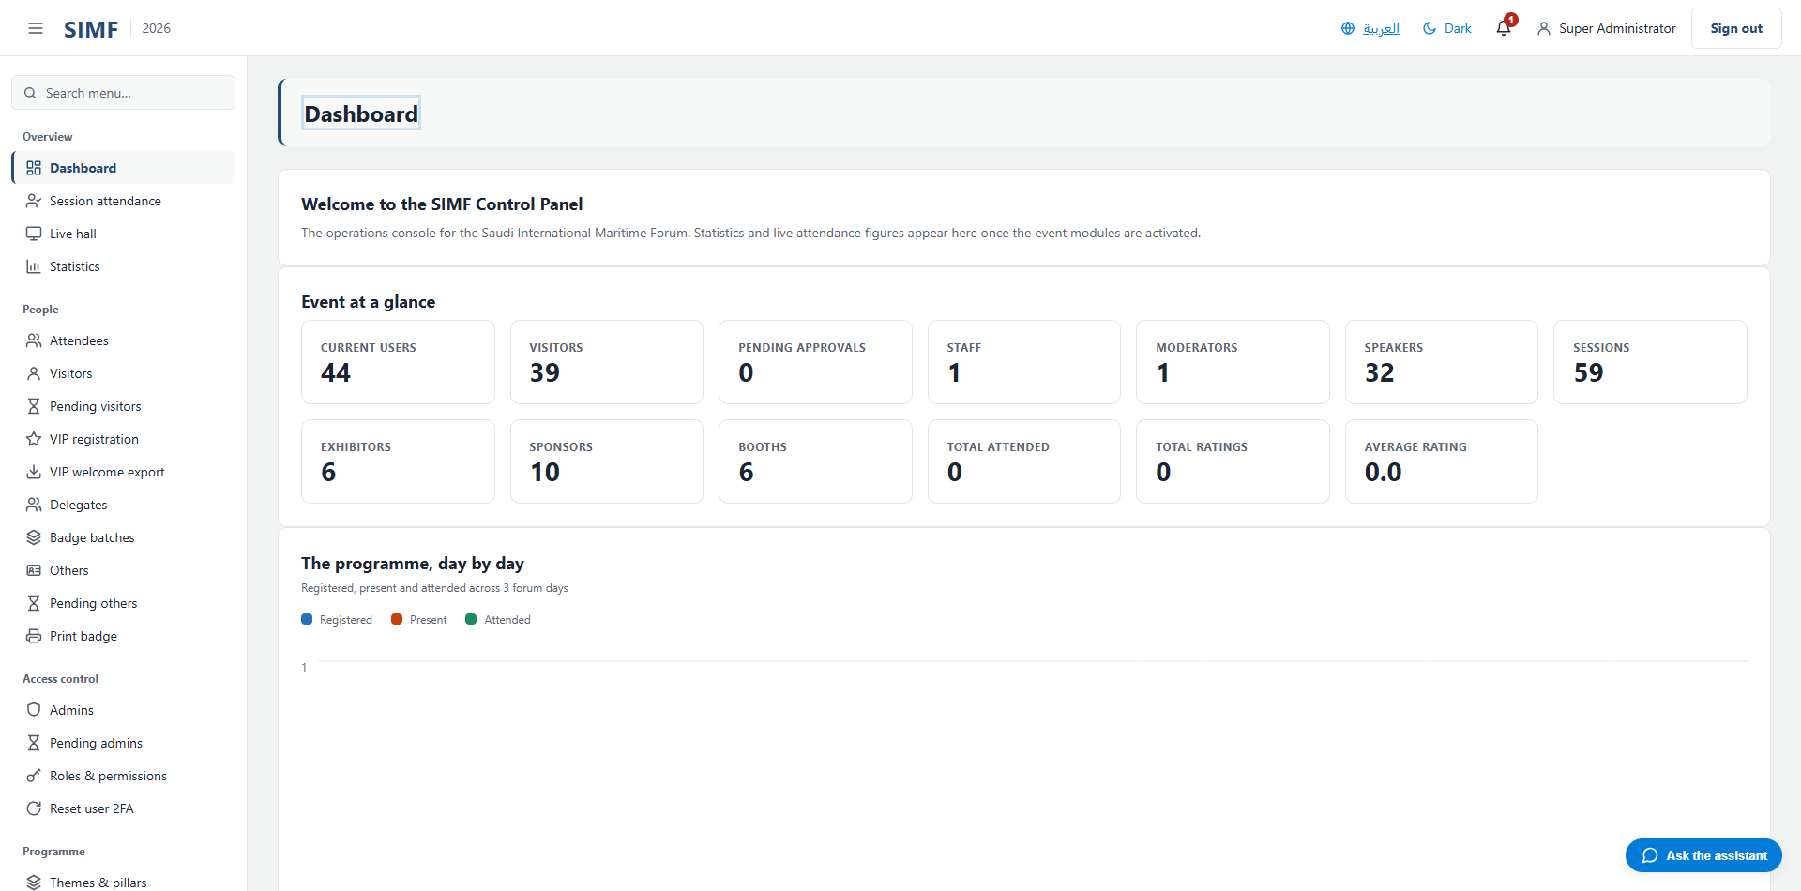
Figure 5 — The dashboard after signing in.

Creating a user by hand
The Control Panel creates three kinds of account, and they are not variations of one form — they are three separate pipelines with different screens, different fields, different rules and different outcomes. Choosing the wrong one is the most common mistake, so this chapter starts with how to choose.
To create | Use | Address | The account ends up
An operator of this Control Panel | Admins | /admin/admins | Awaiting approval, with a 7-day emailed invitation
A visitor or guest attending the forum | Visitors | /admin/visitors | Awaiting approval, with no password and no email
A partner, exhibitor, media or staff account | Others | /admin/others | Awaiting approval, always — never auto-approved
A VIP or VVIP guest | VIP registration | /admin/visitors/vip | As a visitor, plus the VIP protocol fields

The distinction that matters: an administrator receives an emailed invitation and sets a password. A visitor or partner receives neither — their credential is the QR badge, and the badge is only minted when the account is approved.

Creating an administrator
An administrator is somebody who signs in to this Control Panel. Open the menu group Access control, choose Admins, and use the Add button on the grid toolbar. The form is deliberately short — an administrator has no visitor profile, no badge and no identity documents.
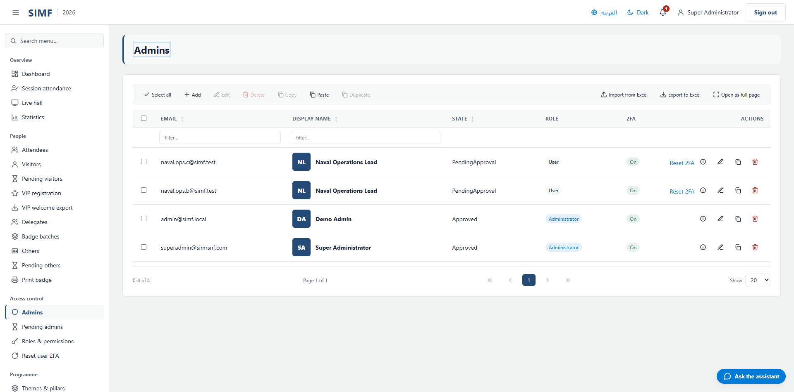
Figure 6 — The administrators list. The Add button opens the create form.
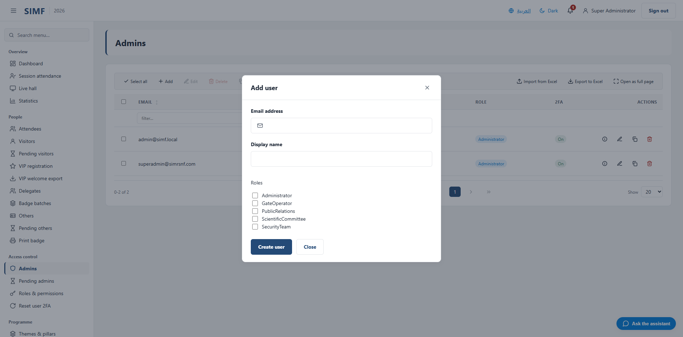
Figure 7 — The create form: an email address, a display name, and one tick box per role.
Field | Required | Limit | Rule the server enforces
Email address | Yes | 256 characters | Must be a valid email address, and must not already belong to an account.
Display name | Yes | 2 to 128 characters | The name shown throughout the Control Panel.
Roles | No | — | One tick box per role. Assigning a role here requires the role-assignment permission as well as the create permission.

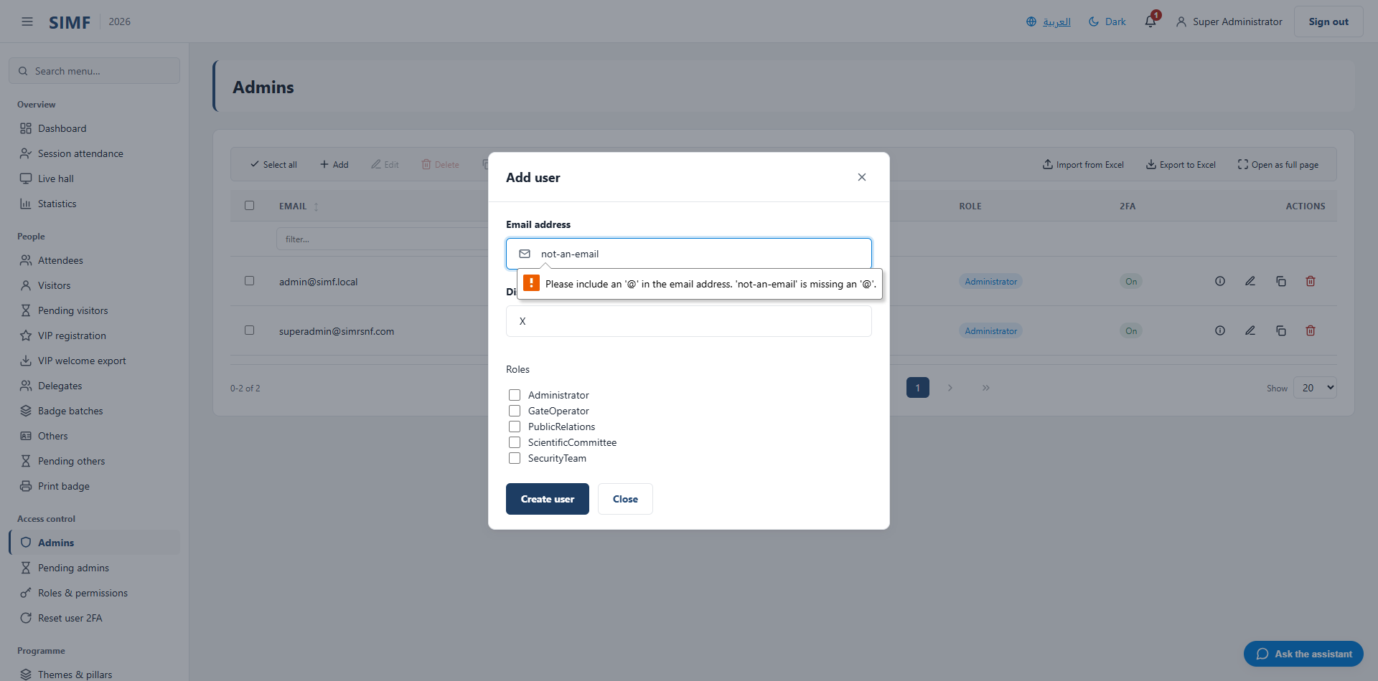
Figure 8 — A refused submission. The email box is a typed field, so the browser catches a malformed address before the form is sent at all; the form's own checks report a short display name and a missing address the same way, and nothing reaches the server until both are right.
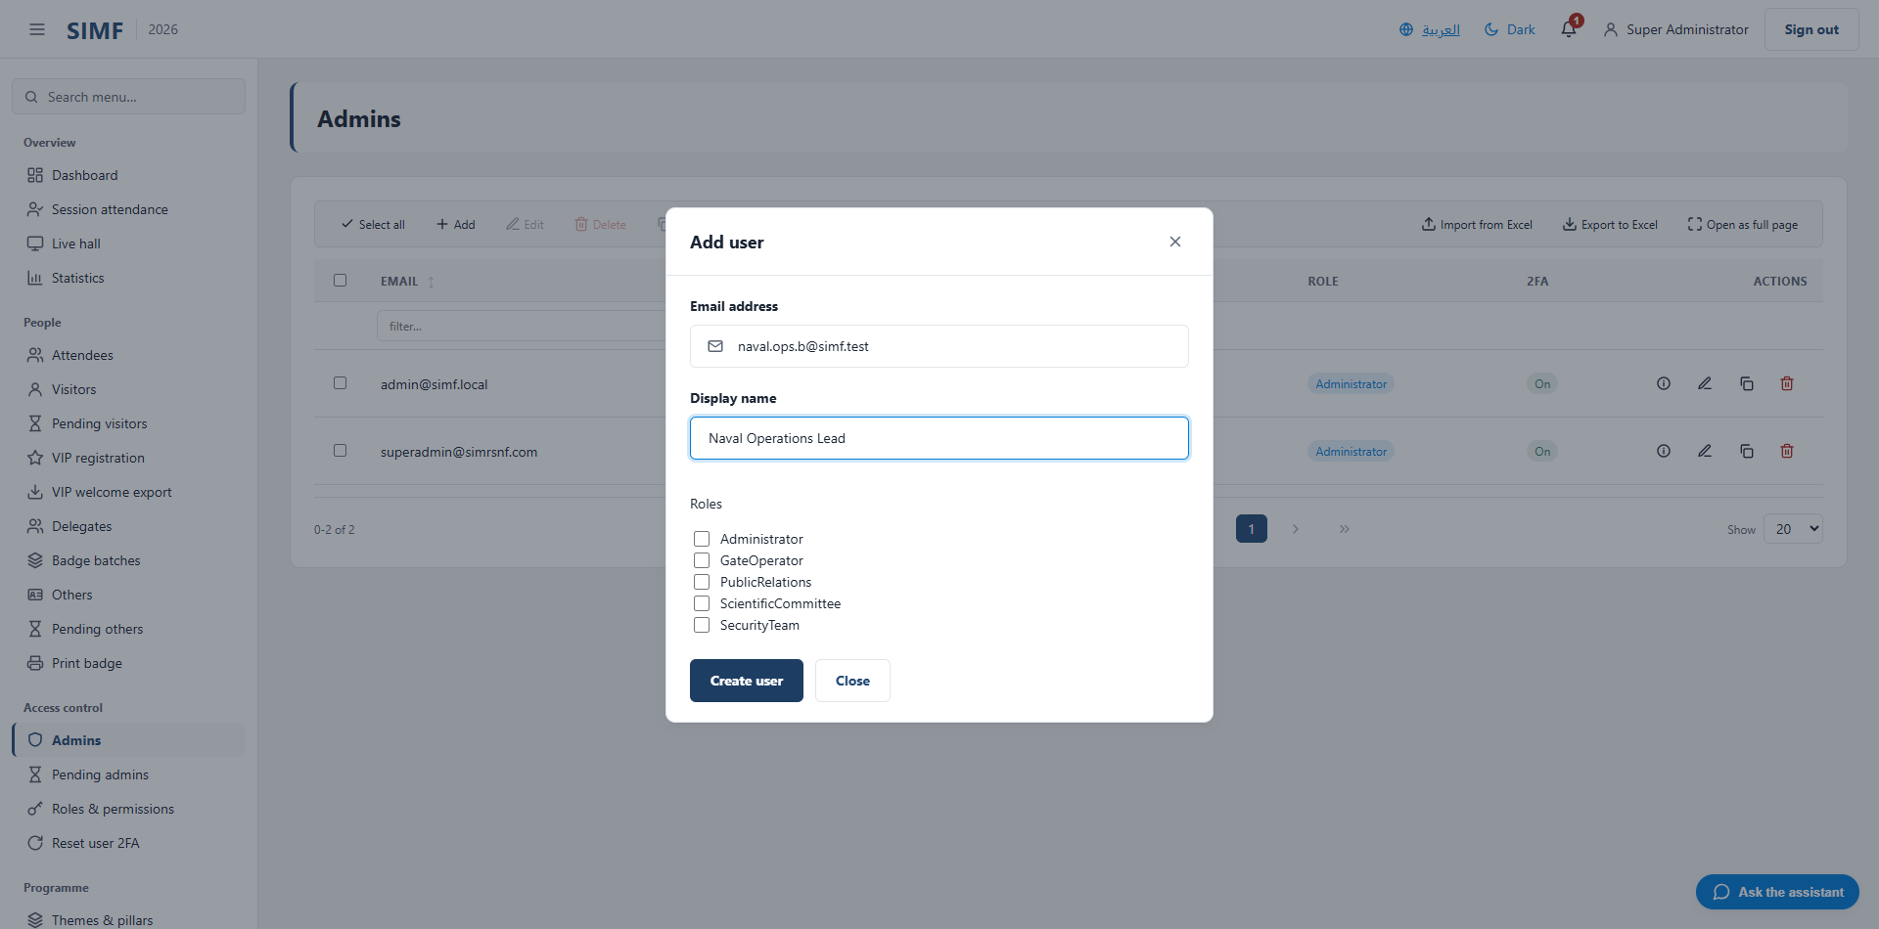
Figure 9 — The same form filled in and ready to submit.
On save the account is created in the awaiting-approval state, an invitation valid for seven days is emailed to the address, and every other approved administrator is notified that an account is waiting. Two-factor is armed on the account from the moment it is created, so the new administrator will be taken through the pairing screen on their first sign-in.
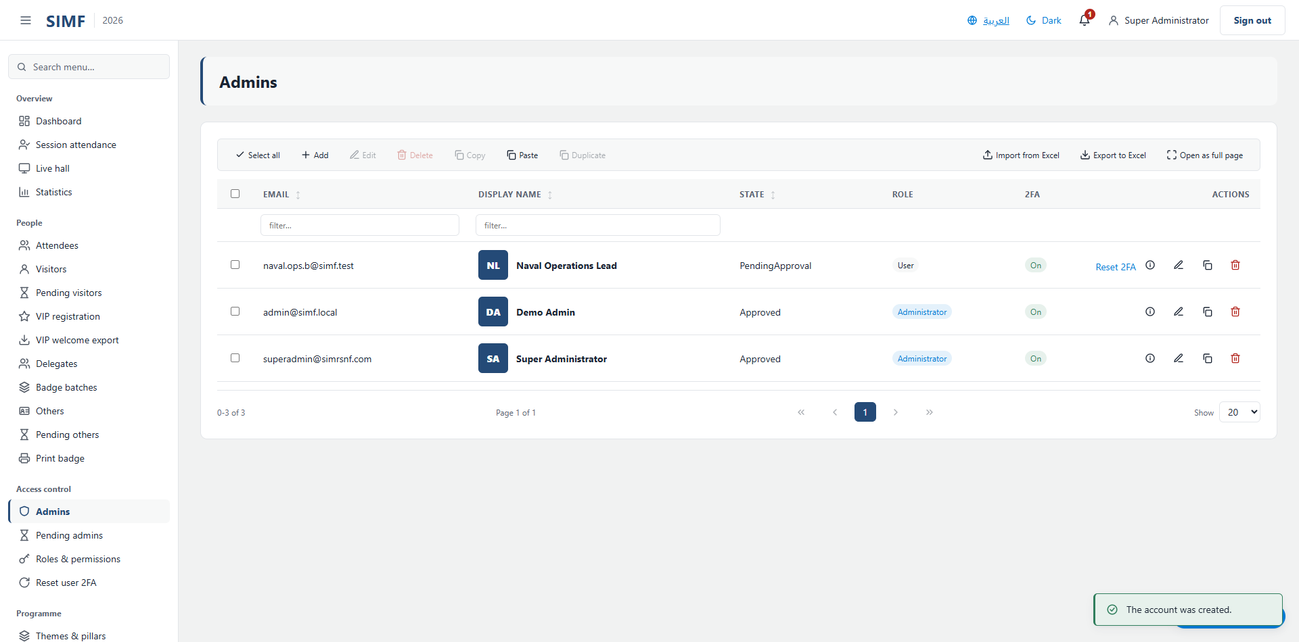
Figure 10 — The new account in the list, awaiting approval, with the confirmation message.
A duplicate email is refused with the error ADMIN_EMAIL_ALREADY_REGISTERED and the form stays open. If the mail server is not configured the account is still created — only the invitation fails to arrive, and it fails quietly, in the background.

Creating a visitor
A visitor is an attendee. The form is the on-site registration desk wizard, and it is long because it captures the identity the gate will check. It is organised into numbered sections; the fields that appear depend on two choices — the profile type, and whether the visitor is Saudi.
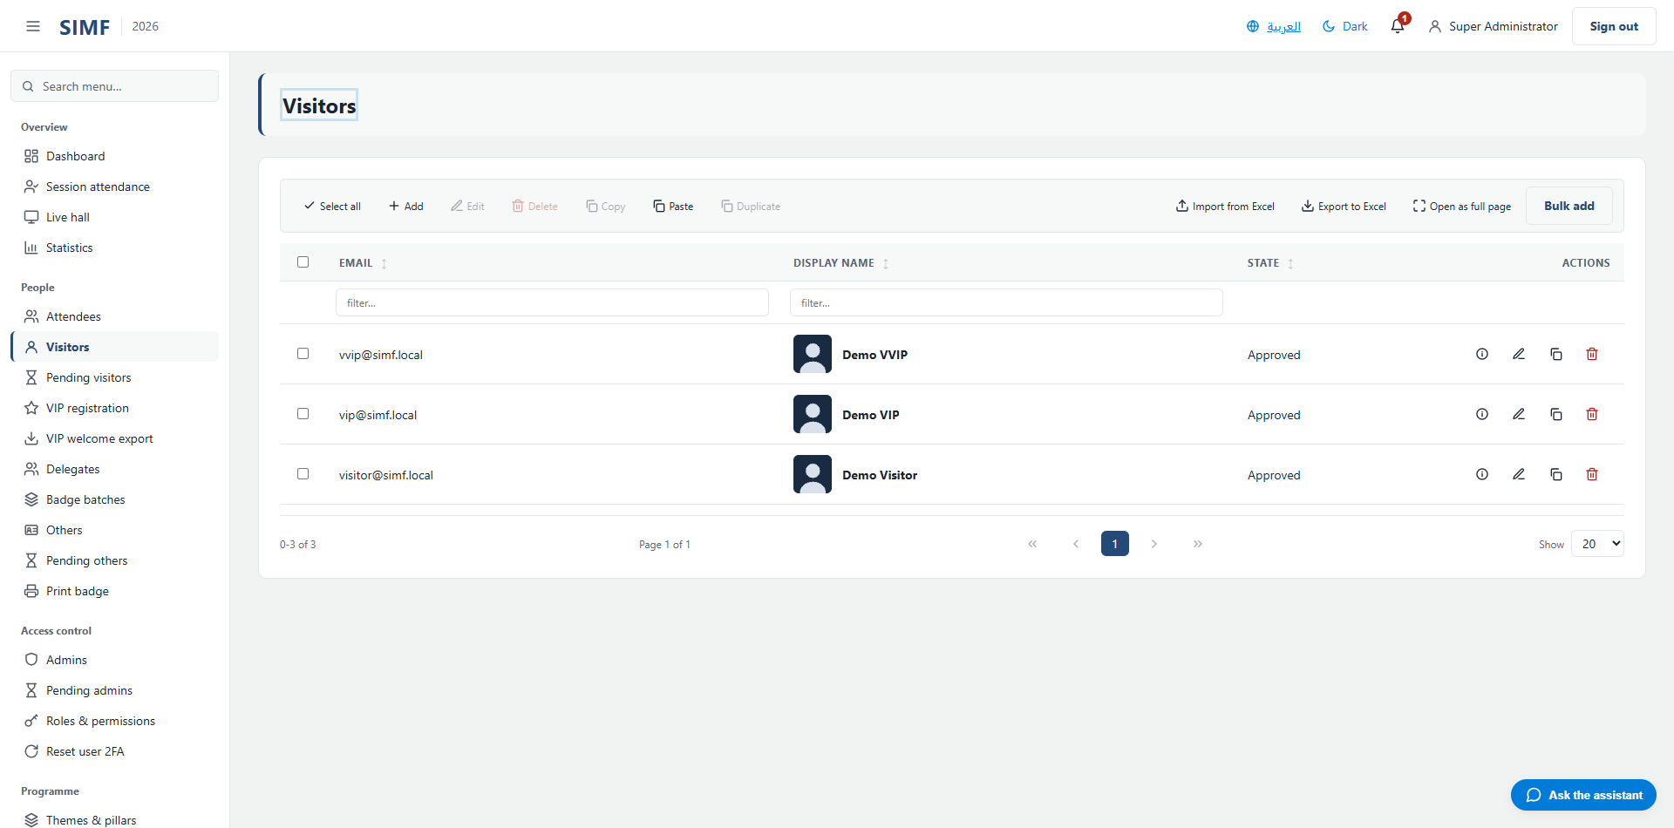
Figure 11 — The visitors list. Add opens the registration wizard.
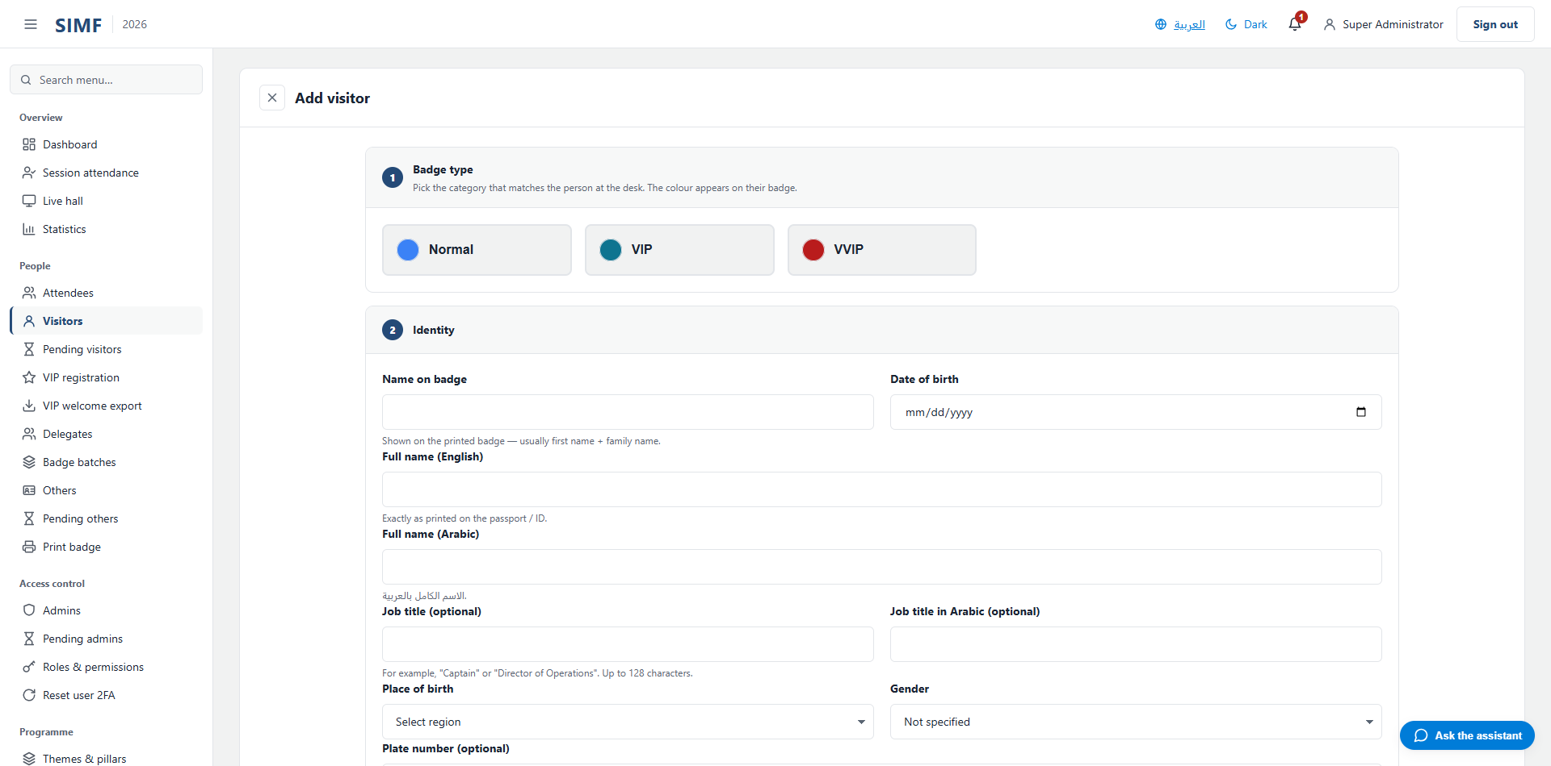
Figure 12 — The wizard opens on the profile type, which decides much of what follows.
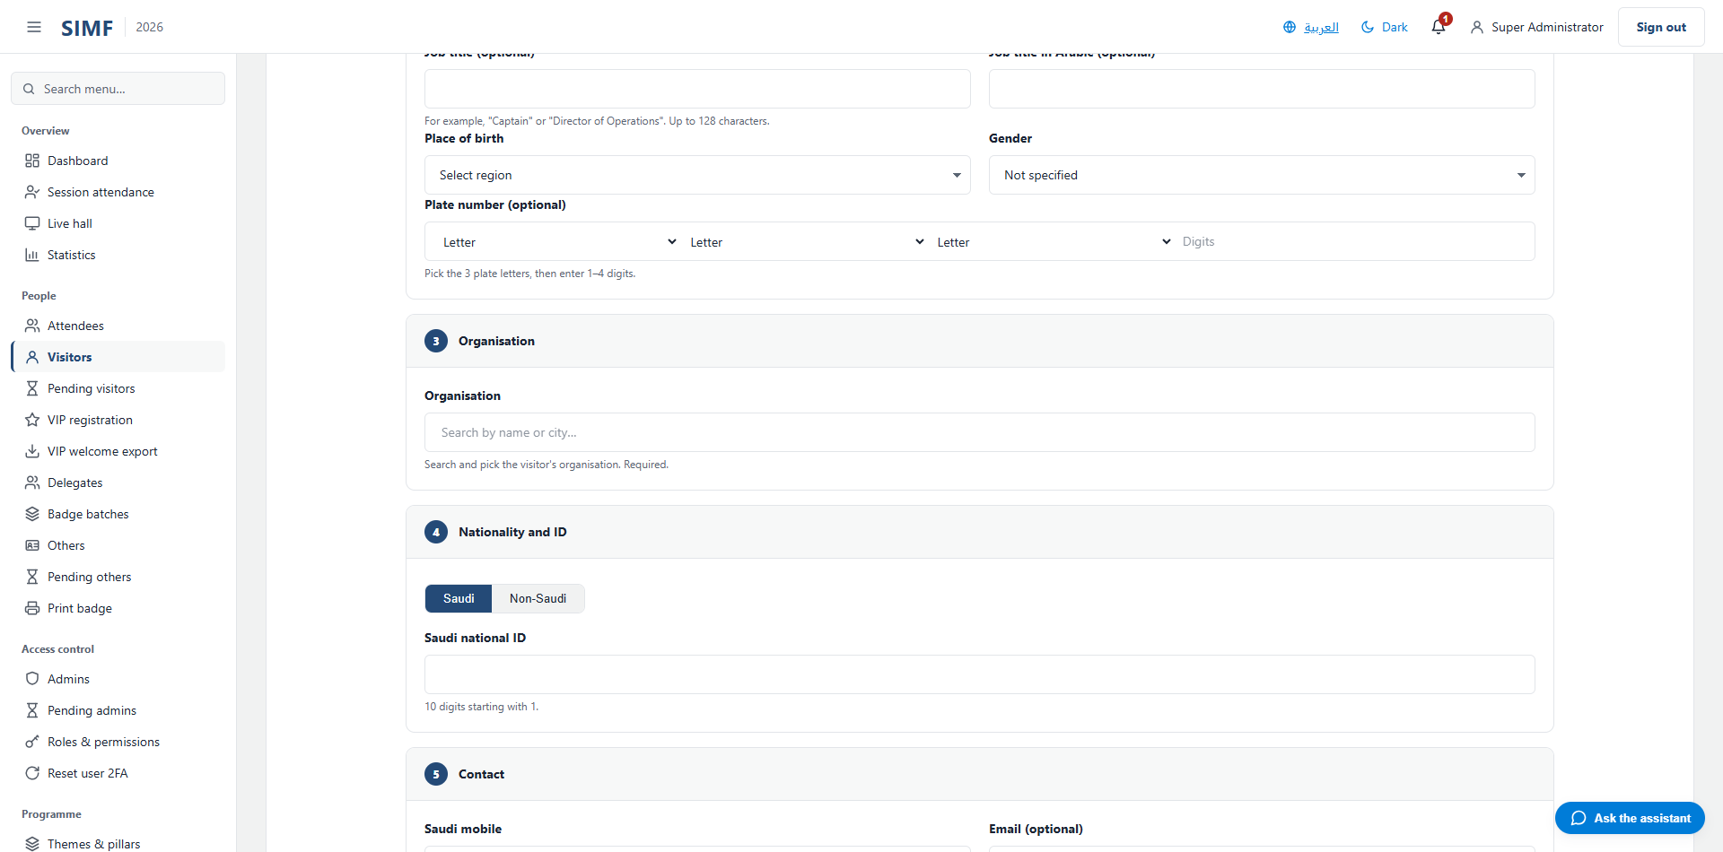
Figure 13 — The identity section.

Identity
Field | Required | Limit | Rule the server enforces
Name on badge | Yes | 128 characters | —
Full name (Arabic) | No | 50 characters | The form allows 128 characters; the server rejects anything over 50. Keep to 50.
Full name (English) | No | 50 characters | Same 128-versus-50 mismatch as the Arabic name.
Job title (optional) | No | 100 characters | —
Job title in Arabic (optional) | No | 100 characters | —
Place of birth | No | 128 characters | A region picker for a Saudi visitor; free text otherwise.

Nationality and identity document
Field | Required | Limit | Rule the server enforces
Saudi national ID | No | 10 digits | Saudi visitors. Must start with 1 and pass the check-digit test; a number that fails it is refused.
Iqama number | No | 10 digits | Non-Saudi residents. Must start with 2 and pass the same check-digit test.
Passport number | No | 20 characters | Length only — the desk applies no format check, so a passport the mobile application would reject is accepted here.

One profile may hold one document of each kind. The same number may appear on more than one profile — the constraint that once made a number unique across all profiles was removed deliberately, because it blocked legitimate registrations.
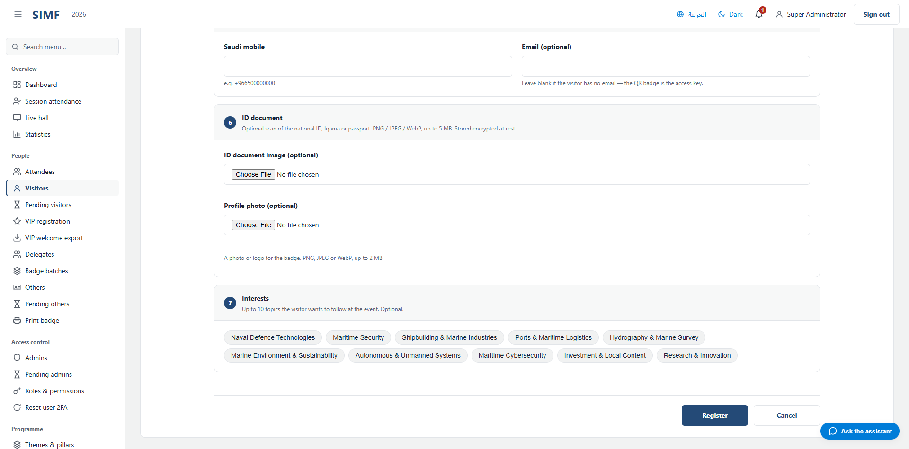
Figure 14 — The nationality section, which decides whether a national ID, an Iqama or a passport is asked for.

Contact and organisation
Field | Required | Limit | Rule the server enforces
Saudi mobile | No | 32 characters | Must be 05XXXXXXXX or +9665XXXXXXXX.
International mobile | No | 32 characters | Must be the international format: a plus sign, the country code, then the number.
Email (optional) | No | 256 characters | —
Organisation | Yes | 150 characters | Chosen from the organisation list. If the employer is not listed, pick the "Other" entry and type the name — this is why that entry exists.


Figure 15 — The lower sections: contact, the identity document and the profile photo.
Interests are offered for visitors only, and at most ten may be chosen.
On save the visitor is created awaiting approval, with no password and no badge. The badge is minted when the account is approved from the pending queue. There is a configuration option that approves a walk-in visitor immediately and prints the badge at the desk, but it ships switched off, and it never applies to partner accounts.

Creating a partner or staff account
The Others page uses the same wizard as the visitor page, with two differences: there is no interests section, and the account is never approved automatically. Every account created here waits for a person to approve it.
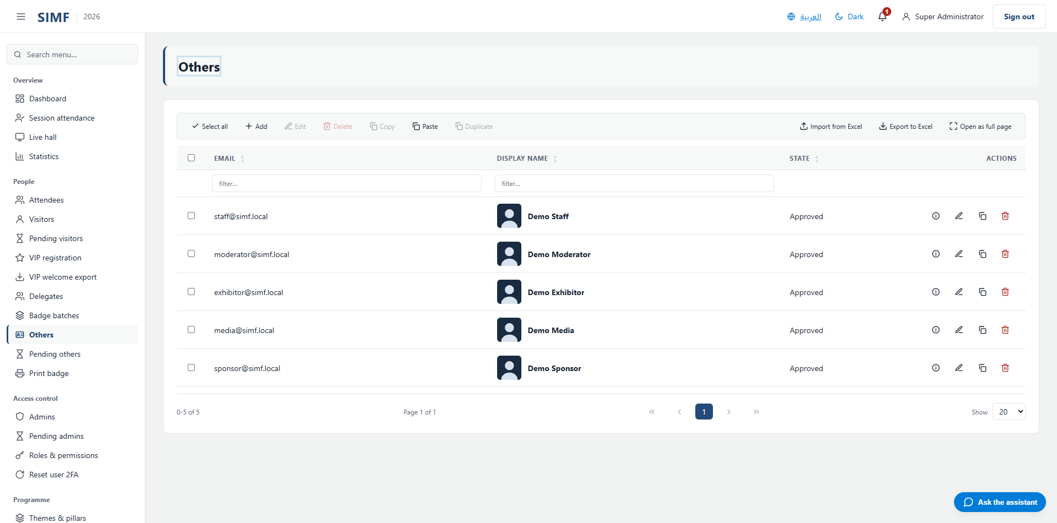
Figure 16 — The partner and staff accounts list.
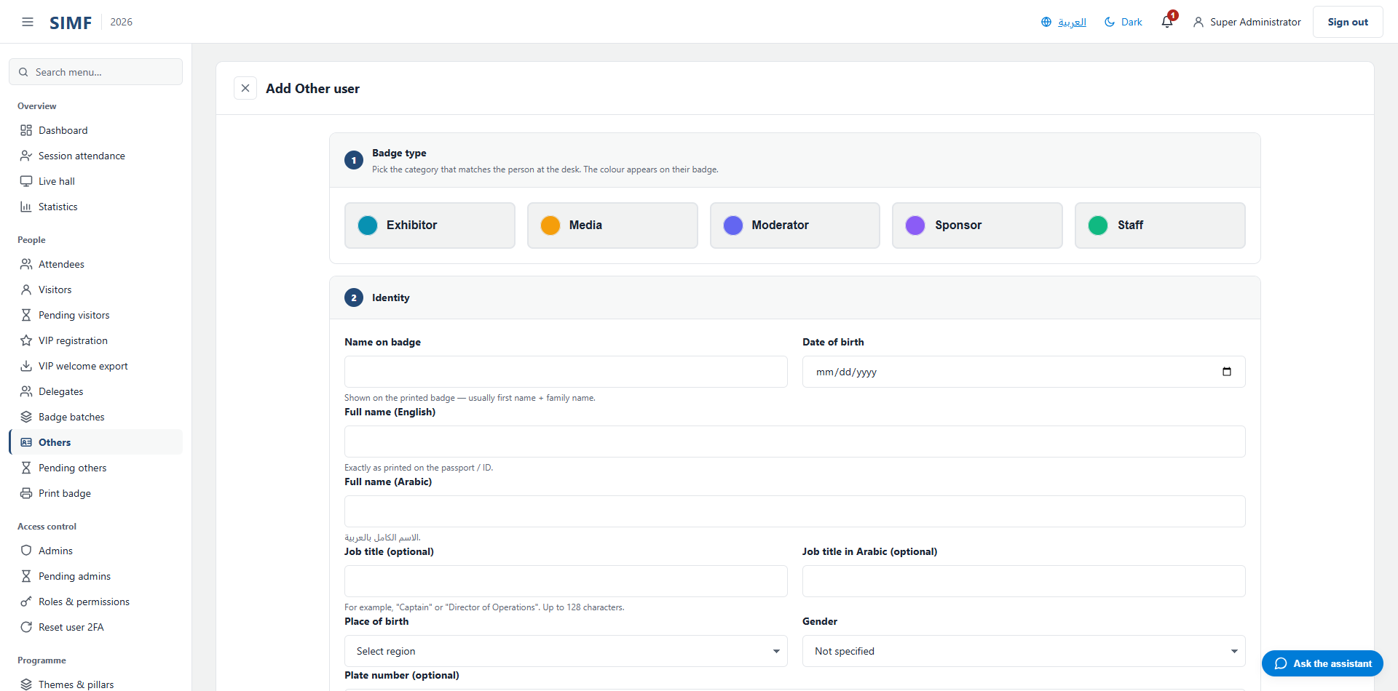
Figure 17 — The same wizard, without the interests section.

Registering a VIP
The VIP page is the visitor wizard with a protocol section added at the top, and a welcome photo alongside the profile photo.
Field | Required | Limit | Rule the server enforces
Mawj system ID (optional) | No | 64 characters | —
Honorific / title (optional) | No | 64 characters | —
Honorific / title in Arabic (optional) | No | 64 characters | —
Preferred language (optional) | No | 16 characters | Arabic or English.

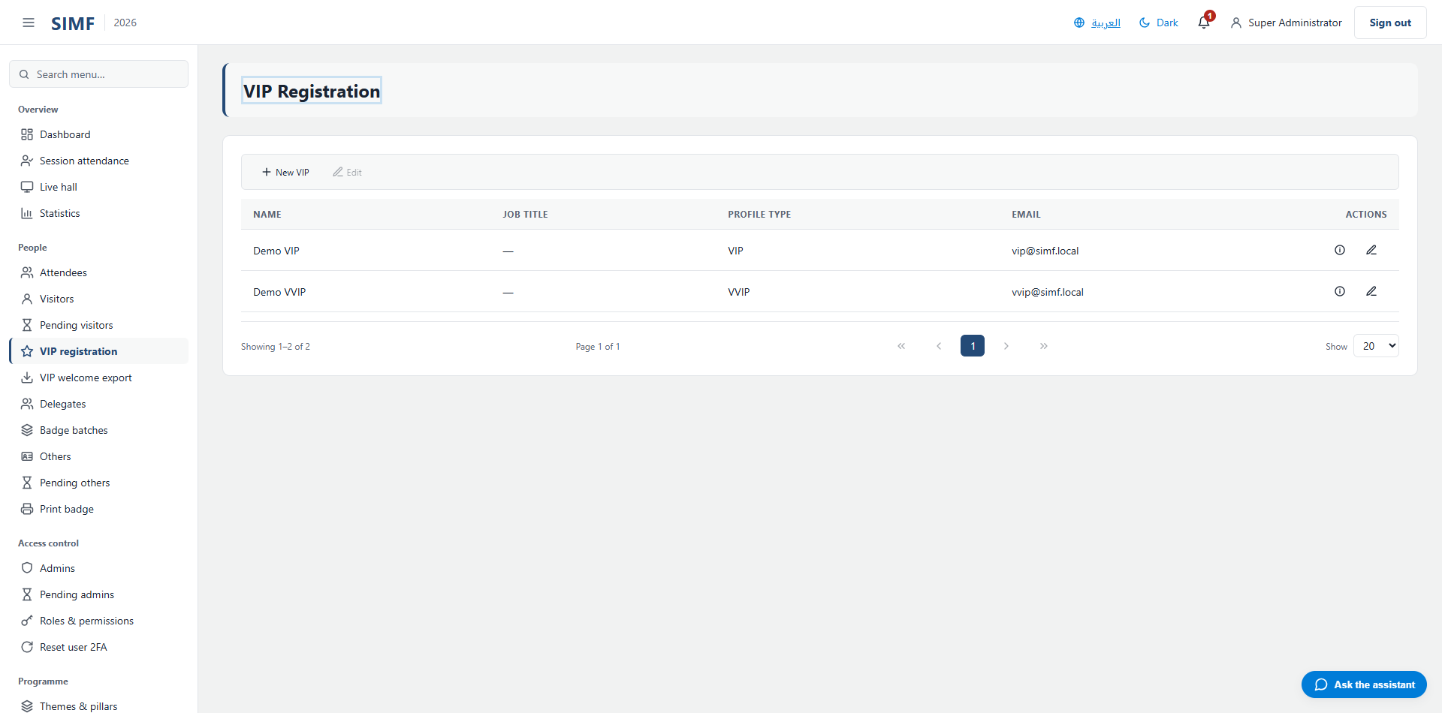
Figure 18 — The VIP registration page.
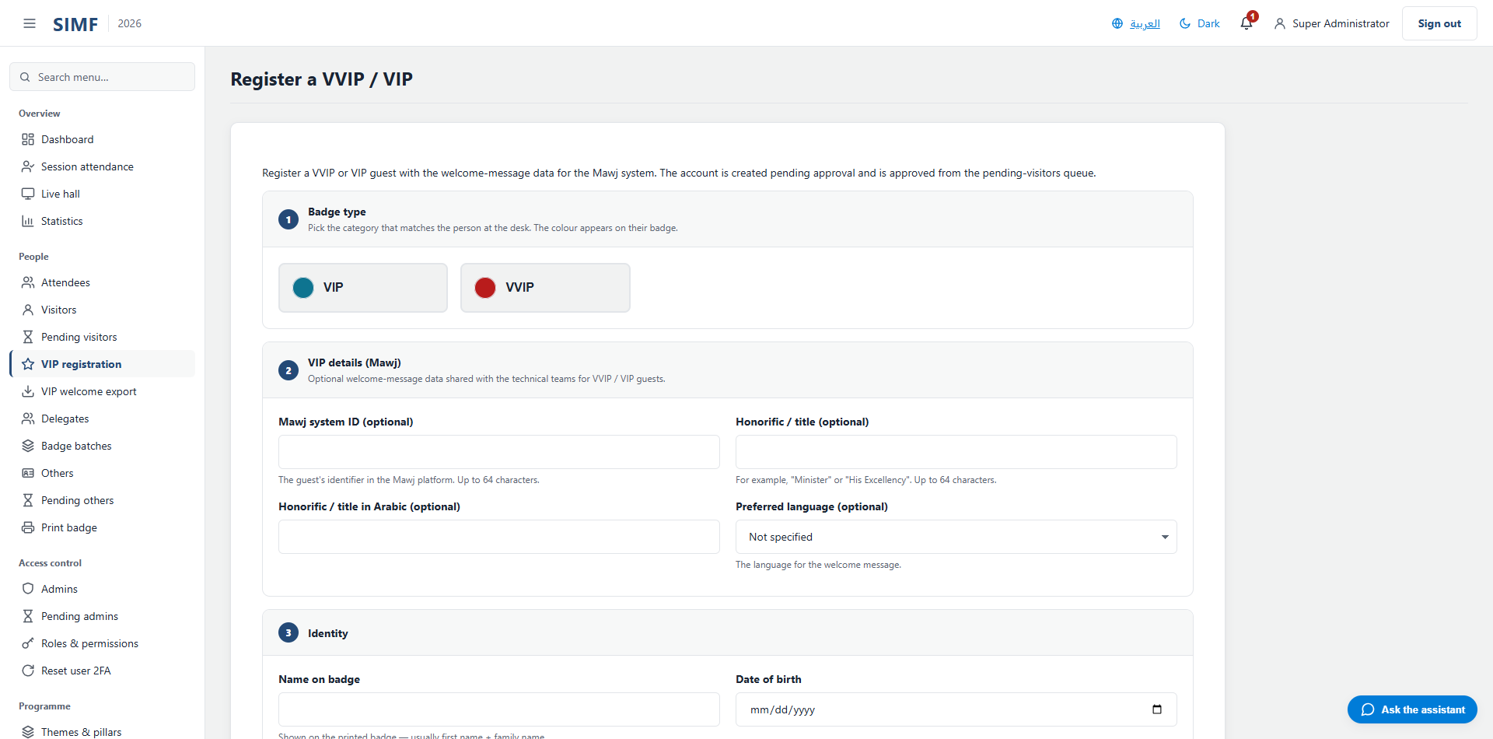
Figure 19 — The VIP wizard, with the protocol section above the identity section.

The profile picture
A profile picture is stored in the system's central file store, encrypted, and served back only to the account itself or to an administrator holding the right permission. It is not a file sitting in a public folder, and it cannot be reached by guessing an address.

Where a picture is set
- By the account owner, from My profile — this is the only place with a cropping tool.
- By an administrator, on the edit form of a visitor or partner account.
- By the registration desk, as part of the create wizard, alongside the identity document.
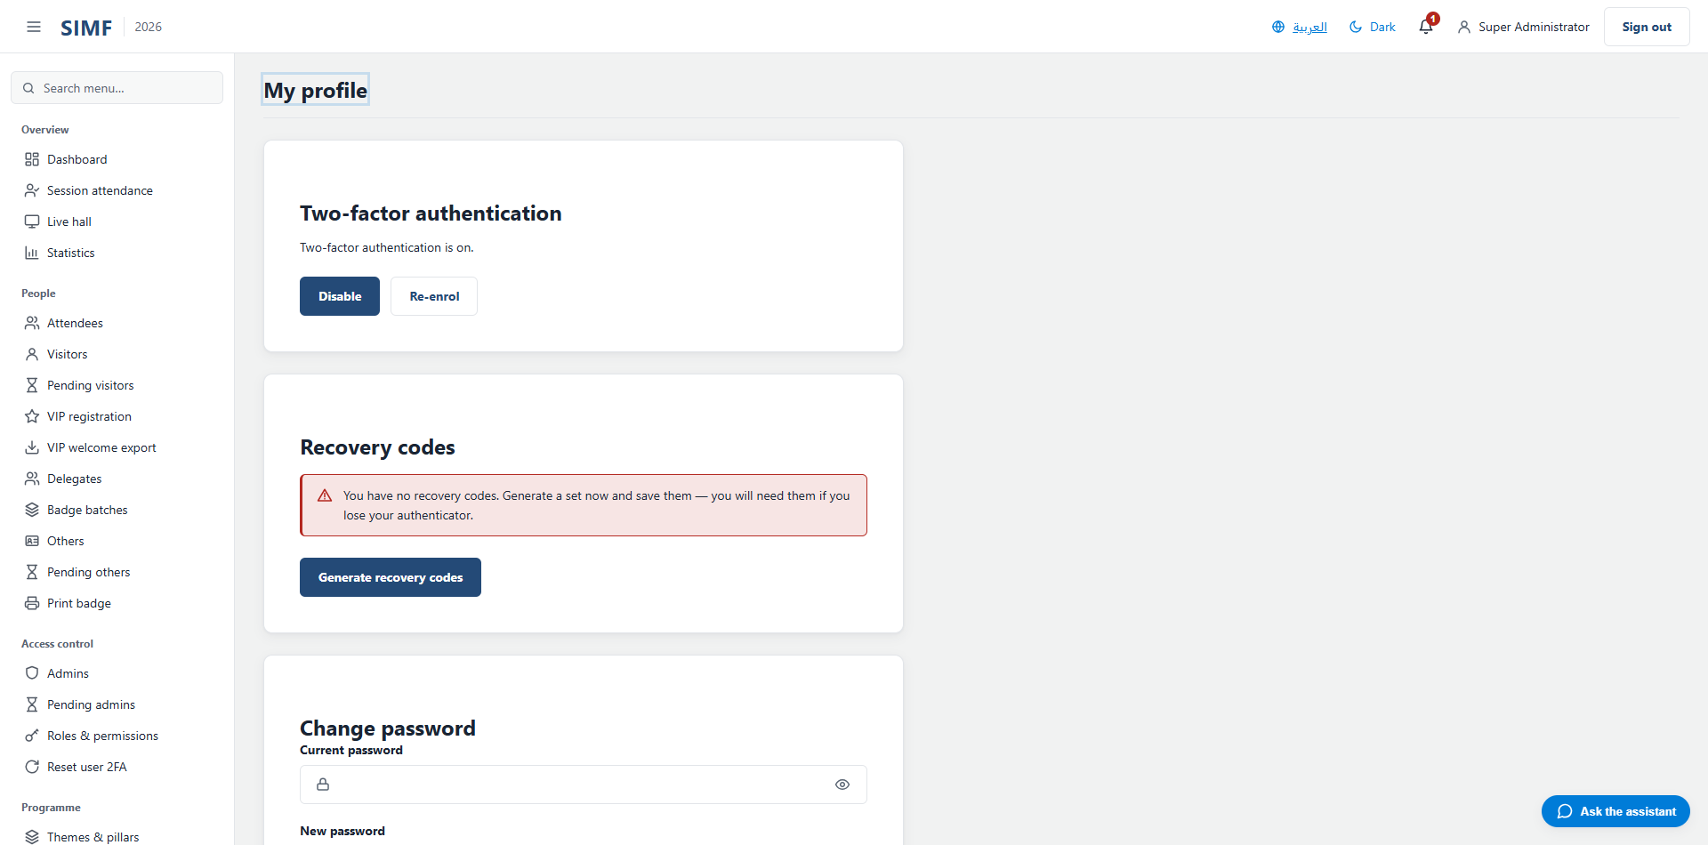
Figure 20 — My profile, where an account sets its own picture.

What the system accepts
Rule | Value
File types | PNG, JPEG or WebP — nothing else
Maximum size | 2 MB for a profile picture; 5 MB for an identity document
Checked how | The file's declared type must match its actual content, so renaming a file to .png does not get it past the check
Cropping | Square, produced at 400 by 400 pixels
Stored | Encrypted, one active picture per account

There is no size check in the browser: an oversized file is uploaded and then refused by the server, so the failure appears after the wait rather than before it.

Replacing and removing
Uploading a new picture retires the previous one in the same step; there is never more than one active picture on an account. Where an account has no picture the Control Panel shows a tile with the person's initials rather than a broken image, so an empty grid cell means no picture was ever set.

Changing an account after it exists
A new account is not usable yet. It waits in a queue until somebody approves it, and only then does it get its badge. This chapter covers the approval queues, editing an account, moving it between types, resetting a lost second factor, and withdrawing access.

The approval queues
There is one queue per kind of account, and each is a separate page with its own permissions. Approving is what mints the QR badge, so until it happens the person cannot pass a gate.
Queue | Address | Approve needs | Reject needs
Pending visitors | /admin/visitors/pending | Visitors.Approve | Visitors.Reject
Pending others | /admin/others/pending | Others.Approve | Others.Reject
Pending admins | /admin/admins/pending | Admins.Approve | Admins.Reject

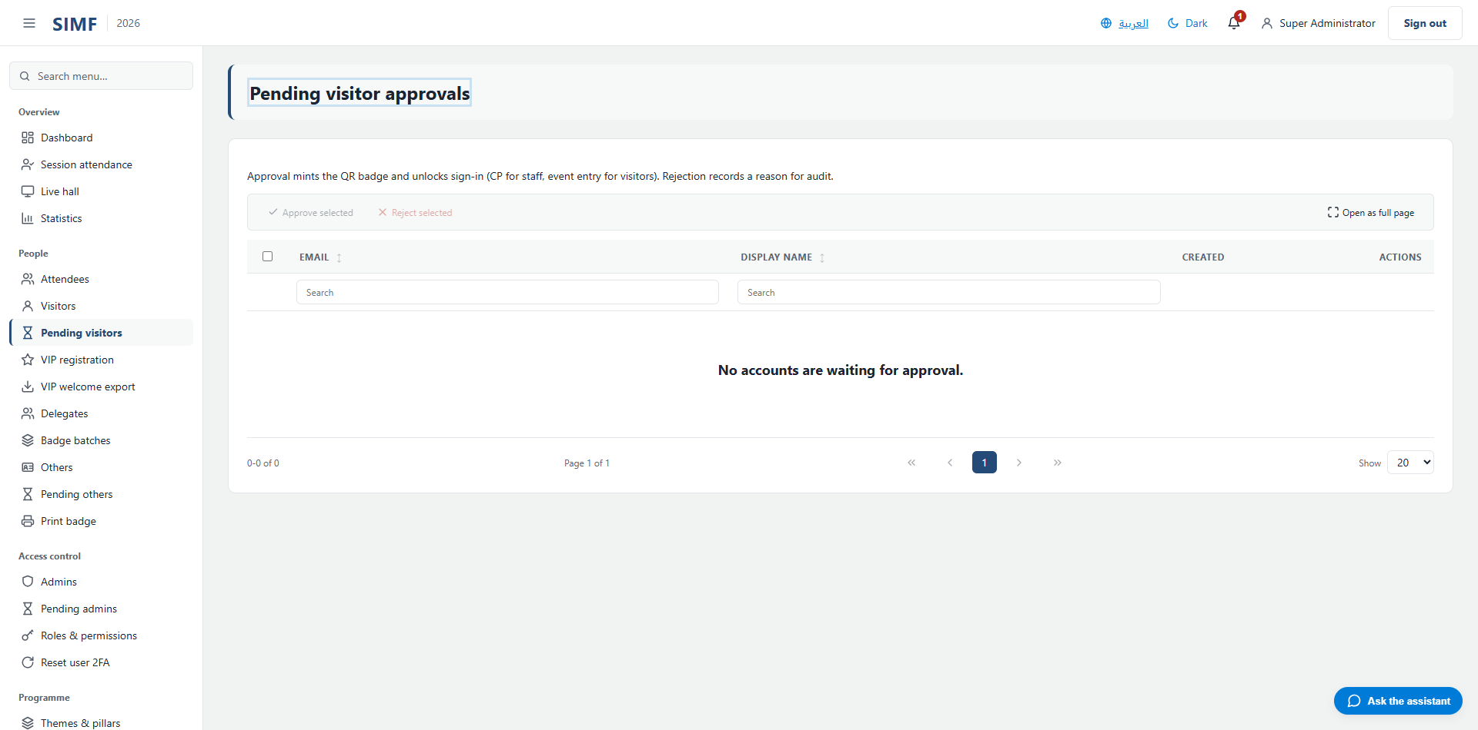
Figure 21 — The pending visitors queue.
Rows can be handled one at a time or in bulk. Rejecting requires a written reason of between 10 and 500 characters, and the button stays disabled until the reason is long enough. The reason is audited, so write something a colleague reading it in six months can act on.
When approving a visitor you may also set the tier at the same time, which saves editing the account afterwards.

Editing an account
The edit form is reached from the row actions on any of the account lists. It changes the email address, the display name, the profile type, the nationality, the two mobile numbers, the meeting preferences and the pictures. It does not change the password — nobody can set another person's password; the account resets its own from the sign-in page.
For a partner or staff account the profile type is required, and the form will not save without one. For a visitor it is optional.

Moving an account between types
An account created in the wrong pipeline does not have to be deleted and rebuilt. The account details view carries a change type control, gated by its own permission, which moves the account between the visitor and partner sides and asks for the profile type it should land on.

Resetting a lost second factor
When somebody loses the phone holding their authenticator, and has no recovery code left, an administrator clears the second factor from Reset user 2FA. The person then pairs a new authenticator on their next sign-in.
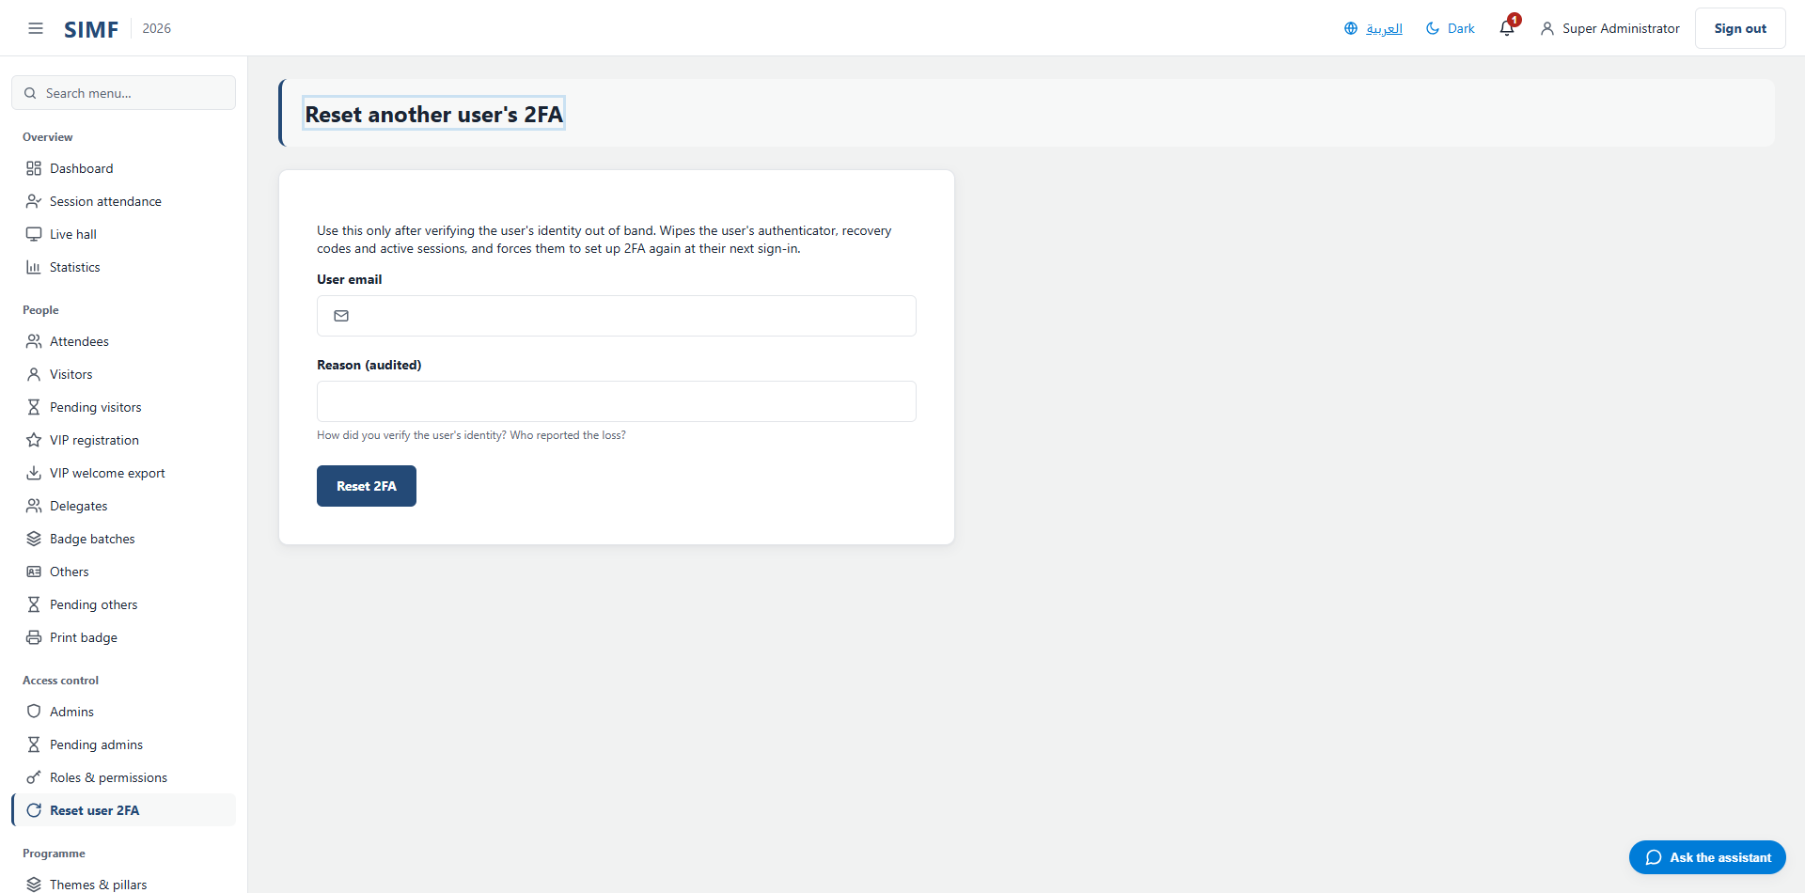
Figure 22 — Resetting a user's second factor.
- A reason is required, 10 to 500 characters, and it is audited.
- You cannot reset your own second factor here — use a recovery code, or ask another administrator.
- You cannot reset another administrator's second factor. The most privileged accounts are re-paired through configuration on the server, deliberately, so that no single administrator can take over another.

Withdrawing access
Delete on an account list is not a deletion. It disables the account, revokes its sessions and notifies the person by email. The row action and the bulk action open the same dialog, which asks for an audited reason of 10 to 500 characters.
Your own row is skipped if you include it, and the result reports it as skipped rather than failing — so a bulk action that reports one fewer than you selected is usually this.

Roles and permissions
What an administrator can see and do is decided by permissions, and permissions are granted to roles, never to a person. To give somebody an ability you put them in a role that holds it. This is the whole model, and it has one deliberate exception: the Administrator role holds a wildcard that grants everything.

Permission names
A permission is written as the page it governs, a full stop, and the action — Visitors.Approve, Roles.AssignPermissions, Admins.ResetTwoFactor. Two permissions guard every page: one lets the page open at all, and one puts it in the menu. They are usually the same, and where they differ the manual's page reference lists both.
A button is gated by the permission of the endpoint it calls, which is not always the page's own. On a page holding two grids over two different things they differ, and on the partner queue the bulk approve and the per-row approve are gated separately because the server gates them separately.

Creating a role
Open Roles and permissions and use Add. A role needs only a name, between 1 and 64 characters, and the name must be unique. A new role starts with no permissions at all, so it grants nothing until permissions are assigned to it.
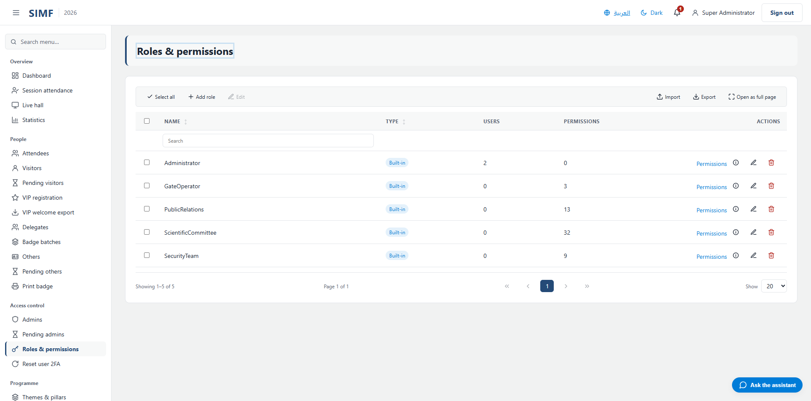
Figure 23 — The roles list.

Granting permissions to a role
The permissions editor lists every permission in the system, grouped by the page it governs, with the ones the role already holds ticked. Tick, untick, and save.
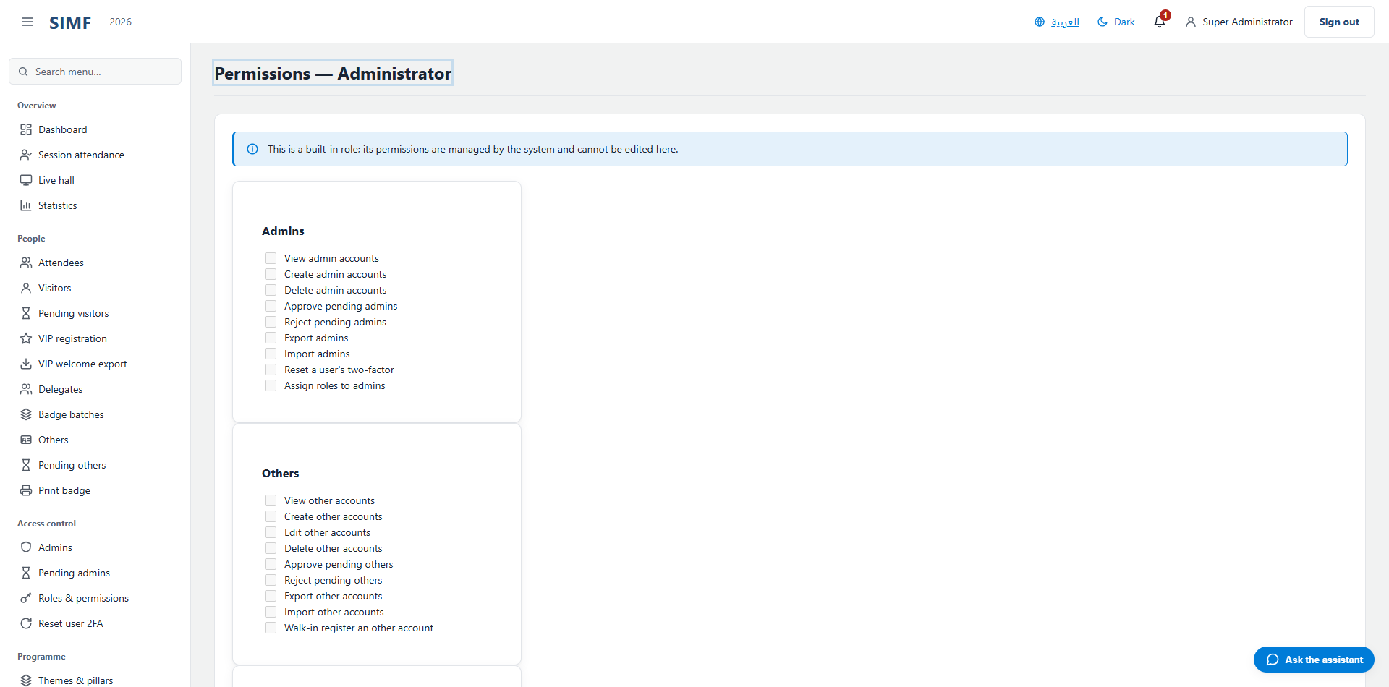
Figure 24 — The permissions editor for one role.
The baseline roles that ship with the system are read-only here. They cannot be edited, renamed or deleted, because the system's own behaviour depends on them.

Giving a person a role
Roles are assigned to administrators only — a visitor or partner account carries none, because it does not sign in to this Control Panel. Assign them either when creating the administrator, or afterwards from the Edit action on the administrators list.

Figure 25 — The administrators list, where roles are assigned.

The guards
- The last administrator cannot have the Administrator role taken away. The system refuses, rather than leaving itself with nobody who can administer it.
- A role still held by somebody cannot be deleted; the error says how many people hold it.
- Assigning a role while creating an account needs the role-assignment permission on top of the create permission, so somebody who may add administrators cannot silently make one powerful.

Deploying to a server
SIMF is installed on premises, on Windows Server with IIS and SQL Server. A deployment is three separate things, done in this order: the pipeline copies the built files onto the server, an operator sets that server's configuration, and the application creates or updates its own database the first time it starts. Nothing else creates the database, and nothing in the pipeline sets a single configuration value.

The estate
There are two servers, and each runs all four applications. The single most important thing to know before running a deployment is that the environment names are misleading:
Environment name | What it actually is | Address
SIMF-Prod | PRE-PRODUCTION | simf.zagali-ict.com
SIM-RNSF | PRODUCTION | web / cp / api.simrsnf.com

This is not a typo to be corrected. Those are the names as registered, and the one that reads like production is not. Anyone who "fixes" the mapping on sight deploys straight to production while believing they are rehearsing. Trust the job names in the pipeline, never the environment string.

The four applications
Application | IIS site | Folder on the server | Public address
API | SIMF.API | D:\System\v1.0.1\api | api.simrsnf.com (internal)
Control Panel | SIMF.CP | D:\System\v1.0.1\cp | cp.simrsnf.com
Website | SIMF.WEB | D:\System\v1.0.1\web | web.simrsnf.com
Mobile edge | SIMF.EDGE | D:\System\v1.0.1\edge | edge.simrsnf.com

The IIS sites and application pools must already exist. The deployment copies files into them; it does not create them. Create them by hand in IIS Manager before the first deployment, with the .NET CLR version set to No Managed Code.

Before the first deployment
- Windows Server with IIS and the ASP.NET Core hosting bundle installed — without the bundle the application pool starts and immediately stops.
- SQL Server, reachable from the application server on port 1433.
- A TLS certificate for each public host name. The one for the API is the one that gets forgotten, because it is internal.
- The host time zone set to Arab Standard Time.
- Write access, for each application pool identity, to the log directory and to the file-store directory.
- For the Flutter web bundle only: the IIS URL Rewrite and Application Request Routing modules, with proxying enabled.

The order of a deployment
- The pipeline builds all four applications and publishes them as one artefact.
- It confirms the target machine, and refuses to continue if the machine is the one named as forbidden for that job — this is what stops a pre-production run reaching production.
- For each application in turn — API first, edge last — it stops the site and its pool, mirrors the files into place, and starts them again, proving both reached the started state.
- The operator then runs that server's configuration scripts as an administrator.
- The operator restarts IIS. Recycling the pool is not enough: the worker process inherits its environment from the service that launched it, so a recycled pool keeps the old values.
- The API is started; it creates or migrates both databases and seeds the first administrator.

The databases
There are two, deliberately kept apart: one holds accounts, roles and permissions, the other holds everything else. There is no manual migration step — the API applies its own migrations at startup, and it applies them to the second database before the first. That order is required, not incidental.
Booting the API against an empty database creates it. Content — the programme, the speakers, the news, the sponsors and the archive — is applied separately, by hand, from the seed scripts. One step in that process is copying the speaker photographs into the file store; without it every photograph returns not-found while the database rows look perfectly healthy.

The first administrator
The system creates exactly one administrator on first boot, from configuration. Its email, its starting password and its authenticator secret are all configuration values. Once it has signed in, change the password, pair a fresh authenticator, and then change those configuration values to new throwaway ones. That last step is the line between deployed and secure.
Two traps. If the configured password or email is blank the seeder writes no administrator, logs the reason, and the system starts up perfectly healthy — every sign-in then fails with nothing visibly wrong. And a password containing a run such as 12345 is rejected by the password rules, with exactly the same silent outcome.

Every configuration value
Configuration reaches the applications as machine-wide environment variables set on the server. The files shipped inside each application carry only non-secret defaults, and they are overwritten by every deployment, so nothing that matters may be edited there.

How a variable name is built
Each application reads its own prefix, and a colon in the setting name becomes a double underscore in the variable name.
Application | Prefix | Example
API | SIMF_API_ | SIMF_API_ConnectionStrings__SimfAppDb
Control Panel | SIMF_CP_ | SIMF_CP_Api__BaseUrl
Website | SIMF_WEB_ | SIMF_WEB_Api__BaseUrl
Mobile edge | SIMF_EDGE_ | SIMF_EDGE_ReverseProxy__KnownProxies__0

A bare SIMF_ prefix binds to nothing. Worse, each application refuses to start if it finds variables using that retired prefix, naming them in the error — so an upgraded server must have the new variables written first and the old ones cleared afterwards, never the other way round. The one exception is ASPNETCORE_ENVIRONMENT, which is read before any prefix applies and stays unprefixed on every host.

How to set one
From an elevated PowerShell prompt on the server, machine scope, then restart IIS so the worker process picks up the new environment block:
[Environment]::SetEnvironmentVariable(
'SIMF_API_ConnectionStrings__SimfAppDb',
'Server=...;Database=SIMF_App;...',
[EnvironmentVariableTarget]::Machine)
iisreset
Recycling the application pool is not enough, and this is the most common reason a correctly set value appears to have no effect.

The values that stop a server starting
Seven values are boot gates: in production, the application refuses to start without its own. This is deliberate — each one protects something that would otherwise fail silently and much later.
Variable | Application
SIMF_API_FileStorage__EncryptionKey | API
SIMF_API_Storage__UserIdDocumentEncryptionKey | API
SIMF_API_Ai__PromptHash__Secret | API
SIMF_CP_DataProtection__KeyRingPath | Control Panel
SIMF_WEB_DataProtection__KeyRingPath | Website
SIMF_EDGE_ReverseProxy__Clusters__api__Destinations__primary__Address | Mobile edge
SIMF_EDGE_ReverseProxy__KnownProxies__0 | Mobile edge

Two of the API's three are encryption keys, and they behave differently under change. The file-store key wraps a per-file key, so it has a rotation path in principle — but the job that finishes a rotation has never been built, so treat it as set once. The identity-document key has no such path at all: changing it strands every encrypted column permanently, with no way back. Escrow both, with the version number stamped alongside the file-store key, before the system carries any real data.
# Generate a 32-byte key, base64-encoded:
openssl rand -base64 32
# The JWT signing key wants more:
openssl rand -base64 48

The API
The API reads by far the most configuration — the connection strings, every key, the mail server, the bootstrap administrator and the AI provider. Its script on a provisioned server carries 82 variables.

Databases
Variable | What it controls | Ships as | Set it to
SIMF_API_ConnectionStrings__SimfIdentityDb | The accounts, roles and permissions database. | empty | Required
SIMF_API_ConnectionStrings__SimfAppDb | Everything else — profiles, programme, gates, meetings. | empty | Required

Both are required. The application throws on the first database access if either is missing — it does not start and then misbehave.

Keys and tokens
Variable | What it controls | Ships as | Set it to
SIMF_API_Jwt__SigningKey | Signs every access token. Also derives the one-time-code and meeting-link hashes, so changing it invalidates those too. | empty | At least 32 bytes; 48 recommended
SIMF_API_Jwt__Issuer | The token issuer name. | SIMF | SIMF
SIMF_API_Jwt__Audience | The token audience name. | SIMF | SIMF
SIMF_API_Jwt__AccessTokenMinutes | How long an access token stays valid. | 5 | 5
SIMF_API_Jwt__SessionLifetimeHours | How long a signed-in session may be refreshed for. | 24 | 24
SIMF_API_Storage__UserIdDocumentEncryptionKey | Encrypts the national ID, Iqama, passport and mobile columns. Cannot be changed once data exists. | empty | A secret — generate one per environment (32 bytes, base64)
SIMF_API_FileStorage__EncryptionKey | Wraps the key of every encrypted stored file. | empty | A secret — generate one per environment (32 bytes, base64)
SIMF_API_FileStorage__KekVersion | The version stamp written into every encrypted file. On a restore the right key under the wrong version fails every read. | 1 | 1
SIMF_API_FileStorage__PreviousEncryptionKey | The superseded key, during a rotation only. | empty | Leave empty
SIMF_API_Ai__PromptHash__Secret | Signs the AI prompt fingerprints. Without it the application falls back to a publicly derivable key. | empty | A secret — generate one per environment

The first administrator
Variable | What it controls | Ships as | Set it to
SIMF_API_SuperAdmin__Email | The bootstrap administrator's address. | superadmin@simrsnf.com | The real address
SIMF_API_SuperAdmin__TempPassword | Its starting password. Must satisfy the password rules, including the no-sequential-run rule. | empty | A secret — generate one per environment
SIMF_API_SuperAdmin__TotpSecret | Its authenticator secret. Without it the most privileged account in the system is protected by a password alone. | empty | A secret — generate one per environment (base32)
SIMF_API_SuperAdmin__PasswordChangeRequired | Force a password change at the first sign-in. | true | true
SIMF_API_Seed__DemoPassword | The shared password of the sample accounts. | empty | Leave empty in production
SIMF_API_Seed__EnableDemoAccounts | Create the sample accounts outside development. | false | false

The sample accounts must not exist on a production system. They are created only in development, or when the switch above is turned on deliberately.

Mail
Variable | What it controls | Ships as | Set it to
SIMF_API_Email__Host | The mail server. | empty | Required
SIMF_API_Email__Port | Its port. | 587 | 587
SIMF_API_Email__User | The mail account. | empty | Required
SIMF_API_Email__Password | Its password. | empty | A secret — generate one per environment
SIMF_API_Email__FromAddress | The address mail is sent from. | no-reply@ammn.com.sa | The verified sender
SIMF_API_Email__FromName | The display name on sent mail. | SIMF | SIMF
SIMF_API_Email__FailureAlertRecipients | Who is told when mail delivery starts failing. | empty | An operations address

Mail failure is invisible from the interface. Sending is queued in the background, so a wrong password does not throw, does not appear on screen, and does not stop an account being created — the messages simply never arrive. Set the alert recipients, and test delivery after every change.
An EMPTY mail host is worse than a wrong one, and this was observed rather than reasoned about. With no host configured the first message to be sent fails in a way the retry logic does not catch, the background sender stops for good, and the health check reports the API as unhealthy from that moment — while the site keeps serving pages normally. If a load balancer is watching that endpoint it will take a working server out of rotation because nobody filled in an SMTP host.

Network and limits
Variable | What it controls | Ships as | Set it to
SIMF_API_ReverseProxy__KnownProxies__0 | The trusted proxy, so a visitor's real address is recovered. | empty | The proxy's IP ADDRESS
SIMF_API_Cors__WebAppOrigins__0 | A browser origin allowed to call the API. Numbered from zero. | empty | Each public site address
SIMF_API_RateLimit__PermitLimit | Requests allowed per address in the window. | 20 | 20
SIMF_API_RateLimit__WindowSeconds | The window, in seconds. | 60 | 60
SIMF_API_Swagger__AllowSwagger | Publish the interactive API documentation in production. | false | false
SIMF_API_FileStorage__RootPath | Where uploaded files are written. | empty | An explicit path that is backed up
SIMF_API_Storage__LogDirectory | Where the log files are written. | logs | An explicit path

The trusted-proxy entry must be an IP address. A host name is read, fails to parse, and is dropped without a word — the setting then looks configured while every visitor shares one rate-limit bucket. If the file-store path is left empty the files land in a default location under ProgramData that nobody chose and that a backup may not cover.

Walk-in desk and offline badges
These govern the on-site registration desk. Every switch ships off, so the desk behaves conservatively until somebody deliberately opens it up for an event day.
Variable | What it controls | Ships as | Set it to
SIMF_API_WalkInMode__Enabled | The desk features as a whole. | false | true on event days
SIMF_API_WalkInMode__ExpiresAt | When the desk switches itself off again. | empty | Blank means never
SIMF_API_WalkInMode__QuickRegister | The shortened desk form. | false | false
SIMF_API_WalkInMode__QuickRegisterRequiresIdentityDocument | Whether the short form still demands an identity document. | true | true
SIMF_API_WalkInMode__AutoApprove | Approve a desk visitor immediately and print the badge. Never applies to partner accounts. | false | Only on an event day
SIMF_API_WalkInMode__SessionWalkIn | Admission to a session at the door. | false | false
SIMF_API_WalkInMode__ArrivalGraceMinutes | How late an arrival still counts. Capped at 240. | 15 | 15
SIMF_API_WalkInMode__AcceptOfflineBadges | Honour badges issued by a desk with no network. | false | false
SIMF_API_WalkInMode__OfflineUpload | Accept a batch uploaded from an offline desk. | false | false
SIMF_API_WalkInMode__AllowBadgeActivation | Let a badge be activated at the desk. | false | false
SIMF_API_WalkInMode__BadgeKey | Signs offline badges. Only meaningful when offline badges are accepted. | empty | A secret — generate one per environment
SIMF_API_WalkInMode__BadgeKeyVersion | Its version stamp. | 0 | 0
SIMF_API_WalkInMode__PreviousBadgeKey | The superseded badge key, during a rotation only. | empty | Leave empty
SIMF_API_WalkInMode__PreviousBadgeKeyVersion | Its version stamp. | 0 | 0

The offline badge desk carries its own copy of the badge key and its version. The two must match the API values exactly, or every badge the desk issues is refused at the gate.

Account lifecycle and devices
Variable | What it controls | Ships as | Set it to
SIMF_API_IdentityLifecycle__RequireControlPanelTwoFactorEnrolment | Force every Control Panel account through authenticator enrolment. | true | true
SIMF_API_IdentityLifecycle__PasswordMaxAgeDays | Expire a password after this many days. Zero means never. | 0 | 0
SIMF_API_IdentityLifecycle__PasswordHistoryCount | How many previous passwords may not be reused. Zero disables it. | 0 | 0
SIMF_API_IdentityLifecycle__DormantAccountDisableDays | Disable an account unused for this long. Zero means never. | 0 | 0
SIMF_API_DeviceKey__RequireStepUpForEnrol | Demand a second factor before a device key is enrolled. | true | true
SIMF_API_DeviceKey__MaxActiveKeysPerUser | How many devices one account may keep enrolled. | 5 | 5
SIMF_API_Jwt__StreamAudience | The audience of the short-lived token that authorises a video stream. | simf-stream | simf-stream
SIMF_API_Jwt__StreamTokenMinutes | How long that token lasts. | 180 | 180

Artificial intelligence
The AI features answer with a harmless echo until a provider is configured, so an unconfigured deployment degrades quietly rather than failing.
Variable | What it controls | Ships as | Set it to
SIMF_API_Ai__DefaultProvider | Which provider answers: Echo, Anthropic, Gemini or OpenAi. | Echo | Anthropic
SIMF_API_Ai__Anthropic__ApiKey | The Anthropic key. | empty | A secret — generate one per environment
SIMF_API_Ai__Anthropic__DefaultModel | The model used by default. | claude-haiku-4-5-20251001 | claude-haiku-4-5-20251001
SIMF_API_Ai__Anthropic__BaseUrl | The provider address. | https://api.anthropic.com | https://api.anthropic.com
SIMF_API_Ai__Anthropic__DefaultMaxTokens | The reply length ceiling. | 2048 | 2048
SIMF_API_Ai__Gemini__ApiKey | The Gemini key, if used. | empty | Leave empty unless used
SIMF_API_Ai__OpenAi__ApiKey | The OpenAI key, if used. | empty | Leave empty unless used

Uploads, media and links
Variable | What it controls | Ships as | Set it to
SIMF_API_UploadScanning__Enabled | Scan every upload before it is stored. | true | true
SIMF_API_FaceDetection__Enabled | Check that an identity photograph contains a face. | true | true
SIMF_API_FaceDetection__MinConfidence | How sure that check must be. | 0.5 | 0.5
SIMF_API_SessionRecordingStorage__MaxUploadBytes | The largest session recording accepted (1 GB). | 1073741824 | 1073741824
SIMF_API_OrganizationHeroVideo__MaxUploadBytes | The largest banner video accepted (200 MB). | 209715200 | 209715200
SIMF_API_OrganizationHeroVideo__PublicApiBaseUrl | The address that video is served from publicly. | empty | The edge address
SIMF_API_MeetingLinks__PublicWebBaseUrl | The site a meeting confirmation link points at. Without it the links in those emails go nowhere. | empty | https://web.simrsnf.com
SIMF_API_MeetingLinks__TokenTtlHours | How long such a link stays valid. | 72 | 72
SIMF_API_Swagger__Username | Guards the interactive documentation when it is published. | empty | Required only if the documentation is published
SIMF_API_Swagger__Password | Its password. | empty | A secret — generate one per environment
SIMF_API_Serilog__MinimumLevel__Default | How much is logged. | Information | Information
SIMF_API_AllowedHosts | The host names the API answers for. | * | api.simrsnf.com

The Control Panel
The Control Panel holds no database of its own. It talks to the API, and it needs somewhere shared to keep the keys that protect its session cookies.
Variable | What it controls | Ships as | Set it to
SIMF_CP_Api__BaseUrl | The API address, with a trailing slash. | http://localhost:5175/ | https://api.simrsnf.com/
SIMF_CP_DataProtection__KeyRingPath | Where the cookie-protection keys live. | empty | A shared, backed-up path
SIMF_CP_Session__LifetimeHours | How long a session lasts. | 8 | 8
SIMF_CP_Storage__LogDirectory | Where its logs are written. | logs | An explicit path
SIMF_CP_AllowedHosts | The host names it will answer for. | * | cp.simrsnf.com

The Control Panel and the Website must be given the SAME API address and the SAME key-ring path. A build-time test fails if the two disagree.

The Website
Variable | What it controls | Ships as | Set it to
SIMF_WEB_Api__BaseUrl | The API address; must match the Control Panel's. | http://localhost:5175/ | https://api.simrsnf.com/
SIMF_WEB_DataProtection__KeyRingPath | Its key ring; must match the Control Panel's path. | empty | The same shared path
SIMF_WEB_AllowedHosts | The host names it will answer for. | * | web.simrsnf.com

The mobile edge
The edge is the only application the mobile app talks to. It is a reverse proxy in front of the API, and it exists so the API itself never has to be published to the internet.
Variable | What it controls | Ships as | Set it to
SIMF_EDGE_ReverseProxy__Clusters__api__Destinations__primary__Address | Where the edge forwards to. | empty | https://api.simrsnf.com/
SIMF_EDGE_ReverseProxy__KnownProxies__0 | The trusted hop in front of the edge. | empty | The load balancer's IP ADDRESS
SIMF_EDGE_AllowedHosts | The host names it will answer for. | * | edge.simrsnf.com

The public web application
The Flutter web bundle is different in kind: its settings are COMPILED INTO the build rather than read from the server, so changing one means rebuilding and redeploying the bundle, not setting a variable and restarting.
Variable | What it controls | Ships as | Set it to
ApiBase | The address the application calls. Must be https and must end in the API version path; the build refuses otherwise. | empty | https://edge.simrsnf.com/api/v1
OutDir | Where the built bundle is written. | empty | The site folder
AppKey | The application key, if the gate is in use. | empty | A secret — generate one per environment
SupportPhone | The support number shown in the application. | empty | The real number
SupportEmail | The support address. | empty | The real address
SocialX, SocialInstagram, SocialLinkedIn, SocialYouTube, SocialTikTok | The social links in the footer. Any left empty is hidden. | empty | The real profiles
VisitSaudiUrl | The tourism link. | https://www.visitsaudi.com | https://www.visitsaudi.com

Every host
Variable | What it controls | Ships as | Set it to
ASPNETCORE_ENVIRONMENT | Which environment the application believes it is in. Unprefixed, and identical on every server. | not set | Production

Setting this to anything other than Production disables the boot gates, turns on the sample-data seeding, and publishes the interactive API documentation. It is the single most consequential value on the server.

Appendix — what writing this manual found
This appendix records what was found while every page was opened and every constraint checked against the code. The first two groups were CORRECTED in the same change that produced this manual, and are kept here because the pattern matters more than any single line: a document and the code drift apart silently, and the drift is only visible to somebody reading both. The third group is behaviour, not error - nothing to fix, but worth knowing before it surprises somebody.

Documents that disagreed with the code — corrected
What a document says | What the code does
Thirteen page references described the page guard as a role check on Administrator — because the TEMPLATE they were copied from did, which is why one error appeared thirteen times | Pages are guarded by a named permission, not by a role. The template now says so, and says why
The administrator manual says the Edit action on the administrators list is an unbuilt placeholder | Edit opens a working role editor and saves through a live endpoint
The administrator manual gives the Control Panel address as cp.simf.local | The repository's own index gives localhost:5158 for a local run
The operations document describes one shared configuration prefix | There have been four, one per application, since August 2026
The operations document lists two storage paths as required | Both were removed; setting them does nothing
The operations document gives the access-token lifetime as 30 minutes | It is 5
The deployment guide says the API configuration script carries 62 values | It declares 82
The recovery procedure says the seeder re-applies the configured authenticator secret on every start | It re-applies it only while two-factor is still switched on for that account

Wording in the product that no longer matched its behaviour — corrected
- Saving a new visitor said an invitation had been sent. None is sent on that path — the wording predated the registration wizard that replaced it. It now says the visitor was registered.
- Saving a partner account showed the ADMINISTRATORS' message, which promises an invitation email that this path never queues. Partner accounts now have their own message, and it says the account is waiting for approval.
- The partner page's supporting line described a seven-day password invitation, which belongs to a create endpoint no page calls. It now describes what the page actually does.

Behaviour worth knowing before it surprises somebody
- With no mail host configured, the background sender stops for good the first time it is asked to send, and the health check reports the whole API as unhealthy from then on — while every page keeps working. Seen during the writing of this manual, after creating an account triggered its first notification.
- On a fresh installation the organisation logo is absent, so its page requests an image that is not there. The page is unharmed; the logo simply has not been uploaded yet.
- The registration desk accepts a passport format that the mobile application would reject, because only the desk skips the format check.
- The Arabic and English name fields accept 128 characters in the browser and are refused above 50 by the server.
- Walking quickly from page to page exhausts the per-address request allowance, because every page fetches the signed-in profile for its header. Nothing breaks; the header request is refused until the window rolls over.

Every page in the Control Panel
This section lists every page the Control Panel serves, in the order the menu presents them. For each: the address, the file that implements it, the permission that gates the page, the permission that puts it in the menu, and a picture of the page as it renders. It is generated from the source code on every build, so it describes the system as it is rather than as it once was.

Overview

Dashboard (/)
Property | Value
Address | /
Implemented by | src/ControlPanel/SIMF.ControlPanel/Components/Pages/Home.razor
Code-behind | src/ControlPanel/SIMF.ControlPanel/Components/Pages/Home.razor.cs
Page permission | Any signed-in user
Menu permission | -

It calls: /account/api/admin/statistics /account/api/admin/statistics/programme

Figure 26 — Dashboard — /

Session attendance (/admin/attendance)
Property | Value
Address | /admin/attendance
Implemented by | src/ControlPanel/SIMF.ControlPanel/Components/Pages/Admin/AttendanceDashboard.razor
Code-behind | src/ControlPanel/SIMF.ControlPanel/Components/Pages/Admin/AttendanceDashboard.razor.cs
Page permission | Attendance.View
Menu permission | Attendance.View

The list shows: Code · Session · Hall · Start (Saudi time) · Total attendees · Live now
It calls: /account/api/admin/attendance/sessions/list /account/api/admin/attendance/summary
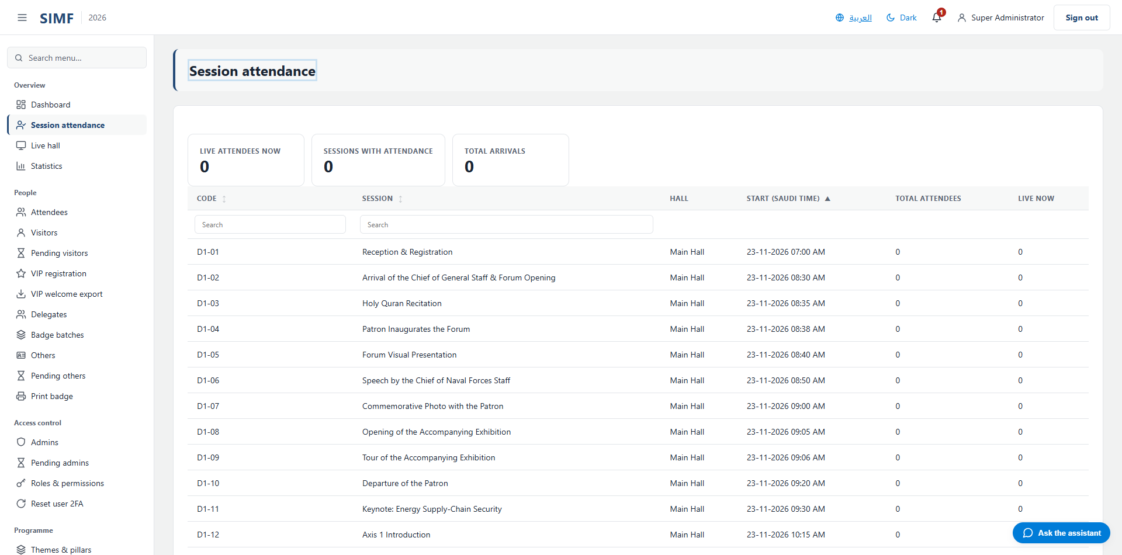
Figure 27 — Session attendance — /admin/attendance

Live hall (/admin/sessions/live-hall)
Property | Value
Address | /admin/sessions/live-hall
Implemented by | src/ControlPanel/SIMF.ControlPanel/Components/Pages/Admin/SessionLiveHall.razor
Code-behind | src/ControlPanel/SIMF.ControlPanel/Components/Pages/Admin/SessionLiveHall.razor.cs
Page permission | Attendance.View
Menu permission | Attendance.View

It calls: /account/api/admin/attendance/sessions/list /account/api/admin/sessions/{session.SessionId}/present/list /account/api/admin/sessions/{session.SessionId}/seat-map
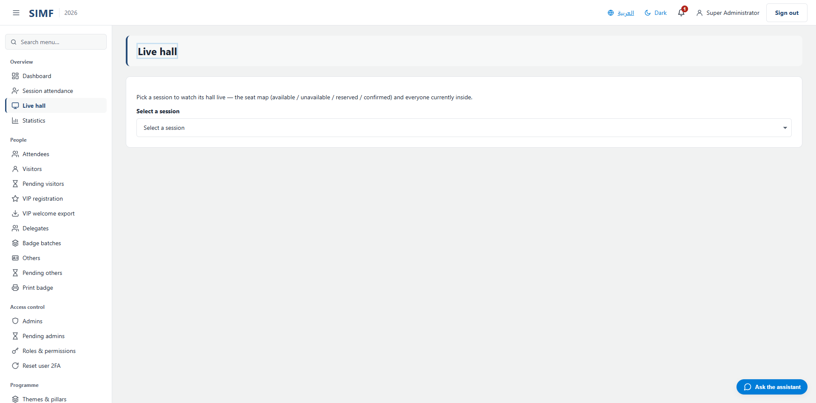
Figure 28 — Live hall — /admin/sessions/live-hall

Statistics (/admin/statistics)
Property | Value
Address | /admin/statistics
Implemented by | src/ControlPanel/SIMF.ControlPanel/Components/Pages/Admin/StatisticsDashboard.razor
Code-behind | src/ControlPanel/SIMF.ControlPanel/Components/Pages/Admin/StatisticsDashboard.razor.cs
Page permission | Statistics.View
Menu permission | Statistics.View

It calls: /account/api/admin/statistics
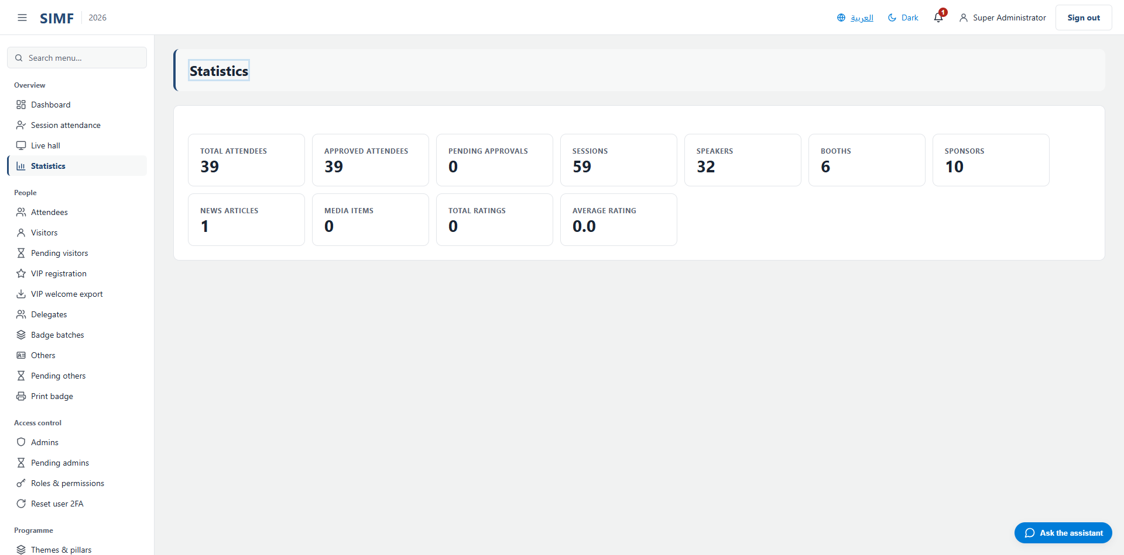
Figure 29 — Statistics — /admin/statistics

People

Attendees (/admin/attendees)
Property | Value
Address | /admin/attendees
Implemented by | src/ControlPanel/SIMF.ControlPanel/Components/Pages/Admin/AttendeesList.razor
Code-behind | src/ControlPanel/SIMF.ControlPanel/Components/Pages/Admin/AttendeesList.razor.cs
Page permission | Attendees.View
Menu permission | Attendees.View

What you can do here
Action | Permission it needs
A button the page gates itself | Attendees.Export

The list shows: Email · Display name · Kind · Profile type · State · QR id · Registered
It calls: /account/api/admin/attendees/export /account/api/admin/attendees/list
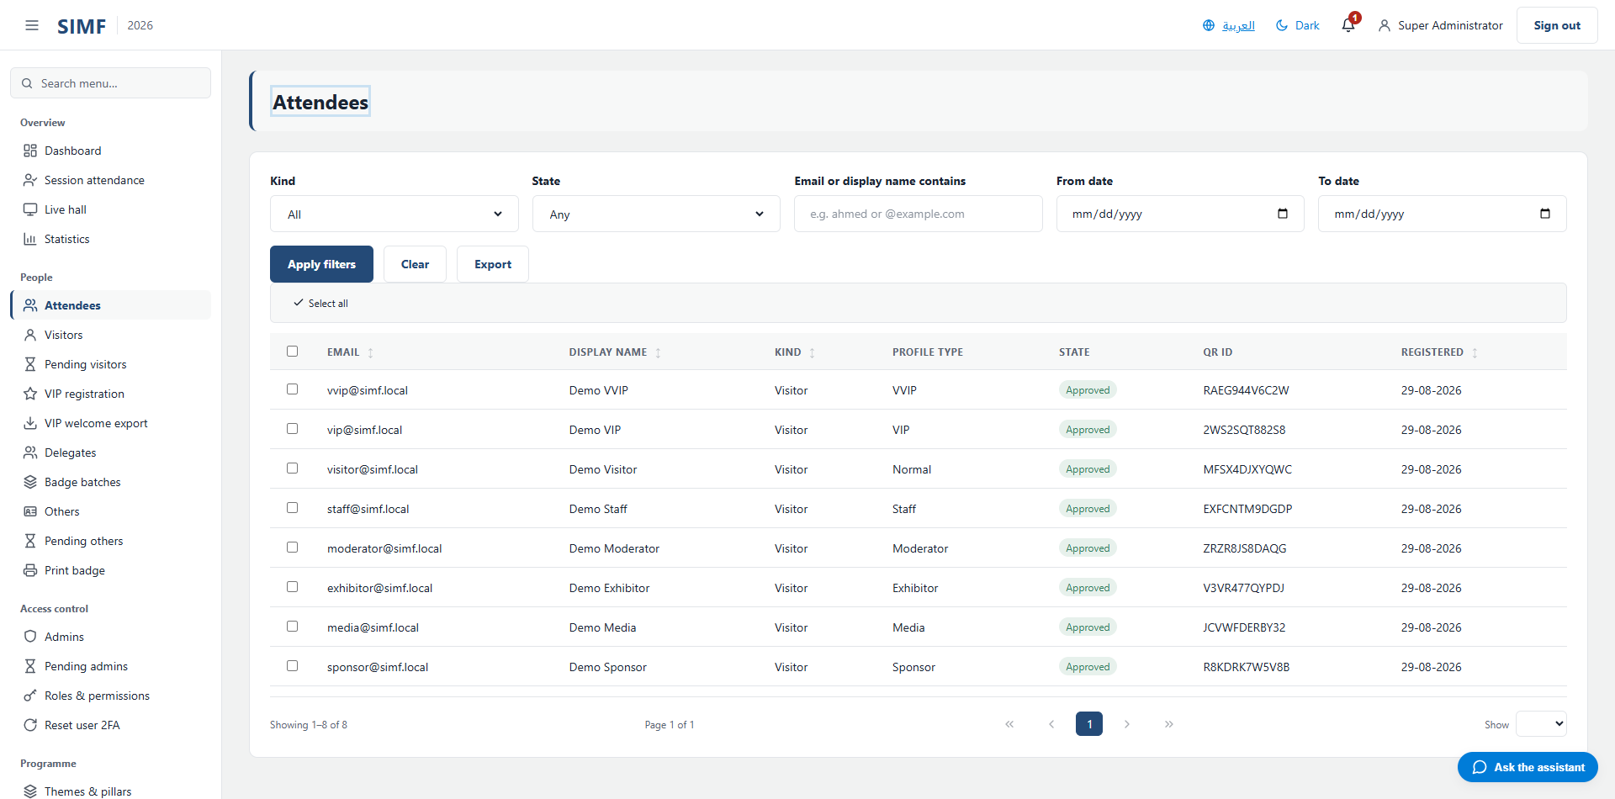
Figure 30 — Attendees — /admin/attendees

Visitors (/admin/visitors)
Property | Value
Address | /admin/visitors
Implemented by | src/ControlPanel/SIMF.ControlPanel/Components/Pages/Admin/VisitorsList.razor
Code-behind | src/ControlPanel/SIMF.ControlPanel/Components/Pages/Admin/VisitorsList.razor.cs
Page permission | Visitors.View
Menu permission | Visitors.View

What you can do here
Action | Permission it needs
Add | Visitors.Create
Edit | Visitors.Edit
Details | No permission of its own
Duplicate | Visitors.Create
Copy | No permission of its own
Copy (on the selected rows) | No permission of its own
Paste | Visitors.Create
Delete | Visitors.Delete
Delete (on the selected rows) | Visitors.Delete
Import from Excel | Visitors.Import
Export to Excel | Visitors.Export
A button the page gates itself | Visitors.BulkGenerate

The list shows: Email · Display name · State
It calls: /account/api/admin/visitors/bulk-delete /account/api/admin/visitors/duplicate /account/api/admin/visitors/export /account/api/admin/visitors/import /account/api/admin/visitors/list /account/api/admin/visitors/{row.Id}/avatar

Figure 31 — Visitors — /admin/visitors

Pending visitors (/admin/visitors/pending)
Property | Value
Address | /admin/visitors/pending
Implemented by | src/ControlPanel/SIMF.ControlPanel/Components/Pages/Admin/PendingVisitors.razor
Code-behind | src/ControlPanel/SIMF.ControlPanel/Components/Pages/Admin/PendingVisitors.razor.cs
Page permission | Visitors.View
Menu permission | Visitors.View

What you can do here
Action | Permission it needs
Approve selected | Visitors.Approve
Reject selected | Visitors.Reject

The list shows: Email · Display name · Created
It calls: /account/api/admin/visitors/{row.Id}/avatar /account/api/admin/visitors/{user.Id}/profile-for-approval

Figure 32 — Pending visitors — /admin/visitors/pending

VIP registration (/admin/visitors/vip)
Property | Value
Address | /admin/visitors/vip
Implemented by | src/ControlPanel/SIMF.ControlPanel/Components/Pages/Admin/VipRegistration.razor
Code-behind | src/ControlPanel/SIMF.ControlPanel/Components/Pages/Admin/VipRegistration.razor.cs
Page permission | Visitors.RegisterOnsite
Menu permission | Visitors.RegisterOnsite

What you can do here
Action | Permission it needs
New VIP | No permission of its own
Edit | No permission of its own
Details | No permission of its own

The list shows: Name · Job title · Profile type · Email
It calls: /account/api/admin/vips/list

Figure 33 — VIP registration — /admin/visitors/vip

VIP welcome export (/admin/visitors/vip/export)
Property | Value
Address | /admin/visitors/vip/export
Implemented by | src/ControlPanel/SIMF.ControlPanel/Components/Pages/Admin/VipExport.razor
Code-behind | src/ControlPanel/SIMF.ControlPanel/Components/Pages/Admin/VipExport.razor.cs
Page permission | Visitors.ExportVip
Menu permission | Visitors.ExportVip

The list shows: Photo · VIP welcome export (Mawj) · Full name (English) · Honorific / title (optional) · Job title (optional) · Mawj system ID (optional) · Preferred language (optional) · Email (optional) · Saudi mobile · Reference number
It calls: /account/api/admin/visitors/vip/roster /account/api/admin/visitors/vip/roster/list /account/api/admin/visitors/{userId}/vip-photo
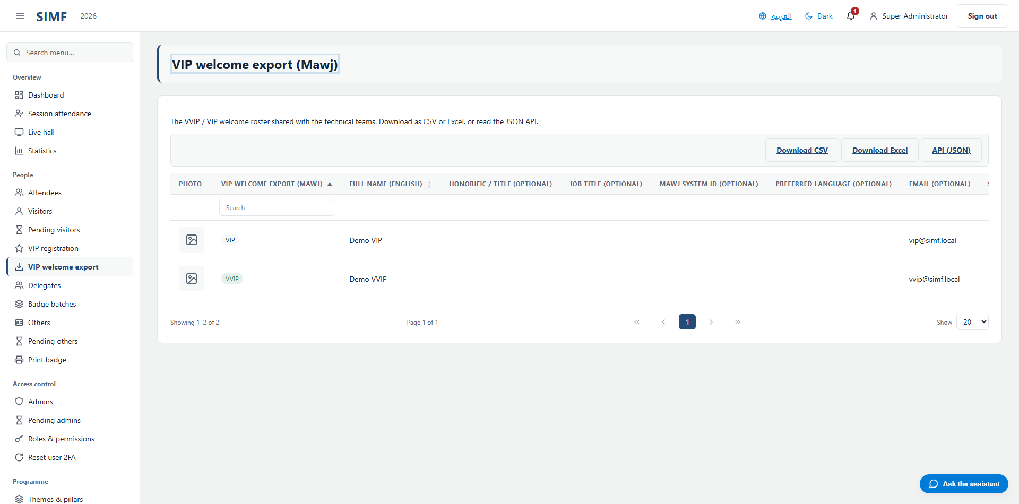
Figure 34 — VIP welcome export — /admin/visitors/vip/export

Delegates (/admin/delegates)
Property | Value
Address | /admin/delegates
Implemented by | src/ControlPanel/SIMF.ControlPanel/Components/Pages/Admin/DelegatesPage.razor
Code-behind | src/ControlPanel/SIMF.ControlPanel/Components/Pages/Admin/DelegatesPage.razor.cs
Page permission | Visitors.RegisterOnsite
Menu permission | Visitors.RegisterOnsite

What you can do here
Action | Permission it needs
A button the page gates itself | Visitors.BulkGenerate

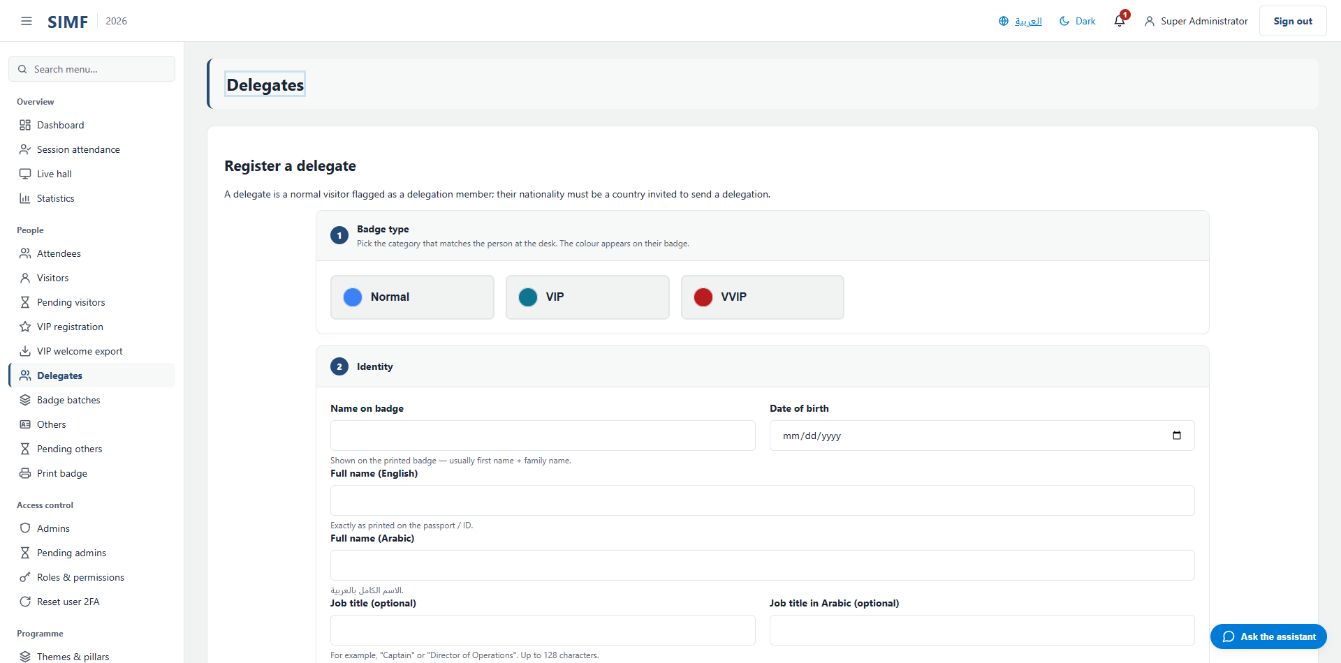
Figure 35 — Delegates — /admin/delegates

Badge batches (/admin/visitors/badge-batches)
Property | Value
Address | /admin/visitors/badge-batches
Implemented by | src/ControlPanel/SIMF.ControlPanel/Components/Pages/Admin/BadgeBatchesPage.razor
Code-behind | src/ControlPanel/SIMF.ControlPanel/Components/Pages/Admin/BadgeBatchesPage.razor.cs
Page permission | Visitors.ViewBatches
Menu permission | Visitors.ViewBatches

What you can do here
Action | Permission it needs
A button the page gates itself | Visitors.BulkGenerate
A button the page gates itself | Visitors.ManageBatches

The list shows: Order · Contents · Total · Delegation · Emailed to · Generated · Status
It calls: /account/api/admin/visitors/badge-batches/list /account/api/admin/visitors/badge-batches/re-email /account/api/admin/visitors/badge-batches/revoke /account/api/admin/visitors/badge-batches/top-up
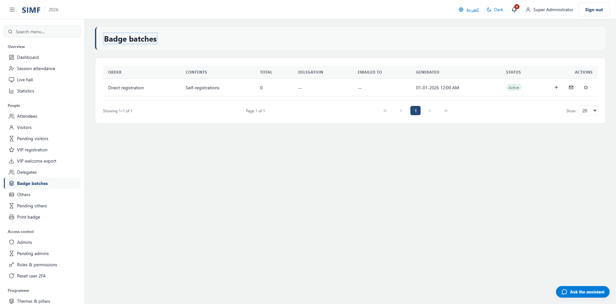
Figure 36 — Badge batches — /admin/visitors/badge-batches

Others (/admin/others)
Property | Value
Address | /admin/others
Implemented by | src/ControlPanel/SIMF.ControlPanel/Components/Pages/Admin/OthersList.razor
Code-behind | src/ControlPanel/SIMF.ControlPanel/Components/Pages/Admin/OthersList.razor.cs
Page permission | Others.View
Menu permission | Others.View

What you can do here
Action | Permission it needs
Add | Others.Create
Edit | Others.Edit
Details | No permission of its own
Duplicate | Others.Create
Copy | No permission of its own
Copy (on the selected rows) | No permission of its own
Paste | Others.Create
Delete | Others.Delete
Delete (on the selected rows) | Others.Delete
Import from Excel | Others.Import
Export to Excel | Others.Export

The list shows: Email · Display name · State
It calls: /account/api/admin/others/bulk-delete /account/api/admin/others/duplicate /account/api/admin/others/export /account/api/admin/others/import /account/api/admin/others/list /account/api/admin/others/{id}/profile /account/api/admin/others/{row.Id}/avatar

Figure 37 — Others — /admin/others

Pending others (/admin/others/pending)
Property | Value
Address | /admin/others/pending
Implemented by | src/ControlPanel/SIMF.ControlPanel/Components/Pages/Admin/PendingOthers.razor
Code-behind | src/ControlPanel/SIMF.ControlPanel/Components/Pages/Admin/PendingOthers.razor.cs
Page permission | Others.View
Menu permission | Others.View

What you can do here
Action | Permission it needs
Approve selected | Others.Approve
Reject selected | Others.Reject

The list shows: Email · Display name · Created
It calls: /account/api/admin/others/{row.Id}/avatar /account/api/admin/others/{user.Id}/profile-for-approval
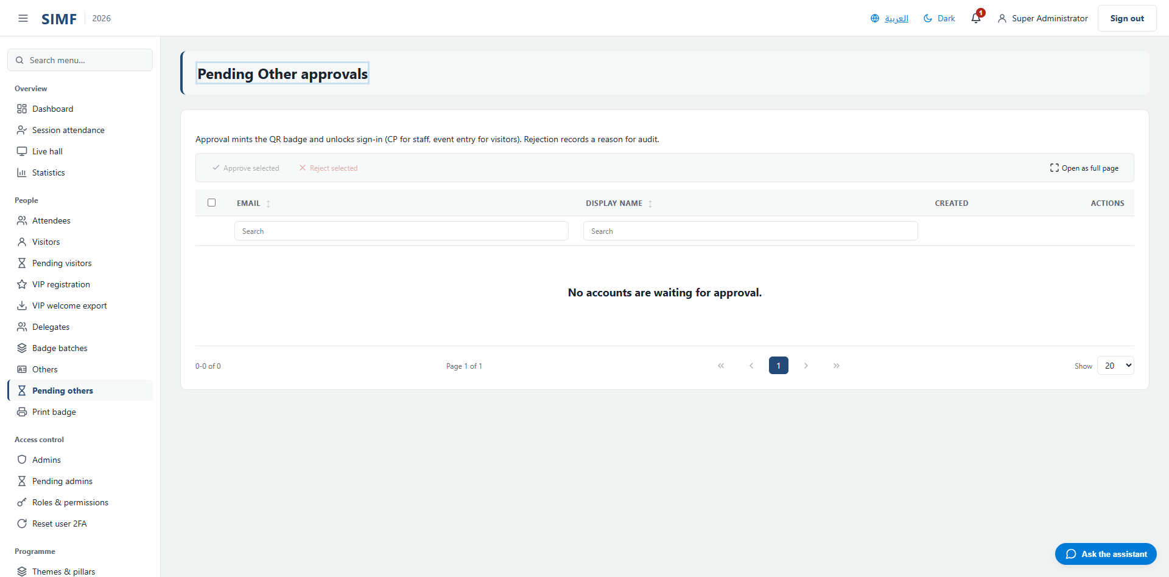
Figure 38 — Pending others — /admin/others/pending

Print badge (/admin/print-bag)
Property | Value
Address | /admin/print-bag
Implemented by | src/ControlPanel/SIMF.ControlPanel/Components/Pages/Admin/PrintBag.razor
Code-behind | src/ControlPanel/SIMF.ControlPanel/Components/Pages/Admin/PrintBag.razor.cs
Page permission | Attendees.PrintBag
Menu permission | Attendees.PrintBag

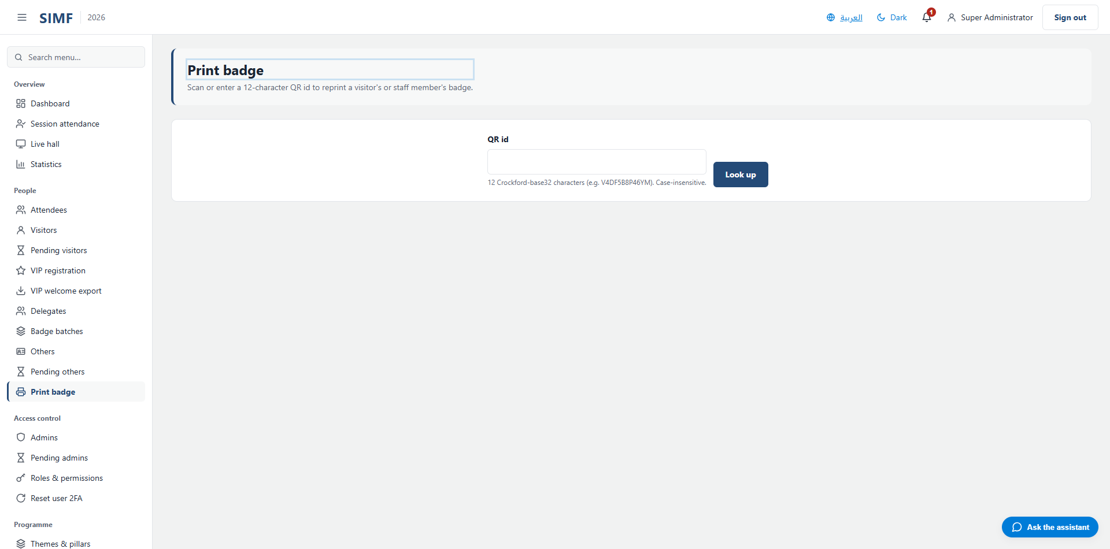
Figure 39 — Print badge — /admin/print-bag

Access control

Admins (/admin/admins)
Property | Value
Address | /admin/admins
Implemented by | src/ControlPanel/SIMF.ControlPanel/Components/Pages/Admin/UsersList.razor
Code-behind | src/ControlPanel/SIMF.ControlPanel/Components/Pages/Admin/UsersList.razor.cs
Page permission | Admins.View
Menu permission | Admins.View

What you can do here
Action | Permission it needs
Add | Admins.Create
Edit | Admins.AssignRoles
Details | No permission of its own
Duplicate | Admins.Create
Copy | No permission of its own
Copy (on the selected rows) | No permission of its own
Paste | Admins.Create
Delete | Admins.Delete
Delete (on the selected rows) | Admins.Delete
Import from Excel | Admins.Import
Export to Excel | Admins.Export

The list shows: Email · Display name · State · Role · 2FA
It calls: /account/api/admin/admins/bulk-delete /account/api/admin/admins/duplicate /account/api/admin/admins/export /account/api/admin/admins/import /account/api/admin/admins/list /account/api/admin/admins/{row.Id}/avatar

Figure 40 — Admins — /admin/admins

Pending admins (/admin/admins/pending)
Property | Value
Address | /admin/admins/pending
Implemented by | src/ControlPanel/SIMF.ControlPanel/Components/Pages/Admin/PendingStaff.razor
Code-behind | src/ControlPanel/SIMF.ControlPanel/Components/Pages/Admin/PendingStaff.razor.cs
Page permission | Admins.View
Menu permission | Admins.View

What you can do here
Action | Permission it needs
Approve selected | Admins.Approve
Reject selected | Admins.Reject

The list shows: Email · Display name · Created
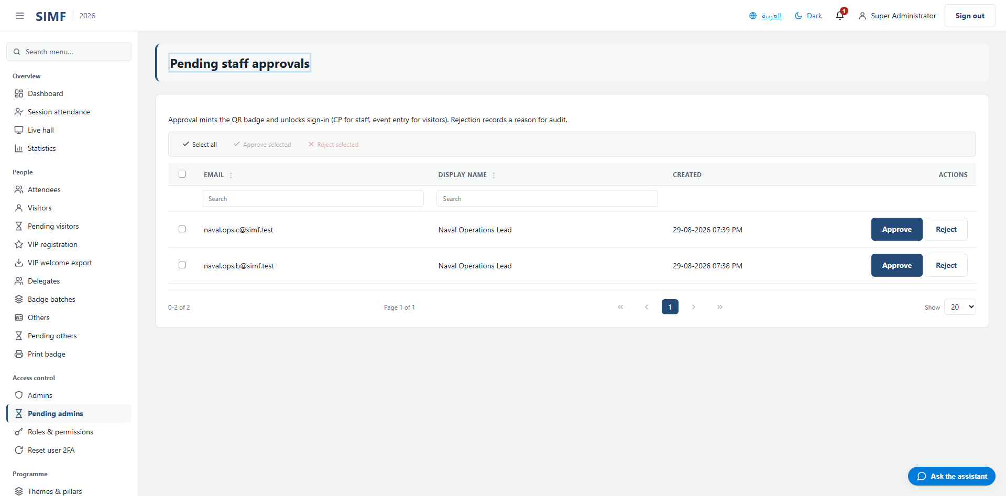
Figure 41 — Pending admins — /admin/admins/pending

Roles & permissions (/admin/roles)
Property | Value
Address | /admin/roles
Implemented by | src/ControlPanel/SIMF.ControlPanel/Components/Pages/Admin/RolesList.razor
Code-behind | src/ControlPanel/SIMF.ControlPanel/Components/Pages/Admin/RolesList.razor.cs
Page permission | Roles.View
Menu permission | Roles.View

What you can do here
Action | Permission it needs
Add role | Roles.Create
Edit | Roles.Edit
Details | No permission of its own
Delete | Roles.Delete
Import | Roles.Import
Export | Roles.Export
A button the page gates itself | Roles.AssignPermissions

The list shows: Name · Type · Users · Permissions
It calls: /account/api/admin/roles/list

Figure 42 — Roles & permissions — /admin/roles

Reset user 2FA (/admin/reset-2fa)
Property | Value
Address | /admin/reset-2fa
Implemented by | src/ControlPanel/SIMF.ControlPanel/Components/Pages/Admin/ResetTwoFactor.razor
Code-behind | src/ControlPanel/SIMF.ControlPanel/Components/Pages/Admin/ResetTwoFactor.razor.cs
Page permission | Admins.ResetTwoFactor
Menu permission | Admins.ResetTwoFactor

It calls: /account/api/admin/reset-2fa

Figure 43 — Reset user 2FA — /admin/reset-2fa

Programme

Themes & pillars (/admin/themes)
Property | Value
Address | /admin/themes
Implemented by | src/ControlPanel/SIMF.ControlPanel/Components/Pages/Admin/ThemesList.razor
Code-behind | src/ControlPanel/SIMF.ControlPanel/Components/Pages/Admin/ThemesList.razor.cs
Page permission | Themes.View
Menu permission | Themes.View

What you can do here
Action | Permission it needs
Add theme | Themes.Create
Edit | Themes.Edit
Details | No permission of its own
Deactivate | Themes.Delete
Import | Themes.Import
Export | Themes.Export

The list shows: Code · Name · Name (Arabic) · Order · Color · Status
It calls: /account/api/admin/themes/list /account/api/admin/themes/{id}
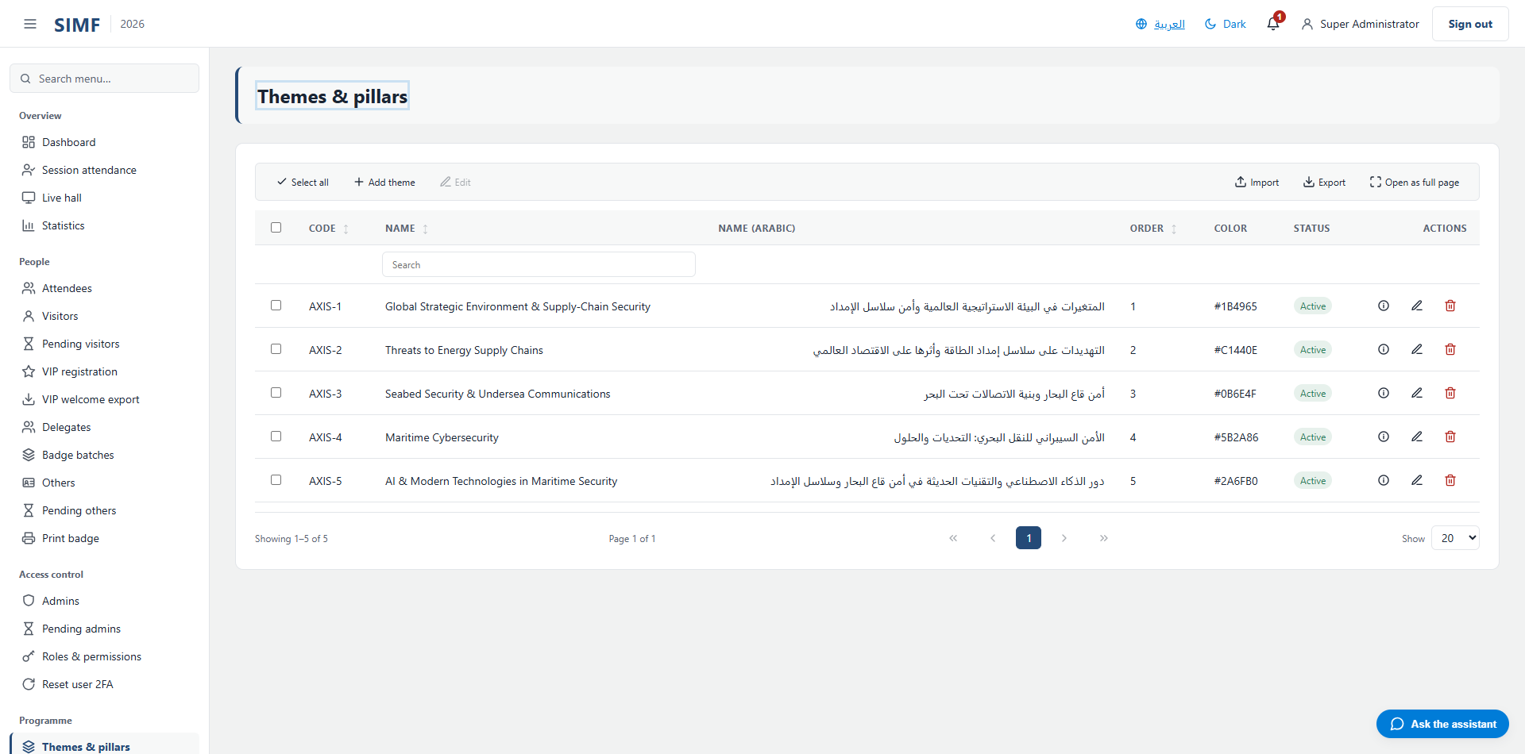
Figure 44 — Themes & pillars — /admin/themes

Sessions (/admin/sessions)
Property | Value
Address | /admin/sessions
Implemented by | src/ControlPanel/SIMF.ControlPanel/Components/Pages/Admin/SessionsList.razor
Code-behind | src/ControlPanel/SIMF.ControlPanel/Components/Pages/Admin/SessionsList.razor.cs
Page permission | Sessions.View
Menu permission | Sessions.View

What you can do here
Action | Permission it needs
Add session | Sessions.Create
Edit | Sessions.Edit
Details | No permission of its own
Deactivate | Sessions.Delete
Import | Sessions.Import
Export | Sessions.Export
A button the page gates itself | Questions.Moderate

The list shows: Code · Title · Title (Arabic) · Hall · Start (Saudi time) · End (Saudi time) · Capacity · Status · Lifecycle
It calls: /account/api/admin/sessions/list /account/api/admin/sessions/{id}
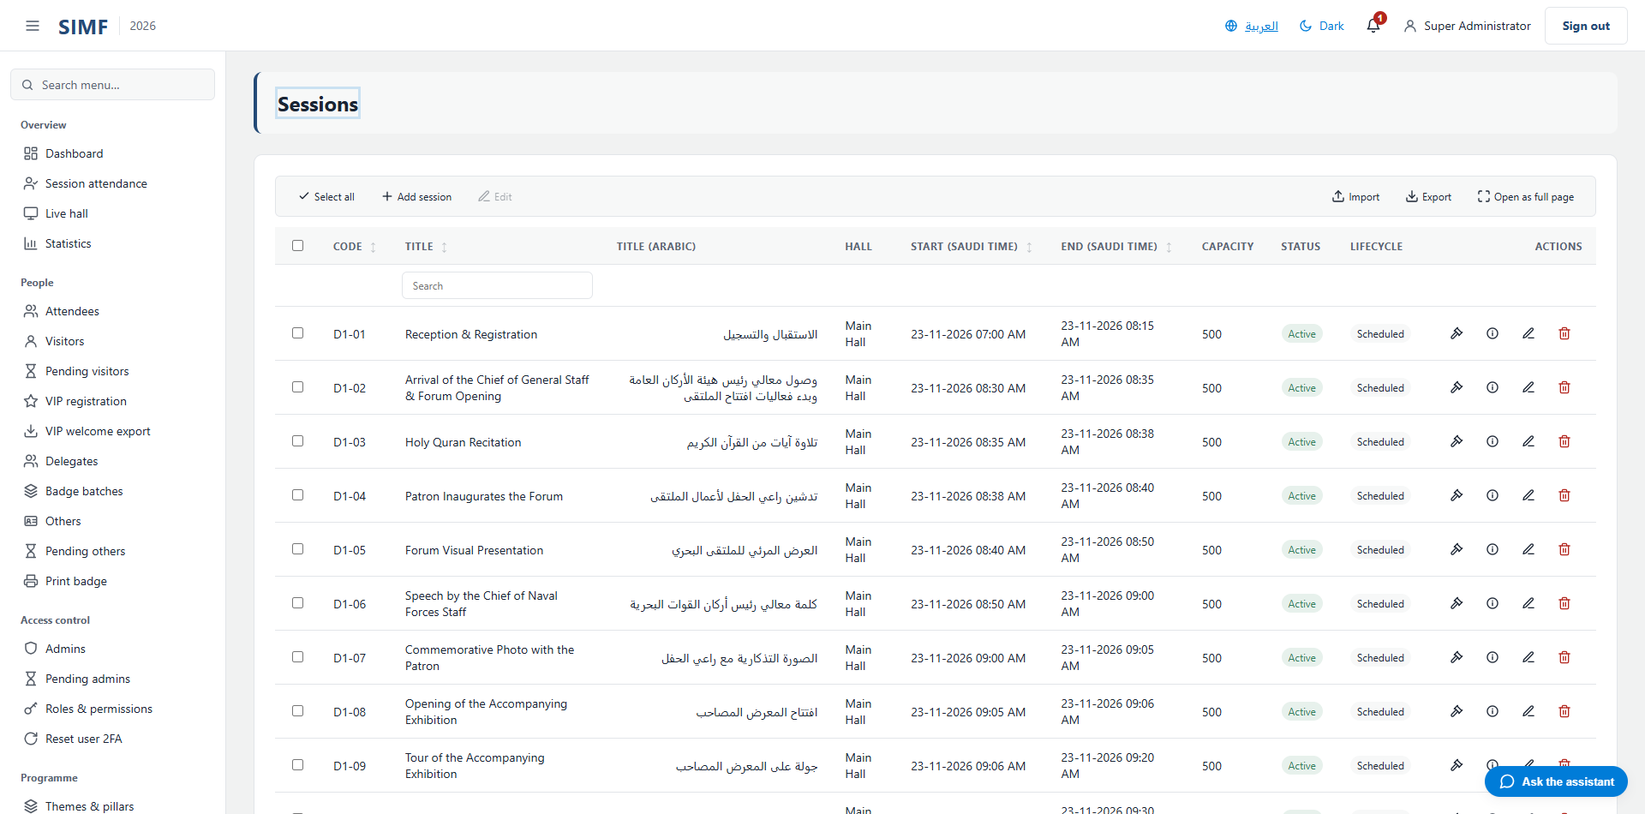
Figure 45 — Sessions — /admin/sessions

Session categories (/admin/session-categories)
Property | Value
Address | /admin/session-categories
Implemented by | src/ControlPanel/SIMF.ControlPanel/Components/Pages/Admin/SessionCategoriesList.razor
Code-behind | src/ControlPanel/SIMF.ControlPanel/Components/Pages/Admin/SessionCategoriesList.razor.cs
Page permission | SessionCategories.View
Menu permission | SessionCategories.View

What you can do here
Action | Permission it needs
Add | SessionCategories.Create
Edit | SessionCategories.Edit
Details | No permission of its own
Delete | SessionCategories.Delete
Import | SessionCategories.Import
Export | SessionCategories.Export

The list shows: Name (English) · Name (Arabic) · Order · Active
It calls: /account/api/admin/session-categories/list /account/api/admin/session-categories/{id}
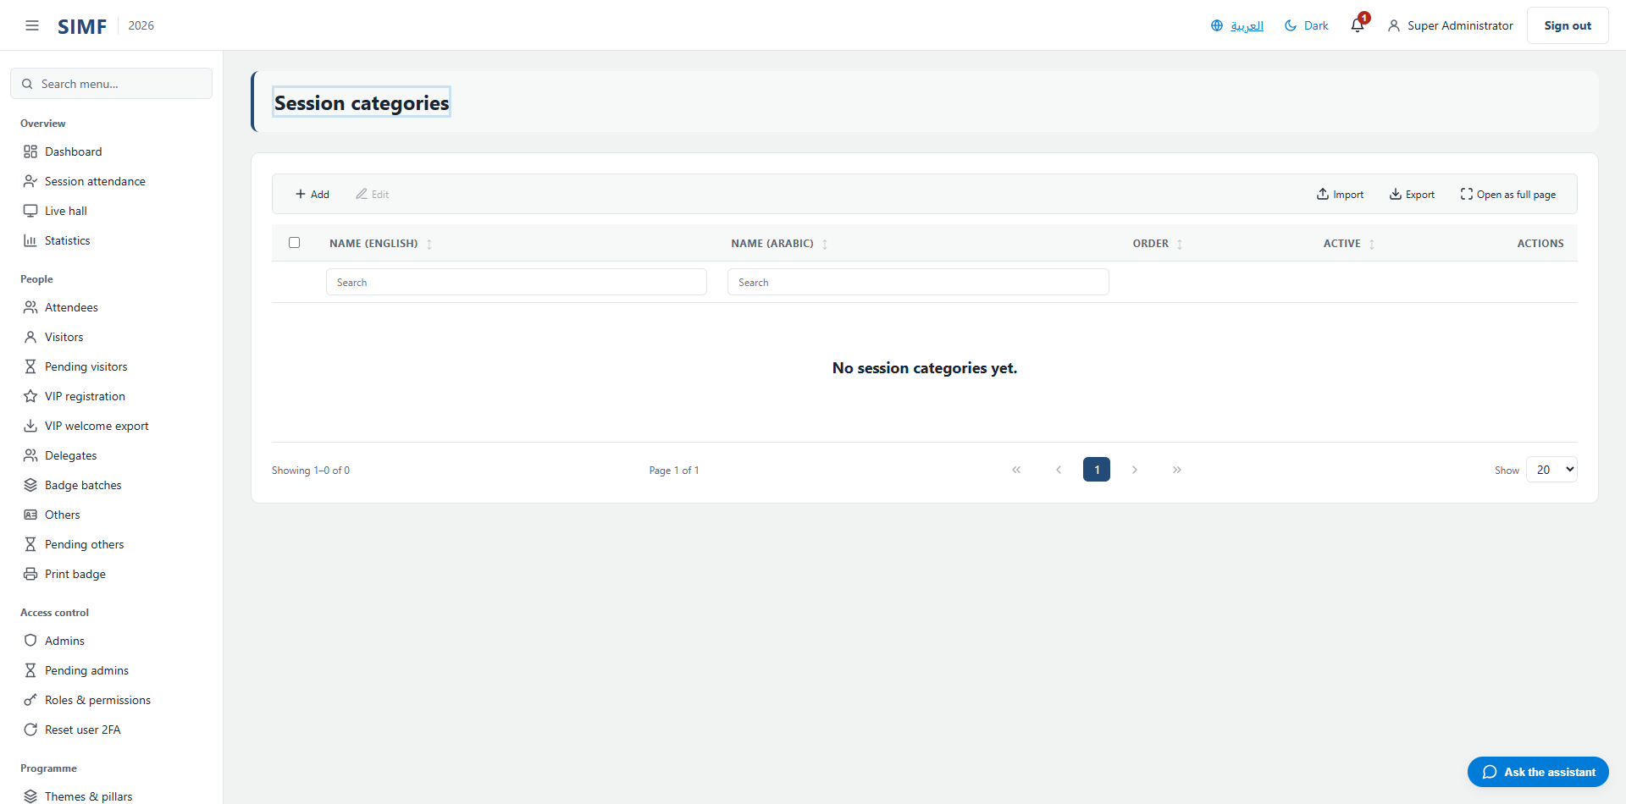
Figure 46 — Session categories — /admin/session-categories

Programme days (/admin/programme-days)
Property | Value
Address | /admin/programme-days
Implemented by | src/ControlPanel/SIMF.ControlPanel/Components/Pages/Admin/ProgrammeDaysList.razor
Code-behind | src/ControlPanel/SIMF.ControlPanel/Components/Pages/Admin/ProgrammeDaysList.razor.cs
Page permission | ProgrammeDays.View
Menu permission | ProgrammeDays.View

What you can do here
Action | Permission it needs
Add | ProgrammeDays.Create
Edit | ProgrammeDays.Edit
Details | No permission of its own
Delete | ProgrammeDays.Delete

The list shows: Date · Title (EN) · Title (AR) · Order · Logo · Active
It calls: /account/api/admin/programme-days/list /account/api/admin/programme-days/{id}
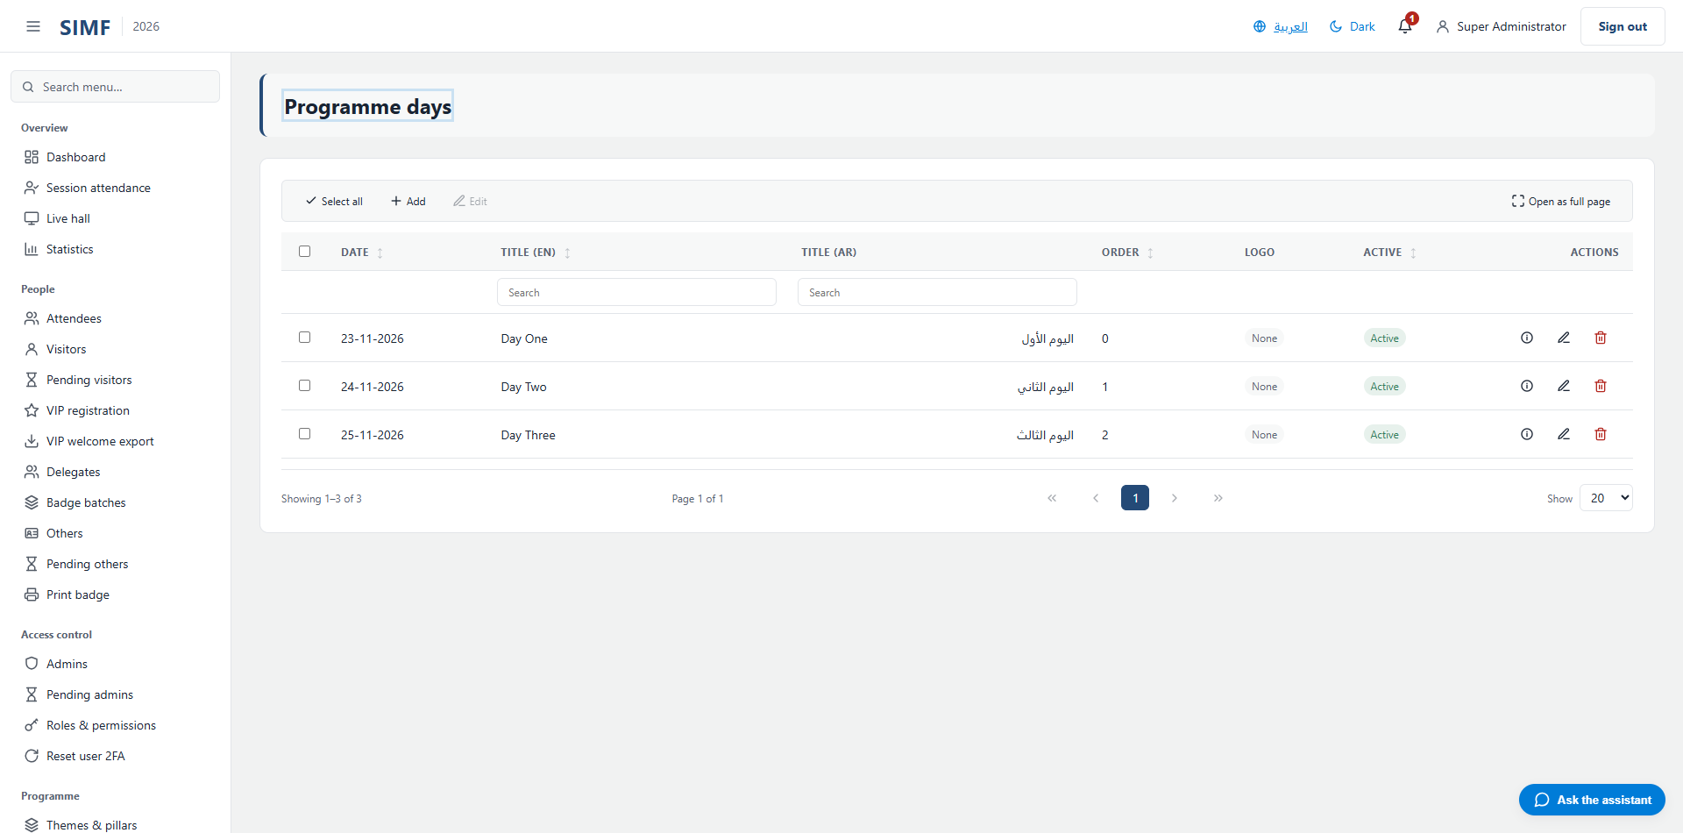
Figure 47 — Programme days — /admin/programme-days

Run of Show (/admin/programme/timeline)
Property | Value
Address | /admin/programme/timeline
Implemented by | src/ControlPanel/SIMF.ControlPanel/Components/Pages/Admin/ProgrammeTimeline.razor
Code-behind | src/ControlPanel/SIMF.ControlPanel/Components/Pages/Admin/ProgrammeTimeline.razor.cs
Page permission | ProgrammeTimeline.View
Menu permission | ProgrammeTimeline.View

It calls: /account/api/admin/sessions/list
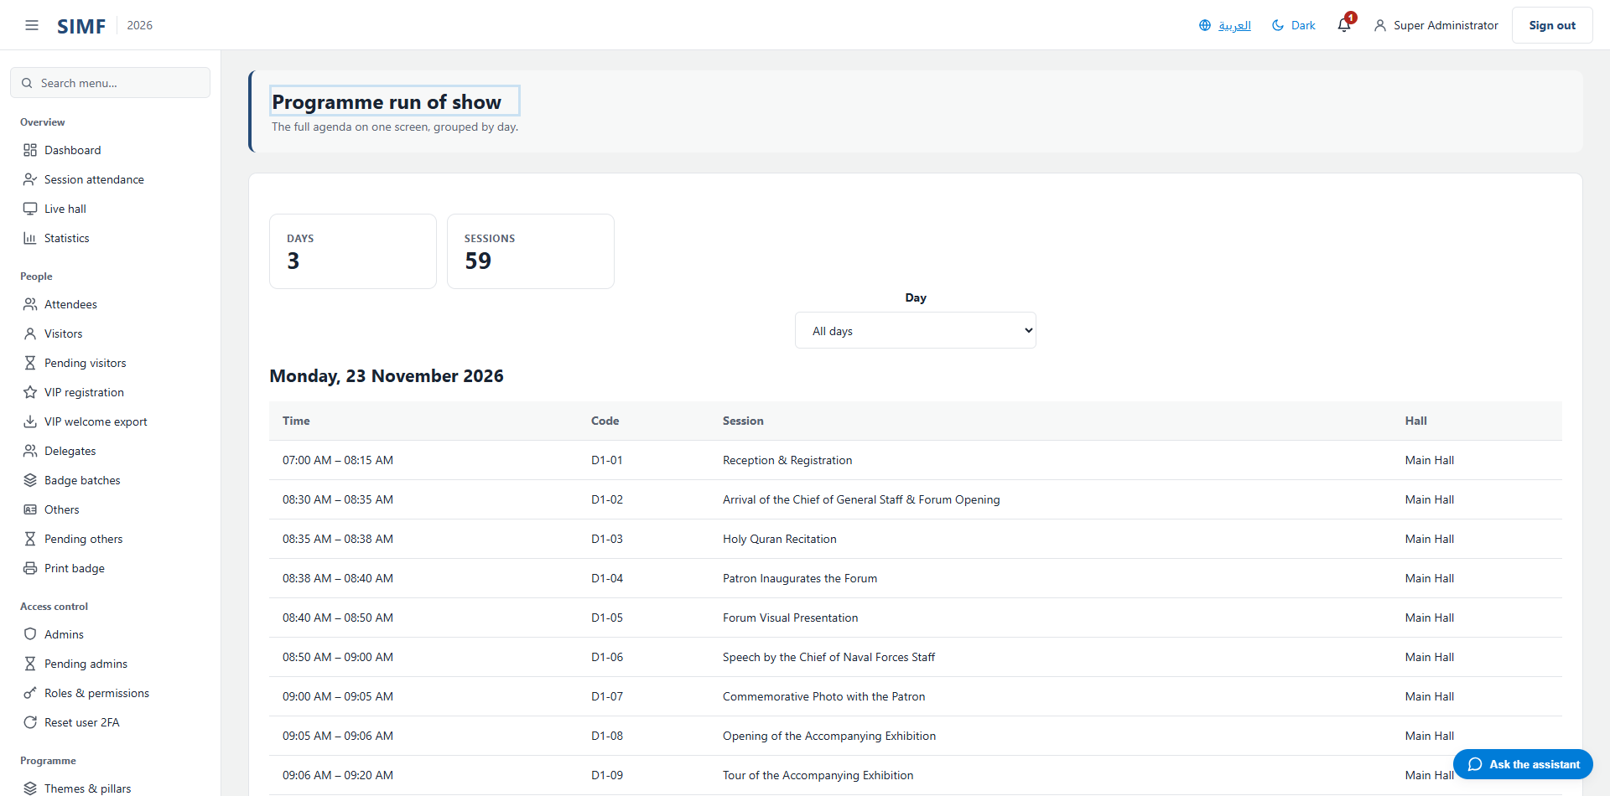
Figure 48 — Run of Show — /admin/programme/timeline

Halls & seating (/admin/halls)
Property | Value
Address | /admin/halls
Implemented by | src/ControlPanel/SIMF.ControlPanel/Components/Pages/Admin/HallsList.razor
Code-behind | src/ControlPanel/SIMF.ControlPanel/Components/Pages/Admin/HallsList.razor.cs
Page permission | Halls.View
Menu permission | Halls.View

What you can do here
Action | Permission it needs
Add hall | Halls.Create
Edit | Halls.Edit
Details | No permission of its own
Deactivate | Halls.Delete
Import | Halls.Import
Export | Halls.Export
A button the page gates itself | SeatLayouts.View

The list shows: Code · Name · Name (Arabic) · Capacity · Floor · Status
It calls: /account/api/admin/halls/list /account/api/admin/halls/{id}
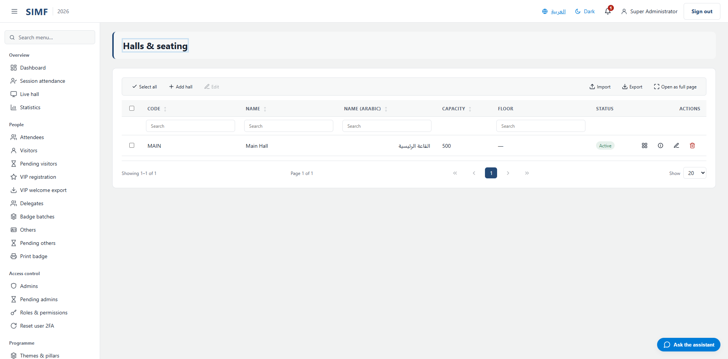
Figure 49 — Halls & seating — /admin/halls

Hall seat layouts (/admin/halls/seat-layouts)
Property | Value
Address | /admin/halls/seat-layouts
Implemented by | src/ControlPanel/SIMF.ControlPanel/Components/Pages/Admin/HallSeatLayoutEditor.razor
Code-behind | src/ControlPanel/SIMF.ControlPanel/Components/Pages/Admin/HallSeatLayoutEditor.razor.cs
Page permission | SeatLayouts.View
Menu permission | SeatLayouts.View

What you can do here
Action | Permission it needs
A button the page gates itself | SeatLayouts.Delete
A button the page gates itself | SeatLayouts.Edit

It calls: /account/api/admin/halls/list /account/api/admin/halls/{_selectedHallId}/seat-layout
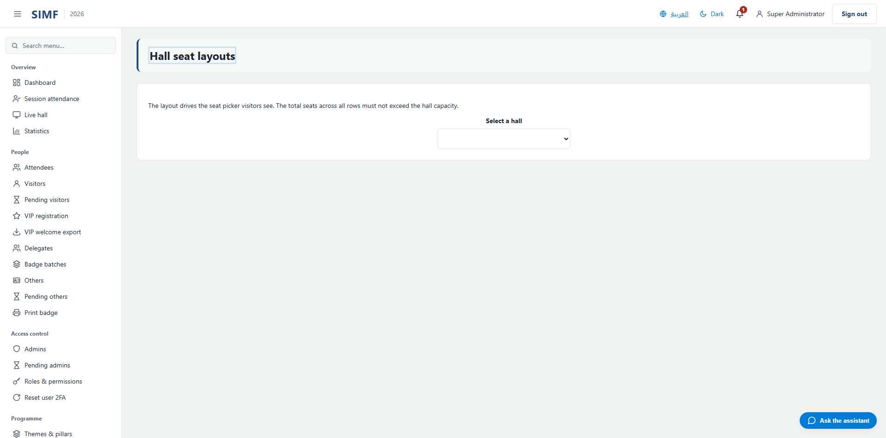
Figure 50 — Hall seat layouts — /admin/halls/seat-layouts

Session seat plans (/admin/sessions/seat-plans)
Property | Value
Address | /admin/sessions/seat-plans
Implemented by | src/ControlPanel/SIMF.ControlPanel/Components/Pages/Admin/SessionSeatPlan.razor
Code-behind | src/ControlPanel/SIMF.ControlPanel/Components/Pages/Admin/SessionSeatPlan.razor.cs
Page permission | SeatPlans.View
Menu permission | SeatPlans.View

What you can do here
Action | Permission it needs
A button the page gates itself | SeatPlans.Edit

It calls: /account/api/admin/halls/{session.HallId}/seat-layout /account/api/admin/sessions/list /account/api/admin/sessions/{_selectedSessionId}/seats/list /account/api/admin/sessions/{_selectedSessionId}/seats/reserve-row /account/api/admin/sessions/{_selectedSessionId}/seats/reserve-seat /account/api/admin/sessions/{_selectedSessionId}/seats/{row.ReservationId}
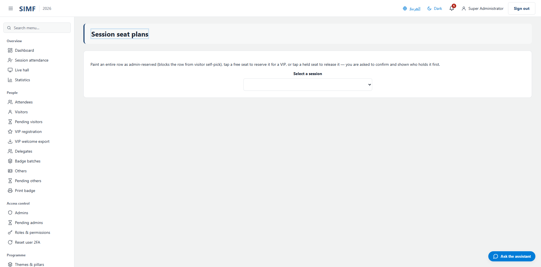
Figure 51 — Session seat plans — /admin/sessions/seat-plans

Speaker meeting requests (/admin/speaker-meeting-requests)
Property | Value
Address | /admin/speaker-meeting-requests
Implemented by | src/ControlPanel/SIMF.ControlPanel/Components/Pages/Admin/SpeakerMeetingRequestsList.razor
Code-behind | src/ControlPanel/SIMF.ControlPanel/Components/Pages/Admin/SpeakerMeetingRequestsList.razor.cs
Page permission | SpeakerMeetingRequests.View
Menu permission | SpeakerMeetingRequests.View

What you can do here
Action | Permission it needs
Export | SpeakerMeetingRequests.Export
A button the page gates itself | SpeakerMeetingRequests.Manage

The list shows: Speaker · Requester · Subject · Status · Submitted · Responded
It calls: /account/api/admin/halls/list /account/api/admin/halls/{hallId}/available-slots /account/api/admin/halls/{hallId}/meeting-tables/list /account/api/admin/speaker-meeting-requests/export /account/api/admin/speaker-meeting-requests/list /account/api/admin/speaker-meeting-requests/{_respondTarget.Id}/respond /account/api/admin/speaker-meeting-requests/{row.Id} /account/api/admin/speaker-meeting-requests/{row.Id}/check-in /account/api/admin/speaker-meeting-requests/{row.Id}/reopen /account/api/admin/speaker-meeting-requests/{row.Id}/resend-confirmation
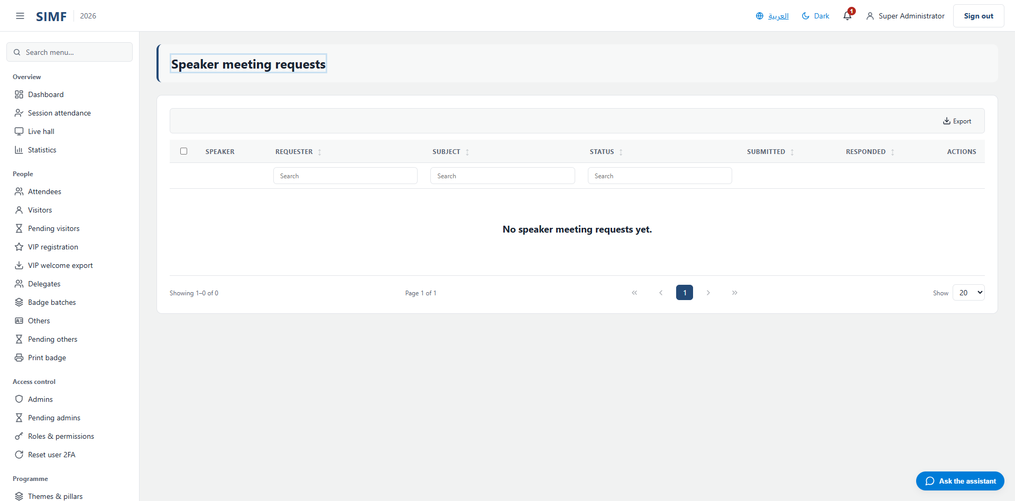
Figure 52 — Speaker meeting requests — /admin/speaker-meeting-requests

Speaker availability (/admin/speaker-availability)
Property | Value
Address | /admin/speaker-availability
Implemented by | src/ControlPanel/SIMF.ControlPanel/Components/Pages/Admin/SpeakerAvailabilityPage.razor
Code-behind | src/ControlPanel/SIMF.ControlPanel/Components/Pages/Admin/SpeakerAvailabilityPage.razor.cs
Page permission | SpeakerMeetingRequests.Manage
Menu permission | SpeakerMeetingRequests.Manage

What you can do here
Action | Permission it needs
A button the page gates itself | SpeakerMeetingRequests.Manage

It calls: /account/api/admin/programme/forum-window /account/api/admin/speaker-availability-windows/{windowId} /account/api/admin/speakers/list /account/api/admin/speakers/{id}/availability-windows
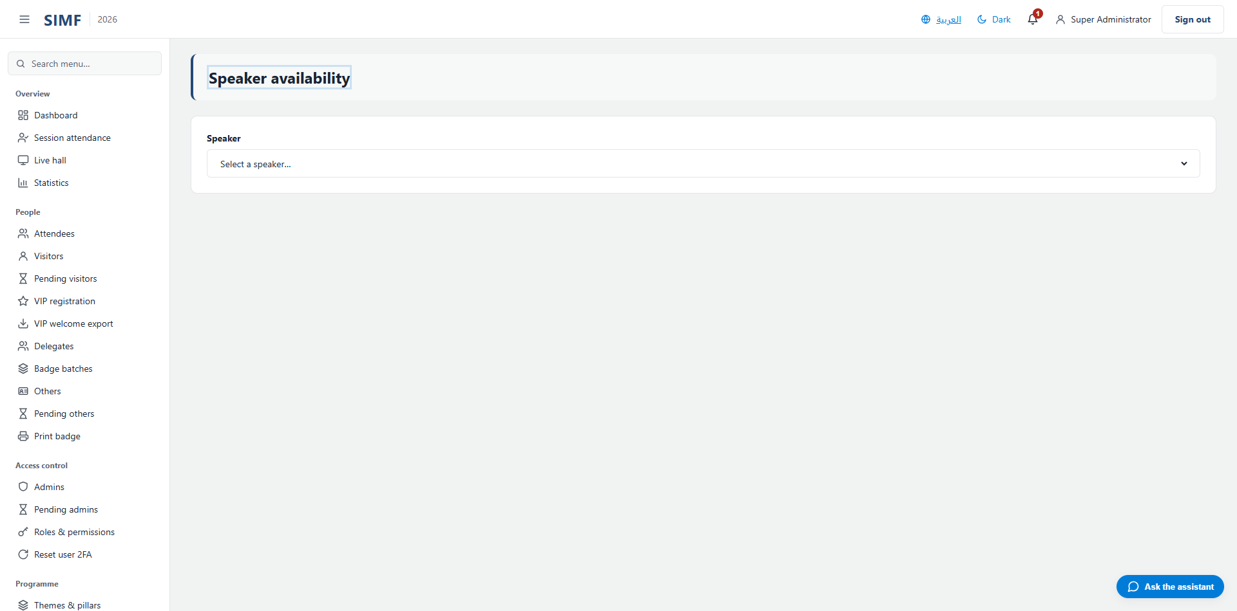
Figure 53 — Speaker availability — /admin/speaker-availability

Hall availability (/admin/hall-availability)
Property | Value
Address | /admin/hall-availability
Implemented by | src/ControlPanel/SIMF.ControlPanel/Components/Pages/Admin/HallAvailabilityPage.razor
Code-behind | src/ControlPanel/SIMF.ControlPanel/Components/Pages/Admin/HallAvailabilityPage.razor.cs
Page permission | HallAvailability.Manage
Menu permission | HallAvailability.Manage

What you can do here
Action | Permission it needs
A button the page gates itself | HallAvailability.Manage

It calls: /account/api/admin/hall-availability-windows/{windowId} /account/api/admin/halls/list /account/api/admin/halls/{id}/availability-windows
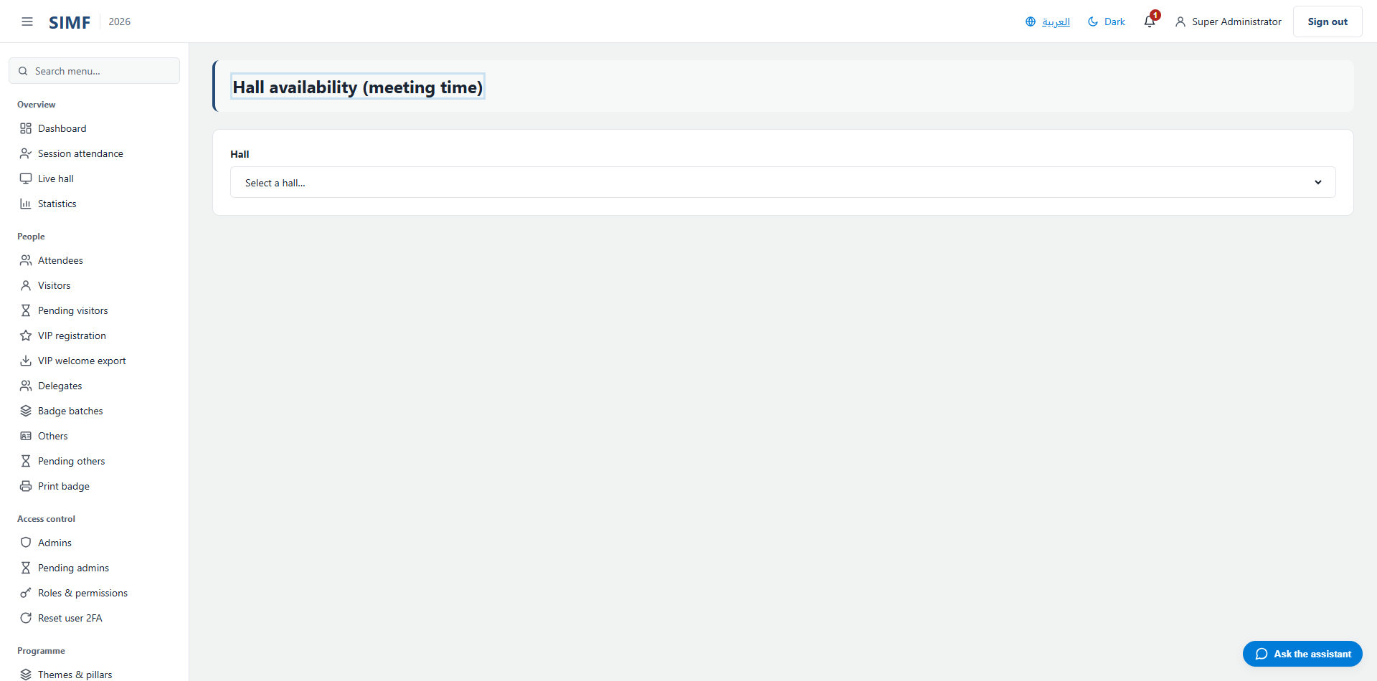
Figure 54 — Hall availability — /admin/hall-availability

Delegation meetings (/admin/delegation-meetings)
Property | Value
Address | /admin/delegation-meetings
Implemented by | src/ControlPanel/SIMF.ControlPanel/Components/Pages/Admin/DelegationMeetingsList.razor
Code-behind | src/ControlPanel/SIMF.ControlPanel/Components/Pages/Admin/DelegationMeetingsList.razor.cs
Page permission | DelegationMeetings.View
Menu permission | DelegationMeetings.View

What you can do here
Action | Permission it needs
A button the page gates itself | DelegationMeetings.Manage

The list shows: From delegation · To delegation · Attendees · Subject · Status · Submitted
It calls: /account/api/admin/delegation-meeting-requests/list /account/api/admin/delegation-meeting-requests/{_respondTarget.Id}/respond /account/api/admin/delegation-meeting-requests/{row.Id} /account/api/admin/delegation-meeting-requests/{row.Id}/check-in /account/api/admin/halls/list /account/api/admin/halls/{hallId}/available-slots /account/api/admin/halls/{hallId}/meeting-tables/list
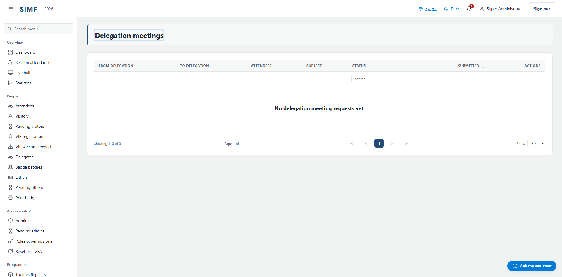
Figure 55 — Delegation meetings — /admin/delegation-meetings

Delegation availability (/admin/delegation-availability)
Property | Value
Address | /admin/delegation-availability
Implemented by | src/ControlPanel/SIMF.ControlPanel/Components/Pages/Admin/DelegationAvailabilityPage.razor
Code-behind | src/ControlPanel/SIMF.ControlPanel/Components/Pages/Admin/DelegationAvailabilityPage.razor.cs
Page permission | DelegationMeetings.Manage
Menu permission | DelegationMeetings.Manage

What you can do here
Action | Permission it needs
A button the page gates itself | DelegationMeetings.Manage

It calls: /account/api/admin/countries/list /account/api/admin/countries/{id}/availability-windows /account/api/admin/delegation-availability-windows/{windowId} /account/api/admin/programme/forum-window
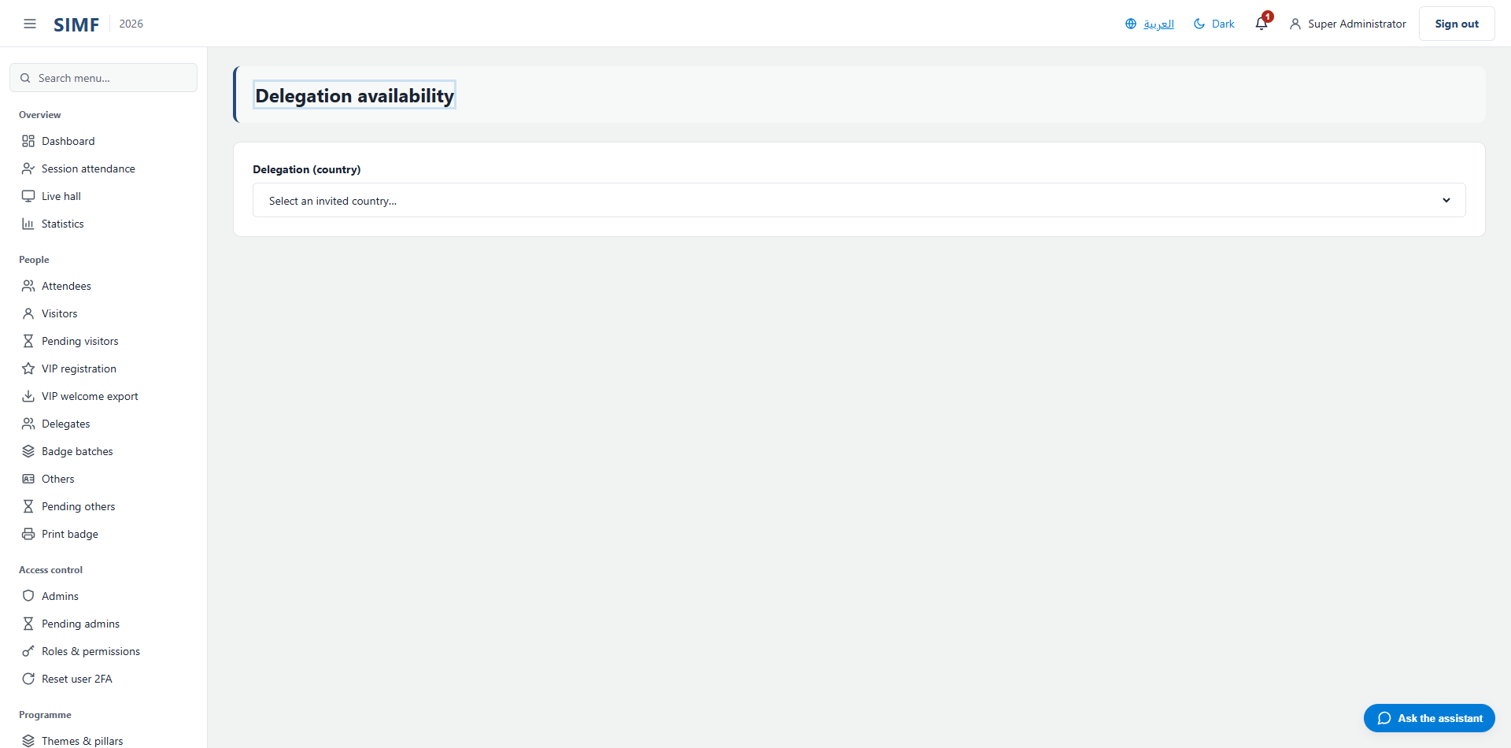
Figure 56 — Delegation availability — /admin/delegation-availability

Document requests (/admin/document-requests)
Property | Value
Address | /admin/document-requests
Implemented by | src/ControlPanel/SIMF.ControlPanel/Components/Pages/Admin/DocumentRequestsList.razor
Code-behind | src/ControlPanel/SIMF.ControlPanel/Components/Pages/Admin/DocumentRequestsList.razor.cs
Page permission | ParticipationDocumentRequests.View
Menu permission | ParticipationDocumentRequests.View

What you can do here
Action | Permission it needs
A button the page gates itself | ParticipationDocumentRequests.Manage

The list shows: Requester · Document · Note · Status · Submitted · Responded
It calls: /account/api/admin/document-requests/list /account/api/admin/document-requests/{_respondTarget.Id}/respond /account/api/admin/document-requests/{row.Id}
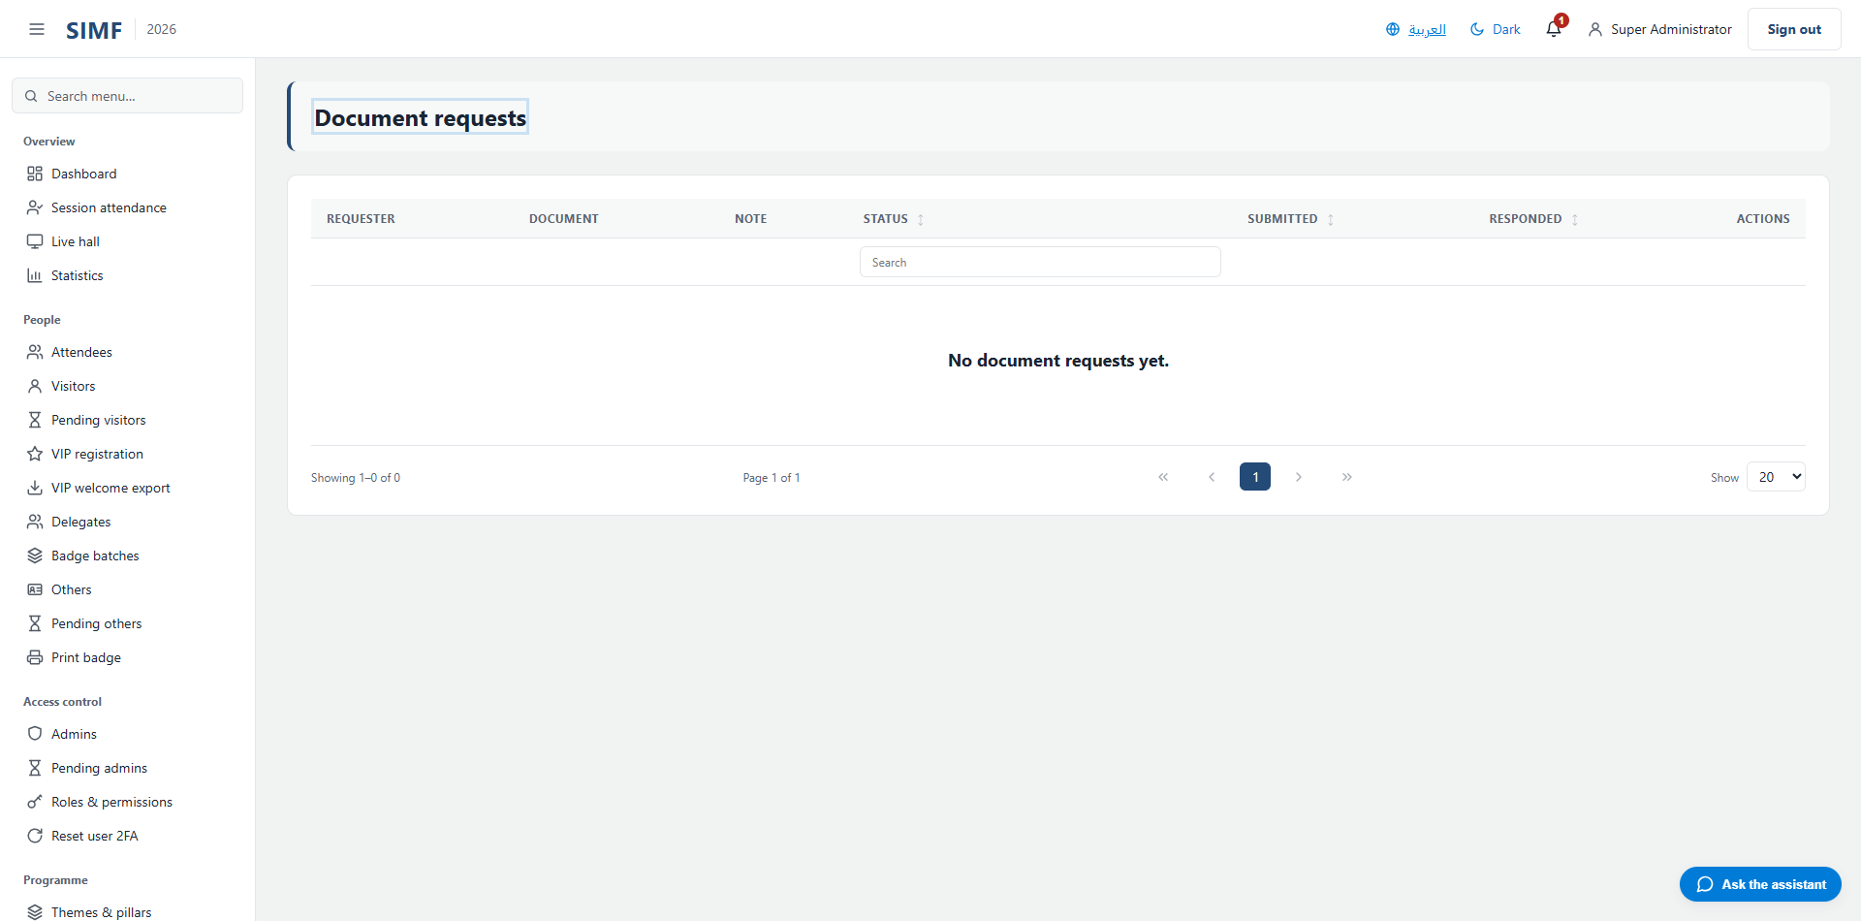
Figure 57 — Document requests — /admin/document-requests

Badge requests (/admin/badge-requests)
Property | Value
Address | /admin/badge-requests
Implemented by | src/ControlPanel/SIMF.ControlPanel/Components/Pages/Admin/BadgeRequestsList.razor
Code-behind | src/ControlPanel/SIMF.ControlPanel/Components/Pages/Admin/BadgeRequestsList.razor.cs
Page permission | BadgeUpdateRequests.View
Menu permission | BadgeUpdateRequests.View

What you can do here
Action | Permission it needs
A button the page gates itself | BadgeUpdateRequests.Manage

The list shows: Requester · Requested title · Current title · Status · Submitted · Responded
It calls: /account/api/admin/badge-requests/list /account/api/admin/badge-requests/{_respondTarget.Id}/respond /account/api/admin/badge-requests/{row.Id}
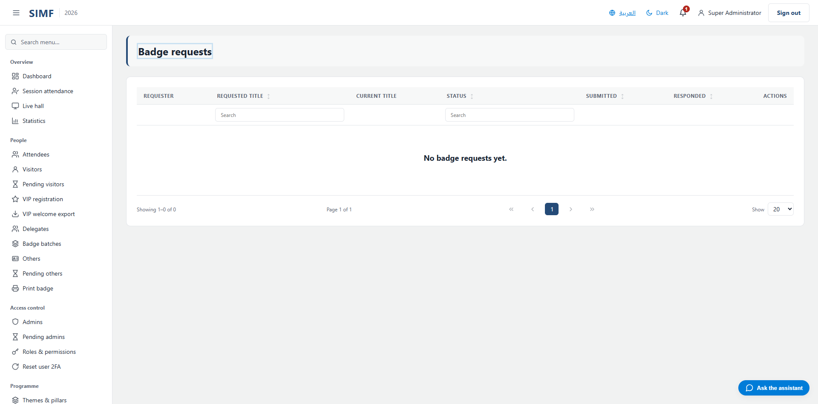
Figure 58 — Badge requests — /admin/badge-requests

Speakers (/admin/speakers)
Property | Value
Address | /admin/speakers
Implemented by | src/ControlPanel/SIMF.ControlPanel/Components/Pages/Admin/SpeakersList.razor
Code-behind | src/ControlPanel/SIMF.ControlPanel/Components/Pages/Admin/SpeakersList.razor.cs
Page permission | Speakers.View
Menu permission | Speakers.View

What you can do here
Action | Permission it needs
Add speaker | Speakers.Create
Edit | Speakers.Edit
Details | No permission of its own
Deactivate | Speakers.Delete
Import | Speakers.Import
Export | Speakers.Export

The list shows: Speaker · Country · Code · Order · Status
It calls: /account/api/admin/speakers/list /account/api/admin/speakers/{id}
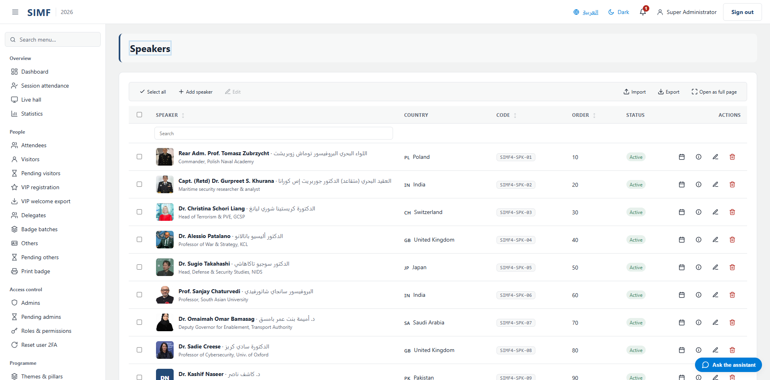
Figure 59 — Speakers — /admin/speakers

Speaker presentations (/admin/speaker-presentations)
Property | Value
Address | /admin/speaker-presentations
Implemented by | src/ControlPanel/SIMF.ControlPanel/Components/Pages/Admin/SpeakerPresentationsList.razor
Code-behind | src/ControlPanel/SIMF.ControlPanel/Components/Pages/Admin/SpeakerPresentationsList.razor.cs
Page permission | Speakers.View
Menu permission | Speakers.View

What you can do here
Action | Permission it needs
Export | Speakers.Export
A button the page gates itself | Speakers.Edit
A button the page gates itself | Speakers.View

The list shows: File · Session · Size
It calls: /account/api/admin/sessions/list /account/api/admin/speaker-presentations/export /account/api/admin/speaker-presentations/{row.Id} /account/api/admin/speaker-presentations/{row.Id}/file /account/api/admin/speakers/list /account/api/admin/speakers/{_speakerId}/presentations
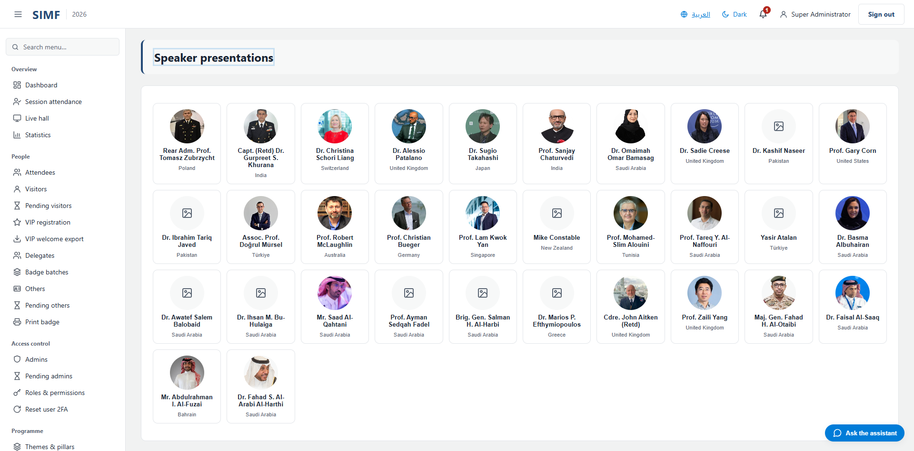
Figure 60 — Speaker presentations — /admin/speaker-presentations

Bookings (/admin/bookings)
Property | Value
Address | /admin/bookings
Implemented by | src/ControlPanel/SIMF.ControlPanel/Components/Pages/Admin/BookingsList.razor
Code-behind | src/ControlPanel/SIMF.ControlPanel/Components/Pages/Admin/BookingsList.razor.cs
Page permission | Bookings.View
Menu permission | Bookings.View

What you can do here
Action | Permission it needs
Export | Bookings.Export

The list shows: Session · Starts (Saudi time) · Seat · Attendee · Booked (Saudi time)
It calls: /account/api/admin/bookings/export /account/api/admin/bookings/list
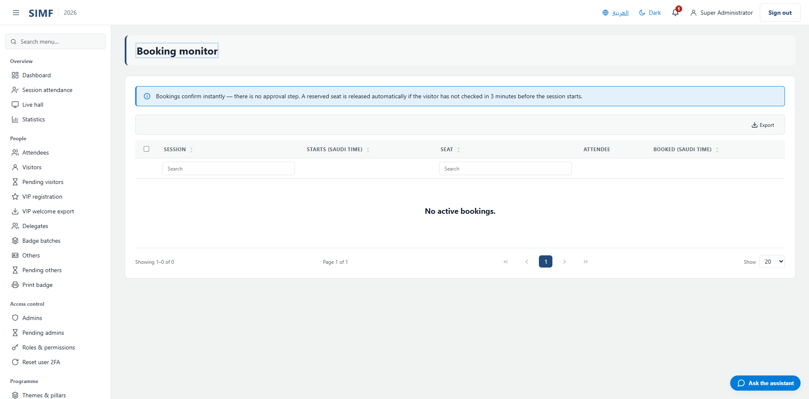
Figure 61 — Bookings — /admin/bookings

Meeting Tables (/admin/meeting-tables)
Property | Value
Address | /admin/meeting-tables
Implemented by | src/ControlPanel/SIMF.ControlPanel/Components/Pages/Admin/MeetingTablesList.razor
Code-behind | src/ControlPanel/SIMF.ControlPanel/Components/Pages/Admin/MeetingTablesList.razor.cs
Page permission | MeetingTables.View
Menu permission | MeetingTables.View

What you can do here
Action | Permission it needs
Add table | MeetingTables.Edit
Edit | MeetingTables.Edit
Details | No permission of its own
Delete | MeetingTables.Edit
Export | MeetingTables.Export
A button the page gates itself | HallAllocations.Edit
A button the page gates itself | Halls.Edit

The list shows: Code · Row · Column · Capacity · Purpose · Mode · Start · End
It calls: /account/api/admin/hall-allocations/{row.Id} /account/api/admin/halls/list /account/api/admin/halls/{hid}/hall-allocations /account/api/admin/halls/{hid}/hall-allocations/list /account/api/admin/halls/{hid}/meeting-tables /account/api/admin/halls/{hid}/meeting-tables/generate /account/api/admin/halls/{hid}/meeting-tables/list /account/api/admin/halls/{hid}/purpose /account/api/admin/meeting-tables/export /account/api/admin/meeting-tables/{_editingTableId} /account/api/admin/meeting-tables/{row.Id}
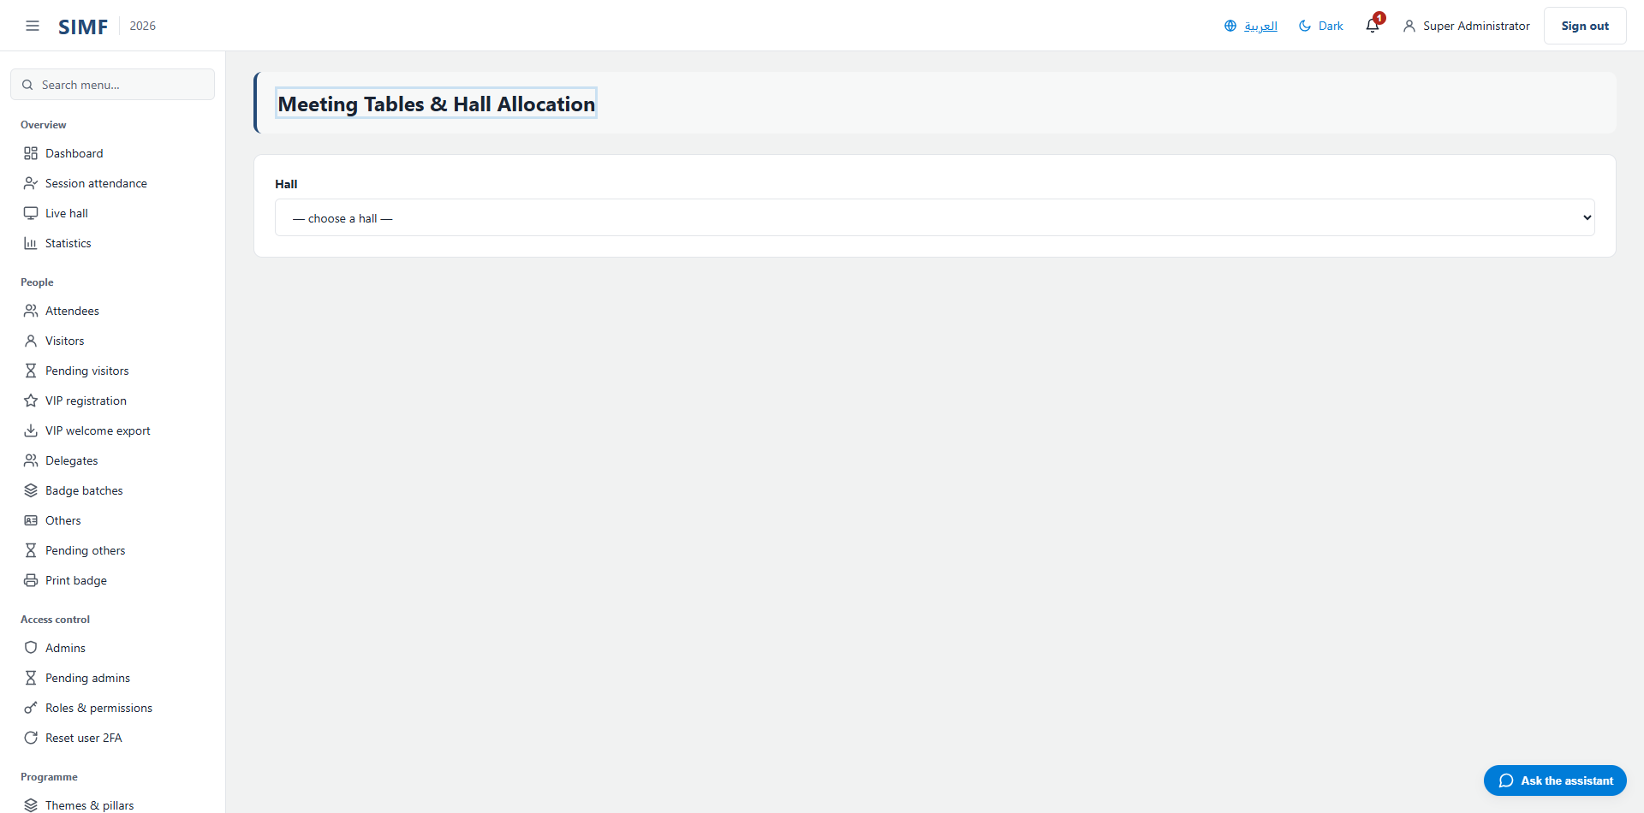
Figure 62 — Meeting Tables — /admin/meeting-tables

Business Meetings (/admin/business-meetings)
Property | Value
Address | /admin/business-meetings
Implemented by | src/ControlPanel/SIMF.ControlPanel/Components/Pages/Admin/BusinessMeetingsList.razor
Code-behind | src/ControlPanel/SIMF.ControlPanel/Components/Pages/Admin/BusinessMeetingsList.razor.cs
Page permission | BusinessMeetings.View
Menu permission | BusinessMeetings.View

What you can do here
Action | Permission it needs
Schedule meeting | BusinessMeetings.Schedule
View | No permission of its own
Export | BusinessMeetings.Export
A button the page gates itself | BusinessMeetings.Cancel

The list shows: Hall · Table · Type · Start · End · Participants · Status
It calls: /account/api/admin/attendees/list /account/api/admin/business-meetings /account/api/admin/business-meetings/export /account/api/admin/business-meetings/list /account/api/admin/business-meetings/{_cancelTarget.Id}/cancel /account/api/admin/business-meetings/{row.Id} /account/api/admin/exhibitors/list /account/api/admin/halls/list /account/api/admin/halls/{hid}/meeting-tables/list /account/api/admin/programme/forum-window
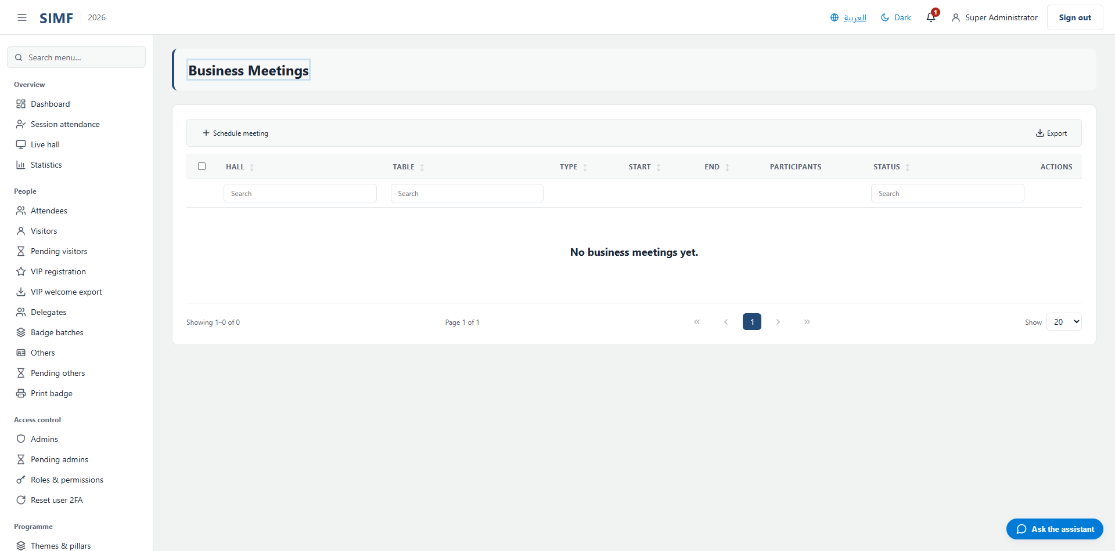
Figure 63 — Business Meetings — /admin/business-meetings

Scientific committee

Session moderators (/admin/session-moderators)
Property | Value
Address | /admin/session-moderators
Implemented by | src/ControlPanel/SIMF.ControlPanel/Components/Pages/Admin/SessionModeratorsList.razor
Code-behind | src/ControlPanel/SIMF.ControlPanel/Components/Pages/Admin/SessionModeratorsList.razor.cs
Page permission | SessionModerators.View
Menu permission | SessionModerators.View

What you can do here
Action | Permission it needs
Add | SessionModerators.Assign
Export | SessionModerators.Export
A button the page gates itself | SessionModerators.Revoke

The list shows: Session · Moderator · Assigned by · Assigned
It calls: /account/api/admin/session-moderators /account/api/admin/session-moderators/assign-options /account/api/admin/session-moderators/export /account/api/admin/session-moderators/list /account/api/admin/session-moderators/{row.SessionId}/{row.UserId}
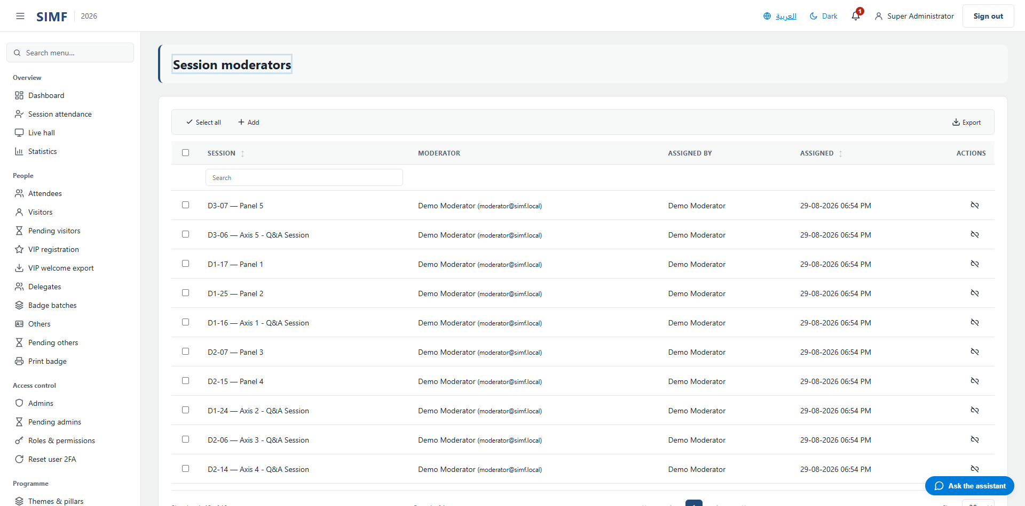
Figure 64 — Session moderators — /admin/session-moderators

Question queue (/admin/question-queue)
Property | Value
Address | /admin/question-queue
Implemented by | src/ControlPanel/SIMF.ControlPanel/Components/Pages/Admin/QuestionQueueList.razor
Code-behind | src/ControlPanel/SIMF.ControlPanel/Components/Pages/Admin/QuestionQueueList.razor.cs
Page permission | Questions.View
Menu permission | Questions.View

What you can do here
Action | Permission it needs
Export | Questions.Export
A button the page gates itself | Questions.Escalate
A button the page gates itself | Questions.Moderate

The list shows: Session · Question · Submitter · Phase · AI verdict
It calls: /account/api/admin/questions/export /account/api/admin/questions/list /account/api/admin/questions/{id}/approve /account/api/admin/questions/{id}/escalate /account/api/admin/questions/{id}/hide
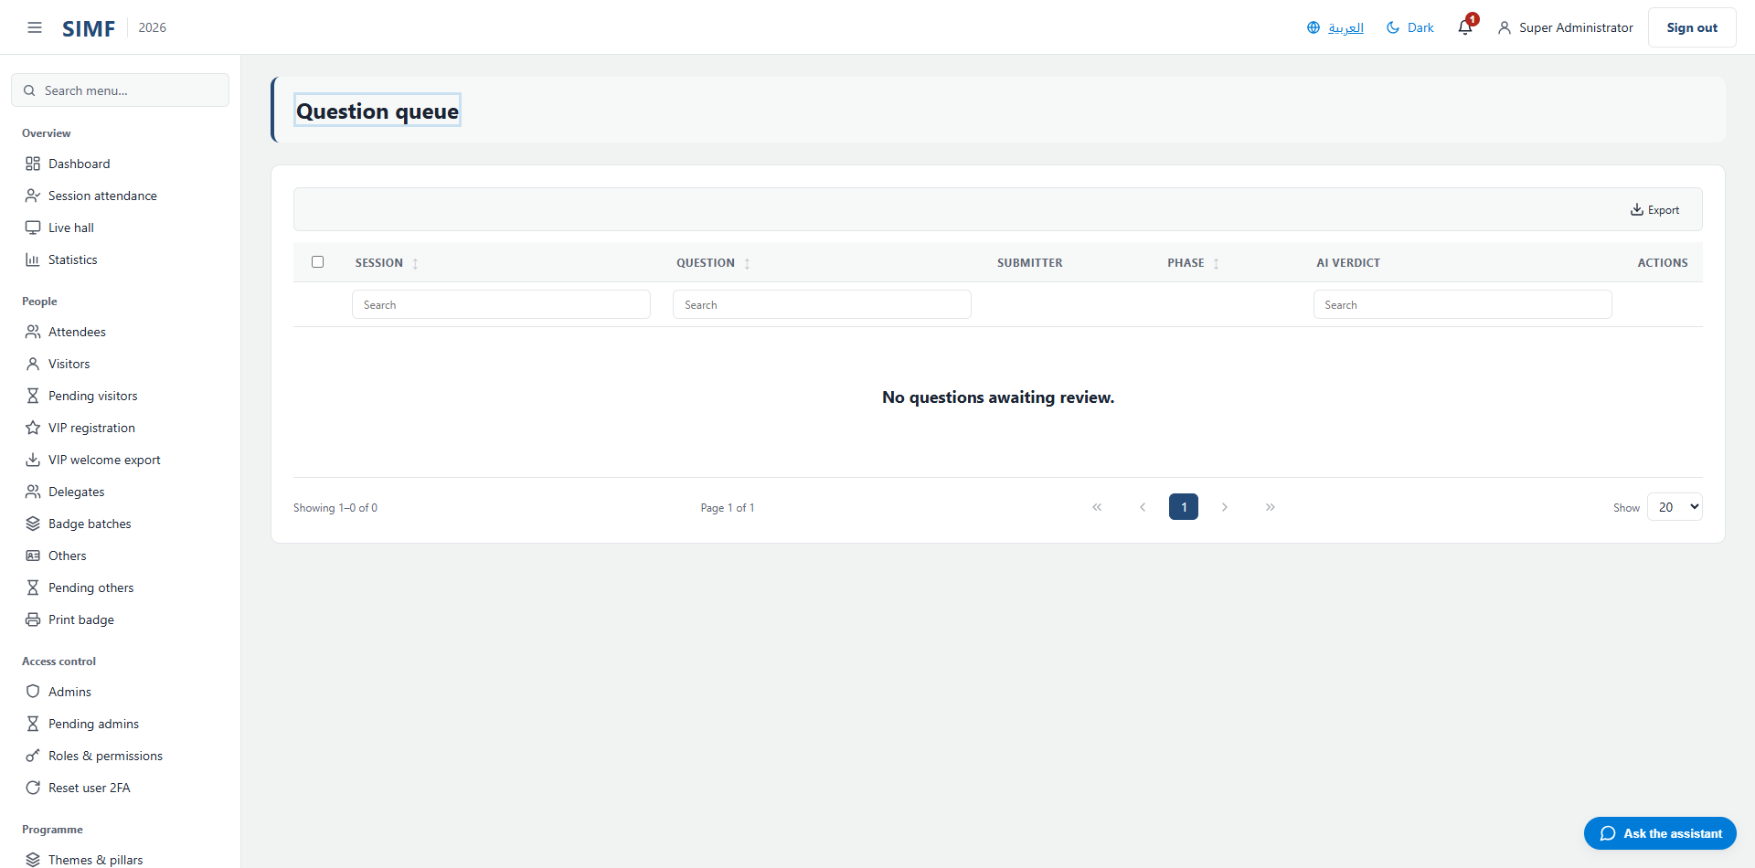
Figure 65 — Question queue — /admin/question-queue

Session summaries (/admin/session-summaries)
Property | Value
Address | /admin/session-summaries
Implemented by | src/ControlPanel/SIMF.ControlPanel/Components/Pages/Admin/SessionSummariesList.razor
Code-behind | src/ControlPanel/SIMF.ControlPanel/Components/Pages/Admin/SessionSummariesList.razor.cs
Page permission | SessionSummaries.View
Menu permission | SessionSummaries.View

What you can do here
Action | Permission it needs
Export | SessionSummaries.Export
A button the page gates itself | SessionSummaries.Approve
A button the page gates itself | SessionSummaries.Edit
A button the page gates itself | SessionSummaries.Publish

The list shows: Session · Status · Source
It calls: /account/api/admin/session-summaries/export /account/api/admin/session-summaries/list /account/api/admin/session-summaries/{_editSessionId} /account/api/admin/session-summaries/{sessionId} /account/api/admin/session-summaries/{sessionId}/generate /account/api/admin/session-summaries/{sessionId}/publish /account/api/admin/session-summaries/{sessionId}/unpublish /account/api/admin/session-summaries/{sessionId}/{action}
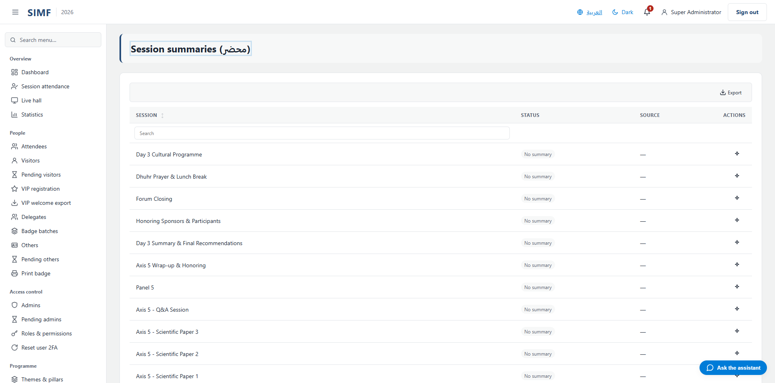
Figure 66 — Session summaries — /admin/session-summaries

Exhibition

Exhibitors (/admin/exhibitors)
Property | Value
Address | /admin/exhibitors
Implemented by | src/ControlPanel/SIMF.ControlPanel/Components/Pages/Admin/ExhibitorsList.razor
Code-behind | src/ControlPanel/SIMF.ControlPanel/Components/Pages/Admin/ExhibitorsList.razor.cs
Page permission | Exhibitors.View
Menu permission | Exhibitors.View

What you can do here
Action | Permission it needs
Add | Exhibitors.Create
Edit | Exhibitors.Edit
Details | No permission of its own
Delete | Exhibitors.Delete
Import | Exhibitors.Import
Export | Exhibitors.Export
A button the page gates itself | Exhibitors.LinkAccount
A button the page gates itself | Exhibitors.RevokeAccount

The list shows: Name (English) · Name (Arabic) · Accounts · Active
It calls: /account/api/admin/exhibitors/list /account/api/admin/exhibitors/{_accountsExhibitorId}/accounts /account/api/admin/exhibitors/{_accountsExhibitorId}/accounts/link /account/api/admin/exhibitors/{_accountsExhibitorId}/accounts/{membershipId} /account/api/admin/exhibitors/{id}
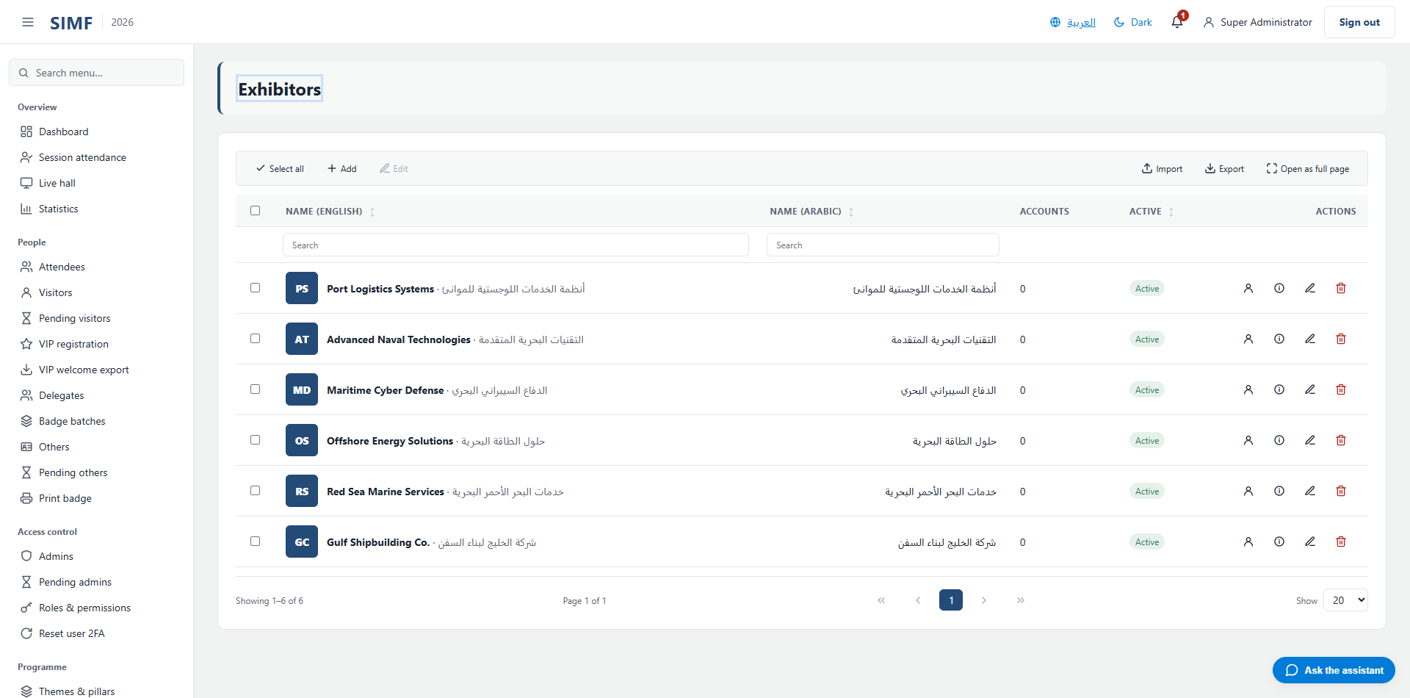
Figure 67 — Exhibitors — /admin/exhibitors

Booths (/admin/booths)
Property | Value
Address | /admin/booths
Implemented by | src/ControlPanel/SIMF.ControlPanel/Components/Pages/Admin/BoothsList.razor
Code-behind | src/ControlPanel/SIMF.ControlPanel/Components/Pages/Admin/BoothsList.razor.cs
Page permission | Booths.View
Menu permission | Booths.View

What you can do here
Action | Permission it needs
Add | Booths.Create
Edit | Booths.Edit
Details | No permission of its own
Delete | Booths.Delete
Import | Booths.Import
Export | Booths.Export

The list shows: Code · Name (English) · Name (Arabic) · Exhibitor · Sector · Hall · Active
It calls: /account/api/admin/booths/list /account/api/admin/booths/{id} /account/api/admin/exhibitors/list /account/api/admin/halls/list
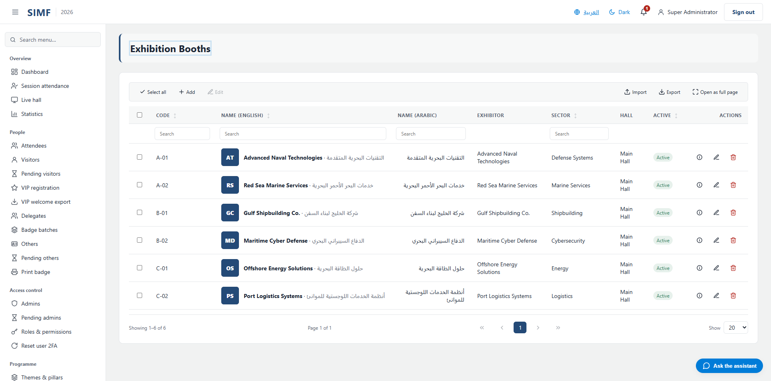
Figure 68 — Booths — /admin/booths

Sponsors (/admin/sponsors)
Property | Value
Address | /admin/sponsors
Implemented by | src/ControlPanel/SIMF.ControlPanel/Components/Pages/Admin/SponsorsList.razor
Code-behind | src/ControlPanel/SIMF.ControlPanel/Components/Pages/Admin/SponsorsList.razor.cs
Page permission | Sponsors.View
Menu permission | Sponsors.View

What you can do here
Action | Permission it needs
Add | Sponsors.Create
Edit | Sponsors.Edit
Details | No permission of its own
Delete | Sponsors.Delete
Import | Sponsors.Import
Export | Sponsors.Export

The list shows: Name (English) · Tier · Link · Display order · Active
It calls: /account/api/admin/sponsors/list /account/api/admin/sponsors/{id}
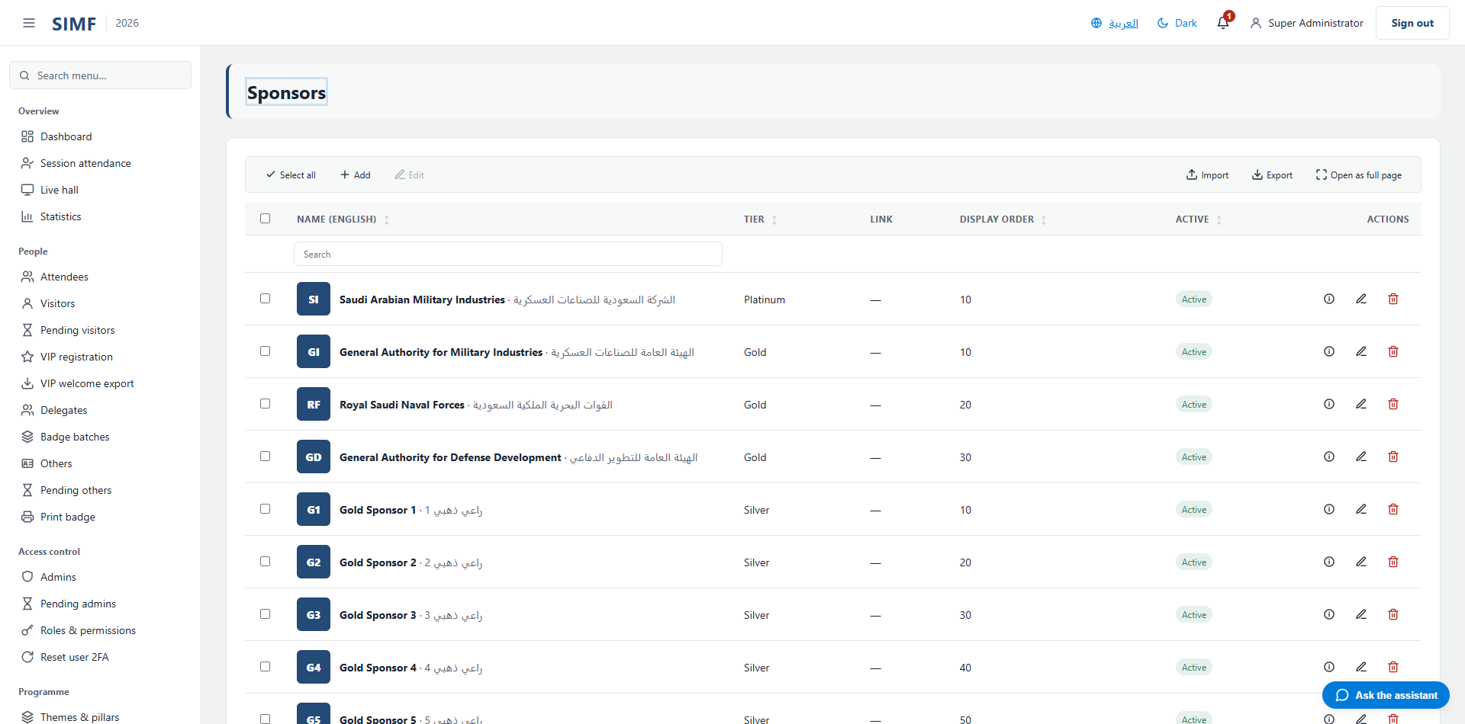
Figure 69 — Sponsors — /admin/sponsors

Venue map (/admin/venue-map)
Property | Value
Address | /admin/venue-map
Implemented by | src/ControlPanel/SIMF.ControlPanel/Components/Pages/Admin/VenueMapList.razor
Code-behind | src/ControlPanel/SIMF.ControlPanel/Components/Pages/Admin/VenueMapList.razor.cs
Page permission | VenueMap.View
Menu permission | VenueMap.View

What you can do here
Action | Permission it needs
Add | VenueMap.Create
Edit | VenueMap.Edit
Details | No permission of its own
Delete | VenueMap.Delete
Import | VenueMap.Import
Export | VenueMap.Export

The list shows: Label · Kind · Position (x, y) · Active
It calls: /account/api/admin/venue-map/list /account/api/admin/venue-map/{id}
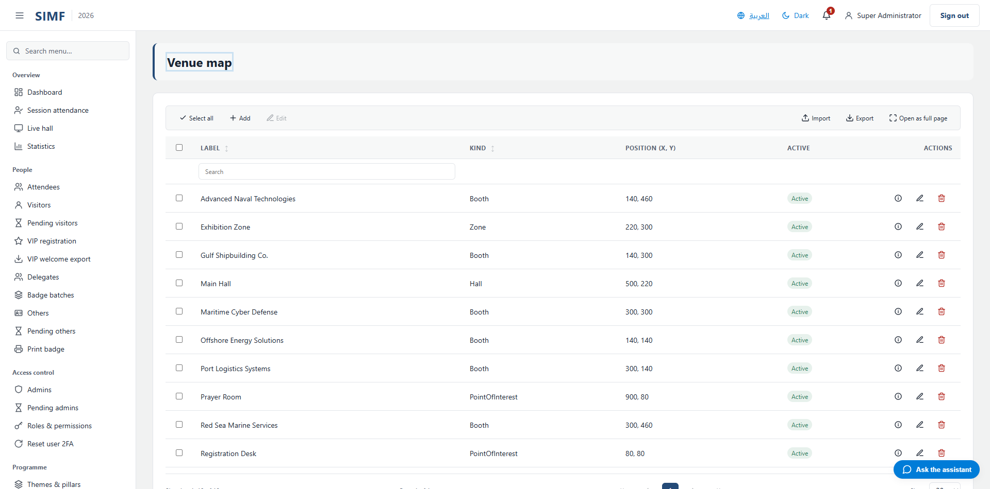
Figure 70 — Venue map — /admin/venue-map

Engagement

Live sessions (/m/live-sessions)
Property | Value
Address | /m/live-sessions
Implemented by | -
Code-behind | -
Page permission | -
Menu permission | Sessions.View
Placeholder | Yes — the module is not built yet

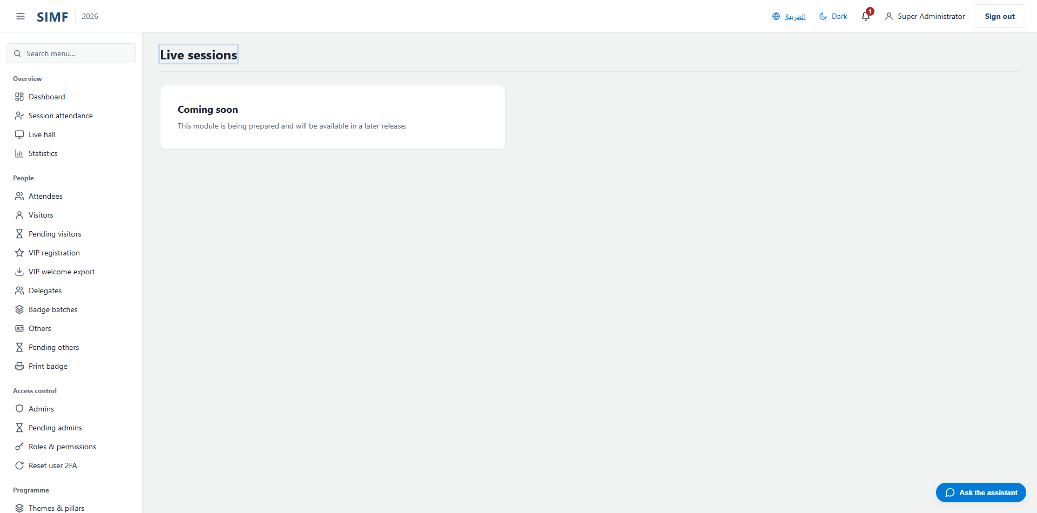
Figure 71 — Live sessions — /m/live-sessions

Ratings (/admin/ratings)
Property | Value
Address | /admin/ratings
Implemented by | src/ControlPanel/SIMF.ControlPanel/Components/Pages/Admin/RatingsList.razor
Code-behind | src/ControlPanel/SIMF.ControlPanel/Components/Pages/Admin/RatingsList.razor.cs
Page permission | Ratings.View
Menu permission | Ratings.View

What you can do here
Action | Permission it needs
Export | Ratings.Export

The list shows: Type · Target · Overall · Answers · Comment · Active · Submitted at
It calls: /account/api/admin/feedback/ratings /account/api/admin/feedback/ratings/kpi /account/api/admin/ratings/export
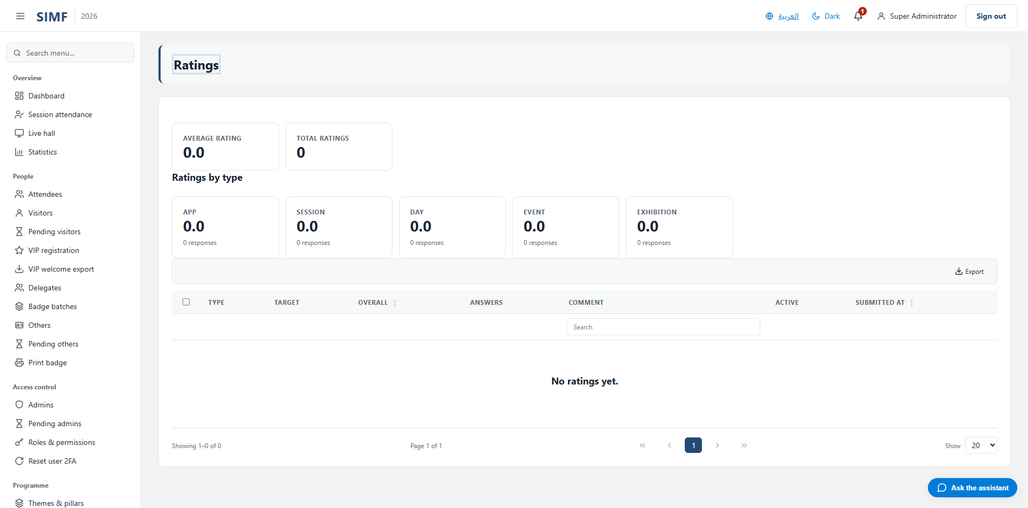
Figure 72 — Ratings — /admin/ratings

Rating configuration (/admin/rating-config)
Property | Value
Address | /admin/rating-config
Implemented by | src/ControlPanel/SIMF.ControlPanel/Components/Pages/Admin/RatingConfig.razor
Code-behind | src/ControlPanel/SIMF.ControlPanel/Components/Pages/Admin/RatingConfig.razor.cs
Page permission | RatingConfig.View
Menu permission | RatingConfig.View

What you can do here
Action | Permission it needs
Add | RatingConfig.Create
Edit | RatingConfig.Edit
Details | No permission of its own
Delete | RatingConfig.Delete

The list shows: Code · Name · Scope · Built-in · Groups · Questions · Responses · Active · Name · Name (Arabic) · Order · Questions · Active · Question · Name (Arabic) · Group · Required · Order · Active
It calls: /account/api/admin/ratings/groups /account/api/admin/ratings/groups/{_groupEditId} /account/api/admin/ratings/groups/{g.Id} /account/api/admin/ratings/questions /account/api/admin/ratings/questions/{_questionEditId} /account/api/admin/ratings/questions/{q.Id} /account/api/admin/ratings/types /account/api/admin/ratings/types/list /account/api/admin/ratings/types/{_selectedType.Id}/groups/list /account/api/admin/ratings/types/{_selectedType.Id}/questions/list /account/api/admin/ratings/types/{_typeEditId} /account/api/admin/ratings/types/{t.Id}
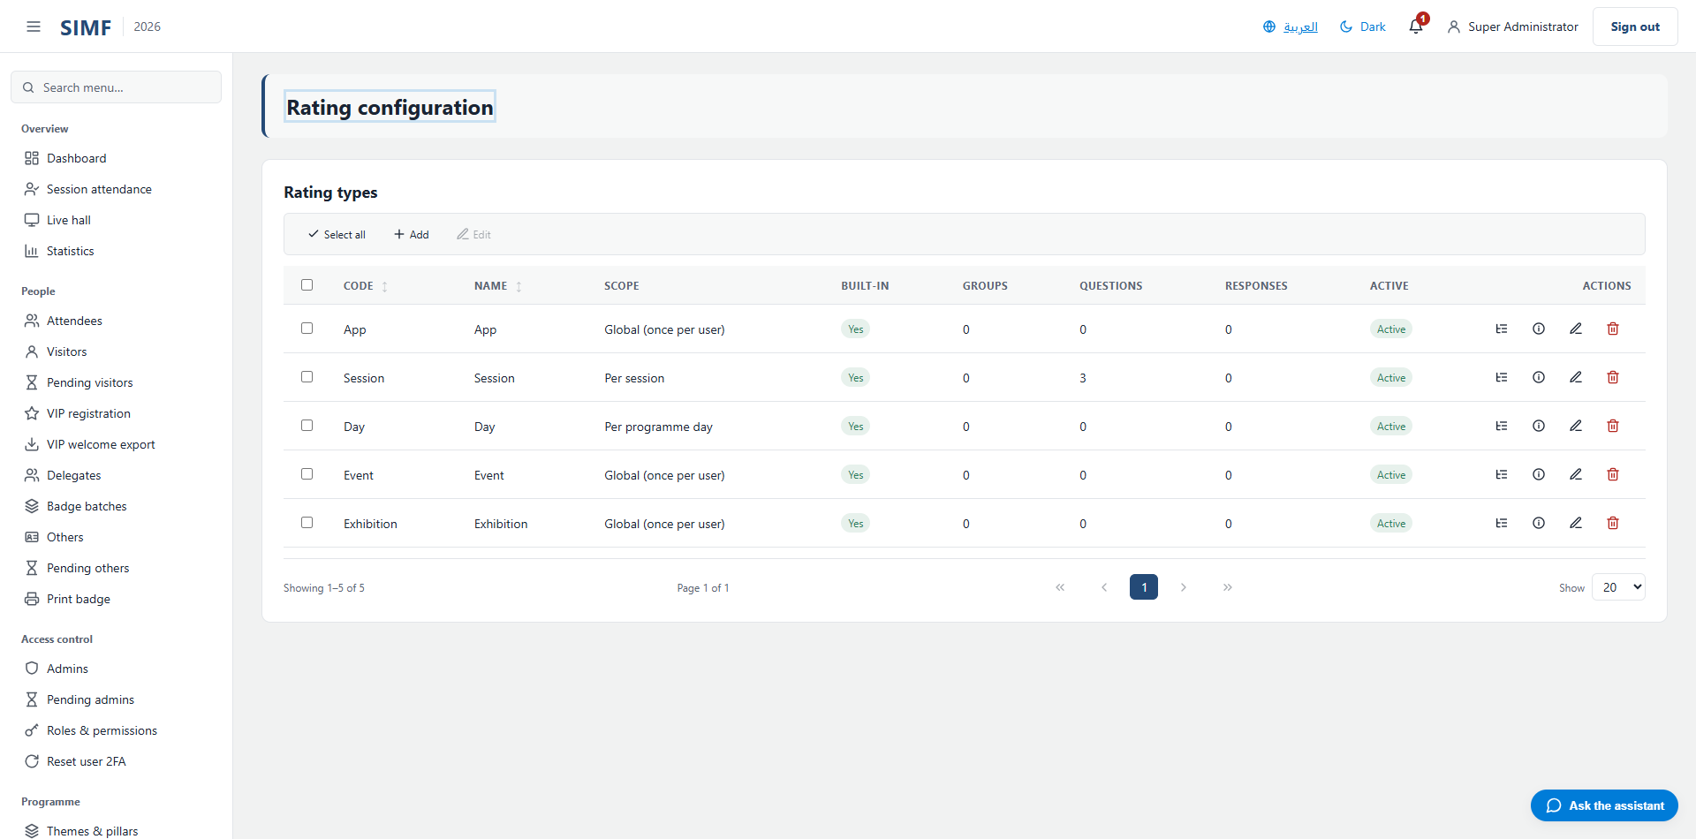
Figure 73 — Rating configuration — /admin/rating-config

Knowledge & AI

FAQ groups & entries (/admin/faq)
Property | Value
Address | /admin/faq
Implemented by | src/ControlPanel/SIMF.ControlPanel/Components/Pages/Admin/FaqManager.razor
Code-behind | src/ControlPanel/SIMF.ControlPanel/Components/Pages/Admin/FaqManager.razor.cs
Page permission | Faq.View
Menu permission | Faq.View

What you can do here
Action | Permission it needs
Add | Faq.Create
Edit | Faq.Edit
Details | No permission of its own
Delete | Faq.Delete

The list shows: Name (EN) · Name (AR) · Order · Entries · Active · Question (EN) · Name (AR) · Order · Active
It calls: /account/api/admin/faq/entries /account/api/admin/faq/entries/{_entryEditId} /account/api/admin/faq/entries/{e.Id} /account/api/admin/faq/groups /account/api/admin/faq/groups/list /account/api/admin/faq/groups/{_groupEditId} /account/api/admin/faq/groups/{_selectedGroup.Id}/entries/list /account/api/admin/faq/groups/{g.Id}
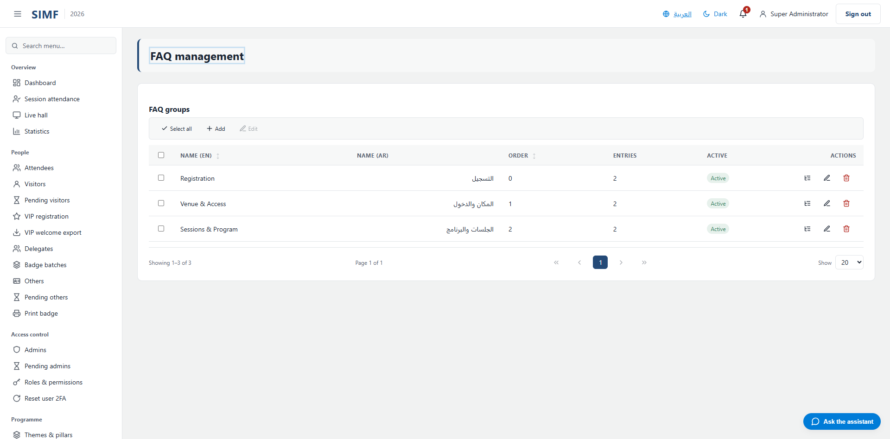
Figure 74 — FAQ groups & entries — /admin/faq

AI dashboard (/admin/ai)
Property | Value
Address | /admin/ai
Implemented by | src/ControlPanel/SIMF.ControlPanel/Components/Pages/Admin/AiDashboard.razor
Code-behind | src/ControlPanel/SIMF.ControlPanel/Components/Pages/Admin/AiDashboard.razor.cs
Page permission | AiDashboard.View
Menu permission | AiDashboard.View

It calls: /account/api/admin/ai/dashboard
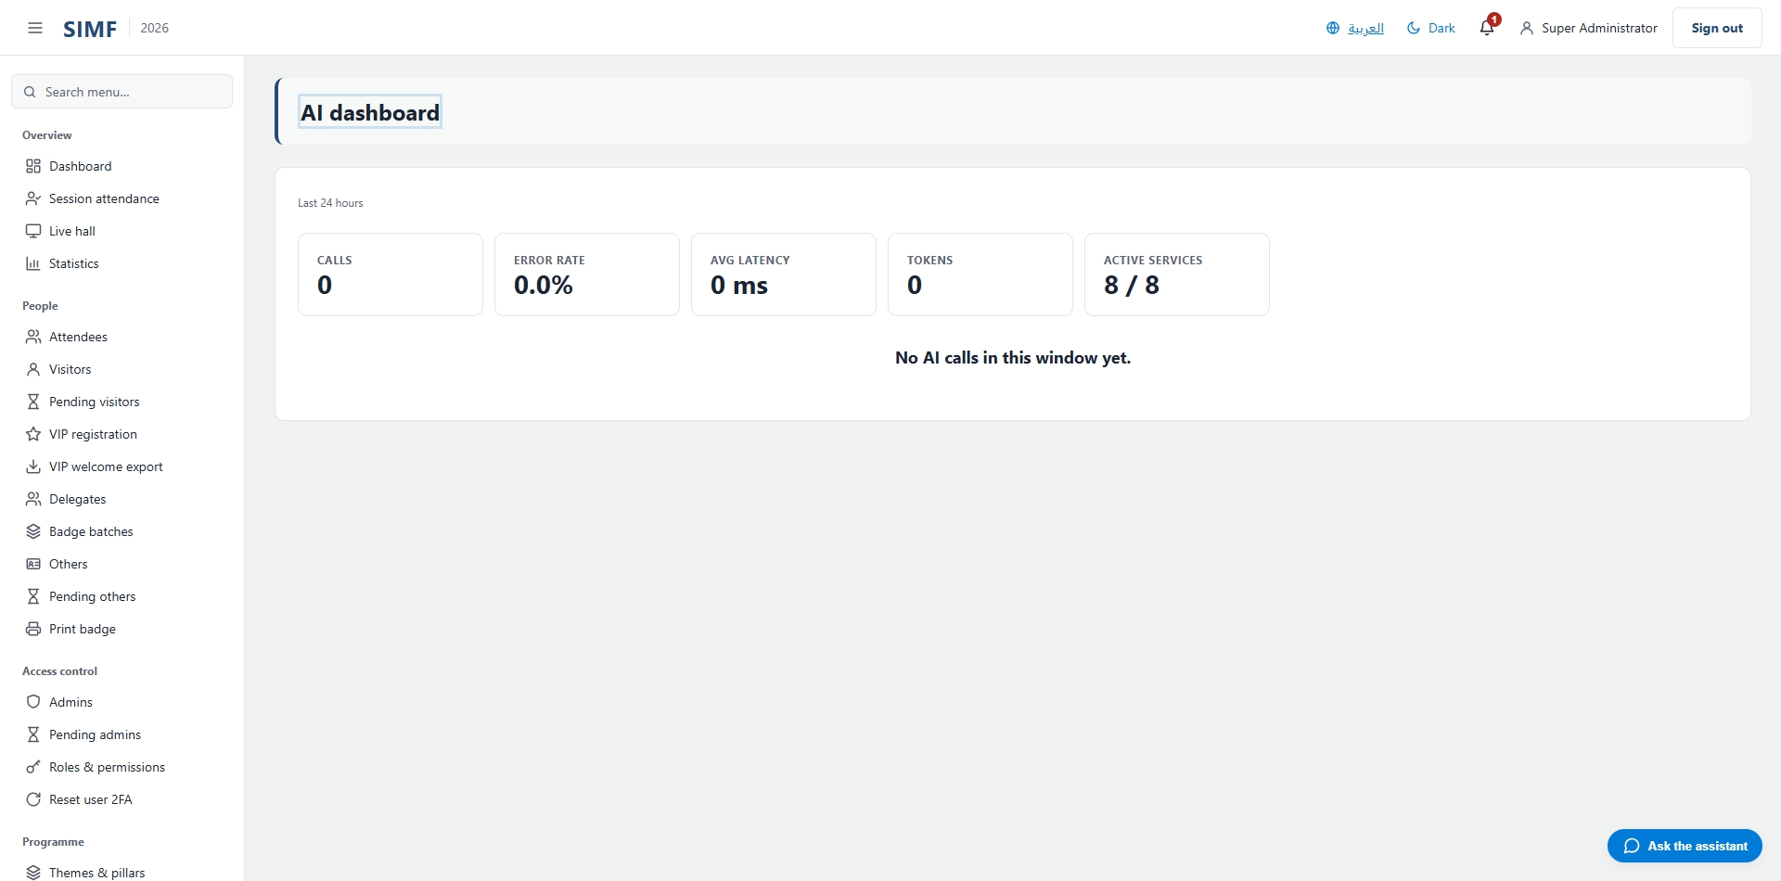
Figure 75 — AI dashboard — /admin/ai

AI services (/admin/ai/services)
Property | Value
Address | /admin/ai/services
Implemented by | src/ControlPanel/SIMF.ControlPanel/Components/Pages/Admin/AiServicesConsole.razor
Code-behind | src/ControlPanel/SIMF.ControlPanel/Components/Pages/Admin/AiServicesConsole.razor.cs
Page permission | AiPrompts.View
Menu permission | AiPrompts.View

What you can do here
Action | Permission it needs
A button the page gates itself | AiPrompts.Edit

The list shows: Service · Active prompt · Provider · Model · Hosting · Prompts
It calls: /account/api/admin/ai/prompts/list
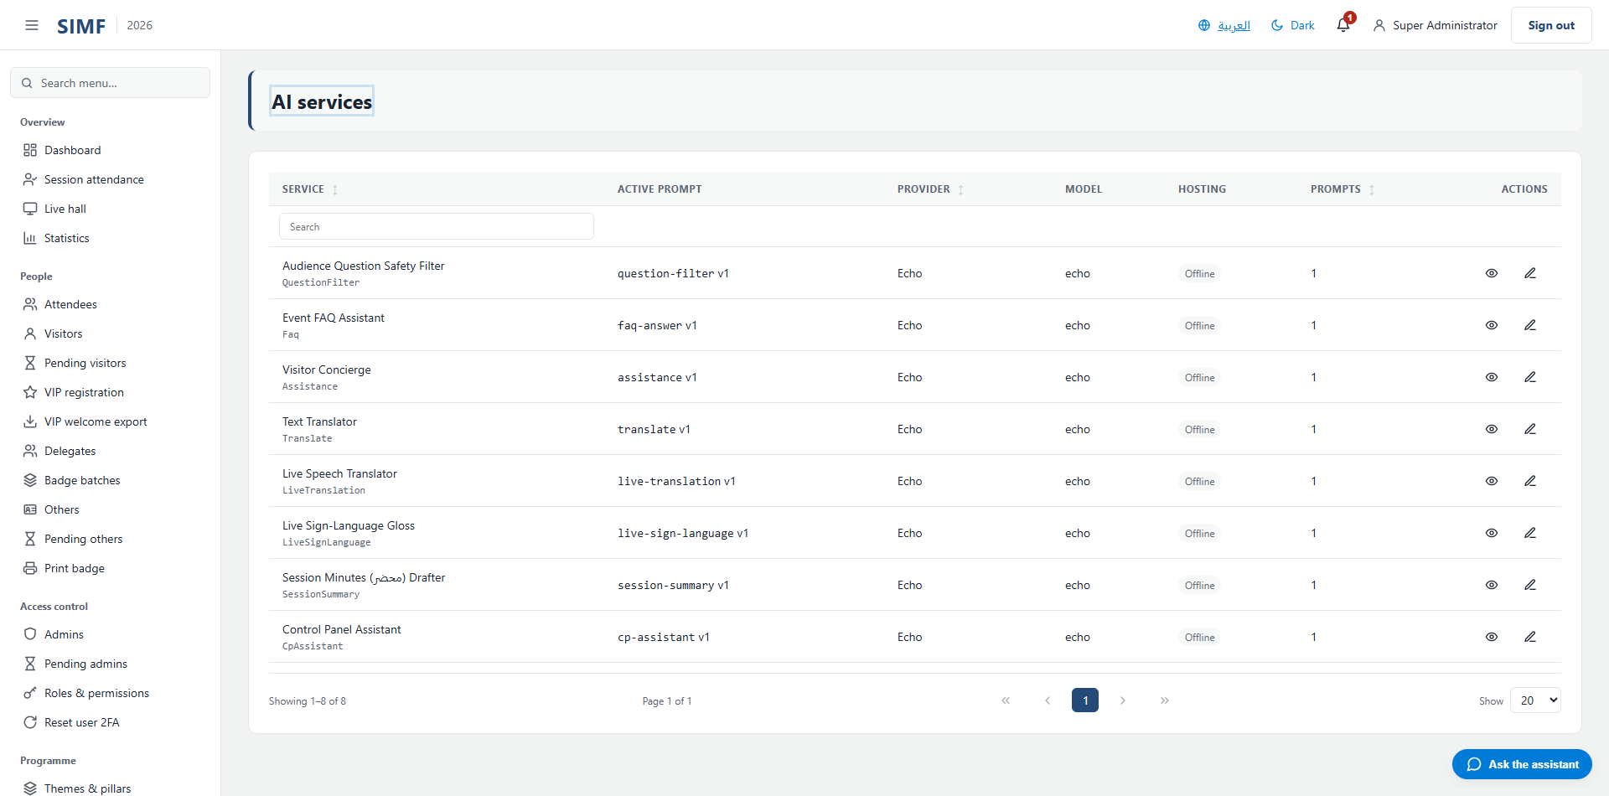
Figure 76 — AI services — /admin/ai/services

AI prompts (/admin/ai/prompts)
Property | Value
Address | /admin/ai/prompts
Implemented by | src/ControlPanel/SIMF.ControlPanel/Components/Pages/Admin/AiPromptsList.razor
Code-behind | src/ControlPanel/SIMF.ControlPanel/Components/Pages/Admin/AiPromptsList.razor.cs
Page permission | AiPrompts.View
Menu permission | AiPrompts.View

What you can do here
Action | Permission it needs
Add | AiPrompts.Create
Edit | AiPrompts.Edit
Details | No permission of its own
Delete | AiPrompts.Delete
Import | AiPrompts.Import
Export | AiPrompts.Export
A button the page gates itself | AiPrompts.Test
A button the page gates itself | AiPrompts.View

The list shows: Key · Feature · Name · Provider · Model · Hosting · Version · Active
It calls: /account/api/admin/ai/prompts/list /account/api/admin/ai/prompts/{_historyPromptId}/history/list /account/api/admin/ai/prompts/{_testTargetId}/test /account/api/admin/ai/prompts/{id}
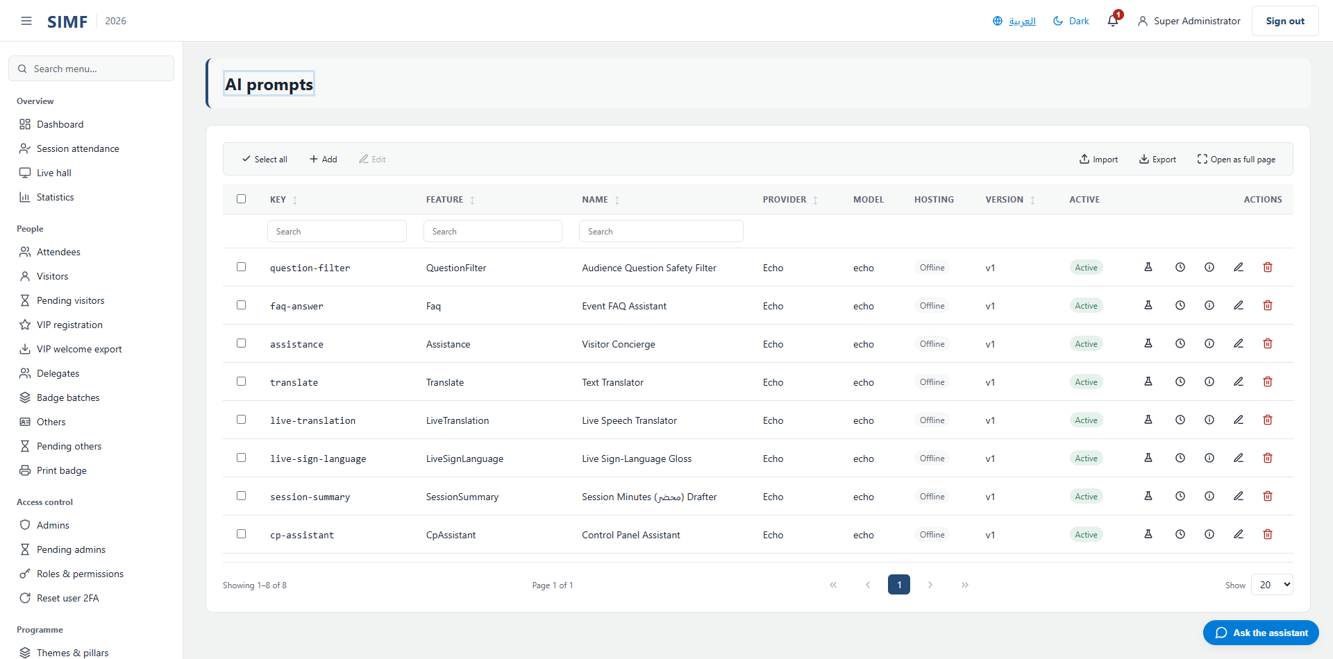
Figure 77 — AI prompts — /admin/ai/prompts

AI invocations (/admin/ai/invocations)
Property | Value
Address | /admin/ai/invocations
Implemented by | src/ControlPanel/SIMF.ControlPanel/Components/Pages/Admin/AiInvocationsLog.razor
Code-behind | src/ControlPanel/SIMF.ControlPanel/Components/Pages/Admin/AiInvocationsLog.razor.cs
Page permission | AiInvocations.View
Menu permission | AiInvocations.View

What you can do here
Action | Permission it needs
A button the page gates itself | AiInvocations.View

The list shows: Time · Prompt key · Feature · Provider · Caller · Latency · Tokens (in/out) · Error
It calls: /account/api/admin/ai/invocations/list /account/api/admin/ai/invocations/{row.Id}
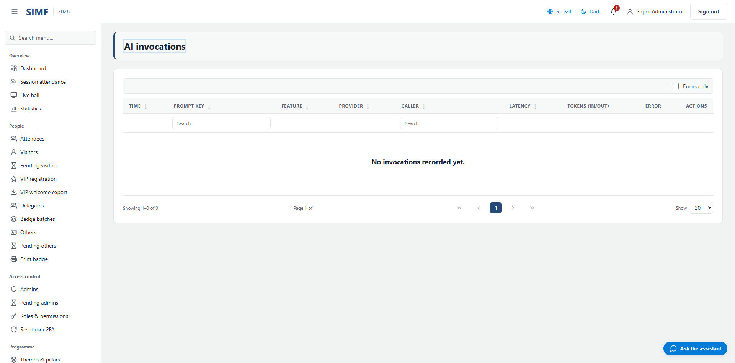
Figure 78 — AI invocations — /admin/ai/invocations

Content

Media library (/admin/media-library)
Property | Value
Address | /admin/media-library
Implemented by | src/ControlPanel/SIMF.ControlPanel/Components/Pages/Admin/MediaLibraryList.razor
Code-behind | src/ControlPanel/SIMF.ControlPanel/Components/Pages/Admin/MediaLibraryList.razor.cs
Page permission | MediaLibrary.View
Menu permission | MediaLibrary.View

What you can do here
Action | Permission it needs
Manage | No permission of its own
A button the page gates itself | MediaLibrary.Manage

The list shows: Category · Owner · Preview · Kind · Source · Active
It calls: /account/api/admin/assets/item/{_deactivateTarget.Id} /account/api/admin/assets/item/{_detailsTarget.Id}/restore /account/api/admin/assets/item/{row.Id} /account/api/admin/assets/list /account/api/admin/assets/{a.Category}/{a.OwnerId}/image
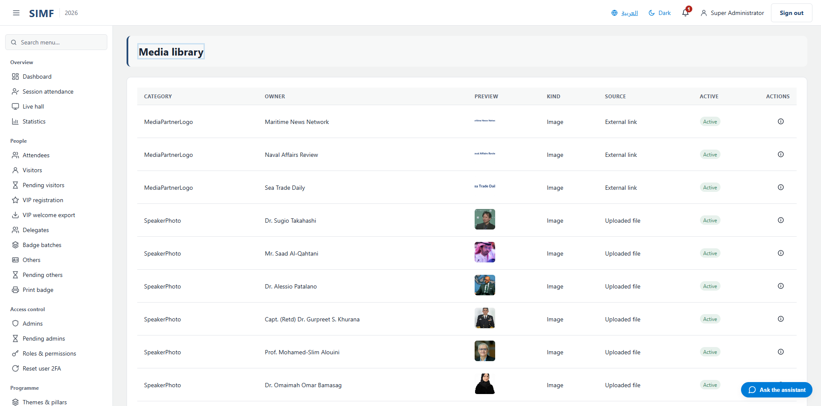
Figure 79 — Media library — /admin/media-library

Content blocks (/admin/content-blocks)
Property | Value
Address | /admin/content-blocks
Implemented by | src/ControlPanel/SIMF.ControlPanel/Components/Pages/Admin/ContentBlocksList.razor
Code-behind | src/ControlPanel/SIMF.ControlPanel/Components/Pages/Admin/ContentBlocksList.razor.cs
Page permission | ContentBlocks.View
Menu permission | ContentBlocks.View

What you can do here
Action | Permission it needs
Add | ContentBlocks.Edit
Edit | ContentBlocks.Edit
Details | No permission of its own
Delete | ContentBlocks.Delete
Import | ContentBlocks.Import
Export | ContentBlocks.Export

The list shows: Key · English · Last updated · Active
It calls: /account/api/admin/content-blocks/list
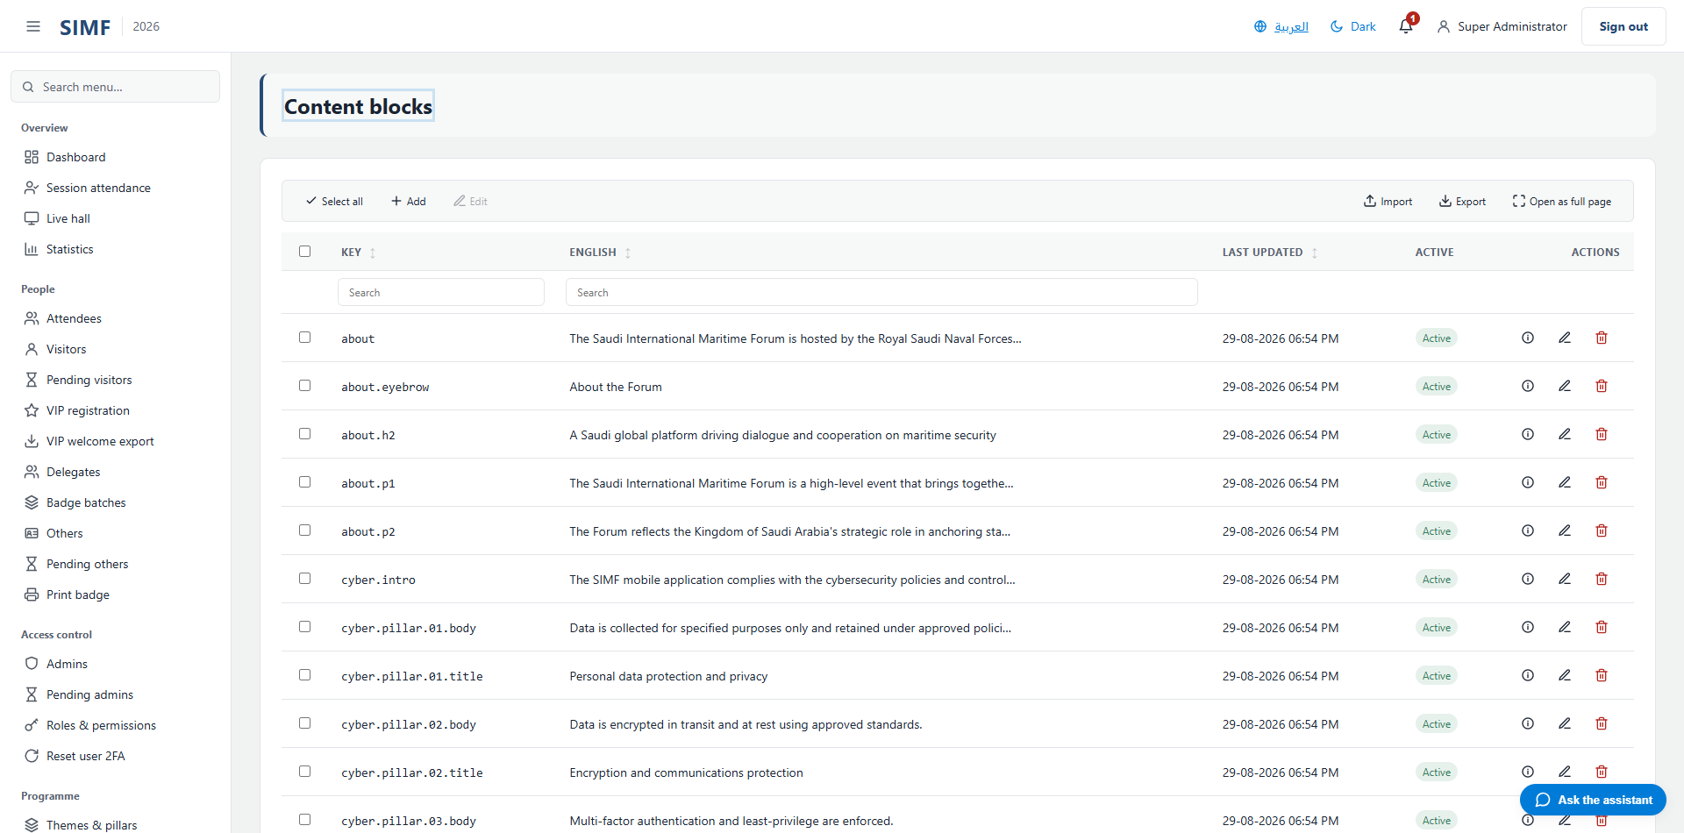
Figure 80 — Content blocks — /admin/content-blocks

Banners (/admin/banners)
Property | Value
Address | /admin/banners
Implemented by | src/ControlPanel/SIMF.ControlPanel/Components/Pages/Admin/BannersList.razor
Code-behind | src/ControlPanel/SIMF.ControlPanel/Components/Pages/Admin/BannersList.razor.cs
Page permission | Banners.View
Menu permission | Banners.View

What you can do here
Action | Permission it needs
Add | Banners.Create
Edit | Banners.Edit
Details | No permission of its own
Delete | Banners.Delete
Import | Banners.Import
Export | Banners.Export

The list shows: Title · Start · End · Order · Active
It calls: /account/api/admin/banners/list /account/api/admin/banners/{id}
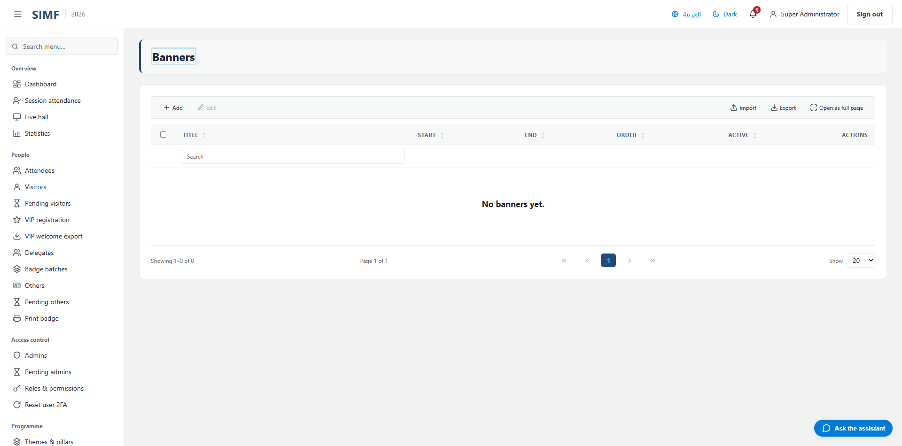
Figure 81 — Banners — /admin/banners

Media Center (/admin/media)
Property | Value
Address | /admin/media
Implemented by | src/ControlPanel/SIMF.ControlPanel/Components/Pages/Admin/MediaList.razor
Code-behind | src/ControlPanel/SIMF.ControlPanel/Components/Pages/Admin/MediaList.razor.cs
Page permission | Media.View
Menu permission | Media.View

What you can do here
Action | Permission it needs
Add | Media.Create
Edit | Media.Edit
Details | No permission of its own
Delete | Media.Delete
Import | Media.Import
Export | Media.Export

The list shows: Type · Title (English) · Title (Arabic) · Album (English) · Album (Arabic) · Image · Order · Active
It calls: /account/api/admin/media/list /account/api/admin/media/{id}
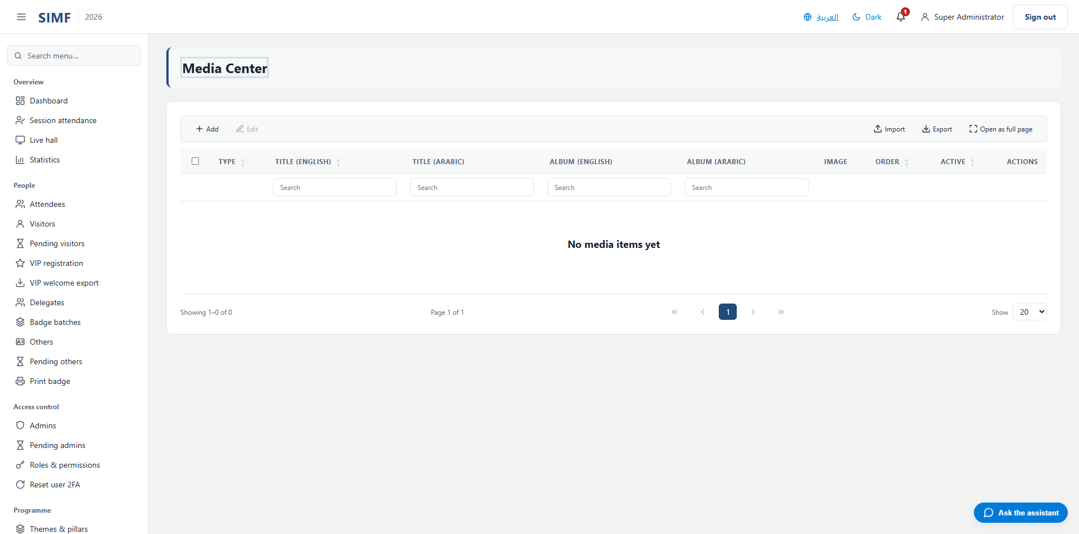
Figure 82 — Media Center — /admin/media

News (/admin/news)
Property | Value
Address | /admin/news
Implemented by | src/ControlPanel/SIMF.ControlPanel/Components/Pages/Admin/NewsList.razor
Code-behind | src/ControlPanel/SIMF.ControlPanel/Components/Pages/Admin/NewsList.razor.cs
Page permission | News.View
Menu permission | News.View

What you can do here
Action | Permission it needs
Add | News.Create
Edit | News.Edit
Details | No permission of its own
Delete | News.Delete
Import | News.Import
Export | News.Export

The list shows: Title (EN) · Title (AR) · Category (EN) · Category (AR) · Published · Order · Active
It calls: /account/api/admin/news/list /account/api/admin/news/{id}
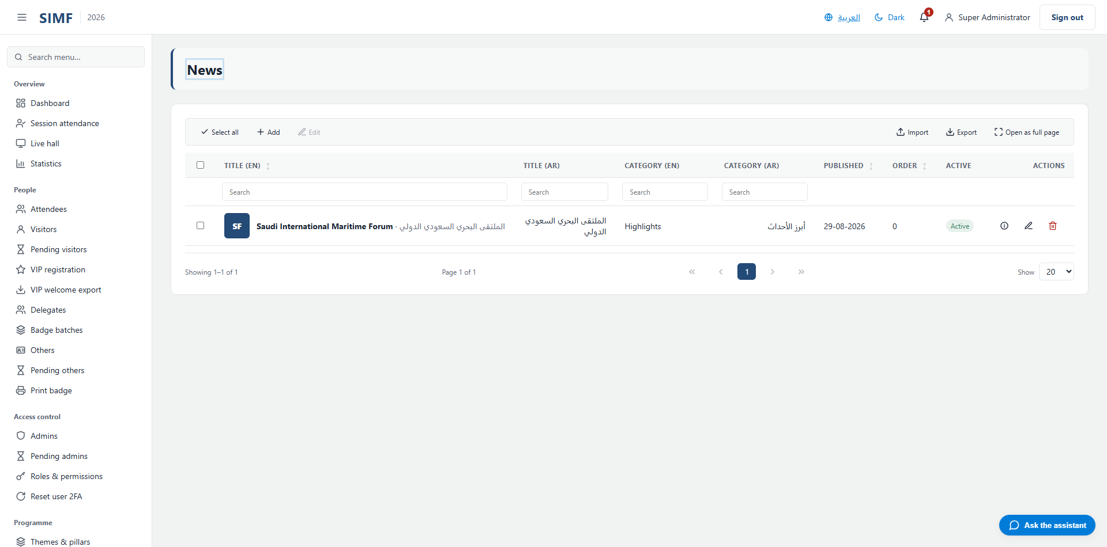
Figure 83 — News — /admin/news

Media Partners (/admin/media-partners)
Property | Value
Address | /admin/media-partners
Implemented by | src/ControlPanel/SIMF.ControlPanel/Components/Pages/Admin/MediaPartnersList.razor
Code-behind | src/ControlPanel/SIMF.ControlPanel/Components/Pages/Admin/MediaPartnersList.razor.cs
Page permission | MediaPartners.View
Menu permission | MediaPartners.View

What you can do here
Action | Permission it needs
Add | MediaPartners.Create
Edit | MediaPartners.Edit
Details | No permission of its own
Delete | MediaPartners.Delete
Import | MediaPartners.Import
Export | MediaPartners.Export

The list shows: Name (English) · Link · Display order · Active
It calls: /account/api/admin/media-partners/list /account/api/admin/media-partners/{id}
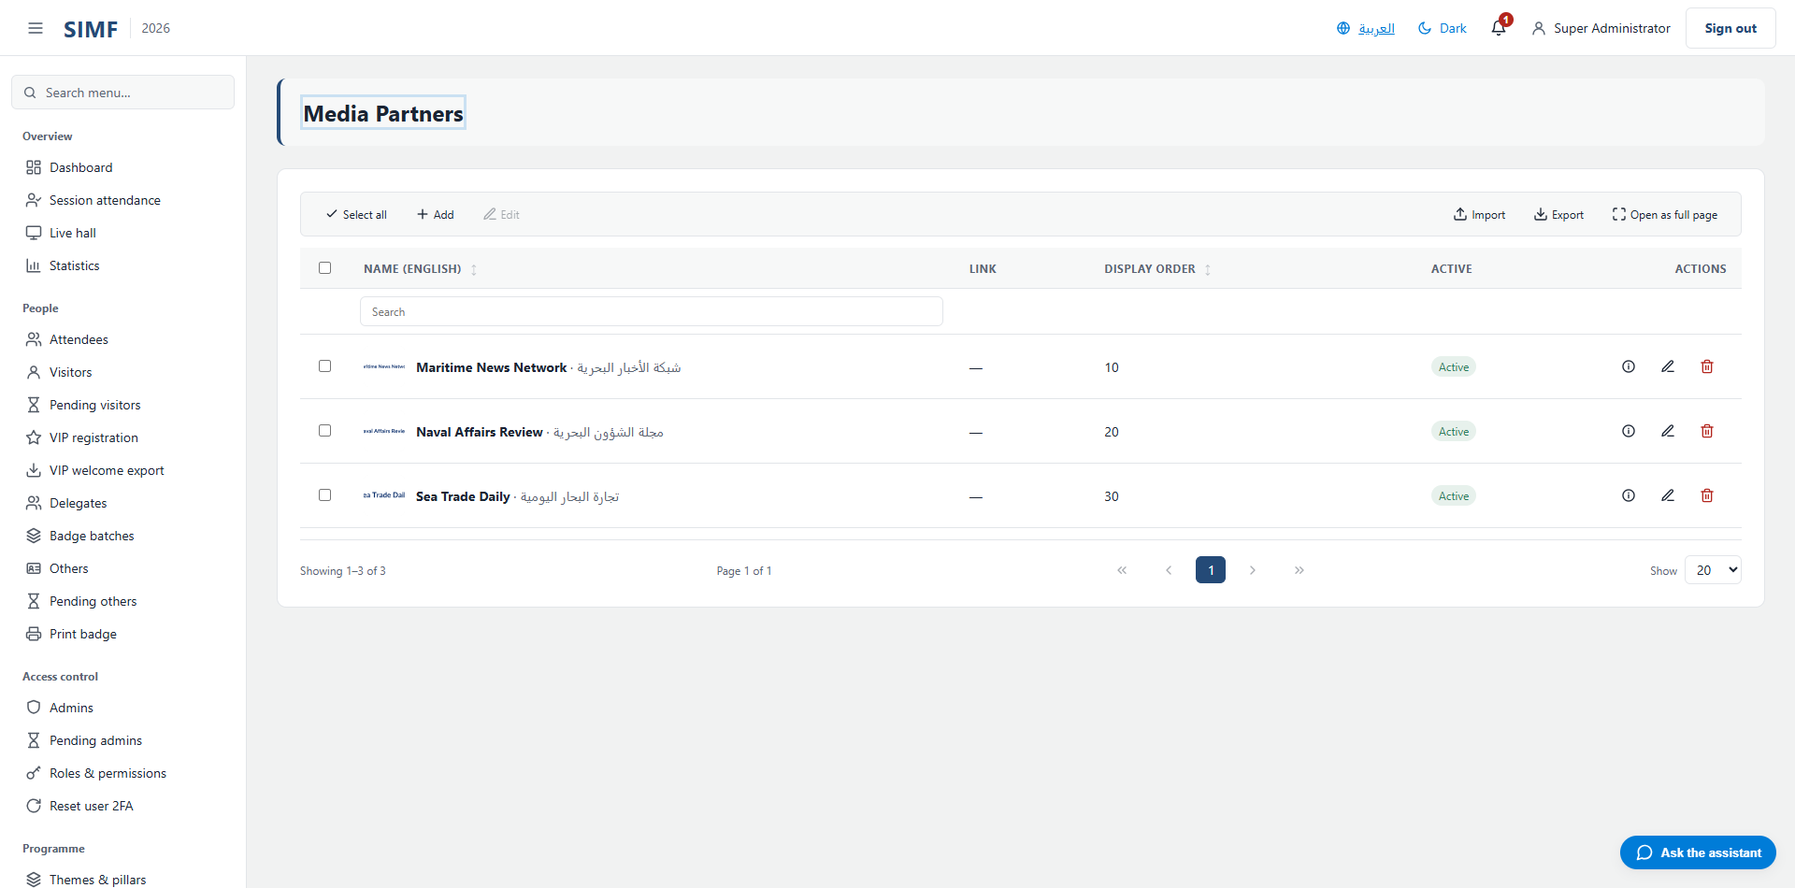
Figure 84 — Media Partners — /admin/media-partners

Previous editions (/admin/archive)
Property | Value
Address | /admin/archive
Implemented by | src/ControlPanel/SIMF.ControlPanel/Components/Pages/Admin/ArchiveList.razor
Code-behind | src/ControlPanel/SIMF.ControlPanel/Components/Pages/Admin/ArchiveList.razor.cs
Page permission | Archive.View
Menu permission | Archive.View

What you can do here
Action | Permission it needs
Add | Archive.Create
Edit | Archive.Edit
Details | No permission of its own
Delete | Archive.Delete
Import | Archive.Import
Export | Archive.Export
A button the page gates itself | Archive.Snapshot

The list shows: Year · Title (English) · Title (Arabic) · Attendees · Sessions · Speakers · Active
It calls: /account/api/admin/archive/list /account/api/admin/archive/snapshot-current
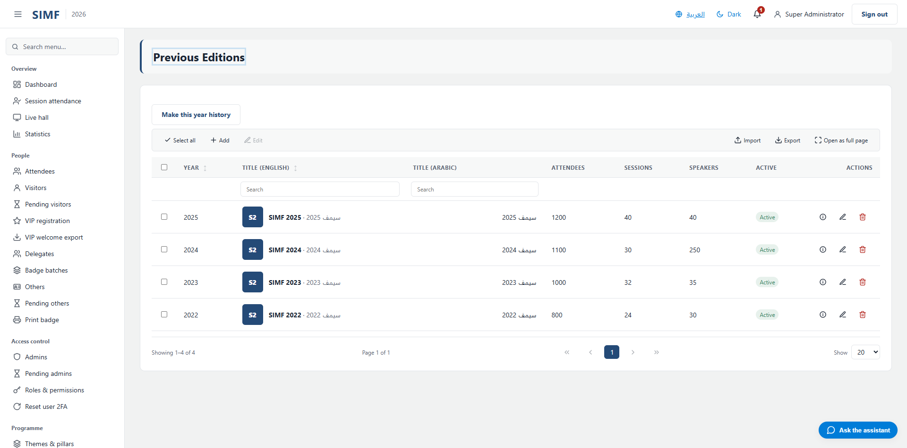
Figure 85 — Previous editions — /admin/archive

Public relations

Invitations (/admin/invitations)
Property | Value
Address | /admin/invitations
Implemented by | src/ControlPanel/SIMF.ControlPanel/Components/Pages/Admin/InvitationsList.razor
Code-behind | src/ControlPanel/SIMF.ControlPanel/Components/Pages/Admin/InvitationsList.razor.cs
Page permission | Invitations.View
Menu permission | Invitations.View

What you can do here
Action | Permission it needs
New invitation | Invitations.Manage
Edit | Invitations.Manage
Details | No permission of its own
Cancel invitation | Invitations.Manage
Export | Invitations.Export

The list shows: Recipient · Profile type · State · Sent · Sent by · Active
It calls: /account/api/admin/invitations/export /account/api/admin/invitations/list /account/api/admin/invitations/{id}
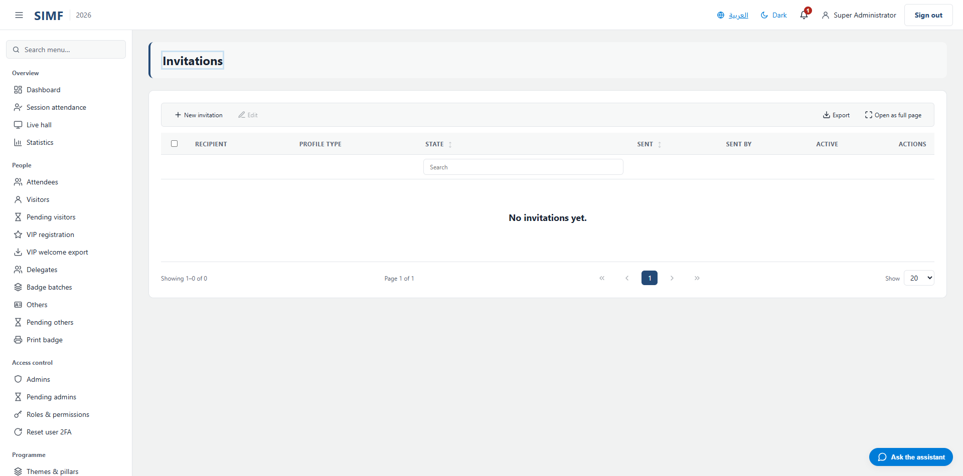
Figure 86 — Invitations — /admin/invitations

VIPs (/admin/vips)
Property | Value
Address | /admin/vips
Implemented by | src/ControlPanel/SIMF.ControlPanel/Components/Pages/Admin/VipsList.razor
Code-behind | src/ControlPanel/SIMF.ControlPanel/Components/Pages/Admin/VipsList.razor.cs
Page permission | Vips.View
Menu permission | Vips.View

What you can do here
Action | Permission it needs
Export | Vips.Export
A button the page gates itself | Vips.Notify

The list shows: Name · Job title · Profile type · Email
It calls: /account/api/admin/vips/export /account/api/admin/vips/list /account/api/admin/vips/notify
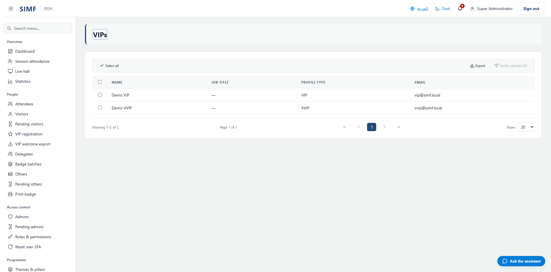
Figure 87 — VIPs — /admin/vips

Announcements (/admin/announcements)
Property | Value
Address | /admin/announcements
Implemented by | src/ControlPanel/SIMF.ControlPanel/Components/Pages/Admin/Announcements.razor
Code-behind | src/ControlPanel/SIMF.ControlPanel/Components/Pages/Admin/Announcements.razor.cs
Page permission | Announcements.View
Menu permission | Announcements.View

What you can do here
Action | Permission it needs
A button the page gates itself | Announcements.Send

The list shows: When · Target · Message · Status · Recipients · Emails
It calls: /account/api/admin/notifications/broadcast /account/api/admin/notifications/broadcast/estimate /account/api/admin/notifications/broadcasts/list /account/api/admin/sessions/list
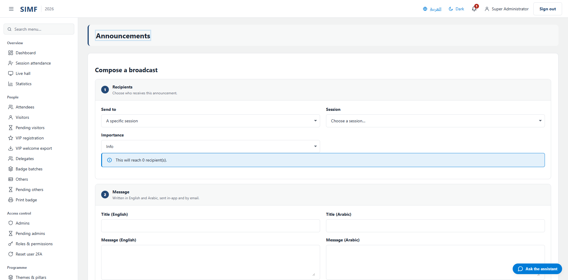
Figure 88 — Announcements — /admin/announcements

Contact inquiries (/admin/contact-inquiries)
Property | Value
Address | /admin/contact-inquiries
Implemented by | src/ControlPanel/SIMF.ControlPanel/Components/Pages/Admin/ContactInquiriesList.razor
Code-behind | src/ControlPanel/SIMF.ControlPanel/Components/Pages/Admin/ContactInquiriesList.razor.cs
Page permission | ContactInquiries.View
Menu permission | ContactInquiries.View

What you can do here
Action | Permission it needs
A button the page gates itself | ContactInquiries.Manage

The list shows: Name · Email · Message · Status · Received
It calls: /account/api/admin/contact-inquiries/list /account/api/admin/contact-inquiries/{row.Id}/handled
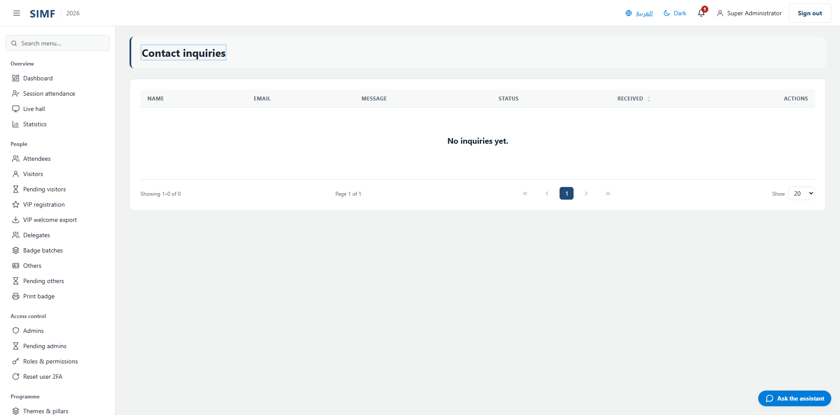
Figure 89 — Contact inquiries — /admin/contact-inquiries

Gates & arrivals

Gates (/admin/gates)
Property | Value
Address | /admin/gates
Implemented by | src/ControlPanel/SIMF.ControlPanel/Components/Pages/Admin/GatesList.razor
Code-behind | src/ControlPanel/SIMF.ControlPanel/Components/Pages/Admin/GatesList.razor.cs
Page permission | Gates.Manage
Menu permission | Gates.Manage

What you can do here
Action | Permission it needs
Add gate | Gates.Manage
Edit | Gates.Manage
Details | No permission of its own
Deactivate | Gates.Manage
Import | Gates.Import
Export | Gates.Export

The list shows: Code · Name · Name (Arabic) · Direction · Allowed types · Operators · Status
It calls: /account/api/admin/gates/list /account/api/admin/gates/{id}
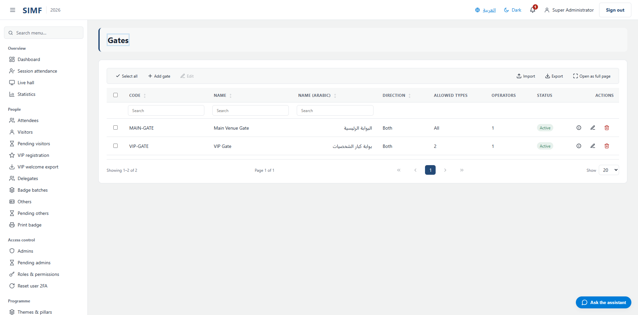
Figure 90 — Gates — /admin/gates

Gate operator (/admin/gates/operator)
Property | Value
Address | /admin/gates/operator
Implemented by | src/ControlPanel/SIMF.ControlPanel/Components/Pages/Admin/GateOperatorConsole.razor
Code-behind | src/ControlPanel/SIMF.ControlPanel/Components/Pages/Admin/GateOperatorConsole.razor.cs
Page permission | Gates.Operate
Menu permission | Gates.Operate

It calls: /account/api/gates/my-assignments /account/api/gates/my-reports/today /account/api/gates/{_selectedGateId}/scans
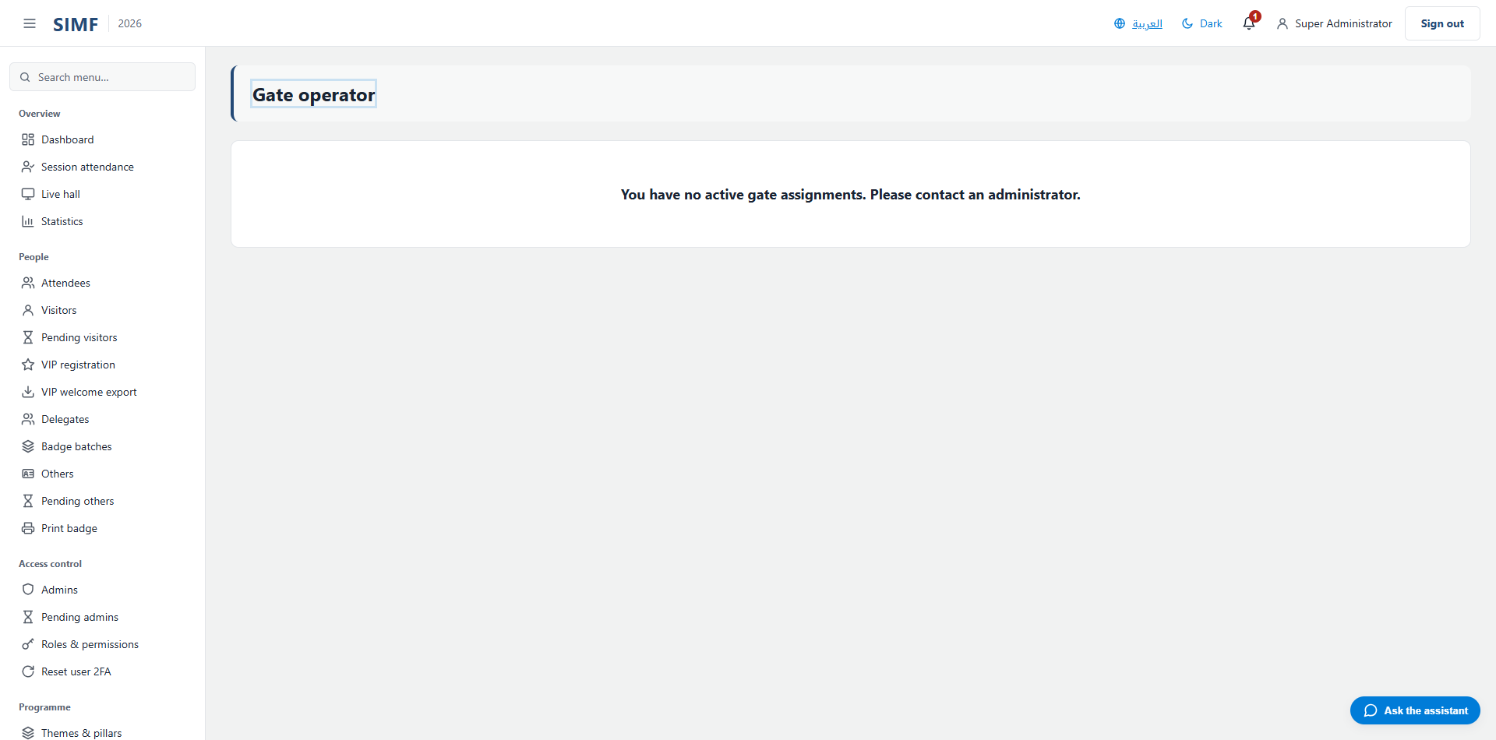
Figure 91 — Gate operator — /admin/gates/operator

Hall arrivals (/admin/hall-arrivals)
Property | Value
Address | /admin/hall-arrivals
Implemented by | src/ControlPanel/SIMF.ControlPanel/Components/Pages/Admin/HallArrivalsConsole.razor
Code-behind | src/ControlPanel/SIMF.ControlPanel/Components/Pages/Admin/HallArrivalsConsole.razor.cs
Page permission | HallArrivals.View
Menu permission | HallArrivals.View

What you can do here
Action | Permission it needs
A button the page gates itself | HallArrivals.Record

It calls: /account/api/admin/hall-arrivals/sessions/list /account/api/admin/sessions/{_selected.Id}/arrivals /account/api/admin/sessions/{_selected.Id}/departures
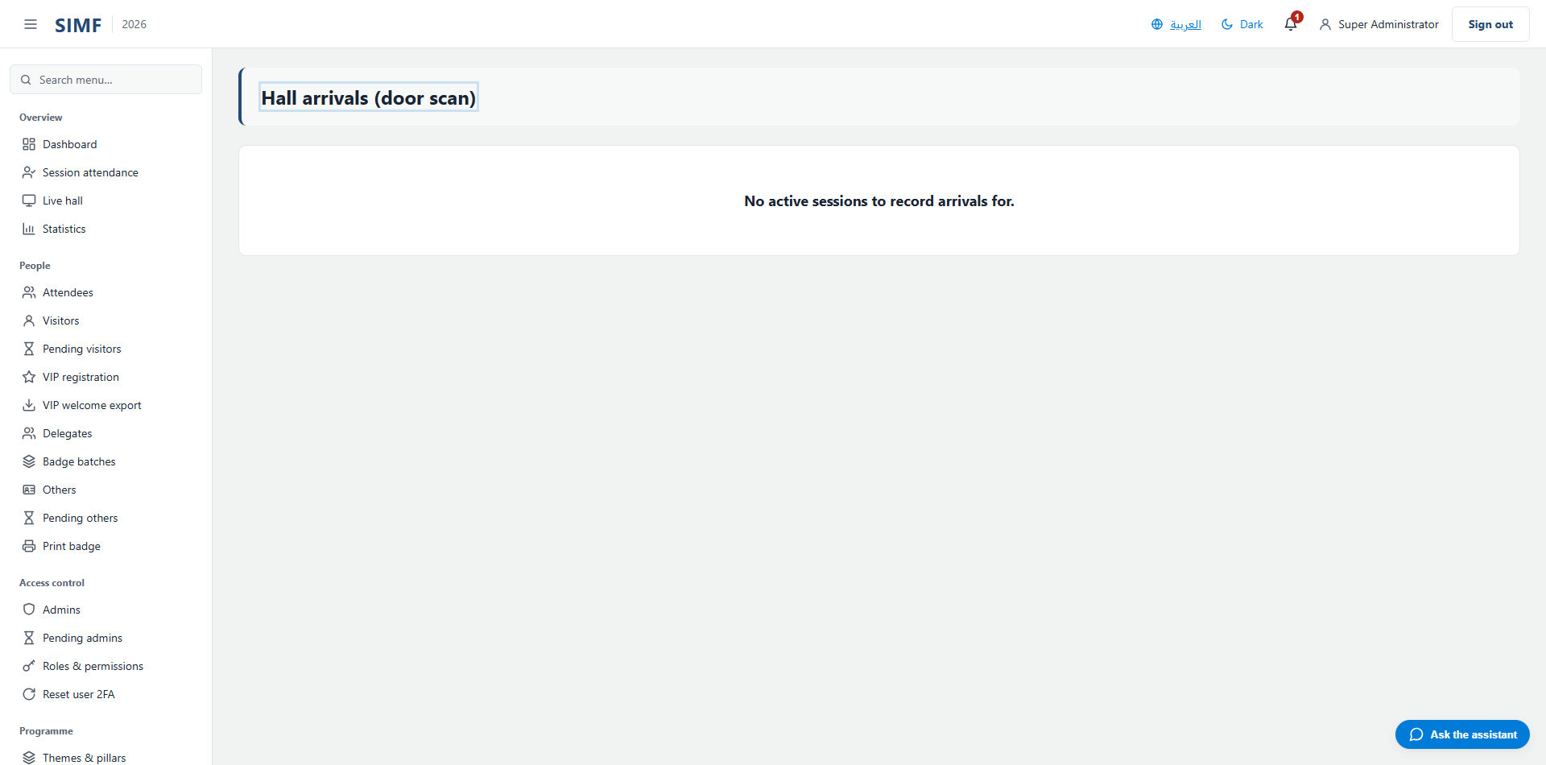
Figure 92 — Hall arrivals — /admin/hall-arrivals

Gates dashboard (/admin/gates/dashboard)
Property | Value
Address | /admin/gates/dashboard
Implemented by | src/ControlPanel/SIMF.ControlPanel/Components/Pages/Admin/GatesOperationsDashboard.razor
Code-behind | src/ControlPanel/SIMF.ControlPanel/Components/Pages/Admin/GatesOperationsDashboard.razor.cs
Page permission | Gates.Manage
Menu permission | Gates.Manage

It calls: /account/api/admin/gates/list /account/api/admin/gates/reports/currently-inside/list
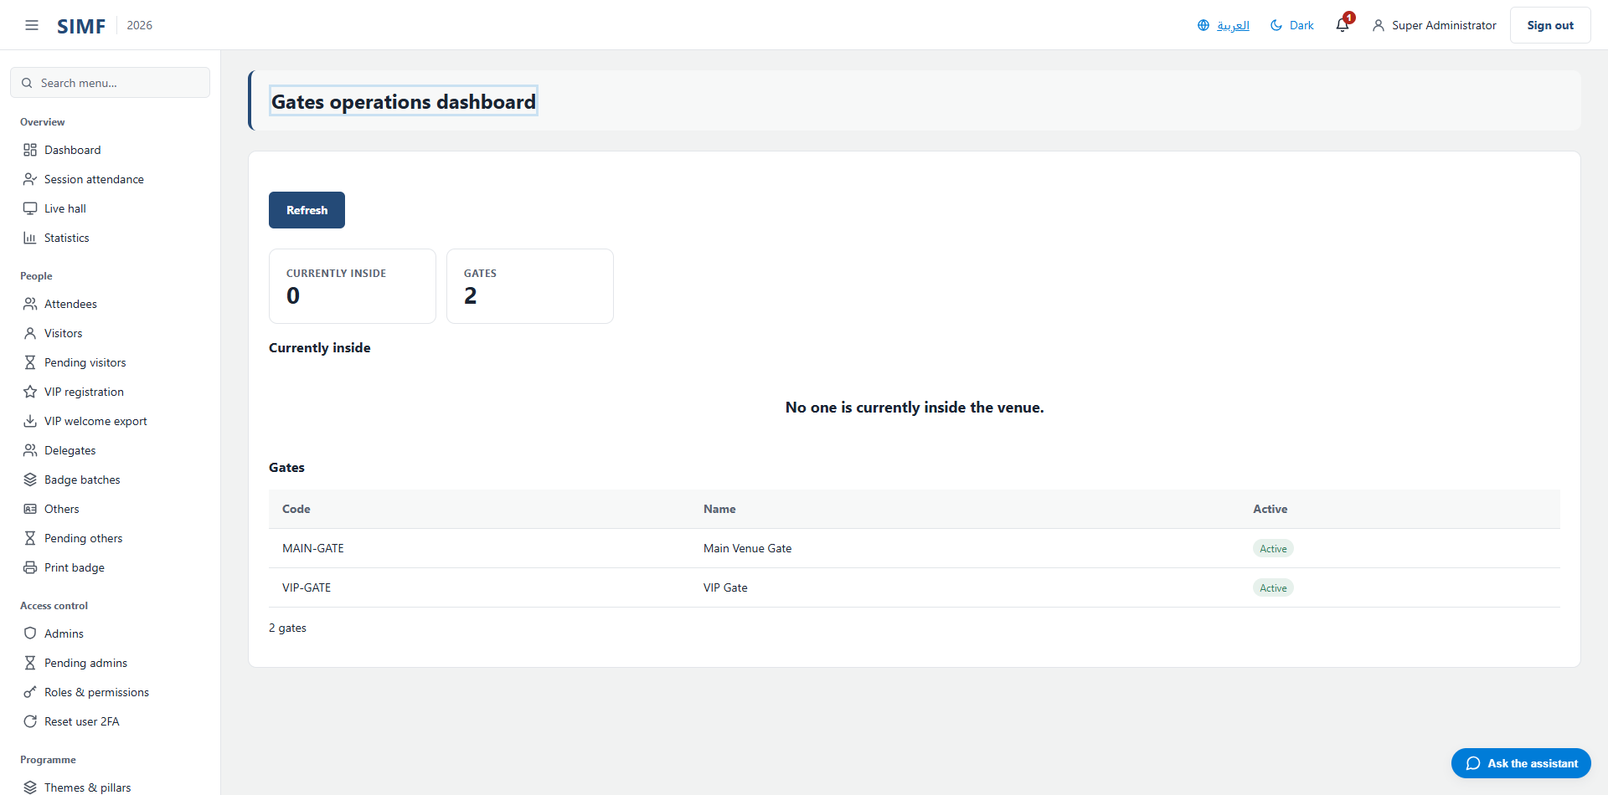
Figure 93 — Gates dashboard — /admin/gates/dashboard

Reference data

Interests (/admin/interests)
Property | Value
Address | /admin/interests
Implemented by | src/ControlPanel/SIMF.ControlPanel/Components/Pages/Admin/InterestsList.razor
Code-behind | src/ControlPanel/SIMF.ControlPanel/Components/Pages/Admin/InterestsList.razor.cs
Page permission | Interests.View
Menu permission | Interests.View

What you can do here
Action | Permission it needs
Add interest | Interests.Create
Edit | Interests.Edit
Details | No permission of its own
Deactivate | Interests.Delete
Import | Interests.Import
Export | Interests.Export

The list shows: Name · Name (Arabic) · Order · Status
It calls: /account/api/admin/interests/list
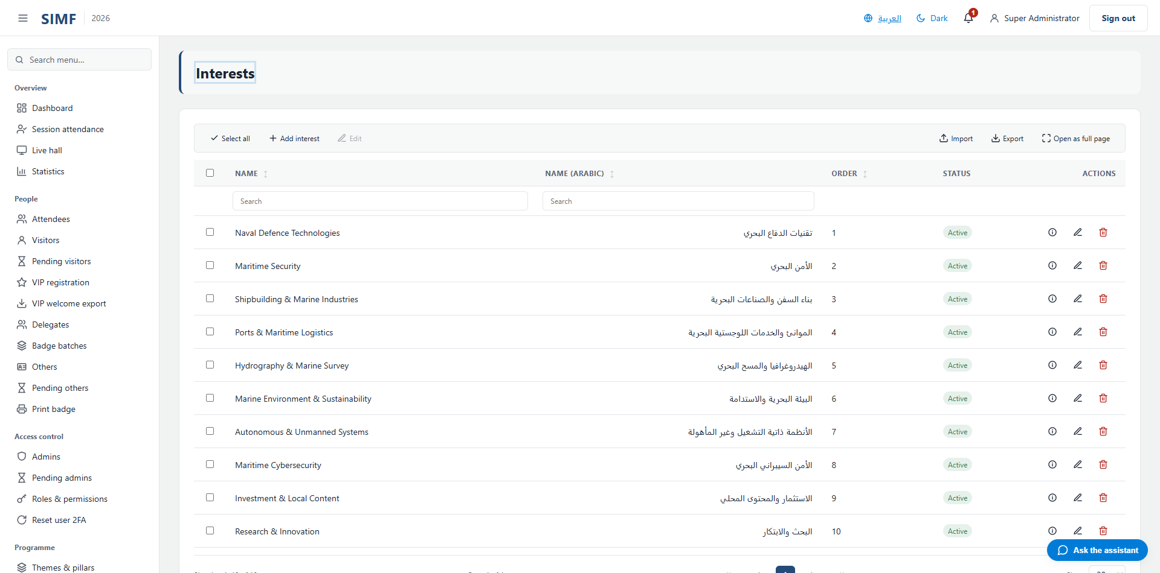
Figure 94 — Interests — /admin/interests

Countries (/admin/countries)
Property | Value
Address | /admin/countries
Implemented by | src/ControlPanel/SIMF.ControlPanel/Components/Pages/Admin/CountriesList.razor
Code-behind | src/ControlPanel/SIMF.ControlPanel/Components/Pages/Admin/CountriesList.razor.cs
Page permission | Countries.View
Menu permission | Countries.View

What you can do here
Action | Permission it needs
Add country | Countries.Create
Edit | Countries.Edit
Details | No permission of its own
Deactivate | Countries.Delete
Import | Countries.Import
Export | Countries.Export

The list shows: ISO id · Code · Name (English) · Name (Arabic) · Dial code · Order · Status
It calls: /account/api/admin/countries/list /account/api/admin/countries/{id}
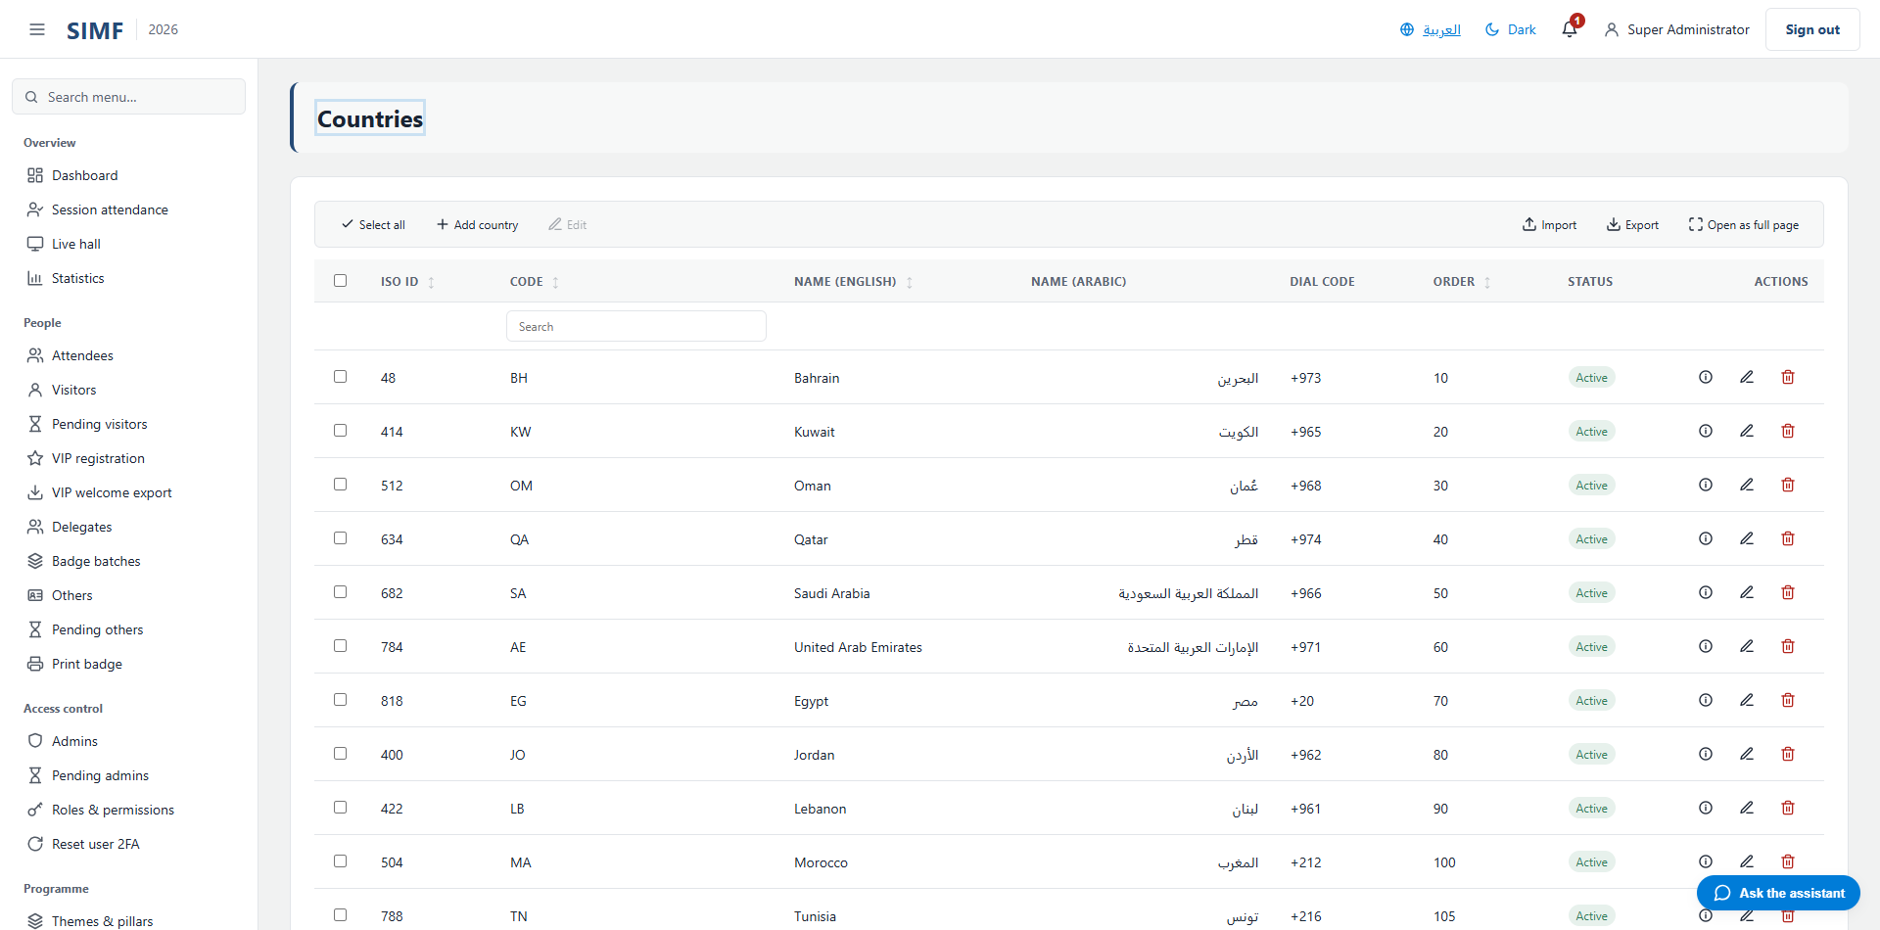
Figure 95 — Countries — /admin/countries

Organisations (/admin/organisations)
Property | Value
Address | /admin/organisations
Implemented by | src/ControlPanel/SIMF.ControlPanel/Components/Pages/Admin/OrganisationsList.razor
Code-behind | src/ControlPanel/SIMF.ControlPanel/Components/Pages/Admin/OrganisationsList.razor.cs
Page permission | Organisations.View
Menu permission | Organisations.View

What you can do here
Action | Permission it needs
Add | Organisations.Create
Edit | Organisations.Edit
Details | No permission of its own
Delete | Organisations.Delete
Import Excel | Organisations.Import
Export | Organisations.Export

The list shows: Name (Arabic) · Name (English) · CR · Sector · City · Active
It calls: /account/api/admin/organisations/export /account/api/admin/organisations/import /account/api/admin/organisations/list /account/api/admin/organisations/{id}
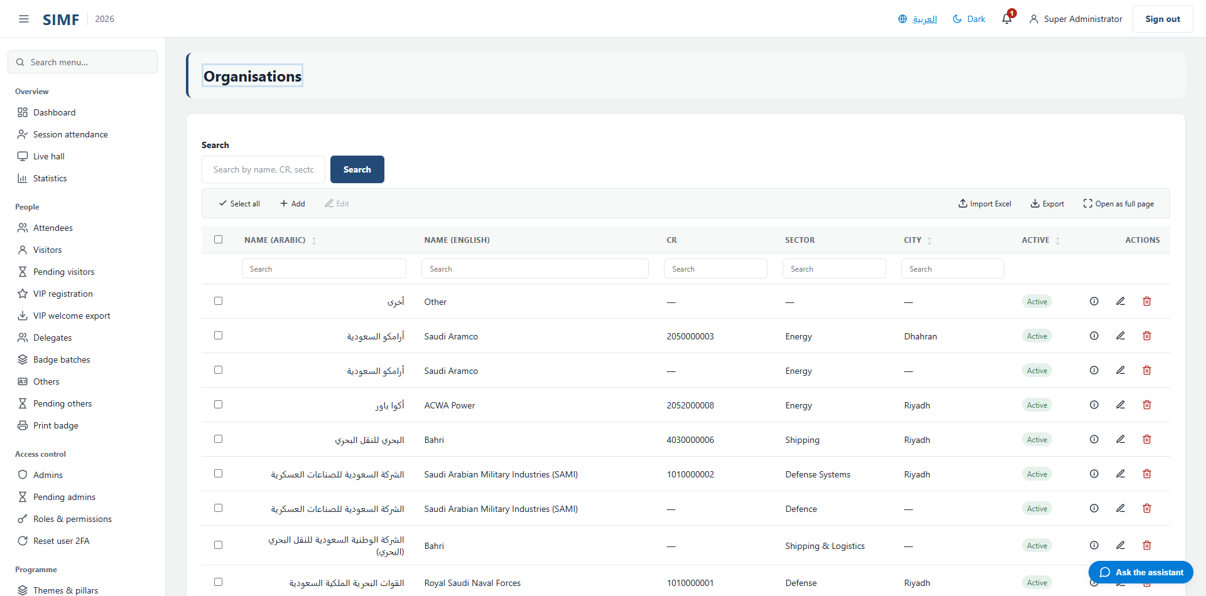
Figure 96 — Organisations — /admin/organisations

Regions (/admin/regions)
Property | Value
Address | /admin/regions
Implemented by | src/ControlPanel/SIMF.ControlPanel/Components/Pages/Admin/RegionsList.razor
Code-behind | src/ControlPanel/SIMF.ControlPanel/Components/Pages/Admin/RegionsList.razor.cs
Page permission | Regions.View
Menu permission | Regions.View

What you can do here
Action | Permission it needs
Add | Regions.Create
Edit | Regions.Edit
Details | No permission of its own
Delete | Regions.Delete

The list shows: Code · Name (Arabic) · Name (English) · Active
It calls: /account/api/admin/regions/list /account/api/admin/regions/{id}
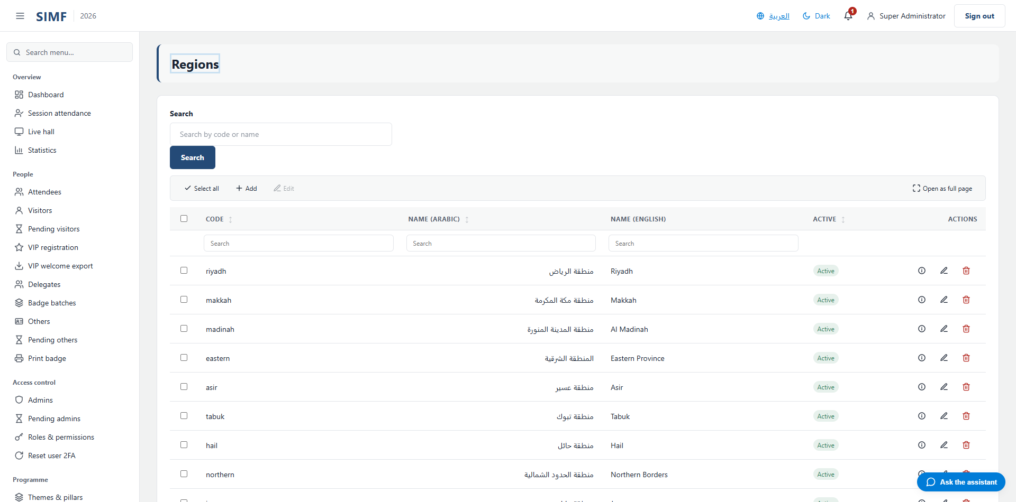
Figure 97 — Regions — /admin/regions

Visitor profile types (/admin/profile-types/visitor)
Property | Value
Address | /admin/profile-types/visitor
Implemented by | src/ControlPanel/SIMF.ControlPanel/Components/Pages/Admin/ProfileTypes/VisitorProfileTypesList.razor
Code-behind | src/ControlPanel/SIMF.ControlPanel/Components/Pages/Admin/ProfileTypes/VisitorProfileTypesList.razor.cs
Page permission | ProfileTypes.View
Menu permission | ProfileTypes.View

What you can do here
Action | Permission it needs
Add profile type | ProfileTypes.Create
Edit profile type | ProfileTypes.Edit
Details | No permission of its own
Deactivate profile type | ProfileTypes.Delete

The list shows: Account type · Name · Name (Arabic) · Page colour · Active
It calls: /account/api/admin/profile-types/list /account/api/admin/profile-types/{_deleteTarget.Id}
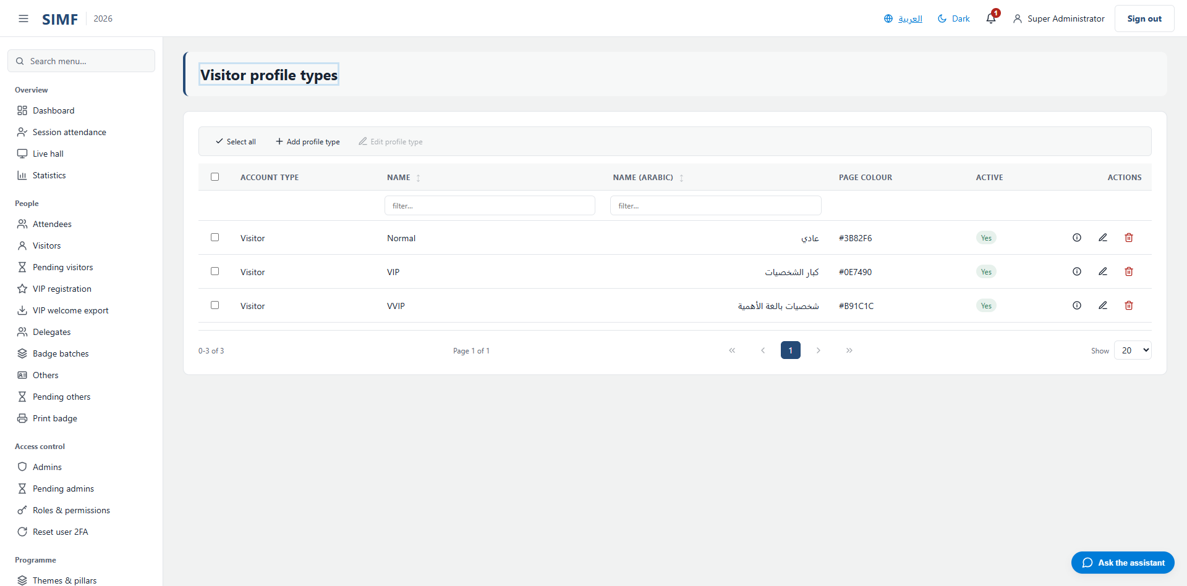
Figure 98 — Visitor profile types — /admin/profile-types/visitor

Other profile types (/admin/profile-types/other)
Property | Value
Address | /admin/profile-types/other
Implemented by | src/ControlPanel/SIMF.ControlPanel/Components/Pages/Admin/ProfileTypes/OtherProfileTypesList.razor
Code-behind | src/ControlPanel/SIMF.ControlPanel/Components/Pages/Admin/ProfileTypes/OtherProfileTypesList.razor.cs
Page permission | ProfileTypes.View
Menu permission | ProfileTypes.View

What you can do here
Action | Permission it needs
Add profile type | ProfileTypes.Create
Edit profile type | ProfileTypes.Edit
Details | No permission of its own
Deactivate profile type | ProfileTypes.Delete

The list shows: Account type · Name · Name (Arabic) · Page colour · Mobile-app role · Active
It calls: /account/api/admin/profile-types/list /account/api/admin/profile-types/{_deleteTarget.Id}
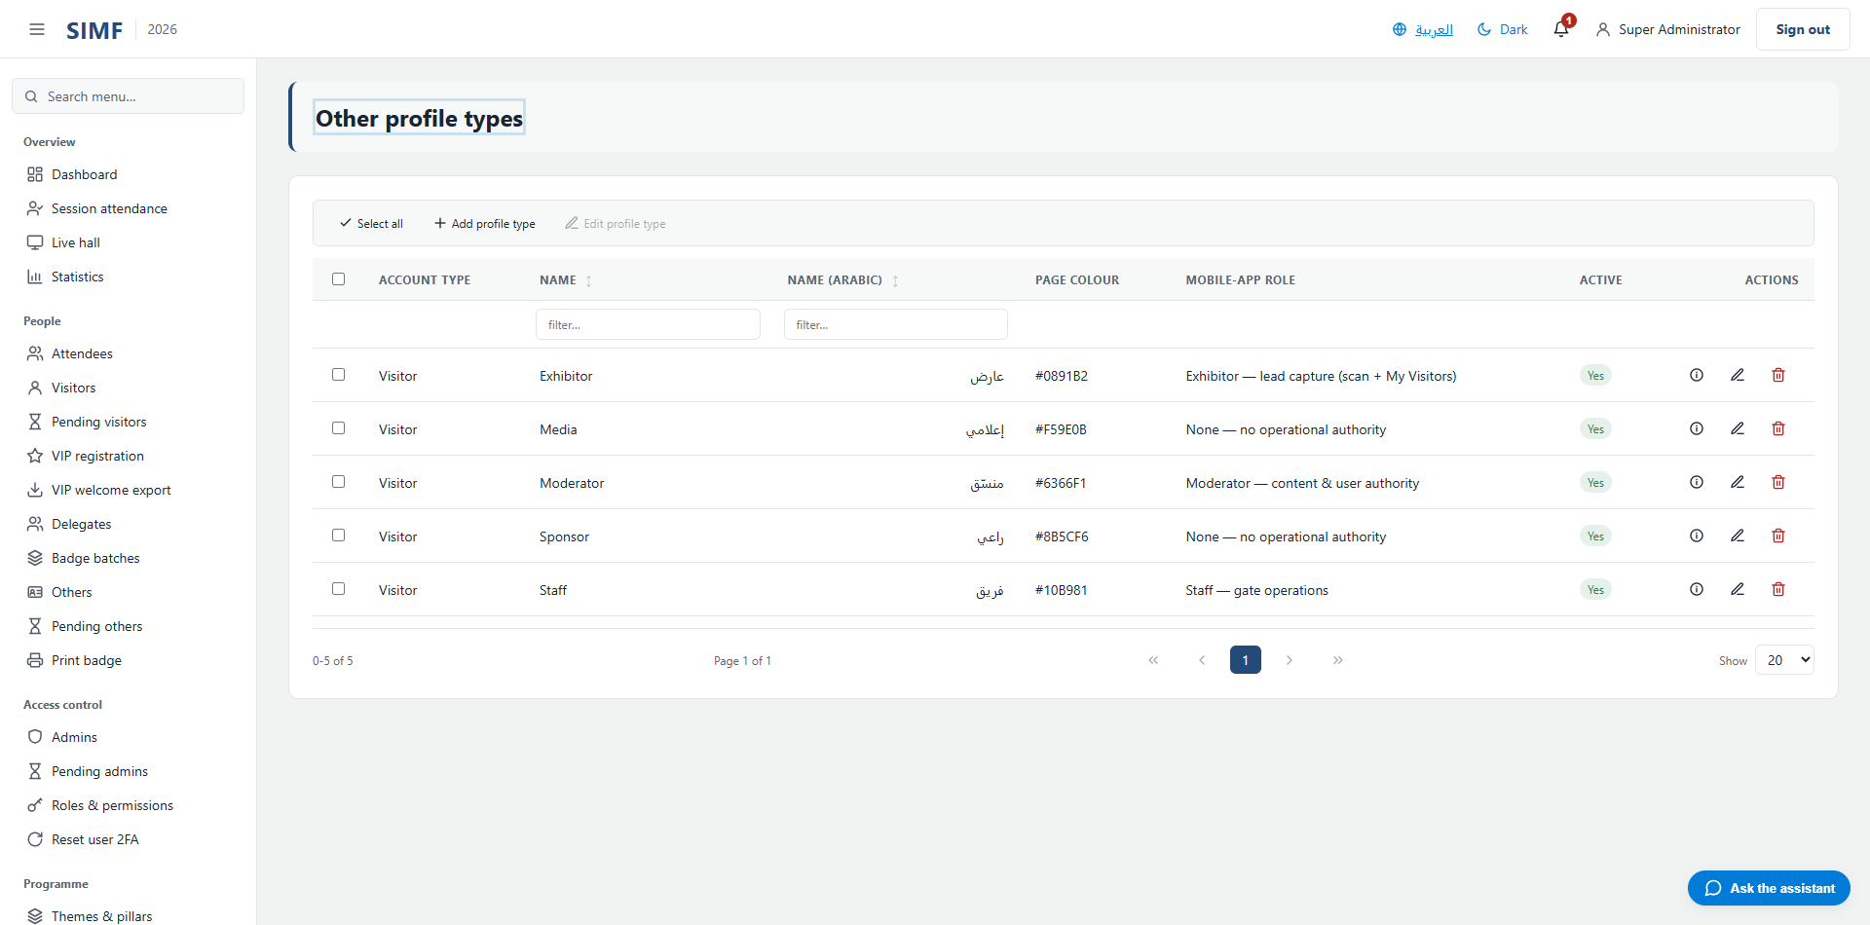
Figure 99 — Other profile types — /admin/profile-types/other

System

Configuration (/admin/configuration)
Property | Value
Address | /admin/configuration
Implemented by | src/ControlPanel/SIMF.ControlPanel/Components/Pages/Admin/ConfigurationList.razor
Code-behind | src/ControlPanel/SIMF.ControlPanel/Components/Pages/Admin/ConfigurationList.razor.cs
Page permission | Configuration.View
Menu permission | Configuration.View

What you can do here
Action | Permission it needs
Add | Configuration.Create
Edit | Configuration.Edit
Details | No permission of its own
Delete | Configuration.Delete
Import | Configuration.Import
Export | Configuration.Export

The list shows: Key · Value · Description · Active
It calls: /account/api/admin/system-settings/list /account/api/admin/system-settings/{id}
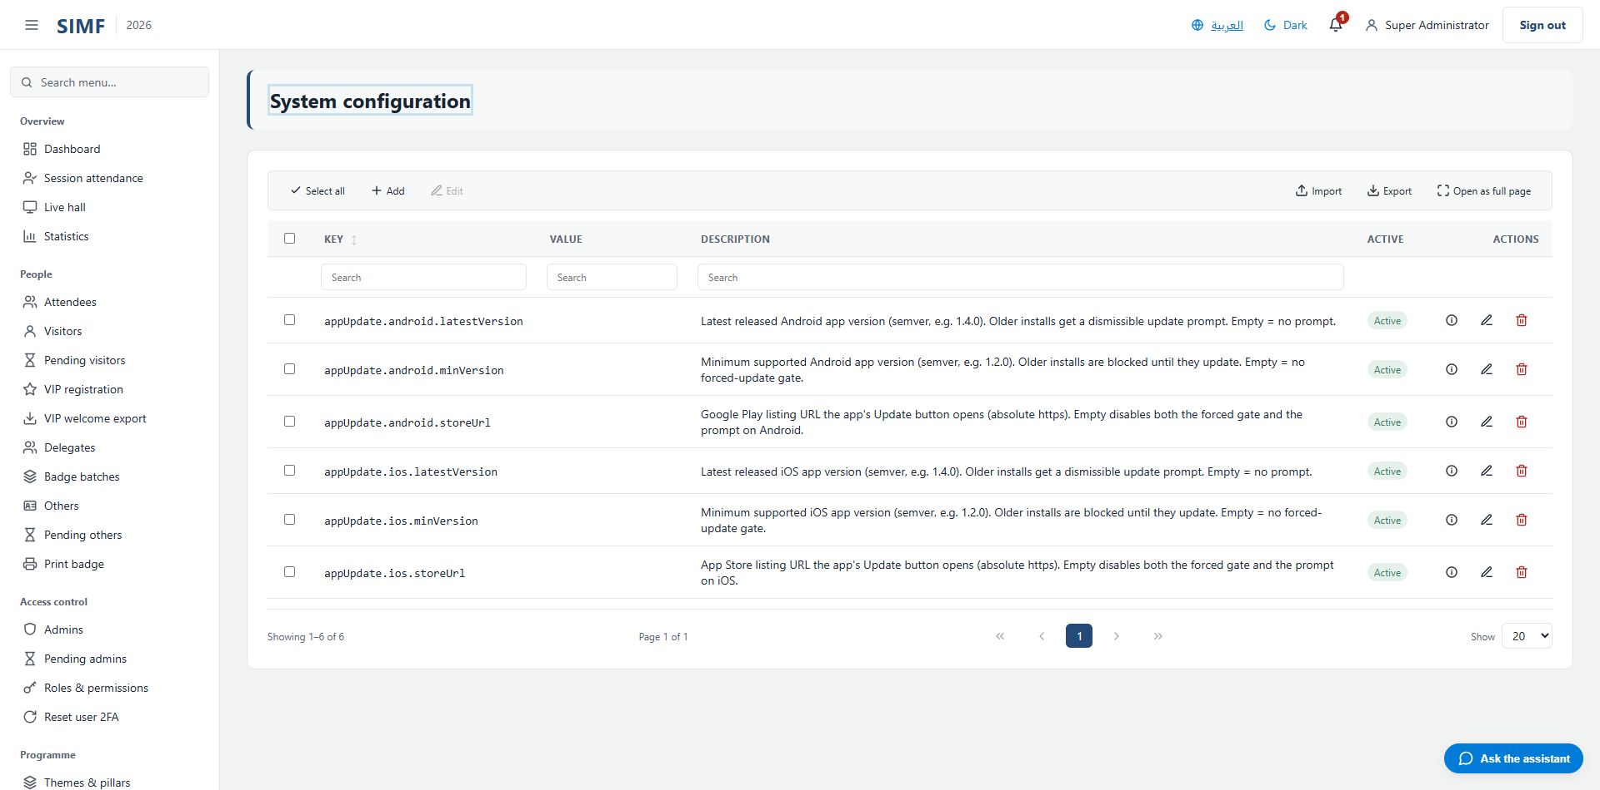
Figure 100 — Configuration — /admin/configuration

Site Settings (/admin/site-settings)
Property | Value
Address | /admin/site-settings
Implemented by | src/ControlPanel/SIMF.ControlPanel/Components/Pages/Admin/SiteSettingsPage.razor
Code-behind | src/ControlPanel/SIMF.ControlPanel/Components/Pages/Admin/SiteSettingsPage.razor.cs
Page permission | Configuration.Edit
Menu permission | Configuration.Edit

It calls: /account/api/admin/site-settings
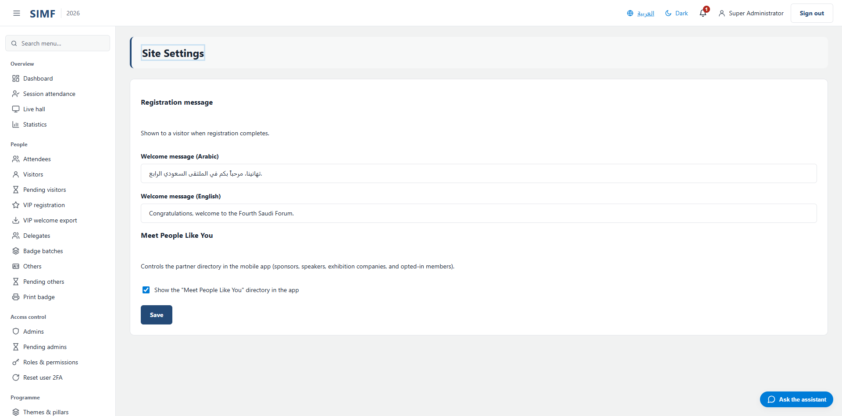
Figure 101 — Site Settings — /admin/site-settings

Walk-in Mode (/admin/walk-in-mode)
Property | Value
Address | /admin/walk-in-mode
Implemented by | src/ControlPanel/SIMF.ControlPanel/Components/Pages/Admin/WalkInModePage.razor
Code-behind | src/ControlPanel/SIMF.ControlPanel/Components/Pages/Admin/WalkInModePage.razor.cs
Page permission | WalkInMode.View
Menu permission | WalkInMode.View

It calls: /account/api/admin/walk-in-mode
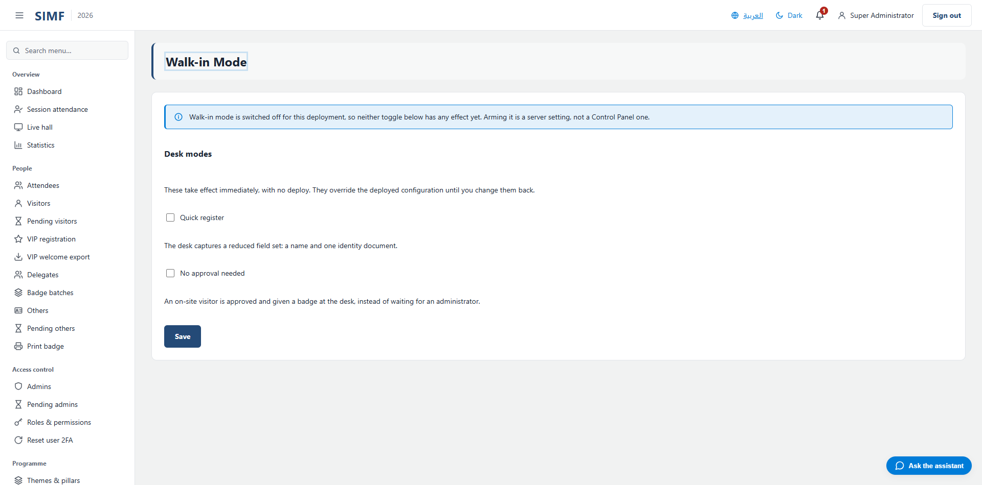
Figure 102 — Walk-in Mode — /admin/walk-in-mode

Email Templates (/admin/email/templates)
Property | Value
Address | /admin/email/templates
Implemented by | src/ControlPanel/SIMF.ControlPanel/Components/Pages/Admin/EmailTemplatesList.razor
Code-behind | src/ControlPanel/SIMF.ControlPanel/Components/Pages/Admin/EmailTemplatesList.razor.cs
Page permission | EmailTemplates.View
Menu permission | EmailTemplates.View

The list shows: Template · Subject · Customised · Version · Updated
It calls: /account/api/admin/email/templates/list /account/api/admin/email/templates/{row.Type}
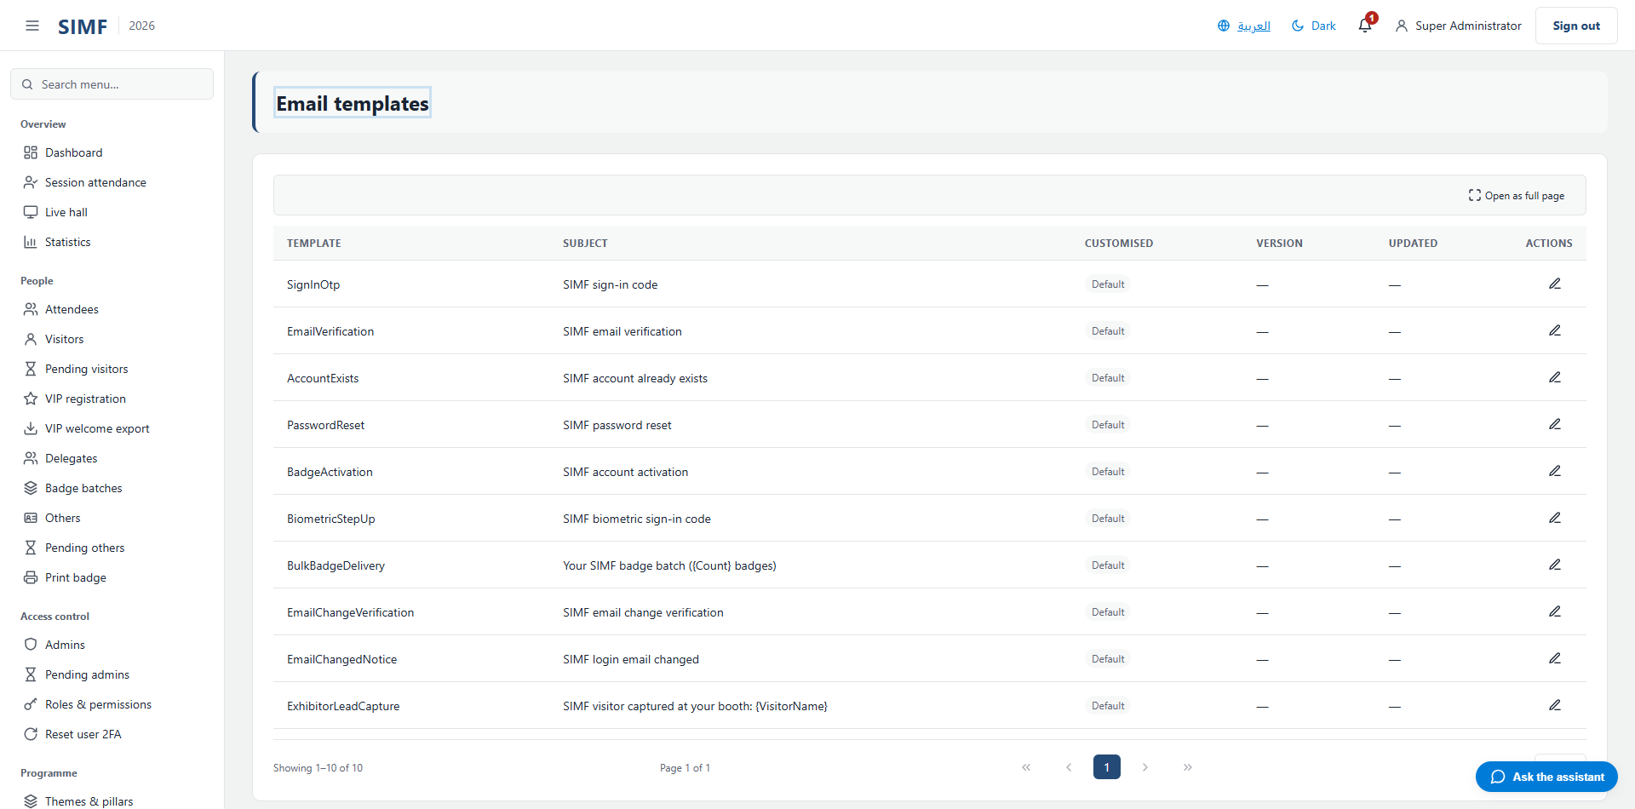
Figure 103 — Email Templates — /admin/email/templates

Organization Profile (/admin/organization-profile)
Property | Value
Address | /admin/organization-profile
Implemented by | src/ControlPanel/SIMF.ControlPanel/Components/Pages/Admin/OrganizationProfilePage.razor
Code-behind | src/ControlPanel/SIMF.ControlPanel/Components/Pages/Admin/OrganizationProfilePage.razor.cs
Page permission | OrganizationProfile.View
Menu permission | OrganizationProfile.View

What you can do here
Action | Permission it needs
+ Add about item | No permission of its own
A button the page gates itself | OrganizationProfile.Manage

It calls: /account/api/admin/organization-profile /account/api/admin/organization-profile/hero-video
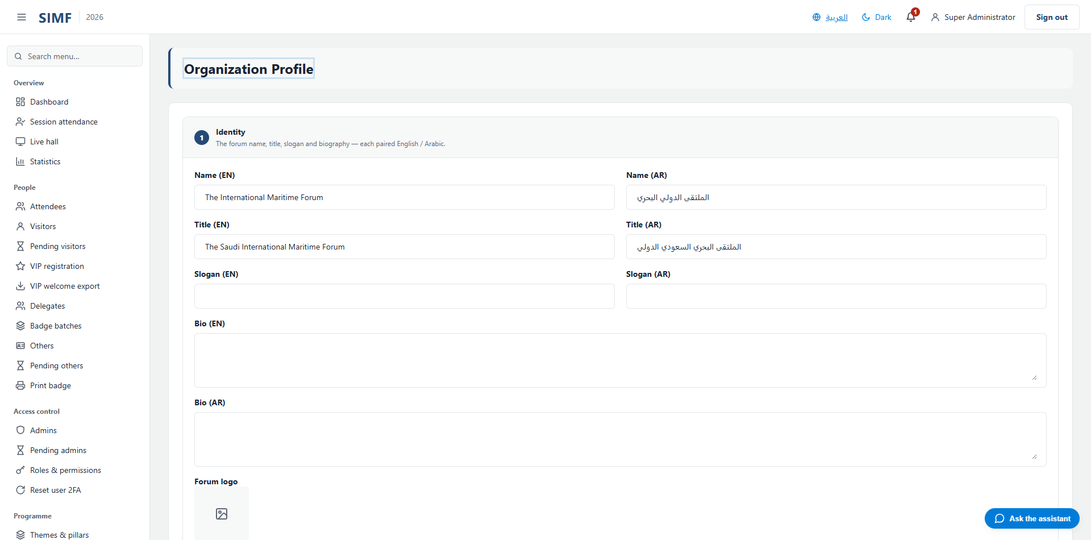
Figure 104 — Organization Profile — /admin/organization-profile

Logs (/admin/logs)
Property | Value
Address | /admin/logs
Implemented by | src/ControlPanel/SIMF.ControlPanel/Components/Pages/Admin/LogsViewer.razor
Code-behind | src/ControlPanel/SIMF.ControlPanel/Components/Pages/Admin/LogsViewer.razor.cs
Page permission | Logs.View
Menu permission | Logs.View

It calls: /account/api/admin/logs/download /account/api/admin/logs/list /account/api/admin/logs/tail
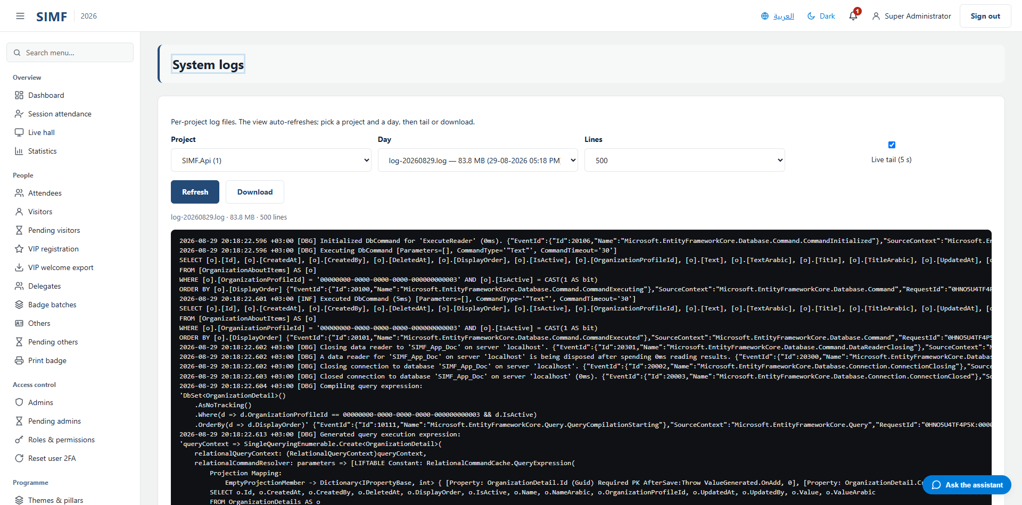
Figure 105 — Logs — /admin/logs

Background services (/admin/ops/services)
Property | Value
Address | /admin/ops/services
Implemented by | src/ControlPanel/SIMF.ControlPanel/Components/Pages/Admin/ServicesMonitor.razor
Code-behind | src/ControlPanel/SIMF.ControlPanel/Components/Pages/Admin/ServicesMonitor.razor.cs
Page permission | ServicesMonitor.View
Menu permission | ServicesMonitor.View

The list shows: Service · Status · Last run · Last success · Runs · Failures · Last error
It calls: /account/api/admin/ops/workers
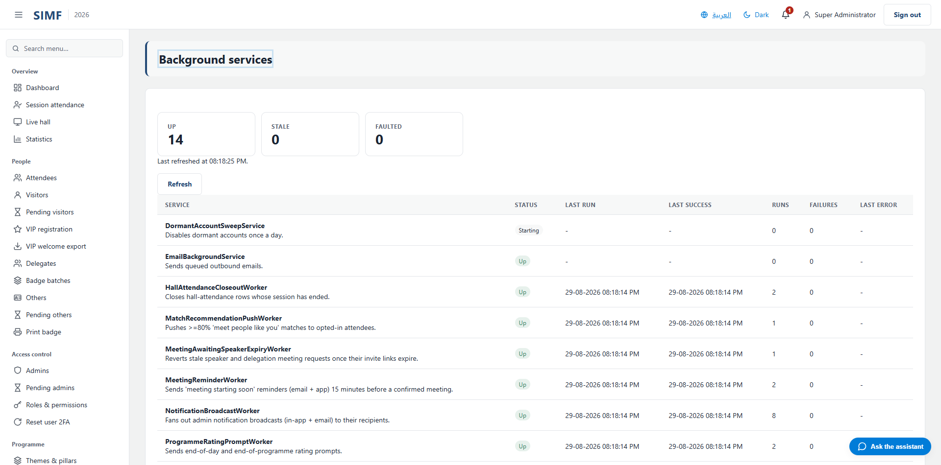
Figure 106 — Background services — /admin/ops/services

Operation log (/admin/operation-log)
Property | Value
Address | /admin/operation-log
Implemented by | src/ControlPanel/SIMF.ControlPanel/Components/Pages/Admin/OperationLogViewer.razor
Code-behind | src/ControlPanel/SIMF.ControlPanel/Components/Pages/Admin/OperationLogViewer.razor.cs
Page permission | OperationLog.View
Menu permission | OperationLog.View

What you can do here
Action | Permission it needs
Details | No permission of its own
A button the page gates itself | OperationLog.Export

The list shows: When (local) · Event · Outcome · Subject email · Source IP
It calls: /account/api/admin/operation-log/export /account/api/admin/operation-log/list /account/api/admin/operation-log/{row.Id}
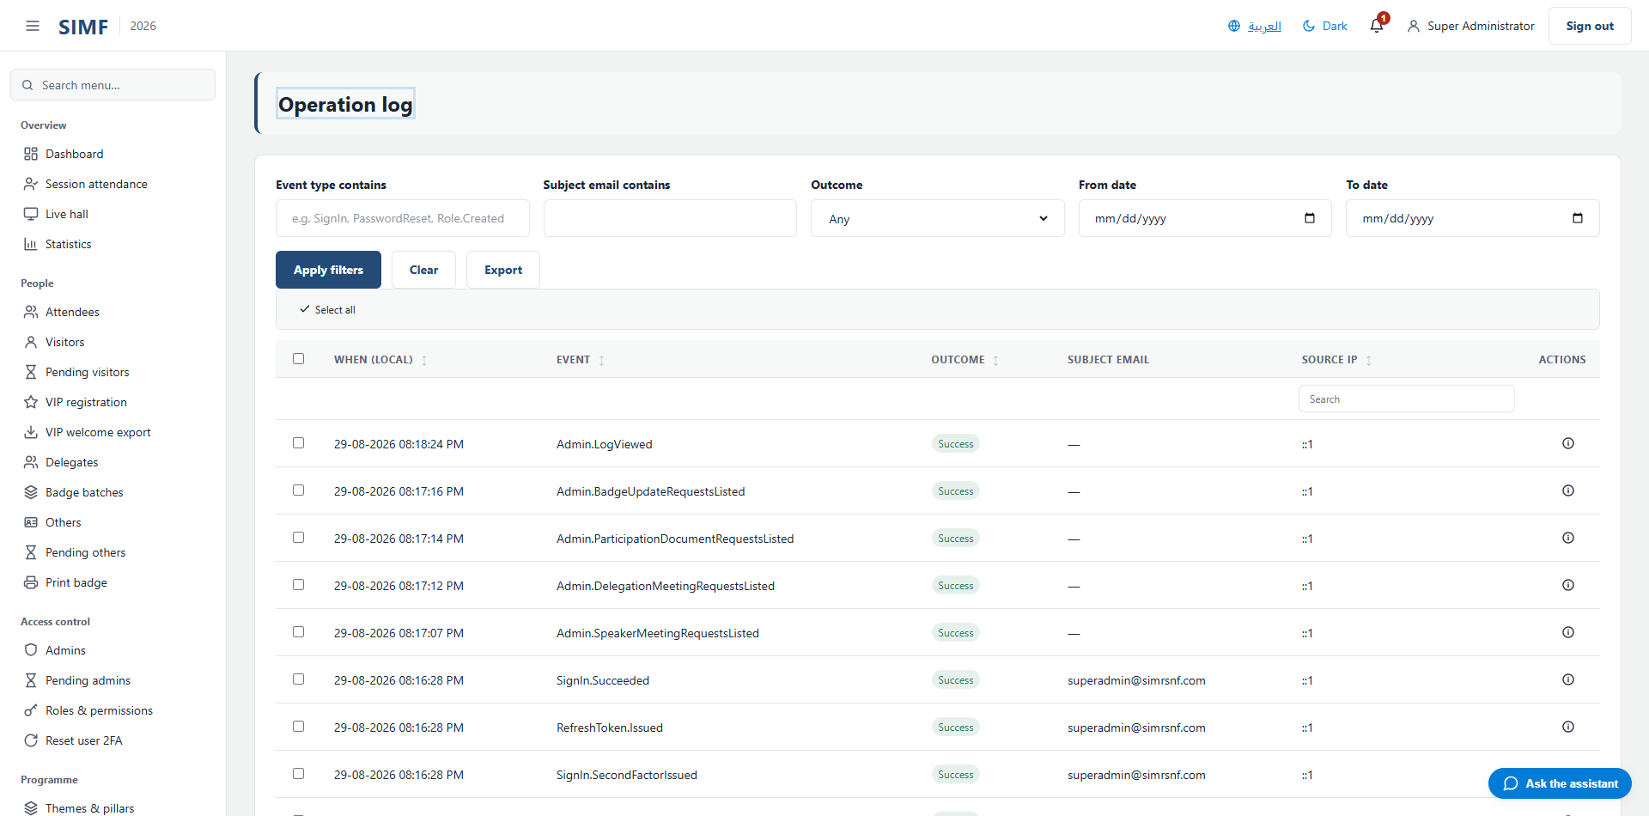
Figure 107 — Operation log — /admin/operation-log

Operations toggles (/admin/operations)
Property | Value
Address | /admin/operations
Implemented by | src/ControlPanel/SIMF.ControlPanel/Components/Pages/Admin/OperationsToggles.razor
Code-behind | src/ControlPanel/SIMF.ControlPanel/Components/Pages/Admin/OperationsToggles.razor.cs
Page permission | Operations.View
Menu permission | Operations.View

What you can do here
Action | Permission it needs
A button the page gates itself | Operations.Edit

It calls: /account/api/admin/archive/visibility /account/api/admin/registration-gate
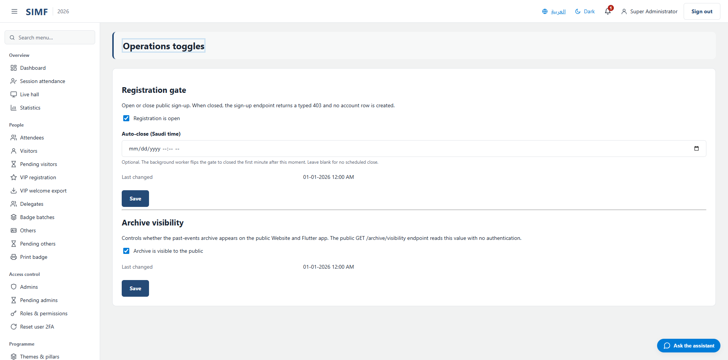
Figure 108 — Operations toggles — /admin/operations

Event edition (/admin/editions)
Property | Value
Address | /admin/editions
Implemented by | src/ControlPanel/SIMF.ControlPanel/Components/Pages/Admin/EventEdition.razor
Code-behind | src/ControlPanel/SIMF.ControlPanel/Components/Pages/Admin/EventEdition.razor.cs
Page permission | Editions.View
Menu permission | Editions.View

What you can do here
Action | Permission it needs
A button the page gates itself | Editions.Open

It calls: /account/api/admin/editions/current /account/api/admin/editions/open
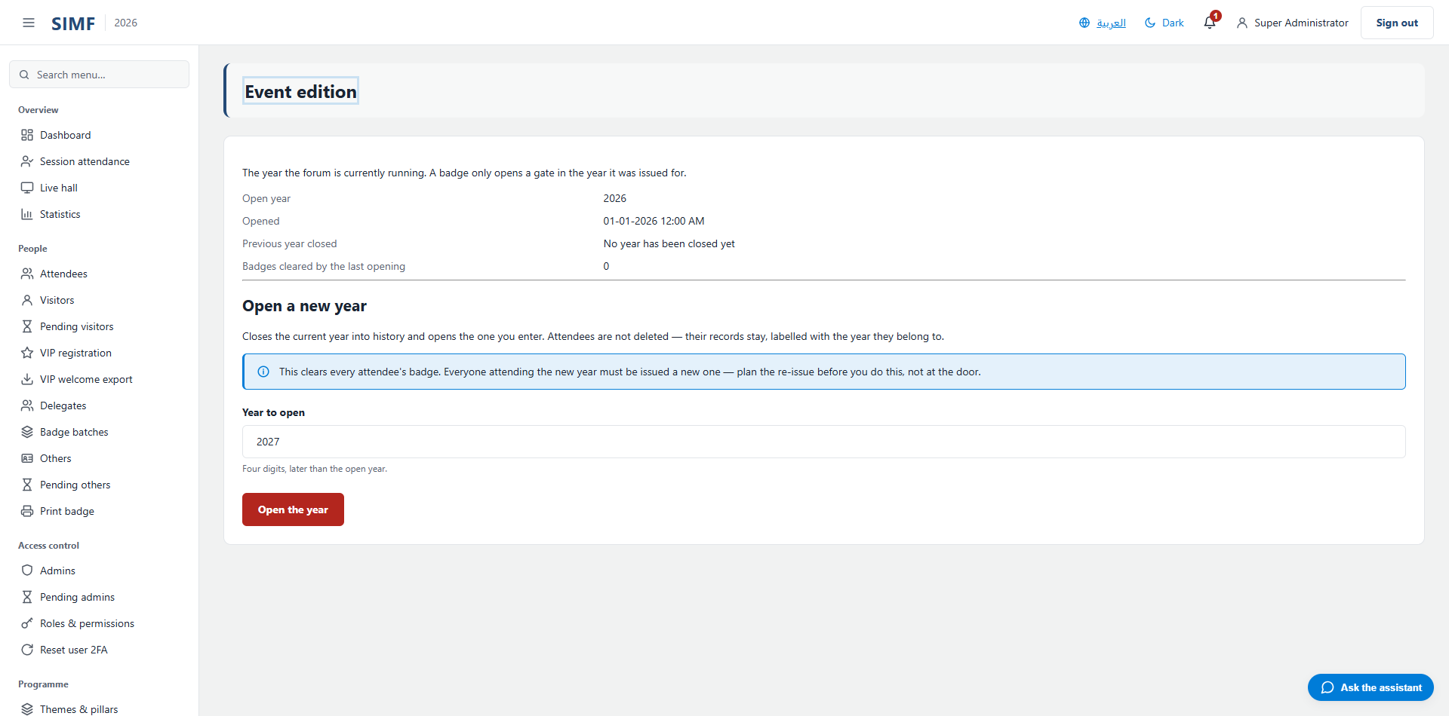
Figure 109 — Event edition — /admin/editions

Reports

All reports (/admin/reports)
Property | Value
Address | /admin/reports
Implemented by | src/ControlPanel/SIMF.ControlPanel/Components/Pages/Admin/Reports/ReportsHub.razor
Code-behind | -
Page permission | Reports.View
Menu permission | Reports.View

What you can do here
Action | Permission it needs
A button the page gates itself | Reports.Attendance
A button the page gates itself | Reports.Engagement
A button the page gates itself | Reports.Gates
A button the page gates itself | Reports.Meetings
A button the page gates itself | Reports.Partners
A button the page gates itself | Reports.Ratings
A button the page gates itself | Reports.Registrations
A button the page gates itself | Reports.Sessions

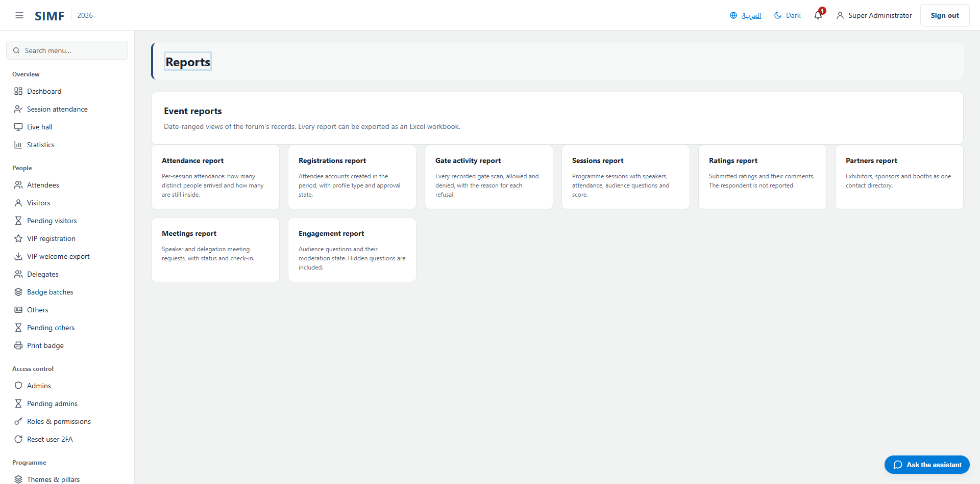
Figure 110 — All reports — /admin/reports

Attendance report (/admin/reports/attendance)
Property | Value
Address | /admin/reports/attendance
Implemented by | src/ControlPanel/SIMF.ControlPanel/Components/Pages/Admin/Reports/AttendanceReport.razor
Code-behind | -
Page permission | Reports.Attendance
Menu permission | Reports.Attendance

What you can do here
Action | Permission it needs
Export | No permission of its own

The list shows: Code · Session · Hall · Start · Attendees · Inside now
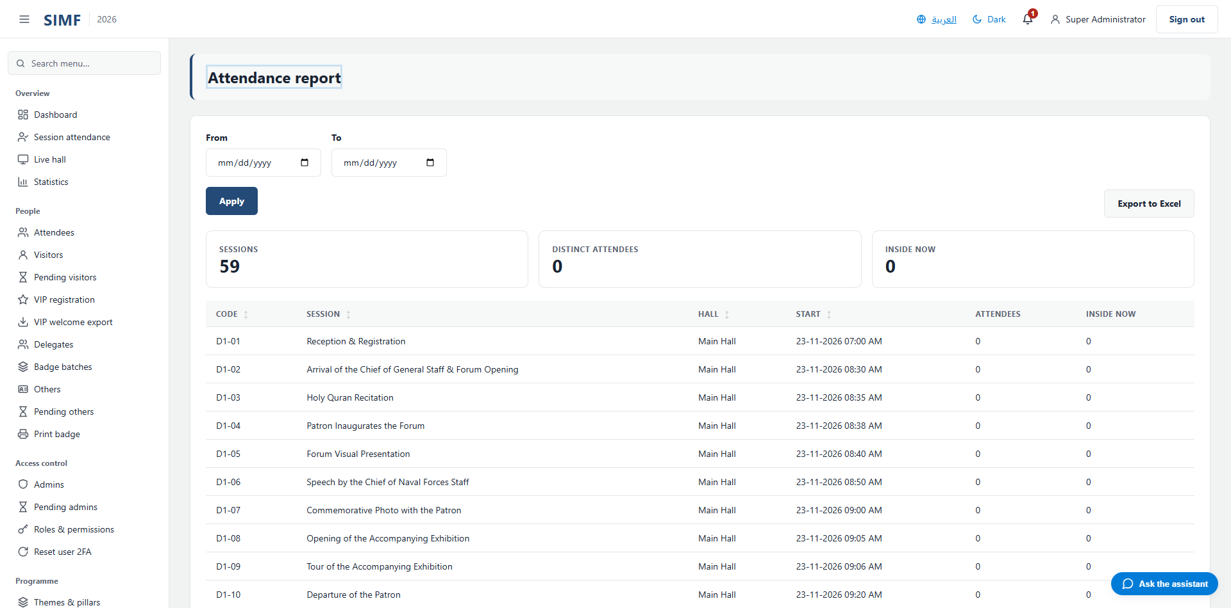
Figure 111 — Attendance report — /admin/reports/attendance

Registrations report (/admin/reports/registrations)
Property | Value
Address | /admin/reports/registrations
Implemented by | src/ControlPanel/SIMF.ControlPanel/Components/Pages/Admin/Reports/RegistrationsReport.razor
Code-behind | -
Page permission | Reports.Registrations
Menu permission | Reports.Registrations

What you can do here
Action | Permission it needs
Export | No permission of its own

The list shows: Name · Email · Profile type · Account state · Registered
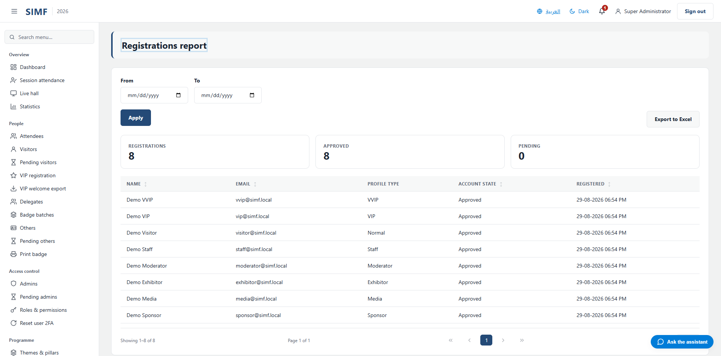
Figure 112 — Registrations report — /admin/reports/registrations

Gate activity report (/admin/reports/gates)
Property | Value
Address | /admin/reports/gates
Implemented by | src/ControlPanel/SIMF.ControlPanel/Components/Pages/Admin/Reports/GateActivityReport.razor
Code-behind | -
Page permission | Reports.Gates
Menu permission | Reports.Gates

What you can do here
Action | Permission it needs
Export | No permission of its own

The list shows: Gate · Scanned · Visitor · Profile type · Direction · Outcome · Denial reason
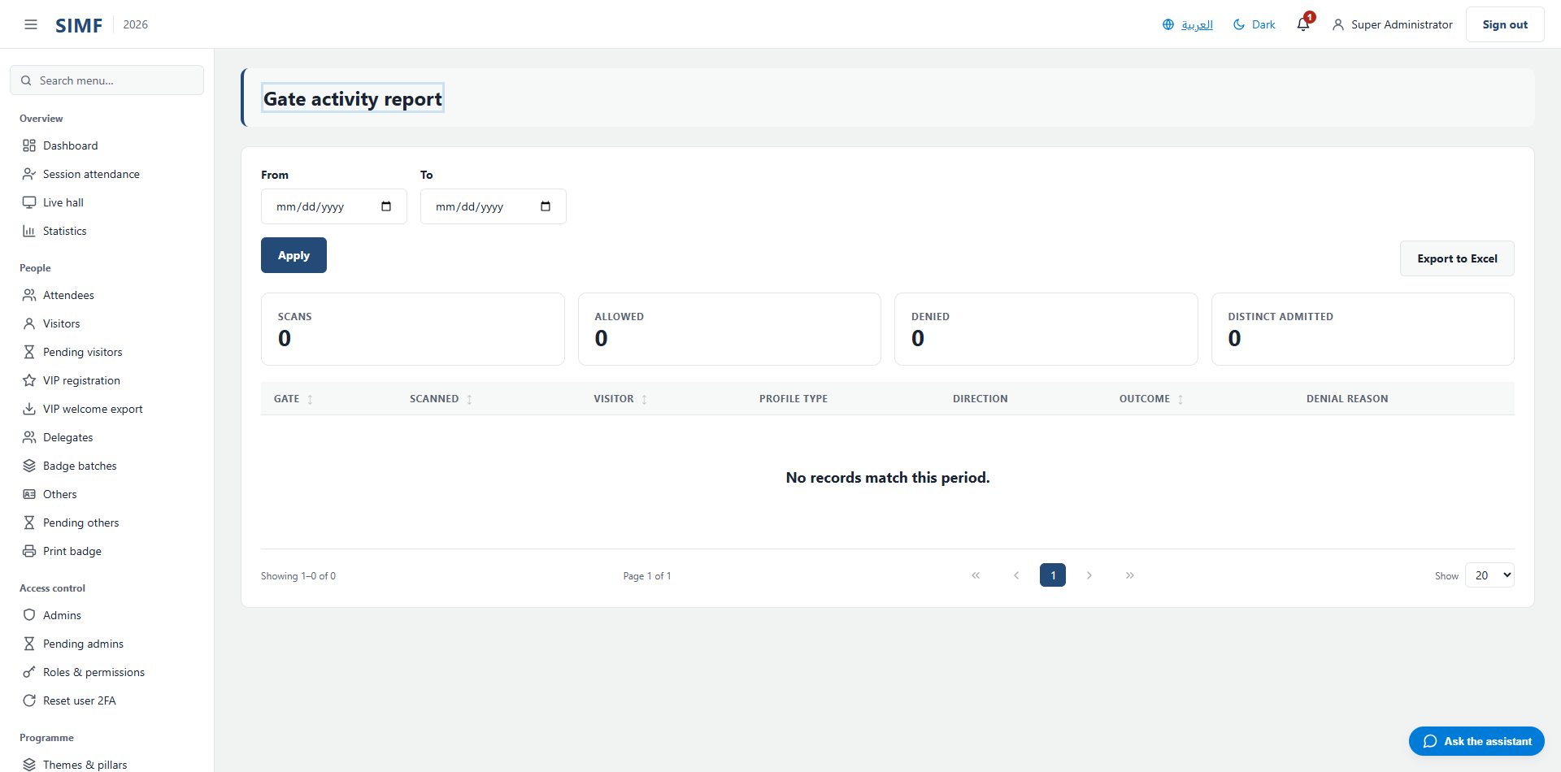
Figure 113 — Gate activity report — /admin/reports/gates

Sessions report (/admin/reports/sessions)
Property | Value
Address | /admin/reports/sessions
Implemented by | src/ControlPanel/SIMF.ControlPanel/Components/Pages/Admin/Reports/SessionsReport.razor
Code-behind | -
Page permission | Reports.Sessions
Menu permission | Reports.Sessions

What you can do here
Action | Permission it needs
Export | No permission of its own

The list shows: Code · Session · Hall · Start · Speakers · Attendees · Questions · Average rating
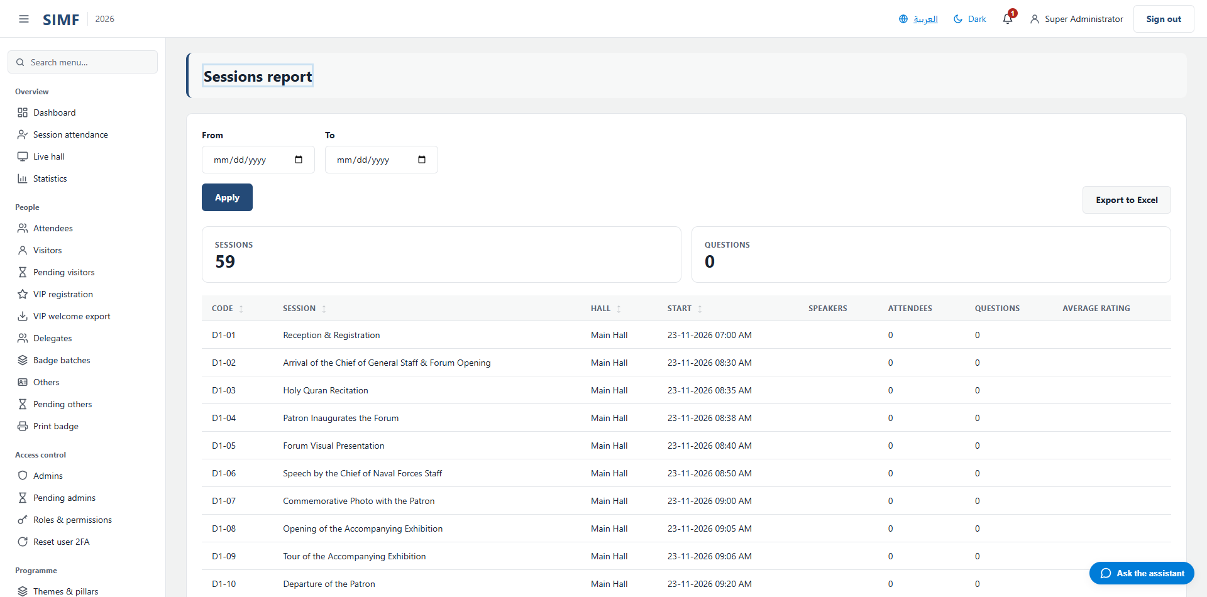
Figure 114 — Sessions report — /admin/reports/sessions

Ratings report (/admin/reports/ratings)
Property | Value
Address | /admin/reports/ratings
Implemented by | src/ControlPanel/SIMF.ControlPanel/Components/Pages/Admin/Reports/RatingsReport.razor
Code-behind | -
Page permission | Reports.Ratings
Menu permission | Reports.Ratings

What you can do here
Action | Permission it needs
Export | No permission of its own

The list shows: Rating type · Scope · Stars · Comment · Submitted
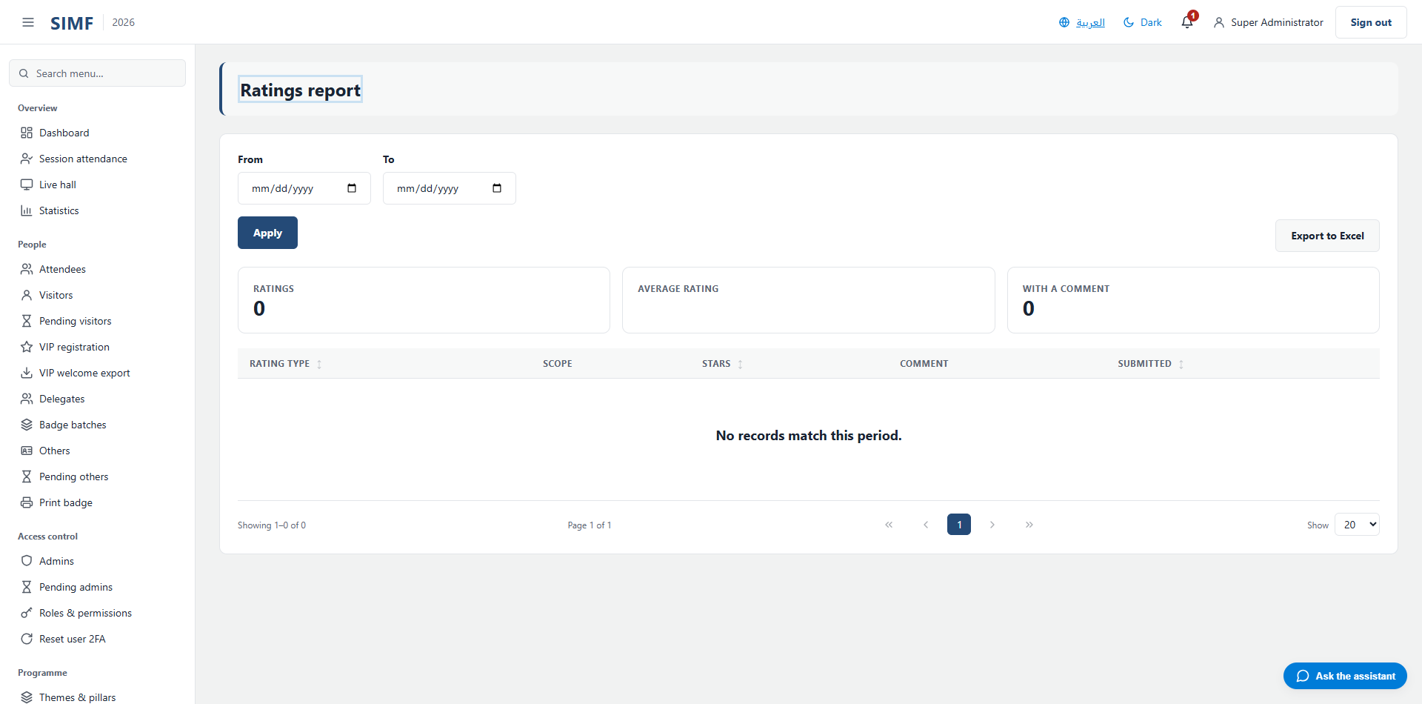
Figure 115 — Ratings report — /admin/reports/ratings

Partners report (/admin/reports/partners)
Property | Value
Address | /admin/reports/partners
Implemented by | src/ControlPanel/SIMF.ControlPanel/Components/Pages/Admin/Reports/PartnersReport.razor
Code-behind | -
Page permission | Reports.Partners
Menu permission | Reports.Partners

What you can do here
Action | Permission it needs
Export | No permission of its own

The list shows: Kind · Name · Tier · Email · Phone · Website
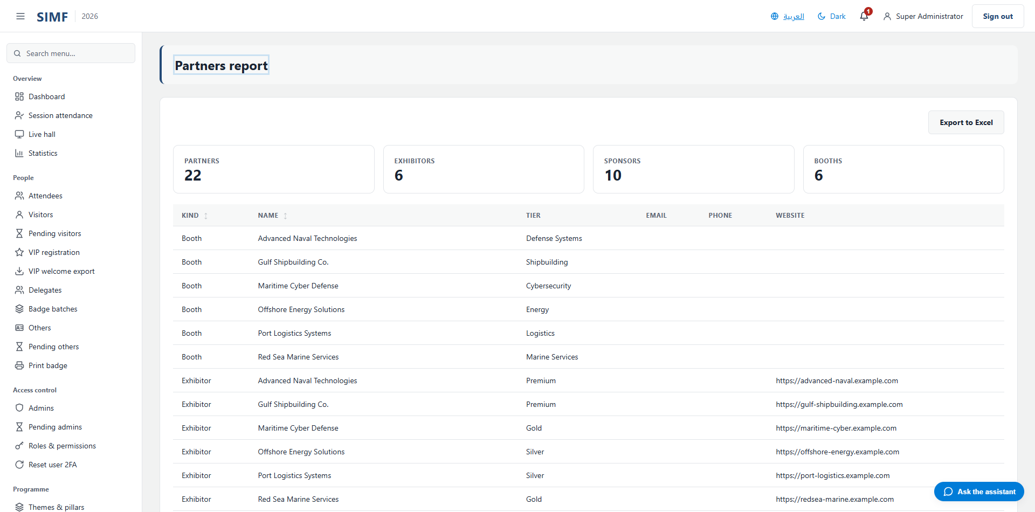
Figure 116 — Partners report — /admin/reports/partners

Meetings report (/admin/reports/meetings)
Property | Value
Address | /admin/reports/meetings
Implemented by | src/ControlPanel/SIMF.ControlPanel/Components/Pages/Admin/Reports/MeetingsReport.razor
Code-behind | -
Page permission | Reports.Meetings
Menu permission | Reports.Meetings

What you can do here
Action | Permission it needs
Export | No permission of its own

The list shows: Kind · Requester · Target · Subject · Slot · Status · Requested
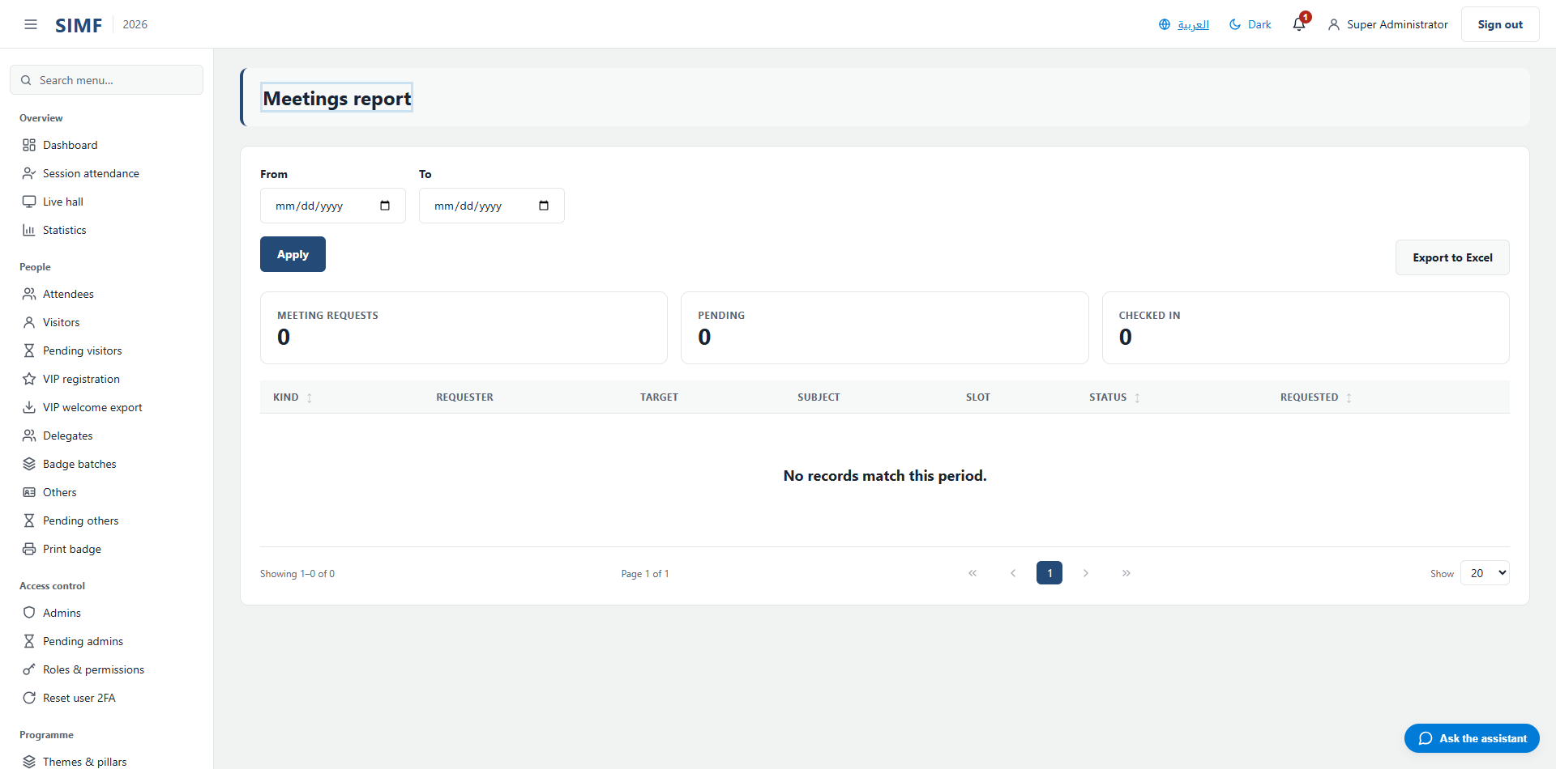
Figure 117 — Meetings report — /admin/reports/meetings

Engagement report (/admin/reports/engagement)
Property | Value
Address | /admin/reports/engagement
Implemented by | src/ControlPanel/SIMF.ControlPanel/Components/Pages/Admin/Reports/EngagementReport.razor
Code-behind | -
Page permission | Reports.Engagement
Menu permission | Reports.Engagement

What you can do here
Action | Permission it needs
Export | No permission of its own

The list shows: Code · Session · Question · Recipient · Status · Phase · Asked
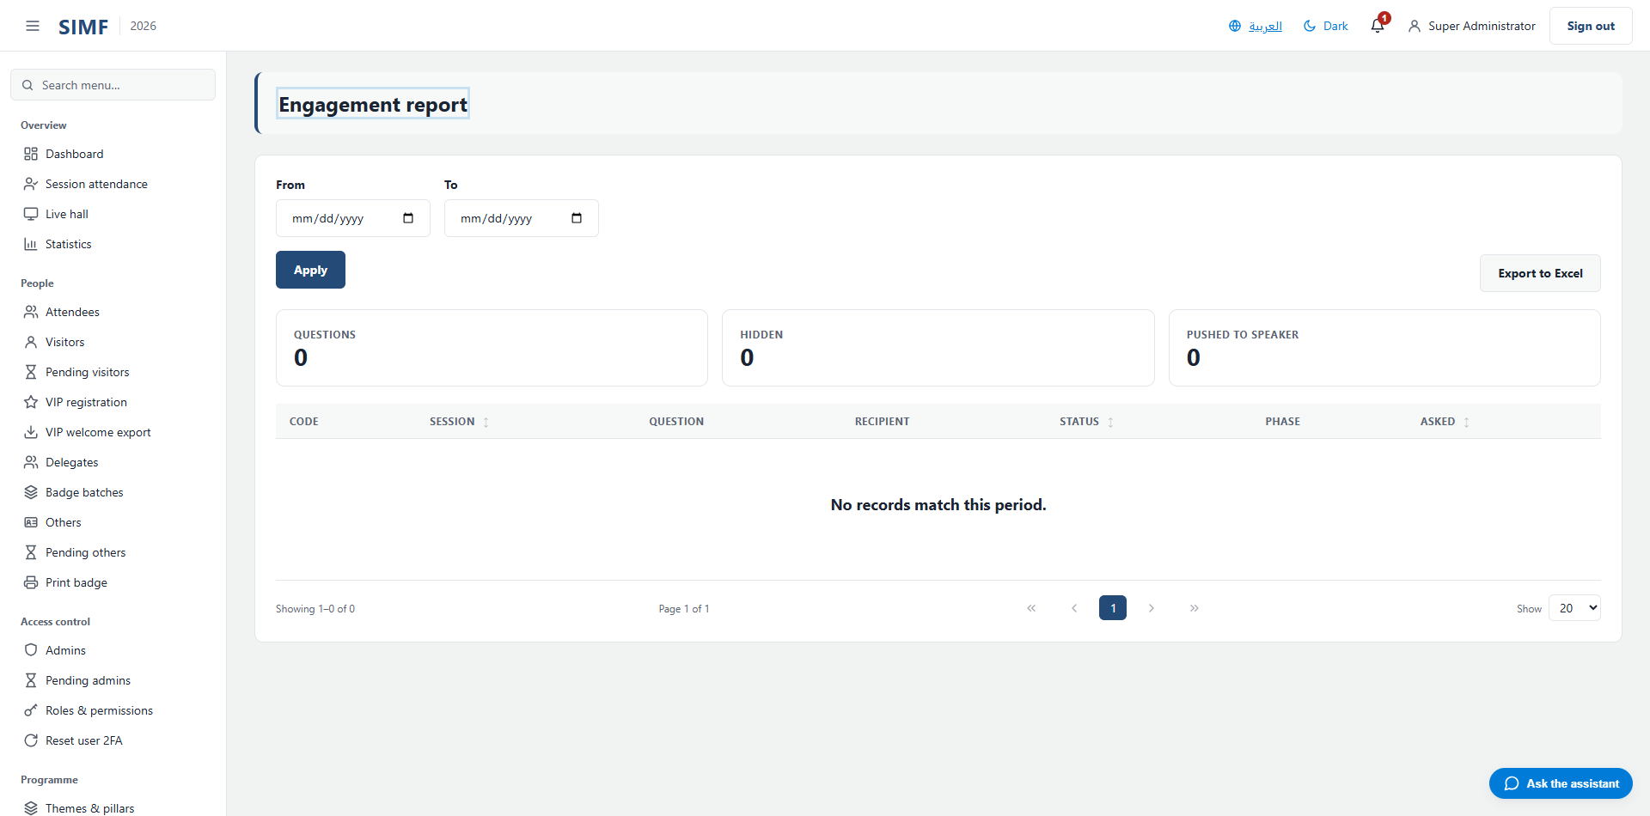
Figure 118 — Engagement report — /admin/reports/engagement

Pages reached from inside another page
These pages have an address but no menu entry. They open from a button or a row inside another page, or they belong to the sign-in flow.

Something went wrong (/Error)
Property | Value
Address | /Error
Implemented by | src/ControlPanel/SIMF.ControlPanel/Components/Pages/Error.razor
Code-behind | src/ControlPanel/SIMF.ControlPanel/Components/Pages/Error.razor.cs
Page permission | Anyone, signed in or not
Menu permission | -

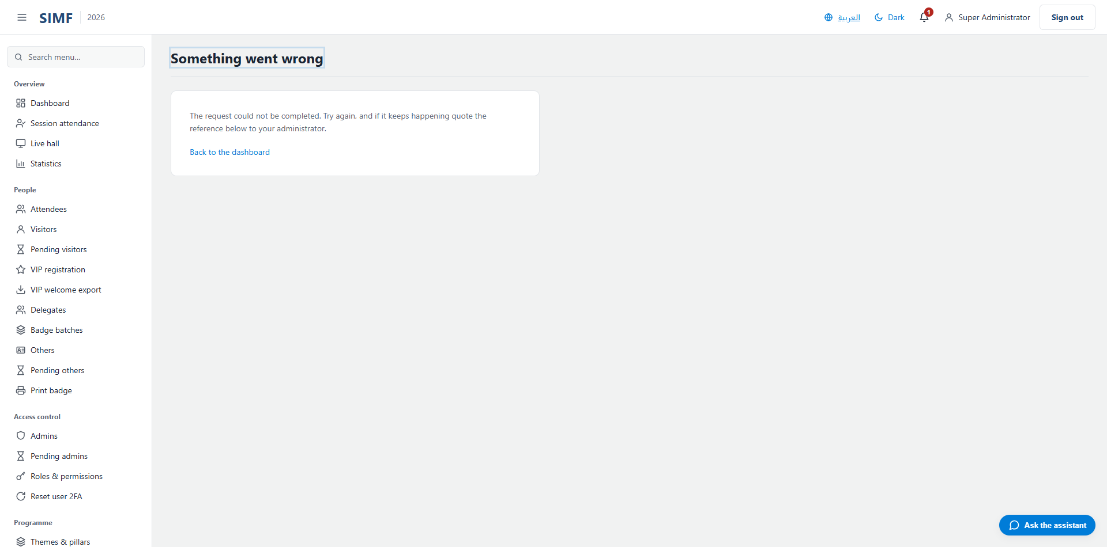
Figure 119 — /Error

Notifications (/account/notifications)
Property | Value
Address | /account/notifications
Implemented by | src/ControlPanel/SIMF.ControlPanel/Components/Pages/Account/Notifications.razor
Code-behind | src/ControlPanel/SIMF.ControlPanel/Components/Pages/Account/Notifications.razor.cs
Page permission | Any signed-in user
Menu permission | -

What you can do here
Action | Permission it needs
Details | No permission of its own
Delete | No permission of its own
Delete (on the selected rows) | No permission of its own

The list shows: Title · Message · Type · Received
It calls: /account/api/notifications/list /account/api/notifications/read-all /account/api/notifications/{row.Id} /account/api/notifications/{row.Id}/read
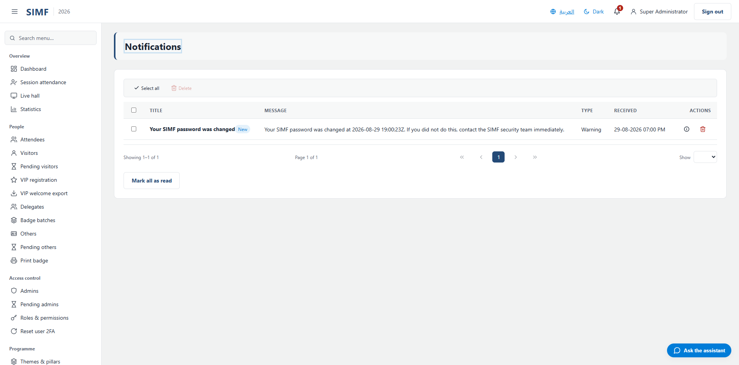
Figure 120 — /account/notifications

My profile (/account/profile)
Property | Value
Address | /account/profile
Implemented by | src/ControlPanel/SIMF.ControlPanel/Components/Pages/Account/Profile.razor
Code-behind | src/ControlPanel/SIMF.ControlPanel/Components/Pages/Account/Profile.razor.cs
Page permission | Any signed-in user
Menu permission | -

It calls: /account/api/avatar /account/api/change-password /account/api/profile /account/api/recovery-codes/regenerate /account/api/totp/confirm /account/api/totp/disable /account/api/totp/setup

Figure 121 — /account/profile

Re-pair authenticator (/account/totp-pairing)
Property | Value
Address | /account/totp-pairing
Implemented by | src/ControlPanel/SIMF.ControlPanel/Components/Pages/Account/TotpPairing.razor
Code-behind | src/ControlPanel/SIMF.ControlPanel/Components/Pages/Account/TotpPairing.razor.cs
Page permission | Any signed-in user
Menu permission | -

It calls: /account/api/totp/pairing /account/api/totp/pairing/verify
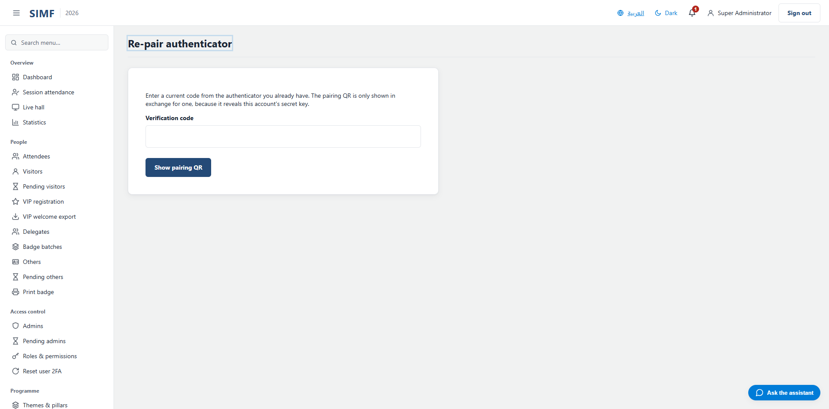
Figure 122 — /account/totp-pairing

Add a new user (/admin/admins/new)
Property | Value
Address | /admin/admins/new
Implemented by | src/ControlPanel/SIMF.ControlPanel/Components/Pages/Admin/CreateUser.razor
Code-behind | src/ControlPanel/SIMF.ControlPanel/Components/Pages/Admin/CreateUser.razor.cs
Page permission | Admins.Create
Menu permission | -

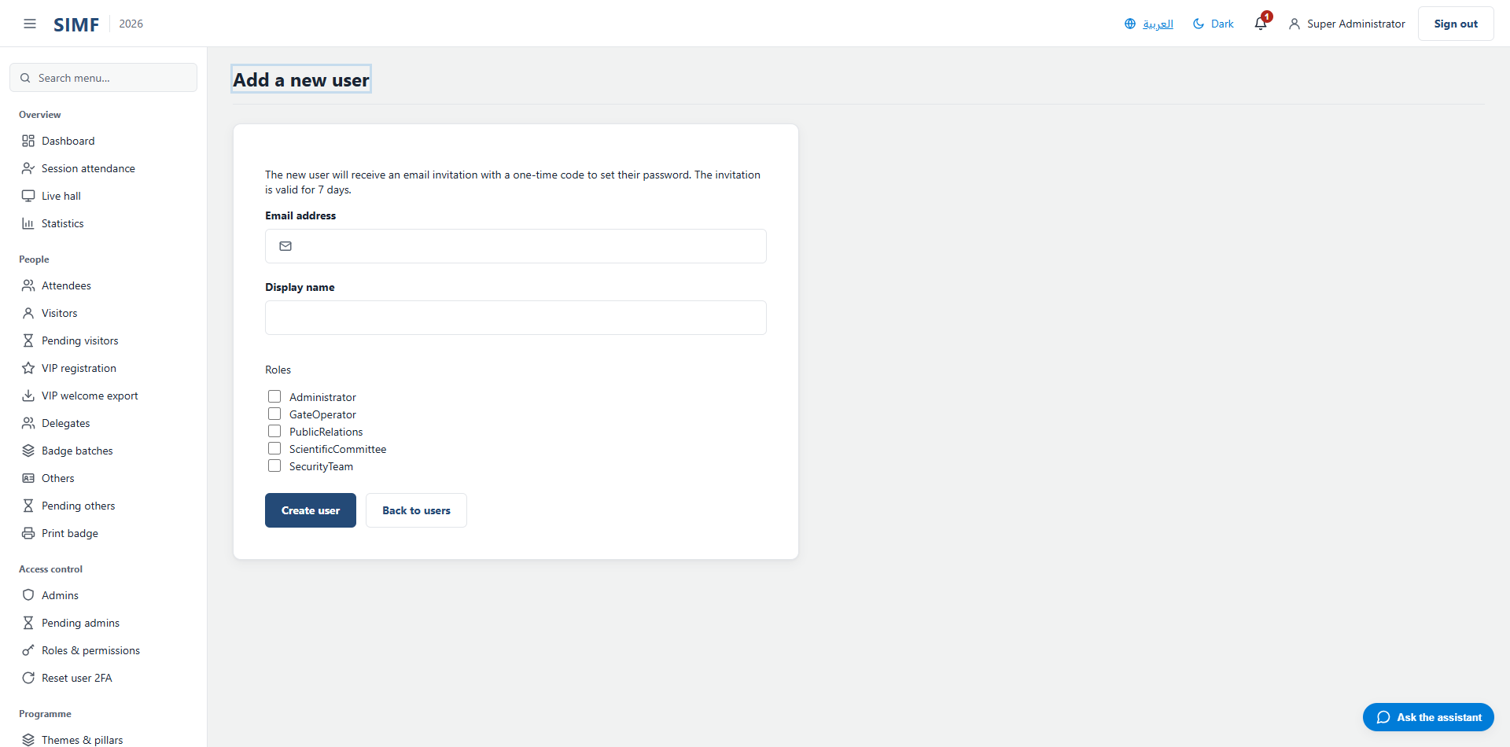
Figure 123 — /admin/admins/new

AI service (/admin/ai/services/{Feature})
Property | Value
Address | /admin/ai/services/{Feature}
Implemented by | src/ControlPanel/SIMF.ControlPanel/Components/Pages/Admin/AiServiceDetail.razor
Code-behind | src/ControlPanel/SIMF.ControlPanel/Components/Pages/Admin/AiServiceDetail.razor.cs
Page permission | AiPrompts.View
Menu permission | -

What you can do here
Action | Permission it needs
A button the page gates itself | AiPrompts.Edit

It calls: /account/api/admin/ai/dashboard /account/api/admin/ai/prompts/list
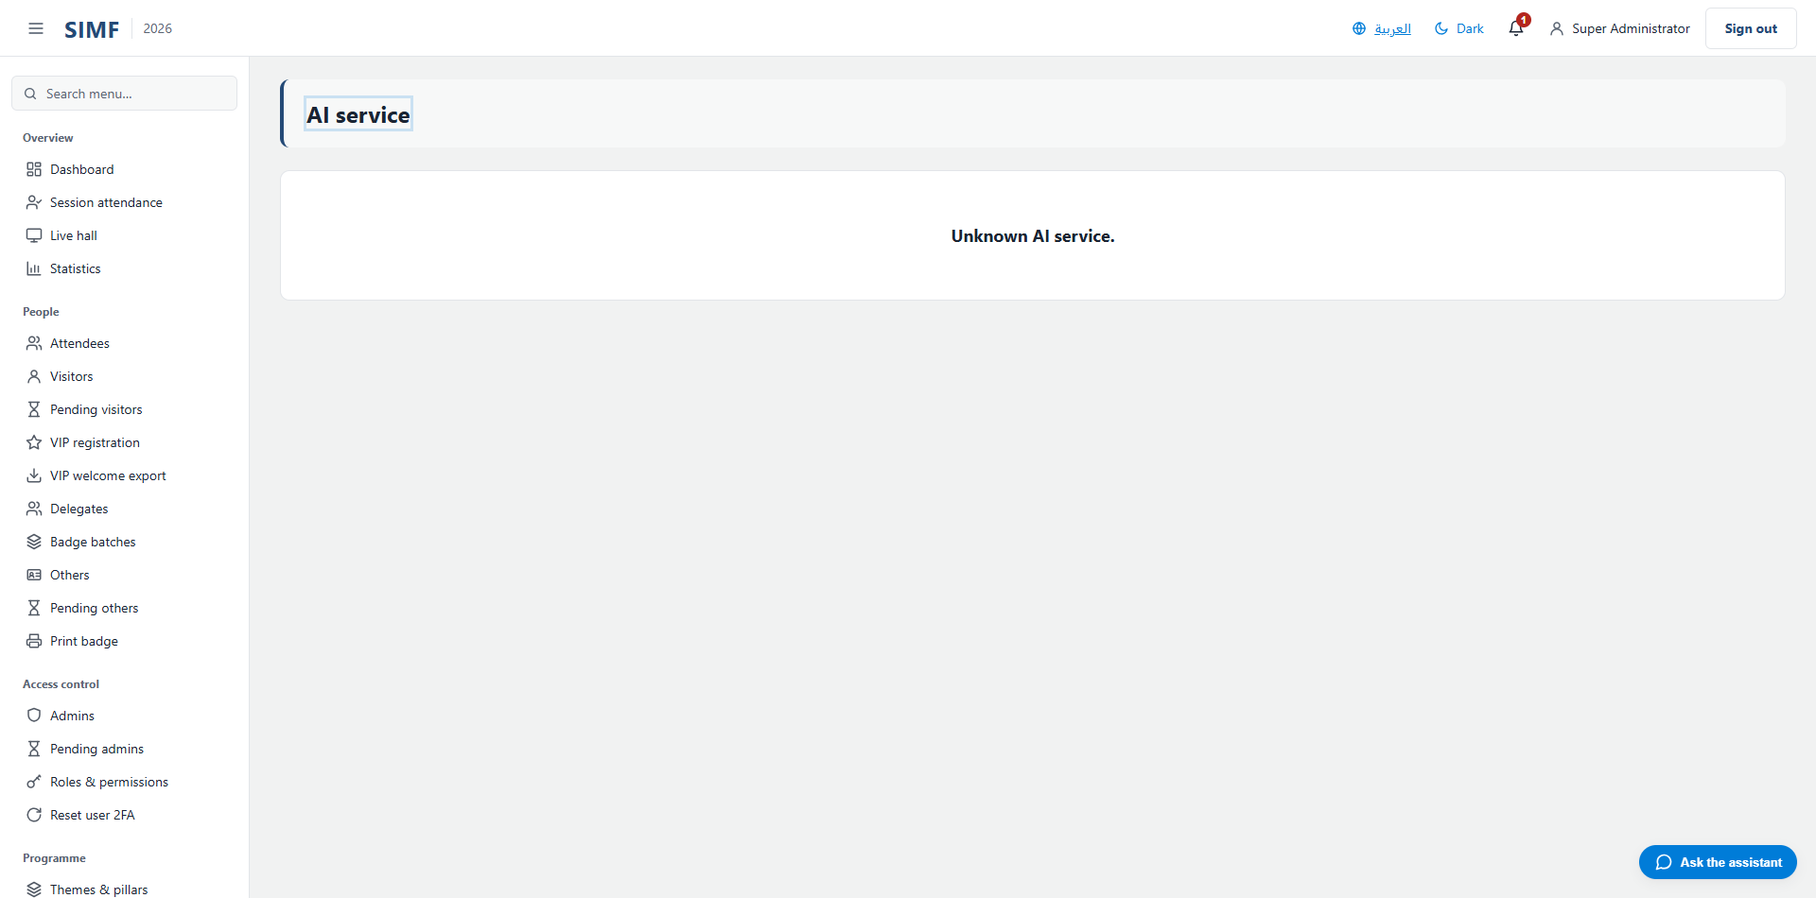
Figure 124 — /admin/ai/services/{Feature}

Add Other user (/admin/others/new)
Property | Value
Address | /admin/others/new
Implemented by | src/ControlPanel/SIMF.ControlPanel/Components/Pages/Admin/CreateOther.razor
Code-behind | src/ControlPanel/SIMF.ControlPanel/Components/Pages/Admin/CreateOther.razor.cs
Page permission | Others.Create
Menu permission | -

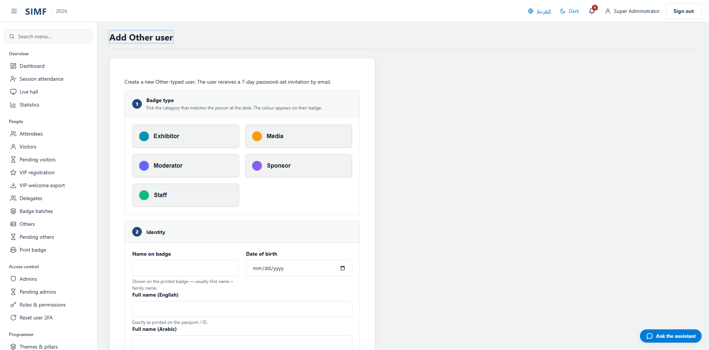
Figure 125 — /admin/others/new

/admin/roles/{RoleId:guid}/permissions (/admin/roles/{RoleId:guid}/permissions)
Property | Value
Address | /admin/roles/{RoleId:guid}/permissions
Implemented by | src/ControlPanel/SIMF.ControlPanel/Components/Pages/Admin/RolePermissionsEditor.razor
Code-behind | src/ControlPanel/SIMF.ControlPanel/Components/Pages/Admin/RolePermissionsEditor.razor.cs
Page permission | Roles.AssignPermissions
Menu permission | -

It calls: /account/api/admin/roles/{RoleId}/permissions

Figure 126 — /admin/roles/{RoleId:guid}/permissions

Add a new visitor (/admin/visitors/new)
Property | Value
Address | /admin/visitors/new
Implemented by | src/ControlPanel/SIMF.ControlPanel/Components/Pages/Admin/CreateVisitor.razor
Code-behind | src/ControlPanel/SIMF.ControlPanel/Components/Pages/Admin/CreateVisitor.razor.cs
Page permission | Visitors.Create
Menu permission | -

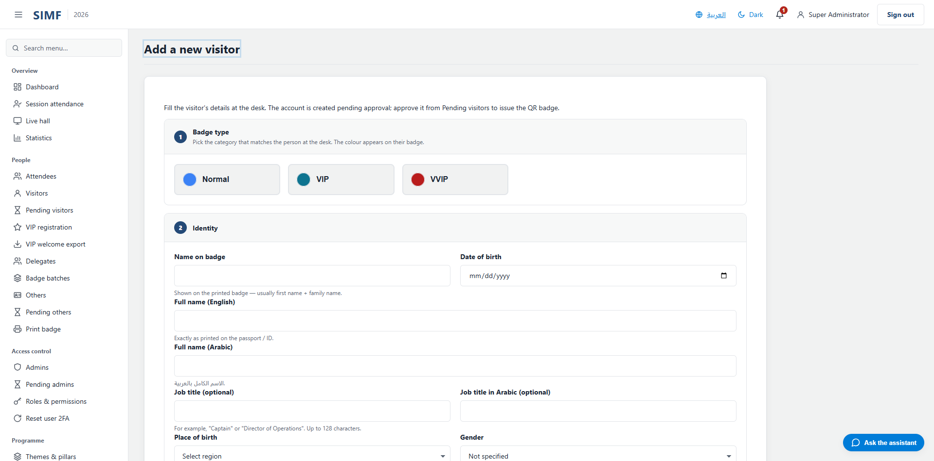
Figure 127 — /admin/visitors/new

Your account is waiting for approval (/auth/pending)
Property | Value
Address | /auth/pending
Implemented by | src/ControlPanel/SIMF.ControlPanel/Components/Pages/Auth/PendingApproval.razor
Code-behind | src/ControlPanel/SIMF.ControlPanel/Components/Pages/Auth/PendingApproval.razor.cs
Page permission | Any signed-in user
Menu permission | -

No screenshot: this address cannot be opened directly by a signed-in reader. The two account-state pages redirect to the dashboard, and the three sign-in pages redirect back to the sign-in form, because each is reachable only at its own point in a flow.

Your account was not approved (/auth/rejected)
Property | Value
Address | /auth/rejected
Implemented by | src/ControlPanel/SIMF.ControlPanel/Components/Pages/Auth/Rejected.razor
Code-behind | src/ControlPanel/SIMF.ControlPanel/Components/Pages/Auth/Rejected.razor.cs
Page permission | Any signed-in user
Menu permission | -

No screenshot: this address cannot be opened directly by a signed-in reader. The two account-state pages redirect to the dashboard, and the three sign-in pages redirect back to the sign-in form, because each is reachable only at its own point in a flow.

Forgot password · SIMF Control Panel (/forgot-password)
Property | Value
Address | /forgot-password
Implemented by | src/ControlPanel/SIMF.ControlPanel/Components/Pages/Auth/ForgotPassword.razor
Code-behind | src/ControlPanel/SIMF.ControlPanel/Components/Pages/Auth/ForgotPassword.razor.cs
Page permission | Anyone, signed in or not
Menu permission | -

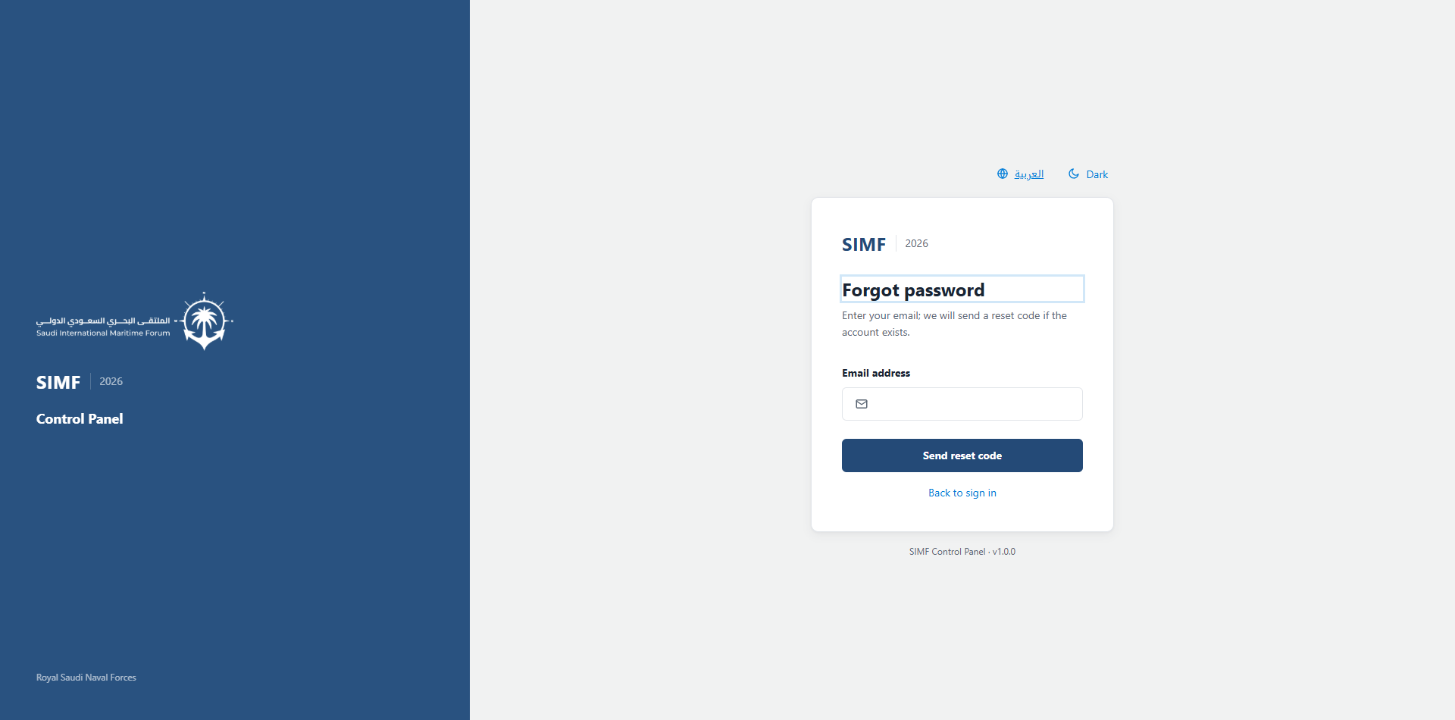
Figure 128 — /forgot-password

Sign in · SIMF Control Panel (/login)
Property | Value
Address | /login
Implemented by | src/ControlPanel/SIMF.ControlPanel/Components/Pages/Auth/SignIn.razor
Code-behind | src/ControlPanel/SIMF.ControlPanel/Components/Pages/Auth/SignIn.razor.cs
Page permission | Anyone, signed in or not
Menu permission | -


Figure 129 — /login

Set up two-factor authentication (/login/enrol-2fa)
Property | Value
Address | /login/enrol-2fa
Implemented by | src/ControlPanel/SIMF.ControlPanel/Components/Pages/Auth/TwoFactorEnrolment.razor
Code-behind | src/ControlPanel/SIMF.ControlPanel/Components/Pages/Auth/TwoFactorEnrolment.razor.cs
Page permission | Anyone, signed in or not
Menu permission | -

No screenshot: this address cannot be opened directly by a signed-in reader. The two account-state pages redirect to the dashboard, and the three sign-in pages redirect back to the sign-in form, because each is reachable only at its own point in a flow.

Recovery code · SIMF Control Panel (/login/recovery)
Property | Value
Address | /login/recovery
Implemented by | src/ControlPanel/SIMF.ControlPanel/Components/Pages/Auth/RecoveryCodeVerify.razor
Code-behind | src/ControlPanel/SIMF.ControlPanel/Components/Pages/Auth/RecoveryCodeVerify.razor.cs
Page permission | Anyone, signed in or not
Menu permission | -

No screenshot: this address cannot be opened directly by a signed-in reader. The two account-state pages redirect to the dashboard, and the three sign-in pages redirect back to the sign-in form, because each is reachable only at its own point in a flow.

Verify · SIMF Control Panel (/login/totp)
Property | Value
Address | /login/totp
Implemented by | src/ControlPanel/SIMF.ControlPanel/Components/Pages/Auth/TotpVerify.razor
Code-behind | src/ControlPanel/SIMF.ControlPanel/Components/Pages/Auth/TotpVerify.razor.cs
Page permission | Anyone, signed in or not
Menu permission | -

No screenshot: this address cannot be opened directly by a signed-in reader. The two account-state pages redirect to the dashboard, and the three sign-in pages redirect back to the sign-in form, because each is reachable only at its own point in a flow.

/m/{Module} (/m/{Module})
Property | Value
Address | /m/{Module}
Implemented by | src/ControlPanel/SIMF.ControlPanel/Components/Pages/ModulePlaceholder.razor
Code-behind | src/ControlPanel/SIMF.ControlPanel/Components/Pages/ModulePlaceholder.razor.cs
Page permission | Sessions.View
Menu permission | -


Figure 130 — /m/{Module}

Page not found (/not-found)
Property | Value
Address | /not-found
Implemented by | src/ControlPanel/SIMF.ControlPanel/Components/Pages/NotFound.razor
Code-behind | -
Page permission | Anyone, signed in or not
Menu permission | -

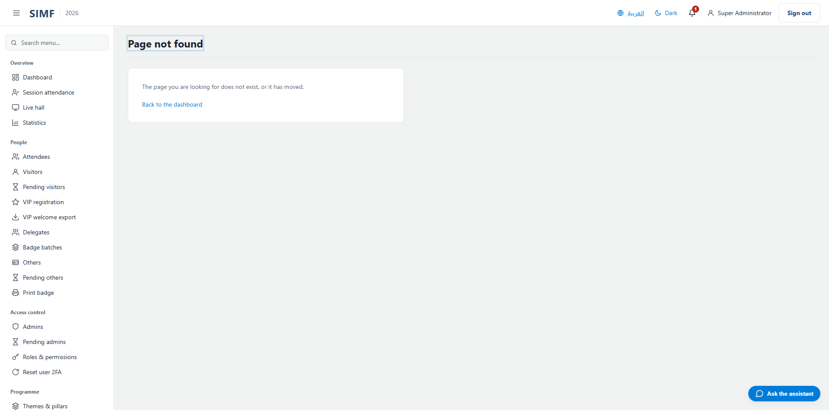
Figure 131 — /not-found

Not permitted (/not-permitted)
Property | Value
Address | /not-permitted
Implemented by | src/ControlPanel/SIMF.ControlPanel/Components/Pages/NotPermitted.razor
Code-behind | -
Page permission | Any signed-in user
Menu permission | -

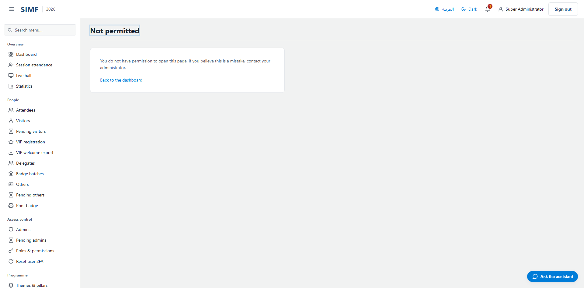
Figure 132 — /not-permitted

Reset password · SIMF Control Panel (/reset-password)
Property | Value
Address | /reset-password
Implemented by | src/ControlPanel/SIMF.ControlPanel/Components/Pages/Auth/ResetPassword.razor
Code-behind | src/ControlPanel/SIMF.ControlPanel/Components/Pages/Auth/ResetPassword.razor.cs
Page permission | Anyone, signed in or not
Menu permission | -

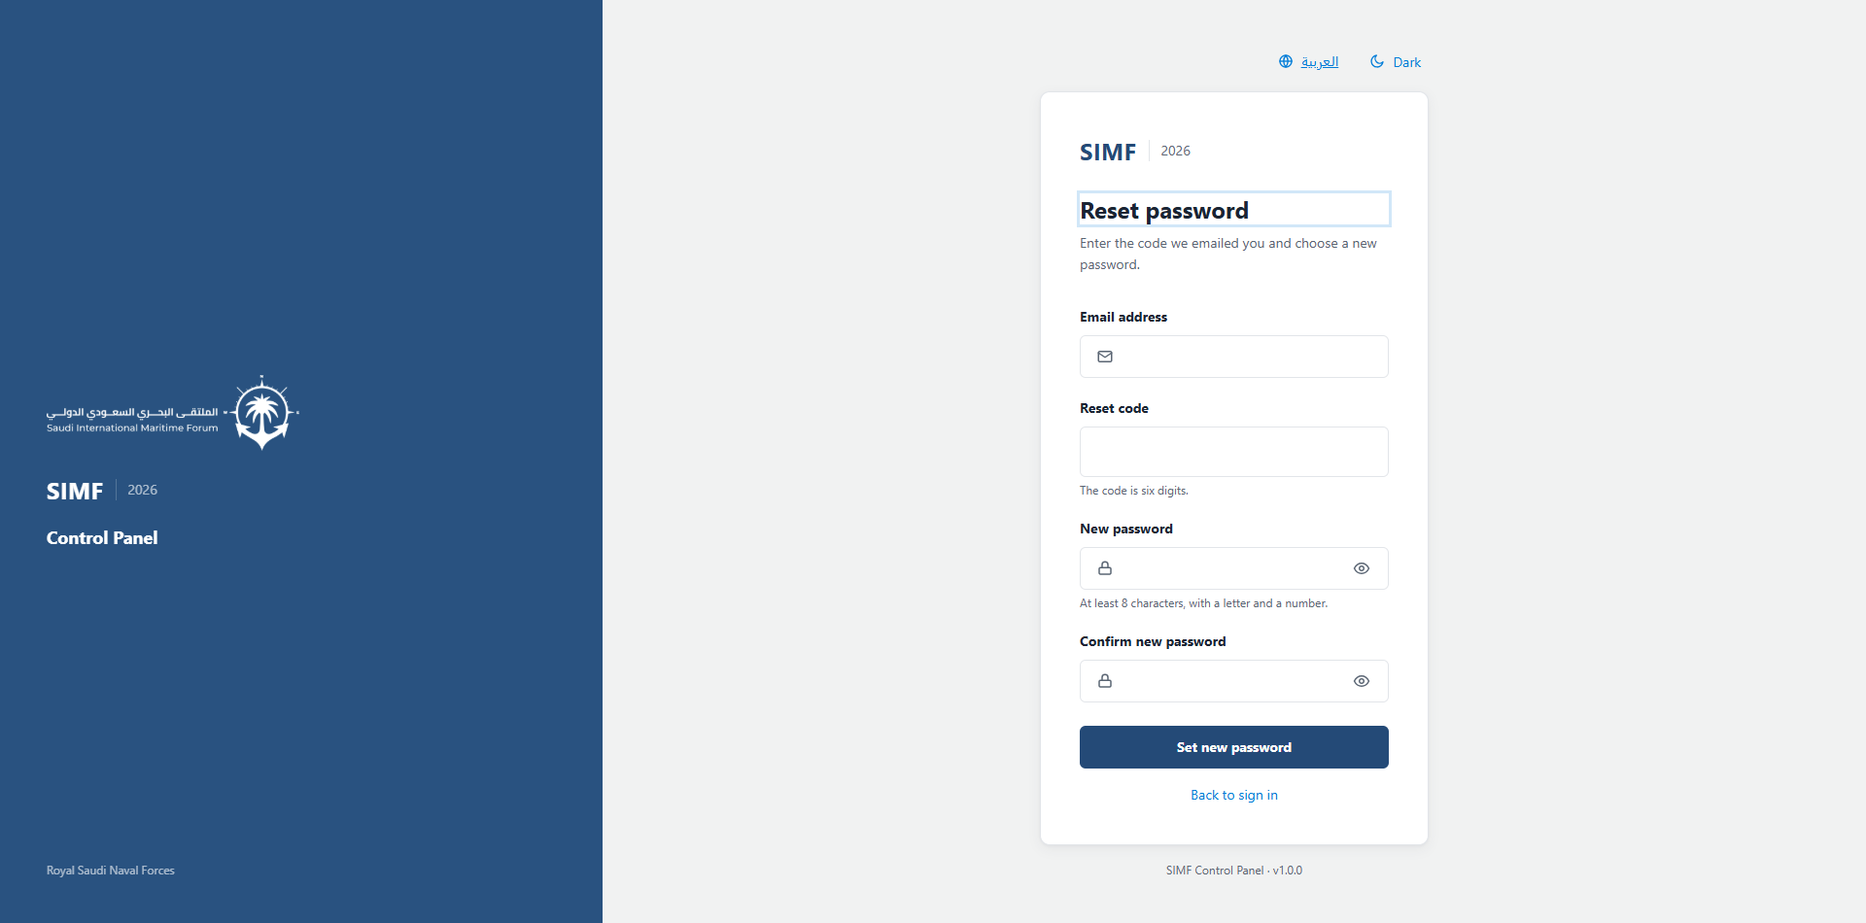
Figure 133 — /reset-password

Session Q&A moderation (/sessions/{SessionId:guid}/moderate)
Property | Value
Address | /sessions/{SessionId:guid}/moderate
Implemented by | src/ControlPanel/SIMF.ControlPanel/Components/Pages/Admin/SessionModerationDesk.razor
Code-behind | src/ControlPanel/SIMF.ControlPanel/Components/Pages/Admin/SessionModerationDesk.razor.cs
Page permission | Questions.Moderate
Menu permission | -

What you can do here
Action | Permission it needs
A button the page gates itself | Questions.Moderate

It calls: /account/api/sessions/{SessionId}/questions/moderate /account/api/sessions/{SessionId}/questions/{row.Id}/hide /account/api/sessions/{SessionId}/questions/{row.Id}/push
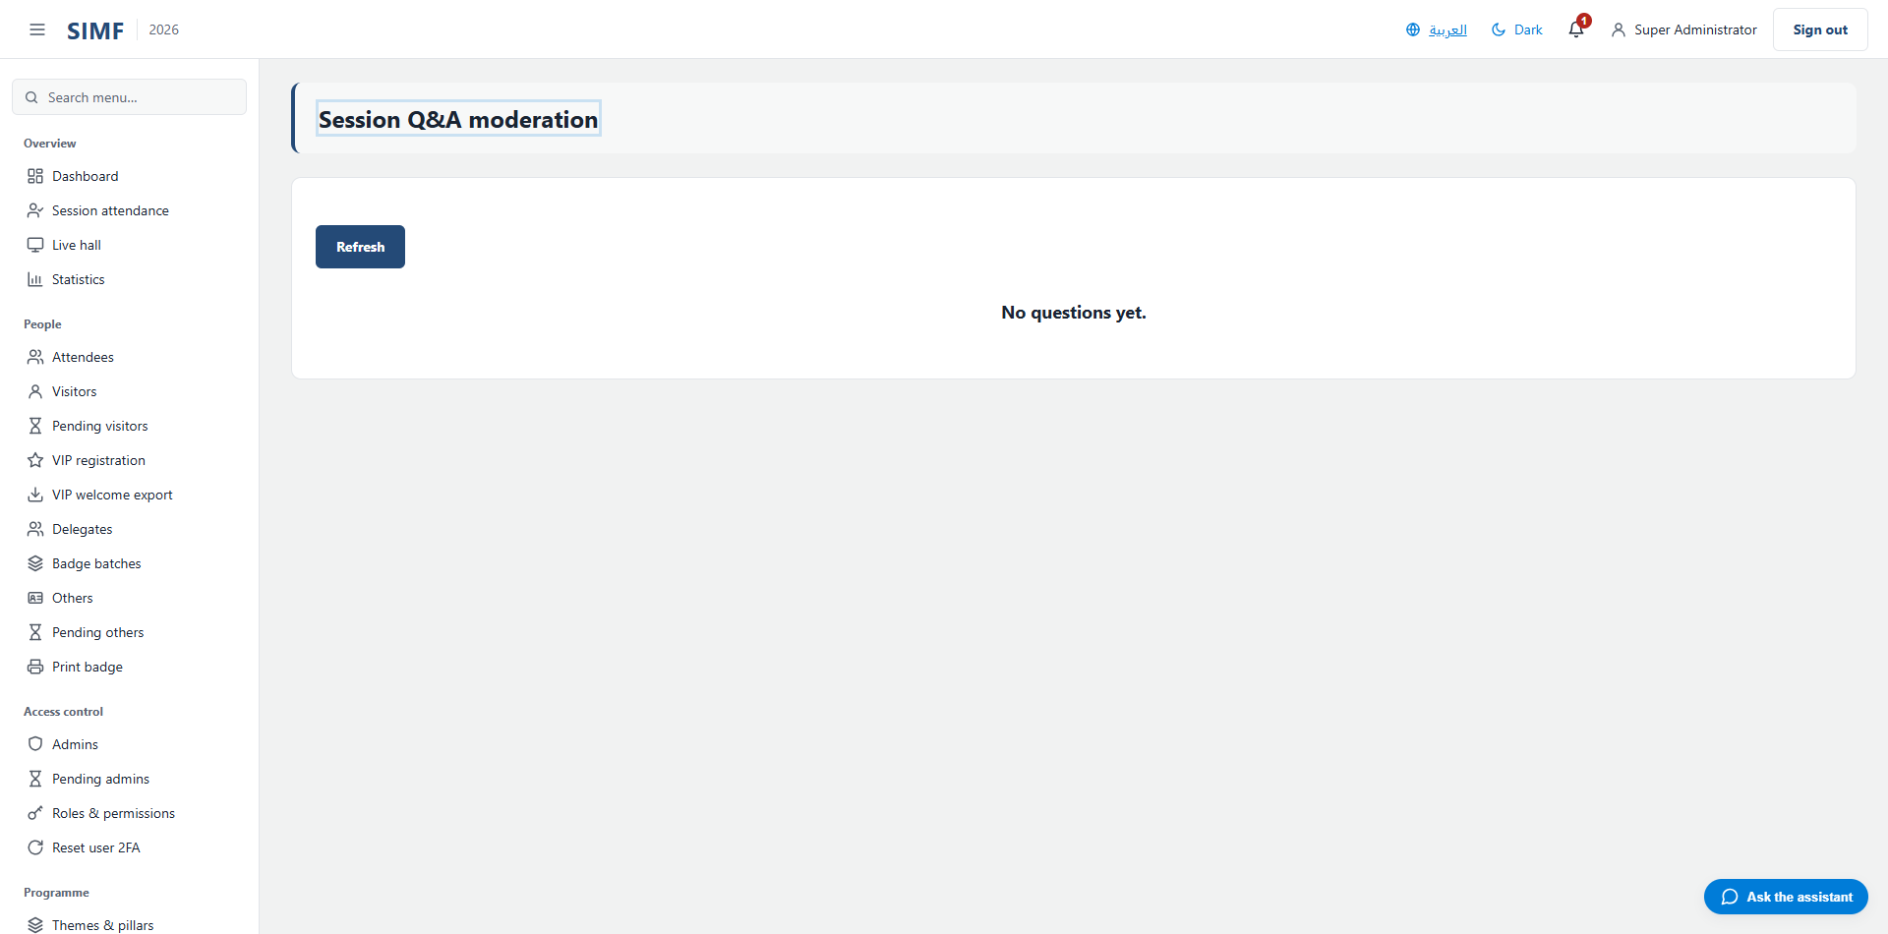
Figure 134 — /sessions/{SessionId:guid}/moderate

