Requester information
Requester Name: |  | General Department:
Email: |  | Section:
Phone Number/extension: |  | Force or BU:
Strategic Information (Filled By Project Owner)
Initiative Name |  | Priority
Project Name, from Roadmap | SIMF 4th Edition 2026
Components from To-Be Architecture Realized
Screening Questions (Filled by Technology)
Requirements/SRS/User Stories Defined and Approved |  |  | Defined. 132 numbered, individually testable requirements in the Business Requirements Document delivered with this design, each mapped to its design section in Annex B. Four open items remain, in that document's section 5.7. Approval is the Ministry's.
Integration Requirements Defined and Approved |  |  | Defined. Section 2.4 and the Communication Requirements Matrix in section 2.8. Four internal systems in HSA; one outbound integration, the YouTube caption import, pending its firewall exception.
Security Requirements Defined and Approved |  |  | Defined. Section 2.9 Solution Security View, aligned to the NCA Secure Application Development Standard and to the PDPL. Four pre-launch activities are scheduled before go-live.
Uses approved Architecture/Design Methodology |  |  | Modular monolith with Domain-Driven Design layering and defence in depth, sections 2.1 and 2.2. Confirmation against Technology's approved methodology is Technology's.
Architecture Constraints Documented |  |  | Yes. The Architecture Constraints row above carries six constraints; sections 1.2, 2.1 and 2.7 carry the hosting, zone and network constraints.
Uses Approved Solution Stack (Hardware/Software) |  |  | .NET 10, Blazor, Flutter, SQL Server 2022 and IIS on Windows Server 2022; per-node sizing in the section 2.1 table. Confirmation against Technology's approved stack is Technology's.
Is system described sufficiently (Section 1.1 to 1.3)) |  |  | Yes. 1.1 the purpose, 1.2 the goals, assumptions and constraints, 1.3 the users, the one external entity and the five internal systems.
Is solution design described sufficiently (Section 2.1 to 2.9) |  |  | Yes. All nine sections are authored in this issue, with four figures, the per-tier sizing table and the Communication Requirements Matrix.
Is the Risk and Mitigation Strategies provided |  |  | Yes. Section 3 gives six risks with impact and mitigation: security, event-day availability, scalability, integration, schedule and change freeze, and data integrity and compliance.
Document Completion Approved? |  |  | For Technology. This row records the review board's own verdict, and is the same decision the Approvals block signs.

Solution Architecture Section (Project Team)
Requirements and Constraints
BRD | The Business Requirements Document is delivered with this design, capturing the business objectives, scope, stakeholders, business rules and the numbered requirement set: 14 business rules, 90 functional requirements, 12 non-functional requirements and 16 operational requirements.
SRS/User Stories | The requirement set is carried by the Business Requirements Document delivered with this design, as 132 individually numbered requirements. Annex B of this document maps every one of those identifiers to the section that designs it, and the Solution Design Document delivered alongside carries the same mapping to its own module sections. Each requirement is written as a single testable statement, so the requirement set is also the acceptance criteria.  The requirements are defined, and are submitted for approval with this issue. Four open items remain, and are listed in the Business Requirements Document, section 5.7.
Solution Requirements | Single-tenant event platform for the Saudi International Maritime Forum. The forum is open to the general public and international in attendance: registration is not restricted to Ministry of Defense personnel and not restricted to Saudi nationals. Scope: visitor registration and administrator approval; digital QR badge and gate access control; forum programme, sessions and seat booking; live session streaming and moderated Q&A; exhibition, booths, sponsors and media partners; news, media gallery and past-edition archive; networking, contact sharing and speaker, delegation and business meetings; notifications; ratings and statistics; and a Control Panel for full event administration without a code release.
Integration Requirements | Internal systems on site in the HSA zone: an SMTP mail relay, MinIO object storage, the GPT OSS 120B inference endpoint, and SQL Server 2022 (Standard in Development and Test, Enterprise in an AlwaysOn Availability Group in production). None is reached across the internet.  External: one integration. The Control Panel imports a published session subtitle from the YouTube caption API, sending the public video id and nothing else. It is the only outbound call the platform makes, it leaves from the SSA zone, and it needs an approved outbound HTTPS 443 exception. Without that exception an administrator pastes or uploads the transcript, and no feature is blocked.  Client-side: YouTube live playback, performed by the attendee device; the platform stores only the stream URL.  SIMF operates its own ASP.NET Core Identity store.
Security Requirements | Authentication: e-mail + password; second factor, e-mailed OTP (visitors) or TOTP authenticator (administrators) with single-use recovery codes; optional ES256 biometric device key on mobile.  Authorization: role-based access control with per-page / per-action permissions baked into the JWT and enforced on both the API and the Control Panel; Administrator = wildcard.  Encryption: TLS 1.2+ in transit; PII columns (national ID / Iqama / passport, mobile numbers) are encrypted at rest with application-level AES-256-GCM under a 32-byte data key. Identity-document images and the other confidential stored files are encrypted at rest with AES-GCM envelope encryption under a second data key, carrying a key version for rotation. Both keys are held in the central key management service backed by a hardware security module, and no key material sits in application configuration. There is no dependency on database-native TDE.  Hardening: WAF, multi-dimensional rate limiting, security headers and CSP, explicit CORS allow-list, upload scanning, and secrets held in the key management service with production boot guards that refuse to start a node whose secrets are absent.  Audit: two append-only trails, OperationLog (security-relevant business events) and RowAudit (row-level before/after images).  Compliance: aligned to the NCA Secure Application Development Standard (ECC / OWASP baselines) and to the Saudi Personal Data Protection Law (PDPL).  Data classification: the platform holds no classified and no militarily sensitive material. Its content is unclassified and falls into three groups: personal data of visitors, speakers and exhibitors; open scientific material (sessions and workshops); and administrative data for exhibition and programme management. Only the first group carries PDPL obligations, and it is the group protected by the encryption, access-control and audit measures above. It includes a facial photograph, which the registrant supplies for the badge and for identity checking at the gate; section 2.9 states exactly what the platform does and does not do with it.
Hosting Requirements | On premises on Windows Server 2022, on the SITE Private Cloud, over SQL Server 2022. Two security areas, SSA and HSA, hold four network zones. The layout is in section 2.1.
Architecture Methodology or Best Practice used | Modular monolith with Domain-Driven Design layering (Domain, Application, Infrastructure, API). The network follows defence in depth: two security areas, SSA and HSA, holding four zones with two firewalls at the zone boundaries, a stateless application tier and a high-availability database.
Architecture Constraints | Frontend: the mobile app, the public website, the Control Panel and the on-site badge desk. Backend: one API. Data: two SQL Server databases and MinIO object storage.  • Hard event deadline with a post-publish change freeze.  • Mandatory NCA security compliance and source-code handover.  • On-premises hosting; SQL Server 2022, Standard edition in Development / Test, Enterprise edition in an AlwaysOn Availability Group for the production event topology (owner decision).  • Two physically separate databases with no cross-database foreign keys, transactions or duplicated live data.  • Arabic primary (RTL) and English secondary throughout.  • The one external integration, the YouTube caption import, depends on an approved outbound HTTPS 443 exception.
Software Specification | .NET 10, FastEndpoints, FluentValidation, EF Core (code-first), Blazor Server + Blazor SSR with the SIMF.Components shared component library, Flutter (Dart) for iOS and Android, SQL Server 2022, IIS, Serilog, MailKit.
Hardware Specification | The hardware specification for this submission, matching section 2.1 and Figure 1. Production: four API hosts, two web hosts, two Control Panel hosts and two database hosts, all Windows Server 2022 with Server and DR, plus two load-balancer pairs, appliance or VM, one at the SSA perimeter and one in front of the API tier. Application hosts are 32 GB RAM, 16 vCPU and 300 GB storage. Database hosts are 64 GB RAM, 8 vCPU and 2 TB storage. The mobile edge and the MinIO hosts are a SIMF proposal confirmed with the site. The LLM server, the mail relay and the key management service are provided by SITE together with the service. Development and Test run one application host and one SQL Server host.

  - 1.1 Purpose
This document describes the high-level design for the SIMF (Saudi International Maritime Forum) platform, delivered for the Royal Saudi Naval Forces (RSNF) under a Ministry of Defense programme. The Project Team completes the Solution Architecture Section, sections 1 to 3 and the Screening Questions, which are complete in this issue. The Requester Information, the Strategic Information and the Approvals are completed by the Ministry on receipt.
1.2 System Overview
Provide a high-level description of the system. Outline the system's goals and how it will address the problem or need. Include any high-level assumptions or constraints.
SIMF is a single-tenant event platform for the Saudi International Maritime Forum. The forum is open to the general public and international in attendance: it is not restricted to Ministry of Defense personnel and not restricted to Saudi nationals, and any member of the public may register subject to administrator approval. It is reached through four client applications, the mobile app, the public website, the Control Panel and the on-site badge desk, which share one backend API and two databases. It has two kinds of user: application users, whose access level is the profile type assigned at approval, and administrators, whose permissions come from a named role. It is designed to:
• Register visitors online, verify their e-mail and identity, and route them through an administrator approval workflow.
• Issue each approved attendee a digital QR badge and control physical entry through gate scanning.
• Publish the forum programme and let attendees browse sessions, reserve seats and receive reminders.
• Stream live sessions and let attendees submit moderated questions.
• Present the exhibition, booths, sponsors, media partners, news, media gallery and the past-edition archive.
• Enable networking, contact sharing, and speaker / delegation / business meeting requests.
• Give organisers a Control Panel to administer every aspect of the event without a code release.
• Collect ratings and feedback and present event statistics.
High-level assumptions and constraints
• The forum runs on fixed dates; the platform must be feature-complete and frozen before it opens, and an outage during the event cannot be rescheduled.
• Hosting is on-premises on the SITE Private Cloud; there is no public-cloud dependency.
• The system must comply with the NCA Secure Application Development Standard.
• Arabic is the primary language (right-to-left); English is secondary.
• Identity data and business data are held in two physically separate SQL Server databases with no cross-database foreign keys.
• The source code is contractually handed over to the customer.
1.3 System Context
Provide System Context for the solution, with Users, External Entities, External and Internal Systems the solution has to interact with.
Users
• Attendees / visitors / VIP delegates, drawn from the general public and from international participants, use the mobile app (Android + iOS) to register, receive a digital badge, reserve seats, watch live sessions, ask questions, network and rate the event, and the public website to read the programme and visit information. Registration and every authenticated journey are in the app; the website has no sign-in, no registration and no account page, and stores no personal data. The two deliberate exceptions are described in section 2.2.
• Anonymous public, use the website to read public content (home, programme, visit information).
• Administrators / organisers / scientific committee / public relations, staffed by Royal Saudi Naval Forces personnel and by the organising company, use the Control Panel, reached on a separate hostname. Each administrator holds a named role whose permissions are restricted per page and per action.
• Gate operators and session moderators, use the mobile app staff / moderator screens and the Control Panel. Badge desk staff use the on-site badge desk application (SIMF.BadgeDesk) to print and issue badges at the venue.
External entities (outbound only)
• YouTube. The Control Panel imports the caption track of a published session video, sending the public video id and nothing else. It is the only call SIMF makes to the internet, and it is optional egress: without the firewall exception an administrator pastes or uploads the transcript instead and no feature is lost.
• YouTube live playback, performed by the attendee device directly; this traffic does not traverse the SIMF backend.
No external entity initiates an inbound connection to SIMF.
Internal systems
• SMTP relay, on site in HSA, transactional e-mail (verification codes, OTP, approval notices, alerts), queued and dispatched asynchronously.
• Syslog / SIEM, centralised structured logging.
• LLM server, on site in HSA, running the SITE-hosted GPT OSS 120B model behind an OpenAI-compatible API. It serves subtitle translation, session minutes, question filtering and the assistants. SIMF.Api is its only caller and no inference leaves the ministry network.
• MinIO, on site in HSA, object storage over the S3 API holding avatars, encrypted identity documents, VIP photos, session recordings, speaker presentations and media assets. Every API node reads back what another wrote.
• SQL Server 2022, hosts the SIMF_Identity and SIMF_App databases. Standard edition, single node, in Development / Test; Enterprise edition in an AlwaysOn Availability Group for the production event topology (owner decision, see section 2.1).
SIMF operates its own ASP.NET Core Identity store.
2.1 Architecture Overview
The Overall Architecture of the Solution with the main conceptual building blocks, systems, sub systems, connections, data stores, users and external systems. With description of each relevant item.
SIMF is a modular monolith. One backend API serves the mobile app, the public website and the Control Panel over two separate databases, SIMF_Identity and SIMF_App. It is hosted on-premises on Windows Server 2022 with SQL Server 2022. It is a three-tier deployment: the presentation, application and data tiers run on separate servers in production.
The architecture is built for the event-day load. Two security areas hold four network zones. Two firewalls sit at the zone boundaries: the perimeter firewall, and an internal firewall between the presentation zone and HSA. SSA holds the access, perimeter and presentation zones and is the only area with internet access. HSA is a single zone holding the application and data tiers, and carries internal traffic only. The internal firewall is the only route into it and permits TCP 443 from the presentation zone alone, so it is also the only barrier in front of the databases and the file store. Figure 1 shows the layout.
Figure 1, SIMF phase one deployment, security areas and on-site services. One box per hosting server, with its zone, firewall, protocol and port. The diagram is reproduced at full page size on the landscape pages that follow section 2.3.
Internet. Attendees use the mobile app and the public website over HTTPS. Administrators use the Control Panel over HTTPS. SIMF makes one outbound call: the Control Panel fetches the caption track of a published session video from YouTube. The AI runs on site, so inference generates no internet traffic. Authentication uses e-mailed one-time passwords, so there is no SMS dependency.
SSA zone. The access zone holds the attendee mobile device, the public website browser and the administrator browser. A web application firewall and load balancer in the perimeter zone terminates TLS, filters traffic against the OWASP rule set and balances requests across healthy nodes. The presentation zone holds the presentation tier and nothing else: the website (SIMF.Web, two nodes), the Control Panel (SIMF.ControlPanel, two nodes with session affinity) and the mobile edge (SIMF.MobileEdge). All three reach data only through the API, over HTTPS 443 across the internal firewall. No presentation project holds a database connection string or an EF Core DbContext, so a compromised presentation host has no direct database access.
HSA zone. Everything that holds or processes SIMF data sits here, and none of it can reach the internet: the API (SIMF.Api, four stateless nodes behind an internal load balancer), the GPT OSS 120B inference endpoint on the on-site LLM server, the on-site SMTP relay, MinIO object storage and the databases. SQL Server 2022 Enterprise runs in an AlwaysOn Availability Group, a read-write primary and one secondary reached through a listener; both databases run in the group with synchronous commit and automatic failover. The API is the only caller of the databases, the LLM server, the mail relay and MinIO.
Transport. Every HTTP connection, client to server and server to server, uses TLS 1.2 or higher. TLS terminates at the load balancer and is re-encrypted to the backend. The mail and database paths run on their own protocols and ports, listed in the Communication Requirements Matrix in section 2.8.
Deployment sizing and capacity
SIMF runs a time-boxed event, so the design point is the event-day peak, not an average load. The platform is sized for about 30,000 concurrent attendees at peak, roughly 50,000 registered at a 0.6 peak factor, with headroom to about 40,000. Target response times at that load are 400 ms for sign-in, 250 ms for a gate scan and 300 ms for a read, at under 75% CPU. Live-session video streams directly from YouTube to the attendee device and never passes through SIMF, so the servers carry the REST traffic, including the bounded polling that backs live notifications and Q&A, not video. The per-tier sizing is below.
Tier / role | Zone | Instances | Spec (per node) | Purpose & sizing basis
WAF + Load Balancer | SSA perimeter | 2 | appliance or VM | TLS termination, OWASP filtering, distribution to the presentation tier; active/passive pair, so neither ingress point is a single point of failure
Mobile edge, SIMF.MobileEdge | SSA presentation | 2 | 8 vCPU / 16 GB / 100 GB, Windows Server 2022 (proposed minimum) | Mobile presentation tier; the app never calls the API directly
Website tier, SIMF.Web | SSA presentation | 2 | 16 vCPU / 32 GB / 300 GB, Windows Server 2022 | Blazor SSR, public and read-heavy
Admin tier, SIMF.ControlPanel | SSA presentation | 2 | 16 vCPU / 32 GB / 300 GB, Windows Server 2022 | Blazor Server with session affinity; makes the YouTube caption call
API load balancer | HSA | 2 | appliance or VM | Distributes across the four API nodes; active/passive pair
API tier, SIMF.Api | HSA | 4 | 16 vCPU / 32 GB / 300 GB, Windows Server 2022 | Stateless REST; runs the scheduled jobs in-process under a single-instance lease, so each job runs once across the tier. No separate worker
LLM server | HSA | - | Provided by SITE | GPT OSS 120B behind an OpenAI-compatible API
Mail server | HSA | - | Provided by SITE | On-site SMTP relay, STARTTLS on 587
Database, SQL Server 2022 Enterprise | HSA | 2 (AlwaysOn AG) | 8 vCPU / 64 GB / 2 TB, Windows Server 2022 | Primary plus one readable secondary; synchronous commit and automatic failover
MinIO object store | HSA | 2 | 8 vCPU / 16 GB / 4 TB, Windows Server 2022 (proposed minimum) | Stored files over the S3 API, including encrypted identity documents

• The workload is read-heavy and cacheable. A per-node in-memory cache absorbs repeated reads; the database serves the rest.
• The application tier is elastic. The API is stateless, so capacity is added by adding nodes; the website and Control Panel scale behind the load balancer with session affinity.
• Under overload the system degrades gracefully: rate limits return a clean 429 rather than failing.
Key architectural principles
• One API, one response envelope and one permission model for every client.
• Two separate databases for identity and business data, with no cross-database foreign keys (see section 2.8).
• Configuration as data: content, categories, roles and permissions are edited from the Control Panel without a release.
2.2 Modules
Describe the Key System modules and their interactions
Client applications
• Mobile application (Flutter, iOS + Android), the attendee-facing application.
• Control Panel (Blazor Server + SIMF.Components), the administration application.
• Public Website (Blazor SSR), informational content about the forum and its programme. It has no sign-in, registration or account page and stores no personal data; registration and all visitor data live in the mobile app and the Control Panel. Two deliberate exceptions: the website assistant passes the visitor's question text to the AI service without storing identity, and the meeting-confirmation page opens from a private per-speaker link.
• Badge desk (SIMF.BadgeDesk, WinForms), a Windows desk application that staff run at the venue to print and issue badges. It works offline and holds no database connection. It posts each shift to the API over HTTPS, to POST /api/v1/admin/offline/batch, authenticated with a bearer token that the operator pastes from a Control Panel session. It is drawn in Figure 2 alongside the three main clients.
Backend API modules (bounded contexts)
• Authentication and registration; Account and profile.
• Programme, sessions, themes, speakers, presentations, summaries, recordings.
• Bookings and seat reservations; Gates and scanning.
• Exhibition, exhibitors and booths; Sponsors.
• News and media; Archive; Notifications.
• Networking and connections; Meetings (speaker, delegation, business).
• Statistics; System configuration; Organisation profile; Reference data.
• AI: subtitle import from the published session video (with manual paste or upload), session-summary drafting for the minutes, attendee-question filtering before questions reach the moderator queue, and the in-app and website assistants. Every feature runs on the SITE-hosted GPT OSS 120B model on the on-site LLM server. Each summary is an automatic draft that the Scientific Committee reviews, approves and publishes before attendees see it.
Backend layers
• SIMF.Api, the HTTP boundary: endpoints, middleware, authentication, authorisation policies, and the scheduled jobs it runs in-process.
• SIMF.Application, use-case orchestration and service abstractions.
• SIMF.Infrastructure, persistence (two DbContexts), storage, e-mail, identity/JWT and audit interceptors.
• SIMF.Domain, entities, aggregates, enums and domain rules; no framework dependencies.
Shared libraries
• SIMF.Common (response envelope, permission catalogue, roles, enums, error codes), SIMF.Contracts (DTOs), SIMF.ApiClient (typed HTTP client), SIMF.Components (shared UI components and design tokens).
Scheduled jobs and storage services
• Scheduled jobs, run in-process by the API host: among them the dormant-account sweep, the registration-gate auto-close, session and meeting reminders, the pre-start seat release, the rating prompts and e-mail dispatch. One API node is elected to run the database-driven jobs, so a reminder is sent once and not once per node; if that node stops, another takes over within one poll interval. E-mail dispatch runs on every node, each draining its own in-process queue. There is no separate worker server.
• Storage services: avatars, encrypted identity documents, VIP photos, session recordings, speaker presentations, media assets.
Module interaction
All clients call the same API. The API exposes two route-prefixed surfaces from one process, /api/v1/app/* for the mobile app and the public website, and /api/v1/admin/* for the Control Panel and the badge desk, sharing one response envelope, one error model and one permission system. A separate OpenAPI document is generated per surface so each client team reads only its own contract.
2.3 System Workflow
Describe the Key System workflows and sequence diagrams
Visitor registration and approval: the visitor signs up in the mobile app, then verifies their e-mail with a one-time code, then completes their profile, then an administrator reviews and approves or rejects in the Control Panel, then on approval the visitor receives a digital QR badge and a notification.
Sign-in with second factor: e-mail + password, then the API issues an e-mailed OTP (visitors) or validates a TOTP code (administrators), then a short-lived access token and a rotating refresh token are issued. Mobile users may enrol a biometric ES256 device key after an OTP step-up.
Seat reservation: the attendee opens a session and reserves a seat (an assigned seat, a random seat, or a one-tap open-seating join). The reservation is confirmed immediately; there is no Control Panel approval step. The seat is held provisionally until the attendee checks in at the hall gate, which confirms it; a sweep shortly before the session releases any hold not checked in. No message is sent on reserving; the app shows the confirmation inline.
Gate scan: a gate operator scans the attendee QR badge, then the API validates the badge, the attendee approval state and the gate's allowed profile types, then the scan is recorded idempotently and an entry / exit outcome is returned.
Live session and Q&A: the attendee opens a live session and plays the configured stream (YouTube, with an HLS or MP4 fallback). A question can be sent at any time before the session and until it ends. Once the session is live, a hall that carries a geofence also requires a hall-arrival record; the QR scan at the hall door writes that record. A hall with no geofence accepts the question, because presence cannot be verified. Automatic arrival by GPS geofence is a deferred enhancement (open item G-OI-2). Every question runs the same three stages: an advisory AI filter tags the question, the Scientific Committee approves, hides or escalates it, and the per-session moderator presents the approved questions on stage (order, hide, push to the speaker).
AI session summary: the session subtitle is imported server-to-server from YouTube (or pasted or uploaded when egress is unavailable) and saved after the team reviews it; the API then calls the configured AI endpoint to draft the summary from that subtitle; the Scientific Committee views the text, edits and approves the draft, then publishes it once the session has started, and attendees read it in the app.
Rating and feedback: rating forms are configurable data; an administrator defines rating types, question groups and questions in the Control Panel without a release. Five types are seeded: App, Session, the overall Forum and the overall Exhibition (each rated once per user) and Day (once per user per programme day). The API prompts attendees by attendance, from its in-process scheduled jobs: a per-session prompt when a session ends, an end-of-day prompt to those who checked in that day, and an end-of-programme prompt for the Forum, Exhibition and App.
These workflows are drawn three ways. Figure 2 is the component view, every component and the protocol and port of every call between them. Figure 3 is the same activity as a data flow, a level 0 context view with its level 1 decomposition. Figure 4 is the end-to-end sequence, the ordered messages of registration and approval, sign-in with the second factor and the gate scan across nine participants. The on-site LLM server and the mail relay are infrastructure rather than components designed as part of this solution, so they appear in the data flow and in the Communication Requirements Matrix in section 2.8 and not in the component view. Labels in the figures are taken from that matrix, so the diagrams and the matrix cannot disagree.

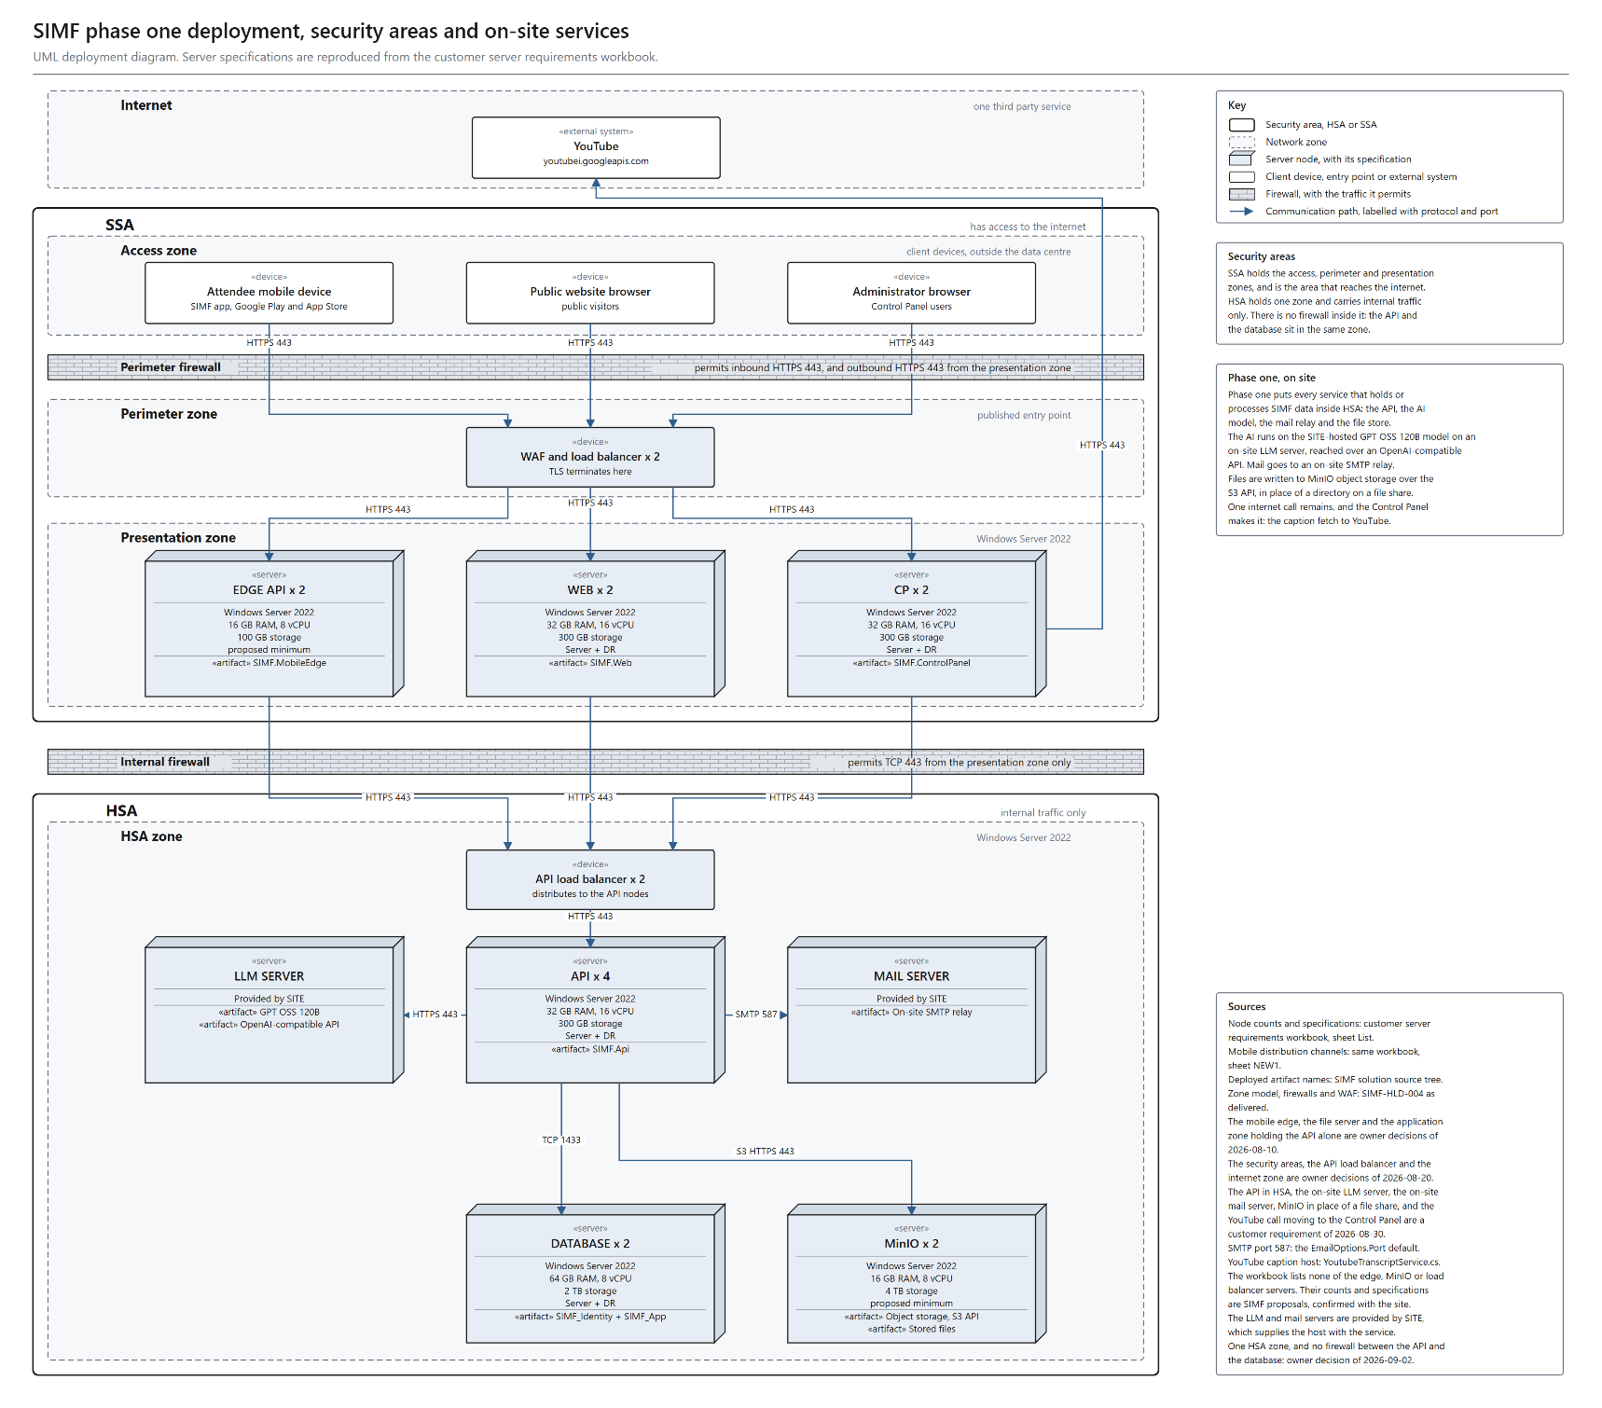
Figure 1. SIMF phase one deployment, security areas and on-site services. A UML deployment diagram: one box per hosting server, with its zone, firewall, protocol and port. Every service that holds or processes SIMF data sits in HSA and has no internet path: the API servers, the databases, the on-site LLM server running GPT OSS 120B, the on-site mail relay, and MinIO object storage. SSA holds the access, perimeter and presentation zones and is the only area with internet access; the one outbound call, the YouTube caption fetch, is made from the Control Panel.

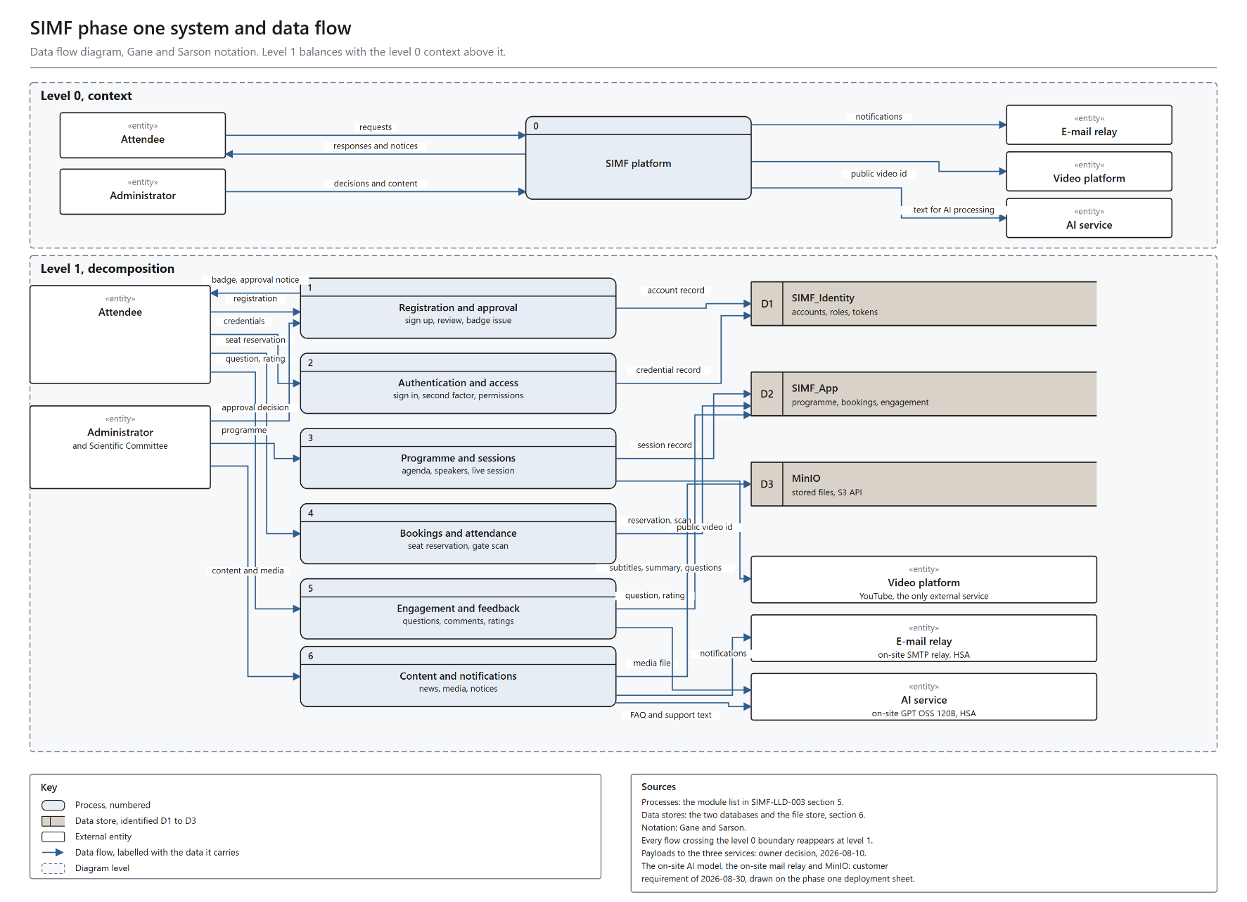
Figure 2. SIMF phase one components and their interaction. Every component, and how each one communicates with the others.

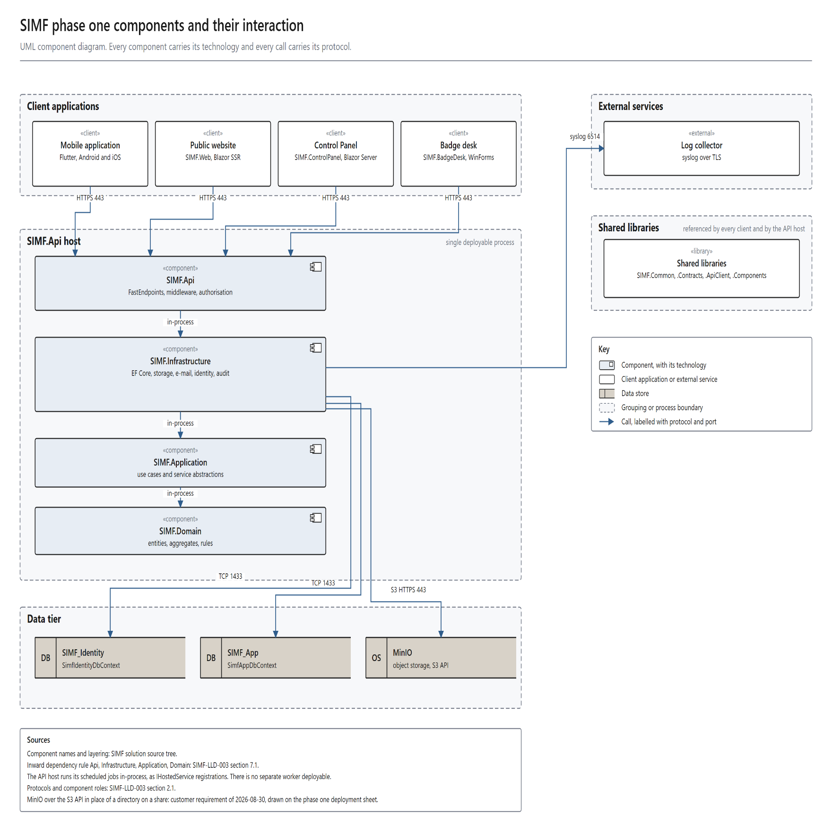
Figure 3. SIMF phase one system and data flow. A data flow diagram in Gane and Sarson notation: a level 0 context view and a level 1 decomposition that balances with it.
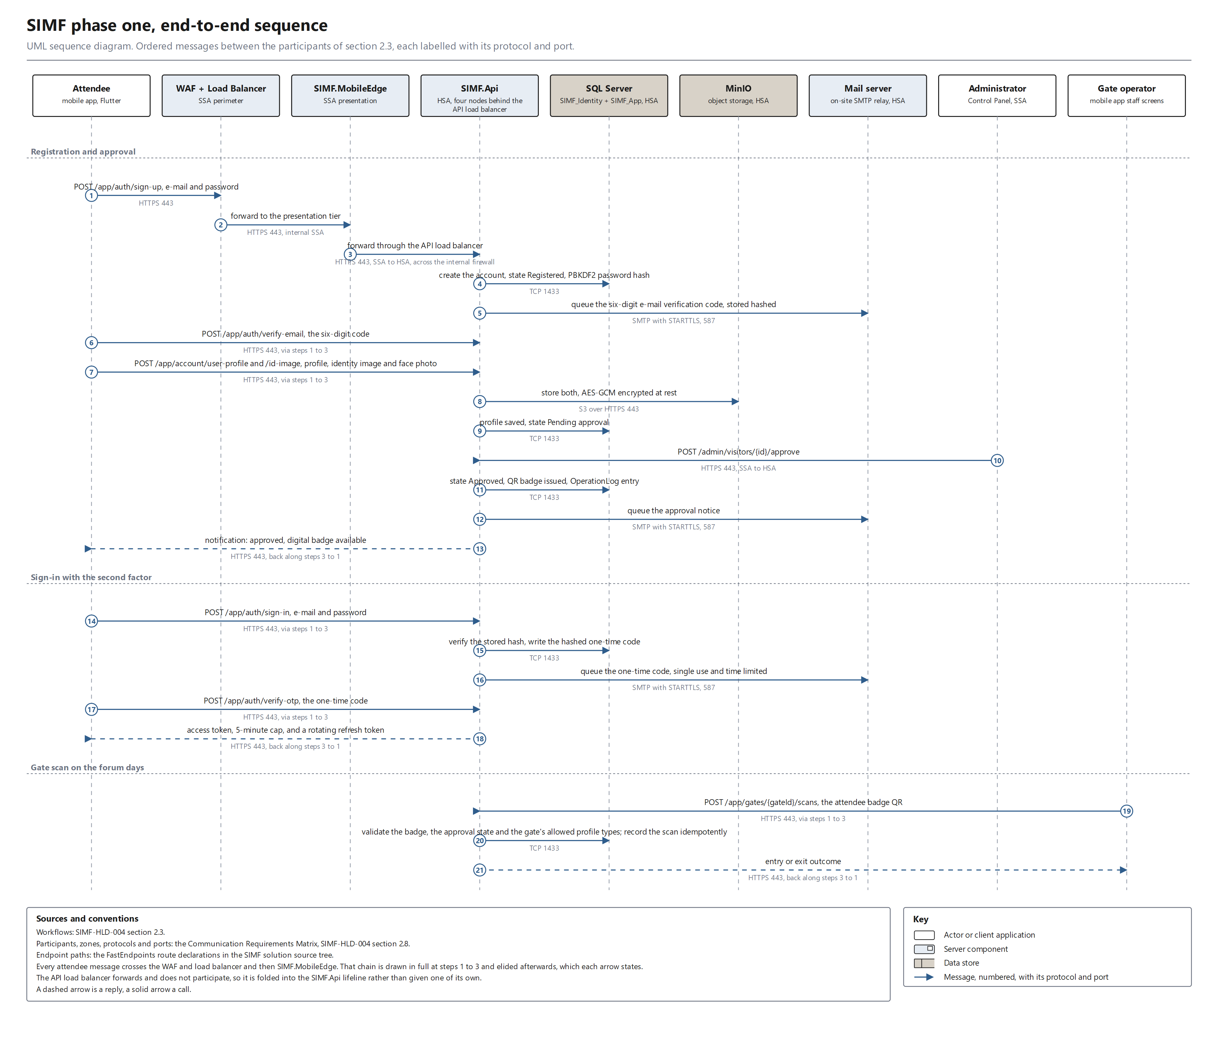Figure 4. SIMF phase one, end-to-end sequence. A UML sequence diagram: nine participants and twenty-one ordered messages, each labelled with its protocol and port, covering registration and approval, sign-in with the second factor, and the gate scan.

2.4 Integration and Interfaces
Define the internal and External Interfaces required for the system
Internal interfaces
Client to API: HTTPS / REST. Every response uses the ApiResult<T> envelope (success, data, error, meta). Errors carry a machine-readable code and bilingual (English + Arabic) messages. Standard headers: application key, device type, Accept-Language, and Authorization: Bearer <JWT> on protected calls.
API to SQL Server: TCP 1433 to SIMF_Identity and SIMF_App via EF Core. A unit of work touches one database at a time; there are no cross-database transactions or foreign keys.
API to SMTP relay: TCP 587, queued and dispatched asynchronously by a background service (MailKit).
API to Syslog / SIEM: structured Serilog events with a correlation ID.
API to MinIO: the S3 API over HTTPS 443, inside HSA. Database rows hold object keys, not blobs.
API to the LLM server: SIMF.Api is the only caller, and the load balancer carries no AI traffic. SIMF.Api calls the SITE-hosted GPT OSS 120B model over an OpenAI-compatible API on HTTPS 443, inside HSA, so no inference leaves the ministry network. Every invocation is logged. The Control Panel prompt test and the Control Panel assistant are rate-limited per administrator. Every other AI call is rate-limited per source IP address.
Control Panel / Website to API: server-to-server over HTTPS using the shared typed client. Browser sessions hold encrypted authentication cookies and never raw bearer tokens.
External interfaces (outbound only, HTTPS 443)
YouTube caption API: server-to-server subtitle import from youtubei.googleapis.com and www.youtube.com. The returned caption host is re-validated before the second request and a no-redirect HTTP client is used (SSRF hardening). This requires the same approved firewall exception; until it is granted the feature degrades gracefully to paste or upload. No credential is sent, because the resource is public. The API returns the caption tracks a published video actually carries, and for a live broadcast it serves English only, so SIMF produces no live Arabic transcription and no live translation and claims none: the published track is imported after the session, or an administrator pastes or uploads the transcript, and the on-site model then translates and summarises it for Scientific Committee approval. The end-to-end time is the minutes or hours that review takes, not a real-time figure.
Client-side external interface
YouTube live playback: the attendee device plays the configured stream URL directly. The platform stores only the URL, and this traffic does not traverse the SIMF backend. The API returns that URL in the session payload. SIMF creates, schedules and manages no broadcast; the media team does that inside YouTube.
Video storage and the video library: SIMF stores video links for the public library and holds no library video files. Session recordings uploaded by the team are held in MinIO, and are listed among the file-store categories in section 2.8. The public video library is published on the forum's YouTube channel and surfaced in SIMF as links, so it needs no additional storage, encoding or bandwidth on ministry servers and does not change the hardware specification.
No personal or confidential information is transferred outside the ministry by SIMF. There are only two external destinations, and they are both YouTube.
1. YouTube caption API, server-to-server, outbound from SIMF. Data sent: the public YouTube video id only. Purpose: retrieve the subtitle track used to draft the session minutes. Sensitivity: public. Personal data: none. Credential: none.
2. YouTube live playback, from the attendee device, not from SIMF. Data sent: the video id, plus whatever the device's own connection necessarily reveals to YouTube (network address and user agent). Purpose: play the stream. No SIMF account identifier, name, e-mail or booking data is included.
Artificial intelligence sends nothing outside the ministry. The table below is the field-level inventory of the delivered AI features and what each sends to the on-site GPT OSS 120B endpoint, which stays inside HSA. The API also retains two endpoints from the withdrawn live-translation and sign-language feature; no client calls them, and anything they carry reaches the same on-site endpoint and goes no further.
Data sent to the on-site AI endpoint, by feature.
AI feature | Fields sent to the on-site model | Personal data | Destination
Question filter | the question text only | No | On-site LLM server (GPT OSS 120B)
FAQ answer | the visitor question and the published FAQ entry | No | On-site LLM server (GPT OSS 120B)
Assistance | the visitor question and the public programme content | No | On-site LLM server (GPT OSS 120B)
Subtitle translation | the imported subtitle text and the target language | No | On-site LLM server (GPT OSS 120B)
Session minutes | session title, speaker display names, abstract and subtitle | Yes, speaker display names | On-site LLM server (GPT OSS 120B)
Control Panel assistant | the administrator question and the Control Panel content | No | On-site LLM server (GPT OSS 120B)
Hard limits enforced on every call: at most 16 input values, keys of at most 64 characters and values of at most 4000 characters.
What cannot be sent, by construction: the caller's identity travels in a separate context object that is never passed into the provider call, so account identifiers, e-mail addresses, national identity or Iqama numbers, passport numbers, badge identifiers and booking records cannot reach the AI service even by mistake.
Session minutes is the only feature that carries any personal data, and that data is the speaker display names, which are already published in the public programme.
2.5 Error Handling and Logging
Error Handling: Describe the error handling strategy, including how exceptions or failures will be handled.
Logging: Provide guidelines for logging (e.g., types of events to log, log format, tools used for log aggregation).
Error Handling: a central middleware converts domain and validation exceptions into the standard ApiResult failure envelope with the correct HTTP status code; clients render the bilingual message. Request validation runs per request shape and returns HTTP 400 with field-level bilingual detail. Invalid states log and throw, there is no silent fallback. Network faults in the typed client are mapped to failed envelopes rather than exceptions. The API refuses to boot in production when a required secret is missing.
Logging: structured logging via Serilog to console and rolling files with 31-day retention, forwarded to the central Syslog / SIEM. Every request carries a correlation ID that is propagated into the logs and both audit trails.
Events logged
• Access and authentication events (sign-in, OTP / TOTP, refresh, sign-out).
• Authorisation denials and rate-limit rejections.
• Security-relevant business events (approvals, configuration changes, gate scans) recorded in the OperationLog trail with actor, subject, source IP, user agent, outcome, error code and correlation ID.
• Row-level data changes, recorded in the RowAudit trail with operation, before / after images, affected columns, actor snapshot and correlation ID.
• System errors and unhandled exceptions.
Both audit trails are append-only at the application level, so the record cannot be rewritten by the application.
2.6 User Interface (UI) Design
Describe the UI Design
UI Overview: three front-ends share one design system and are fully bilingual (Arabic primary / RTL, English secondary / LTR). The badge desk of section 2.2 is a fourth client with its own WinForms interface.
• Mobile application (Flutter, iOS + Android), a persistent five-tab shell (Home, Sessions, Badge, Map, Profile) over the main feature areas: onboarding and splash; sign-in / sign-up / OTP / biometric; profile and registration; programme and session detail; seat picker; digital badge and QR; venue map; live broadcast; AI summary; news; media gallery; archive; booths; sponsors; media partners; questions; networking; contacts (vCard share / scan); my meetings; gate scan (staff); session moderation (moderator); notifications; accessibility; feedback and rating.
• Control Panel (Blazor Server + SIMF.Components), 14 navigation groups: Overview, People, Access Control, Programme, Scientific Committee, Exhibition, Engagement, Knowledge, Content, Public Relations, Gates, Reference Data, System and Reports. Every list page uses one standard data-grid component (filter, select-all, row checkbox, quiet per-row icon actions) with a shared CRUD framework, so all administration pages behave identically.
• Public Website (Blazor SSR), statically rendered public content (home, programme, visit information) for speed. The only interactive elements are the visitor assistant and the meeting-confirmation page, which opens from a private per-speaker link.
Wireframes and mockups: the approved visual design is applied through one design-token source of truth for colour, typography, spacing and radius, shared by the Control Panel and the website through the SIMF.Components library and mirrored in the mobile app. The screens it produces are the per-client feature areas and navigation groups listed above.
Usability considerations: Arabic-first RTL layout with automatic mirroring; a single design-token source of truth for colour, typography, spacing and radius; flexible responsive widths (the platform is used on phones and tablets); pull-to-refresh on every data screen; accessibility controls on mobile (text size, high contrast, reduced motion); the website targets WCAG AA.
2.7 Operational Model View
Defines the distribution of the System's components onto zones, together with the VLANs necessary, and the deployment of components supported by each zone, to enable the required component interactions in order to achieve the functional and non-functional requirements within the constraints of technology
Provide for Dev, Pre-prod, and Prod
SIMF uses four environments, promoted in order with no skipping: Development, Test, Staging and Production. Promotion is gated by a clean, zero-warning Release build, and a build warning or a vulnerable dependency fails the pipeline and stops promotion; the unit, integration and end-to-end suites are run on the developer's machine before a push.
Development and Test. A single node runs the application sites and one SQL Server Standard instance, with OpenAPI enabled.
Staging. Mirrors the production topology as a live rehearsal, ready two weeks before launch, and is where the load test runs.
Production. The full architecture of section 2.1: in SSA the WAF and load balancer, the website and Control Panel tiers (two nodes each, with session affinity) and the mobile edge; in HSA the API tier (four nodes) behind its load balancer, the LLM server, the mail relay, MinIO, and SQL Server 2022 Enterprise in an AlwaysOn Availability Group. Per-tier specifications are the sizing table in section 2.1.
Zone allocation
• Internet, the single outbound external service (the YouTube caption API). No SIMF server and no client device runs here.
• SSA Zone, the attendee mobile device, the public website browser and the administrator browser, the WAF and load balancer, the website and Control Panel tiers, and the mobile edge.
• HSA Zone, the API load balancer and four API hosts, the on-site LLM server, the on-site mail relay, two database hosts and MinIO object storage. The databases and the object store are reached only from the API hosts.
• Two firewalls sit at the zone boundaries, as set out in section 2.1.
Production prerequisites
• Issue a CA-signed TLS certificate for the published SIMF host names, and the client certificates the presentation tier presents to the API, with their storage, rotation and revocation assigned to the same authority. The mobile client needs no change: it carries no trust-all setting and performs ordinary certificate validation.
• Optional egress. Open outbound internet access from the Control Panel hosts to the YouTube caption hosts only, under an FQDN allow-list with every request logged. The restriction is a firewall rule rather than an application control: no forward-proxy client is configured in the application code, and no host in HSA holds an internet route at all. Refusing it costs no feature: the transcript is pasted or uploaded instead. No other host and no other internet destination requires an outbound route. The syslog feed from the application hosts to the ministry log collector stays inside the ministry network and does not cross the perimeter firewall; it is carried as its own row in the Communication Requirements Matrix in section 2.8.
• Provision MinIO object storage in the HSA zone. Provision one shared data-protection key ring folder that both website nodes and both Control Panel nodes can read and write. Enable session affinity for the website and Control Panel tiers. Neither tier starts in production without the key ring.
• Configure the host log shipper on each application host to forward the rolling log files to the ministry log collector. The application writes the files; the forwarding is a deployment step, not an application sink.
Service operations
• Four sites run as IIS sites and application pools: the API, the Control Panel, the website and the mobile edge. The deployment pipeline stops each site, copies the new files over it and starts it again, one site at a time, in that order.
• The API runs its scheduled jobs in-process. There is no separate worker server. Restarting the jobs means restarting the API application pool. One exclusive SQL Server application lock elects a single API node to run them, so the four-node tier runs each scheduled job once. The e-mail dispatcher is the exception: its queue is in-process, so every node drains its own.
• Production configuration is applied as machine-scope, SIMF-prefixed environment variables by per-site scripts, which carry the non-secret values only. Secrets are not carried in configuration at all: each API node reads its signing key and its two data keys from the key management service at start-up, and a boot guard stops the node if they cannot be read. The hosts, protocols and ports are the Communication Requirements Matrix in section 2.8.
2.8 Data Architecture View
A description for the system persistent data storage perspective, this section is optional if there is little or no persistent data or the translation between the Design Model and the Data Model is trivial.
Explain the expected traffic flow of data explaining the interaction between all elements and Zones, supported by applied security controls. Expected concurrent sessions and throughput
Database Architecture: SIMF uses two physically separate SQL Server 2022 databases. The separation is permanent and is itself a security control, it isolates and freezes the identity surface.
• SIMF_Identity, users, roles, permissions, role-permissions, refresh tokens, account and OTP codes, second-factor tokens, TOTP recovery codes, biometric device keys, password history, and per-user notifications.
• SIMF_App, all business data: profiles, programme and sessions, halls and seat reservations, gates and scans, exhibition and booths, sponsors, news, media, archive, networking, meetings, feedback and ratings, venue map, system settings, organization profile, and the audit tables.
Separation rules (permanent invariants)
• No cross-database foreign keys. A reference from a business entity to a user is a bare GUID (a logical foreign key) resolved on read with a second query, never a database constraint and never a cross-database join.
• No duplicated live data. Identity-owned data is never copied into SIMF_App. The only permitted copies are immutable audit snapshots (the actor display name and e-mail captured at write time) so the audit trail is self-contained.
• No cross-database transaction. A unit of work touches one database at a time.
The two connection strings may address the same instance or separate physical servers, which is what lets the single-server development topology and any future scaled-out production topology share one design.
Data Flow: Attendees and administrators reach SIMF over HTTPS. TLS terminates at the WAF and load balancer, which routes public pages to SIMF.Web, administrator traffic to SIMF.ControlPanel and mobile traffic to SIMF.MobileEdge. Those three call SIMF.Api over HTTPS 443 across the internal firewall, through the API load balancer. SIMF.Api authenticates and authorises the caller, runs the use case, and reads or writes the database over TCP 1433. Files are read and written through MinIO over the S3 API, e-mail is queued to the on-site SMTP relay, AI inference is performed by the on-site GPT OSS 120B endpoint, and the Control Panel makes the one outbound caption call. Every request carries a correlation ID written to the logs and both audit trails.
Data Storage
• Database: Microsoft SQL Server 2022. Production runs the Enterprise edition in an AlwaysOn Availability Group: a read-write primary and one secondary behind a listener, giving automatic failover. Development and test use a single Standard-edition instance.
• File storage: MinIO object storage for avatars, identity documents, photos, recordings, presentations and media. Four categories are encrypted at rest with application-level AES-GCM: avatars, identity documents, VIP photos and speaker presentations; the rest are protected by access control. Database rows hold object keys, not blobs. The content is classified into 25 service categories across 4 sensitivity tiers: nineteen hold uploaded bytes and six hold a validated external URL rather than bytes. Session recordings are deliberately not encrypted at rest, because a range request needs seekable content and the authenticated-encryption mode is not seekable; they are protected by access control, and no client reaches MinIO directly.
Data Integrity and Validation
• Database constraints: primary keys, foreign keys (within a single database), unique and filtered-unique indexes (for example one active reservation per seat per session) prevent duplication and enforce relational consistency.
• Transaction management: each unit of work is atomic within one database, preventing partial updates.
• Input validation: all input is validated server-side at the API boundary regardless of client validation. Validation rules, database column lengths and UI field limits are kept aligned. EF Core parameterises every query, there is no raw SQL string concatenation.
• Audit trails: the RowAudit and OperationLog trails described in section 2.5.
• Encryption: PII (national ID / Iqama / passport and mobile numbers) and identity-document images are encrypted at rest; all traffic is encrypted in transit.
• Soft delete: business entities are deactivated rather than physically removed, preserving referential history.
Expected concurrent sessions and throughput: the platform is sized for the three forum days, when the registration surge, live-session concurrency, gate-scan bursts and notification fan-out coincide. The capacity target is about 30,000 concurrent active attendees at peak (about 50,000 registered at a 0.6 peak factor) with headroom; the per-tier sizing that carries it is the table in section 2.1.
See also section 2.9 Sizing and Performance View.
Communication Requirements Matrix. Every flow on Figure 1, with its protocol and port. IP addresses, ranges and VLANs are assigned by the site network team.
Source | Destination | Protocol | Port | Direction | Purpose
Mobile app (Internet) | WAF + Load Balancer | HTTPS / TLS 1.2+ | 443 | Inbound | App traffic
Public browser (Internet) | WAF + Load Balancer | HTTPS / TLS 1.2+ | 443 | Inbound | Public website traffic
Administrator (Internet) | WAF + Load Balancer | HTTPS / TLS 1.2+ | 443 | Inbound | Control Panel traffic
WAF + Load Balancer | SIMF.MobileEdge | HTTPS | 443 | Internal, SSA | Mobile edge
WAF + Load Balancer | SIMF.Web | HTTPS | 443 | Internal, SSA | Public website rendering
WAF + Load Balancer | SIMF.ControlPanel | HTTPS | 443 | Internal, SSA | Administration (session affinity)
SIMF.MobileEdge / SIMF.Web / SIMF.ControlPanel | API load balancer | HTTPS | 443 | SSA to HSA | Server-to-server typed API client from the website and the Control Panel. The mobile edge reverse-proxies the app's request.
API load balancer | SIMF.Api | HTTPS | 443 | Internal, HSA | Distribution across the four API nodes
SIMF.Api | LLM server (GPT OSS 120B) | HTTPS | 443 | Internal, HSA | Inference over an OpenAI-compatible API
SIMF.Api | Mail server | SMTP / STARTTLS | 587 | Internal, HSA | Transactional e-mail dispatch
SIMF.Api | SQL Server (AG listener) | TCP / TDS | 1433 | Internal, HSA | Data access (SIMF_Identity + SIMF_App)
SIMF.Api | MinIO | HTTPS / S3 API | 443 | Internal, HSA | Stored files
SQL replica to SQL replica | SQL Server (AlwaysOn AG) | TCP | 5022 | Internal, HSA | Availability Group replication
SIMF.ControlPanel | YouTube caption hosts | HTTPS | 443 | Outbound | Caption import, public video id only.
All application hosts | Ministry log collector | Syslog / TLS | 6514 | Outbound | Centralised structured logging
Attendee device (Internet) | YouTube | HTTPS | 443 | Client-side | Live session playback (does not traverse SIMF)

2.9 Solution and Non-Functional Views
The views and information that provides how NFRs are Met.
Solution Security View
Application Security, authentication: e-mail + password for all audiences. Second factor: e-mailed one-time password for visitors, TOTP authenticator for administrators with single-use recovery codes. Optional biometric sign-in on mobile using an enrolled ES256 device key. SIMF operates its own ASP.NET Core Identity store.
Tokens: short-lived RS256 JWT access tokens (5-minute cap) with rotating refresh tokens and an absolute 24-hour session cap. Signing is asymmetric: the private key is held by the API inside HSA and nowhere else, and the verifiers hold only the public key, so no presentation-tier host carries signing material and compromising one cannot mint a token. Token reuse is detected, and a per-user security stamp allows a session to be revoked immediately. The signing algorithm is pinned, so alg:none and algorithm-confusion attacks are rejected.
Authorization: role-based access control with per-page / per-action permissions. Permission codes live in a single catalogue, are seeded idempotently, are baked into the JWT and are enforced on both the API and the Control Panel; Administrator holds a wildcard. Tests, run before each push, fail when any Control Panel page or admin endpoint is missing its permission gate, an ungated admin surface is treated as a security defect, not a bug.
Web Application Firewall. A WAF at the edge filters common web attacks (SQL injection, XSS, CSRF), blocks malicious requests before they reach the application, and alerts on suspicious activity, in line with the NCA standard.
Load Balancer. Distributes traffic across healthy nodes, centralises TLS termination, and health-checks each node. The website and Control Panel run with session affinity; the API is stateless and load-balanced round-robin.
Encryption in transit. All traffic is TLS 1.2 or higher, terminated at the load balancer and re-encrypted to the backend. The presentation tier and the application tier authenticate each other with mutual TLS, so reaching the API needs a client certificate and not merely a network position.
Encryption at rest. Identity-document images and the other encrypted file categories use AES-256-GCM envelope encryption: a fresh data key for each file, sealed under a key-encryption key. Personal-data columns (national ID, Iqama, passport and mobile numbers) are encrypted with AES-256-GCM under their own key. Both keys live in the central key management service, backed by a hardware security module; no key material sits in application configuration. Each key carries a version and a rotation window keeps the previous version available, so data encrypted under the old key still decrypts while it is re-wrapped under the new one.
Hashing: passwords are hashed by ASP.NET Core Identity; refresh tokens and one-time codes are stored hashed and never in clear text.
Request protection and hardening: multi-dimensional rate limiting, per IP on the authentication bucket, per e-mail on credential endpoints, a global safety cap, and per-administrator on AI calls, with audited rejections; security headers and a Content-Security-Policy; an explicit CORS origin allow-list (never a wildcard); OpenAPI / Swagger disabled by default in production and gated behind Basic authentication when enabled; upload scanning; secrets held in the key management service with production boot guards; prompt sanitisation on every text passed to the AI model, so an instruction hidden inside an imported transcript or a submitted question cannot steer it; and least-privilege database accounts, where schema migrations are applied by a deployment account holding DDL rights and the runtime account holds data rights only.
Audit: two append-only trails. OperationLog records security-relevant business events with an actor snapshot, source IP, user agent and correlation ID. RowAudit records row-level before / after images with an actor snapshot and correlation ID. Both are append-only at the database as well as in the application: the runtime account may insert into them but may not update or delete, and every entry is also shipped to the ministry log collector, so an actor with database access cannot erase their own trail.
Compliance: aligned to the NCA Secure Application Development Standard, with ECC and OWASP baselines, and to the Saudi Personal Data Protection Law (PDPL). The PDPL obligations are met as follows. Lawful basis and consent: a registrant enters their own data and accepts the terms as the final step before submitting, and no registration is accepted without that acceptance. Purpose limitation: the data is collected to admit a person to a physical event, and the platform puts it to no other purpose; it is not profiled, not sold and not shared outside the ministry estate. Minimisation: the fields collected are those an entry badge and a security approval need; the job title is optional, and the facial photograph is required for a male audience registrant and offered to a female registrant without being required of her. Right of access and correction: the account holder reads and edits their own profile in the application at any time. Right of erasure: the holder deletes their own account from the application, which removes their personal data, destroys the stored identity document and photographs, revokes every session and device key, and disables the account. The action is irreversible, and it is available to a pending or rejected account as well as an approved one, because a person refused entry is exactly the person most entitled to be erased. The photograph alone can also be deleted without deleting the account. Residency: every store holding personal data sits inside HSA and no personal data leaves the estate. Retention: personal data is held for the edition it was collected for and is disposed of on the schedule the owner sets with the ministry data-protection function; the disposal itself uses the same erasure path described above.
Data classification: the system holds no classified or militarily sensitive information. The data is unclassified but includes personal data of visitors, speakers and exhibitors, which is processed under the PDPL and the National Cybersecurity Authority controls. No data is sent to a cloud artificial-intelligence service. The on-site model receives session content to summarise and question text to filter. The call carries no account identifier. The personal data includes a facial photograph and a scanned identity document, supplied by the registrant at the identity-image and photo-verification steps of registration and consented to when the terms are accepted before the registration is submitted. Three separate mechanisms touch a face, and they are deliberately kept apart. First, a presence check on the uploaded photograph: the server confirms the image contains a human face, so that a badge is not issued against a blank, a logo or an unusable picture. It runs offline on the application server inside HSA, against a detection model shipped with the application, and neither the image nor any value derived from it leaves the platform. Second, a guided liveness capture in the mobile application, which asks the user to smile and to turn their head; it runs entirely on the device and the only thing it produces is the photograph itself. Third, the optional biometric sign-in, where the fingerprint or face is checked by the operating system to unlock a private key held in the device security element; that biometric never reaches SIMF. The platform performs no facial recognition. It computes no face embedding, stores no biometric template, and matches no face against any other face or against any external register. The photograph is stored as an ordinary encrypted file under the same AES-GCM envelope as every other confidential file, and the account holder can delete it from the application, which removes the stored file.
Pre-launch deployment activities. Four activities are scheduled between acceptance of this design and go-live. Each can only be carried out on the production estate, which is why none is closed at design time. Operations rotate the secrets present in development configuration history, closed when production values are issued from the key management service. The owner issues a CA-signed certificate, closed when it is installed at the load balancer. Operations enables the identity-lifecycle controls, password expiry and history and dormant-account disable, closed when the maximum password age is set above zero. The owner commissions an independent penetration test, closed on acceptance of its report.
Passwords and sign-in. A password is stored only as a one-way PBKDF2-HMAC-SHA256 hash with a per-user salt and a work factor, the ASP.NET Core Identity default. The plaintext is never stored and cannot be recovered from the hash.
Subsequent sign-in: the user submits the password; the API applies the same derivation to the submitted value and compares the result with the stored hash. On success a second factor is required, an e-mailed one-time code for visitors or a TOTP authenticator code for administrators. Only then are tokens issued.
No password is e-mailed to a self-registered attendee. The e-mail carries a six-digit verification code, not a password. The code is itself stored hashed, is compared in constant time, expires, and is consumed on first use.
Administrator accounts created by invitation receive a single-use six-digit code, valid for seven days. The code is stored hashed and is consumed on first use. The invitee opens the Control Panel, enters the code and sets their own password, so no shared or temporary password is ever transmitted.
Forced change is implemented and enforced. When an account carries the PasswordChangeRequired flag, every token-issuing path is blocked (initial password step, second-factor verify, recovery-code verify, one-time-code verify and refresh) until the user sets a new password through the reset flow. Sign-in raises the flag automatically once a password passes the maximum password age, a setting that ships at zero, which disables the check, and is set above zero as one of the pre-launch deployment activities listed at the end of this section.
Mobile enrolment and the device key. Enrolment: the attendee signs up with e-mail and password, verifies the e-mail with a six-digit code, completes the profile, and waits for administrator approval. Ordinary sign-in is password plus an e-mailed one-time code, which is hashed at rest, compared in constant time, time-limited and consumed on first use.
Device-key enrolment: after a successful sign-in, and only after the user passes an operating-system biometric or device-credential prompt, the app generates an ECDSA P-256 key pair on the device. Only the public key is sent to the server, as a SubjectPublicKeyInfo DER structure; it is stored against the account with a device identifier, and that record is the device binding. The server accepts ES256 only and rejects any key it cannot parse as ECDSA P-256.
Private-key storage, stated precisely: the private key is generated inside the device hardware security element and never exists outside it: the Android Keystore, using StrongBox where the device provides it, and the iOS Secure Enclave. User authentication is required at the key itself, so a signature cannot be produced without the biometric or device credential. The key is not exportable, is never transmitted, and cannot be extracted from a rooted or jailbroken device.
Authentication: the server issues a random challenge with a five-minute lifetime. The app signs it with the private key and returns the signature. The server verifies the signature against the registered public key, then clears the challenge with a single atomic conditional update that succeeds only if the challenge is still the one that was issued, so a replayed signature is rejected.
Revocation: the user can disable biometric sign-in in the app and an administrator can revoke the device; the key record is stamped as revoked and every subsequent challenge and verification for it is refused.
Lost or replaced device: the old device key is revoked, which immediately makes it useless. The user signs in on the new device with password plus e-mailed one-time code, then enrols a new key pair. No key material is exported, backed up or transferred between devices.
Solution Availability View
Database tier. High availability comes from the SQL Server 2022 Enterprise AlwaysOn Availability Group.
• A read-write primary and one readable secondary run with synchronous commit and automatic failover. Both databases run in the group; the listener routes write to the primary and read-only queries to a secondary. The cluster quorum witness is confirmed with the site network team.
• Backup and restore: the backup set is four artefacts, and a restore is only valid if all four are taken from the same point. They are the SIMF_App database, the SIMF_Identity database, the contents of the object store, and an escrowed copy of the encryption keys held in the key management service. The keys are part of the set because the database columns and the stored files are encrypted: a restore without them returns unreadable data. Backups are scheduled and are restored into a non-production environment on a defined cycle, because a backup that has never been restored is not evidence of recovery. Migration order is enforced (App database before Identity) so deployments stay forward-compatible. The underlying infrastructure redundancy, the storage snapshots, the off-host retention and the secondary site, is provided by SITE as part of the private cloud. The recovery point and recovery time objectives are set with SITE during deployment planning.
Application tier. Adding API nodes adds capacity with no redesign, because the API holds no session state.
Operational availability: /health is a readiness probe used by the load balancer and monitors to pull unhealthy instances out of rotation. It reports the in-process scheduled jobs from their heartbeat registry: healthy when every job is up, degraded when one has missed its schedule, unhealthy when one has faulted. Rollback restores the last known-good binaries, re-checks health and re-runs the smoke test. The three forum days are the critical availability window, and an outage during them cannot be rescheduled. Disaster recovery: the hardware is licensed Server plus DR. The recovery site, the recovery time objective, the recovery point objective and the method of replicating the databases and the object store to it are confirmed with the site, and are carried as an open item.
Solution Management and Monitoring View
Syslog / SIEM integration: the API, the Control Panel and the website write structured Serilog events to rolling files on each host. The events cover authentication events, authorisation denials, access logs, business actions, rate-limit rejections and system errors. Every event carries a correlation ID for end-to-end tracing. Section 2.7 records how the files reach the ministry log collector. Fifteen Sigma 2.x detection rules are supplied with the system.
Audit trails: the OperationLog and RowAudit database trails provide a durable, queryable record of who did what, when, from where and with what outcome, surfaced to administrators through the Control Panel.
Health and performance monitoring: the /health endpoint reports readiness. The monitoring toolchain collects system health metrics (CPU, memory, response time, throughput) and database query performance, and alerts on thresholds so degradation is detected early.
Usage monitoring: the Control Panel presents event statistics (registrations and approvals, session attendance, seat bookings, gate scans, engagement and ratings) giving insight into peak usage and supporting operational and strategic decision-making during the forum.
Background-services monitor: the scheduled background jobs report a heartbeat to an in-process registry. The Control Panel "Background services" page reads the registry of the API node that answers the request and lists that node's workers with their state (up, starting, stale or faulted), last run, run and failure counts and last error, refreshing on a short interval; the same registry feeds a "workers" check on /health, so a stalled or faulted job pulls the readiness probe to degraded. Worker logs are written to their own folder, separate from the API request logs, and are viewable through the Control Panel log viewer.
The monitoring and alerting toolchain is selected during deployment planning.
Solution Sizing and Performance View
System scaling and load handling: the platform is built scale-ready so that scaling out is a deployment change rather than a redesign.
• Web tier: SIMF.Web scales horizontally behind the load balancer by adding nodes, with session affinity enabled.
• Backend tier: SIMF.Api is stateless, so nodes are added to absorb registration surges, gate-scan bursts and live-session load. The baseline is four API nodes at 16 vCPU / 32 GB each (see the section 2.1 sizing table).
• Database tier: the database nodes scale vertically (more CPU, RAM and faster storage). Development and test use a single Standard node. Staging runs the production Enterprise edition in an Availability Group, so query plans, read routing and failover are exercised on the production configuration before any release reaches it.
Performance considerations: response time and throughput are addressed structurally rather than by tuning alone.
• Queries are indexed and projected; list endpoints page at source rather than filtering in memory. Each list resource declares its own default page size and its own maximum, and a request for more rows than the maximum is clamped to it.
• The API is stateless, so no session store sits on the request path.
• E-mail is queued and dispatched asynchronously, so SMTP latency never blocks a request.
• Live notifications and Q&A use client polling on a bounded interval of 30 seconds; no server-push transport ships in this build. At the 30,000-attendee peak that is about 1,000 requests a second spread across four API nodes. Each poll is conditional and answered from the response cache, returning 304 with no database work when nothing has changed, so the poll traffic sits inside the rate-limit budget rather than competing with it.
Caching strategy: reference and configuration data (categories, settings, site content) is cached at the application layer to reduce database load, and static web assets are served with cache headers. A distributed cache can be added behind the existing abstractions if load testing calls for it. A caching layer can be placed in front of MinIO on the same terms, so that a burst of viewers for a session recording consumes cache bandwidth rather than API capacity.
Load testing and scaling: peak-shaped load tests run in staging before the event, covering registration surge, live-session concurrency, scan bursts, notification fan-out and mixed steady state. No tier scales itself. Capacity is added by deploying another node.
Load-test pass/fail thresholds (p95 response time, error rate, concurrent sessions and throughput) are set during staging load testing.
3. Risks and Mitigation Strategies
Identify any potential risks that could impact the success of the system (e.g., technology risk, security risk, scalability).
Describe strategies to mitigate these risks.
Security Risk
Potential Impact: unauthorised access to attendee personal data (national ID / Iqama / passport) or to administrative functions; a data breach through an unprotected endpoint; compromise of signing keys or credentials.
Mitigation Strategies: per-page / per-action permission gating enforced on both the API and the Control Panel, with tests, run before each push, that fail when a surface is ungated. PII and identity documents encrypted at rest; TLS 1.2+ in transit. A WAF at the SSA-zone edge. Multi-dimensional rate limiting with audited rejections. Secrets held in the key management service, backed by a hardware security module, with production boot guards. Append-only audit trails. Alignment to the NCA Secure Application Development Standard, with an independent penetration test before handover.
The pre-launch deployment activities listed in section 2.9 are scheduled before go-live, each with an owner and a closing condition.
Availability Risk (event day)
Potential Impact: the forum runs on fixed dates, so an outage during the three forum days cannot be recovered or rescheduled. Registration surge, live-session concurrency, gate-scan bursts and notification fan-out coincide in that window.
Mitigation Strategies: the event-day architecture, a WAF and load balancer, a stateless multi-node API tier, and the Enterprise AlwaysOn Availability Group for high availability. A readiness probe at /health pulls unhealthy nodes from rotation. Last known-good binaries are retained for rollback, and peak-shaped load testing runs in staging before the event.
Scalability and Performance Risk
Potential Impact: performance degradation at peak. Registration surge, live-session concurrency, scan bursts and notification fan-out coincide, and resource exhaustion could cause slow responses or downtime.
Mitigation Strategies: the scaling, query, e-mail and caching measures set out in the Solution Sizing and Performance View above, and the staging load test that runs before the event.
Integration Risk
Potential Impact: the caption import depends on outbound internet access. If egress is not approved, subtitle import does not operate and the administrator pastes or uploads the transcript instead. The AI features are not affected, because inference runs on the on-site model inside HSA and needs no egress at all. A misconfigured egress rule would widen the attack surface, which is why the only internet destination permitted is the YouTube caption host and the only source permitted to reach it is the Control Panel. The application hosts hold one further outbound route, syslog over TLS on TCP 6514 to the ministry log collector.
Mitigation Strategies: the AI runs on the SITE-hosted GPT OSS 120B model on an on-site LLM server inside HSA, so there is no external AI provider, no provider credential in use, no provider outage exposure and no inference egress. The provider sits behind one abstraction, so the endpoint is a configuration value.
The caption import requires the outbound egress listed in the production prerequisites (section 2.7). The AI features require no egress at all.
Schedule and Change-Freeze Risk
Potential Impact: the event date is immovable and the platform is frozen before publication, so a defect found after the freeze is expensive and disruptive to correct.
Mitigation Strategies: four-stage promotion (Development, then Test, then Staging, then Production) with no skipping. Trunk-based development with pull-request review and a zero-warnings Release build. A build warning or a vulnerable dependency fails the pipeline and stops promotion. The unit, integration and end-to-end suites sit in the pipeline behind a switch that is off by owner decision, so they are run on the developer's machine before a push and a failing test does not stop the build. Every page carries an authored end-to-end regression scenario set, which is run as the regression record before a release. Dependency vulnerability scanning and SBOM generation run in the pipeline.
Data Integrity and Compliance Risk
Potential Impact: loss or corruption of attendee, booking or scan data; inability to evidence who changed what for a compliance audit.
Mitigation Strategies: the identity and business databases are physically separated with no cross-database foreign keys, transactions or duplicated live data, which isolates and freezes the identity surface. Atomic single-database units of work. Database-enforced keys and filtered unique indexes (for example, one active reservation per seat per session). Soft delete preserves history, so a business row is never orphaned by a deletion. A scheduled reconciliation resolves each cross-database reference and reports any business row whose identity owner is missing, so a logical foreign key cannot rot unnoticed. Every row change is captured in RowAudit with before / after images, and security-relevant events in OperationLog; both trails are append-only and carry actor and correlation ID. The persistence and enum contract surface is under a change freeze with controlled additive lifts.

Approvals

Technology Expert, Role 1  Signature: _______________________________ | Date__________
Technology Head  Signature: _____________________________ | Date__________
Technology Director  Signature: _____________________________ | Date__________

Annex B. Requirement traceability
The Business Requirements Document delivered with this design carries 132 numbered requirements: 14 business rules, 90 functional requirements, 12 non-functional requirements and 16 operational requirements. This annex maps every one of those identifiers to the section that designs it, so a reviewer can follow any requirement from the business document into the design and back. Identifiers are listed individually rather than as ranges, so each one can be searched for. Four requirements are marked withdrawn, FR-706, FR-707, FR-807 and BR-08: they were removed from scope in the Business Requirements Document and nothing in this design implements them.
Functional requirements.
Service | Requirement identifiers | Designed in
F-01 Accounts and Authentication | FR-101, FR-102, FR-103, FR-104, FR-105, FR-106, FR-107, FR-108 | 2.9 Solution Security View
F-02 Registration and Approval | FR-201, FR-202, FR-203, FR-204, FR-205, FR-206, FR-207, FR-208, FR-209, FR-210, FR-211, FR-212, FR-213, FR-214, FR-215, FR-216, FR-217 | 2.3 System Workflow
F-03 Badge and Access Control | FR-301, FR-302, FR-303, FR-304, FR-305 | 2.3 System Workflow
F-04 Forum Programme | FR-401, FR-402, FR-403, FR-404, FR-405, FR-406, FR-407, FR-408, FR-409 | 2.2 Modules
F-05 Bookings and Attendance | FR-501, FR-502, FR-503, FR-504, FR-505, FR-506 | 2.3 System Workflow
F-06 Exhibition | FR-601, FR-602, FR-603, FR-604, FR-605 | 2.2 Modules
F-07 Engagement and Live Sessions | FR-701, FR-702, FR-703, FR-704, FR-705, FR-706 (withdrawn), FR-707 (withdrawn), FR-708, FR-709, FR-710 | 2.4 Integration and Interfaces
F-08 Networking and Cognitive AI | FR-801, FR-802, FR-803, FR-804, FR-805, FR-806, FR-807 (withdrawn), FR-808 | 2.2 Modules
F-09 Notifications | FR-901, FR-902, FR-903, FR-904 | 2.2 Modules
F-10 Media, News and Archive | FR-1001, FR-1002, FR-1003, FR-1004, FR-1005, FR-1006 | 2.2 Modules
F-11 Statistics | FR-1101, FR-1102, FR-1103, FR-1104 | 2.2 Modules
F-12 Control Panel and Configuration | FR-1201, FR-1202, FR-1203, FR-1204, FR-1205, FR-1206, FR-1207, FR-1208 | 2.6 User Interface (UI) Design

Business rules, non-functional and operational requirements.
Identifier | Kind | Designed in
BR-01 | Business rule | 2.9 Solution Security View
BR-02 | Business rule | 2.9 Solution Security View
BR-03 | Business rule | 2.3 System Workflow
BR-04 | Business rule | 2.3 System Workflow
BR-05 | Business rule | 2.3 System Workflow
BR-06 | Business rule | 2.3 System Workflow
BR-07 | Business rule | 2.2 Modules
BR-08 | Business rule | Withdrawn, not designed
BR-09 | Business rule | 2.2 Modules
BR-10 | Business rule | 2.4 Integration and Interfaces
BR-11 | Business rule | 2.2 Modules
BR-12 | Business rule | 2.5 Error Handling and Logging
BR-13 | Business rule | 2.9 Solution Security View
BR-14 | Business rule | 2.2 Modules
NFR-01 | Non-functional | 2.9 Solution Security View
NFR-02 | Non-functional | 2.9 Solution Security View
NFR-03 | Non-functional | 2.5 Error Handling and Logging
NFR-04 | Non-functional | 2.9 Solution Sizing and Performance View
NFR-05 | Non-functional | 2.9 Solution Availability View
NFR-06 | Non-functional | 2.6 User Interface (UI) Design
NFR-07 | Non-functional | 2.6 User Interface (UI) Design
NFR-08 | Non-functional | 2.6 User Interface (UI) Design
NFR-09 | Non-functional | 2.2 Modules
NFR-10 | Non-functional | 2.1 Architecture Overview
NFR-11 | Non-functional | 2.8 Data Architecture View
NFR-12 | Non-functional | 2.1 Architecture Overview
OP-01 | Operational | 2.1 Architecture Overview
OP-02 | Operational | 2.8 Data Architecture View
OP-03 | Operational | 2.9 Solution Availability View
OP-04 | Operational | 2.9 Solution Availability View
OP-05 | Operational | 2.9 Solution Management and Monitoring View
OP-06 | Operational | 2.9 Solution Sizing and Performance View
OP-07 | Operational | 2.2 Modules
OP-08 | Operational | 2.2 Modules
OP-09 | Operational | 2.4 Integration and Interfaces
OP-10 | Operational | 2.9 Solution Availability View
OP-11 | Operational | 2.4 Integration and Interfaces
OP-12 | Operational | 2.4 Integration and Interfaces
OP-13 | Operational | 2.8 Data Architecture View
OP-14 | Operational | 2.4 Integration and Interfaces
OP-15 | Operational | 2.1 Architecture Overview
OP-16 | Operational | 2.4 Integration and Interfaces

