
Version | Date
2.1 | 8 September 2026
Business Requirements Document
Item | Detail
Project Name | Saudi International Maritime Forum (SIMF 2026)
Identifier | SIMF-BRD-001
Edition | English
Change History
Version | Date | Author | Reason for change
1.0 | 21 July 2026 | Apexium (Business Analysis Team) | First issue.
1.1 | 12 August 2026 | Apexium (Business Analysis Team) | Owner clarifications answered on the audience, the data classification, the administrators, the external integrations, the website scope, the video library and the AI capabilities.
1.2 | 30 August 2026 | Apexium (Business Analysis Team) | Phase one hosting requirements added. The AI, the mail relay and the file store move on site into HSA with the API and the databases. The only remaining internet call is made from the Control Panel in SSA.
1.3 | 30 August 2026 | Apexium (Business Analysis Team) | Technology-team review answered. The AI model is named as GPT OSS 120B, hosted by SITE on site. The registration photograph is corrected: FR-207 called it an optional field, while the system requires a face photograph from a male audience registrant, captures it through a guided live capture and verifies on the server that it contains a human face. The job title moves to FR-202 and the identity image is stated as required in FR-205. No identifier changes and the requirement count is unchanged.
2.0 | 4 September 2026 | Apexium (Business Analysis Team) | Full rewrite of the document for the version 2.0 delivery, issued in English with the High Level Design and the Solution Design Document. The requirement identifiers and their meaning are unchanged, and so are the counts: 132 requirements in total, of which BR-08, FR-706, FR-707 and FR-807 are withdrawn. The version 1.0 date is corrected from 19 July 2026 to 21 July 2026, so that this table and the Revision History agree.
2.1 | 8 September 2026 | Apexium (Business Analysis Team) | Corrected the video wording so the document matches the agreed scope. The platform streams nothing: the session director produces each session and publishes it to the forum's YouTube channel, and the platform holds only the resulting address and embeds the player. FR-701 is reworded accordingly, BR-10, FR-702 and FR-807 are withdrawn, and the statistics list in FR-1102 is corrected.
Approvers
Approver Name | Job Role | Date | Signature
[To be completed by the owner] | Document Owner Representative (Ministry of Defense / Royal Saudi Naval Forces) | [To be completed by the owner] | [To be completed by the owner]
[To be completed by the owner] | Document Owner Representative 2 (General Directorate of Information Technology) | [To be completed by the owner] | [To be completed by the owner]
Revision History
Version | Date | Author | Comments
1.0 | 21 July 2026 | Apexium | First issue of the Business Requirements Document.
1.1 | 12 August 2026 | Apexium | Clarifications update. No change to the agreed scope.
1.2 | 30 August 2026 | Apexium | Phase one hosting requirements. No change to the agreed scope.
1.3 | 30 August 2026 | Apexium | Technology-team review answered. FR-807 is withdrawn and FR-701 is corrected to post-session translation. The rest of the agreed scope is unchanged.
2.0 | 4 September 2026 | Apexium | Full rewrite for the version 2.0 delivery, issued in English. The agreed scope, the requirement identifiers and their meaning are unchanged. The version 1.0 date is now consistent at 21 July 2026 in this table and in the Change History, which previously read 19 July 2026.
2.1 | 8 September 2026 | Apexium | Corrected the video wording so the document matches the agreed scope. The platform streams nothing: the session director produces each session and publishes it to the forum's YouTube channel, and the platform holds only the resulting address and embeds the player. FR-701 is reworded accordingly, BR-10, FR-702 and FR-807 are withdrawn, and the statistics list in FR-1102 is corrected.
Document Reviewers
Date | Reviewer Name | Comments
[To be completed by the owner] | [To be completed by the owner] | Review of the business scope and approval of the requirements.
Related Documents
The delivery consists of the three documents below, each at version 2.1 and each issued in English.
Identifier | Title | Version
SIMF-BRD-001 | Business Requirements Document, this document | 2.1
SIMF-HLD-005 | High Level Design | 2.1
SIMF-LLD-004 | Solution Design Document | 2.1
Table of Contents
1. Introduction 3
1.1 Document Purpose 3
1.2 Roles and Responsibilities 3
2. Overview 4
2.1 Problem Description 4
2.2 Current Situation (As-Is) 4
2.3 Proposed Solution (To-Be) 4
2.3.1 Objectives and Key Benefits 4
2.3.2 Scope 5
2.3.3 Out of Scope 5
3. Business Process 6
4. System Roles 9
5. System Requirements 10
5.1 Business Rules 10
5.2 User Requirements 10
5.3 Operational Requirements 14
5.4 Non-Functional Requirements 14
5.5 Constraints 15
5.6 Assumptions 15
5.7 Open Items 15
6. Attachments 16

Glossary and Abbreviations
The terms and abbreviations used in this document are listed below.
# | Term / Abbreviation | Description
1 | SIMF | Saudi International Maritime Forum; the platform that runs the 2026 forum and its exhibition.
2 | RSNF | Royal Saudi Naval Forces; the beneficiary of the system.
3 | MoD | Ministry of Defense.
4 | BRD | Business Requirements Document, this document.
5 | NCA | National Cybersecurity Authority, and its standards ECC-1:2018 and CSCC-1:2019.
6 | Control Panel | The internal administration interface used to run the forum.
7 | App | The attendee mobile application, on Android and iOS.
8 | Website | The public website of the forum.
9 | MFA / TOTP | Multi-factor authentication and time-based one-time password; the second authentication factor required for internal-user sign-in.
10 | QR | The quick-response code printed on the entry badge.
11 | API | The application programming interface exposed to the client applications.
12 | Badge | The entry pass, carrying a unique reference number, a QR code and a category colour.
13 | VIP | A visitor in the very-important-persons category.
14 | Moderator | A role that manages the questions for the sessions assigned to them, through the app.
15 | PR | Public Relations team; reviews one-to-one meeting requests.
16 | GPS | Global Positioning System; the basis of the deferred in-venue presence and movement capability.
17 | OWASP | Open Worldwide Application Security Project; its Top 10 and ASVS are referenced security baselines.
18 | DDD | Domain-Driven Design; the layering approach followed in the engineering standards.
19 | AI | Artificial intelligence; used for the assistant, the session summaries, the post-session translation and the recommendations.
20 | SMS | Short message service; one of the channels the notification abstraction supports, enabled only when a provider and its egress are approved.
21 | RTL / LTR | Right-to-left and left-to-right text direction, Arabic and English.
22 | GPT OSS 120B | The language model behind the AI capabilities, hosted by SITE on an on-site LLM server in HSA.

1. Introduction

1.1 Document Purpose
This document records the business requirements for the Saudi International Maritime Forum (SIMF 2026) system. The system is one integrated platform that runs the forum and its exhibition. It covers registration and security vetting, badge issue and access control, the scientific programme, engagement, networking between attendees, media and news, and statistics.
The document states the objectives and the scope of the solution and records the requirements agreed with the owner. The analysis, design, development, testing and quality-assurance teams work from this single approved reference, and every requirement carries a stable identifier so it can be traced into design, code and tests. It is written at the business level, above the detailed software requirements and above the per-feature design work.
It is one of three documents delivered together. This is the Business Requirements Document, SIMF-BRD-001, English edition, version 2.1. The design detail sits in the High Level Design, SIMF-HLD-005, version 2.1, and in the Solution Design Document, SIMF-LLD-004, version 2.1.

1.2 Roles and Responsibilities
The table lists the parties involved in producing this document and the solution, and the responsibilities each one carries.
Role | Responsibilities
Product Owner / Owner (Ministry of Defense, Royal Saudi Naval Forces) | Approves the business scope, the requirements and their priorities. Supplies the legal text (Terms and Conditions and Policies) and the owner content. Takes the open decisions: the statistics list and the media fields (OI-1), and the external providers (OI-2).
General Directorate of Information Technology | Reviews the technical requirements and verifies compliance with the NCA standards. Approves the runtime environment, the architecture and the integration.
Apexium (vendor and development team) | Analyses and documents the requirements, and builds, tests and delivers the solution. Publishes the mobile applications to the stores. Hands over the source code and the accompanying documentation, and supports and maintains the software after handover.
Smart Time (event management) | Manages and runs the forum's events officially on behalf of the Ministry of Defense and the Royal Saudi Naval Forces, and operates the platform in service of each edition. Support and maintenance of the software stay with Apexium.
Organising teams (Security, PR, Technical, Scientific, Logistics, Marketing) | Run the forum from the Control Panel within the permissions granted to each team. Review registrations, exhibitors, content and sessions.
Administrator | Manages roles, permissions, dynamic categories, settings and content. Sets the final user type and permissions for approved registrations. Administrators are drawn from Royal Saudi Naval Forces personnel and from the organising company, and each administrator holds a named role whose permissions are restricted per page and per action.

2. Overview

2.1 Problem Description
The Saudi International Maritime Forum is a recurring event, and this is its fourth edition. Every edition so far has had its systems, its website and its app rebuilt from scratch. That approach is costly and slow. It leaves each edition's data in a different place, it produces no reusable platform and no consolidated record across editions, and it forces the cybersecurity controls, the technology choices and any intelligent features to be worked out again every time.
The requirements in this document come from the material supplied by the owner and from a series of interviews with the owner's representatives.

2.2 Current Situation (As-Is)
Each edition of the forum runs on bespoke systems, a bespoke website and a bespoke app, built for that edition alone. Nothing carries over. The event identity, the content, the categories and the dates are fixed per edition, each edition's data is stored separately, and a new build with its own security posture and its own technology is commissioned every time the forum is held.
There is no single configurable platform, no centralised store spanning the editions, and no consistent reusable base for cybersecurity compliance or for AI-assisted features.

2.3 Proposed Solution (To-Be)
The solution is one dynamic, reusable platform: a single backend and a unified API serving the administrative Control Panel, the public website and the attendee mobile app. It runs any edition of the forum without code changes.
On that dynamic base the platform covers the full event lifecycle: registration, security vetting and approval, badge issue and access control, the programme, sessions and bookings, sessions and engagement, networking between attendees, the exhibition and sponsors, media, news and archive, notifications, and statistics. It runs on-premises as a single tenant.
The forum is open to the general public and is international in attendance. It is not restricted to Ministry of Defense personnel and it is not restricted to Saudi nationals. Any member of the public may register, subject to administrator approval.

2.3.1 Objectives and Key Benefits
- Deliver one dynamic, configurable platform that serves the current edition and every future edition of the forum without a rebuild. Everything that changes between editions is set from the Control Panel: name, colours, logos, content, categories, start and end dates, and archiving.
- Hold the data of all editions in a single central location, with each edition's archive controlled from the Control Panel.
- Build on a modern technology stack and embed AI and emerging technologies: the cognitive assistant, AI session summaries, AI filtering of attendee questions, post-session subtitle translation, and smart recommendations.
- Comply with the National Cybersecurity Authority (NCA) cybersecurity standards, with full Arabic and English support.
- Secure registration, security vetting, attendance approval, badge issue and access control.
- Manage the scientific programme, sessions and bookings, and measure attendance inside the halls.
- Enable session viewing and audience engagement through questions, with accessibility provision and review controls.
- Strengthen networking between attendees, and recommend sessions and one-to-one meetings.
- Provide per-day and overall statistics and dashboards for the event.

2.3.2 Scope
- The dynamic configuration layer, covering the event name, colours, logos and visual identity, categories, start and end dates, content and archiving, together with the centralised multi-edition data store.
- The AI capabilities, all built and delivered on the on-site GPT OSS 120B model hosted by SITE: subtitle import from the published session video, with manual paste or upload as the fallback; AI session summaries, which become the session minutes once the scientific committee reviews and approves them; AI filtering of attendee questions before they reach the speaker; the cognitive assistant in the app and on the website; subtitle translation after the session; and smart recommendations.
- The backend and the unified API, the Control Panel, the public website and the mobile app. The public website carries informational content only: it has no user registration and it stores no personal data. Registration and all visitor data live in the mobile app and the Control Panel.
- Accounts and authentication, registration and approval, and role and permission management.
- Badges and access control, hall-arrival check-in and attendance measurement.
- The scientific programme, sessions, speakers, bookings and the seat map.
- The exhibition, booths, sponsors and the venue map.
- Sessions, questions and session summaries, networking, the cognitive assistant and the FAQ.
- Multi-channel notifications, media, news and archive, statistics, and Control Panel settings.
- The video library as links only. The platform holds no library video files. The public library is published on the forum's YouTube channel and is surfaced in the platform as links, so it needs no additional storage, encoding or bandwidth on the owner's servers.

2.3.3 Out of Scope
- Payment, ticketing, invoicing and finance. The platform has no payment, ticketing, invoicing or finance capability of any kind, and none is planned. Attendance at the forum is free.
- Identity federation. There is no single sign-on, no ministry directory integration and no federation with any external identity provider. The users are members of the public rather than ministry personnel, so there is nothing to federate. The platform runs its own identity store.
- Procuring the WhatsApp provider. The platform reaches it through an abstraction and the provider is chosen later. The AI model (GPT OSS 120B, hosted by SITE on site) and the broadcast platform (YouTube) are decided and are in scope. What remains outside the software scope is the network approval that permits the caption import.
- Authoring the legal text (Terms and Conditions and Policies). The owner supplies it.
- The GPS geofence chain: automatic arrival detection, and attendance and movement tracking from GPS presence. It is deferred pending the venue-boundary decision, open item G-OI-2. Arrival and attendance are recorded by QR check-in at the hall.
- The visual design of the mobile app. The external UI/UX designer supplies it.
- Procuring the hardware, the network and the physical infrastructure of the venue. This sits outside the software scope.

3. Business Process
The processes set out below are the main ones the proposed solution supports. Three of them are core flows, and each of those three is drawn as a BPMN diagram after the list.
- Registration and approval: a user creates an account and confirms the email address with a verification code. The user then completes the registration data and accepts the terms, and the request becomes "waiting for approval". The Security team reviews the request and approves or rejects it. On approval the Administrator sets the final user type and permissions.
- Badge and entry: a badge is issued after approval. It carries a unique reference number, a QR code and a category colour. The badge is verified at the venue entrance and the entry is recorded. The process also covers registration on site and reprinting a badge.
- Attendance in the halls: an attendee's arrival at a hall is recorded by a QR scan at the door. Attendance at a session is derived from those arrival records.
- Bookings: an attendee registers to attend a session. In halls with assigned seating the attendee reserves a specific seat, and reservations may not overlap in time. The reservation confirms immediately with no approval. A reserved seat is cancelled automatically 3 minutes before the session starts if the attendee has not checked in. The attendee checks in and out of the session at the hall.
- Session and engagement: a session is presented by embedding its YouTube broadcast, with the caption track that broadcast carries. Questions can be sent at any time before the session and until it ends. Once the session has started, a hall that carries a geofence also requires the attendee's hall check-in record. A hall with no geofence accepts the question, because presence cannot be verified. Each question is handled by the moderator it is assigned to.
- Networking and meetings: a user chooses interests and the system recommends attendees with a match score. A one-to-one meeting request can be sent, and it is routed to the PR team for approval.
- Exhibition: an administrator records the exhibiting organisation in the Control Panel and assigns its booth. The administrator then provisions or links the accounts that represent the organisation on the stand.
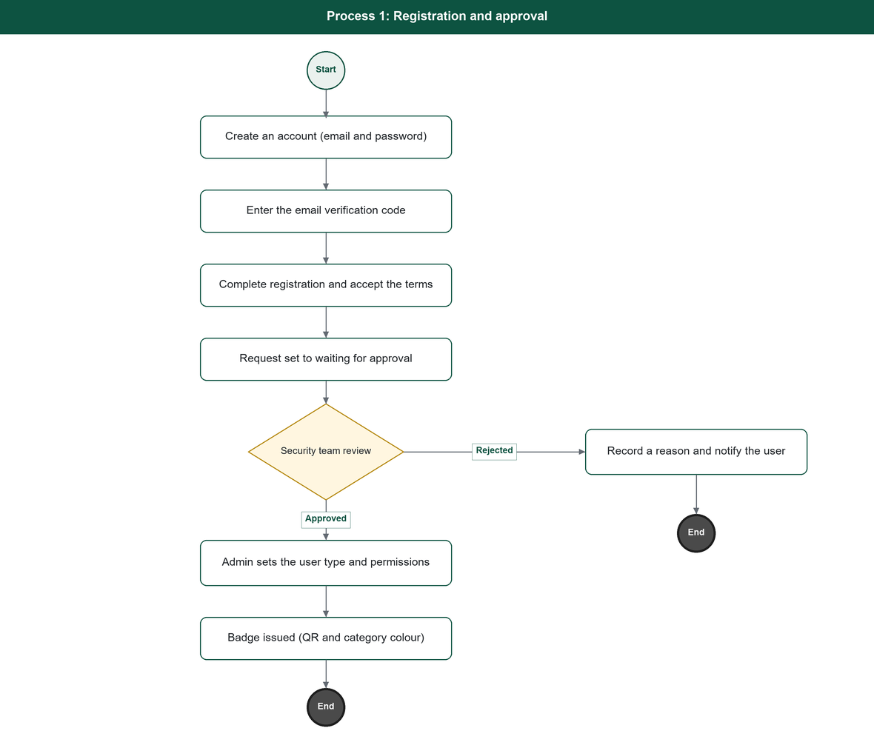
Figure 1. Registration and approval process.
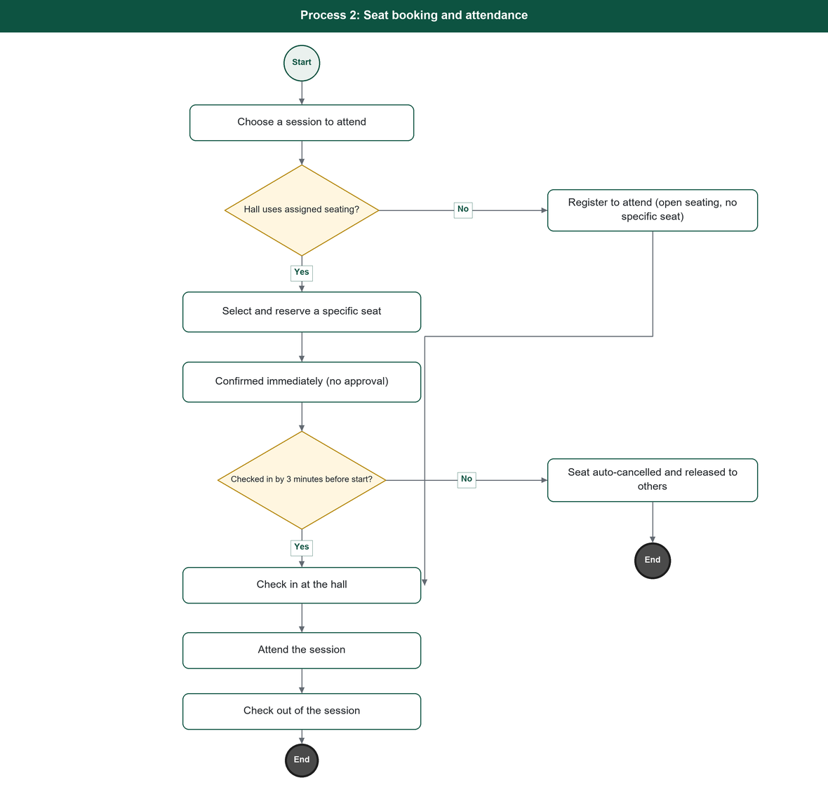
Figure 2. Seat booking and attendance process.
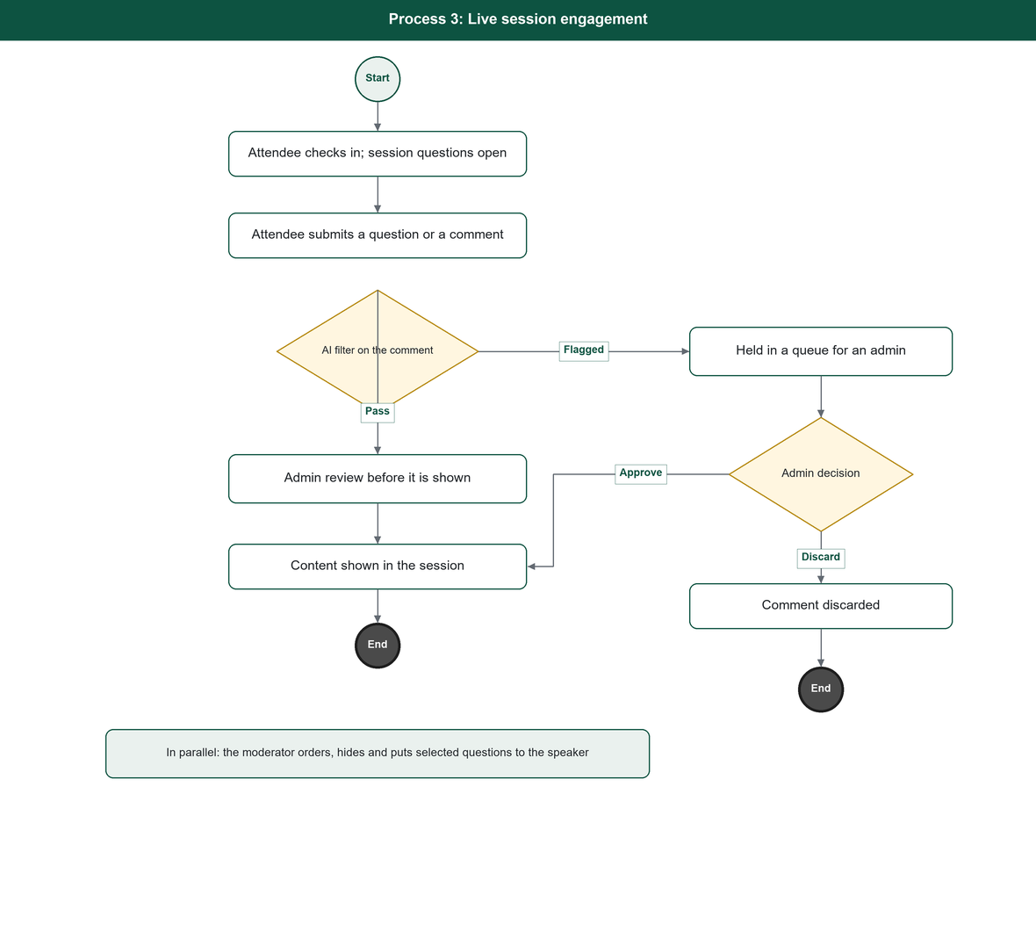
Figure 3. Session engagement process.

4. System Roles
Four things are fixed by the system: the Administrator role, the catalogue of pages and actions, and the five mobile-app roles Guest, Visitor, Exhibitor, Moderator and Staff. Every other Control Panel role is dynamic, built and assigned by the Administrator. Both the roles and the registration types appear in the table below.
ID | Role Name | Role Description
1 | Administrator | Runs the system from the Control Panel, holds every permission, and creates and assigns all other roles.
2 | Organising teams (dynamic roles) | Security, PR, Technical, Scientific, Logistics and Marketing. Each is a role the Administrator builds and assigns.
3 | Visitor | A registered attendee who registers in the mobile app. Sub-types are VIP, Normal and any further sub-type added in the Control Panel, each with its own colour.
4 | Exhibitor | A registered exhibiting organisation that holds a booth.
5 | Other | A registration type that covers Media, Sponsor and any further type added in the Control Panel.
6 | Moderator | An app role that manages the questions for the sessions assigned to it. No Control Panel access.
7 | Staff | Field operations only: badge scanning, on-site registration and hall-door check-in. No Control Panel access.
8 | Guest | An unregistered user browsing public content in the app. Personal features are locked.

5. System Requirements
This section is the contract the system is built and accepted against. It carries 132 numbered requirements: 14 business rules, 90 user requirements, 16 operational requirements and 12 non-functional requirements. Every identifier is stable, and the Solution Design Document traces each one to the module that implements it and to its verification method. Four requirements are withdrawn: BR-08, FR-706, FR-707 and FR-807. Their rows are retained so that no identifier is ever reused and the traceability stays complete.

5.1 Business Rules
Rule ID | Description
BR-01 | Every administrative page and endpoint requires a permission. Public content is readable without an account. NFR-02 states the anonymous surface.
BR-02 | Internal-user (Control Panel) sign-in requires a TOTP second factor every time.
BR-03 | The Security team approves or rejects a registration; on approval the Admin sets the final user type and permissions.
BR-04 | A badge is issued only after the registration is approved, and carries a unique reference number, a QR code and a colour by category.
BR-05 | An attendee may hold multiple bookings provided the session times do not overlap.
BR-06 | Attendance registration and seat reservation confirm immediately with no approval. A reserved seat that is not checked in is automatically cancelled 3 minutes before the session starts and released to others.
BR-07 | A session's questions close at session end and have no lower bound, so a question can be asked before the session starts. Once the session has started, a hall that carries a geofence also requires the attendee's hall check-in record; a hall with no geofence accepts the question, because presence cannot be verified.
BR-08 | Withdrawn. Attendee comments are not delivered.
BR-09 | One-to-one meeting requests are routed to the PR team.
BR-10 | Withdrawn. Not delivered.
BR-11 | Roles, permissions, dynamic categories and content are managed from the Control Panel without a code change.
BR-12 | Security actions, approvals and configuration changes are recorded in the operation log.
BR-13 | Personal data is encrypted at rest and in transit per the NCA standard.
BR-14 | Registration can be opened and closed from the Control Panel, closes automatically at the end of the last forum day, and can be overridden manually.

5.2 User Requirements
The requirements are grouped by service, one row per identifier. Where a requirement depends on a decision that is still open, the row names the open item that closes it.
Service ID | Service | Req. ID | Requirement Description
F-01 | Accounts and Authentication | FR-101 | The system shall let a person create an account with an email address, a password and a password confirmation.
F-01 | Accounts and Authentication | FR-102 | The system shall send a six-digit verification code to the email and shall require the code to be entered before the registration can continue.
F-01 | Accounts and Authentication | FR-103 | The system shall let a user request a new verification code, and shall invalidate the previous one when it does.
F-01 | Accounts and Authentication | FR-104 | The system shall authenticate a user by email and password, and the mobile app shall additionally offer device-biometric sign-in (fingerprint or Face ID) once the account is set up on the device.
F-01 | Accounts and Authentication | FR-105 | The system shall require a TOTP second factor for every Control Panel (internal user) sign-in.
F-01 | Accounts and Authentication | FR-106 | The system shall issue a short-lived access token and a rotating refresh token on sign-in.
F-01 | Accounts and Authentication | FR-107 | The system shall provide a password-reset flow by email verification code.
F-01 | Accounts and Authentication | FR-108 | The system shall validate the format of a mobile phone number against a standard national number format on registration.
F-02 | Registration and Approval | FR-201 | The system shall let a verified user complete a registration by choosing a registration type of Visitor or Other.
F-02 | Registration and Approval | FR-202 | The system shall collect the registration fields: the four-part Arabic name; the English name as in the passport; nationality; date of birth; place of birth. The job title is collected as an optional field.
F-02 | Registration and Approval | FR-203 | The system shall collect an identity number: the national ID for Saudis, or a passport number or Iqama number chosen by non-Saudis.
F-02 | Registration and Approval | FR-204 | The system shall collect a mobile number inside the Kingdom and, for overseas visitors, a mobile number outside the Kingdom.
F-02 | Registration and Approval | FR-205 | The system shall require an ID image as an attachment before a registration can be completed, and shall support further attachment types added later.
F-02 | Registration and Approval | FR-206 | The system shall let the user select the venue zone (area of the venue) they plan to attend, after registration.
F-02 | Registration and Approval | FR-207 | The system shall capture a facial photograph of the registrant through a guided live capture in the mobile application, which asks the registrant to smile and to turn their head, and shall verify on the server that the captured image contains a human face before accepting it. The photograph is required for a male audience registrant and is offered to a female registrant without being required of her. The verification is a presence test only: the system performs no facial recognition, stores no biometric template, and matches no face against any other face or register.
F-02 | Registration and Approval | FR-208 | The system shall present the Terms and Conditions and require the user's consent before the registration is submitted.
F-02 | Registration and Approval | FR-209 | On submission the system shall set the request to "waiting for approval" and shall send the user a message with the contact details.
F-02 | Registration and Approval | FR-210 | The system shall show the user the status of their registration request through the review stages.
F-02 | Registration and Approval | FR-211 | The system shall let the Security team view registration requests, review the submitted data, and approve or reject each request.
F-02 | Registration and Approval | FR-212 | The system shall provide a select-all control so the Security team can approve requests in bulk.
F-02 | Registration and Approval | FR-213 | On approval the system shall let the Admin set the final user type and the user's permissions.
F-02 | Registration and Approval | FR-214 | On rejection the system shall record a reason and inform the user.
F-02 | Registration and Approval | FR-215 | The system shall let a person use the mobile app as a Guest without registering.
F-02 | Registration and Approval | FR-216 | The system shall let registration be opened and closed from the Control Panel, shall support an automatic close at the end of the last forum day, and shall allow a manual override at any time.
F-02 | Registration and Approval | FR-217 | The system shall support on-site registration and badge reprint for a person who arrives without a badge.
F-03 | Badge and Access Control | FR-301 | The system shall issue an entry badge with a unique reference number and a QR code to an approved user.
F-03 | Badge and Access Control | FR-302 | The system shall colour the badge by the user's category.
F-03 | Badge and Access Control | FR-303 | The system shall verify a badge QR code at venue entry and record the entry.
F-03 | Badge and Access Control | FR-304 | The system shall let one attendee scan another attendee's badge QR to save that person as a contact.
F-03 | Badge and Access Control | FR-305 | The system shall record a user's arrival at a session hall by a QR scan at the hall door, and shall hold an enter time and a leave time per session; automatic arrival detection by a GPS geofence around the hall is a deferred enhancement (open item G-OI-2).
F-04 | Forum Programme | FR-401 | The system shall let the Scientific team manage the forum themes or pillars and their sub-topics.
F-04 | Forum Programme | FR-402 | The system shall let the Scientific team create and manage sessions, each with a title, description, theme, hall, category, start and end time, and speakers, in Arabic and English.
F-04 | Forum Programme | FR-403 | The system shall mark whether a session carries a broadcast.
F-04 | Forum Programme | FR-404 | The system shall let halls be created with a defined seating capacity, and shall allow the capacity to be changed.
F-04 | Forum Programme | FR-405 | The system shall hold a seat grid per hall and support seat assignment.
F-04 | Forum Programme | FR-406 | The system shall manage speaker profiles (name, rank, bio, qualifications, training experience, awards, photo and country flag) and shall link speakers to sessions.
F-04 | Forum Programme | FR-407 | The system shall hold the presentation files delivered by speakers.
F-04 | Forum Programme | FR-408 | The system shall present the agenda to attendees, filterable by day, with search, and shall let an attendee open a session's detail.
F-04 | Forum Programme | FR-409 | The system shall let an attendee add a session to their device calendar and set a reminder.
F-05 | Bookings and Attendance | FR-501 | The system shall let an attendee register to attend a session and, in a hall with assigned seating, select and reserve a specific seat.
F-05 | Bookings and Attendance | FR-502 | The system shall allow an attendee to hold any number of bookings provided the session times do not overlap.
F-05 | Bookings and Attendance | FR-503 | The system shall confirm attendance registration and seat reservation immediately, with no approval step, and shall automatically cancel a reserved seat 3 minutes before the session starts if the attendee has not checked in, releasing it for others.
F-05 | Bookings and Attendance | FR-504 | The system shall let an attendee cancel a booking any time before the session starts.
F-05 | Bookings and Attendance | FR-505 | The system shall show an attendee their assigned seat and a seat map for the hall.
F-05 | Bookings and Attendance | FR-506 | The system shall record session check-in and check-out at the hall and track attendance from these records.
F-06 | Exhibition | FR-601 | The system shall let an administrator record an exhibiting organisation with its details in the Control Panel.
F-06 | Exhibition | FR-602 | The system shall let an administrator assign a booth to an exhibitor and provision or link the accounts that represent it.
F-06 | Exhibition | FR-603 | The system shall maintain a booth directory (hall, booth number, logo, descriptor, contact, phone and email).
F-06 | Exhibition | FR-604 | The system shall maintain sponsors in four tiers: Platinum, Gold, Silver and Bronze.
F-06 | Exhibition | FR-605 | The system shall present an interactive venue map of halls, zones and booths, with navigation to a booth or to an assigned seat.
F-07 | Engagement and Sessions | FR-701 | The system shall present a session by embedding the YouTube player at the broadcast address an administrator records, with a language choice among the caption tracks that broadcast carries. The session director publishes the broadcast and the platform holds only its address. Translation and captions are not produced during a session.
F-07 | Engagement and Sessions | FR-702 | Withdrawn. Not delivered.
F-07 | Engagement and Sessions | FR-703 | The system shall let an attendee send a question to the moderator during a session, addressed to the session's speaker or its host (chair).
F-07 | Engagement and Sessions | FR-704 | The system shall accept a session's questions from before the session starts and shall close them at session end. Once the session has started, the system shall additionally require the attendee's hall check-in record where the hall carries a geofence, and shall accept the question where it does not.
F-07 | Engagement and Sessions | FR-705 | The system shall let a moderator, for the sessions assigned to them, view the incoming questions, reorder or hide them, and put selected questions to the speaker.
F-07 | Engagement and Sessions | FR-706 | Withdrawn. Attendee comments are not delivered.
F-07 | Engagement and Sessions | FR-707 | Withdrawn. Attendee comments are not delivered.
F-07 | Engagement and Sessions | FR-708 | The system shall produce an AI-generated summary of a session (key points, recommendations and a transcript).
F-07 | Engagement and Sessions | FR-709 | The system shall provide a dynamic rating and feedback capability that lets an attendee submit a rating and written feedback. Five rating types are currently defined: the session, the day, the programme, the exhibition and the app. The rating types are managed as dynamic content, and rating is offered to an attendee on the basis of attendance.
F-07 | Engagement and Sessions | FR-710 | The system shall notify attendees about current and upcoming sessions. Notifications are targeted by session booking or by audience; location-based targeting is not delivered.
F-08 | Networking and Cognitive AI | FR-801 | The system shall let a user choose interests, and shall maintain the interest list as a dynamic category.
F-08 | Networking and Cognitive AI | FR-802 | The system shall suggest matches to a user based on shared interests and shared sessions, with a match score. Scored suggestions are drawn from the profiles of other approved attendees who opted in, Visitor profiles included. The partner directory is a separate, unscored list covering speakers, sponsors and booth companies together with Other-type profiles that opt in; Visitor profiles (Normal and VIP) never appear in that directory. The set of discoverable profile types is managed from the Control Panel.
F-08 | Networking and Cognitive AI | FR-803 | When a match score reaches 80% or more, the system shall send the user a push notification recommending that person.
F-08 | Networking and Cognitive AI | FR-804 | The system shall let an attendee send a one-to-one meeting request, and shall route it to the PR team for approval.
F-08 | Networking and Cognitive AI | FR-805 | The system shall provide a cognitive-AI assistant that answers attendee questions, backed by a FAQ knowledge base.
F-08 | Networking and Cognitive AI | FR-806 | The system shall organise the FAQ knowledge in two levels (groups, then entries within a group) and shall let the Technical team manage both from the Control Panel.
F-08 | Networking and Cognitive AI | FR-807 | Withdrawn. Not delivered.
F-08 | Networking and Cognitive AI | FR-808 | The system shall reach the cognitive-AI provider through an abstraction so the provider can be set without a code change.
F-09 | Notifications | FR-901 | The system shall deliver notifications over in-app and email channels through one notification abstraction. SMS and WhatsApp are supported by the same abstraction and are enabled only if the ministry approves a gateway and its egress.
F-09 | Notifications | FR-902 | The system shall send registration and approval updates, session reminders, VIP invitations and meeting confirmations.
F-09 | Notifications | FR-903 | The system shall confirm a seat reservation immediately in the app, with no notification sent on reserving, and shall send a reminder when a session has started and the user has not checked in.
F-09 | Notifications | FR-904 | The system shall let the channel mix for a notification type be set by configuration, not by code.
F-10 | Media, News and Archive | FR-1001 | The system shall let the Marketing team manage a Media Center section (media coverage, social content and posts) from the Control Panel.
F-10 | Media, News and Archive | FR-1002 | The system shall let the Marketing team manage news items, each with a category.
F-10 | Media, News and Archive | FR-1003 | The system shall maintain a photo and video gallery and a media partners directory.
F-10 | Media, News and Archive | FR-1004 | The system shall hold previous editions of the forum, each with a title, brief, sessions, place, time, image, video, previous speakers and statistics.
F-10 | Media, News and Archive | FR-1005 | The system shall control the visibility of the current edition's archive from the Control Panel, so it appears only after the event ends.
F-10 | Media, News and Archive | FR-1006 | The exact field set of media and news items is an open item to be confirmed with the owner (OI-1).
F-11 | Statistics | FR-1101 | The system shall present per-day statistics: registrations, badges printed, registered VIP count, media badges printed, and total check-ins.
F-11 | Statistics | FR-1102 | The system shall present overall statistics: themes, topics, speakers, participating countries, total registrations and badges, attendance per day, total attendance and total audience questions.
F-11 | Statistics | FR-1103 | The system shall show current attendance on the Control Panel dashboard; tracking attendee movement, dwell time and routes inside the venue from GPS presence is a deferred enhancement (open item G-OI-2).
F-11 | Statistics | FR-1104 | The exact statistics list and the dashboards are an open item to be confirmed with the owner (OI-1).
F-12 | Control Panel and Configuration | FR-1201 | The system shall run the Control Panel on roles and permissions; each user shall see only what their role permits.
F-12 | Control Panel and Configuration | FR-1202 | The system shall let an Admin add roles and adjust permissions from the Control Panel.
F-12 | Control Panel and Configuration | FR-1203 | The system shall let content (titles, texts, the in-app welcome message, banners, logos and images, section labels and page content) be edited from the Control Panel without a code change.
F-12 | Control Panel and Configuration | FR-1204 | The system shall let dynamic categories (registration types, user sub-types, session categories, interests and others) be added, hidden or deleted from the Control Panel, each with its own colour.
F-12 | Control Panel and Configuration | FR-1205 | The system shall record changes and approvals in an operation log.
F-12 | Control Panel and Configuration | FR-1206 | The system shall apply the approved visual identity across the Control Panel, the website and the app.
F-12 | Control Panel and Configuration | FR-1207 | The system shall present the Policies and the Terms and Conditions, using legal text supplied by the client.
F-12 | Control Panel and Configuration | FR-1208 | The system shall let each edition's identity and settings (the event name, the colours and visual identity, the logos, and the edition's start and end dates) be configured from the Control Panel, so a new edition is set up without a code change.

5.3 Operational Requirements
Requirement ID | Description
OP-01 | The system shall run on-premises behind a reverse proxy.
OP-02 | The system shall keep the SIMF_Identity and SIMF_App databases physically separated, with no cross-database relations or transactions.
OP-03 | The system shall retain the last known-good published build for rollback.
OP-04 | The system shall provide periodic backup and reliable restore of data.
OP-05 | The system shall monitor and alert on the scheduled jobs the API runs in-process.
OP-06 | The system shall sustain the peak load throughout the forum, with a realistic load test before launch.
OP-07 | The system shall allow registration open and close, and archive visibility, to be controlled from the Control Panel.
OP-08 | The system shall integrate the email gateway behind the notification abstraction. SMS and WhatsApp gateways plug into the same abstraction when a provider and its egress are approved.
OP-09 | The system shall embed the broadcast and render the interactive venue map from venue data held on site. No external map service is integrated.
OP-10 | The system shall expose a /health endpoint for monitoring.
OP-11 | The system shall expose its functions only through the versioned API.
OP-12 | The system shall run the AI features on the GPT OSS 120B model, which SITE hosts on an on-site LLM server inside HSA (the security area that carries internal traffic only and has no internet path), reached over an OpenAI-compatible API, so that no AI request leaves the ministry network.
OP-13 | The system shall store uploaded files in on-site MinIO object storage inside HSA, reached over the S3 API, in place of a directory on a file share.
OP-14 | The system shall send all email through an on-site mail relay inside HSA.
OP-15 | The system shall place the API servers, the databases, the LLM server, the mail relay and the object store inside HSA with no internet path, and the Control Panel, the website and the mobile edge inside SSA, which is the only area with internet access.
OP-16 | The system shall produce session subtitles after the session, by importing the published caption track or by administrator paste or upload, then translating and summarising them on the on-site model for committee review before publication.

5.4 Non-Functional Requirements
Requirement ID | Description
NFR-01 | Security. The system shall meet the NCA Secure Application Development Standard and the controls it references (ECC-1:2018, CSCC-1:2019, the OWASP Top 10 and OWASP ASVS), and shall apply defence-in-depth across every layer.
NFR-02 | Authorisation. Every administrative endpoint and screen shall require a permission. The anonymous surface is limited to public content on the website and in the app, and to the authentication endpoints that run before a token exists.
NFR-03 | Audit. The system shall log security-relevant actions (sign-in, permission change, approval, configuration change) with enough context to reconstruct events.
NFR-04 | Performance. The system shall sustain the event-day peak load, about 30,000 concurrent attendees at peak, roughly 50,000 registered at a 0.6 peak factor. The system shall pass a realistic load test against that peak before launch.
NFR-05 | Availability. The system shall stay available throughout the forum, with health checks, a reverse proxy, and a retained last known-good build for rollback. The committed availability is 99.9 percent across the three forum days and 99.5 percent outside the event window. The recovery point objective is zero for the databases, which run in a synchronous-commit Availability Group, and 15 minutes for the object store. The recovery time objective is 5 minutes for the failure of a node or a database, and 4 hours for the loss of the HSA zone.
NFR-06 | Localisation. The system shall be fully bilingual: Arabic (primary, RTL) and English (LTR). No user-facing string is hardcoded. Dates display as dd-MM-yyyy with Latin digits.
NFR-07 | Usability and accessibility. The mobile app shall provide accessibility settings. Colour shall never be the only signal of state. The interfaces shall be operable by keyboard where they run in a browser.
NFR-08 | Compatibility. The website and Control Panel shall run on current mainstream browsers; the mobile app shall run on supported Android and iOS versions.
NFR-09 | Maintainability. The system shall follow the engineering standards: layered domain-driven design, zero-warning builds, tests with every change, and no duplicated code.
NFR-10 | Configurability. Content, categories, roles and permissions shall be changeable from the Control Panel without a release.
NFR-11 | Data protection. Personal data (identity numbers, contact details, attachments) shall be encrypted at rest and in transit, and handled per the NCA standard.
NFR-12 | Data residency. All SIMF data shall be stored and processed on site inside HSA. No personal data, uploaded document or conversation transcript shall be sent to an external service.

5.5 Constraints
- The technology stack is fixed: .NET 10, FastEndpoints, Blazor (Server and SSR) with the SIMF.Components shared component library, Flutter, and SQL Server 2022.
- The system is single-tenant and on-premises.
- The forum dates are not hardcoded; each edition's start and end dates are configured from the Control Panel.
- The system must satisfy the National Cybersecurity Authority standards and the Saudi Personal Data Protection Law (PDPL).
- Arabic is the primary language; Arabic and English are both fully supported.
- The delivered solution is frozen against change once it is published for the event.
- The source code is handed over by 25 January 2027.
- Data classification: the system holds no classified and no militarily sensitive information. The data is unclassified but includes personal data of visitors, speakers and exhibitors, processed under the PDPL and the National Cybersecurity Authority controls. No personal or operational data is sent to any cloud artificial-intelligence service.
- The one external integration, YouTube, requires an approved outbound firewall exception, and the call is made from the Control Panel. The AI runs on site and needs no external access.

5.6 Assumptions
- The external UI/UX designer delivers the mobile app's visual design.
- The legal text for the Terms and Conditions and the Policies is supplied by the client.
- The exact statistics list and the media and news field sets are fixed once the owner confirms them (open item OI-1).

5.7 Open Items
Each item below closes when the owner confirms the related decision. The Affects column names the requirements that depend on it.
Open Item | Description | Affects
OI-1 | Confirm the media and news field sets and the statistics list with the owner. | FR-1006, FR-1104
OI-2 | Confirm the WhatsApp provider when it is procured, and confirm the outbound firewall exception for the caption import made from the Control Panel. The AI model is decided: GPT OSS 120B, hosted by SITE on site, so it needs no network exception. The broadcast platform (YouTube) is decided. | FR-701, FR-901
G-OI-2 | Confirm the venue boundary for the GPS geofence (automatic arrival detection and movement tracking). | FR-305, FR-1103
OI-4 | Confirm the document classification with the owner. | Cover page (document classification)

6. Attachments
This document is delivered as a standalone document and has no attachments.

