Requester information
Requester Name: |  |  | General Department:
Email: |  |  | Section:
Phone Number/extension: |  |  | Force or BU:
Strategic Information (Filled By Project Owner)
Initiative Name |  |  | Priority
Project Name, from Roadmap | SIMF 4th Edition 2026
Components from To-Be Architecture Realized
Screening Questions (Filled by Technology)
Requirements/SRS/User Stories Defined and Approved |  | Defined. The Business Requirements Document delivered with this design carries 132 numbered, individually testable requirements. The Solution Design Document, also delivered with this design, traces every one of those identifiers to the module that implements it and to its verification method. Approval is the Ministry's.
Integration Requirements Defined and Approved |  | Defined. Section 2.4 gives every interface with its protocol, port, payload and authentication, and section 2.8 carries the Communication Requirements Matrix. One outbound integration remains pending its firewall exception.
Security Requirements Defined and Approved |  | Defined. Section 2.9 Solution Security View, aligned to the National Cybersecurity Authority Secure Application Development Standard and to the Personal Data Protection Law. Open items are listed in section 3.
Uses approved Architecture/Design Methodology |  | Modular monolith with Domain Driven Design layering and defence in depth, described in sections 2.1 and 2.2, with the alternatives considered and rejected recorded in the section 2.1 decisions table. Confirmation against Technology's approved methodology rests with Technology.
Architecture Constraints Documented |  | Yes. The Architecture Constraints row of this section states them, and sections 1.2, 2.1 and 2.7 carry the hosting, zone and network constraints that follow from them.
Uses Approved Solution Stack (Hardware/Software) |  | The stack is stated in the Software Specification and Hardware Specification rows of this section, with per node sizing in the section 2.1 table. Confirmation against Technology's approved stack rests with Technology.
Is system described sufficiently (Section 1.1 to 1.3)) |  | Yes. Section 1.1 gives the purpose, scope and glossary, section 1.2 the goals, quality goals, assumptions and non-goals, and section 1.3 the stakeholders, their concerns and the system boundary.
Is solution design described sufficiently (Section 2.1 to 2.9) |  | Yes. Sections 2.1 to 2.9 are complete, with three figures, the per tier sizing table, the architecture decisions table, the interface table and the Communication Requirements Matrix.
Is the Risk and Mitigation Strategies provided |  | Yes. Section 3 gives the risk register with impact, likelihood, mitigation and owner for each risk, and the open items register with a closing condition for every item still outstanding.
Document Completion Approved? |  | For Technology. This row records the review board's own verdict, and is the same decision the Approvals block signs.

Document identification | Document SIMF-HLD-005, version 2.1, status Issued for review. Apexium issues and authors it for the Royal Saudi Naval Forces (RSNF) under a Ministry of Defense programme, roadmap project SIMF 4th Edition 2026. It conforms to IEEE 1016-2009 and ISO/IEC/IEEE 42010:2011. Issue date is TBD, owner Apexium, recorded in Hijri and Gregorian at issue.
BRD (Business Requirements Document) | A Business Requirements Document is delivered with this design and records the business objectives, scope, stakeholders and business rules. The Solution Design Document traces every requirement identifier to the module that implements it.
SRS / User Stories | The functional, non-functional and operational requirements are carried in the Business Requirements Document rather than a separate specification. The Solution Design Document carries the traceability and the verification method for each of them.
Solution Requirements | The platform is single-tenant and open to public and international registration. Four client applications share one backend API and two databases. Sections 1.2 and 1.3 give the goals and the system boundary; section 2.2 names the modules.
Integration Requirements | Section 1.3 fixes the system boundary and names every external and internal system the platform depends on. Section 2.4 defines each interface, with its direction, protocol and port, authentication and error behaviour, and marks the interfaces still to be agreed.
Security Requirements | The platform runs its own identity store, and sign-in uses an e-mail address, a password and a second factor. Permissions are granted per page and per action, and confidential columns and files use AES-256-GCM with keys in a key management service. Section 2.9 carries the full posture and the alignment to the Saudi Personal Data Protection Law (PDPL).
Hosting Requirements | Hosting is on premises on the SITE Private Cloud, on Windows Server 2022 with SQL Server 2022. Two security areas contain four network zones. Figure 1 and section 2.1 give the network layout; section 2.7 maps components onto environments.
Architecture Methodology or Best Practice used | Section 2.1 records the architectural style and the decisions taken with their rejected alternatives; section 2.2 sets out the layering and the module boundaries. The design follows defence in depth, keeps the application tier stateless and makes the database tier highly available.
Architecture Constraints | The forum runs on fixed dates, the platform freezes before it opens, and an outage cannot be rescheduled. There is no public-cloud dependency, and the source code is handed over to the customer. Section 1.2 numbers the constraints; section 2.8 states the two-database separation invariants.
Software Specification | The stack is .NET 10 with FastEndpoints, FluentValidation and EF Core in code-first mode. The front ends use Blazor Server and Blazor SSR over the shared SIMF.Components library, with Flutter and Dart for Android and iOS. IIS hosts the web tier, Serilog carries logging, and section 2.2 assigns each part to its module.
Hardware Specification | The figures below are the hardware agreed with the customer. Production runs four API hosts, two website hosts, two Control Panel hosts, two SIMF.MobileEdge hosts and two database hosts. Traffic passes two active/passive pairs. A web application firewall (WAF) and load balancer pair sits at the internet edge. An API load balancer pair sits in front of the application tier. Section 2.1 gives per-node sizing; the mobile edge and MinIO figures are a supplier proposal in the section 3 register.

  - 1.1 Purpose
This document is the high-level design of the platform built for the Saudi International Maritime Forum (SIMF). It addresses the Ministry of Defense technology review board and the Royal Saudi Naval Forces (RSNF) as system owner. It also serves the teams that build, host and support the platform. Section 1.3 names each stakeholder and their concerns.
The description conforms to IEEE 1016-2009 for software design descriptions and to ISO/IEC/IEEE 42010:2011 for architecture description.
This document carries no database schema, no interface specification and no unit-level logic. The Solution Design Document, delivered alongside it, carries all three.
The Requester Information, Strategic Information and Approvals blocks are Ministry-owned; the Ministry completes them on receipt.
Glossary
Each acronym below carries its expansion and its role in the design.
Acronym | Expansion | Role in this design
SIMF | Saudi International Maritime Forum | The forum and its platform
RSNF | Royal Saudi Naval Forces | System owner
SITE | A company name, not an abbreviation | Hosts the platform, and supplies the AI model and the e-mail service
SSA | Secure Service Area | Outer security area
HSA | High Security Area | Inner security area
NCA | National Cybersecurity Authority | Cybersecurity regulator
ECC | Essential Cybersecurity Controls | NCA control baseline
PDPL | Personal Data Protection Law | Saudi data protection law
OWASP | Open Worldwide Application Security Project | Application security baseline
WAF | Web application firewall | Perimeter control
KMS | Key management service | Holds encryption keys
HSM | Hardware security module | Backs the KMS
AG | Availability Group | Database high availability
TDS | Tabular Data Stream | SQL Server wire protocol
API | Application programming interface | Backend service surface
REST | Representational State Transfer | Interface style for the API
RTO | Recovery time objective | Availability commitment
RPO | Recovery point objective | Availability commitment
OTP | One-time password | Second factor
TOTP | Time-based one-time password | Second factor
DDD | Domain-Driven Design | Backend layering
TBD | To be determined | Open item with a named owner

1.2 System Overview
The Saudi International Maritime Forum (SIMF) platform is a single-tenant event platform. It serves the Royal Saudi Naval Forces (RSNF) under a Ministry of Defense programme, and the current edition is SIMF 4th Edition 2026. Any member of the public may register, in the Kingdom or abroad, subject to administrator approval. The platform verifies each registrant, issues a digital badge and controls entry by gate scan. It publishes the programme, takes seat reservations, sends reminders, presents sessions broadcast on YouTube and moderates audience questions. It presents the exhibition, sponsors, media partners, news and the past-edition archive, and it supports networking and meeting requests. It collects ratings, feedback and statistics, and organisers administer the whole event from the Control Panel without a code release.
Attendance at the forum is free. The platform holds no payment, ticketing, invoicing or finance capability, and none is planned.

Quality goals
Four quality goals shape the design, each stated with the scenario that measures it.
Quality goal | Measurable scenario | Target
Availability across the forum days | Attendees, gate operators and organisers use the platform throughout the three forum days. | The availability objectives in section 2.9
Gate response under peak arrival | An operator scans a badge at the gate while arrivals peak. | 250 ms at the 95th percentile for a gate scan, at 3,000 concurrent users
Confidentiality of personal data | A reader reaches database rows or stored files without holding the encryption keys. | Identity numbers, mobile numbers and identity-document images stay unreadable; controls in section 2.9
Feature freeze before launch | The forum opens on its fixed dates. | Feature-complete and frozen before opening day, with defect corrections only after that point

Assumptions and constraints
1. The forum runs on fixed dates, so the delivery date cannot move.
2. An outage inside the event window cannot be rescheduled.
3. Hosting stays on premises, with no public-cloud dependency.
4. The source code passes to the customer at handover, as the contract requires.
1.3 System Context
At this level the platform is a black box: named users on one side, named systems on the other.
Four client applications sit on that boundary: the Flutter mobile app for Android and iOS, the public website, the Control Panel, and the on-site SIMF.BadgeDesk. The mobile app reaches the platform through SIMF.MobileEdge rather than the backend API.
Nine stakeholder groups hold a distinct interface and a distinct concern.
Stakeholder | Interface | Primary concern
Attendees and VIP delegates | Mobile app | Purpose: registration, badge, seats, session participation
Anonymous public | Public website | Purpose: programme and visit information, no account
Administrators and organisers | Control Panel | Suitability: run the event without a code release
Scientific Committee | Control Panel | Suitability: the published forum programme
Gate operators and session moderators | Mobile app and Control Panel | Feasibility: scan throughput, moderated questions
Badge desk staff | SIMF.BadgeDesk | Feasibility: badges issued at the venue
RSNF, the Royal Saudi Naval Forces | Owner; receives platform and source code | Purpose and lifecycle risk: freeze, handover
SITE, the hosting provider | Private cloud, mail relay, inference server | Feasibility within supplied capacity
Smart Time, the official event manager | The forum and its editions | Maintainability and evolvability across editions

One external system and six internal systems complete the context.
System | Boundary | Direction | Channel
YouTube | External | Outbound only | HTTPS caption fetch; playback on the attendee device
SMTP mail relay | Internal, on site | Outbound from the API | SMTP, queued and asynchronous
MinIO object storage | Internal, on site | From the API only | S3 API
GPT OSS 120B inference endpoint | Internal, on site | From the API only | OpenAI-compatible HTTPS, traffic stays on site
SQL Server 2022 | Internal, on site | From the API only | TLS-protected SQL client connection
Ministry log collector | Internal | Outbound from each host | Syslog; the host ships the rolling files
Key management service, hardware security module | Internal | Read at node start-up | Product selection pending, section 2.4
No external system initiates an inbound connection to the platform. Client applications on the internet connect inbound through the WAF and the load balancer. Section 2.8 states the protocol and port for each connection.

2.1 Architecture Overview
Architectural style and tiers
The platform is a modular monolith with domain-driven design (DDD) layering. One backend application, SIMF.Api, serves the mobile application, the public website and the Control Panel. Persistence is split across two databases, SIMF_Identity and SIMF_App. Hosting is on premises on Windows Server 2022 with SQL Server 2022. The deployment is three-tier, and in production each tier occupies its own servers. The presentation tier holds SIMF.Web, SIMF.ControlPanel and SIMF.MobileEdge. The application tier is four stateless SIMF.Api hosts. The data tier is SQL Server with the MinIO object store. No presentation project holds a database connection string, so a compromised presentation host gives no direct route to the data. Development and Test run four sites on one node: the API, the Control Panel, the website and the mobile edge.
Security areas, zones and firewalls
Two security areas, SSA and HSA, hold four network zones. Both full names are TBD, owner the site network team, closing condition sign-off of the deployment network design. SSA holds three zones: access, perimeter and presentation. It is the only security area with internet access. The access zone holds attendee devices and administrator browsers. The perimeter zone holds the combined web application firewall (WAF) and load balancer. The presentation zone holds the presentation tier alone. HSA is a single zone carrying internal traffic only, and it holds the application and data tiers. Nothing in HSA has a route to the internet.
Two firewalls stand at zone boundaries. The perimeter firewall guards the internet-facing boundary of SSA. It admits inbound client traffic and permits one outbound destination, the caption fetch described in section 2.4. Its port-level rule set is TBD, owner the site network team, closing condition sign-off of the deployment network design. The internal firewall separates the presentation zone from HSA and is the only route in. It permits TCP 443, and only from the presentation zone. It is also the only barrier in front of the data tier.
Figure 1 answers where each component runs and which boundary each connection crosses. It draws one box per hosting server and labels every arrow with its protocol and port, which section 2.8 lists in full.
Capacity basis
The forum is time-boxed, so sizing targets the event-day peak, not an average load. The design assumes about 5,000 platform users a day and about 1,000 attendees on site, and the largest hall seats 500. A peak factor of 0.6 gives about 3,000 concurrent users, with headroom to about 4,000. At that load the 95th percentile targets are 400 ms for sign-in, 250 ms for a gate scan and 300 ms for a read. Those targets hold while processor use stays below 75 percent. Session video reaches the attendee device from YouTube, and section 2.4 records that path, so the tiers are sized for REST traffic alone. Section 2.9 sets out scale-out and overload behaviour.
The following table gives each tier with its zone, node count, specification and purpose.
Tier | Zone | Instances | Specification per node | Purpose
WAF and load balancer | SSA perimeter | 2, active/passive | Appliance or virtual machine | Terminates TLS, filters against the Open Web Application Security Project (OWASP) rule set, balances to presentation
SIMF.MobileEdge | SSA presentation | 2 | 8 vCPU / 16 GB / 100 GB, proposed minimum | Presentation tier for the mobile application, which never calls the API directly
SIMF.Web | SSA presentation | 2 | 16 vCPU / 32 GB / 300 GB | Public website, server-side rendered, read-heavy
SIMF.ControlPanel | SSA presentation | 2 | 16 vCPU / 32 GB / 300 GB | Administrative Control Panel; needs session affinity
API load balancer | HSA | 2, active/passive | Appliance or virtual machine | Distributes requests across the four API nodes
SIMF.Api | HSA | 4 | 16 vCPU / 32 GB / 300 GB | Stateless REST application tier
Language model server | HSA | TBD, owner SITE | Supplied by SITE | Hosts the GPT OSS 120B model behind an OpenAI-compatible interface
Mail server | HSA | TBD, owner SITE | Supplied by SITE | On-site SMTP relay, STARTTLS on port 587
Database | HSA | 2 | 8 vCPU / 64 GB / 2 TB | Hosts both databases; section 2.9 covers availability
MinIO object store | HSA | 2 | 8 vCPU / 16 GB / 4 TB, proposed minimum | S3 file store, reached only through the API

The following table records the architectural decisions and the alternatives rejected.
Decision | Chosen | Rejected alternative | Reason
Application structure | Modular monolith with DDD layering | Microservices | The API is stateless, so event-day capacity comes from adding nodes, not from splitting services.
Persistence | Two databases, SIMF_Identity and SIMF_App | One shared database | Identity data stays in its own store; section 2.8 states the separation invariants.
AI inference | On-site GPT OSS 120B model | A cloud AI service | The call stays inside HSA and generates no internet traffic, so no attendee data leaves the site.
Session video | YouTube plays to the attendee device | Relaying video through the backend | A relay would need a tier sized for video bandwidth on event day.
Second-factor delivery | One-time password (OTP) by e-mail | SMS | E-mail removes any dependency on an SMS supplier and reaches international attendees without a local number.
Live updates | Bounded client polling | A server push transport | Polling rides the sized REST path and holds no long-lived connection per attendee.
Scheduled work | Jobs run in process on the API tier | A separate worker tier | No fourth tier to size, deploy or fail over.
Identity | Own identity store serving visitors and administrators | Ministry directory integration or single sign-on federation | The users are members of the general public and international attendees, and hold no ministry account to federate.
Database edition | SQL Server 2022 Enterprise | Standard edition | Standard edition offers no readable secondary; section 2.9 sets out the availability design.

2.2 Modules
Client applications
• Mobile application: Flutter on iOS and Android, serving attendees. It reaches the backend through SIMF.MobileEdge rather than directly.
• Control Panel: Blazor Server with the SIMF.Components library, serving administrators.
• Public website: Blazor SSR, carrying forum and programme information. It has no sign-in, registration or account page and persists no personal data. Two pages differ. The visitor assistant relays question text to the artificial intelligence service without retaining identity. A meeting-confirmation link is private to one speaker.
• Badge desk: SIMF.BadgeDesk, a WinForms application that prints badges on site. It works offline with no database connection, uploading each shift over one batch endpoint on the administration surface.
Backend layers
The backend is one process in four layers. SIMF.Api is the boundary, holding endpoints, middleware, authentication and authorisation policies. SIMF.Application holds use-case orchestration and the service abstractions. SIMF.Infrastructure implements those abstractions, covering persistence, storage, e-mail, identity and the audit interceptors. SIMF.Domain holds entities, aggregates, enumerations and rules, carries no framework dependency and depends on no other layer. Dependencies run inwards, from the boundary towards the domain.
Bounded contexts
The backend divides its work into bounded contexts, grouped by area.
Area | Contexts | Covers
Identity | Authentication and registration; account and profile | Sign-up, credentials, profiles
Programme | Programme; bookings; meetings | Sessions, speakers, presentations, summaries
Venue | Gates and scanning; exhibition; sponsors | On-site entry, booths
Content | News and media; archive; notifications; networking | Published content, archived material, notifications, connections
Platform | Statistics; system configuration; organisation profile; reference data | Reporting, settings, lookups
Artificial intelligence | AI | Subtitle import, summary drafting, question filtering, assistants

Every AI feature runs against the on-site model server in section 1.3. Section 2.8 describes the databases behind these contexts.
Interfaces and scheduled work
One API process publishes two separately gated surfaces. One serves the attendee clients, the mobile application and the public website. The other serves administration, the Control Panel and the badge desk. Both share one response envelope, one error model and one permission model.
The scheduled jobs run inside the API host; there is no worker server. They sweep dormant accounts, close the registration gate and release unclaimed seats before a session starts. Others send session and meeting reminders, issue rating prompts and dispatch e-mail. One node is elected to run the database-driven jobs, so a reminder is issued once for the tier, not per node. If it stops, another takes over within one polling interval. E-mail dispatch runs on every node, each draining its own queue.
2.3 System Workflow
Seven workflows are architecturally significant. Figure 2, the system and data flow diagram, shows the processes, stores and trust boundaries these workflows cross. Figure 3, the end-to-end sequence, orders the exchange between the clients, the API and the stores. It covers registration and approval, sign-in with the second factor, and the gate scan.
Registration and approval
1. The visitor signs up in the mobile application.
2. The visitor confirms the e-mail address with a one-time password (OTP).
3. The visitor completes the profile.
4. An administrator reviews the registration in the Control Panel and approves or rejects it.
5. Approval issues a digital quick-response (QR) badge and notifies the visitor.
Sign-in with the second factor
1. The user submits an e-mail address and a password.
2. The user supplies the second factor, which section 2.9 defines.
3. The API validates the factor and returns a short-lived access token with a rotating refresh token.
4. A mobile user may then enrol a biometric device key, which requires an OTP step-up challenge.
Seat reservation
1. The attendee opens a session, then chooses an assigned seat, takes a random seat, or joins open seating with one tap.
2. The API accepts the reservation immediately, with no approval step and no outbound message; the application acknowledges it inline.
3. The hold stays provisional until check-in at the hall gate converts it into a confirmed seat.
4. A sweep shortly before the session releases every hold whose owner has not checked in.
Gate scan
1. A gate operator scans the attendee's QR badge.
2. The API validates the badge, the approval state, and the profile types that gate admits.
3. The API records the scan idempotently and returns an entry or exit outcome.
Session broadcast and moderated questions
1. The attendee opens the session, and the application embeds the YouTube player at the broadcast address an administrator recorded in the Control Panel.
2. The attendee may submit a question before the session and until it ends.
3. Once the session has started, a hall with a geofence accepts questions only from attendees whose door scan recorded arrival. A hall without one accepts every question.
4. An advisory artificial intelligence (AI) filter tags each question.
5. The Scientific Committee approves, hides or escalates it.
6. The session moderator presents approved questions on stage.
The platform defers automatic arrival detection from device location; the section 3 register records its owner and closing condition.
AI session summary
1. The Control Panel fetches the caption from the published video and hands the subtitle to the API. A team member may paste or upload it instead.
2. The team reviews the subtitle before the API stores it.
3. The API calls the on-site AI service to draft a summary from the subtitle.
4. The Scientific Committee edits and approves the draft, then publishes it only after the session starts.
5. Attendees read the published summary in the application.
Rating and feedback
1. An administrator defines rating types, groups and questions in the Control Panel without a software release.
2. The platform ships five seeded types: App, Session, Forum, Exhibition and Day.
3. Scheduled jobs issue prompts from attendance, per session at its end and per day to that day's arrivals.
4. A closing prompt covers Forum, Exhibition and App.
5. Each type accepts one submission per user; Day accepts one per programme day.

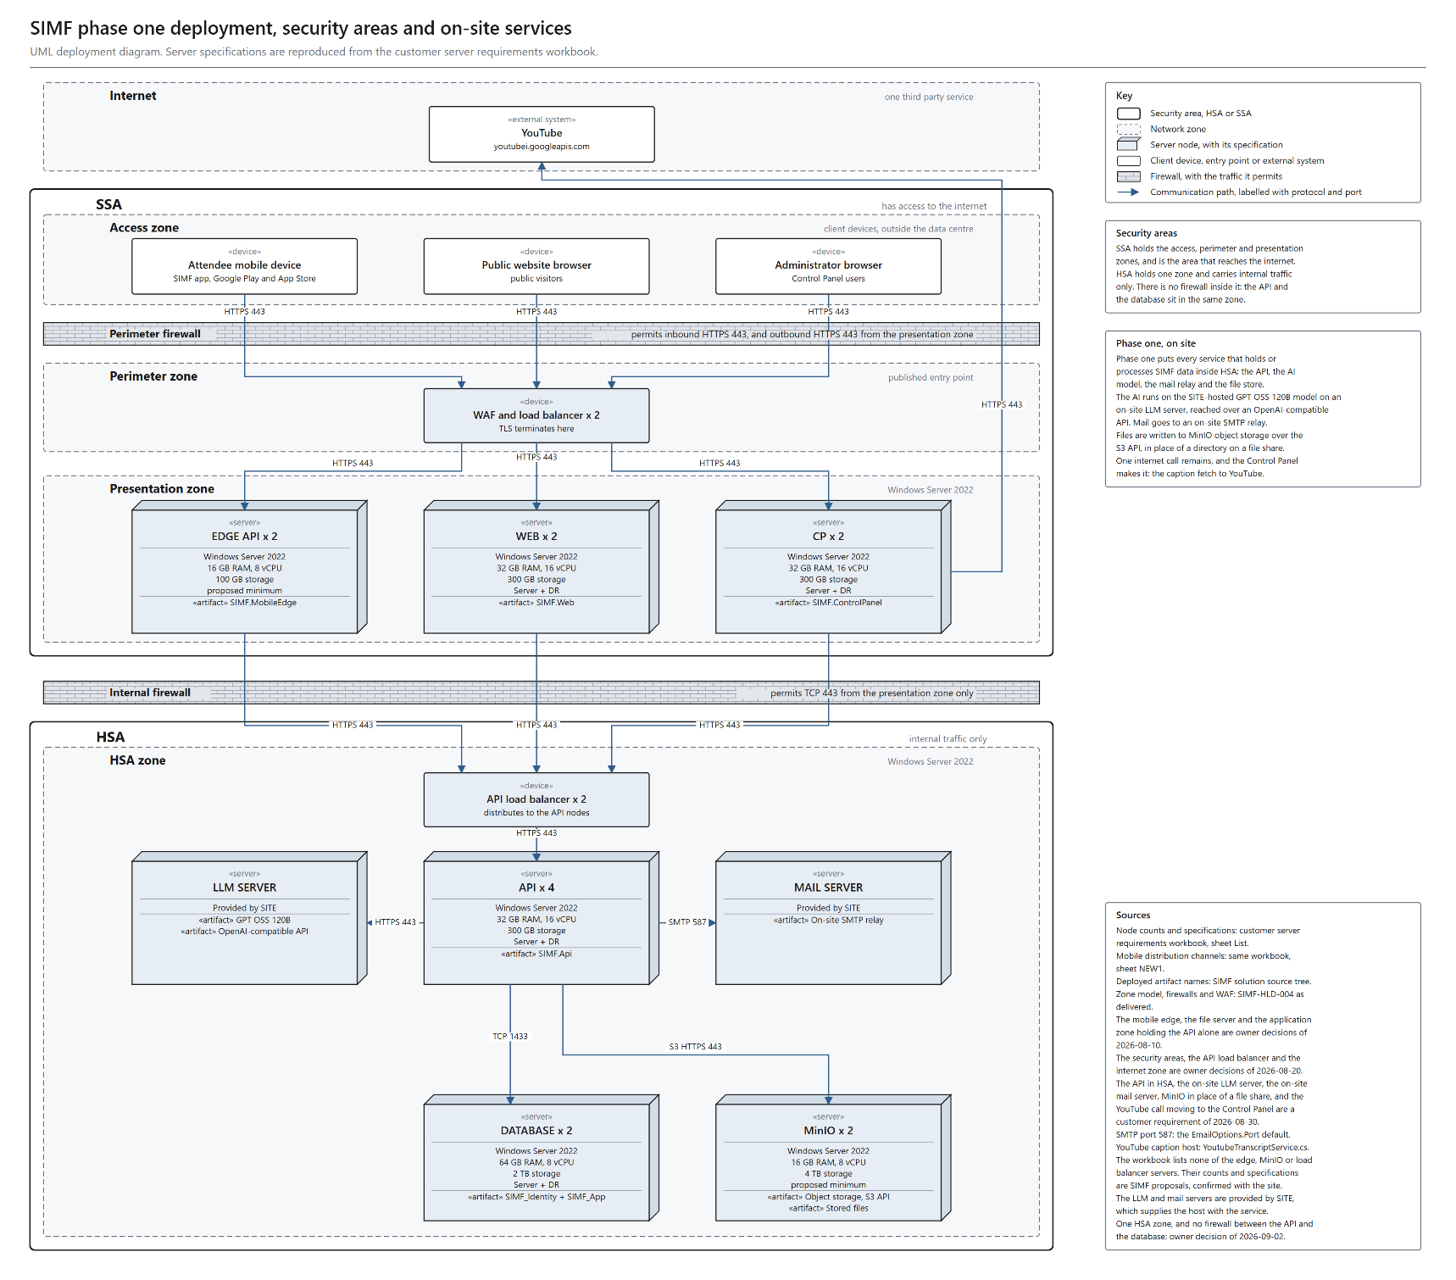
Figure 1. Deployment, security areas and network zones. A UML deployment diagram with one box per hosting server. Each host sits in its network zone, both firewalls carry the rule they enforce, and every connection carries its protocol and port.

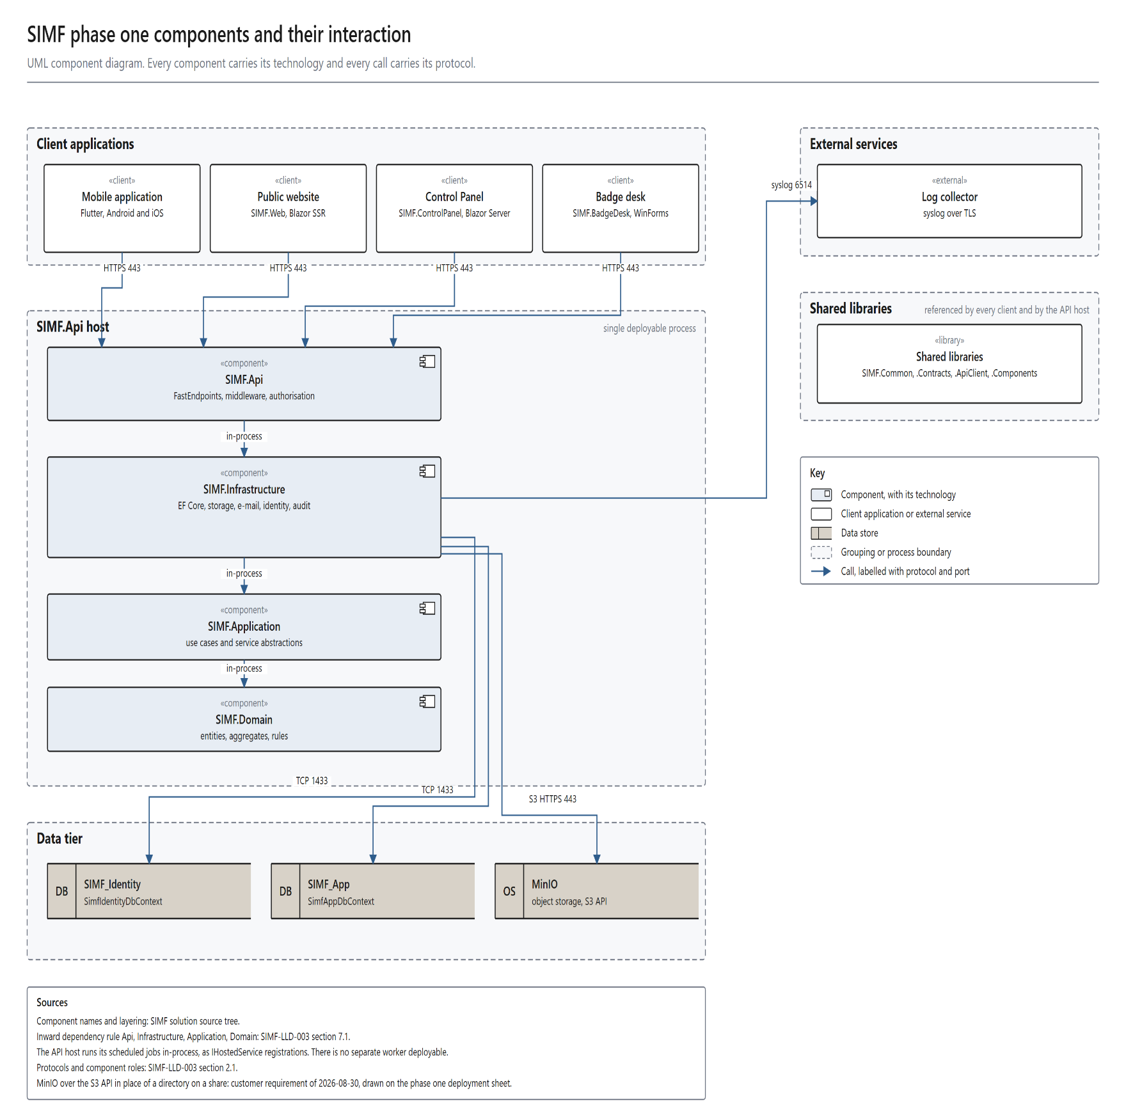
Figure 2. System and data flow. A data flow diagram in Gane and Sarson notation: a level 0 context view of the platform and its external parties, and a level 1 decomposition that balances with it. Every flow that leaves the ministry network is drawn.
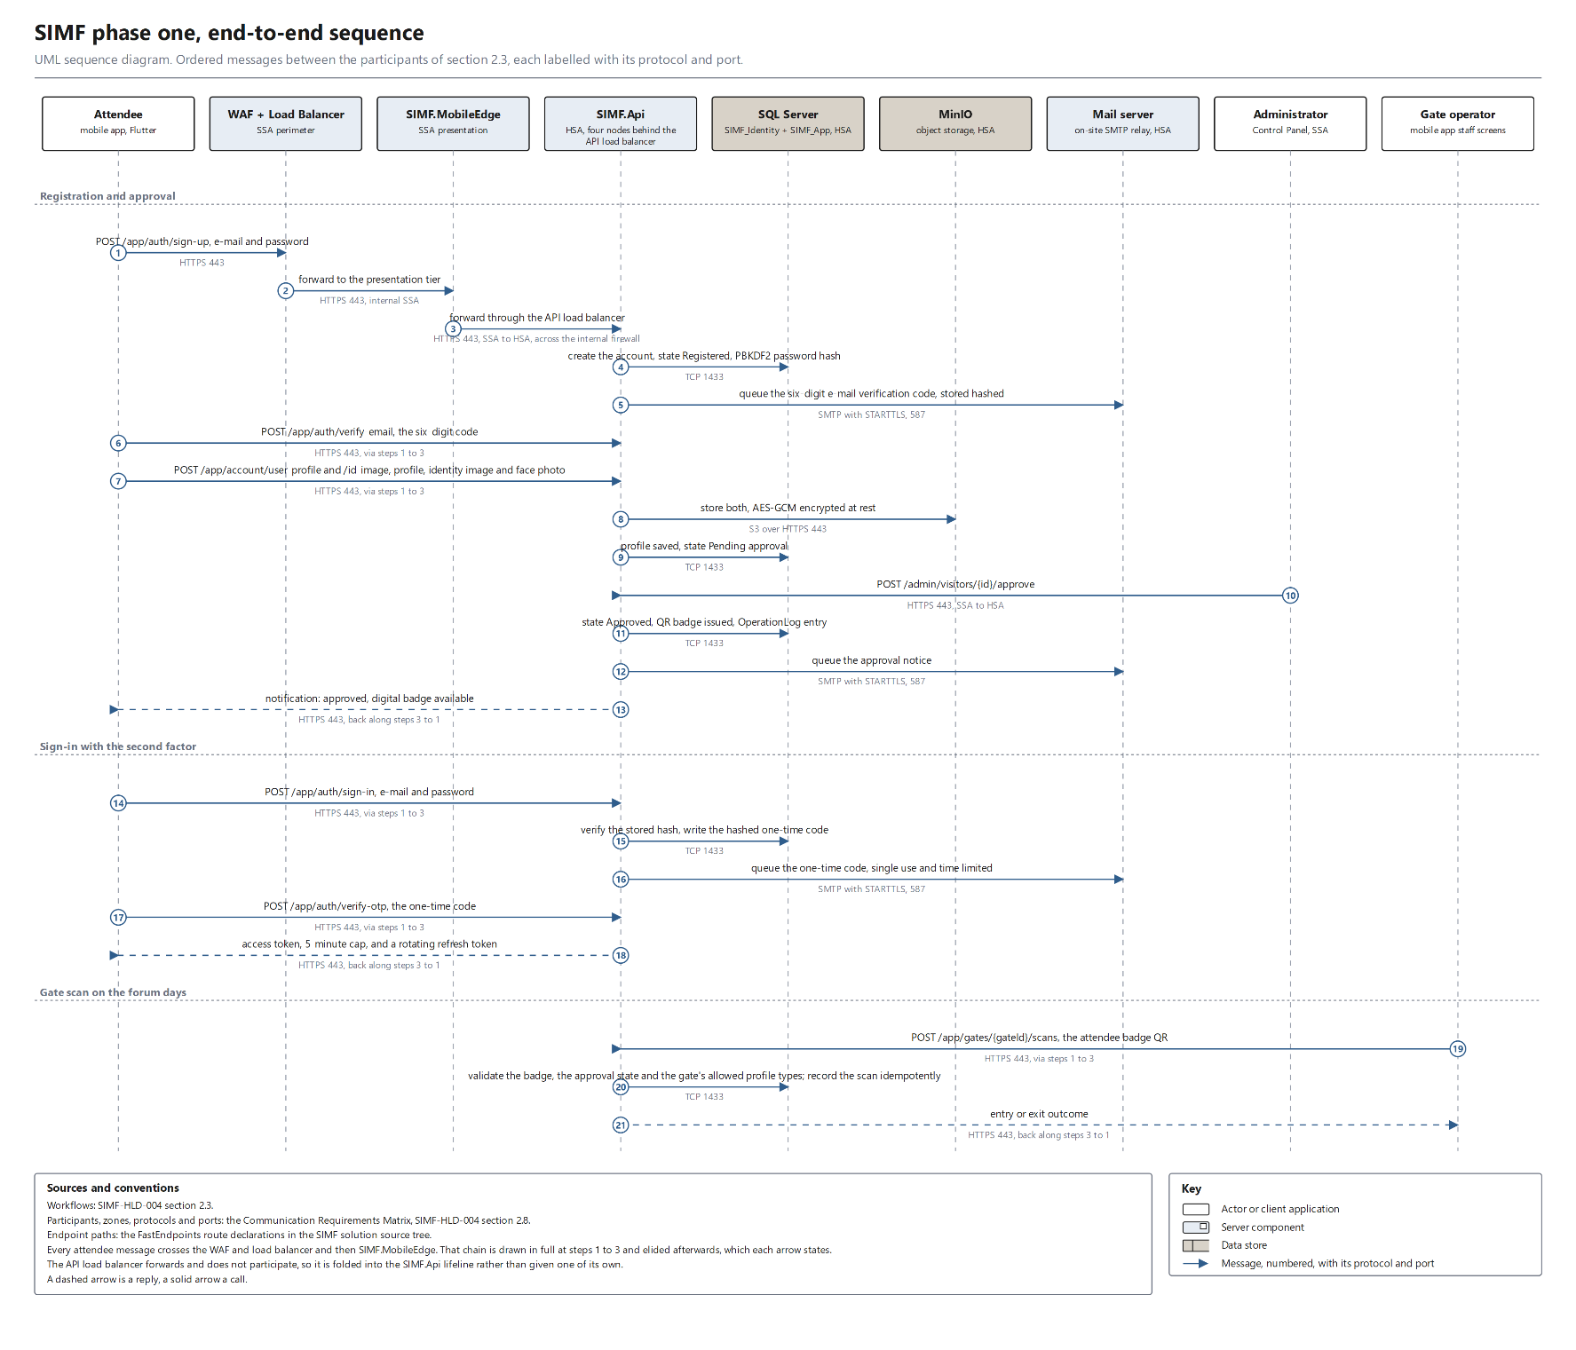
Figure 3. End-to-end sequence. A UML sequence diagram over nine participants, with ordered messages each carrying its protocol and port, covering registration and approval, sign-in with the second factor, and the gate scan.

2.4 Integration and Interfaces
The platform sends no personal or confidential data beyond the ministry network.
The platform holds ten interfaces, eight internal, one outbound and one on the attendee's device. The communication matrix in 2.8 carries the protocol and port of each one.
Interface | Direction | Protocol and port | Payload | Authentication | Failure behaviour | Status
Client applications to API | Inbound | (2.8) | ApiResult envelope | JSON Web Token (JWT) bearer, protected routes | Coded bilingual failure envelope | Pending: WAF appliance (SITE)
Control Panel and Website to API | Server to server | (2.8) | Same envelope, typed client | Encrypted cookie, no browser token | Failed envelope, no exception | Agreed
Mobile app to mobile edge | Device to edge | (2.8) | TBD, Apexium | TBD, Apexium | TBD, Apexium | Pending: payload, authentication
Badge desk to admin API | On-site client | (2.8) | One batch per shift | TBD, Apexium | Failure envelope (2.5) | Pending: authentication
API to SQL Server | API to database tier | (2.8) | EF Core, two databases (2.8) | Least-privilege account (2.9) | No silent fallback (2.5) | Pending: quorum witness (SITE)
API to SMTP relay | API outbound | (2.8) | Queued outbound mail | TBD, Apexium | Queued; the request does not wait | Agreed
API to MinIO object store | API outbound, inside HSA | (2.8) | Objects; rows hold keys | TBD, Apexium | No silent fallback (2.5) | Pending: KMS and HSM (SITE)
API to model server | API outbound, inside HSA | (2.8) | Per-feature fields | TBD, SITE | No silent fallback (2.5) | Pending: authentication
YouTube caption import | Outbound to the internet | (2.8) | Public video id only | None, public resource | Administrator supplies the transcript | Pending: egress exception (SITE)
Client-side video playback | Device to YouTube | (2.8) | Stream address only; no media on SIMF servers | None | Playback is independent of the platform | Agreed

Six delivered features call the on-site GPT OSS 120B model, plus a Control Panel prompt test.
Feature | Fields sent | Personal data | Destination
Question filter | Question text only | No | On-site model
FAQ answer | Visitor question, published FAQ entry | No | On-site model
Visitor assistance | Visitor question, public programme content | No | On-site model
Subtitle translation | Subtitle text, target language | No | On-site model
Session minutes | Title, speaker display names, abstract, subtitle | Yes, names already public | On-site model
Control Panel assistant | Administrator question, Control Panel content | No | On-site model
Control Panel prompt test | Administrator test prompt | Possible. The prompt is free text typed by an administrator. | On-site model

Every model call carries a bounded field set that the server validates before dispatch. The ceilings sit in the Solution Design Document. The caller's identity never enters a model call. Account identifiers, e-mail addresses, national identity, Iqama and passport numbers, badge identifiers and booking records stay outside the call.
The caption call leaves SSA through the perimeter firewall to an allow-list of fully qualified domain names, and every request is logged. The import re-checks the caption host named in the first reply and refuses redirects, blocking server-side request forgery. Without the firewall exception, an administrator pastes or uploads the transcript, and no feature stops. YouTube use covers embedded playback and one caption retrieval. The session director produces each session and publishes it to the forum's YouTube channel; the platform holds only the resulting address and plays it in an embedded player. The platform captures, produces, stores and serves no video.
2.5 Error Handling and Logging
Failure model
Central middleware converts domain and validation exceptions into the section 2.4 failure envelope and selects the matching HTTP status code. A validation failure answers 400 and names each offending field in Arabic and English. The API logs an invalid state and raises it; no path silently substitutes a default. In production the API refuses to start when it cannot read a required secret.
Logging and audit
Serilog writes structured events to rolling files, retained locally for 31 days. Every request carries a correlation identifier into the logs and both audit trails. The platform logs seven event classes:
• Authentication, covering sign-in, one-time password (OTP), time-based one-time password (TOTP), token refresh and sign-out
• Authorisation denials
• Rate-limit rejections
• Artificial intelligence invocations
• Security-relevant business events
• Row-level data changes
• Unhandled system errors
Two audit trails record who changed what.
Trail | What it records | Attributes captured
OperationLog | Security-relevant business events: approvals, configuration changes, gate scans | Actor, subject, source IP address, user agent, outcome, error code, correlation identifier
RowAudit | Row-level data changes | Operation, before and after images, affected columns, actor snapshot, correlation identifier

Both trails are append-only in the application and at the database: the runtime account may insert rows but may not update or delete them. A host log shipper, configured at deployment, forwards the files and trail entries to the ministry log collector. An actor holding database access therefore cannot erase their own trail.
2.6 User Interface (UI) Design
One design system covers the mobile application, the Control Panel and the public website. All three are fully bilingual: Arabic is the primary language and reads right to left, English the secondary language and reads left to right. The badge desk is a fourth client and sits outside that design system.
Client shells and rendering
Section 2.2 names each client's technology; this section states only the shell and rendering model.
• Mobile application: a persistent tab shell carries the navigation.
• Control Panel: interactively rendered; every list page uses one standard data grid above a shared create, read, update and delete framework.
• Public website: statically rendered, with interactive elements confined to a small number of pages.
• Badge desk: a Windows Forms desktop client, covered in section 2.2.
Tokens, layout and accessibility
Colour, typography, spacing and corner radius are defined once and shared by all three clients. Every layout starts Arabic first in right-to-left form and mirrors automatically for English. Widths are responsive rather than fixed, for phone and tablet use. The website targets Web Content Accessibility Guidelines (WCAG) level AA. The mobile client lets the user set text size, high contrast and reduced motion. The screen and route inventory for every client sits in section 4 of the Solution Design Document. The minimum supported browser and mobile operating system versions remain open; section 3 carries them in the open items register.
2.7 Operational Model View
Environments
SIMF runs on four environments, and every change reaches production by passing through each of them in order.
The four environments differ in topology, database edition, node allocation and purpose.
Environment | Topology | Database edition | Nodes | Purpose
Development | One node hosting all four sites | SQL Server Standard, one instance | One application node, one database instance | Feature development, with the OpenAPI description exposed
Test | One node hosting all four sites | SQL Server Standard, one instance | One application node, one database instance | Integrated verification before promotion, with the OpenAPI description exposed
Staging | The production topology, reproduced | As production | As production; counts TBD, owner SITE operations, closing when SITE issues them | Pre-production rehearsal of the live service
Production | Three tiers, presentation, application and data, across two security areas, shown in Figure 1 | SQL Server 2022 Enterprise in an AlwaysOn Availability Group | As section 2.1 specifies | Live service

Staging fills the pre-production role. It must be available two weeks before launch, and the load test runs there. Promotion skips no environment. A change is promoted only after a clean Release build carrying zero warnings. A build warning, or a dependency with a known vulnerability, fails the pipeline and halts promotion.
Zones and network addressing
Figure 1 and the section 2.1 zone table allocate every production component to its security area, SSA or HSA. The same table allocates each component to its network zone. It also carries the per-tier hardware specification. Network addressing and virtual local area network (VLAN) allocation are not yet assigned; section 3 carries them as OI-09.
Production prerequisites
Four items must be in place before go-live, and each carries a named owner. A fifth item is recommended rather than required.
1. A certificate authority signed TLS certificate covering the published SIMF host names. Owner: SITE operations.
2. MinIO object storage provisioned inside HSA. Owner: SITE operations.
3. One shared data-protection key ring folder that the website nodes and the Control Panel nodes can read and write. Owner: SITE operations. Neither site starts without it.
4. Session affinity enabled on the website and Control Panel tiers. Owner: SITE operations.
5. Recommended: an outbound exception permitting the Control Panel hosts, and no other host, to reach the YouTube caption hosts. Owner: the site network team. Section 2.4 states what the platform does when the exception is refused. Section 3 carries it as OI-07.
Service operations
Production hosts four Internet Information Services (IIS) sites, each with its own application pool. The four sites are the API, the Control Panel, the website and the mobile edge. Each site deploys independently of the other three, so one site restarts without stopping the others. Scheduled jobs run inside the API process, as section 2.2 describes, so restarting them means recycling the API application pool. Each node reads its signing key and its two data keys from the key management service (KMS) at start-up. Section 2.5 gives the behaviour when a key cannot be read, and it states how log files reach the ministry log collector.
2.8 Data Architecture View
Logical data groups
Two physically separate SQL Server 2022 databases hold all persistent data. The split is permanent and isolates the identity surface. SIMF_Identity holds accounts, roles and permissions, token and second-factor material, device keys and password history. SIMF_App holds business data: profiles, the programme, seating and gate activity, published content, networking, feedback, configuration and both audit trails.
Separation invariants
These three rules are permanent.
• No foreign key spans the two databases; a business record names a user by a bare identifier, resolved by a second query.
• Live data is never duplicated; the one permitted copy is an immutable audit snapshot of the actor's name and e-mail.
• No transaction spans both databases, and each connection string may address one instance or two servers.
Data flow
TLS terminates at the WAF and load balancer, which routes each client to its presentation component. Those components call SIMF.Api through the API load balancer, crossing the internal firewall. The API authorises the caller, then reaches the databases, file store, mail relay and inference endpoint. The badge desk workstation sits on the venue network, outside the SSA and the HSA. It uploads each shift through the WAF and load balancer; section 2.1 states the firewall rule that governs this path. Figure 2 shows these flows and their trust boundaries.
File store
The file store holds binary content kept out of the database and readable by any node. MinIO serves it over the S3 API; database rows carry only object keys. Every read and write passes through the API, which applies the content's category policy; no client reaches the store. Four sensitivity tiers classify stored content. Section 2.9 states which content is encrypted at rest. The tier definitions and the rule that assigns content to a tier are TBD, owner Apexium. The closing condition is the file classification published in the Solution Design Document.
Integrity and validation
• Primary keys, foreign keys and unique indexes inside each database prevent duplication.
• Each unit of work is atomic within one database, so no partial update survives.
• The software engineering standards document governs server-side input validation and parameterised data access.
• Section 2.9 states the encryption posture, at rest and in transit.
• Business records are deactivated rather than deleted, preserving referential history; section 2.5 defines the audit trails.
Concurrent sessions and throughput are stated in section 2.1.
Communication requirements matrix
The matrix below records every flow drawn on Figure 1.
Source | Destination | Protocol | Port | Direction | Purpose
Mobile app, Internet | WAF and load balancer | HTTPS, TLS 1.2+ | 443 | Inbound | Application traffic
Public browser, Internet | WAF and load balancer | HTTPS, TLS 1.2+ | 443 | Inbound | Website traffic
Administrator, Internet | WAF and load balancer | HTTPS, TLS 1.2+ | 443 | Inbound | Control Panel traffic
Badge desk workstation, venue network | WAF and load balancer | HTTPS, TLS 1.2+ | 443 | Inbound | Badge desk shift batch upload
WAF and load balancer | SIMF.MobileEdge | HTTPS | 443 | Internal, SSA | Mobile edge requests
WAF and load balancer | SIMF.Web | HTTPS | 443 | Internal, SSA | Website rendering
WAF and load balancer | SIMF.ControlPanel | HTTPS | 443 | Internal, SSA | Administration
SIMF.MobileEdge, SIMF.Web, SIMF.ControlPanel | API load balancer | HTTPS | 443 | SSA to HSA | Presentation to API
API load balancer | SIMF.Api | HTTPS | 443 | Internal, HSA | API node distribution
SIMF.Api | GPT OSS 120B server | HTTPS | 443 | Internal, HSA | Model inference
SIMF.Api | Mail server | SMTP with STARTTLS | 587 | Internal, HSA | Transactional e-mail
SIMF.Api | SQL Server Availability Group listener | TCP, TDS | 1433 | Internal, HSA | Both databases
SIMF.Api | MinIO object store | HTTPS, S3 API | 443 | Internal, HSA | File access
SQL Server replica | SQL Server replica | TCP | 5022 | Internal, HSA | Availability Group replication
SIMF.ControlPanel | YouTube caption hosts | HTTPS | 443 | Outbound | Caption import, video identifier only
Application hosts | Ministry log collector | Syslog over TLS | 6514 | Outbound | Centralised structured logging
Attendee device, Internet | YouTube | HTTPS | 443 | Client-side | Playback, no SIMF server

2.9 Solution and Non-Functional Views
Security
Every audience signs in with an e-mail address and a password. The platform stores a password only as a one-way hash, and can force a change before sign-in completes. Visitors confirm with a one-time password (OTP) sent by e-mail, administrators with a time-based one-time password (TOTP) or a single-use recovery code. No token is issued until the second factor succeeds, and the platform never e-mails a password. Mobile sign-in may add a device key, generated inside the device hardware security element and never exported. Only its public half is registered against the account and device. An administrator can revoke a device, after which the server refuses its key.
Access tokens are JSON Web Tokens (JWT), signed asymmetrically rather than with a shared secret. Only the API inside HSA holds the private key, so no presentation host can mint a token. Access tokens are short-lived, refresh tokens rotate on use, and reuse is detected. An absolute session cap applies, and a security stamp revokes a session at once. The Solution Design Document carries the token lifetimes and the signing algorithm. Authorisation is role-based access control (RBAC), with per-page and per-action permissions from one catalogue, enforced on the API and the Control Panel alike.
A web application firewall (WAF) at the edge blocks injection, cross-site scripting and cross-site request forgery. All traffic runs on TLS 1.2 or higher, terminated at the load balancer and re-encrypted onward. Section 2.4 states the authentication each internal interface carries. AES-256-GCM protects the encrypted file categories and the national identity, Iqama, passport and mobile number columns. Those keys and the application secrets live in the key management service (KMS) behind a hardware security module (HSM), never in configuration.
Rate limiting applies on several dimensions, not one global rule, and every rejection reaches the audit trail. The application sets security headers and a content security policy, and allows cross-origin resource sharing (CORS) only from an explicit origin list. It scans every uploaded file. Text sent to the on-site model is sanitised against hidden instructions. Database accounts hold least privilege, and the runtime account holds data rights only.
Section 2.5 describes the two audit trails.
An offline server-side check inside HSA confirms an uploaded photograph holds a human face, so no badge is issued against an unusable picture. The mobile application runs a guided liveness capture wholly on the device, producing the photograph and nothing else. Optional biometric sign-in asks the operating system to check a fingerprint or face, which unlocks the device key and never reaches SIMF. The platform performs no facial recognition, computes no face embedding, stores no biometric template and matches no face against any register.
The platform meets its Saudi Personal Data Protection Law (PDPL) obligations as follows.
Obligation | How the platform meets it | Control point
Lawful basis | The registrant enters their own data and accepts the terms | Registration form
Purpose limitation | Personal data serves event admission only, and is never profiled, sold or shared | Access control
Minimisation | Fields are limited to what a badge and a security approval require | Registration form
Access and correction | The holder reads and edits their profile, and may delete the photograph alone | Profile screen
Erasure | Irreversible erasure hard deletes the personal data and files, revokes sessions and device keys, and disables the account; the business record survives without identifying data, an exception to the deactivation rule in section 2.8 | Mobile application, any account state
Residency | Every store holding personal data sits inside the HSA zone | Hosting zones, Figure 1
Retention and disposal | Personal data is scoped to the edition it was collected for and disposed of through the erasure path; the disposal schedule is open, item OI-05 | Ministry data-protection function

The design conforms to its mandated standards as follows.
Standard | Conformance | Open items
NCA Secure Application Development Standard | Designed to conform | Independent penetration test not yet commissioned, item OI-01, section 3
NCA Essential Cybersecurity Controls (ECC) | Conforms except on identity lifecycle | Password expiry ships inactive; enabling it, secret rotation and the signed certificate are pre-launch activities, item OI-01, section 3
Saudi Personal Data Protection Law | Designed to conform | Retention schedule not yet agreed, item OI-05, section 3
OWASP application security baseline | Designed to conform | WAF appliance and ruleset agreed at deployment, section 2.4
Availability
Database availability rests on a SQL Server 2022 Enterprise AlwaysOn Availability Group (AG) holding both databases. It runs one read-write primary and one readable secondary, replicates by synchronous commit, and fails over automatically. The listener routes write to the primary and read-only queries to the secondary. A cluster quorum witness completes the cluster; its configuration is open in section 3.
A valid restore needs four artefacts from one point in time. They are the two databases, the object store contents, and an escrowed copy of the encryption keys. The keys belong in that set because encrypted columns and files restore unreadable without them. Backups run on a schedule, and a set is restored into a non-production environment on a defined cycle. Cadence, retention and the rehearsal interval are TBD, owner SITE. The recovery site and its replication method remain open in section 3.
The platform commits to the following availability, recovery point and recovery time objectives.
Objective | Commitment | Basis
Availability during the three forum days | 99.9 percent | An outage inside the event window cannot be rescheduled. Time inside a node or database recovery, bounded by the recovery time objective below, is excluded; the permitted number of such events per window is TBD, owner SITE, confirmed in the deployment plan
Availability outside the event window | 99.5 percent | Normal service
Recovery point objective, databases, node or replica failure | Zero | The Availability Group runs synchronous commit, so a committed transaction is on both replicas before the commit returns
Recovery point objective, object store | 15 minutes | Snapshot interval, confirmed with SITE during deployment planning
Recovery point objective, loss of the HSA zone | The backup cadence, which cannot better the 15-minute object store interval | A zone loss restores from the four artefact backup set, so the exposure is the gap between backups
Recovery time objective, node or database failure | 5 minutes | Availability Group failover is automatic and takes seconds; the budget covers detection, load balancer rotation and client retry
Recovery time objective, loss of the HSA zone | 4 hours | A restore from the four artefact backup set, not a failover

Monitoring
Each host writes structured events to rolling files, each carrying a correlation identifier for tracing. Section 2.7 states how they reach the ministry log collector, and administrators read both audit trails in the Control Panel. A health endpoint serves as the readiness probe and reports the scheduled jobs from their heartbeat registry. A faulted job turns the node degraded and drops it from rotation. A monitoring toolchain collects processor, memory, response-time, throughput and query metrics, and alerts on thresholds. The Control Panel presents usage statistics for registrations, attendance, bookings, scans and ratings. The alerting product, its thresholds and the escalation path are TBD, owner SITE.
Sizing and Performance
Scaling out is a deployment change, not a redesign: nothing scales itself, and capacity is added node by node. The website scales horizontally behind the load balancer. The API is stateless, so nodes are added freely for registration surges, gate-scan bursts and session load. Its baseline is four nodes, sized in section 2.1; the database tier scales vertically instead.
Queries are indexed and projected, and list endpoints page at the data source rather than in memory. Live notifications and questions use bounded conditional polling, and this build carries no server-push transport. At the peak concurrency given in section 2.1, polling is roughly 100 requests per second across the four API nodes. The Solution Design Document carries the poll interval, the cache behaviour and the response codes. Reference data is cached. No SIMF tier serves video: a session plays on the attendee device from YouTube (2.4). Load tests in staging set the pass thresholds, which section 3 carries.

3. Risks and Mitigation Strategies
Six risks govern delivery. Likelihood is the residual assessment once the mitigation is in place, and each mitigation names the section that implements it.
The table below sets out each risk with its impact, likelihood, mitigation and owner.
Risk | Impact | Likelihood | Mitigation | Owner
Security | Exposure of attendee identity documents, or an unauthorised administrative action | Low | Permission gating per page and action, encryption at rest and in transit, a web application firewall, rate limiting, key management service secrets, and pre-handover penetration testing (2.9) | Apexium
Event-day availability | Loss of registration, gate entry and session access during the forum window, against the constraints in 1.2 | Low | Load balancer, stateless multi-node application tier, Availability Group failover, health-probe rotation, and rollback to the last good build (2.7, 2.9) | SITE
Scalability and performance | Registration surge, session concurrency, gate-scan bursts and notification fan-out coincide and slow responses | Medium | Scale-out per tier, indexed and paged queries, bounded polling with caching, and peak-shaped staging load tests (2.9) | Apexium
Supplier and technology dependency | A SITE-supplied service is delayed or withdrawn: hosting, mail relay, model server or recovery site | Medium | Inference runs on site, so no external provider sits in the path; the provider is one configurable abstraction (2.4) | SITE
Data protection | Loss or corruption of attendee, booking or scan data, or no evidence of who changed it | Low | Separated databases with no cross-database key or transaction, database-enforced integrity, soft delete, reconciliation of logical references, and append-only audit trails (2.5, 2.8) | Apexium
Schedule and change freeze | A defect found after the freeze is expensive and disruptive to correct | Medium | Four-stage promotion with no stage skipped, reviewed pull requests, a pipeline that halts on a warning or vulnerable dependency, and per-page regression scenarios (2.7) | Apexium

Open items register
The register below is the only list of open items in the design.
Identifier | Item | Owner | Closing condition
OI-01 | Pre-launch deployment activities listed in 2.7 and 2.9 | SITE | Each activity completed and verified in production before go-live
OI-02 | Venue boundary for the deferred geofence behaviour | RSNF | Boundary confirmed, then the behaviour designed and scheduled
OI-03 | The statistics metric list | RSNF | Metric list confirmed in writing
OI-04 | Load test pass thresholds | Apexium | Thresholds agreed, then met by a peak-shaped staging run
OI-05 | Personal data retention schedule | RSNF | Retention period approved for each category of personal data
OI-06 | Availability Group quorum witness | SITE | Witness type and location confirmed and configured
OI-07 | Outbound exception for the caption import | SITE | Rule approved and in place, or transcript upload adopted instead
OI-08 | Proposed sizing for the mobile edge and object store hosts | SITE | Node count and specification agreed with the customer
OI-09 | Network addressing and virtual local area network allocation | SITE network team | Addresses and identifiers issued for every zone
OI-10 | Recovery site, and the replication method for the databases and the object store | SITE | Site named and replication confirmed against the four-hour recovery time objective
OI-11 | Minimum supported browser and mobile operating system versions | Apexium | Confirmed from the delivered client build configuration
Pre-launch activities close before go-live; the rest stay open until their closing condition is met.

Approvals

Technology Expert, Role 1  Signature: _______________________________ | Date__________
Technology Head  Signature: _____________________________ | Date__________
Technology Director  Signature: _____________________________ | Date__________

