Requester information
Requester Name: |  | General Department:
Email: |  | Section:
Phone Number/extension: |  | Force or BU:
Strategic Information (Filled By Project Owner)
Initiative Name |  | Priority
Project Name, from Roadmap
Components from To-Be Architecture Realized
Screening Questions (Filled By Technology)
Requirements/SRS/User Stories Defined and Approved |  |  | Yes/No/Comments
Integration Requirements Defined and Approved |  |  | Yes/No/Comments
Security Requirements Defined and Approved |  |  | Yes/No/Comments
Uses approved Architecture/Design Methodology |  |  | Yes/No/Comments
Architecture Constraints Documented |  |  | Yes/No/Comments
Uses Approved Solution Stack (Hardware/Software) |  |  | Yes/No/Comments
Is system described sufficiently (Section 1.1 to 1.3)) |  |  | Yes/No/Comments
Is solution design described sufficiently (Section 2.1 to 2.9) |  |  | Yes/No/Comments
Is the Risk and Mitigation Strategies provided |  |  | Yes/No/Comments
Document Completion Approved? |  |  | Yes/No/Comments

Solution Architecture Section (Project Team)
Requirements and Constraints
BRD | The Business Requirements Document is a separate controlled document in Arabic and English editions, covering the business objectives, scope, stakeholders and business requirements. It is complemented by the functional design specifications, one per module.
SRS/User Stories | The functional design specifications, one per module, and the product backlog. A per-page end-to-end test-case catalogue of 194 authored files provides the executable acceptance criteria. A formally controlled software requirements specification is pending outstanding owner decisions.
Solution Requirements | Single-tenant event platform for the Saudi International Maritime Forum. Visitor registration and administrator approval; digital QR badge and gate access control; forum programme, sessions and seat booking; live session streaming, moderated questions and comments; exhibition, booths, sponsors and media partners; news, media gallery and past-edition archive; networking, contact sharing and speaker, delegation and business meetings; notifications; ratings and statistics; and a Control Panel for full event administration without a code release.
Integration Requirements | Internal: SMTP e-mail relay, Syslog and SIEM, a filesystem file store, and SQL Server 2022 (Standard in Development and Test, Enterprise in an availability group for production).  External, outbound only through the controlled egress point: the video platform caption API, and the AI service. The AI service is not active in the delivered configuration. Both destinations need an outbound firewall exception that is not yet approved.  Client-side: live playback performed by the attendee device. The platform stores only the stream URL.  Not integrated: Active Directory and LDAP. SIMF operates its own ASP.NET Core Identity store.
Security Requirements | Authentication: e-mail and password; second factor by e-mailed one-time password for visitors or TOTP authenticator for administrators with single-use recovery codes; optional ES256 biometric device key on mobile.  Authorization: role-based access control with per-page and per-action permissions baked into the token and enforced on both the API and the Control Panel.  Encryption: TLS 1.2 or higher in transit; national identity, Iqama and passport numbers, mobile numbers and identity-document images encrypted at rest with application-level AES-GCM.  Hardening: web application firewall, multi-dimensional rate limiting, security headers and content security policy, explicit origin allow-list, upload scanning, secrets from environment variables with start-up guards.  Audit: two append-only trails for security-relevant business events and row-level before and after images.  Data protection: the data held is unclassified and includes personal data for visitors, speakers and exhibitors, processed under the Personal Data Protection Law (PDPL).  Compliance: aligned to the NCA Secure Application Development Standard, with ECC and OWASP baselines.
Hosting Requirements | On-premises on Windows Server 2022, on the SITE Private Cloud, behind a load balancer and firewalls, over SQL Server 2022. The three-zone network layout is in section 2.1.
Architecture Methodology or Best Practice used | Modular monolith with Domain-Driven Design layering of Domain, Application, Infrastructure and API. The network follows a defence-in-depth three-zone model of Internet, application-server zone and data zone, with a stateless, horizontally scaled application tier and a high-availability database.
Architecture Constraints | Three tier: presentation (public website and Control Panel), application (backend API), data (database).  Hard event deadline with a post-publish change freeze.  Mandatory NCA security compliance and source-code handover.  On-premises hosting on SQL Server 2022. Development and Test run a single node. Production runs the two database nodes of the customer server requirements workbook as an availability group.  Two physically separate databases with no cross-database foreign keys, transactions or duplicated live data.  Arabic primary and right-to-left, English secondary throughout.
Software Specification | .NET 10, FastEndpoints, FluentValidation, EF Core code-first, Blazor Server and Blazor SSR, the shared SIMF.Components library over a single design-token stylesheet, Flutter for iOS and Android, SQL Server 2022, IIS, Serilog, MailKit.
Hardware Specification | Production: WEB 2 nodes, API 4 nodes and CP 2 nodes, each Windows Server 2022 with 32 GB RAM, 16 vCPU and 300 GB; Database 2 nodes, Windows Server 2022 with 64 GB RAM, 8 vCPU and 2 TB. Pre-production: one front-end node carrying WEB, API and CP (32 GB, 16 vCPU, 300 GB) and one database node carrying the databases and the file store (32 GB, 8 vCPU, 1000 GB). Every production row is marked Server and DR. Reproduced in the sizing table in section 2.1.

  - Purpose
This document describes the high-level design of the SIMF platform, the Saudi International Maritime Forum, delivered for the Royal Saudi Naval Forces under a Ministry of Defense programme.
1.2 System Overview
SIMF is a single-tenant event platform for the Saudi International Maritime Forum. Three front-end applications, the mobile application, the public website and the Control Panel, share one backend API and two databases.
Audience
- The forum is international. The platform is open to all segments of the public and to visitors from outside the Kingdom.
- Access is not restricted to Ministry of Defense personnel and not restricted to Saudi nationals.
- Registration covers visitors, speakers, exhibitors, media and official delegations.
System goals
- Register visitors online, verify e-mail and identity, and route each registration through administrator approval.
- Issue every approved attendee a digital QR badge and control physical entry by gate scanning.
- Publish the forum programme and let attendees browse sessions, reserve seats and receive reminders.
- Stream live sessions with captions and a sign-language feed, and take moderated questions and comments.
- Present the exhibition, booths, sponsors, media partners, news, media gallery and the past-edition archive.
- Support networking, contact sharing, and speaker, delegation and business meeting requests.
- Give organisers a Control Panel that administers the whole event without a code release.
- Collect ratings and feedback and present event statistics.
Assumptions and constraints
- The forum runs on fixed dates. The platform is feature-complete and frozen before it opens, and an outage during the event cannot be rescheduled.
- Hosting is on-premises on the SITE Private Cloud. There is no public-cloud dependency.
- The system is aligned to the NCA Secure Application Development Standard.
- Arabic is the primary language and is right-to-left. English is secondary.
- Identity data and business data are held in two physically separate SQL Server databases with no cross-database foreign keys.
- The source code is handed over to the customer.
1.3 System Context
Users
- Attendees, visitors and VIP delegates. Mobile application on Android and iOS. Register, hold a digital badge, browse the programme, reserve seats, watch live sessions, ask questions, network and rate the event.
- Anonymous public. Public website. Read published content only. The website carries no account and takes no registration.
- Administrators, organisers, scientific committee and public relations. Control Panel, reached on a separate hostname.
- Gate operators and session moderators. Mobile application staff and moderator screens, and the Control Panel.
Administrator population
Administrator accounts are held by Royal Saudi Naval Forces personnel and by staff of the organising company. Every account carries a defined role, and every page and every action is gated by its own permission code.
External entities, outbound only
- Video platform. Live session playback, performed by the attendee device. Caption import, server-to-server from SIMF.Api.
- AI service. Not active in the delivered configuration. The endpoint is a configuration value. See section 2.4.
No external entity initiates an inbound connection to SIMF.
Internal systems
- SMTP relay. Transactional e-mail for verification codes, one-time passwords, approval notices and alerts, queued and dispatched asynchronously.
- Syslog and SIEM. Centralised structured logging.
- File store. Filesystem store for avatars, encrypted identity documents, VIP photos, session recordings, speaker presentations and media assets.
- SQL Server 2022. Hosts the SIMF_Identity and SIMF_App databases.
SIMF does not integrate with Active Directory or LDAP. It operates its own ASP.NET Core Identity store.
2.1 Architecture Overview
SIMF is a modular monolith. One backend API serves the mobile application, the public website and the Control Panel over two separate databases, SIMF_Identity and SIMF_App. Hosting is on-premises on Windows Server 2022 with SQL Server 2022.
Deployment tiers
The deployment is three tier, and the tiers run on separate servers in production.
- Presentation tier. SIMF.Web on two web hosts, SIMF.ControlPanel on two admin hosts with session affinity.
- Application tier. SIMF.Api on four stateless API hosts.
- Data tier. SQL Server 2022 in the HSA zone.
Neither presentation project holds a database connection string or an EF Core DbContext. Both reach data only through the API over HTTPS 443, so a compromise of a presentation host yields no direct database access. Development and Test run all three sites on one node.
Network zones
- Internet. Attendee devices, administrator browsers and the video platform. No SIMF server runs here.
- SSA zone, application servers. WAF and load balancer in an active and standby pair; the API, website and admin tiers; the internal SMTP relay; the log collector; and the single controlled egress point. Scheduled jobs run in-process inside the API host.
- HSA zone, data. The two database nodes and the shared file store, reached only from the application servers.
- A firewall sits at each zone boundary. Every connection uses TLS 1.2 or higher, terminated at the load balancer and re-encrypted to the backend.
Database edition
Production requires SQL Server 2022 Enterprise. Both databases belong to one availability group, and the Basic Availability Groups of Standard edition carry a single database each. Development and Test run a single Standard instance.
Figures
Figure 1 shows the production estate as delivered, with the web, API and Control Panel hosts inside one application zone. Figure 2 shows the target estate agreed on 10 August 2026, in which the presentation zone holds the web, Control Panel and mobile-edge hosts and the application zone holds the API alone. Both are reproduced at full page size on the landscape pages that follow section 2.3.
Deployment sizing and capacity
The design point is the event-day peak, not an average load. The platform is sized for about 30,000 concurrent attendees, about 50,000 registered at a 0.6 peak factor. Target response times at that load are 400 ms for sign-in, 250 ms for a gate scan and 300 ms for a read, below 75 per cent CPU. Live video streams from the video platform to the attendee device and never passes through SIMF, so the servers carry REST traffic and not video.
Node counts and specifications below are reproduced from the customer server requirements workbook, sheet List.
Tier or role | Zone | Nodes | Specification per node | Basis
WAF and load balancer | SSA edge | 2, active and standby | Provided by the site network team | TLS termination, OWASP filtering, layer 7 balancing and health probes. Not a workbook row.
API tier, SIMF.Api | SSA | 4 | Windows Server 2022, 32 GB RAM, 16 vCPU, 300 GB | Stateless REST for all three clients. Workbook row API, Server and DR.
Website tier, SIMF.Web | SSA | 2 | Windows Server 2022, 32 GB RAM, 16 vCPU, 300 GB | Blazor SSR, read-heavy, served from cache with session affinity. Workbook row WEB, Server and DR.
Admin tier, SIMF.ControlPanel | SSA | 2 | Windows Server 2022, 32 GB RAM, 16 vCPU, 300 GB | Blazor Server, operator scale, sticky circuits. Workbook row CP, Server and DR.
Background jobs | SSA | none of their own | Hosted inside the API tier | Scheduled jobs are IHostedService instances inside SIMF.Api, so the workbook carries no worker row.
Database, SQL Server 2022 | HSA | 2 | Windows Server 2022, 64 GB RAM, 8 vCPU, 2 TB | SIMF_Identity and SIMF_App in an availability group. Workbook row Database, Server and DR.
Shared file store | HSA | on the database nodes | Included in the 2 TB above | Stored files including encrypted identity documents. The workbook pairs the file store with the database node.
Pre-production
One front-end node carrying WEB, API and CP together (Windows Server 2022, 32 GB RAM, 16 vCPU, 300 GB) and one database node carrying both databases and the file store (Windows Server 2022, 32 GB RAM, 8 vCPU, 1000 GB).
Capacity note, internal video library
This sizing carries REST traffic and per-session recordings only. Hosting a public video library on ministry servers, option B in section 2.8, would add storage capacity, transcoding, bandwidth and backup load and would change this table. It is not costed in this submission.
Architectural principles
- One API, one response envelope and one permission model for every client.
- Two separate databases for identity and business data, with no cross-database foreign keys. See section 2.8.
- A stateless API tier, so capacity is added by adding nodes.
- Configuration as data. Content, categories, roles and permissions are edited from the Control Panel without a release.
- The workload is read-heavy and cacheable. Reads are served from a per-node in-memory cache; the database handles writes and cache misses.
- Under overload, rate limits and per-dependency circuit breakers return a clean 429 or 503 rather than failing.
2.2 Modules
Client applications
- Mobile application. Flutter, iOS and Android. The attendee-facing application.
- Control Panel. Blazor Server. The administration application.
- Public website. Blazor SSR. Published content only.
Backend API modules
- Authentication and registration; account and profile.
- Programme, sessions, themes, speakers, presentations, summaries and recordings.
- Bookings and seat reservations; gates and scanning.
- Exhibition, exhibitors and booths; sponsors.
- News and media; archive; notifications.
- Networking and connections; speaker, delegation and business meetings.
- Statistics; system configuration; organisation profile; reference data.
- AI features; auditing and logs.
Backend layers
- SIMF.Api. The HTTP boundary: endpoints, middleware, authentication, authorisation policies and background workers.
- SIMF.Application. Use-case orchestration and service abstractions.
- SIMF.Infrastructure. Persistence over two DbContexts, storage, e-mail, identity and JWT, and audit interceptors.
- SIMF.Domain. Entities, aggregates, enums and domain rules, with no framework dependencies.
Shared libraries
- SIMF.Common. Response envelope, permission catalogue, roles, enums and error codes.
- SIMF.Contracts. Data transfer objects.
- SIMF.ApiClient. Typed HTTP client.
- SIMF.Components. Shared UI components and design tokens.
Module interaction
All three clients call the same API. The API exposes two route-prefixed surfaces from one process, one for the mobile application and the public website and one for the Control Panel, sharing one response envelope, one error model and one permission system. A separate OpenAPI document is generated per surface.
2.3 System Workflow
Visitor registration and approval
The visitor signs up in the mobile application, verifies the e-mail address with a one-time code, and completes the profile. An administrator reviews the request in the Control Panel and approves or rejects it. On approval the visitor receives a digital QR badge and a notification.
Sign-in with a second factor
E-mail and password, then an e-mailed one-time password for visitors or a TOTP authenticator code for administrators. A short-lived access token and a rotating refresh token are then issued. Mobile users may enrol a biometric device key after a one-time password step-up.
Seat reservation
The attendee opens a session and reserves an assigned seat, a random seat or a one-tap open-seating place. The reservation is confirmed immediately with no Control Panel approval step. The seat is held provisionally until the attendee checks in at the hall gate. A sweep shortly before the session releases any hold not checked in.
Gate scan
A gate operator scans the attendee QR badge. The API validates the badge, the approval state of the attendee and the profile types the gate allows, records the scan idempotently and returns an entry or exit outcome.
Live session and questions
The attendee opens a live session and plays the configured stream. A question may be sent before the session or during it. Both run the same three stages: an advisory AI filter tags the question, the Scientific Committee approves, hides or escalates it, and the session moderator presents the approved questions. Comments follow a separate path of AI filter, then administrator approval, then the feed.
Session minutes
The session subtitle track is imported from the video platform, or pasted or uploaded when egress is unavailable, and saved after review. The API then calls the configured AI endpoint to draft the minutes from that subtitle. The Scientific Committee edits and approves the draft, an administrator publishes it, and attendees read it in the application.
Rating and feedback
Rating forms are configurable data. An administrator defines rating types, question groups and questions in the Control Panel without a release. Background workers prompt attendees by attendance: after a session ends, at the end of a day for those who checked in, and at the end of the programme.
Where these workflows are drawn
Figure 3 shows every component with its technology and every call with its protocol and port. Figure 4 shows the same ground as a data flow diagram, with a level 0 context view and a level 1 decomposition into six numbered processes. The protocol and port on every line are taken from the Communication Requirements Matrix in section 2.8, so the figures and the matrix cannot disagree.

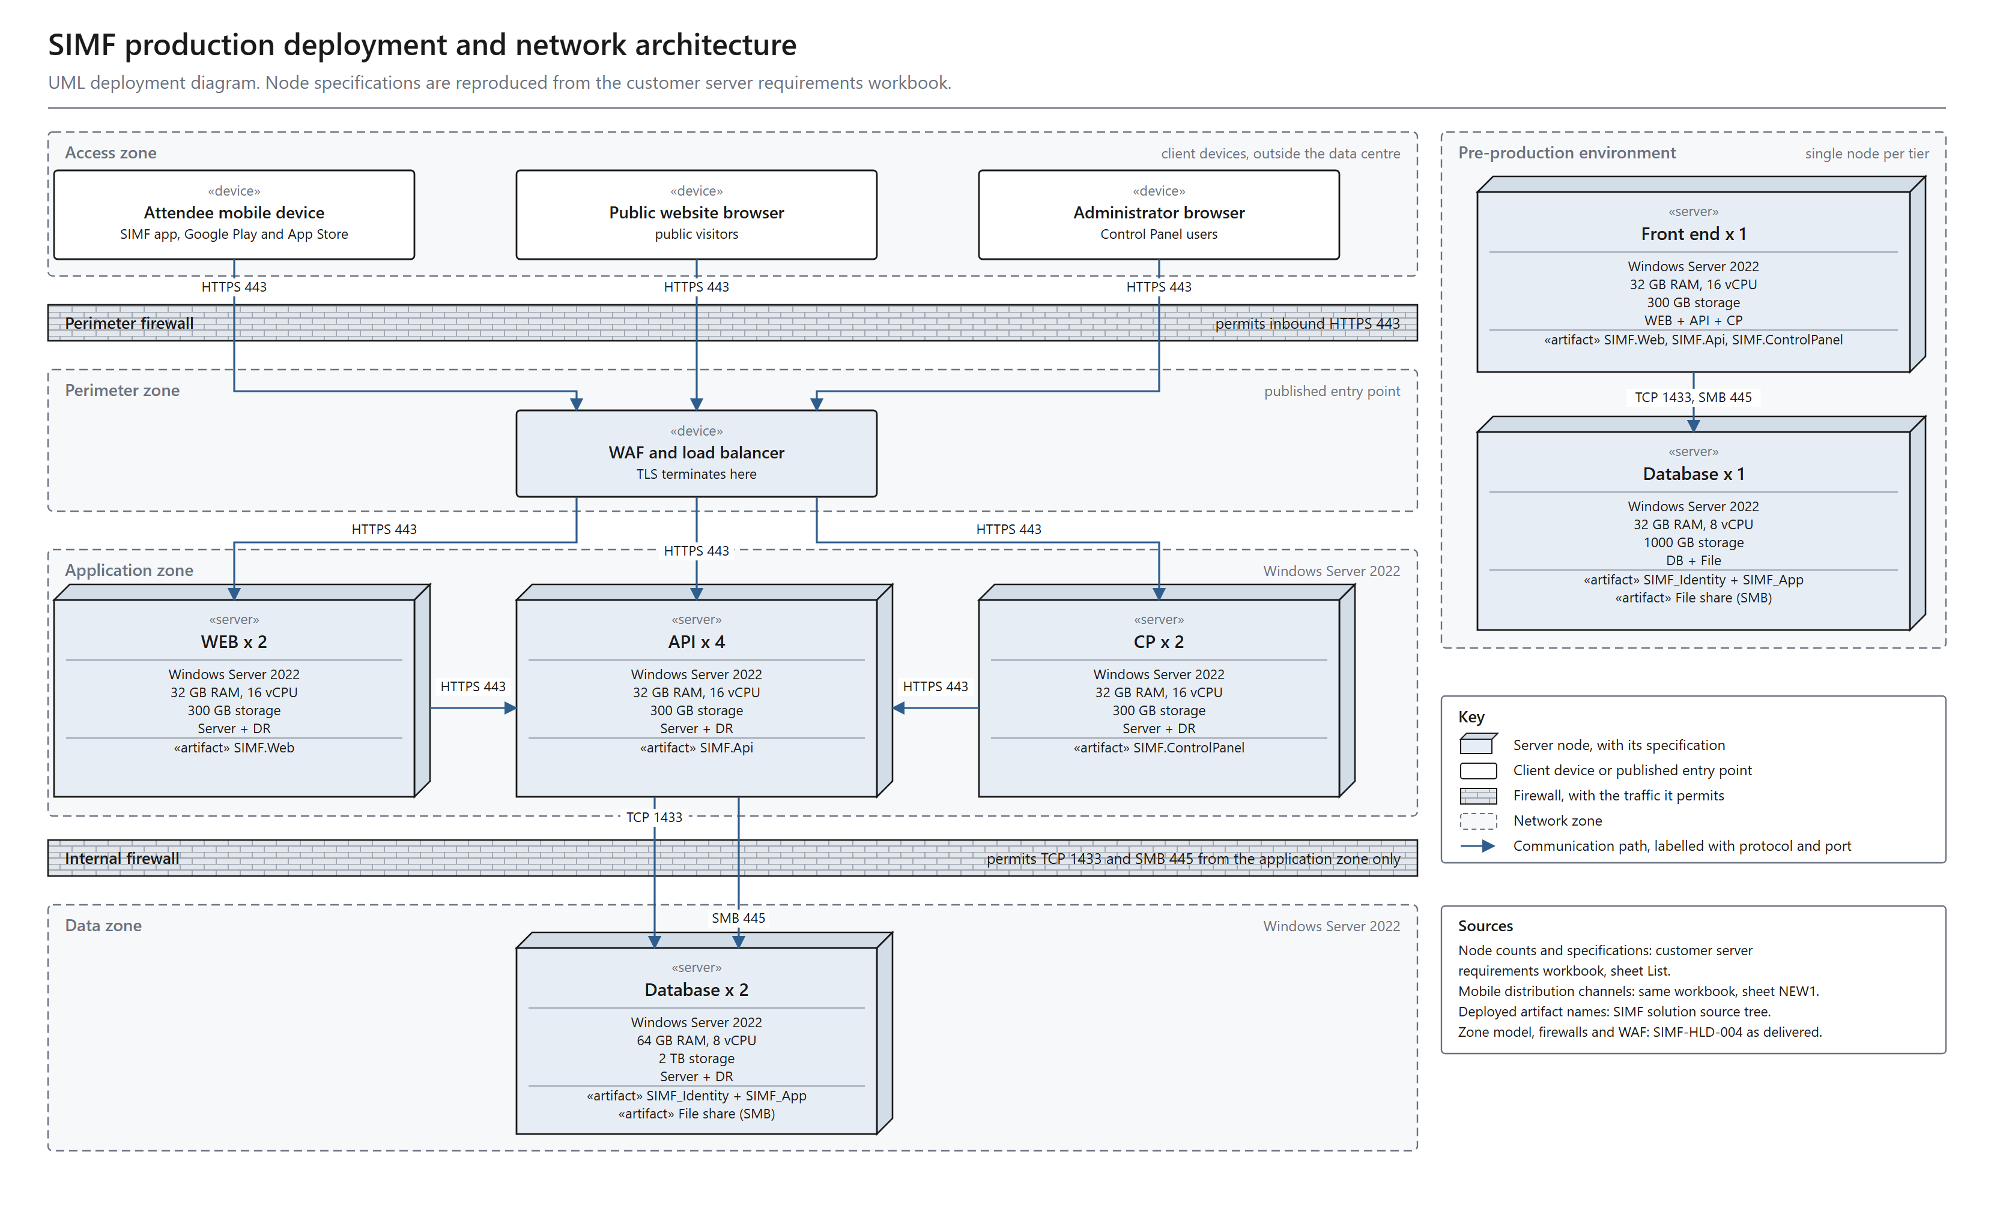
Figure 1. SIMF production deployment and network architecture, the estate as delivered. A UML deployment diagram: one node per hosting server, with its zone, its specification and the protocol and port of every path.
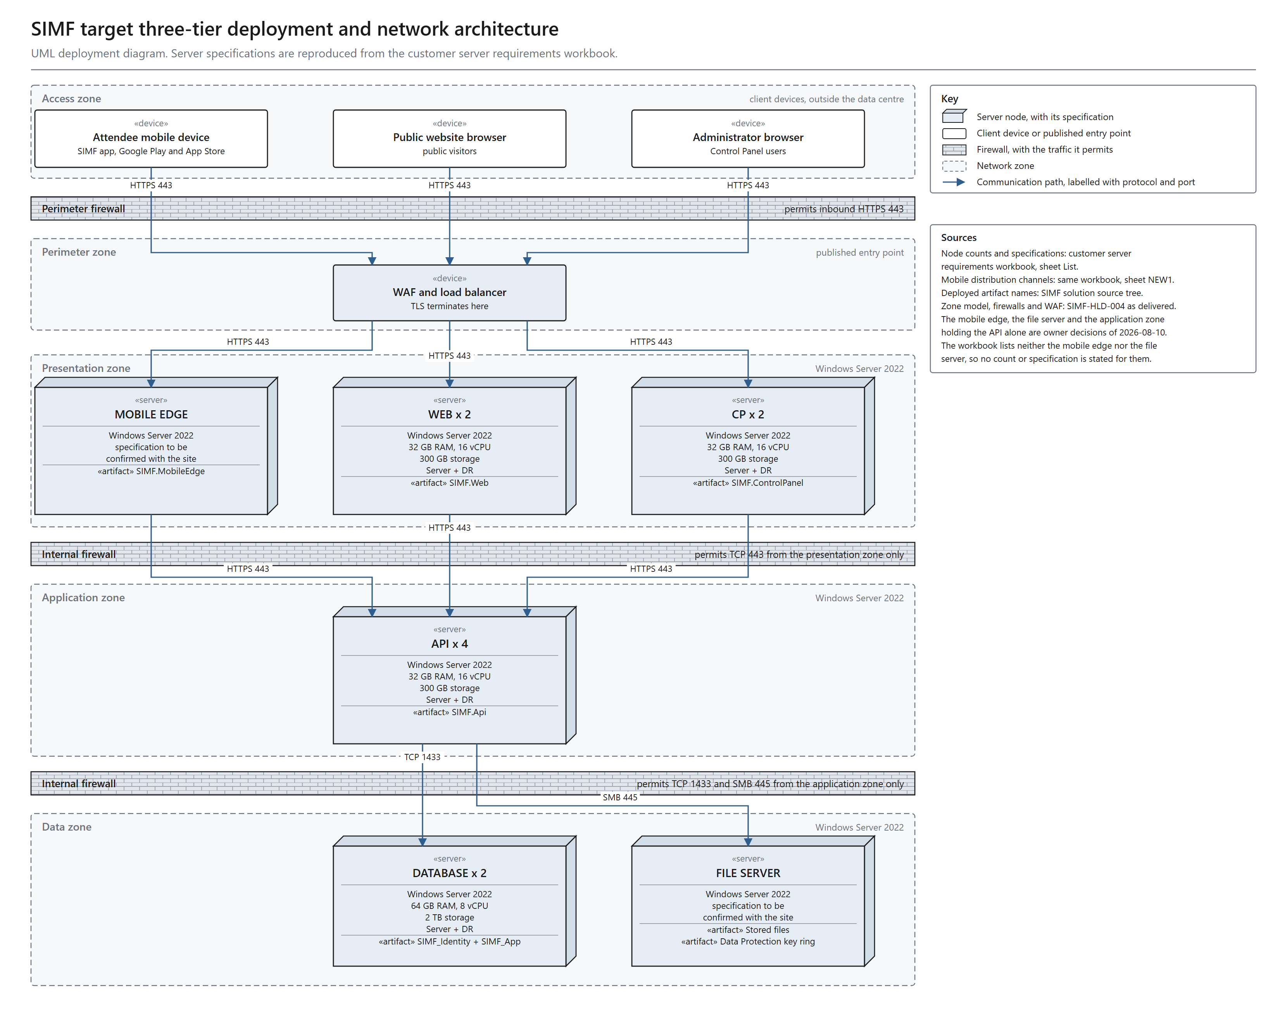
Figure 2. SIMF target three-tier deployment, agreed on 10 August 2026. A UML deployment diagram: the presentation zone holds the web, Control Panel and mobile-edge hosts, and the application zone holds the API alone, reachable only from the presentation zone.
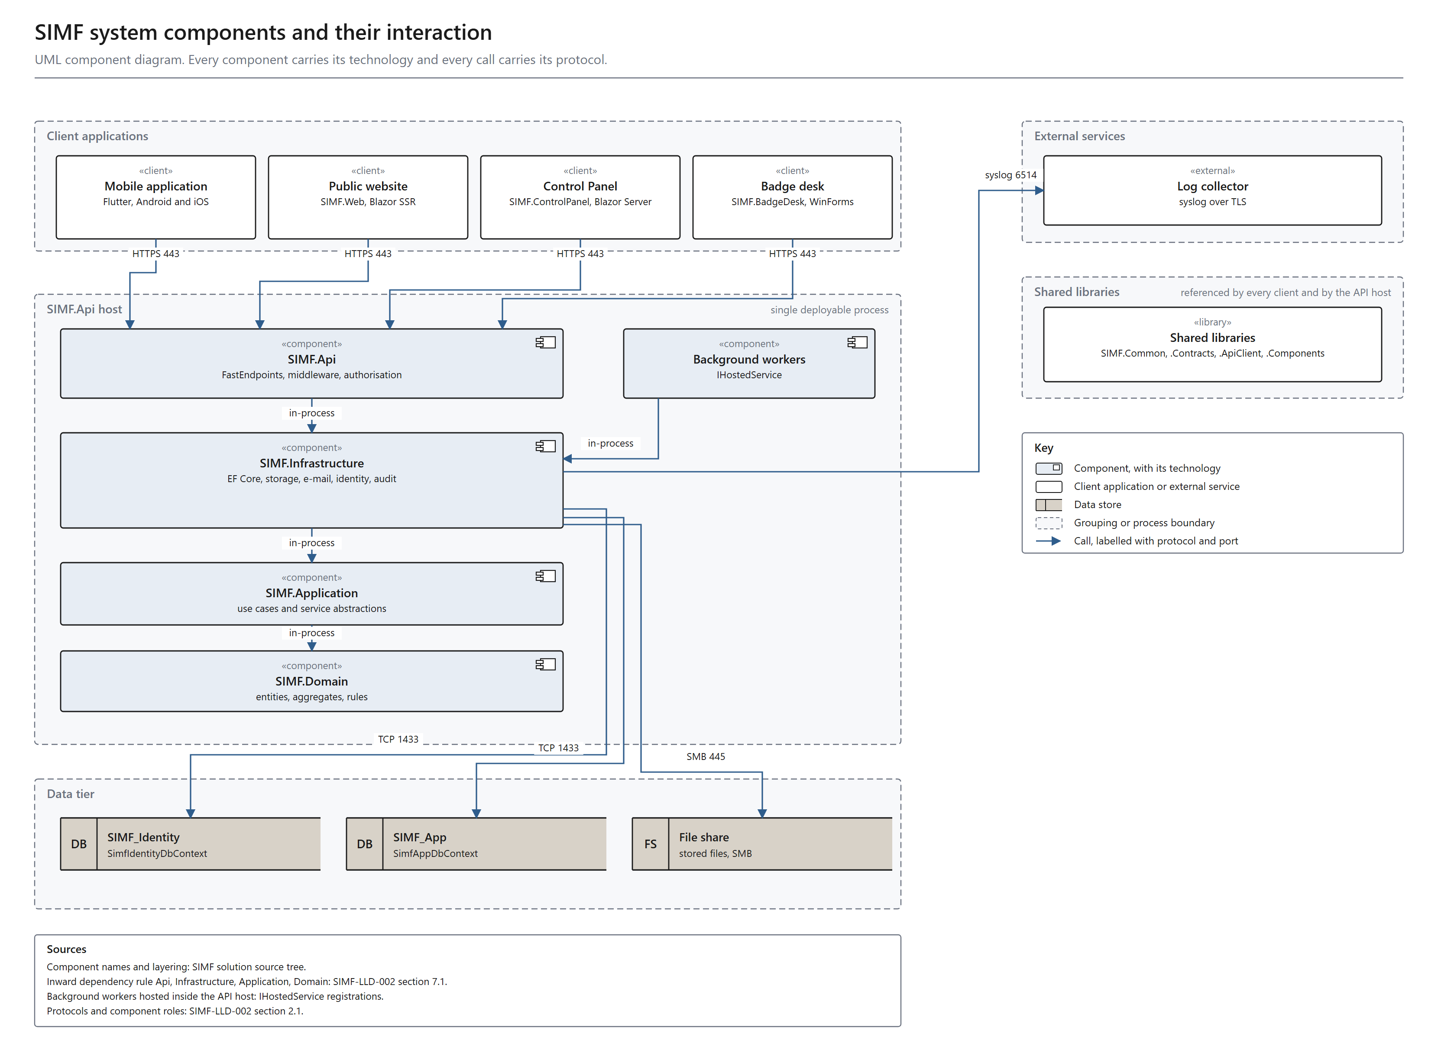
Figure 3. SIMF system components and their interaction. A UML component diagram: every component with its technology, and every call labelled with its protocol and port.
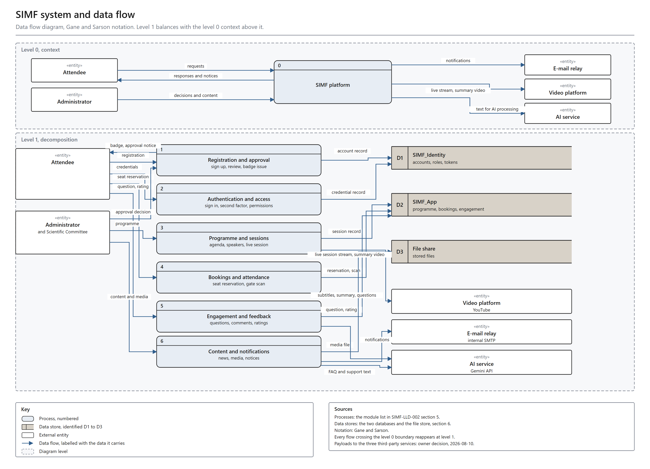
Figure 4. SIMF system and data flow. A data flow diagram in Gane and Sarson notation: a level 0 context view and a level 1 decomposition that balances with it.

Third-party services and the data sent to them
The video platform, the AI service and the e-mail relay are reached over public or internal URLs. They are integration endpoints, not components designed as part of this solution, so they appear in the data flow view and not in the component view. What matters about each is the data that crosses the system boundary.
- Video platform. Receives the live session stream while a session is running, published by the media team inside the platform and not by SIMF. SIMF sends it a public video id when importing captions. No attendee record and no personal data accompany either.
- AI service. Receives nothing in the delivered configuration, because no provider is enabled. Once a provider is enabled it would receive the fields listed in the inventory in section 2.4: session speech and text for subtitles, session content for summarisation, attendee questions for filtering, and FAQ and support text for the assistants.
- E-mail relay. Receives notifications only: the account, booking, session and announcement messages raised by the platform, each addressed to its recipient. It receives no session content and nothing from the AI or video paths.
2.4 Integration and Interfaces
Internal interfaces
- Client to API. HTTPS and REST. Every response uses the ApiResult envelope of success, data, error and meta. Errors carry a machine-readable code and bilingual messages. Standard headers are the application key, the device type, Accept-Language, and a bearer token on protected calls.
- API to SQL Server. TCP 1433 to SIMF_Identity and SIMF_App through EF Core. A unit of work touches one database at a time. There are no cross-database transactions and no cross-database foreign keys.
- API to SMTP relay. TCP 587, queued and dispatched asynchronously.
- API to Syslog and SIEM. Structured events with a correlation id.
- API to file store. SMB 445 when the store is shared. Database rows hold relative paths, never blobs.
- Website and Control Panel to API. Server-to-server over HTTPS with the shared typed client. Browser sessions hold encrypted authentication cookies and never raw bearer tokens.
Artificial intelligence
- Provider: pluggable and selected by configuration. SIMF.Api is the only caller, and the load balancer carries no AI traffic.
- Delivered setting: a local stub. No API key is present, no inference runs, and no AI request leaves the ministry network today.
- Intended provider: Google Gemini, at generativelanguage.googleapis.com.
- Enabling it requires a data-residency decision and an outbound firewall exception. The internal network currently blocks that destination.
- While the provider is disabled, every AI feature falls back to manual entry, paste or upload.
- An on-premises inference endpoint would keep every request inside the SSA zone and produce no egress. No on-premises inference service is in place today.
External interfaces, outbound only, through the controlled egress point, HTTPS 443
- Video platform captions. Server-to-server subtitle import from youtubei.googleapis.com and www.youtube.com. Data sent: the public video id only. No personal data and no credential are sent, and the call is unauthenticated because the resource is public. The returned caption host is re-validated before the second request and the HTTP client does not follow redirects. Egress approval is pending and the feature degrades to paste or upload.
- AI service. generativelanguage.googleapis.com. Not active in the delivered configuration. Egress approval is required before the provider can be enabled and is currently blocked.
Client-side external interface
- Live playback. The attendee device plays the stored stream URL directly. The platform stores only the URL, and this traffic does not traverse the SIMF backend. SIMF does not create, schedule or manage broadcasts.
No inbound interface is exposed to any external entity.
Data sent to the AI endpoint once a provider is enabled
AI feature | Fields sent once a provider is enabled | Personal data | Destination
Question filter | The question text only | No | Configured AI endpoint
FAQ answer | The visitor question and the published FAQ entries | No | Configured AI endpoint
Assistance | The visitor question and the public programme context | No | Configured AI endpoint
Translation | The source text and the target language | No | Configured AI endpoint
Live translation | The live caption line and the target language | No | Configured AI endpoint
Live sign language | The live caption line | No | Configured AI endpoint
Session minutes | Session title, speaker display names, abstract, and the subtitle transcript in English and Arabic | Yes, speaker display names | Configured AI endpoint
Control Panel assistant | The administrator question and the Control Panel context | No | Configured AI endpoint
Website assistant | The visitor question and the published FAQ content | No | Configured AI endpoint
Session minutes is the only feature that carries personal data, and that data is the speaker display names, which are already published in the public programme.
The caller identity travels in a separate context object that is never passed into the provider call, so account identifiers, e-mail addresses, national identity and Iqama numbers, passport numbers, badge identifiers and booking records cannot reach the AI service.
Hard limits are enforced on every call: at most 16 input values, keys of at most 64 characters and values of at most 4000 characters. Every invocation is logged and rate-limited per administrator.
Website assistant
The public website carries an assistant that answers from published FAQ content. It passes the visitor question text to the AI endpoint and stores no visitor identity. It follows the same provider configuration as every other AI feature.
2.5 Error Handling and Logging
Error handling
- A central middleware converts domain and validation exceptions into the standard failure envelope with the correct HTTP status code. Clients render the bilingual message.
- Request validation runs per request shape and returns HTTP 400 with field-level bilingual detail.
- Invalid states are logged and thrown. There is no silent fallback.
- Network faults in the typed client are mapped to failed envelopes rather than exceptions.
- The API refuses to start in production when a required secret is missing.
Logging
- Structured logging to console and rolling files with 31-day retention, forwarded to the central Syslog and SIEM.
- Every request carries a correlation id propagated into the logs and both audit trails.
Events logged
- Access and authentication events: sign-in, one-time password, TOTP, refresh and sign-out.
- Authorisation denials and rate-limit rejections.
- Security-relevant business events such as approvals, configuration changes and gate scans, recorded with actor, subject, source address, user agent, outcome, error code and correlation id.
- Row-level data changes, recorded with operation, before and after images, affected columns, actor snapshot and correlation id.
- System errors and unhandled exceptions.
Both audit trails are append-only at the application level, so the record cannot be rewritten by the application.
2.6 User Interface (UI) Design
Three front-ends share one design system and are bilingual, with Arabic primary and right-to-left and English secondary.
Mobile application
Flutter on iOS and Android. A persistent five-tab shell of Home, Sessions, Badge, Map and Profile over about 34 feature areas: onboarding, sign-in and sign-up, profile and registration, programme and session detail, seat picker, digital badge, venue map, live broadcast, session minutes, news, media gallery, archive, booths, sponsors, media partners, comments and questions, networking, contacts, meetings, gate scan for staff, session moderation, notifications, accessibility and rating.
Control Panel
Blazor Server. About 12 navigation groups: Overview, People, Access Control, Programme, Scientific Committee, Exhibition, Engagement, Knowledge, Content, Public Relations, Gates and Reference Data. Every list page uses one standard data-grid component with a shared CRUD framework, so all administration pages behave identically.
Public website
Blazor SSR, statically rendered published content: home, about, objectives, organiser, themes, venue, programme, opening, sessions, exhibition, government meetings, speakers, partners, archive, discover and visit information.
- The website carries no sign-in, no registration and no account page, and stores no personal data. Registration and all visitor data are held in the mobile application and the Control Panel.
- Two pages are public by token or by content only. The meeting confirmation page is opened from a private per-speaker link. The assistant passes the visitor question text to the AI endpoint without an identity.
Wireframes and mockups
The approved design is maintained in the project design file, with a per-page node map and a page index.
Usability
- Arabic-first right-to-left layout with automatic mirroring.
- One design-token source of truth for colour, typography, spacing and radius.
- Responsive widths for phones and tablets, and pull-to-refresh on every data screen.
- Accessibility controls on mobile for text size, high contrast and reduced motion. The website targets WCAG AA.
2.7 Operational Model View
SIMF uses four environments, promoted in order with a test gate at each step: Development, Test, Staging and Production.
- Development and Test. A single node runs the three application sites and one SQL Server Standard instance, with OpenAPI enabled.
- Staging. Mirrors the production topology as a live rehearsal, ready two weeks before launch, and carries the load test.
- Production. The architecture of section 2.1, with the per-tier specifications of the sizing table.
Zone allocation
- Internet. Attendees, administrators and the video platform. No SIMF server runs here.
- SSA zone. The WAF and load balancer; the API, website and admin tiers, which carry the background jobs in-process; the internal SMTP relay and log collector; the controlled egress point; and the AI endpoint when an on-premises provider is configured.
- HSA zone. The two database nodes running the availability group, the shared file store and the backups, reached only from the application servers.
- A firewall sits at each zone boundary.
Production prerequisites
- Issue a CA-signed TLS certificate and remove the development trust-all setting from the mobile client.
- Open outbound access, through the controlled egress point, to the caption hosts youtubei.googleapis.com and www.youtube.com.
- Open outbound access, through the controlled egress point, to generativelanguage.googleapis.com before the AI provider is enabled. The internal network currently blocks this destination and a named firewall exception is required. Without it the AI features run on their manual fallback and live captioning is unavailable.
- Provision the shared file store and enable session affinity for the website and Control Panel tiers.
Service operations
- The three application sites run as IIS sites and application pools. One operations script installs, removes, starts, stops and restarts each site and reports its status.
- The background workers run in-process in the API application pool, so restarting the workers restarts that pool. The operations script exposes this as a separate target.
- Production configuration and every secret are applied as machine-scope environment variables by per-service scripts. The committed templates carry empty values and the real values are set on the server.
SMTP relay and SIEM hosting
- SMTP relay. Internal to the SSA zone, reached from SIMF.Api over SMTP with STARTTLS on TCP 587. It is the only e-mail path and it does not use the edge gateway.
- Log collector and SIEM. Internal to the SSA zone, receiving syslog over TLS on TCP 6514 from the application hosts. Fifteen Sigma 2.x detection rules are supplied with the system. The application writes structured events to rolling files, and a host log shipper configured at deployment forwards them.
- Neither component traverses the edge firewall or any Internet gateway.
Egress control
No application host except the egress point holds an outbound route. The egress host applies an FQDN allow-list and logs every request before traffic passes the edge firewall. The control is enforced at the network layer by the egress host and the firewall rules, not by a forward-proxy client in the application.
2.8 Data Architecture View
Data classification
- The content and data held by the platform are unclassified. No secret and no militarily sensitive information is held.
- The platform holds personal data for visitors, speakers and exhibitors. It is processed under the Personal Data Protection Law (PDPL) and the controls of the National Cybersecurity Authority.
- Categories held: personal and company data for speakers, visitors and exhibitors; open scientific material for sessions and workshops; and administrative data for exhibition and programme management.
- No personal or operational data is sent to a cloud AI service, with one stated exception: the session-minutes feature carries speaker display names, which are already published in the public programme. The complete field inventory is in section 2.4.
Database architecture
SIMF uses two physically separate SQL Server 2022 databases. The separation is permanent and is itself a security control, because it isolates and freezes the identity surface.
- SIMF_Identity. Users, roles, permissions, role-permissions, refresh tokens, account and one-time codes, second-factor tokens, recovery codes, biometric device keys, password history and per-user notifications.
- SIMF_App. All business data: profiles, programme and sessions, halls and seat reservations, gates and scans, exhibition and booths, sponsors, news, media, archive, networking, meetings, feedback and ratings, venue map, system settings, organisation profile and the audit tables.
Separation rules
- No cross-database foreign key. A reference from a business entity to a user is a bare identifier resolved on read with a second query, never a database constraint and never a cross-database join.
- No duplicated live data. Identity-owned data is never copied into SIMF_App. The only permitted copies are immutable audit snapshots, so the audit trail is self-contained.
- No cross-database transaction. A unit of work touches one database at a time.
Data storage
- Database. SQL Server 2022. Production runs the two database nodes as an availability group behind a listener, giving automatic failover. Development and Test use a single instance.
- File store. A shared filesystem store for avatars, identity documents, photos, recordings, presentations and media. Database rows hold references, not blobs.
File store contents
The file store holds binary content that must not sit in the database and that every application node must be able to read. In the multi-node topology it is a clustered SMB share in the HSA zone. Content is classified into 18 service categories across 4 sensitivity tiers: avatar, identity document, VIP photo, speaker photo, speaker presentation, session recording, news image, media-gallery image, media-partner logo, sponsor logo, exhibitor logo, booth logo, company logo, organisation logo, organisation hero video, programme-day image, banner and archive cover.
- Four categories are encrypted at rest: avatar, identity document, VIP photo and speaker presentation.
- Session recordings are not encrypted at rest, because HTTP range requests need seekable content and the authenticated-encryption mode used is not seekable. They are protected by access control instead.
- Access is only ever through the API, which enforces the per-category policy on every read and write. The share is not reachable from any client, from the website or from the Control Panel.
Video storage and the video library
- Live sessions are not stored by SIMF. The platform holds the stream URL only, and the stream runs from the video platform to the attendee device.
- Per-session recordings are uploaded by an administrator, held in the file store and served by the API with HTTP range requests. They are session artefacts attached to a session, not a public library.
- A public video library is not built. It is outside the scope delivered in this submission, and two options are open for a customer decision.
- Option A. Host the library on the forum channel of the video platform and hold links only. No new infrastructure is needed. Conditional on the outbound egress listed in section 2.7.
- Option B. Host the library on ministry servers. Requires storage capacity, processing and transcoding, bandwidth and backup. This is new work that needs a capacity estimate and approval, and it changes the server specification in the sizing table in section 2.1.
Data integrity and validation
- Database constraints. Primary keys, foreign keys within a single database, and unique and filtered-unique indexes, for one active reservation per seat per session.
- Transaction management. Each unit of work is atomic within one database, so no partial update is possible.
- Input validation. All input is validated server-side at the API boundary regardless of client validation. Validation rules, database column lengths and user-interface field limits are kept aligned. Every query is parameterised.
- Audit trails. Every insert, update and delete is captured with before and after images, an actor snapshot and a correlation id. Security-relevant business events are captured separately. Both trails are append-only.
- Encryption. National identity, Iqama and passport numbers, mobile numbers and identity-document images are encrypted at rest. All traffic is encrypted in transit.
- Soft delete. Business entities are deactivated rather than removed, preserving referential history.
Data flow
Attendees and administrators reach SIMF over HTTPS. TLS terminates at the load balancer, which routes public pages to SIMF.Web and application and API traffic to SIMF.Api. SIMF.Api authenticates and authorises the caller, runs the use case and reads or writes the database over TCP 1433. Files are read and written through the file store, e-mail is queued to the SMTP relay, and the outbound caption call leaves through the controlled egress point. Every request carries a correlation id written to the logs and both audit trails.
Concurrency and throughput
The platform is sized for the three forum days, when the registration surge, live-session concurrency, gate-scan bursts and notification fan-out coincide. The capacity target is about 30,000 concurrent active attendees at peak. Pass and fail thresholds are set during staging load testing and recorded in the deployment prerequisites.
Communication Requirements Matrix
The ports and protocols are the standard values for each flow. IP addresses, ranges and VLANs are assigned by the site network team.
Source | Destination | Protocol | Port | Direction | Purpose
Mobile application (Internet) | WAF and load balancer | HTTPS, TLS 1.2+ | 443 | Inbound | Application API traffic
Public browser (Internet) | WAF and load balancer | HTTPS, TLS 1.2+ | 443 | Inbound | Public website traffic
Administrator (Internet) | WAF and load balancer | HTTPS, TLS 1.2+ | 443 | Inbound | Control Panel traffic
WAF and load balancer | SIMF.Web | HTTPS | 443 | Internal | Public website rendering, session affinity
WAF and load balancer | SIMF.Api | HTTPS | 443 | Internal | API traffic, stateless, round-robin
SIMF.Web, SIMF.ControlPanel | SIMF.Api | HTTPS | 443 | Internal | Server-to-server typed API client
SIMF.Api | SQL Server availability group listener | TCP, TDS | 1433 | Internal | Data access to SIMF_Identity and SIMF_App
SQL Server node | SQL Server node | TCP | 5022 | Internal | Availability group replication
SIMF.Api | SMTP relay | SMTP, STARTTLS | 587 | Internal | Transactional e-mail, internal relay, no Internet gateway
All application hosts | Log collector and SIEM | Syslog, TLS | 6514 | Internal | Centralised structured logging, forwarded by a host log shipper
SIMF.Api | Shared file store | SMB | 445 | Internal | File store access
SIMF.Api | AI endpoint, on-premises | HTTPS | 443 | Internal | Inference when an on-premises provider is configured
SIMF.Api | Controlled egress point | HTTPS | 443 | Internal | Both outbound calls leave through this host
Controlled egress point | youtubei.googleapis.com, www.youtube.com | HTTPS | 443 | Outbound | Caption import. Egress approval pending
Controlled egress point | generativelanguage.googleapis.com | HTTPS | 443 | Outbound | AI inference when the provider is enabled. Currently blocked, firewall exception required
Attendee device (Internet) | Video platform | HTTPS | 443 | Client-side | Live session playback, does not traverse SIMF

2.9 Solution – Non-Functional Views
Solution Security View
Authentication
- E-mail and password for all audiences. Second factor: an e-mailed one-time password for visitors, a TOTP authenticator for administrators with single-use recovery codes.
- Optional biometric sign-in on mobile using an enrolled ES256 device key.
- Passwords are stored only as a one-way PBKDF2-HMAC-SHA256 hash with a per-user salt and a work factor. The plaintext is never stored and cannot be recovered. No password is ever e-mailed.
- Administrator accounts created by invitation receive a single-use link valid for seven days. The invitee sets their own password, so no shared or temporary password is transmitted.
- Forced change is enforced. When an account carries the password-change-required flag, every token-issuing path is blocked until the user sets a new password.
- SIMF operates its own ASP.NET Core Identity store. There is no Active Directory dependency.
Tokens
- Short-lived HS256 access tokens with a five-minute cap, rotating refresh tokens and an absolute 24-hour session cap.
- Token reuse is detected, and a per-user security stamp revokes a session immediately.
- The signing algorithm is pinned, so algorithm-confusion attacks are rejected.
Authorization
- Role-based access control with per-page and per-action permissions. Permission codes live in a single catalogue, are seeded idempotently, are baked into the token and are enforced on both the API and the Control Panel.
- Build-time tests fail the build if any Control Panel page or administrative endpoint is missing its permission gate.
Mobile device key
- After a successful sign-in, and only after an operating-system biometric or device-credential prompt, the application generates an ECDSA P-256 key pair on the device. Only the public key is sent to the server and stored against the account with a device identifier.
- The private key is held in the platform secure storage service, the iOS Keychain or Android EncryptedSharedPreferences under the Keystore-derived master key. It never leaves the device.
- Authentication uses a server-issued random challenge with a five-minute lifetime, signed on the device and verified against the registered public key. The challenge is cleared by an atomic conditional update, so a replayed signature is rejected.
- Revocation. The user can disable biometric sign-in and an administrator can revoke the device. Every subsequent challenge for a revoked key is refused.
- Lost or replaced device. The old key is revoked, the user signs in with password and one-time password, then enrols a new key pair. No key material is exported or transferred.
Network and platform hardening
- A web application firewall at the edge filters SQL injection, cross-site scripting and cross-site request forgery, and alerts on suspicious activity.
- Multi-dimensional rate limiting: per address on authentication, per e-mail on credential endpoints, a global safety cap, and per administrator on AI calls, with audited rejections.
- Security headers and a content security policy; an explicit origin allow-list and never a wildcard; OpenAPI disabled by default in production; upload scanning.
- Secrets are supplied only through environment variables, with production start-up guards.
Encryption
- In transit. TLS 1.2 or higher, terminated at the load balancer and re-encrypted to the backend.
- At rest. National identity, Iqama and passport numbers, mobile numbers and identity-document images are encrypted with application-level AES-GCM envelope encryption, the key supplied through an environment variable. Refresh tokens and one-time codes are stored hashed.
Audit and compliance
- Two append-only trails: security-relevant business events, and row-level before and after images. Each carries an actor snapshot, source address, user agent and correlation id.
- Aligned to the NCA Secure Application Development Standard, with ECC and OWASP baselines. A documented gap analysis drives the remediation programme.
Owner and operations actions still open
- Rotate the secrets present in development configuration history.
- Issue a CA-signed certificate and remove the mobile development TLS bypass.
- Enable the identity-lifecycle controls for password expiry, password history and dormant-account disable.
- Deploy the web application firewall.
- Commission an independent penetration test.
Solution Availability View
Database tier
- A read-write primary and one replica run with synchronous commit and automatic failover, reached through an availability-group listener. Both databases run in the group. Development and Test use a single node.
- Scheduled backups of both databases and the file store support recovery. Migration order is enforced so deployments stay forward-compatible.
Application tier
- The API is stateless and load-balanced round-robin. The website and Control Panel are server-interactive and run with session affinity. Adding nodes adds capacity with no redesign.
Load balancer
- Health checks monitor node health continuously and route traffic only to operational nodes.
- Failover reroutes traffic automatically when a node becomes unavailable.
Operational availability
- The health endpoint is a real readiness probe, checking that the database is reachable and migrations are applied, and is used by the load balancer to pull unhealthy instances out of rotation.
- Rollback restores the last known-good binaries, re-checks health and re-runs the smoke test.
- The three forum days are the critical availability window, and an outage during them cannot be rescheduled.
Solution Management and Monitoring View
- Syslog and SIEM. A centralised structured logging system collects events from the API, the Control Panel, the website and the database tier, capturing authentication events, authorisation denials, access logs, business actions, rate-limit rejections and system errors. Every event carries a correlation id for end-to-end tracing.
- Audit trails. The two database trails provide a durable, queryable record of who did what, when, from where and with what outcome, surfaced to administrators through the Control Panel.
- Health and performance. The health endpoint reports readiness. CPU, memory, response time, throughput and database query performance are monitored to support capacity planning and threshold-based alerting.
- Usage. The Control Panel presents event statistics for registrations and approvals, session attendance, seat bookings, gate scans, engagement and ratings.
- Background services. Scheduled jobs report a heartbeat to an in-process registry. A Control Panel page lists every worker with its state, last run, run and failure counts and last error. The same registry feeds a check on the health endpoint, so a stalled or faulted job pulls readiness to degraded.
- The monitoring and alerting toolchain is selected during deployment planning.
Solution Sizing and Performance View
Scaling
- Web tier. SIMF.Web scales horizontally behind the load balancer by adding nodes, with session affinity enabled.
- Backend tier. SIMF.Api is stateless, so nodes absorb registration surges, gate-scan bursts and live-session load. The baseline is four API nodes at 16 vCPU and 32 GB each.
- Database tier. The two-node availability group carries the load and scales vertically.
Performance
- Queries are indexed and projected. List endpoints page at source, with a default page size of 20 and a grid cap of 200, rather than filtering in memory.
- The API is stateless, so no session store sits on the request path.
- E-mail is queued and dispatched asynchronously, so relay latency never blocks a request.
- Live notifications and questions use client polling on a bounded interval.
Caching
- Reference and configuration data is cached at the application layer to reduce database load. Static web assets are served with cache headers. A distributed cache can be added behind the existing abstractions if load testing calls for it.
Load testing
- Peak-shaped load tests run in staging, covering registration surge, live-session concurrency, scan bursts, notification fan-out and mixed steady state. Pass and fail thresholds for response time, error rate, concurrent sessions and throughput are set there.
3. Risks and Mitigation Strategies
Security Risk
- Potential impact. Unauthorised access to attendee personal data or to administrative functions; a data breach through an unprotected endpoint; compromise of signing keys or credentials.
- Mitigation. Per-page and per-action permission gating enforced on both the API and the Control Panel, with build-time tests that fail the build if a surface is ungated. Personal data and identity documents encrypted at rest, TLS 1.2 or higher in transit. A web application firewall at the SSA-zone edge. Multi-dimensional rate limiting with audited rejections. Secrets supplied only through environment variables with start-up guards. Append-only audit trails. Alignment to the NCA Secure Application Development Standard, with an independent penetration test before handover.
- Outstanding. The secrets present in development configuration history must be rotated, a CA-signed certificate must replace the self-signed certificate, and the mobile development TLS bypass must be removed. These are owner and operations actions.
Availability Risk, event day
- Potential impact. The forum runs on fixed dates, so an outage during the three forum days cannot be recovered or rescheduled. Registration surge, live-session concurrency, gate-scan bursts and notification fan-out coincide in that window.
- Mitigation. A WAF and load balancer, a stateless multi-node API tier, and the two-node availability group for high availability. A readiness probe pulls unhealthy nodes from rotation. Last known-good binaries are retained for rollback, and peak-shaped load testing runs in staging before the event.
Scalability and Performance Risk
- Potential impact. Performance degradation at peak, when resource exhaustion could cause slow responses or downtime.
- Mitigation. A stateless API tier for horizontal scale-out; client polling on a bounded interval for live data; indexed, projected and server-paged queries; asynchronous e-mail dispatch; and application-layer caching. Load testing to peak shapes in staging, with dashboards and usage thresholds.
Integration Risk
- Potential impact. Both outbound integrations depend on a firewall exception that is not yet approved. Without it the caption import does not operate and the AI provider cannot be enabled, so session minutes, question filtering, the assistants and live captioning run on their manual fallback or do not run. A misconfigured egress rule would widen the attack surface.
- Mitigation. Every AI feature has a manual fallback of paste or upload, so no feature is hard-blocked. The provider sits behind one abstraction, so an on-premises endpoint can be adopted by configuration. All egress is funnelled through the single controlled egress point with a host allow-list, keeping the egress surface auditable. Every AI invocation is logged and rate-limited per administrator. All integration points, hosts, protocols and ports are in the Communication Requirements Matrix in section 2.8.
Schedule and Change-Freeze Risk
- Potential impact. The event date is immovable and the platform is frozen before publication, so a defect found after the freeze is expensive and disruptive to correct.
- Mitigation. Four-stage promotion with no skipping, where a failing gate stops promotion. Trunk-based development with pull-request review, a zero-warnings release build, and unit, integration and end-to-end test gates in the pipeline. A per-page end-to-end test-case catalogue is maintained as executable regression proof. Dependency vulnerability scanning and software bill-of-materials generation run in the pipeline.
Data Integrity and Compliance Risk
- Potential impact. Loss or corruption of attendee, booking or scan data; inability to evidence who changed what for a compliance audit.
- Mitigation. The identity and business databases are physically separated with no cross-database foreign keys, transactions or duplicated live data. Atomic single-database units of work. Database-enforced keys and filtered unique indexes. Soft delete preserves history. Every row change is captured with before and after images, and security-relevant events separately; both trails are append-only and carry actor, source address and correlation id.
Annex A. Technical review, requests and responses
The technical review of the previous submission raised thirteen points. This annex holds the review request and the response to each one, and names the section of this document that carries the design content behind the response.
Point | Subject | Response in one line | Section
1 | Two tier or three tier, and tier deployment | Three tier. Presentation, application and data tiers are separate servers in production. | 2.1
2 | Live stream flow | Delivered directly from the video platform to the device. It is not routed through the backend. | 2.4
3 | Embed only, or platform APIs | Embed only, plus one caption retrieval call. SIMF creates and manages no stream. | 2.4
4 | AI and caption API outbound flow | Two outbound destinations, both through the controlled egress point. The AI provider is disabled in the delivered configuration. | 2.4, 2.7
5 | Authentication and e-mailed passwords | Passwords are stored as PBKDF2 hashes. No password is ever e-mailed. Forced change is enforced. | 2.9
6 | Purpose and content of the file share | Binary content the database must not hold. 18 categories across 4 sensitivity tiers, 4 encrypted at rest. | 2.8
7 | Sequence diagrams | Not provided in sequence-diagram notation. The workflows are given as numbered walkthroughs in 2.3 with the data flow diagram at Figure 4. | 2.3, Figure 4
8 | Mobile enrolment and the ES256 key | Key pair generated on the device, only the public key registered, challenge signed, revocable. | 2.9
9 | Data shared with external services | The video platform receives a public video id. The AI service receives nothing today; the field inventory states what it would receive. | 2.4
10 | SIEM and SMTP in the diagram | Both internal to the SSA zone. SMTP on 587, SIEM on 6514. The matrix carries both. | 2.7, Figure 3
11 | Load balancer to AI connection | No such connection. It was a diagram error and is removed. Only SIMF.Api calls the AI endpoint. | 2.1, Figure 3
12 | Outbound path from the AI component | Agreed. No AI egress exists today. Any egress leaves through the egress point and the edge firewall. | 2.7
13 | Hosting server per component | Figure 1 shows one box per hosting server, and the matrix matches it row by row. | 2.1, Figure 1

Point 1
Review request. Clarify whether the solution follows a two tier or three tier deployment architecture and whether the presentation layer and the backend layer, API and business layer, are deployed separately or hosted on the same application server.
SIMF response. Three tier, and the tiers are deployed on separate servers in production.
Presentation tier: SIMF.Web on two web hosts, and SIMF.ControlPanel on two admin hosts with session affinity. Application tier: SIMF.Api on four stateless API hosts. Data tier: SQL Server 2022 in the HSA zone.
The separation is enforced in the code as well as the topology. Neither presentation project holds a database connection string or an EF Core DbContext. Both reference only the shared client libraries and reach data through the API over HTTPS 443, so a compromise of a presentation host yields no direct database access.
Development and Test run all three sites on a single node, which is the intended footprint for those environments. Figure 1 shows one box per hosting server, and Figure 2 shows the target estate in which the presentation and application zones are separated as well.

Point 2
Review request. Clarify the role and communication flow of the video platform integration, including whether the live stream is delivered directly from the platform to the mobile application and public website, or routed through the application backend.
SIMF response. The live stream is delivered directly from the video platform to the attendee device. It is not routed through the application backend.
SIMF stores only the stream URL on the session record and returns it in the session payload. The player in the mobile application then connects to the platform itself and receives the video over HTTPS 443.
The consequences are deliberate: no video, audio or segment traffic traverses any SIMF server, the platform carries no streaming bandwidth, and no live stream content is held by SIMF. The device-direct path is drawn in Figure 3.

Point 3
Review request. Also clarify whether the solution only embeds the live stream or uses platform APIs to create, manage, or retrieve live stream and caption information.
SIMF response. SIMF does not create, schedule or manage broadcasts. Those actions are performed by the media team inside the video platform.
SIMF does two things only. It embeds playback using the stored URL, and it makes one server-to-server call to retrieve the caption track for a published video id, which feeds the drafting of the session minutes.
The caption call is not essential. If it is unavailable the administrator pastes or uploads the transcript instead.

Point 4
Review request. Clarify the purpose and outbound communication flow between the application backend, the AI provider and the caption API, including the data exchange and authentication method.
SIMF response. There are two outbound destinations. Both leave the network through the single controlled egress point, and neither is approved yet.
Caption import. Purpose: retrieve the subtitle track that feeds the session minutes. Destination: youtubei.googleapis.com and www.youtube.com. Data sent: the public video id only. No personal data and no credential are sent, and the call is unauthenticated because the resource is public.
AI inference. Purpose: session minutes, question filtering, the assistants, translation and live captioning. Intended destination: generativelanguage.googleapis.com. Authentication would be that provider's API-key header. The delivered configuration selects a local stub with no API key, so no inference runs and no AI request leaves the ministry network today. Enabling the provider requires a data-residency decision and a named firewall exception, and the internal network currently blocks the destination.
The complete field-level inventory of what each AI feature would send is in section 2.4. While the provider is disabled, every AI feature falls back to manual entry, paste or upload.
Path for both: SIMF.Api to the controlled egress point, both in the SSA zone, which applies an FQDN allow-list and logs every request, then out through the edge firewall. For the caption call the returned host is re-validated before the second request and the HTTP client does not follow redirects.

Point 5
Review request. How will users be authenticated during subsequent logins if passwords are not stored. Also clarify whether the password sent by e-mail is temporary, how it is securely verified and whether users are required to change it upon first login.
SIMF response. Passwords are stored, but only as a one-way hash. SIMF stores a PBKDF2-HMAC-SHA256 hash with a per-user salt and a work factor. The plaintext is never stored and cannot be recovered from the hash.
Subsequent sign-in: the user submits the password, the API applies the same derivation to the submitted value and compares the result with the stored hash. On success a second factor is required, an e-mailed one-time code for visitors or a TOTP authenticator code for administrators. Only then are tokens issued.
No password is e-mailed to a self-registered attendee. The e-mail carries a six-digit verification code, not a password. The code is stored hashed, compared in constant time, expires, and is consumed on first use.
Administrator accounts created by invitation receive a single-use link valid for exactly seven days. The invitee sets their own password when they use it and the link is then consumed, so no shared or temporary password is ever transmitted.
Forced change is implemented and enforced. When an account carries the password-change-required flag, which is set when an administrator rotates a credential or a password reaches its maximum age, every token-issuing path is blocked until the user sets a new password.

Point 6
Review request. Clarify the purpose of the file share storage and specify the type of files and data that will be stored in it.
SIMF response. Purpose: to hold binary content that must not be stored in the database and that must be readable by every application node. In the multi-node production topology it is a clustered SMB share in the HSA zone, so any API node can read back what another node wrote. Database rows hold relative paths, never blobs.
Content is classified into 18 service categories across 4 sensitivity tiers. The categories are avatar, identity document, VIP photo, speaker photo, speaker presentation, session recording, news image, media-gallery image, media-partner logo, sponsor logo, exhibitor logo, booth logo, company logo, organisation logo, organisation hero video, programme-day image, banner and archive cover.
Four categories are encrypted at rest: avatar, identity document, VIP photo and speaker presentation. Session recordings are not encrypted at rest, because HTTP range requests need seekable content and the authenticated-encryption mode used is not seekable. They are protected by access control instead.
Access is only ever through the API, which enforces the per-category policy on every read and write. The share is not reachable from any client, from the website or from the Control Panel.

Point 7
Review request. Provide sequence diagrams for the key system workflows, clearly showing the interaction and communication between all relevant system components.
SIMF response. Sequence diagrams in UML sequence notation are not provided in this submission. What is provided is stated plainly so the gap is visible.
Section 2.3 gives each key workflow as a numbered walkthrough: visitor registration and approval, sign-in with a second factor, seat reservation, gate scan, live session and questions, session minutes, and rating and feedback. Each names the actor, the component that handles each step, and the decision and exception paths.
Figure 3, the component and interaction view, shows every component with its technology and every call with its protocol and port.
Figure 4, the system and data flow, shows a level 0 context view and a level 1 decomposition into six numbered processes over the three data stores, and every flow that crosses the level 0 boundary reappears in the level 1 view.
The protocol and port on every line in the figures is taken from the Communication Requirements Matrix in section 2.8, so the figures and the matrix cannot disagree.

Point 8
Review request. Clarify the mobile enrolment and authentication flow including the one-time password process, secure storage of the ES256 private key on the device, public key registration, device binding, key revocation, and the process flow when the device is lost or replaced.
SIMF response. Enrolment. The attendee signs up with e-mail and password, verifies the e-mail with a six-digit code, completes the profile, and waits for administrator approval. Ordinary sign-in is password plus an e-mailed one-time code, which is hashed at rest, compared in constant time, time-limited and consumed on first use.
Device-key enrolment. After a successful sign-in, and only after the user passes an operating-system biometric or device-credential prompt, the application generates an ECDSA P-256 key pair on the device. Only the public key is sent to the server, as a SubjectPublicKeyInfo DER structure. It is stored against the account with a device identifier, and that record is the device binding. The server accepts ES256 only.
Private-key storage. The private key is held in the platform secure storage service, the iOS Keychain accessible only after first unlock on that device, or Android EncryptedSharedPreferences under the Keystore-derived master key. It never leaves the device and is never transmitted. Binding the key to a hardware secure element is a defined hardening step that does not change the server contract.
Authentication. The server issues a random challenge with a five-minute lifetime. The application signs it with the private key and returns the signature. The server verifies the signature against the registered public key, then clears the challenge with a single atomic conditional update that succeeds only if the challenge is still the one issued, so a replayed signature is rejected.
Revocation. The user can disable biometric sign-in in the application and an administrator can revoke the device. The key record is stamped as revoked and every subsequent challenge and verification for it is refused.
Lost or replaced device. The old device key is revoked, which immediately makes it useless. The user signs in on the new device with password plus an e-mailed one-time code, then enrols a new key pair. No key material is exported, backed up or transferred between devices.

Point 9
Review request. Clarify the data shared with each external service, including its type, purpose, sensitivity and whether any personal or confidential information is transferred outside the ministry.
SIMF response. There are two external destinations and one client-side path.
Caption import, server-to-server and outbound from SIMF. Data sent: the public video id only. Purpose: retrieve the subtitle track used to draft the session minutes. Sensitivity: public. Personal data: none. Credential: none.
Live playback, from the attendee device and not from SIMF. Data sent: the video id, plus whatever the device connection necessarily reveals to the platform, its network address and user agent. Purpose: play the stream. No SIMF account identifier, name, e-mail address or booking record is included.
AI service. Nothing is sent today, because no provider is enabled. The field inventory in section 2.4 is the complete list of what each AI feature would receive once a provider is enabled. Of those, only the session-minutes feature carries personal data, and that data is the speaker display names, which are already published in the public programme. If the provider were an on-premises endpoint the data would stay inside the SSA zone.
By construction, the caller identity travels in a separate context object that is never passed into the provider call, so account identifiers, e-mail addresses, national identity and Iqama numbers, passport numbers, badge identifiers and booking records cannot reach the AI service.

Point 10
Review request. Clarify in the diagram the SIEM and SMTP components, their communication paths, hosting locations, and applicable gateways, and update the communication matrix accordingly.
SIMF response. Both are internal and both are hosted in the SSA zone. The customer server requirements workbook lists a server for neither, so both are drawn in Figure 3, the component and interaction view, each with its protocol and port.
SMTP relay: an internal relay in the SSA zone, reached from SIMF.Api, which holds the e-mail queue, over SMTP with STARTTLS on TCP 587. It is the only e-mail path, it is internal, and it does not use the edge gateway. Mail is queued and dispatched asynchronously.
Log collector and SIEM: hosted in the SSA zone and receiving syslog over TLS on TCP 6514 from the application hosts. Fifteen Sigma 2.x detection rules are supplied with the system. The application writes structured events to rolling log files, and forwarding those files to the collector is performed by a host log shipper configured at deployment rather than by an application sink, so it is an operational deployment step.
Neither component traverses the edge firewall or any Internet gateway. Both carry a row in the Communication Requirements Matrix in section 2.8.

Point 11
Review request. In the diagram, clarify the purpose of the direct connection between the load balancer and the AI component, and whether AI requests are routed directly through the load balancer or through the main application.
SIMF response. That connection has no purpose. It was an error in the previous diagram and it has been removed.
AI requests are made only by the main application. SIMF.Api, through its infrastructure layer, calls the configured AI endpoint. There is no other caller and no other path, whatever provider is configured.
The load balancer carries no AI traffic of any kind. Its role is limited to terminating client TLS, filtering against the OWASP rule set and distributing client requests across the application tiers.
Figure 3 shows the single AI path, drawn from the infrastructure layer to the configured AI endpoint and from nowhere else.

Point 12
Review request. Clarify the outbound communication path from the AI component to the external services, including the firewall, gateway and network zone. The AI component should not connect directly.
SIMF response. Agreed, and it does not. No AI provider is enabled in the delivered configuration, so there is no AI egress at all today, and no application host except the egress point holds an outbound route.
When the ministry enables an external provider, that traffic takes the same single controlled path as the caption import and never a direct connection from the AI component: SIMF.Api in the SSA zone, to the controlled egress point in the SSA zone, which applies an FQDN allow-list and logs every request, then through the edge firewall and the perimeter gateway.
The AI endpoint is not a hosting server, so it does not appear in Figure 1, which shows servers. It is drawn in Figure 3, which shows components.
One point of precision, so the control is not over-stated: this restriction is enforced at the network layer, by the egress host and the firewall rules. No forward-proxy client is configured in the application code, so the control is a deployment and network control rather than an application feature. The application requires no change for it to take effect.

Point 13
Review request. Update the deployment diagram to show the hosting server for each component rather than grouping the components under a single application server, and update the communication matrix accordingly.
SIMF response. Figure 1 replaces the previous grouped diagram and shows one box per hosting server, each placed in its zone with its gateway.
Internet zone: attendee mobile device, public website browser, administrator browser, and the video platform. No SIMF server is hosted here.
SSA zone: WAF and load balancer, active and standby; API hosts, four; web hosts, two; and admin hosts, two, which are the four server rows in the customer server requirements workbook. Also the internal SMTP relay, the log collector and SIEM, and the controlled egress point. The background jobs need no server of their own, being hosted services inside the API host.
HSA zone: the two database hosts of the workbook, running the availability group primary and its replica, and carrying the shared file store.
The Communication Requirements Matrix in section 2.8 matches Figure 1 row by row.

Annex B. Customer clarification points
The customer raised seven clarification points on the previous submission. Each is answered in the section of this document that owns the subject. This annex gives the answer in one line and names that section.
No. | Clarification requested | Answer in one line | Section
1 | Is the site restricted to Ministry of Defense personnel | No. The forum is international and the platform is open to all segments of the public, not restricted to ministry personnel or to Saudi nationals. | 1.2, 1.3
2 | Classification of the content and data | Unclassified. No secret or militarily sensitive information is held. Personal data for visitors, speakers and exhibitors is processed under the PDPL and the NCA controls. | 2.8, 2.9
3 | Are the administrators ministry staff and external staff | Both. Royal Saudi Naval Forces personnel and staff of the organising company, each with a defined role and per-page and per-action permissions. | 1.3, 2.9
4 | Is an external AI and video integration required | Yes, two separate integrations. Both need an outbound firewall exception that the internal network currently blocks. Without it the AI features run on their manual fallback. | 2.4, 2.7, 2.8
5 | Data categories, and whether the website holds personal data | Three categories: personal and company data, open scientific material, and administrative data. The website carries published content only, with no registration and no personal data. | 2.6, 2.8
6 | Public video storage together with streaming | A public video library is not built. Per-session recordings are stored and streamed internally. Two options are open for a customer decision, and option B changes the server specification. | 2.1, 2.8
7 | AI tools for analysing video content | All are built: caption import, session minutes with committee approval, question filtering, and the application, website and Control Panel assistants. Live translation and a sign-language feed are also provided. All await the provider being enabled. | 1.2, 2.3, 2.4

Approvals

Technology Expert, Role 1  Signature: _______________________________ | Date__________
Technology Head  Signature: _____________________________ | Date__________
Technology Director  Signature: _____________________________ | Date__________

