SIMF-2026



Software Architecture and Design
High-Level Design
System Architecture Overview
SIMF-HLD-001

Document | High-Level Design (HLD)
System | SIMF - Saudi international Maritime forum
Version | 1.0
Date | 2026-07-25
Status | Draft for review
Audience | Solution Architecture & leading engineer

Confidential Engineering & Architecture Team

Document Control
Field | Value
Document | High-Level Design (HLD)
System | SIMF - Saudi International Maritime Forum platform
Version | 1.0 (Draft)
Date | 2026-06-25
Status | Draft for review
Audience | Solution architects, lead engineers, security reviewers, client technical representatives

This document is written to a generic industry HLD template and is self-contained. It is grounded in the current source tree on branch feature/app-cp-api-split, not only in the 2026-05-21 controlled-document baseline. For the formally controlled architecture record see SIMF-SAD-001; for the contract-level detail see the companion Low-Level Design (SIMF-LLD-001). This HLD is not (yet) registered as a type in SIMF-DMP-001 §4.2.

Contents
1. Introduction 4
1.1 Purpose 4
1.2 Scope 4
1.3 What SIMF is 4
1.4 Definitions and acronyms 5
1.5 Reference documents 5
2. System context 6
2.1 Context diagram 6
2.2 Primary actors and channels 6
2.3 External integrations 7
3. Architecture overview 7
3.1 Architectural style 7
3.2 Logical layering (backend) 7
3.3 Physical / deployment view 8
4. Component architecture 8
4.1 Component inventory 8
4.2 Backend API (SIMF.Api) 9
4.3 Client applications 10
4.4 Real-time (SIMF.RealTime) - as-designed vs. as-built 11
5. Technology stack 11
6. Data architecture 11
6.1 Two-database separation 11
6.2 Separation rules (permanent invariants) 12
6.3 Data conventions (high level) 12
7. Integration and interface design 12
7.1 Client ↔ API 12
7.2 API ↔ external services 12
8. Security architecture 13
8.1 Authentication 13
8.2 Authorisation 13
8.3 Request protection and hardening 13
8.4 Data protection and audit 13
8.5 Compliance posture 13
9. Deployment and operations 14
9.1 Environments 14
9.2 CI/CD 14
9.3 Health, rollback and observability 14
10. Non-functional requirements (quality attributes) 14
11. Cross-cutting concerns 15
12. Key architectural decisions 15
13. Assumptions, constraints and open items 16

1. Introduction

1.1 Purpose
This High-Level Design describes the architecture of the SIMF platform end-to-end: its major components, how they are layered, how they communicate, where data lives, how the system is secured, and how it is deployed. It is the entry point for anyone who needs to understand the shape of the system before reading code or the detailed Low-Level Design.

1.2 Scope
The HLD covers the whole system:
- the Backend API (.NET 10, FastEndpoints),
- the Control Panel (Blazor Server admin application),
- the public Website (Blazor SSR with interactive auth islands),
- the Mobile application (Flutter, Android + iOS),
- the two SQL Server databases (SIMF_Identity, SIMF_App),
- the shared libraries that bind the .NET surfaces together, and
- the deployment, operations and security envelope around them.

1.3 What SIMF is
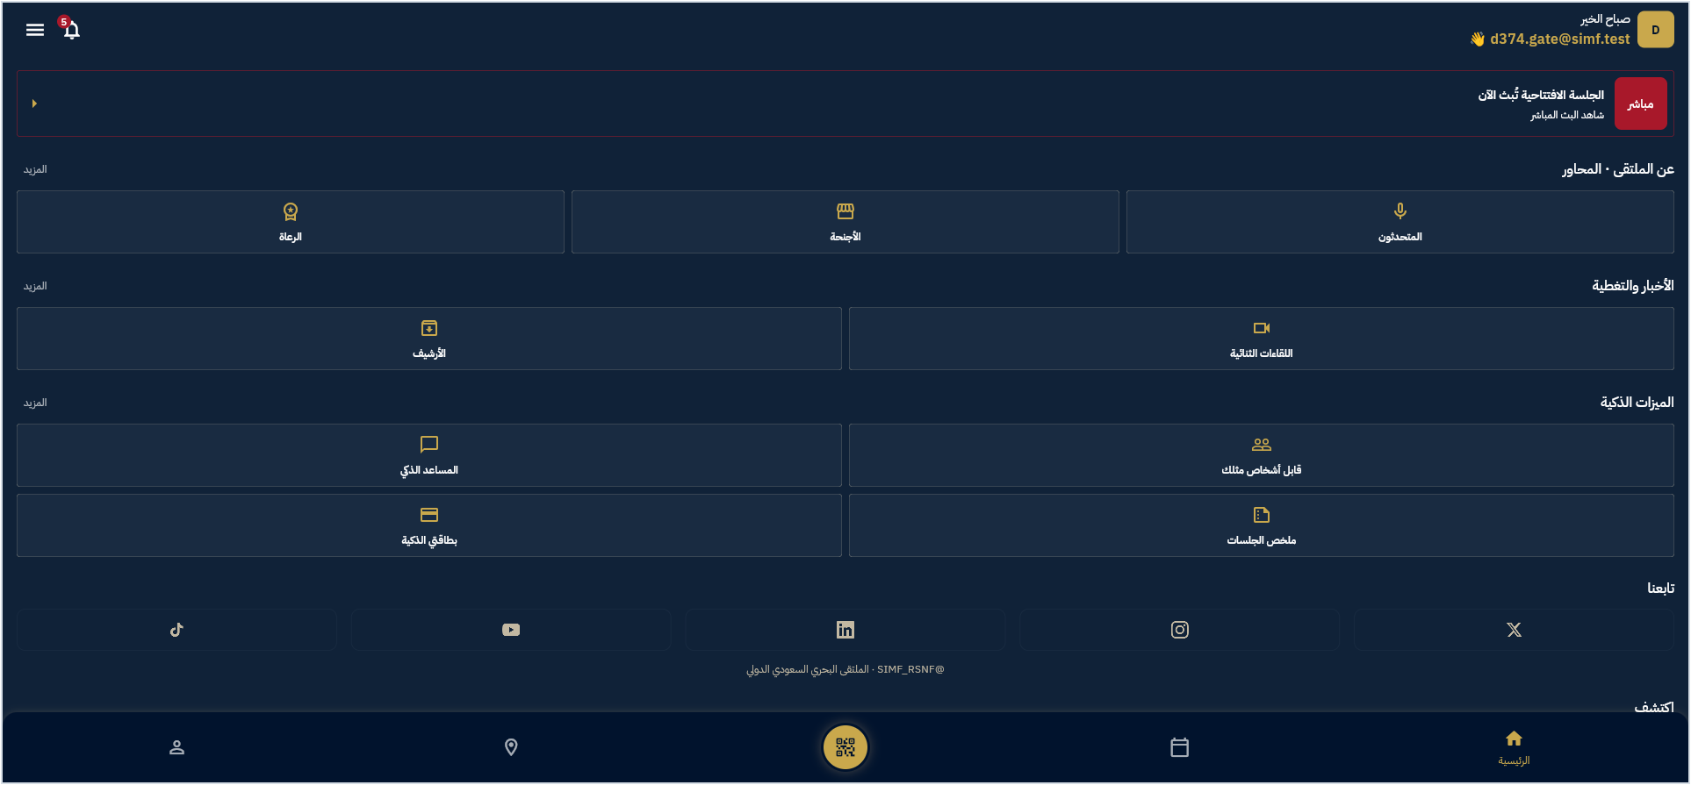
Figure 1. SIMF mobile app - attendee Home (Arabic RTL, navy theme)
SIMF is a single-tenant event platform for a maritime forum run for the Royal Saudi Naval Forces (RSNF) under a Ministry of Defense programme. It serves three audiences through three front-ends that share one backend:
- Attendees / visitors / VIP delegates use the mobile app (and the public website) to register, receive a digital badge, browse the programme, reserve seats, watch live sessions, ask questions, network, and rate the event.
- Organisers / administrators / scientific committee / public-relations / gate operators use the Control Panel to manage every aspect of the event.
- Anonymous public use the website to read public content (home, programme, visit information) and to begin registration.

1.4 Definitions and acronyms
Term | Meaning
API | Application Programming Interface (the FastEndpoints HTTP backend)
CP | Control Panel (Blazor Server admin app)
BFF | Backend-for-Frontend (the thin server-side endpoint layer in CP/Website)
DDD | Domain-Driven Design
JWT | JSON Web Token
TOTP | Time-based One-Time Password (authenticator app)
OTP | One-Time Password (e-mailed code)
RBAC | Role-Based Access Control
PII | Personally Identifiable Information
RTL / LTR | Right-to-Left / Left-to-Right text direction (Arabic / English)
NCA | National Cybersecurity Authority (Saudi Arabia)
SSR | Server-Side Rendering
SoT | Source of Truth

1.5 Reference documents
SIMF-SAD-001 (Software Architecture Document), SIMF-API-001 (API Specification), SIMF-DAT-001 (Data Model & Database Design), SIMF-MAA-001 (Mobile Application Architecture), SIMF-CPD-001 (Control Panel Design), SIMF-RPM-001 (Roles & Permissions), SIMF-OPS-001 (Deployment & Operations), SIMF-SES-001 (Engineering Standards), and the companion SIMF-LLD-001 (Low-Level Design).

2. System context

2.1 Context diagram
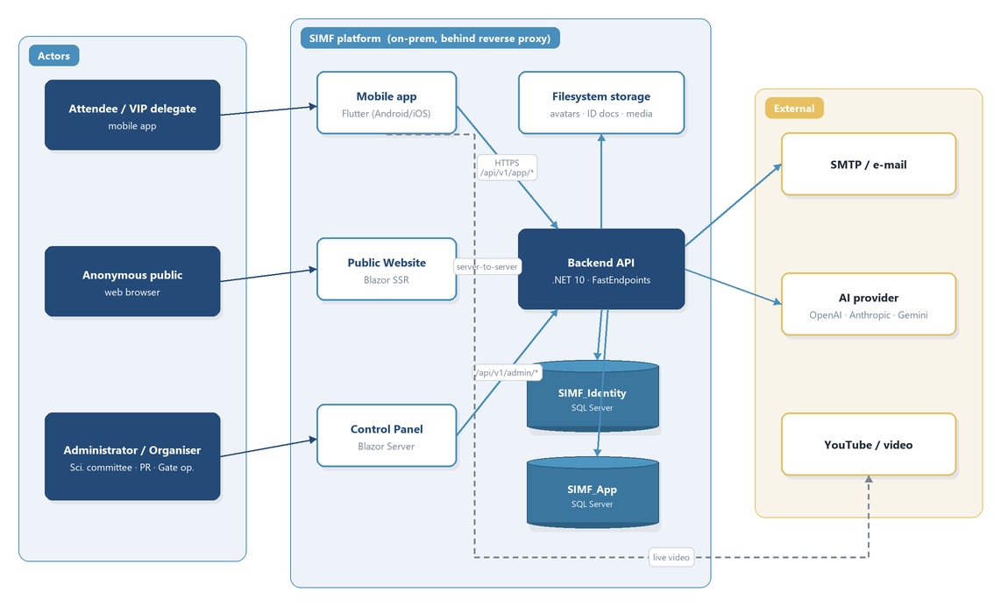
Figure 2. System context - actors, platform surfaces and external integrations

2.2 Primary actors and channels
Actor | Channel | Authentication
Attendee / visitor | Mobile app | Email + password, e-mail OTP second factor, optional biometric (device key)
VIP / delegate | Mobile app + CP-provisioned | Same as visitor; delegate flag granted by admin
Anonymous public | Website | None for public reads; registration starts the visitor flow
Administrator | Control Panel | Email + password + TOTP (authenticator) second factor
Gate operator | Mobile app (staff role) + CP operator console | Standard auth + role grant
Scientific committee / moderator | CP + mobile moderator screens | Standard auth + per-session grant / role

2.3 External integrations
- SMTP - transactional e-mail (verification codes, OTP, approval notices, alerts), sent asynchronously through an in-process queue.
- AI provider - pluggable (Echo stub, OpenAI, Anthropic, Gemini) behind an abstraction; used for session-summary generation and comment/question filtering. Provider is a configuration choice, not a code change.
- Video / live stream - YouTube (via the app's YouTube iframe player) with HLS/MP4 fallback for live sessions and sign-language feeds.
- Maps - a 2D venue map rendered from data the admin maintains (no third-party map service dependency in the current design).

3. Architecture overview

3.1 Architectural style
SIMF is a modular monolith with a single backend API fronting three client applications and two databases. The backend follows Domain-Driven Design layering and is organised internally by bounded context (feature area). There is one HTTP API process; the audience split between app users and administrators is structural (route prefixes and separate OpenAPI documents), not a separate deployable service.
Key principles:
- One API, one envelope, one permission model shared by every client.
- Two physically separate databases for identity vs. business data, with no cross-database foreign keys (see §6).
- Stateless API tier (no in-process session state) so the event-day deployment can scale out horizontally without redesign.
- Configuration over code - content, categories, roles, permissions, and many behaviours are editable from the Control Panel without a release.

3.2 Logical layering (backend)
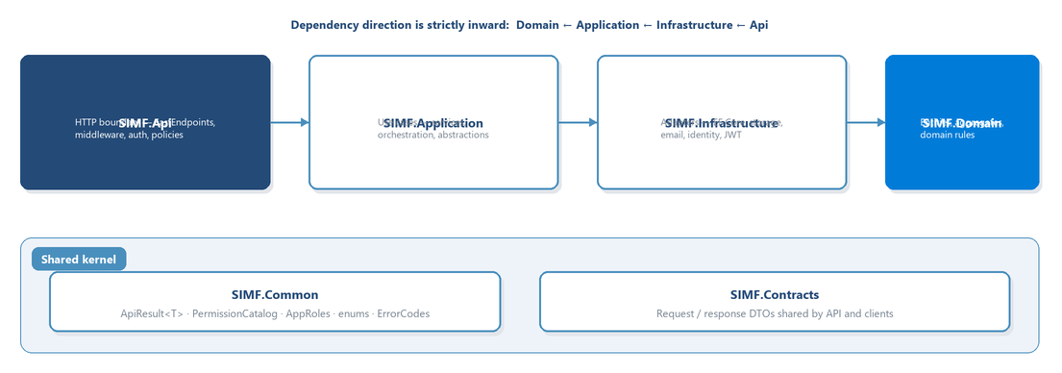
Figure 3. Backend logical layering - dependencies point inward
Dependency direction is strictly inward: Domain ← Application ← Infrastructure ← Api. SIMF.Domain has no framework dependencies. SIMF.Application holds use cases and abstractions with no ASP.NET/EF dependency. SIMF.Infrastructure implements those abstractions (EF Core, storage, e-mail, identity). SIMF.Api is the HTTP boundary.

3.3 Physical / deployment view
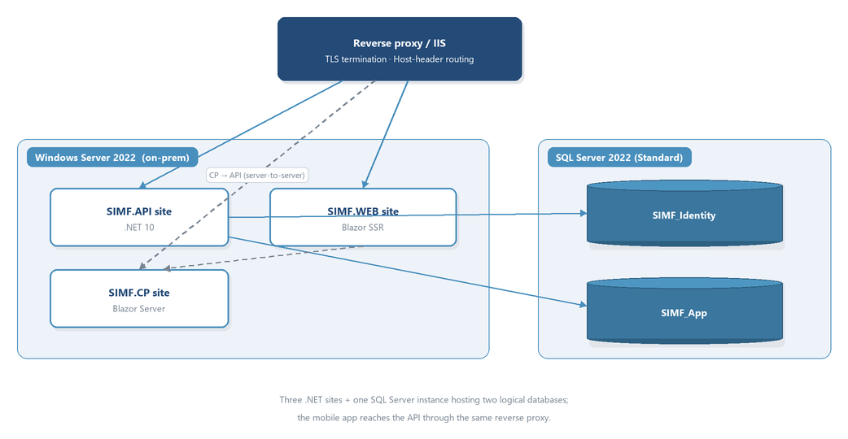
Figure 4. Physical / deployment view
Three .NET sites (API, Control Panel, Website) plus one SQL Server instance hosting two logical databases. The mobile app reaches the API through the same reverse proxy. The two client web sites call the API server-to-server using the shared typed client; browser sessions hold encrypted auth cookies, never raw bearer tokens.

4. Component architecture

4.1 Component inventory
# | Component | Technology | Responsibility
1 | SIMF.Api | .NET 10, FastEndpoints | The HTTP API: authentication, authorisation, all app/admin endpoints, middleware, background workers
2 | SIMF.Application | .NET 10 | Use-case orchestration, service contracts (abstractions)
3 | SIMF.Infrastructure | .NET 10, EF Core | Persistence (two DbContexts), storage, e-mail, JWT/identity, audit interceptors
4 | SIMF.Domain | .NET 10 | Entities, aggregates, enums, domain rules
5 | SIMF.RealTime | .NET 10 | Reserved for real-time push (SignalR); placeholder on this branch (see §4.4)
6 | SIMF.ControlPanel | Blazor Server, MudBlazor | Admin UI for the whole event
7 | SIMF.Web | Blazor SSR + interactive islands | Public website + visitor self-service auth
8 | Mobile app (simf_app) | Flutter (Riverpod, go_router, Dio) | Attendee-facing Android/iOS application
9 | SIMF.Common | .NET 10 | Shared kernel: ApiResult<T>, PermissionCatalog, AppRoles, enums, error codes
10 | SIMF.Contracts | .NET 10 | Request/response DTOs shared by API and clients
11 | SIMF.ApiClient | .NET 10 | Typed HTTP client used by CP and Website
12 | SIMF.Components | Blazor (Razor class library) | Shared Simf* UI components, themes, design tokens

4.2 Backend API (SIMF.Api)
The API is the heart of the system. It exposes two surfaces from one process:
- App surface - routes under /api/v1/app/*, consumed by the mobile app and the website's public reads and visitor self-service.
- Admin surface - routes under /api/v1/admin/*, consumed by the Control Panel.
Both surfaces share the same response envelope (ApiResult<T>), the same error model, the same standard headers, and the same permission system. Two OpenAPI documents are emitted (one filtered to /app/*, one to /admin/*) so each client team reads only its own surface.
Internally the API is organised by bounded context / feature area, including: Auth & registration, Account/profile, Programme & sessions, Bookings & seats, Gates & scan, Exhibition & booths, Sponsors, News & media, Archive, Notifications, Networking, Meetings (speaker + delegation + business), Statistics, System configuration, Organisation/About, and Reference data.
The API also hosts background workers (dormant-account sweep, registration-gate auto-close, session reminders, e-mail dispatch) and storage services (avatars, encrypted ID documents, VIP photos, session recordings, speaker presentations, media assets).

4.3 Client applications
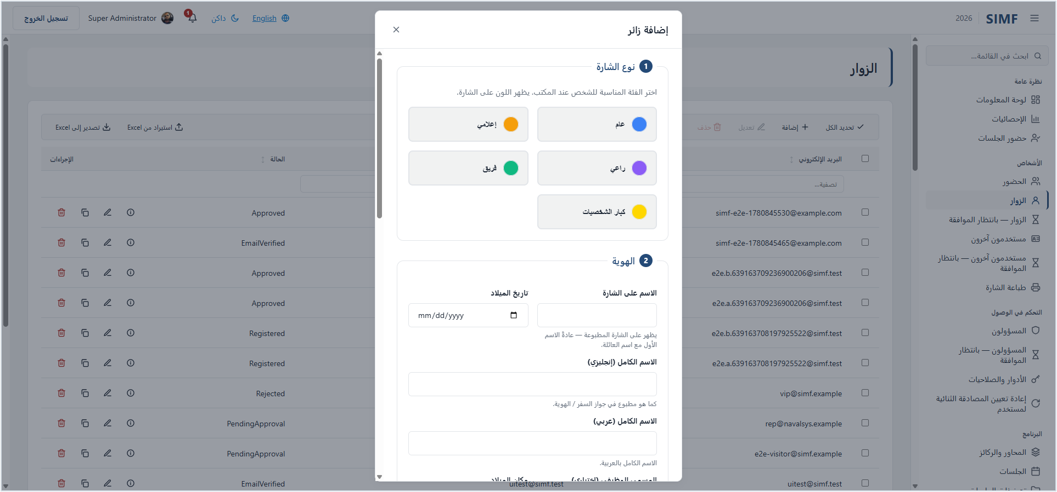
Figure 5. SIMF Control Panel - visitor administration with the add-visitor dialog
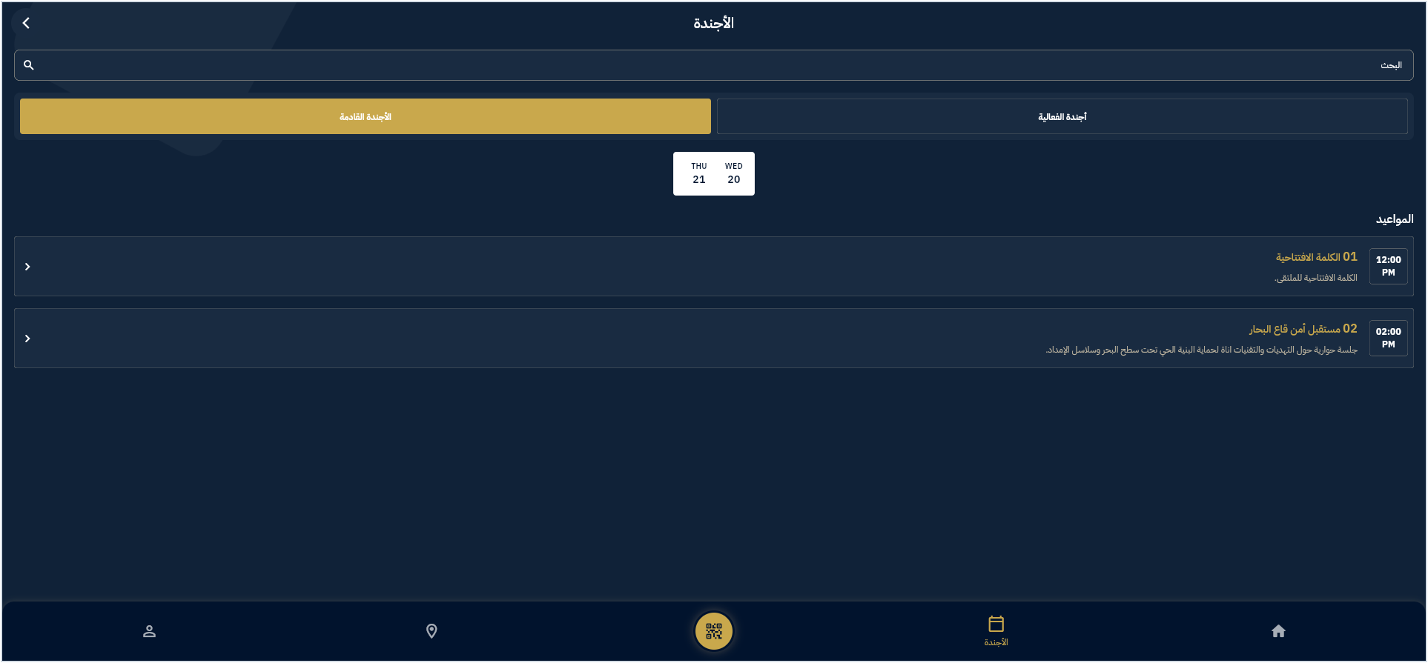
Figure 6. SIMF mobile app - programme / agenda browsing
- Control Panel (SIMF.ControlPanel) - Blazor Server (interactive server render). Cookie authentication with silent token refresh; every page and action is gated by a permission code; list pages use a standard data-grid component; full English/Arabic localisation with RTL. It calls the admin API surface through the typed client.
- Website (SIMF.Web) - Blazor SSR for fast static public pages, with interactive islands for the authentication and account flows (sign-in, OTP, forgot/reset password, profile, pending/rejected status, notifications). Public content pages call the app API's public reads.
- Mobile app (simf_app) - Flutter for Android and iOS. Riverpod state management, go_router with a persistent 5-tab bottom-navigation shell, a single Dio HTTP client with bearer-token and language interceptors, secure token storage, biometric sign-in, QR badge and scanning, and a navy-always bilingual (RTL) theme.

4.4 Real-time (SIMF.RealTime) - as-designed vs. as-built
The architecture intends SignalR-based push for live notifications, live-session interaction, and Q&A moderation, and the deployment design accounts for a SignalR backplane at event-day scale. As built on the current branch, the SIMF.RealTime project is a placeholder (no hubs are wired into the API host); clients currently obtain notifications and live data through REST reads. This HLD documents the intended design and flags the gap; the LLD records the as-built state precisely. Closing this gap is tracked as outstanding work.

5. Technology stack
Layer | Technology
Backend runtime | .NET 10
API framework | FastEndpoints + FluentValidation
ORM / persistence | EF Core (code-first) on SQL Server 2022
Identity | ASP.NET Core Identity (SimfUser, SimfRole) + custom JWT issuance
Admin UI | Blazor Server + MudBlazor + shared Simf* components
Public UI | Blazor SSR + interactive server islands
Mobile | Flutter (Dart), Riverpod, go_router, Dio
Auth tokens | JWT (HS256), refresh-token rotation, TOTP/e-mail OTP second factor
E-mail | MailKit over SMTP, queued/asynchronous
Logging | Serilog (console + rolling file, 31-day retention)
CI/CD | Azure Pipelines (trunk-based on main), IIS deploy
Hosting | On-premises Windows Server behind a reverse proxy

6. Data architecture

6.1 Two-database separation
SIMF uses two physically separate SQL Server databases:
- SIMF_Identity (SimfIdentityDbContext) - users, roles, permissions, role-permissions, refresh tokens, account codes/OTP, second-factor tokens, recovery codes, biometric device keys, password history, and per-user notifications.
- SIMF_App (SimfAppDbContext) - everything else: profiles, programme/sessions, seat reservations, halls, exhibition/booths, sponsors, news/media, archive, networking, meetings, feedback/ratings, gates/scans, system settings, venue map, organisation profile, and the audit tables.

6.2 Separation rules (permanent invariants)
- No cross-database foreign keys. A reference from an App entity to a user is a bare Guid (logical FK), resolved on read with a second query, never a database constraint or cross-DB join.
- No duplicated live data. Identity-owned data is never copied into SIMF_App (or vice versa). The only permitted copies are immutable audit snapshots (display-name/e-mail captured at write time in OperationLog / RowAudit / GateScan) so the audit trail is self-contained.
- No cross-database transaction. A unit of work touches one database at a time.
The two connection strings may point at the same instance or separate servers, supporting both the development single-server topology and an event-day scale-out.

6.3 Data conventions (high level)
- Most business entities inherit a common audit base (Id, CreatedAt/By, UpdatedAt/By, IsActive, DeletedAt) and are soft-deleted by flipping IsActive and stamping DeletedAt.
- User-facing text is bilingual - entities carry an English and an Arabic field (Name/NameArabic, Title/TitleArabic, …). Public JSON field names are stable to preserve the shipped mobile wire contract.
- PII at rest (national ID / Iqama / passport numbers and mobile numbers, plus ID-document images) is encrypted.
- The detailed entity-by-entity model, columns, keys, enums and migration history are in the companion LLD (§4) and in SIMF-DAT-001.

7. Integration and interface design

7.1 Client ↔ API
- Transport: HTTPS only. Mobile uses a single Dio client; CP/Website use the shared typed client server-to-server.
- Envelope: every response is an ApiResult<T> carrying success, data, error, and optional meta. Errors carry a machine code and bilingual (English + Arabic) messages.
- Standard headers: application key, device type, Accept-Language, and Authorization: Bearer <JWT> on protected calls.
- Pagination: simple list endpoints use page/pageSize in meta; admin grids use a GridQuery POST body (skip/top/search/sort/filters) returning a GridPage<T>.

7.2 API ↔ external services
- E-mail: queued and sent asynchronously by a background service; failures can raise out-of-band alerts.
- AI provider: consumed through a provider abstraction; every invocation is logged (telemetry, redaction markers) and rate-limited per administrator.
- Video: clients play the configured live-stream URL (YouTube iframe with HLS/MP4 fallback); the platform stores only the URL.

8. Security architecture

8.1 Authentication
- Email + password for all audiences. Second factor: e-mail OTP for visitors, TOTP (authenticator) for administrators; optional biometric sign-in on mobile via an ES256 device key.
- Access tokens are short-lived JWTs (HS256). Refresh tokens rotate on use; the session has an absolute 24-hour cap. Token reuse is detected and a per-user security-stamp check lets the system revoke a session immediately.

8.2 Authorisation
- RBAC with per-page/per-action permissions. Permission codes (format Page.Action) live in a single PermissionCatalog, are seeded idempotently, baked into the JWT as perm claims, and enforced on both the API and the Control Panel.
- Administrator holds the wildcard * and satisfies any permission.
- Build-time tests fail the build if a Control Panel page or admin endpoint is missing its permission gate - an ungated admin surface is treated as a security defect.

8.3 Request protection and hardening
- Rate limiting is multi-dimensional: per-IP (auth bucket), per-email (credential endpoints), a global safety cap, and per-admin (AI test). Rejections are audited.
- Security headers and a Content-Security-Policy are applied; OpenAPI/Swagger is gated by Basic auth and disabled by default in production.
- Secrets (JWT signing key, ID-document encryption key, SMTP password, AI keys) come from environment variables, never committed; the API fails to boot in production when required secrets are missing.

8.4 Data protection and audit
- PII encrypted at rest (ID numbers, mobiles, ID-document images).
- The two-database split is itself a control - the identity surface is isolated and frozen.
- Two audit trails: a durable OperationLog of security-relevant business events (sign-in, approvals, configuration changes, …) and a RowAudit row-level change log (insert/update/delete with before/after images), both append-only with actor snapshots and correlation IDs.

8.5 Compliance posture
The system is being aligned to the NCA Secure Application Development Standard (and ECC / OWASP baselines). A documented gap analysis drives a remediation programme (password policy, PII-at-rest, CSP, audit-of-denials, upload AV scanning, CI test-gate + dependency/SCA + SBOM, threat model). Several items are owner/operations actions (rotate committed secrets, issue a CA certificate, remove the development TLS bypass in the mobile release, WAF, independent penetration test) and remain open at the time of writing.

9. Deployment and operations

9.1 Environments
Four-stage promotion: Development → Test → Staging → Production, no skipping; a failing gate stops promotion. Development/Test run a single-server topology; the event-day production topology is built scale-ready (stateless API, externalised config) so scale-out is a deployment change, not a redesign.

9.2 CI/CD
Trunk-based on main with pull-request review. The pipeline builds three apps in Release with zero-warnings, runs unit/integration/E2E tests as a gate, runs dependency vulnerability scanning and SBOM generation, then deploys to IIS sites with last-known-good binaries preserved for rollback.

9.3 Health, rollback and observability
- /health is a real readiness check (database reachable, migrations applied) used by the proxy and monitors to pull unhealthy instances.
- Migration order is enforced (App database before Identity database) to keep deploys forward-compatible.
- Rollback restores the last-known-good binary, re-checks health, and re-runs the smoke test.
- Observability is Serilog structured logging plus the OperationLog/RowAudit database trails; the three forum days are the critical monitoring window.

10. Non-functional requirements (quality attributes)
Priority | Attribute | Intent / target
1 | Security | Defence in depth; every endpoint authorised and auditable; NCA / OWASP alignment
2 | Event-day availability | No avoidable single point of failure on the event-day path; validated by peak-shaped load tests (registration surge, live-session concurrency, scan bursts, notification fan-out, mixed steady state)
3 | Maintainability | One clear way to do things; DDD layering; a new engineer productive in days
4 | Configurability | Content, categories, labels, roles, permissions editable from the Control Panel without a release
5 | Performance | Stateless API, push instead of polling (intended), indexed queries; specific p95/error-rate thresholds set during load testing
6 | Portability of dependencies | AI provider and notification channels swappable via abstractions and configuration
- | Localization | Arabic (primary, RTL) and English (LTR) throughout
- | Accessibility | Mobile accessibility controls (text size, high contrast, reduced motion); web aims at WCAG AA

Concrete load-test pass/fail thresholds and the monitoring/alerting toolchain are open items to be fixed during staging.

11. Cross-cutting concerns
- Error handling - a central middleware converts domain/validation exceptions into the standard ApiResult failure envelope with the correct HTTP status; clients render the bilingual message.
- Validation - FluentValidation per request shape; failures return HTTP 400 with field-level, bilingual detail.
- Localization - bilingual everywhere; the chosen language flows from the client's Accept-Language header and drives the response message language.
- Configuration - the Options pattern binds typed config sections; production overrides and all secrets come from SIMF_-prefixed environment variables (double-underscore for nesting).
- Correlation - every request carries a correlation ID, propagated into logs and both audit trails for end-to-end tracing.

12. Key architectural decisions
ID (decision log) | Decision | Rationale
D-157 / D-246 | Two physically separate databases (Identity vs App), no cross-DB FKs | Isolate and freeze the identity/security surface; independent scaling and hardening
D-247 | One API, app/admin split by route prefix + dual OpenAPI docs | Single envelope/permission model and code reuse, with audience-scoped contracts
D-207 / D-208 | Per-page/per-action permissions, roles-only assignment, JWT-baked, Administrator = * | Fine-grained, enforceable-on-both-tiers access control
- | Modular monolith with DDD layering | Maintainability and a clear single source of truth
- | Stateless API tier, externalised config | Event-day scale-out without redesign
D-110 (+ lifts) | Schema/enum freeze with controlled additive lifts | Protect the shipped mobile wire contract and persistence surface
D-443 | NCA token caps (5-min access / 24-h absolute) + single-flight refresh | Compliance and resilience under a refresh storm

13. Assumptions, constraints and open items
Constraints
- Hard event deadline and a post-publish change freeze; mandatory NCA security compliance; source handover obligation.
- On-premises hosting behind a reverse proxy; SQL Server 2022 Standard edition.
Open items (do not guess)
- Real-time (SignalR) hubs are not implemented on the current branch (see §4.4).
- Specific load-test thresholds and the monitoring/alerting toolchain are unset.
- Owner/operations security actions remain outstanding: rotate the secrets currently in git history, issue a CA-signed certificate and remove the mobile development TLS bypass, enable the new identity-lifecycle knobs (password expiry/history, dormant-account disable), WAF, and an independent penetration test.
- A live-video provider, the venue geofence/attendance chain, and the final statistics metric list remain deferred decisions.

End of High-Level Design.

