SIMF-2026



Software Architecture and Design
Low-Level Design
Detailed Component & Data Design
SIMF-LLD-001

Document | Low-Level Design (LLD)
System | SIMF - Saudi international Maritime forum
Version | 1.0
Date | 2026-07-25
Status | Draft for review
Audience | Engineers implementing / maintaining SIMF

Confidential Engineering & Architecture Team

Document Control
Field | Value
Document | Low-Level Design (LLD)
System | SIMF - Saudi International Maritime Forum platform
Version | 1.0 (Draft)
Date | 2026-06-25
Status | Draft for review
Audience | Engineers implementing, extending, reviewing or maintaining SIMF

Written to a generic industry LLD template, self-contained, and grounded in the current source tree on branch feature/app-cp-api-split. Depth is representative: every component is covered, with class/method/schema-level detail and sequence diagrams for the important flows, using representative examples rather than an exhaustive per-method catalogue. Companion: SIMF-HLD-001 (High-Level Design). Authoritative contract docs: SIMF-API-001, SIMF-DAT-001, SIMF-RPM-001.
Verification notes: file paths, class names, routes, enum values and migration names below were read from source. Where the source itself marks something as not-yet-implemented or reserved, the LLD says so explicitly rather than inventing detail.

Contents
1. Introduction 5
1.1 Purpose and scope 5
1.2 How to read this document 5
2. Backend solution structure and layering 5
2.1 Projects and dependency direction 5
2.2 Bounded contexts 6
3. Backend request pipeline and cross-cutting design 6
3.1 Host configuration 6
3.2 Middleware pipeline (order) 7
3.3 The response envelope 7
3.4 Endpoint pattern (FastEndpoints) 7
3.5 Pagination 8
4. Authentication and authorisation (internals) 8
4.1 Token service 8
4.2 Second factor and refresh 9
4.3 Permission system 9
5. Audit, soft-delete and base entities 9
5.1 Base entities 9
5.2 Audit interceptors 10
5.3 Operation log 10
6. Backend feature design 10
6.1 Storage services 10
6.2 Background workers 11
6.3 Representative endpoint catalogue 11
6.4 Representative service walkthrough - seat reservation 12
7. Data model and database design 12
7.1 Contexts 12
7.2 SIMF_Identity entities 12
7.3 SIMF_App entities (grouped) 13
7.4 Enums (frozen against rename/reorder; additive values allowed) 14
7.5 Migration history 15
8. Control Panel (low-level design) 15
8.1 Hosting and auth 15
8.2 BFF pattern 15
8.3 Permission gating 15
8.4 List-page and CRUD standard 16
9. Website (low-level design) 16
10. Mobile application (low-level design) 16
10.1 Layout and packages 17
10.2 Networking 17
10.3 State, routing and theme 17
10.4 Screens 18
11. Shared libraries (low-level design) 18
12. Key sequence diagrams 19
12.1 Visitor sign-in with e-mail OTP 19
12.2 Admin action authorisation (permission gate) 19
12.3 Seat reservation and approval 20
12.4 Gate scan (idempotent) 20
13. Configuration, options and secrets 20
14. Appendices 21
14.1 Enum reference (selected, integer-backed) 21
14.2 Endpoint catalogue 22
14.3 Migration history (per context) 22
14.4 As-built deltas / open items 22

1. Introduction

1.1 Purpose and scope
This LLD describes how SIMF is built: project structure, the request pipeline, the classes and interfaces that implement each cross-cutting concern, the endpoint pattern and feature areas, the database schema, the two web front-ends, the Flutter app's layering, the shared libraries, and the runtime flows that tie them together. It is detailed enough to implement against and to review against.

1.2 How to read this document
Sections 2–6 cover the backend. Section 7 is the data model. Sections 8–11 cover the clients and shared code. Section 12 collects sequence diagrams for the highest-value flows. Section 14 holds reference tables (enums, endpoints, migrations).

2. Backend solution structure and layering

2.1 Projects and dependency direction
Solution file: SIMF.slnx.
Backend (src/Backend/)
Project | References | Role
SIMF.Domain | SIMF.Common | Entities, aggregates, enums, domain rules. No framework deps.
SIMF.Application | SIMF.Domain, SIMF.Common, SIMF.Contracts | Use cases, service abstractions. No ASP.NET/EF.
SIMF.Infrastructure | SIMF.Domain, SIMF.Application | EF Core contexts, storage, e-mail, identity, JWT, audit interceptors.
SIMF.Api | SIMF.Application, SIMF.Infrastructure, SIMF.RealTime, SIMF.Common, SIMF.Contracts | FastEndpoints host, middleware, auth, policies, workers.
SIMF.RealTime | SIMF.Application | Reserved for SignalR push. Placeholder (csproj only) on this branch.

Shared (src/Shared/)
Project | References | Role
SIMF.Common | - | ApiResult<T>, ApiError, PermissionCatalog, AppRoles, enums, ErrorCodes, GridQuery
SIMF.Contracts | SIMF.Common | Request/response DTOs
SIMF.ApiClient | SIMF.Common, SIMF.Contracts | Typed HTTP client for CP + Website
SIMF.Components | SIMF.Common | Shared Simf* Blazor components + theme tokens

The dependency rule is strictly inward (Domain ← Application ← Infrastructure ← Api). This is what keeps the domain testable and the persistence concerns isolated.

2.2 Bounded contexts
Endpoints live under src/Backend/SIMF.Api/Endpoints/ organised by feature folder; the matching use cases live under src/Backend/SIMF.Application/. Feature areas include: Auth/IdentityAccess, Account/MyArea, Programme (sessions/themes/speakers/presentations/summaries/recordings), SeatReservations/Bookings, Gates, Exhibition/Exhibitors/Booths, Sponsors, News/Media, Archive, Notifications, Networking, MeetingRequests (speaker/delegation) + BusinessMeetings, Statistics, Configuration (system settings / organisation profile / site settings), Organisations, Contacts, Faq, Feedback, Cms (content blocks/banners), Ai, Venue, Operations, Auditing/Logs.

3. Backend request pipeline and cross-cutting design

3.1 Host configuration
src/Backend/SIMF.Api/Program.cs configures the host. Highlights:
- FastEndpoints with route prefix api/v1.
- Dual OpenAPI documents (D-247): an app document filtered to /app/* and a cp document filtered to /admin/*.
- Authentication: JWT bearer (default scheme) plus a distinct StreamToken scheme for short-lived recording-stream tokens.
- Authorisation: named policies plus a dynamic permission-policy provider.
- CORS: explicit origin allow-list (never wildcard).
- Swagger: always on in Development; in Production gated behind Basic auth and an AllowSwagger flag, with a boot guard that refuses to start if enabled without credentials.
- Rate limiting: global per-IP plus named policies (auth, auth-email, ai-test).
- Health: GET /health.
- Hosted services: dormant-account sweep, registration-gate auto-close, session reminders, e-mail dispatch.
- Startup migration + seed: App database migrated before Identity database; then identity/reference seeding.

3.2 Middleware pipeline (order)
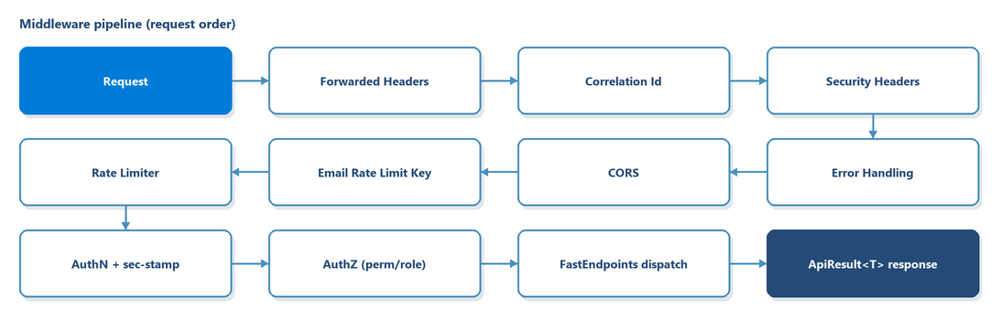
Figure 1. Backend middleware pipeline (request order)
Key middleware classes (all under src/Backend/SIMF.Api/):
Class | Responsibility
CorrelationIdMiddleware | Read/generate X-Correlation-Id; enrich logs
SecurityHeadersMiddleware | Apply baseline security response headers
ErrorHandlingMiddleware | Convert exceptions to ApiResult.Fail with correct status
EmailRateLimitKeyMiddleware | Extract email from credential bodies for per-email throttling
SwaggerBasicAuthMiddleware | Gate OpenAPI UI in production

3.3 The response envelope
src/Shared/SIMF.Common/ApiResult.cs:
public sealed class ApiResult<T>
{
public bool Success { get; init; }
public T? Data { get; init; }
public ApiError? Error { get; init; }
public object? Meta { get; init; } // pagination / counts
public static ApiResult<T> Ok(T data, object? meta = null);
public static ApiResult<T> Fail(ApiError error);
}

ApiError (src/Shared/SIMF.Common/ApiError.cs) carries Code, Message, MessageArabic, and a list of ApiErrorDetail (Field, Message, MessageArabic). ApiCallResult<T> pairs an HTTP status with the envelope so clients can branch on 401/403/etc. DataValidationException (extends ApiException) is the domain-level validation error caught by the error middleware.

3.4 Endpoint pattern (FastEndpoints)
Every endpoint is a class with Configure() (route, verbs, policies/anonymous, tags, rate limiting, summary) and HandleAsync(). A representative create endpoint:
public sealed class SignUpEndpoint(IRegistrationService registration)
: Endpoint<SignUpRequest, ApiResult<SignUpResponse>>
{
public override void Configure()
{
Post("/app/auth/sign-up");
AllowAnonymous();
Tags("Authentication");
Options(rb => rb.RequireRateLimiting("auth"));
}

public override async Task HandleAsync(SignUpRequest req, CancellationToken ct)
{
var res = await registration.SignUpAsync(req, ct);
await Send.ResponseAsync(ApiResult<SignUpResponse>.Ok(res), 201, ct);
}
}

An admin endpoint gates on a permission policy and the approved-account policy:
public override void Configure()
{
Post("/admin/visitors/list");
Policies(
PermissionCatalog.PolicyFor(PermissionCatalog.Visitors.View),
nameof(AuthorizationPolicies.RequireApprovedAccount));
Tags("Admin");
}

Validation uses FluentValidation Validator<TRequest> classes; failures are converted to HTTP 400 with code = VALIDATION_FAILED and bilingual field detail.

3.5 Pagination
- Simple lists (app GETs): ?page=&pageSize=&sort=&search=; paging metadata returned in meta.
- Admin grids (POST): a GridQuery body (Skip, Top, Search, Sort, SortDescending, Filters) returning GridPage<T> (Items, Total, Skip, Top) inside data (src/Shared/SIMF.Common/GridQuery.cs). Default page size 20; grid cap 200; export/import caps higher.

4. Authentication and authorisation (internals)

4.1 Token service
IJwtTokenService / JwtTokenService (src/Backend/SIMF.Infrastructure/Identity/JwtTokenService.cs):
- CreateAccessToken(SimfUser, roles, permissions, MobileAppRole) issues an HS256 JWT with claims: sub, email, jti, display_name, security_stamp, account_state, user_type, mobile_app_role, one role per role, and one perm per permission code (the Administrator collapses to a single *).
- CreateRecordingStreamToken(sessionId, userId) issues a minimal, short-lived token bound to a distinct audience (Jwt:StreamAudience) so it can never be replayed as a user token.
JWT validation (JwtBearerSetup): MapInboundClaims = false, issuer/audience/lifetime/signing validated, algorithm pinned to HS256 (rejects alg:none/confusion), 30-second clock skew. The default scheme also runs a security-stamp check so revoking a role or disabling an account takes effect immediately; the StreamToken scheme skips that check for the hot streaming path.

4.2 Second factor and refresh
- Visitors: e-mailed OTP (AccountCode, purpose SignInOtp). Admins: TOTP, with single-use TotpRecoveryCode fallback.
- Refresh tokens are stored hashed (RefreshToken, with RotatedFromId chain) and rotate on use; reuse of a rotated token is detected. The session has an absolute 24-hour cap (Jwt:SessionLifetimeHours).
- Biometric sign-in uses an enrolled ES256 DeviceKey (challenge/response), with an OTP step-up to enrol (AccountCodePurpose.BiometricEnrolStepUp).

4.3 Permission system
PermissionCatalog (src/Shared/SIMF.Common/PermissionCatalog.cs) is the single source of truth:
- Wildcard = "*", ClaimType = "perm", PolicyPrefix = "perm:".
- PolicyFor(code) → "perm:" + code; IsPermissionPolicy, CodeFromPolicy are the inverses.
- Codes are nested classes per page (Visitors.View, Sessions.Edit, Bookings.Approve, Gates.Manage, …); PermissionCatalog.All lists each with its baseline role(s) for idempotent seeding.
API enforcement (src/Backend/SIMF.Api/Authorization/PermissionAuthorization.cs):
- PermissionPolicyProvider materialises perm:<code> policies on demand.
- PermissionAuthorizationHandler passes if the caller's perm claims contain the code or the wildcard.
Named policies (in AuthorizationPolicies) include RequireApprovedAccount, AdministratorOnly, and the gate policies (GatesManage, GatesOperate, GatesViewOwnReports).
The same PermissionCatalog is reused by the Control Panel (see §8.3), so the API and the CP enforce identical codes, and dedicated tests fail the build if a page/endpoint is ungated.

5. Audit, soft-delete and base entities

5.1 Base entities
src/Backend/SIMF.Domain/Common/BaseEntity.cs:
- BaseAuditEntity (current): Id, CreatedAt, CreatedBy, UpdatedAt?, UpdatedBy?, IsActive = true, DeletedAt?, and Deactivate() (soft-delete).
- BaseEntity (legacy/minimal): Id, CreateBy, CreatedAt.
Soft delete is by convention: Deactivate() flips IsActive; list queries filter IsActive == true.

5.2 Audit interceptors
Two SaveChangesInterceptors in src/Backend/SIMF.Infrastructure/Auditing/, registered in order on the App context (the Identity context registers the row-audit interceptor):
- AuditStampingSaveChangesInterceptor - stamps CreatedAt/By on insert (if unset) and UpdatedAt/By on every update, sourcing the actor from IRequestContext.ActorUserId and the time from TimeProvider.
- RowAuditingSaveChangesInterceptor - captures every insert/update/delete into a RowAudit row (table name, entity type, operation, JSON primary key, old/new value JSON, affected columns, actor snapshot, correlation ID). Excludes append-only tables such as GateScan.
IRequestContext (src/Backend/SIMF.Application/Abstractions/IRequestContext.cs, implementation HttpRequestContext) surfaces SourceIp, UserAgent, CorrelationId, ActorUserId, ActorDisplayName without coupling services to HttpContext.

5.3 Operation log
OperationLogEntry (table OperationLog) is written explicitly by services for security-relevant business events via IAuditLog / AuditLog (src/Backend/SIMF.Infrastructure/Auditing/AuditLog.cs): EventType, Outcome, subject (e-mail / user id / display name snapshot), actor (id / display name), SourceIp, UserAgent, CorrelationId, ErrorCode, Detail, TimestampUtc. Both audit tables are append-only at the application level.

6. Backend feature design

6.1 Storage services
All under src/Backend/SIMF.Infrastructure/, filesystem-backed, rows hold relative paths:
Concern | Interface / class | Notes
Avatars | IAvatarStorage / FilesystemAvatarStorage | Storage:AvatarBase
ID documents | EncryptedUserIdDocumentStorage | AES-encrypted at rest (Storage:UserIdDocumentEncryptionKey)
VIP photos | FilesystemVipPhotoStorage
Session recordings | ISessionRecordingStorage / FilesystemSessionRecordingStorage | range-served via stream token
Speaker presentations | ISpeakerPresentationStorage / FilesystemSpeakerPresentationStorage
Media images | IMediaImageStorage / FilesystemMediaImageStorage
Unified asset library | IImageAssetStorage / FilesystemImageAssetStorage | D-357

PII fields are encrypted through IPiiEncryptor; a boot guard requires the key in production.

6.2 Background workers
Worker | File / registration | Purpose
DormantAccountSweepService | SIMF.Api/HostedServices/ | Daily disable of dormant accounts (IdentityLifecycle:DormantAccountDisableDays; no-op if unset)
RegistrationGateAutoCloseWorker | Infrastructure | Auto-close sign-up at the scheduled time (D-166)
SessionReminderWorker | Infrastructure | "Session starting soon" reminders (D-217), dedup via Session.ReminderSentUtc
EmailBackgroundService | SIMF.Infrastructure/Email/ | Drains EmailQueue; sends via SmtpEmailSender (MailKit)

6.3 Representative endpoint catalogue
The full catalogue is in Appendix 14.2 and SIMF-API-001. Representative routes per area:
Area | App surface (examples) | Admin surface (examples)
Auth | POST /app/auth/sign-in, /verify-otp, /verify-totp, /refresh, /forgot-password, /reset-password | -
Account | GET /app/bootstrap, GET/POST /app/account/user-profile, POST /app/account/avatar | GET /admin/visitors/{id}
Programme | GET /app/programme/days, GET /app/programme/sessions/{id} | POST /admin/sessions/list, POST/PUT/DELETE /admin/sessions
Bookings | POST /app/sessions/{id}/seats/reserve, /reserve-random, /open-seating | POST /admin/bookings/{id}/approve / reject
Gates | POST /app/gates/{gateId}/scans, GET /app/gates/my-reports/today | POST /admin/gates, PUT /admin/gates/{id}
Exhibition | GET /app/booths, GET /app/sponsors | POST /admin/exhibitors/list, POST /admin/sponsors
News/Media | GET /app/news, GET /app/media | POST /admin/news, POST /admin/media/list
Networking/Meetings | POST /app/account/connections, POST /app/programme/speaker-meeting-request, GET /app/my-meetings | POST /admin/business-meetings/list, POST /admin/delegation-meetings/list
Feedback | POST /app/feedback/rate, POST /app/sessions/{id}/questions | POST /admin/session-comments/{id}/approve
Statistics/Config | GET /app/site-settings | GET /admin/statistics, GET /admin/system-settings, POST /admin/operation-logs/list

6.4 Representative service walkthrough - seat reservation
- ReserveSeatEndpoint (POST /app/sessions/{sessionId}/seats/reserve) validates the request and resolves the caller from the JWT (RequireApprovedAccount).
- The seat-reservation service loads the Session and its Hall/HallSeatLayout, checks the SeatSelectionMode, and verifies the seat is free using the filtered unique index (one active reservation per seat per session).
- It creates a SeatReservation (Kind = UserBooking, Status = Pending when approval is required) and saves; the audit interceptors stamp and row-audit the insert.
- On approval (ApproveBookingEndpoint), Status → Approved, ReviewedByUserId/At set, and a Notification (BookingConfirmed) is queued; rejection sets Status → Rejected with a reason and queues BookingRejected.
See §12 for the sequence diagram.

7. Data model and database design

7.1 Contexts
- SimfIdentityDbContext (src/Backend/SIMF.Infrastructure/Persistence/SimfIdentityDbContext.cs) extends IdentityDbContext<SimfUser, SimfRole, Guid>; migrations history table __EFMigrationsHistory_Identity.
- SimfAppDbContext (same folder) extends DbContext; receives IPiiEncryptor; history table __EFMigrationsHistory_App.
Configurations are applied via ApplyConfigurationsFromAssembly from SIMF.Infrastructure.Persistence.Configurations.

7.2 SIMF_Identity entities
Entity | Table | Key columns / notes
SimfUser | AspNetUsers | Id (Guid); DisplayName, AccountState, UserType, PasswordChangeRequired, SecurityStamp, PasswordChangedAtUtc, LastSuccessfulSignInAtUtc, AvatarRelativePath
SimfRole | AspNetRoles | Id; IsBaseline
Permission | Permissions | Code, Page, Action, DisplayName
RolePermission | RolePermissions | composite (RoleId,PermissionId)
RefreshToken | RefreshTokens | UserId, TokenHash, ExpiresAt, RevokedAt, RotatedFromId
AccountCode | AccountCodes | UserId, Purpose (enum), Code, ExpiresAt, ConsumedAt, AttemptCount
SecondFactorToken | SecondFactorTokens | UserId, TokenHash, Kind (enum), ExpiresAt, AttemptCount
TotpRecoveryCode | TotpRecoveryCodes | UserId, CodeHash, ConsumedAt
DeviceKey | DeviceKeys | UserId, PublicKey (ES256 SPKI), Algorithm, CurrentChallenge, ChallengeExpiresAt
Notification | Notifications | UserId, Kind (enum), Title/TitleArabic, Body/BodyArabic, Severity, ReadAt, RelatedEntityType/Id
PasswordHistoryEntry | PasswordHistory | UserId, PasswordHash, CreatedAtUtc (reuse prevention)
RowAudit | RowAudits | row-level change log (Identity side)

7.3 SIMF_App entities (grouped)
All business entities except join tables and certain append-only tables inherit BaseAuditEntity (Id, CreatedAt/By, UpdatedAt/By, IsActive, DeletedAt). Cross-DB user references are bare Guid "logical FKs".

Programme: Theme, Hall (capacity, SeatSelectionMode, geofence cols), Speaker (AllowsMeetingRequests, social, ContactId), SpeakerPresentation, ProgrammeDay, Session (Code, HallId, CategoryId?, Type?, StartUtc/EndUtc, Status, recording cols, LiveStreamUrl, LiveSignLanguageUrl, LiveCaptions(Arabic), ReminderSentUtc), SessionSpeaker (composite, Role), SessionTheme (composite), SessionCategory, SessionSummary (ReviewApproved?), HallAttendance.
Profiles & reference: UserProfile (UserId logical FK unique, bilingual name, Gender, NationalId/IqamaNumber/PassportNumber/mobiles encrypted at rest, OrganisationId?, ProfileTypeId?, IsDelegate, QrId unique, ReferenceNumber, VIP cols), UserProfileType (IsForVisitor, MobileAppRole), UserInterest, Organisation, Country (int key, ISO-3166 code, IsInvited).
Seats & venue: HallSeatLayout (1:1 hall), SeatReservation (Kind, Status, review cols, filtered unique index), VenueMapNode (Kind, X/Y, HallId?/BoothId?).
Sessions content: SessionQuestion (Recipient, Phase, Status, AiFilterVerdict?), SessionModerator, SessionComment (Status, LikeCount, moderation cols), SessionCommentLike.
Exhibition: Booth (officer cols, ExhibitorId?, ContactId?, map X/Y), Exhibitor, ExhibitorMembership, ExhibitorVisitorScan, Sponsor (Tier, Tagline(Arabic), ContactId?).
Media/news/archive: News, MediaItem (Kind), MediaPartner, ArchiveEdition (owns ArchiveMediaItem, ArchiveSessionTitle, ArchivePastSpeaker).
Engagement: Rating (overall + optional per-element stars), ContentBlock, Banner, FaqGroup (owns FaqEntry), Connection (networking), Invitation.
Meetings: MeetingTable, HallAllocation, BusinessMeeting (owns BusinessMeetingParticipant), SpeakerMeetingRequest, SpeakerAvailabilityWindow, DelegationMeetingRequest.
Contacts: Contact (shared, referenced by Speaker/Sponsor/MediaPartner/Booth/Exhibitor), VisitorShareToken, SavedContact.
Operations/config: RegistrationGate (singleton), ArchiveVisibility (singleton), Gate (owns GateProfileTypeAllow, GateAssignment), GateScan (append-only, bigint identity, snapshot cols), ScanIdempotency, SystemSetting, OrganizationProfile (owns OrganizationAboutItem, OrganizationDetail).
AI: AiPrompt, AiPromptHistory (append-only), AiInvocation (telemetry).
Audit: OperationLogEntry (OperationLog), RowAudit (RowAudits).

7.4 Enums (frozen against rename/reorder; additive values allowed)
Located in src/Shared/SIMF.Common/Enums/. Representative values (full list in Appendix 14.1):
- AccountState: Registered=0, EmailVerified=1, PendingApproval=2, Approved=3, Rejected=4, Disabled=5.
- UserType: Visitor=0, (1 reserved - was Other, removed D-186), Admin=2.
- AccountCodePurpose: EmailVerification=0, PasswordReset=1, SignInOtp=2, BadgeActivationOtp=3, BiometricEnrolStepUp=4.
- SecondFactorKind: Totp=0, EmailOtp=1, PasswordChange=2.
- MobileAppRole: None=0, Visitor=1, Staff=2, Moderator=3.
- SessionStatus: Scheduled=0, Held=1, Recorded=2, Published=3.
- SeatReservationKind: UserBooking=0, RandomAssignment=1, AdminReservedRow=2, OpenSeating=3.
- BookingStatus: Pending=0, Approved=1, Rejected=2.
- SponsorTier: Platinum=0, Gold=1, Silver=2, Bronze=3.
- NotificationKind: a by-name-persisted enum (e.g. BookingConfirmed=40, SessionReminder=41, BookingRejected=42, MeetingScheduled=43, MeetingCancelled=44).
- Plus venue/scan/meeting/networking/media/AI enums (Appendix 14.1).

7.5 Migration history
Each context has a single InitialModel migration plus a series of additive named migrations (e.g. D186_*, D199_EventModules, D217_*, D227..D230, D248_*, D260_*, D463_*, SecA210_EncryptUserProfilePii, D495_AddOrganizationProfile). The Identity schema is frozen (D-110); App migrations land additively per controlled freeze-lift. Full list in Appendix 14.3.

8. Control Panel (low-level design)
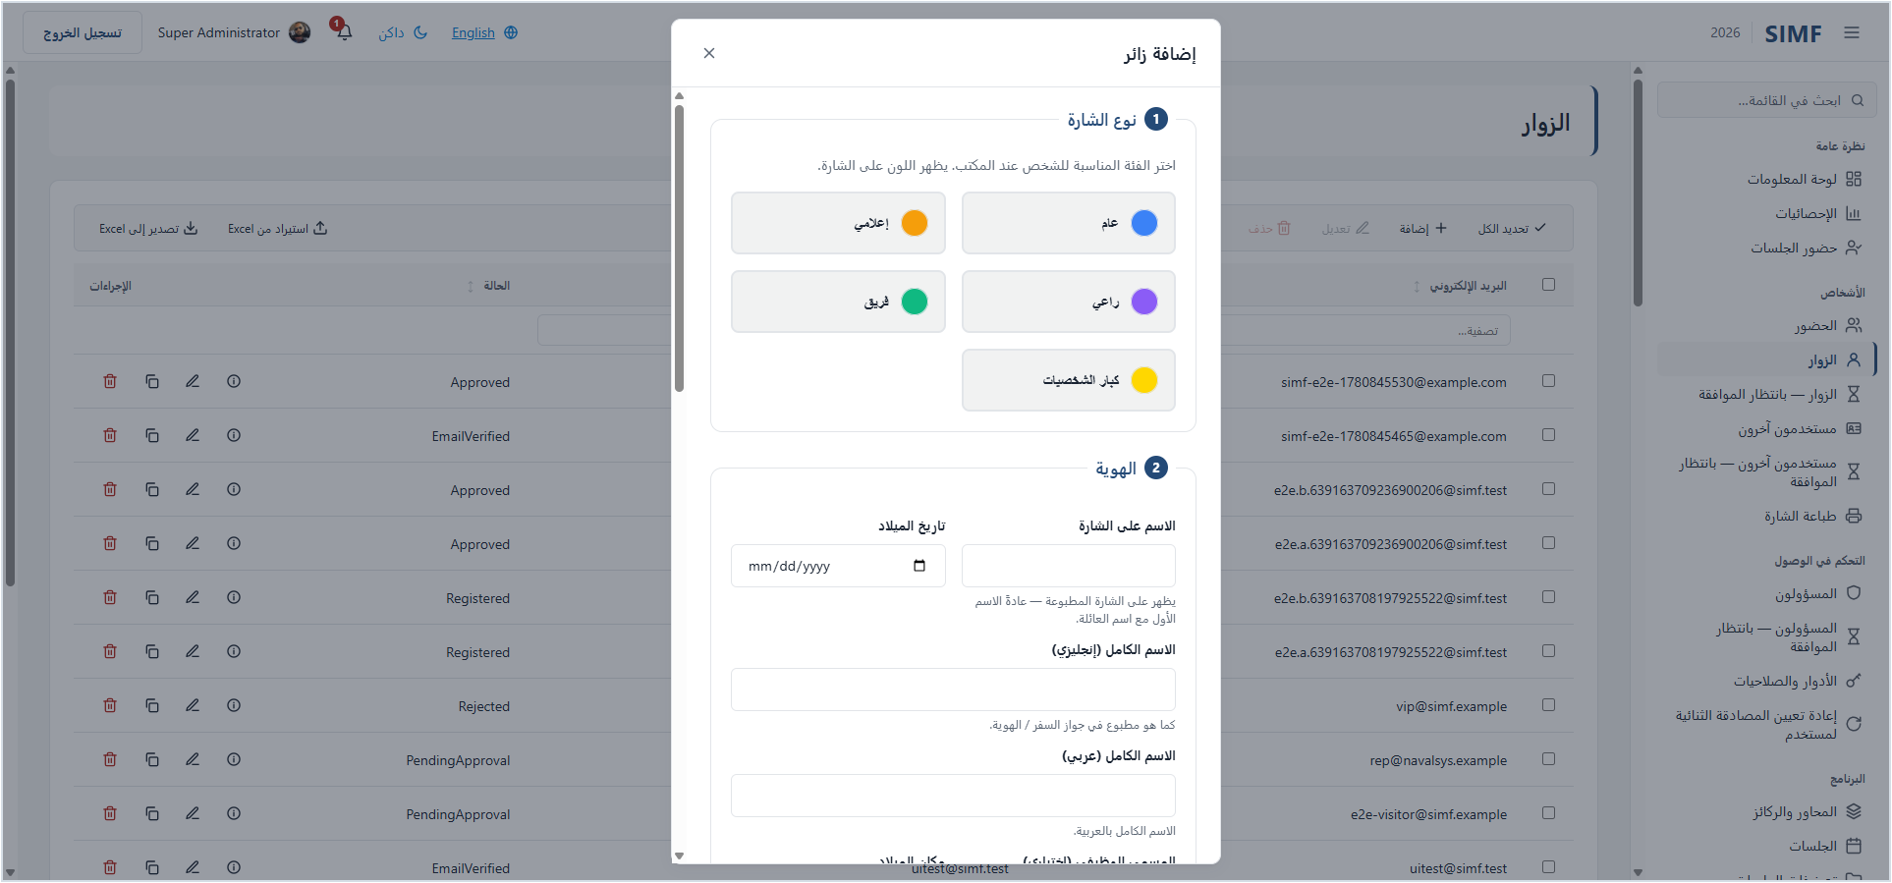
Figure 2. Control Panel - SimfDataGrid list page and CRUD dialog (visitor admin)

8.1 Hosting and auth
Blazor Server, interactive-server render with prerendering disabled (AppRenderMode.InteractiveServerNoPrerender). Cookie authentication (simf.cp.auth, 8-hour sliding) with SimfCookieRefreshHandler.OnValidatePrincipalAsync rotating the access token from the refresh token before expiry (D-121). The SignalR circuit allows large payloads (QR/image transfer).

8.2 BFF pattern
Browser sessions never hold raw bearer tokens. A thin endpoint layer (SIMF.ControlPanel/Endpoints/AuthEndpoints.cs) handles the credential/second-factor steps and stores tokens in the encrypted cookie; the access token is held per-circuit in SimfAuthSession and forwarded to the API by the typed client.

8.3 Permission gating
The CP reuses PermissionCatalog. A dynamic PermissionPolicyProvider + PermissionAuthorizationHandler (SIMF.ControlPanel/Authorization/PermissionAuthorization.cs) materialise perm:<code> policies. Mechanisms:
- Pages: @attribute [RequirePermission(PermissionCatalog.X.Y)].
- Nav items: each CpNavigation item carries a RequiredPermission.
- Action buttons: wrapped in <AuthorizedAction Permission="...">.
CpNavigation (SIMF.ControlPanel/CpNavigation.cs) defines ~12 nav groups (Overview, People, Access Control, Programme, Scientific Committee, Exhibition, Engagement, Knowledge, Content, Public Relations, Gates, Reference Data) over the /admin/* routes. Tests (CpNavigationPermissionTests) fail the build if a page is ungated.

8.4 List-page and CRUD standard
Every list page uses SimfDataGrid (filter, select-all, row checkbox, quiet per-row icon actions) with the shared CRUD framework (CrudShell, CrudPageFrame, CrudDialogFrame, CrudFormBase, CrudGridExcel). Dialog-vs-full-page presentation is a per-page user preference (CpPreferences, localStorage; D-353). Localization via IStringLocalizer<Strings> (resx Strings.resx/Strings.ar.resx); dir is set from CultureInfo.CurrentUICulture.

9. Website (low-level design)
Blazor SSR for public content (Home, Programme, Visit) rendered statically for speed, with interactive islands (@rendermode AppRenderMode.InteractiveServerNoPrerender) for the auth and account flows: Auth/SignIn, Auth/OtpVerify, Auth/ForgotPassword, Auth/ResetPassword, Account/UserProfile, Account/Notifications, Account/PendingApproval, Account/Rejected. Cookie auth (simf.web.auth) with the same refresh handler; public reads use SimfPublicClient. A smaller SignalR message-size cap reflects the lighter payloads. Auth is binary (signed-in vs anonymous); the website has no per-page permission policies.

10. Mobile application (low-level design)
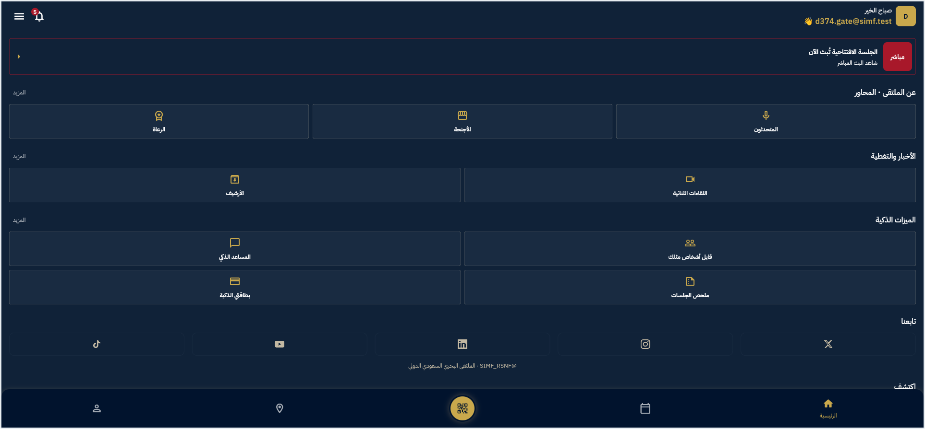
Figure 3. Mobile app - persistent 5-tab shell and Home
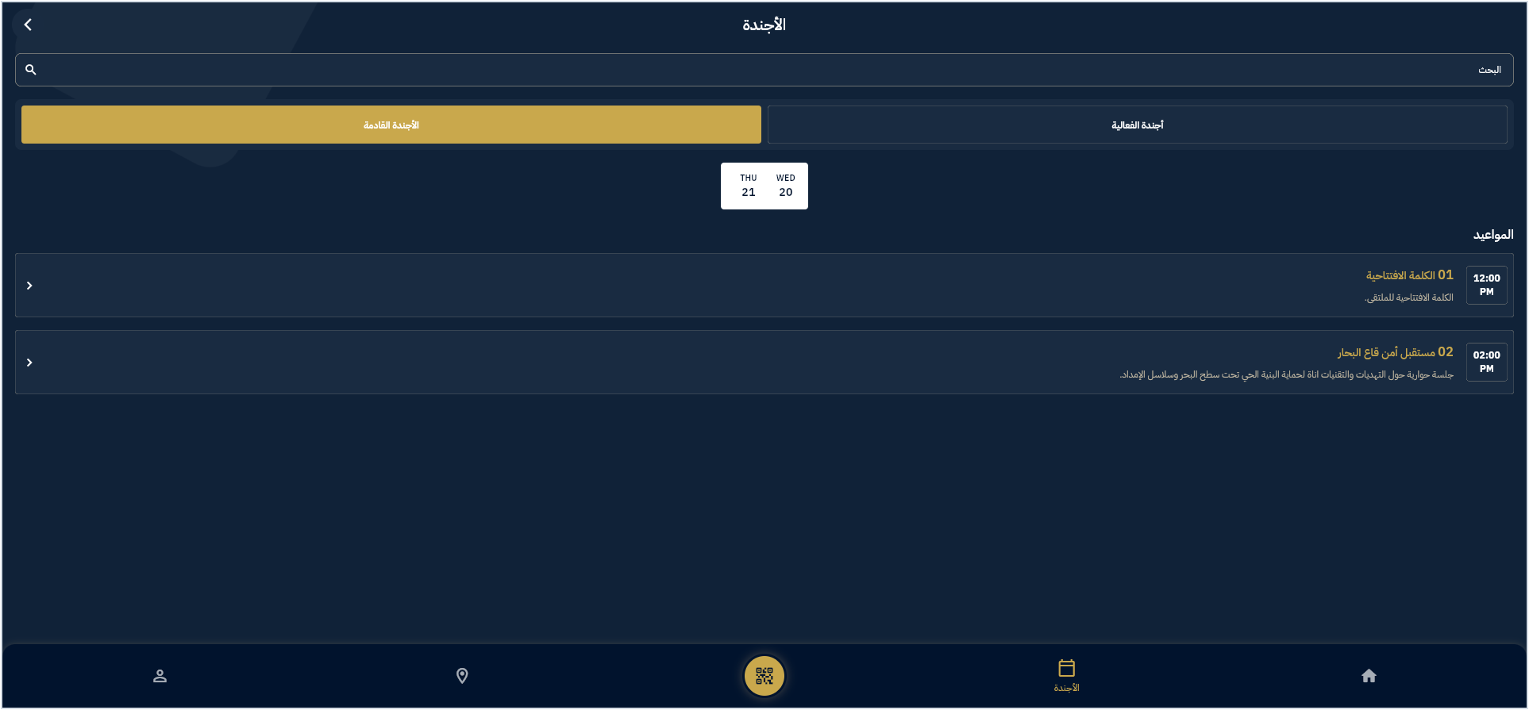
Figure 4. Mobile app - programme feature (agenda)

10.1 Layout and packages
- App: src/Mobile/simf_app (Flutter, Riverpod, go_router, Dio).
- Local packages (src/Mobile/packages/, tracked): simf_data_pkg (single HTTP layer: SimfApiClient, ApiResult, ApiFailure, secure/prefs storage) and simf_auth_pkg (auth controller/state, session, AppRole, biometric ES256 device keys).

10.2 Networking
A single SimfApiClient (Dio) with interceptors:
- HeadersInterceptor - attaches X-App-Key, X-Device-Type, Accept-Language (read live from the locale controller), and Authorization: Bearer <token> (read live from the auth token source).
- LoggingInterceptor - dev/test only.
On 401 the client refreshes via POST /app/auth/refresh (with skipAuthRefresh) and replays once. Concurrent 401s share one in-flight refresh future (single-flight, D-443). Authenticated images use getBytes() (never bare Image.network, which cannot carry the bearer token or the self-signed-TLS handling). A self-signed-TLS bypass is installed for the SIMF API host only (development/PoC; no-op on web) - flagged as a security item to remove for production.

10.3 State, routing and theme
- State: Riverpod (Notifier + providers); auth state restored asynchronously on cold start while the splash holds protected routes.
- Routing: go_router with StatefulShellRoute.indexedStack - a persistent 5-tab bottom nav (Home, Sessions, Badge, Map, Profile) with state preserved per tab; auth and role gates (staff/moderator) redirect appropriately. The app privilege model is AppRole/MobileAppRole (Guest/Visitor/Staff/Moderator).
- Theme: navy-always (dark theme pinned), bilingual with automatic RTL for Arabic; a global app-bar invariant (notifications bell + language toggle + inert dark-mode indicator + hamburger) appears on every in-app page.

10.4 Screens
~34 feature folders under lib/features/ covering: onboarding/splash/guest, auth (sign-in, sign-up steps, OTP, badge sign-in/activation, biometric step-up), profile/registration, home, sessions (+seat picker, my-seat, join hub), speakers, badge/QR, venue map, my-area (+identity liveness), live broadcast, AI summary, news, gallery, archive, booths, sponsors, media partners, comments, questions, meet-people, contacts (share/scan vCard), chatbot, exhibitor lead scan, gate scan (staff), session moderation (moderator), my-meetings, feedback/rate, notifications, accessibility, more, about, content/terms.

11. Shared libraries (low-level design)
- SIMF.Common - ApiResult<T>, ApiError/ApiErrorDetail, ApiCallResult<T>, DataValidationException, ErrorCodes, GridQuery/GridPage<T>, AppRoles (Administrator, GateOperator, PublicRelations) + VipProfileTypes, all enums, and PermissionCatalog.
- SIMF.Contracts - request/response DTOs grouped by feature (Authentication, Account, Programme, Admin, Feedback, Archive, Exhibitors, …).
- SIMF.ApiClient - typed clients: SimfAuthClient (api/v1/app/auth/), SimfAccountClient (api/v1/app/), SimfAdminClient (api/v1/admin/), SimfPublicClient (anonymous reads). Network faults are mapped to failed ApiResult envelopes (no exceptions to the caller). Base address resolved by SimfApiBaseAddress (HTTPS enforced outside Development; self-signed support flag).
- SIMF.Components - Simf* form/layout/control components, the CRUD framework, and the theme token CSS (theme.tokens.css as the single source of truth for colour/typography/ spacing/radius/motion; light/dark/grey themes).

12. Key sequence diagrams

12.1 Visitor sign-in with e-mail OTP
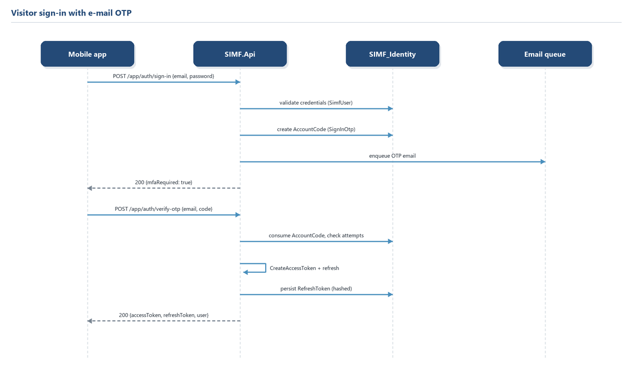
Figure 5. Visitor sign-in with e-mail OTP

12.2 Admin action authorisation (permission gate)
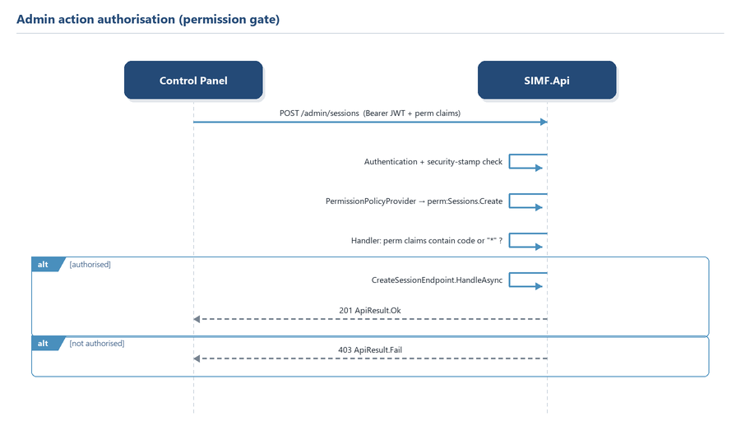
Figure 6. Admin action authorisation - the permission gate

12.3 Seat reservation and approval
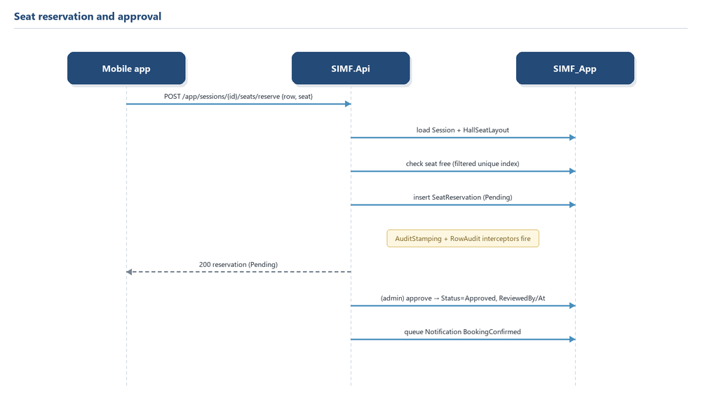
Figure 7. Seat reservation and approval

12.4 Gate scan (idempotent)
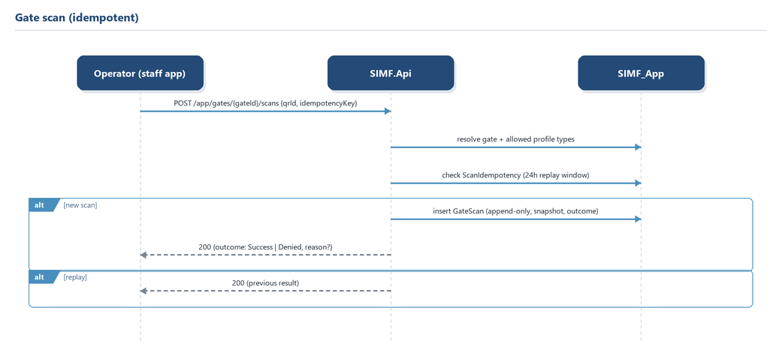
Figure 8. Gate scan (idempotent)

13. Configuration, options and secrets
Typed config via the Options pattern; production overrides and secrets via SIMF_-prefixed environment variables (double-underscore for nesting, e.g. SIMF_Jwt__SigningKey). Representative sections:
Section | Keys (examples) | Required in prod
ConnectionStrings | SimfIdentityDb, SimfAppDb | Yes (boot fails if missing)
Jwt | SigningKey, Issuer, Audience, AccessTokenMinutes, SessionLifetimeHours, StreamAudience, StreamTokenMinutes | SigningKey yes
Storage | AvatarBase, UserIdDocumentBase, UserIdDocumentEncryptionKey, VipPhotoBase, LogDirectory | encryption key yes
Email | Host, Port, User, Password, FromAddress, FailureAlertRecipients | host/user/password yes
SuperAdmin | Email, TempPassword, TotpSecret | rotate after first login
Cors | WebAppOrigins, DevWebOrigins | explicit allow-list
RateLimit | PermitLimit/WindowSeconds, EmailPermitLimit, GlobalPermitLimit, AiTestPermitLimit | defaults present
Swagger | AllowSwagger, Username, Password | off by default
ReverseProxy | KnownProxies | yes (for correct client IP)
IdentityLifecycle | PasswordMaxAgeDays, PasswordHistoryCount, DormantAccountDisableDays | default off
UploadScanning | Enabled | on by default
Ai | DefaultProvider, per-provider ApiKey/BaseUrl/DefaultModel, PromptHash:Secret | key required if provider used

Boot guards refuse to start in production when required secrets are missing. Note: some secrets exist in committed development config and must be rotated/purged before handover - see the security remediation register; this is an owner/operations action, not a code item.

14. Appendices

14.1 Enum reference (selected, integer-backed)
SignInAudience (Web/Cp/App) · AccountState · AccountCodePurpose · SecondFactorKind · UserType · AuditOutcome (Success/Failure) · RowAuditOperation (Insert/Update/Delete) · NotificationKind (by name) · NotificationSeverity (Info/Success/Warning/Error) · MobileAppRole · Gender · SessionStatus · SessionType? · SessionSpeakerRole (Speaker/Host) · SessionCommentStatus · QuestionStatus · QuestionPhase · SessionQuestionRecipient · SeatReservationKind · SeatSelectionMode · BookingStatus · VenueMapNodeKind · DirectionMode · ScanDirection · ScanOutcome · ScanSource · AttendanceMethod · HallPurpose · SponsorTier · ConnectionState · MeetingPartyKind · BusinessMeetingType · BusinessMeetingStatus · HallAllocationMode · MeetingRequestStatus · InvitationState · MediaKind · ArchiveMediaKind. (Exact integer assignments are in src/Shared/SIMF.Common/Enums/; values are frozen against rename/reorder, additive-only.)

14.2 Endpoint catalogue
The authoritative, full catalogue (every route, verb, request/response DTO and permission) is SIMF-API-001 and the endpoint classes under src/Backend/SIMF.Api/Endpoints/. §6.3 lists representative routes per feature area and the app/admin split convention (/api/v1/app/* vs /api/v1/admin/*).

14.3 Migration history (per context)
- Identity: InitialModel, AddSnapshotColumns, AddProfileTypeMobileAppRole, AddJobTitleToUserProfile, MoveProfilesToAppDb, AddDeviceKeys, D186_FoldOtherUsersIntoVisitor, SecA713_AddPasswordChangedAt, SecA720_AddPasswordHistory, SecA731_AddLastSuccessfulSignIn.
- App: InitialModel → additive series including AddSessions, AddOperationsToggles, MoveProfilesToAppDb, AddInvitations, AddSessionQuestions, AddCms, AddSeatReservations, AddAiModule, D186_*, D188_*, D199_EventModules, D202_*, D211_AddFaq, D217_*, D220..D226_*, D227..D233_*, D237/D240/D241_*, D248_AddBusinessMeetings, D260_AddContact, D269/D271..D278_*, D286_*, D357_AddAssets, D371/D373_*, D426/D429/D432/D439/D452/D456/D463/D472..D478/D485_*, SecA210_EncryptUserProfilePii, D495_AddOrganizationProfile.
(See src/Backend/SIMF.Infrastructure/Persistence/Migrations/{Identity,App}/ for the canonical, timestamped list.)

14.4 As-built deltas / open items
- SignalR / SIMF.RealTime is a placeholder - no hubs are wired into the API on this branch; clients use REST. Closing this is outstanding work.
- The mobile self-signed-TLS bypass and committed development secrets are flagged security items for owner/operations action before handover.
- Specific load-test thresholds and the monitoring/alerting toolchain are unset.

End of Low-Level Design.

