
Version: 1.2
Date: 30 August 2026 (17 Rabi al-Awwal 1448 H)
Business Requirements Document
Project Name | Saudi International Maritime Forum (SIMF 2026)
Identifier | SIMF-BRD-001

Version | Date | Author | Reason for change
1.0 | 21 July 2026 | Apexium (Business Analysis Team) | First issue
1.1 | 12 August 2026 | Apexium (Business Analysis Team) | Owner clarifications answered: audience, data classification, administrators, external integrations, website scope, video library and AI capabilities.
1.2 | 30 August 2026 | Apexium (Business Analysis Team) | Phase one hosting requirements added: the AI, the mail relay and the file store move on site into HSA with the API and the databases, and the only remaining internet call is made from the Control Panel in SSA.
Approvers
Approver Name | Job Role | Date | Signature
[To be completed by the owner] | Document Owner Representative  (Ministry of Defense / Royal Saudi Naval Forces)
[To be completed by the owner] | Document Owner Representative 2  (General Directorate of Information Technology)

Revision History
Version | Date | Author | Comments
1.0 | 19 July 2026 | Apexium | First issue of the Business Requirements Document.
1.1 | 12 August 2026 | Apexium | Clarifications update; no change to the agreed scope.
1.2 | 30 August 2026 | Apexium | Phase one hosting requirements; no change to the agreed scope.
Document Reviewers
Date | Reviewer Name | Comments
[To be completed by the owner] | [To be completed by the owner] | Review of the business scope and approval of the requirements.

Table of Contents
1. Introduction 5
1.1 Document Purpose 5
1.2 Roles and Responsibilities 5
2. Overview 5
2.1 Problem Description 5
2.2 Current Situation (As-Is) 6
2.3 Proposed Solution (To-Be) 6
2.3.1 Objectives and Key Benefits 6
2.3.2 Scope 7
2.3.3 Out of Scope 7
3. Business Process 7
4. System Roles 10
5. System Requirements 11
5.1 Business Rules 11
5.2 User Requirements 11
5.3 Operational Requirements 15
5.4 Non-Functional Requirements 16
5.5 Constraints 16
5.6 Assumptions 16
5.7 Open Items 17
6. Attachments 17

Glossary and Abbreviations
Defining terms improves the precision of communication and understanding across the document. The terms and abbreviations used are listed below.
# | Term / Abbreviation | Description
1 | SIMF | Saudi International Maritime Forum; the forum and exhibition management platform for 2026.
2 | RSNF | Royal Saudi Naval Forces; the beneficiary of the system.
3 | MoD | Ministry of Defense.
4 | BRD | Business Requirements Document (this document).
5 | NCA | National Cybersecurity Authority and its standards (ECC-1:2018 and CSCC-1:2019).
6 | Control Panel | The internal administration interface used to run the forum.
7 | App | The attendee mobile application on Android and iOS.
8 | Website | The public website of the forum.
9 | MFA / TOTP | Multi-factor authentication / time-based one-time password; the second authentication factor required for internal-user sign-in.
10 | QR | The quick-response code printed on the entry badge.
11 | API | The application programming interface exposed to the three client applications.
12 | Badge | The entry pass carrying a unique reference number, a QR code and a category colour.
13 | VIP | A visitor in the very-important-persons category.
14 | Moderator | A role that manages the questions for the sessions assigned to them through the app.
15 | PR | Public Relations team; reviews exhibitors and one-to-one meeting requests.
16 | GPS | Global Positioning System; the basis of the deferred in-venue presence and movement capability.
17 | OWASP | Open Worldwide Application Security Project; its Top 10 and ASVS are referenced security baselines.
18 | DDD | Domain-Driven Design; the layering approach followed in the engineering standards.
19 | AI | Artificial intelligence; used for the assistant, session summaries, comment moderation, translation and recommendations.
20 | SMS | Short message service; one of the four notification channels.
21 | RTL / LTR | Right-to-left / left-to-right text direction (Arabic / English).

1. Introduction

1.1 Document Purpose
This document sets out the business requirements for the Saudi International Maritime Forum (SIMF 2026) system, an integrated platform that runs the forum and exhibition: registration and security vetting, badge issue and access control, the scientific programme, live engagement, networking between attendees, media and news, and statistics.
It defines the objectives and scope of the solution and records the requirements agreed with the owner, so the analysis, design, development, testing and quality-assurance teams work from a single approved reference and each requirement can be traced into design, code and tests through a stable identifier. It is written at the business level, above the detailed software requirements and the per-feature design work.

1.2 Roles and Responsibilities
The table below shows the parties involved in producing the document and the solution, and the responsibilities of each.
Role | Responsibilities
Product Owner / Owner  (Ministry of Defense, Royal Saudi Naval Forces) | - Approve the business scope, the requirements and their priorities.  - Supply the legal text (Terms and Conditions and Policies) and the owner content.  - Take the open decisions (the statistics list and media fields, OI-1; the external providers, OI-2).
General Directorate of Information Technology | - Review the technical requirements and verify compliance with the NCA standards.  - Approve the runtime environment, the architecture and the integration.
Apexium (vendor / development team) | - Analyse and document the requirements, and build, test and deliver the solution.  - Hand over the source code and the accompanying documentation.
Organising teams  (Security, PR, Technical, Scientific, Logistics, Marketing) | - Run the forum from the Control Panel within the permissions granted to each team.  - Review registrations, exhibitors, content and sessions.
Administrator | - Manage roles, permissions, dynamic categories, settings and content.  - Set the final user type and permissions for approved registrations.  Administrators are drawn from Royal Saudi Naval Forces personnel and from the organising company. Each administrator holds a named role whose permissions are restricted per page and per action.

2. Overview

2.1 Problem Description
The Saudi International Maritime Forum is a recurring event, and this is its fourth edition. Each previous edition ran on its own separately built systems, website and app, produced from scratch for that edition and then set aside. Rebuilding every time is costly and slow, scatters each edition's data in a different place, leaves no single reusable platform and no consolidated record across editions, and forces the cybersecurity controls, the technology choices and any intelligent features to be worked out again from the ground up for every edition. What is needed is one dynamic, configurable system and app, built on modern technology, embedding AI and emerging technologies, and compliant with the National Cybersecurity Authority (NCA) standards, that can serve the current edition and every future edition without being rebuilt, with all editions' data held in one central location. The requirements in this document are based on the material provided by the owner and a series of interviews with the owner's representatives.

2.2 Current Situation (As-Is)
Each edition of the forum has been delivered on its own bespoke systems, website and app, built specifically for that edition. Nothing carries over: the event identity, content, categories and dates are fixed per edition, each edition's data is stored separately, and a new build, with its own security posture and technology, is commissioned every time the forum is held. There is no single configurable platform, no centralised store spanning the editions, and no consistent, reusable base for cybersecurity compliance or for AI-assisted features.

2.3 Proposed Solution (To-Be)
Design one dynamic, reusable platform, a single backend and unified API serving the administrative Control Panel, the public website and the attendee mobile app, that can run any edition of the forum without code changes. Everything that varies between editions is configured from the Control Panel: the event name, the colours, the logos and visual identity, the content and data, the categories, the start and end dates, and the archiving of past editions. All editions' data is held in one central location, so the same system is valid for the current edition and every future edition. The platform is built on a modern technology stack, embeds AI and emerging technologies (a cognitive assistant and knowledge base, AI-generated session summaries, AI comment moderation, AI live translation and accessibility, and smart attendee and session recommendations), and is engineered to comply with the National Cybersecurity Authority (NCA) standards. On this dynamic base the platform covers the full event lifecycle: registration, security vetting and approval, badge issue and access control, the programme, sessions and bookings, live streaming and engagement, networking between attendees, the exhibition and sponsors, media and news and archive, notifications and statistics, running on-premises as a single tenant. The forum is open to the general public and international in attendance: it is not restricted to Ministry of Defense personnel and not restricted to Saudi nationals, and any member of the public may register subject to administrator approval.

2.3.1 Objectives and Key Benefits
- Deliver one dynamic, configurable platform that serves the current edition and every future edition of the forum without a rebuild, with everything that changes between editions (name, colours, logos, content, categories, start and end dates, archiving) set from the Control Panel.
- Hold all editions' data in a single central location, with each edition's archive controlled from the Control Panel.
- Build on a modern technology stack and embed AI and emerging technologies (cognitive assistant, AI summaries, AI moderation, AI translation and accessibility, and smart recommendations).
- Comply with the National Cybersecurity Authority (NCA) cybersecurity standards, with full Arabic and English support.
- Secure registration, security vetting, attendance approval, badge issue and access control.
- Manage the scientific programme, sessions and bookings, and measure attendance inside the halls.
- Enable live streaming and engagement (questions and comments) with accessibility and review controls.
- Strengthen networking between attendees and recommend sessions and one-to-one meetings.
- Provide per-day and overall statistics and dashboards for the event.

2.3.2 Scope
- The dynamic configuration layer (event name, colours, logos and visual identity, categories, start and end dates, content and archiving) and the centralised multi-edition data store.
- • The AI and accessibility capabilities, all built and delivered: subtitle generation from the session video (with manual paste or upload as the fallback), AI session summaries that become the session minutes after the scientific committee reviews and approves them, AI filtering of attendee questions before they reach the speaker, the cognitive assistant in the app and on the website, AI comment moderation, live translation and captions, the sign-language feed during live sessions, and smart recommendations.
- • The backend and the unified API, the Control Panel, the public website and the mobile app. The public website carries informational content only: it has no user registration and stores no personal data. Registration and all visitor data live in the mobile app and the Control Panel.
- Accounts and authentication, registration and approval, and role and permission management.
- Badges and access control, hall-arrival check-in and attendance measurement.
- The scientific programme, sessions, speakers, bookings and the seat map.
- The exhibition, booths, sponsors and the venue map.
- Live sessions, questions, comments and session summaries, networking, the cognitive assistant and the FAQ.
- Multi-channel notifications, media, news and archive, statistics, and Control Panel settings.
- • The video library: the platform stores video links only and holds no video files. The public library is published on the forum’s YouTube channel and surfaced in the platform as links, so it needs no additional storage, encoding or bandwidth on the owner’s servers.

2.3.3 Out of Scope
- • Procuring the WhatsApp provider; it is reached through an abstraction and the provider is chosen later. The cognitive-AI provider (Google Gemini) and the live-broadcast platform (YouTube) are decided and in scope; what remains outside the software scope is the network approval that permits reaching them.
- Authoring the legal text (Terms and Conditions and Policies); it is supplied by the owner.
- The GPS geofence chain (automatic arrival detection, and attendance and movement tracking from GPS presence); deferred pending the venue-boundary decision (open item G-OI-2). Arrival and attendance are recorded by QR check-in at the hall.
- The visual design of the mobile app; supplied by the external UI/UX designer.
- Procuring the hardware, network and physical infrastructure of the venue; outside the software scope.

3. Business Process
The following describes the main business processes of the proposed solution. A BPMN process diagram for each of the three core flows follows the descriptions.
- Registration and approval: a user creates an account and confirms the email with a verification code, then completes the registration data and accepts the terms, so the request becomes "waiting for approval"; the Security team reviews and approves or rejects it, and on approval the Admin sets the final user type and permissions.
- Badge and entry: a badge with a unique reference number, a QR code and a category colour is issued after approval, verified at the venue entrance and the entry recorded; on-site registration and badge reprint are supported.
- Attendance in the halls: an attendee's arrival at a hall is recorded by a QR scan at the door, and session attendance is measured from the arrival records.
- Bookings: an attendee registers to attend a session or, in halls with assigned seating, reserves a specific seat (with no time overlap); the reservation confirms immediately with no approval, a reserved seat is cancelled automatically 3 minutes before the session starts if the attendee has not checked in, and the attendee checks in and out of the session at the hall.
- Live session and engagement: a session is streamed with live translation or captions; questions open after the attendee has checked in at the hall and close at session end; the moderator manages the questions assigned to them; comments pass through an AI filter and then an admin review before being shown.
- Networking and meetings: a user chooses interests, the system recommends attendees and sessions with a match score, and a one-to-one meeting request can be sent and routed to the PR team for approval.
- Exhibition: an organisation registers as an exhibitor, the PR team reviews and approves it, and assigns the booth in the same step.
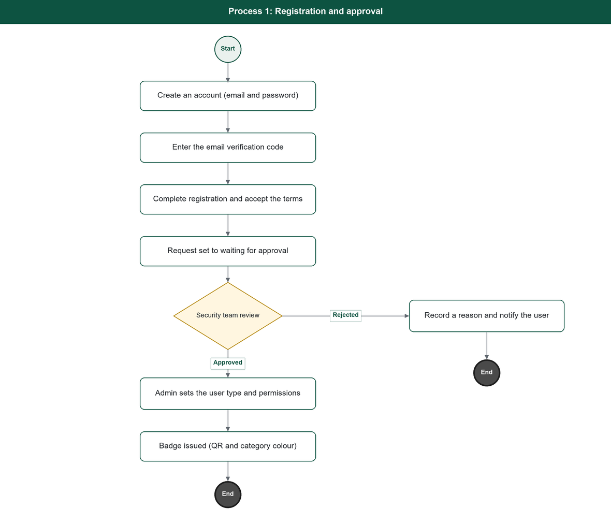
Figure 1. Registration and approval process.
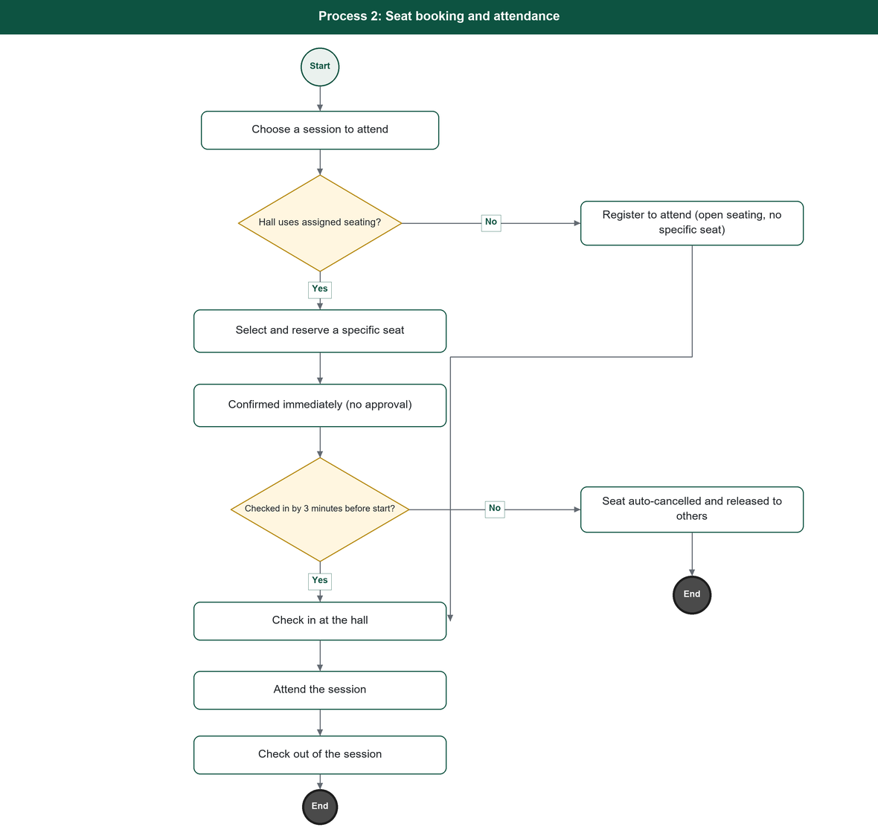
Figure 2. Seat booking and attendance process.
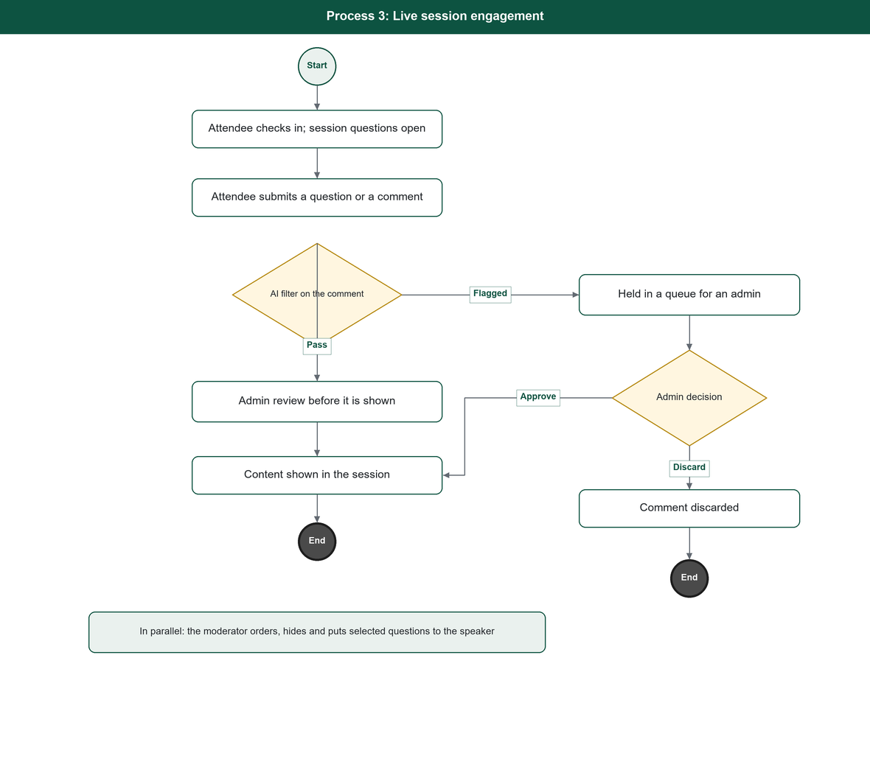
Figure 3. Live session engagement process.

4. System Roles
Roles are dynamic: the Administrator builds and assigns them, and the system fixes only the Administrator role and the catalogue of pages and actions. The table lists the system user types.
ID | Role Name | Role Description
1 | Administrator | Runs the system from the Control Panel, holds every permission, and creates and assigns all other roles.
2 | Organising teams (dynamic roles) | Security, PR, Technical, Scientific, Logistics and Marketing; each a role the Administrator builds and assigns.
3 | Visitor | A registered attendee via the website and app; sub-types VIP, Normal and others added in the Control Panel, each with its own colour.
4 | Exhibitor | A registered exhibiting organisation with a booth.
5 | Other | A registration type covering Media, Sponsor and any further type added in the Control Panel.
6 | Moderator | An app role that manages the questions for the sessions assigned to them (no Control Panel access).
7 | Staff | Field operations only: badge scanning, on-site registration and hall-door check-in (no Control Panel access).
8 | Guest | An unregistered user browsing public content in the app; personal features are locked.

5. System Requirements

5.1 Business Rules
Rule ID | Description
BR-01 | Access to every page and endpoint requires a permission; the only anonymous functions are sign-in, sign-up and password reset.
BR-02 | Internal-user (Control Panel) sign-in requires a TOTP second factor every time.
BR-03 | The Security team approves or rejects a registration; on approval the Admin sets the final user type and permissions.
BR-04 | A badge is issued only after the registration is approved, and carries a unique reference number, a QR code and a colour by category.
BR-05 | An attendee may hold multiple bookings provided the session times do not overlap.
BR-06 | Attendance registration and seat reservation confirm immediately with no approval. A reserved seat that is not checked in is automatically cancelled 3 minutes before the session starts and released to others.
BR-07 | A session's questions open only after the attendee has checked in at the hall, and close at session end.
BR-08 | Every comment passes through an AI filter and then an admin review before it is shown; a comment is never discarded on the AI result alone.
BR-09 | One-to-one meeting requests and exhibitor approvals are routed to the PR team.
BR-10 | The live stream is available in any location, with no geographic restriction.
BR-11 | Roles, permissions, dynamic categories and content are managed from the Control Panel without a code change.
BR-12 | Security actions, approvals and configuration changes are recorded in the operation log.
BR-13 | Personal data is encrypted at rest and in transit per the NCA standard.
BR-14 | Registration can be opened and closed from the Control Panel, closes automatically at the end of the last forum day, and can be overridden manually.

5.2 User Requirements
The table lists the user requirements grouped by service, with a stable identifier per requirement for traceability. Each requirement states what the system is obliged to provide; rows recording open items are marked as such.
Service ID | Service | Req. ID | Requirement Description
F-01 | Accounts and Authentication | FR-101 | The system shall let a person create an account with an email address, a password and a password confirmation.
 |  | FR-102 | The system shall send a six-digit verification code to the email and shall require the code to be entered before the registration can continue.
 |  | FR-103 | The system shall let a user request a new verification code, and shall invalidate the previous one when it does.
 |  | FR-104 | The system shall authenticate a user by email and password, and the mobile app shall additionally offer device-biometric sign-in (fingerprint or Face ID) once the account is set up on the device. Nafath sign-in is not offered.
 |  | FR-105 | The system shall require a TOTP second factor for every Control Panel (internal user) sign-in.
 |  | FR-106 | The system shall issue a short-lived access token and a rotating refresh token on sign-in.
 |  | FR-107 | The system shall provide a password-reset flow by email verification code.
 |  | FR-108 | The system shall validate the format of a mobile phone number against a standard national number format on registration.
F-02 | Registration and Approval | FR-201 | The system shall let a verified user complete a registration by choosing a registration type of Visitor or Other.
 |  | FR-202 | The system shall collect the registration fields: the four-part Arabic name; the English name as in the passport; nationality; date of birth; place of birth.
 |  | FR-203 | The system shall collect an identity number: the national ID for Saudis, or a passport number or Iqama number chosen by non-Saudis.
 |  | FR-204 | The system shall collect a mobile number inside the Kingdom and, for overseas visitors, a mobile number outside the Kingdom.
 |  | FR-205 | The system shall accept an ID image as an attachment, and shall support further attachment types added later.
 |  | FR-206 | The system shall let the user select the venue zone (area of the venue) they plan to attend, after registration.
 |  | FR-207 | The system shall accept optional fields: job title and a personal photo.
 |  | FR-208 | The system shall present the Terms and Conditions and require the user's consent before the registration is submitted.
 |  | FR-209 | On submission the system shall set the request to "waiting for approval" and shall send the user a message with the contact details.
 |  | FR-210 | The system shall show the user the status of their registration request through the review stages.
 |  | FR-211 | The system shall let the Security team view registration requests, review the submitted data, and approve or reject each request.
 |  | FR-212 | The system shall provide a select-all control so the Security team can approve requests in bulk.
 |  | FR-213 | On approval the system shall let the Admin set the final user type and the user's permissions.
 |  | FR-214 | On rejection the system shall record a reason and inform the user.
 |  | FR-215 | The system shall let a person use the mobile app as a Guest without registering.
 |  | FR-216 | The system shall let registration be opened and closed from the Control Panel, shall support an automatic close at the end of the last forum day, and shall allow a manual override at any time.
 |  | FR-217 | The system shall support on-site registration and badge reprint for a person who arrives without a badge.
F-03 | Badge and Access Control | FR-301 | The system shall issue an entry badge with a unique reference number and a QR code to an approved user.
 |  | FR-302 | The system shall colour the badge by the user's category.
 |  | FR-303 | The system shall verify a badge QR or barcode at venue entry and record the entry.
 |  | FR-304 | The system shall let one attendee scan another attendee's badge QR to save that person as a contact.
 |  | FR-305 | The system shall record a user's arrival at a session hall by a QR scan at the hall door, and shall hold an enter time and a leave time per session; automatic arrival detection by a GPS geofence around the hall is a deferred enhancement (open item G-OI-2).
F-04 | Forum Programme | FR-401 | The system shall let the Scientific team manage the forum themes or pillars and their sub-topics.
 |  | FR-402 | The system shall let the Scientific team create and manage sessions, each with a title, description, theme, hall, category, start and end time, and speakers, in Arabic and English.
 |  | FR-403 | The system shall mark a session as live or non-live.
 |  | FR-404 | The system shall let halls be created with a defined seating capacity, and shall allow the capacity to be changed.
 |  | FR-405 | The system shall hold a seat grid per hall and support seat assignment.
 |  | FR-406 | The system shall manage speaker profiles (name, rank, bio, qualifications, training experience, awards, photo and country flag) and shall link speakers to sessions.
 |  | FR-407 | The system shall hold the presentation files delivered by speakers.
 |  | FR-408 | The system shall present the agenda to attendees, filterable by day, with search, and shall let an attendee open a session's detail.
 |  | FR-409 | The system shall let an attendee add a session to their device calendar and set a reminder.
F-05 | Bookings and Attendance | FR-501 | The system shall let an attendee register to attend a session and, in a hall with assigned seating, select and reserve a specific seat.
 |  | FR-502 | The system shall allow an attendee to hold any number of bookings provided the session times do not overlap.
 |  | FR-503 | The system shall confirm attendance registration and seat reservation immediately, with no approval step, and shall automatically cancel a reserved seat 3 minutes before the session starts if the attendee has not checked in, releasing it for others.
 |  | FR-504 | The system shall let an attendee cancel a booking any time before the session starts.
 |  | FR-505 | The system shall show an attendee their assigned seat and a seat map for the hall.
 |  | FR-506 | The system shall record session check-in and check-out at the hall and track attendance from these records.
F-06 | Exhibition | FR-601 | The system shall let an organisation register as an Exhibitor with the organisation's details.
 |  | FR-602 | The system shall let the PR team review and approve an exhibitor and assign the booth in the same step.
 |  | FR-603 | The system shall maintain a booth directory (hall, booth number, logo, descriptor, contact, phone and email).
 |  | FR-604 | The system shall maintain sponsors in four tiers: Platinum, Gold, Silver and Bronze.
 |  | FR-605 | The system shall present an interactive venue map of halls, zones and booths, with navigation to a booth or to an assigned seat.
F-07 | Engagement and Live Sessions | FR-701 | The system shall stream a live session and shall show AI translation or live captions with a language choice.
 |  | FR-702 | The system shall make the live stream available in any location, without geographic restriction.
 |  | FR-703 | The system shall let an attendee send a question to the moderator during a session, addressed to the session's speaker or its host (chair).
 |  | FR-704 | The system shall open a session's questions only after the attendee has checked in at the hall, and shall close them at session end.
 |  | FR-705 | The system shall let a moderator, for the sessions assigned to them, view the incoming questions, reorder or hide them, and put selected questions to the speaker.
 |  | FR-706 | The system shall accept attendee comments on a session and shall pass each comment through an AI filter and then an admin review before it is shown.
 |  | FR-707 | The system shall hold an AI-rejected comment in a queue for an admin, who can approve or discard it; the system shall not discard a comment on the AI result alone.
 |  | FR-708 | The system shall produce an AI-generated summary of a session (key points, recommendations and a transcript).
 |  | FR-709 | The system shall provide a dynamic rating and feedback capability that lets an attendee submit a rating and written feedback. Four rating scopes are currently defined: the session, the day, the programme, and the app. The rating scopes are managed as dynamic content, and rating is offered to an attendee on the basis of attendance.
 |  | FR-710 | The system may optionally notify users in the vicinity of the venue about live or upcoming sessions. This is an optional feature and is not a mandatory requirement.
F-08 | Networking and Cognitive AI | FR-801 | The system shall let a user choose interests, and shall maintain the interest list as a dynamic category.
 |  | FR-802 | The system shall suggest matches to a user based on shared interests and shared sessions, with a match score. Suggestions cover speakers, sponsors and booth companies, and Other-type profiles that opt in; Visitor profiles (Normal and VIP) are never included. The set of discoverable profile types is managed from the Control Panel.
 |  | FR-803 | When a match score reaches 80% or more, the system shall send the user a session recommendation and a push notification.
 |  | FR-804 | The system shall let an attendee send a one-to-one meeting request, and shall route it to the PR team for approval.
 |  | FR-805 | The system shall provide a cognitive-AI assistant that answers attendee questions, backed by a FAQ knowledge base.
 |  | FR-806 | The system shall organise the FAQ knowledge in two levels (groups, then entries within a group) and shall let the Technical team manage both from the Control Panel.
 |  | FR-807 | The system shall provide accessibility AI: sign-language and speech conversion, and live captions.
 |  | FR-808 | The system shall reach the cognitive-AI provider through an abstraction so the provider can be set without a code change.
F-09 | Notifications | FR-901 | The system shall deliver notifications over four channels (in-app, email, SMS and WhatsApp) through one notification abstraction.
 |  | FR-902 | The system shall send registration and approval updates, session reminders, VIP invitations and meeting confirmations.
 |  | FR-903 | The system shall confirm a seat reservation immediately in the app, with no notification sent on reserving, and shall send a reminder when a session has started and the user has not checked in.
 |  | FR-904 | The system shall let the channel mix for a notification type be set by configuration, not by code.
F-10 | Media, News and Archive | FR-1001 | The system shall let the Marketing team manage a Media Center section (media coverage, social content and posts) from the Control Panel.
 |  | FR-1002 | The system shall let the Marketing team manage news items, each with a category.
 |  | FR-1003 | The system shall maintain a photo and video gallery and a media partners directory.
 |  | FR-1004 | The system shall hold previous editions of the forum, each with a title, brief, sessions, place, time, image, video, previous speakers and statistics.
 |  | FR-1005 | The system shall control the visibility of the current edition's archive from the Control Panel, so it appears only after the event ends.
 |  | FR-1006 | The exact field set of media and news items is an open item to be confirmed with the owner (OI-1).
F-11 | Statistics | FR-1101 | The system shall present per-day statistics: registrations, badges printed, registered VIP count, media badges printed, and total check-ins.
 |  | FR-1102 | The system shall present overall statistics: themes, topics, speakers, participating countries, total registrations and badges, attendance per day, total attendance, broadcast hours and total audience questions.
 |  | FR-1103 | The system shall show attendance live on the Control Panel dashboard; tracking attendee movement, dwell time and routes inside the venue from GPS presence is a deferred enhancement (open item G-OI-2).
 |  | FR-1104 | The exact statistics list and the dashboards are an open item to be confirmed with the owner (OI-1).
F-12 | Control Panel and Configuration | FR-1201 | The system shall run the Control Panel on roles and permissions; each user shall see only what their role permits.
 |  | FR-1202 | The system shall let an Admin add roles and adjust permissions from the Control Panel.
 |  | FR-1203 | The system shall let content (titles, texts, the in-app welcome message, banners, logos and images, section labels and page content) be edited from the Control Panel without a code change.
 |  | FR-1204 | The system shall let dynamic categories (registration types, user sub-types, session categories, interests and others) be added, hidden or deleted from the Control Panel, each with its own colour.
 |  | FR-1205 | The system shall record changes and approvals in an operation log.
 |  | FR-1206 | The system shall apply the approved visual identity across the Control Panel, the website and the app.
 |  | FR-1207 | The system shall present the Policies and the Terms and Conditions, using legal text supplied by the client.
 |  | FR-1208 | The system shall let each edition's identity and settings (the event name, the colours and visual identity, the logos, and the edition's start and end dates) be configured from the Control Panel, so a new edition is set up without a code change.

5.3 Operational Requirements
Requirement ID | Description
OP-01 | The system shall run on-premises behind a reverse proxy.
OP-02 | The system shall keep the SIMF_Identity and SIMF_App databases physically separated, with no cross-database relations or transactions.
OP-03 | The system shall retain the last known-good published build for rollback.
OP-04 | The system shall provide periodic backup and reliable restore of data.
OP-05 | The system shall monitor and alert on background services and workers.
OP-06 | The system shall sustain the peak load throughout the forum, with a realistic load test before launch.
OP-07 | The system shall allow registration open and close, and archive visibility, to be controlled from the Control Panel.
OP-08 | The system shall integrate the email, SMS and WhatsApp gateways behind the notification abstraction.
OP-09 | The system shall embed the live-broadcast stream and integrate a map service for the interactive venue map.
OP-10 | The system shall expose a /health endpoint for monitoring.
OP-11 | The system shall expose its functions only through the versioned API; the website, Control Panel and app are its only clients.
OP-12 | The system shall run the AI assistant on an on-site LLM server inside HSA, reached over an OpenAI-compatible API, so that no AI request leaves the ministry network.
OP-13 | The system shall store uploaded files in on-site MinIO object storage inside HSA, reached over the S3 API, in place of a directory on a file share.
OP-14 | The system shall send all email through an on-site mail relay inside HSA.
OP-15 | The system shall place the API servers, the databases, the LLM server, the mail relay and the object store inside HSA with no internet path, and the Control Panel, the website and the mobile edge inside SSA, which is the only area with internet access.

5.4 Non-Functional Requirements
Requirement ID | Description
NFR-01 | Security. The system shall meet the NCA Secure Application Development Standard and the controls it references (ECC-1:2018, CSCC-1:2019, the OWASP Top 10 and OWASP ASVS), and shall apply defence-in-depth across every layer.
NFR-02 | Authorisation. Every endpoint and screen shall require a permission. Only sign-in, sign-up and password reset are anonymous.
NFR-03 | Audit. The system shall log security-relevant actions (sign-in, permission change, approval, configuration change) with enough context to reconstruct events.
NFR-04 | Performance. The system shall sustain the expected event load, sized at roughly one new registered user every 30 seconds at peak, and shall pass a realistic load test before launch.
NFR-05 | Availability. The system shall stay available throughout the forum, with health checks, a reverse proxy, and a retained last known-good build for rollback.
NFR-06 | Localisation. The system shall be fully bilingual: Arabic (primary, RTL) and English (LTR). No user-facing string is hardcoded. Dates display as dd-MM-yyyy with Latin digits.
NFR-07 | Usability and accessibility. The mobile app shall provide accessibility settings, including sign-language and live-caption support. Colour shall never be the only signal of state. The interfaces shall be operable by keyboard where they run in a browser.
NFR-08 | Compatibility. The website and Control Panel shall run on current mainstream browsers; the mobile app shall run on supported Android and iOS versions.
NFR-09 | Maintainability. The system shall follow the engineering standards: layered domain-driven design, zero-warning builds, tests with every change, and no duplicated code.
NFR-10 | Configurability. Content, categories, roles and permissions shall be changeable from the Control Panel without a release.
NFR-11 | Data protection. Personal data (identity numbers, contact details, attachments) shall be encrypted at rest and in transit, and handled per the NCA standard.
NFR-12 | Data residency. All SIMF data shall be stored and processed on site inside HSA. No personal data, uploaded document or conversation transcript shall be sent to an external service.

5.5 Constraints
- The technology stack is fixed: .NET 10, FastEndpoints, Blazor with MudBlazor, Flutter, and SQL Server 2022.
- The system is single-tenant and on-premises.
- The forum dates are not hardcoded; each edition's start and end dates are configured from the Control Panel.
- • The system must satisfy the National Cybersecurity Authority standards and the Saudi Personal Data Protection Law (PDPL).
- Arabic is the primary language; Arabic and English are both fully supported.
- The design is frozen after publication.
- The source code is handed over by 25 January 2027.
- • Data classification: the system holds no classified and no militarily sensitive information. The data is unclassified but includes personal data of visitors, speakers and exhibitors, processed under the PDPL and the National Cybersecurity Authority controls. No personal or operational data is sent to any cloud artificial-intelligence service.
- • The one external integration, YouTube, requires an approved outbound firewall exception, and the call is made from the Control Panel in SSA. The AI runs on site and needs no external access.

5.6 Assumptions
- The external UI/UX designer delivers the mobile app's visual design.
- • The WhatsApp provider is deferred and reached through an abstraction. The cognitive-AI provider is Google Gemini and the live-broadcast platform is YouTube; both are decided, and both depend on the network exception recorded in the constraints above.
- The legal text for the Terms and Conditions and the Policies is supplied by the client.
- The exact statistics list and the media and news field sets are fixed once the owner confirms them (open item OI-1).

5.7 Open Items
Items to be confirmed with the owner as the related decisions close.
Open Item | Description | Affects
OI-1 | Confirm the media and news field sets and the statistics list with the owner. | FR-1006, FR-1104
OI-2 | Confirm the WhatsApp provider when it is procured. The cognitive-AI provider (Google Gemini) and the live broadcast (YouTube) are decided; what remains open is the network exception that permits outbound access to them. | FR-701, FR-808, FR-901
G-OI-2 | Confirm the venue boundary for the GPS geofence (automatic arrival detection and movement tracking). | FR-305, FR-1103
OI-4 | Confirm the document classification with the owner. | Cover page (document classification)

6. Attachments
This document is delivered as a standalone document and has no attachments.

