Response to the Technical Review
SIMF-HLD-002 MoD HLD External v0.07
Document | SIMF-HLD-004 Response to the Technical Review, version 1.0
Responds to | SIMF-HLD-002 MoD HLD External v0.07, thirteen clarification requests
Companion document | SIMF-HLD-004 MoD HLD External v1.0, the updated High Level Design
Subject | Saudi International Maritime Forum (SIMF) platform
Prepared by | Apexium
Classification | Public

Purpose
This document answers each of the thirteen clarification requests raised in the technical review of SIMF-HLD-002. Every request is reproduced exactly as it was received, in bold. The SIMF response follows immediately underneath it in a smaller font, so the answer is always distinguishable from the question. Three diagrams were requested; they are reproduced at full page size in the annex.
Two answers correct statements that appeared in v0.07. First, artificial intelligence no longer runs in the cloud: every inference is performed on an on-premises service inside the SSA zone. Second, the direct connection drawn between the load balancer and the AI service was an error in the v0.07 diagram and has been removed. Both corrections are carried into the updated design document.
Summary of the responses
# | Subject of the request | Response in one line
1 | Two tier or three tier, and tier deployment | Three tier. Presentation, application and data tiers are separate servers in production.
2 | YouTube live stream flow | Delivered directly from YouTube to the device. It is not routed through the backend.
3 | Embed only, or YouTube APIs | Embed only, plus one caption retrieval call. SIMF creates and manages no stream.
4 | AI and caption API outbound flow | No AI provider is enabled, so no AI traffic leaves. Only the caption call goes out, carrying a public video id.
5 | Authentication and e-mailed passwords | Passwords are stored as PBKDF2 hashes. No password is ever e-mailed. Forced change is enforced.
6 | Purpose and content of the file share | Binary content the database must not hold. 18 categories, 4 tiers, 4 encrypted at rest.
7 | Sequence diagrams | Provided. Figure 2 for components and interaction, Figure 3 for the workflows.
8 | Mobile enrolment and the ES256 key | Key pair generated on the device, only the public key registered, challenge signed, revocable.
9 | Data shared with external services | Only YouTube, and only a public video id. Nothing is sent to an AI provider today.
10 | SIEM and SMTP in the diagram | Both internal to the SSA zone. SMTP on 587, SIEM on 6514. The matrix is updated.
11 | Load balancer to AI connection | No such connection. It was a diagram error and is removed. Only SIMF.Api calls the AI endpoint.
12 | Outbound path from the AI service | Agreed. No AI egress exists today. Any egress is via the egress point and edge firewall.
13 | Hosting server per component | Done. Figure 1 shows one box per hosting server, and the matrix is updated to match.
Responses in full
Point 1. Clarify whether the solution follows a two tier or three tier deployment architecture and whether the presentation layer and the backend layer API / business layer are deployed separately or hosted on the same application server.
SIMF response
Three tier, and the tiers are deployed on separate servers in production.
Presentation tier: SIMF.Web (Blazor SSR) on two web hosts, and SIMF.ControlPanel (Blazor Server) on two admin hosts with session affinity. Application tier: SIMF.Api on four stateless API hosts. Data tier: SQL Server 2022 in the HSA zone.
The separation is structural, not only physical. Neither presentation project holds a database connection string or an EF Core DbContext; they reference only the shared client libraries and reach data solely through the API over HTTPS 443. A compromise of a presentation host therefore yields no direct database access.
Development and Test run all three sites on a single node, which is the intended footprint for those environments. Figure 1 shows one box per hosting server.
Point 2. clarify the role and communication flow of the YouTube integration, including whether the live stream is delivered directly from YouTube to the mobile application and public website , or routed through the application backend.
SIMF response
The live stream is delivered directly from YouTube to the attendee device. It is not routed through the application backend.
SIMF stores only the stream URL on the Session record and returns it in the session payload. The player in the mobile app and in the website then connects to YouTube itself and receives the video over HTTPS 443.
Consequences, which are deliberate: no video, audio or segment traffic traverses any SIMF server; the platform carries no streaming bandwidth; and SIMF holds no media content. See Figure 1 connector 11 and Figure 3 step 13.
Point 3. Also clarify whether the solution only embeds the live stream or uses YouTube APIs to create , manage, or retrieve live stream and caption information.
SIMF response
SIMF does not create, schedule or manage broadcasts. Those actions are performed by the media team inside YouTube.
SIMF does two things only. First, it embeds playback, using the stored URL. Second, it makes one server-to-server call to retrieve the caption (subtitle) track for a published video id, which feeds the drafting of the session minutes.
The caption call is not essential. If it is unavailable, the administrator pastes or uploads the transcript instead, so no feature is blocked by it.
Point 4. clarify the purpose and outbound communication flow between the application backend , the AI provider and the YouTube caption API including the data exchange and authentication method
SIMF response
These are two different cases, and only one of them is outbound.
Artificial intelligence: in the configuration delivered for the forum no AI provider is enabled, so no AI request leaves the ministry network and no inference is performed at all. Inference sits behind a single abstraction and the provider is a configuration value; the delivered value is a local stub that answers without calling anything. SIMF.Api is the only caller in every case, and the load balancer carries no AI traffic.
Enabling a provider is an explicit ministry decision, and that is the point at which the data question arises. An on-premises inference endpoint keeps every request inside the SSA zone and produces no egress. An external provider would send the fields listed in the table below Point 9 out through the controlled egress point, authenticated with that provider's API-key or bearer-token header, and would require a data-residency decision first. The codebase carries clients for three external providers, each of which accepts a configurable base URL, so the same client addresses an on-premises endpoint without a code change. No on-premises inference service is in place today.
YouTube caption API: this is the only outbound integration in the system. Purpose: import the subtitle track that feeds the session minutes. Data sent: the public YouTube video id, and nothing else. No personal data, no account data and no credential are sent, and the call is unauthenticated because the resource is public.
Path: SIMF.Api to the controlled egress point host (both in the SSA zone), which applies an FQDN allow-list and logs every request, then out through the edge firewall. The returned caption host is re-validated before the second request, and the HTTP client does not follow redirects. See Figure 1 connectors 6 and 7.
Point 5. How users will be authenticated during subsequent logins if passwords are not stored. Also clarify whether the password sent by email is temporary , how it is securely verified and whether users are required to change it upon first login.
SIMF response
Passwords are stored, but only as a one-way hash. SIMF stores a PBKDF2-HMAC-SHA256 hash with a per-user salt and a work factor (the ASP.NET Core Identity default). The plaintext is never stored and cannot be recovered from the hash.
Subsequent sign-in: the user submits the password, the API applies the same derivation to the submitted value and compares the result with the stored hash. On success a second factor is required, an e-mailed one-time code for visitors or a TOTP authenticator code for administrators. Only then are tokens issued.
No password is e-mailed to a self-registered attendee. The e-mail carries a six-digit verification code, not a password. The code is itself stored hashed, is compared in constant time, expires, and is consumed on first use.
Administrator accounts created by invitation receive a single-use invitation link valid for exactly seven days. The invitee sets their own password when they use it, and the link is then consumed, so no shared or temporary password is ever transmitted.
Forced change is implemented and enforced. When an account carries the PasswordChangeRequired flag, which is set when an administrator rotates a credential or when a password reaches its maximum age, every token-issuing path is blocked (initial password step, second-factor verify, recovery-code verify, one-time-code verify and refresh) until the user sets a new password through the reset flow.
Point 6. Clarify the purpose of the file share storage and specify the type of files and data that will be stored in it.
SIMF response
Purpose: to hold binary content that must not be stored in the database and that must be readable by every application node. In the multi-node production topology it is a clustered SMB share in the HSA zone, so any API node can read back what another node wrote. Database rows hold relative paths, never blobs.
Content is classified into 18 service categories across 4 sensitivity tiers. The categories are: avatar, identity document, VIP photo, speaker photo, speaker presentation, session recording, news image, media-gallery image, media-partner logo, sponsor logo, exhibitor logo, booth logo, company logo, organisation logo, organisation hero video, programme-day image, banner and archive cover.
Four categories are encrypted at rest: avatar, identity document, VIP photo and speaker presentation. Session recordings are deliberately not encrypted at rest, because HTTP range requests (206 Partial Content) require seekable content and the authenticated-encryption mode used is not seekable; they are protected by access control instead.
Access is only ever through the API, which enforces the per-category policy on every read and write. The share is not reachable from any client, from the website or from the Control Panel.
Point 7. Provide sequence diagrams for the key system workflows , clearly showing the interaction and communication between all relevant system components.
SIMF response
Provided at full page size, as Figure 2 and Figure 3.
Figure 2, component and interaction view, shows every component (three clients, the four internal layers of the SIMF.Api process, the background worker, the shared libraries, the AI service, the SMTP relay, the SIEM collector, the controlled egress point, the two databases and the file store) and labels every connector with its protocol and port.
Figure 3, key system workflows, shows the end-to-end sequence across four participants (attendee, SIMF.Api, administrator and Scientific Committee, and data and internal services) in 23 numbered steps: sign-up, e-mail verification, profile storage, approval or rejection, badge issue, sign-in with second factor, seat reservation, gate scan, live session, question and moderation, subtitle import, minutes drafting and approval, and rating and feedback.
Connector labels in the figures are taken from the Communication Requirements Matrix in section 2.8, so the diagrams and the matrix cannot disagree.
Point 8. Clarify the mobile enrolment and authentication flow including the OTP process, secure storage of the ES256 private key on the device, public key registration, device binding, key revocation. And the process flow when the device is lost or replaced.
SIMF response
Enrolment: the attendee signs up with e-mail and password, verifies the e-mail with a six-digit code, completes the profile, and waits for administrator approval. Ordinary sign-in is password plus an e-mailed one-time code, which is hashed at rest, compared in constant time, time-limited and consumed on first use.
Device-key enrolment: after a successful sign-in, and only after the user passes an operating-system biometric or device-credential prompt, the app generates an ECDSA P-256 key pair on the device. Only the public key is sent to the server, as a SubjectPublicKeyInfo DER structure; it is stored against the account with a device identifier, and that record is the device binding. The server accepts ES256 only and rejects any key it cannot parse as ECDSA P-256.
Private-key storage, stated precisely: the private key is held in the platform secure storage service, which is the iOS Keychain (accessible only after first unlock, on this device only) and Android EncryptedSharedPreferences under the Android Keystore-derived master key. It never leaves the device and is never transmitted. It is not yet bound to a hardware secure element; migrating the key into the Android Keystore or StrongBox and the iOS Secure Enclave, with user authentication required at the key itself, is a defined hardening step that does not change the server contract.
Authentication: the server issues a random challenge with a five-minute lifetime. The app signs it with the private key and returns the signature. The server verifies the signature against the registered public key, then clears the challenge with a single atomic conditional update that succeeds only if the challenge is still the one that was issued, so a replayed signature is rejected.
Revocation: the user can disable biometric sign-in in the app and an administrator can revoke the device; the key record is stamped as revoked and every subsequent challenge and verification for it is refused.
Lost or replaced device: the old device key is revoked, which immediately makes it useless. The user signs in on the new device with password plus e-mailed one-time code, then enrols a new key pair. No key material is exported, backed up or transferred between devices.
Point 9. Clarify the data shared with each external services, including its type, purpose , sensitivity and whether any personal or confidential information is transferred outside the ministry.
SIMF response
No personal or confidential information is transferred outside the ministry by SIMF. There are only two external destinations, and they are both YouTube.
1. YouTube caption API, server-to-server, outbound from SIMF. Data sent: the public YouTube video id only. Purpose: retrieve the subtitle track used to draft the session minutes. Sensitivity: public. Personal data: none. Credential: none.
2. YouTube live playback, from the attendee device, not from SIMF. Data sent: the video id, plus whatever the device's own connection necessarily reveals to YouTube (network address and user agent). Purpose: play the stream. No SIMF account identifier, name, e-mail or booking data is included.
Artificial intelligence sends nothing today, because no provider is enabled. The table below is the complete field-level inventory of what each AI feature would receive once a provider is enabled. If that provider is an on-premises endpoint the data stays inside the SSA zone; if it is an external provider the same fields would leave through the controlled egress point, which is why enabling one requires a data-residency decision first.
Data sent to the AI service, by feature
AI feature | Fields sent once a provider is enabled | Personal data | Destination
Question filter | the question text only | No | Configured AI endpoint
FAQ answer | the visitor question and the published FAQ entries | No | Configured AI endpoint
Assistance | the visitor question and the public programme context | No | Configured AI endpoint
Translation | the source text and the target language | No | Configured AI endpoint
Live translation | the live caption line and the target language | No | Configured AI endpoint
Live sign language | the live caption line | No | Configured AI endpoint
Session minutes | session title, speaker display names, abstract, and the subtitle transcript in English and Arabic | Yes, speaker display names | Configured AI endpoint
Control Panel assistant | the administrator question and the Control Panel context | No | Configured AI endpoint
Hard limits enforced on every call: at most 16 input values, keys of at most 64 characters and values of at most 4000 characters.
What cannot be sent, by construction: the caller's identity travels in a separate context object that is never passed into the provider call, so account identifiers, e-mail addresses, national identity or Iqama numbers, passport numbers, badge identifiers and booking records cannot reach the AI service even by mistake.
Session minutes is the only feature that carries any personal data, and that data is the speaker display names, which are already published in the public programme.
No provider is enabled in the delivered configuration, so none of these fields is sent anywhere today. The table states what each feature would send once the ministry enables a provider.
Point 10. Clarify in the diagram the SIEM and SMTP components , their communication paths, hosting locations, and applicable gateways and update the communication matrix accordingly.
SIMF response
Both are internal, both are hosted in the SSA zone, and both now appear as their own hosting servers in Figure 1.
SMTP relay: an internal relay in the SSA zone, reached from SIMF.Api and the worker host over SMTP with STARTTLS on TCP 587. It is the only e-mail path, it is internal, and it does not use the edge gateway; mail is queued and dispatched asynchronously.
Log collector and SIEM: hosted in the SSA zone and receiving syslog over TLS on TCP 6514 from the application hosts. Fifteen Sigma 2.x detection rules are supplied with the system. One point of precision: the application writes structured events to rolling log files, and forwarding those files to the collector is performed by a host log shipper configured at deployment, not by an application sink. It is therefore an operational deployment step, and it is listed as such.
Neither component traverses the edge firewall or any Internet gateway. The Communication Requirements Matrix in section 2.8 has been updated for both.
Point 11. In the diagram Clarify the purpose of the direct connection between the load balancer and the SIMF.ai and whether AI requests are routed directly through the load balancer or through the main application.
SIMF response
That connection has no purpose. It was an error in the v0.07 diagram and it has been removed.
AI requests are made only by the main application. SIMF.Api, through its infrastructure layer, calls the configured AI endpoint. There is no other caller and no other path, whatever provider is configured.
The load balancer carries no AI traffic of any kind. Its role is limited to terminating client TLS, filtering against the OWASP rule set and distributing client requests across the application tiers.
Figure 1 states this on the drawing itself, and Figure 2 connector 6 shows the single AI path.
Point 12. Clarify the outbound communication path from SIMF.ai to the external services, including the firewall , gateway and network zone . SIMF.ai shouldn't connect directly .
SIMF response
Agreed, and it does not. No AI provider is enabled in the delivered configuration, so there is no AI egress at all, and no application host except the egress point holds an outbound route. If the ministry later enables an external provider, that traffic would take the same single controlled path as the caption import, never a direct connection from the AI component. The AI endpoint is drawn in Figure 1 as a configured endpoint rather than a deployed host.
The only outbound flow in the system is the YouTube caption import, and its full path is: SIMF.Api (SSA zone) to the controlled egress point host (SSA zone), which applies an FQDN allow-list and logs every request, then through the edge firewall and perimeter gateway to the Internet. No application host other than the egress point holds an outbound route.
One point of precision, so the control is not over-stated: this restriction is enforced at the network layer, by the egress host and the firewall rules. No forward-proxy client is configured in the application code, which means the control is a deployment and network control rather than an application feature. The application requires no change for it to take effect.
Point 13. Update the deployment diagram to show the hosting server for each component rather than groping the component under application server and update communication matrix accordingly to the above points.
SIMF response
Done. Figure 1 replaces the previous grouped diagram and shows one box per hosting server, each placed in its zone with its gateway.
Internet zone: attendee mobile device, public website browser, administrator browser, and YouTube. No SIMF server is hosted here.
SSA zone: WAF and load balancer (active and standby), API hosts (four), web hosts (two), admin hosts (two), worker host, AI endpoint, SMTP relay host, log collector and SIEM host, and the controlled egress point host.
HSA zone: database host running the AlwaysOn primary, database hosts running the two readable secondaries, the file store host and the file-share witness host.
The Communication Requirements Matrix in section 2.8 has been updated row by row to match, including the removal of the outbound AI row and its replacement by an internal SSA-zone row.
Annex. Diagrams
The three diagrams requested by the technical review follow, one per page. Those pages are landscape and carry a reduced header, so that each diagram is reproduced at full page size and stays legible. They are identical to the figures in the updated design document.

Figure 1. SIMF deployment and network architecture. One box per hosting server, with its zone, gateway, protocol and port. Answers points 10, 11, 12 and 13.
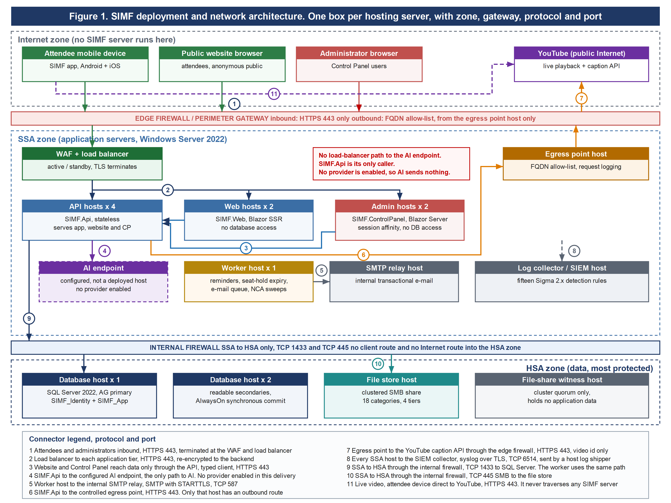
Figure 2. SIMF component and interaction view. Every component, and how each one communicates with the others. Answers points 1 and 7.
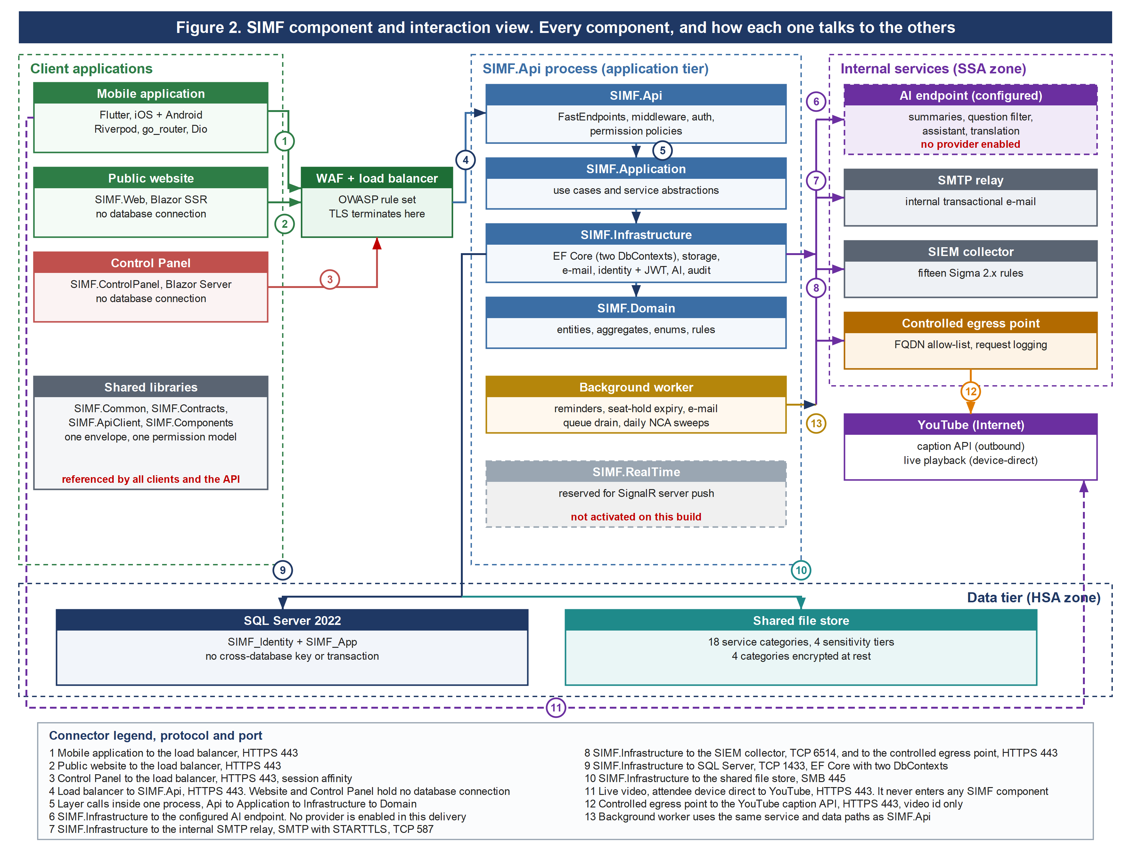
Figure 3. Key system workflows, from registration through approval, booking, hall entry, the live session and the minutes, to feedback. Answers point 7.
