CoursesManagementApp
Sprint Report
Team name: GoTI

Ζάγκας Δημοσθένης 4359
Ψαλίδας Ζήσης 3369
Βάρελης Παναγιώτης 3388

Versions History
Date | Version | Description | Author
2/05 | 1.1 | First Sprint | GoTI
10/05 | 1.2 | Second Sprint | GoTI
16/05 | 1.3 | Third Sprint | GoTI
18/05 | 1.4 | Extra Details | GoTI

Introduction
This document provides information concerning the <X> sprint of the project.

Purpose

Document Structure
The rest of this document is structured as follows. Section 2 describes out Scrum team and specifies this Sprint's backlog. Section 3 specifies the main design concepts for this release of the project.

Scrum team and Sprint Backlog
<For the user stories included in this release specify below corresponding tests using a typical tabular form.>

Scrum team
Product Owner | Zarras
Scrum Master | ....
Development Team | GoTI (the Gank of Three Idiots)

Sprints
<List below the sprints that you performed and the user stories that have been realized in each Sprint>
Sprint No | Begin Date | End Date | Number of weeks | User stories
1 | 25/04 | 2/05 | 1 | US1,US2
2 | 03/5 | 10/05 | 1 | US3,US4,US5
3 | 11/05 | 16/05 | 1 | US6,US7,US8,US9,US10
4 | 16/05 | 18/05 | - | Extra Details/Fixes

Use Cases
<Specify the concrete Use Cases that describe the interaction of the user with the applications, as derived from the abstract user stories. Give a UML Use Case diagram and the detailed use case descriptions.>

<Use Case 1>
Use case ID | US1
Actors | Instructor
Pre conditions | Knowing the username and the password.
Main flow of events | - The use case starts when the user types the link to the application  - A log in page appears  - The user inputs the credentials  - Correct credentials: The user is sent to the page with the list of the courses  - Incorrect credentials: The user is prompted with a message “incorrect credentials”
Alternative flow 1 | [Alternative flow of events IF ANY that takes place in case of an exception]
Alternative flow 2 | .......
Post conditions

<Use Case 2>
Use case ID | US2
Actors | Instructor
Pre conditions | Having logged in  A course existing (for updating information for the course)
Main flow of events | - The use case starts when the user logs in successfully  - The list of the courses appears  - Under the “Actions” tab, the user has the option to “Update” the courses information  - The update button sends the user to a new page, with the fields of the course (name, description etc), filled in.  - The user can make changes and the save them.
Alternative flow 1 | For the user to change the students grades, the user needs to open the student list and access each student separately. Will be described in a different US
Alternative flow 2 | .......
Post conditions

<Use Case 3>
Use case ID | US3
Actors | Instructor
Pre conditions | Having logged in
Main flow of events | - The use case starts when the user clicks the “add course” button  - A new page loads, showing the empty fields of a course (name, year, etc.)  - The user fills in the fields  - Presses the save button  - The page with the courses list loads, showing the new course created
Alternative flow 1 | The user has the option to return to the course list at any time by pressing the “return” button
Alternative flow 2 | The user has the option to not fill in a field, in order to update it later on
Post conditions | A new course has been added

<Use Case 4>

Use case ID | US4
Actors | Instructor
Pre conditions | Having logged in  A course existing in the list
Main flow of events | - The use case starts when the user clicks the “delete” button in the action tab on a course  - A message pops up, asking for confirmation
Alternative flow 1
Alternative flow 2
Post conditions | The course gets deleted

<Use Case 5>

Use case ID | US5
Actors | Instructor
Pre conditions | Having logged in  A course existing in the list
Main flow of events | - The use case starts when the user clicks the “update” button at the action tab  - The update button sends the user to a new page, with the fields of the course (name, description etc), filled in.  - The user can make changes and the save them.
Alternative flow 1 | The user has the option to return to the list without making any changes by clicking the “return” button
Alternative flow 2
Post conditions | The course info gets updated

<Use Case 6>

Use case ID | US6
Actors | Instructor
Pre conditions | Having logged in  A course existing in the list
Main flow of events | - The use case starts when the user clicks the “show students” button at the action tab  - A new page loads, with the students of that course
Alternative flow 1
Alternative flow 2
Post conditions | The page with the list of the students loads

<Use Case 7>

Use case ID | US7
Actors | Instructor
Pre conditions | Having opened the page with the students list
Main flow of events | - The user story begins when the user clicks the “add student” button  - A new page loads, with the fields (name, year, etc) of the student empty  - The user fills in the fields and clicks save  - A new student has been created in that course
Alternative flow 1 | The user has the option to return to the list without making any changes by clicking the “return” button
Alternative flow 2
Post conditions | The course info gets populated with an extra student

<Use Case 8>

Use case ID | US8
Actors | Instructor
Pre conditions | A student existing in the course
Main flow of events | - The user story starts when the user clicks the “delete” button at a student  - A confirmation message appears  - The user clicks yes and the student gets deleted
Alternative flow 1 | The user has the option to click no at the confirmation message
Alternative flow 2
Post conditions | The student gets deleted

<Use Case 9>

Use case ID | US5
Actors | Instructor
Pre conditions | A student existing in the course
Main flow of events | - The user story starts when the user clicks the “update” button at a student  - A new page loads with the student fields already filled in  - The user can change each field  - The user clicks save  - The page with the list of the students loads
Alternative flow 1 | The user has the option to return to the list without making any changes by clicking the “return” button
Alternative flow 2
Post conditions | The student info gets updated

<Use Case 5>

Use case ID | US10
Actors | Instructor
Pre conditions | A student existing in the course
Main flow of events | - The user story begins when the user clicks the “update” button in the action tab of the student  - The page with the student info loads  - The user can change the grades of the student  - The user clicks save  - The page of the students list loads
Alternative flow 1 | The user has the option to return to the list without making any changes by clicking the “return” button
Alternative flow 2
Post conditions | The student grades get updated

Design

Architecture

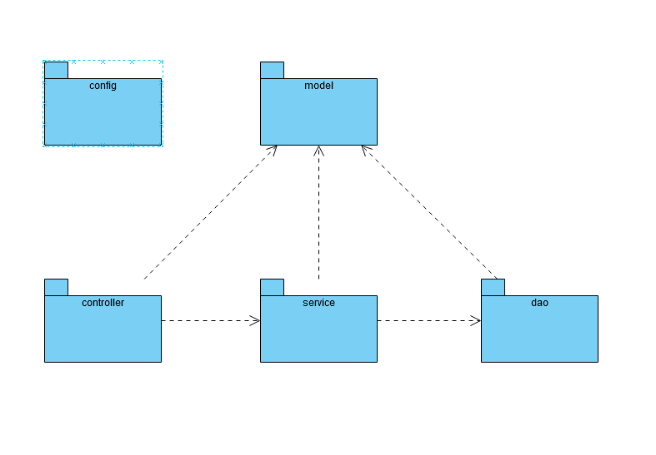
The config package (Security class) is being called from the system (springboot), thus having no relation with the other packages.

Design
Class Name: CourseApplicationSecurityConfig
Responsibilities:  - The security of the application  - Redirecting the user to the log in page | Collaborations:  - None (we think)

Class Name: CoursesMgtAppController
Responsibilities:  - Creating the link between the front end (html) and the services  - Connecting the functions of the app to the UI  - Connecting functions such as delete from the front end directly to the data base (through the service,dao) | Collaborations:  - Course class (model pckg)  - Student class (model pckg)  - CourseService (service pckg)  - StudentService (service pckg)

Class Name: CourseDAO
Responsibilities:  - Interface. Declares methods that will be used with the JPA to connect the service to the table courses in the database | Collaborations:  - Course (model pckg)

Class Name: CourseDAOImp
Responsibilities:  - Do we need it? | Collaborations:  - None (?)

Class Name: StudentDAO
Responsibilities:  - Interface. Declares methods that will be used with the JPA to connect the service to the table students in the database | Collaborations:  - Student (model pckg)

Class Name: StudentDAOImp
Responsibilities:  - Do we need it? | Collaborations:  - None (?)

Class Name: Student
Responsibilities:  - Match the table of the database to fields that can be used later  - Create get methods that will be used later | Collaborations:  - None
Class Name: Course
Responsibilities:  - Match the table of the database to fields that can be used later  - Create get methods that will be used later | Collaborations:  - None

Class Name: CourseService
Responsibilities:  - Interface. Declares the methods that will be implemented | Collaborations:  - Course (model pckg)

Class Name: CourseServiceImp
Responsibilities:  - Implements the methods that will be used in the controller to access the data from the database | Collaborations:  - CourseDAO (dao pckg)  - Course (model pckg)  - StatisticStrategy (statistics pck)

Class Name: StudentService
Responsibilities:  - Interface. Declares the methods that will be implemented | Collaborations:  - Student (model pckg)

Class Name: StudentServiceImp
Responsibilities:  - Implements the methods that will be used in the controller to access the data from the database | Collaborations:  - StudentDAO (dao pckg)  - Student (model pckg)

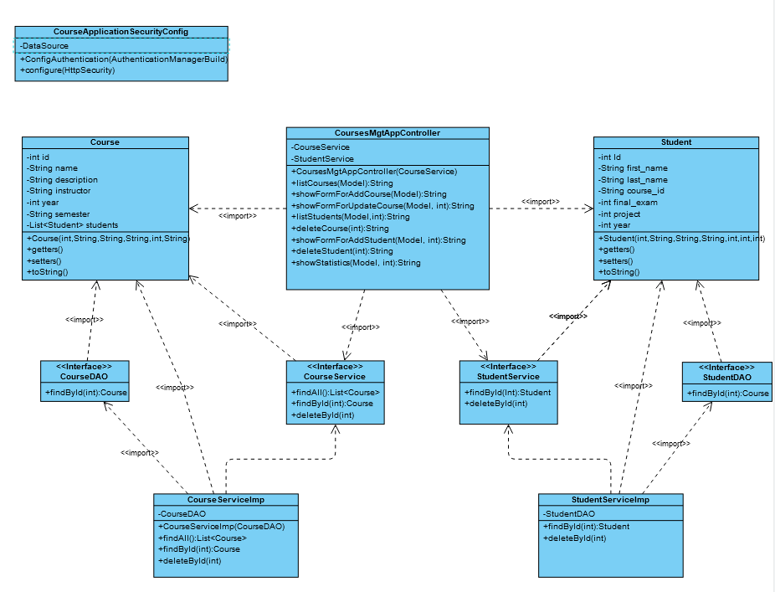
Σημείωση: Έγιναν μερικές αλλαγές της τελευταίας στιγμής που δεν προλάβαμε να καταγράψουμε στο report.

