# People's Friendship University of Russia

## Lab report number 1

## Completed

### Student Name:Ally Mohammed Zayan Ahamed

### Group :HKH-01-18

### Lecturer:Kulyabov Dimitry Sergeevich

## Purpose

How to work with git version control systems

# Tasks

1.Create a repository

2.Create and upload files made on personal device to github

3.Make a commit and push to the github repository

4.Make a release

5.Generate a report and create a presentation in pdf,docx and markdown formatts

6.Create a final release

# Subject of the study

Git. Markdown

# Technical equipments used

Computer,WiFi,Git console(Git bash),a notepad to write markdown files

# List of Illustrations

# For lab work

Created a repository on github(fig. 1)

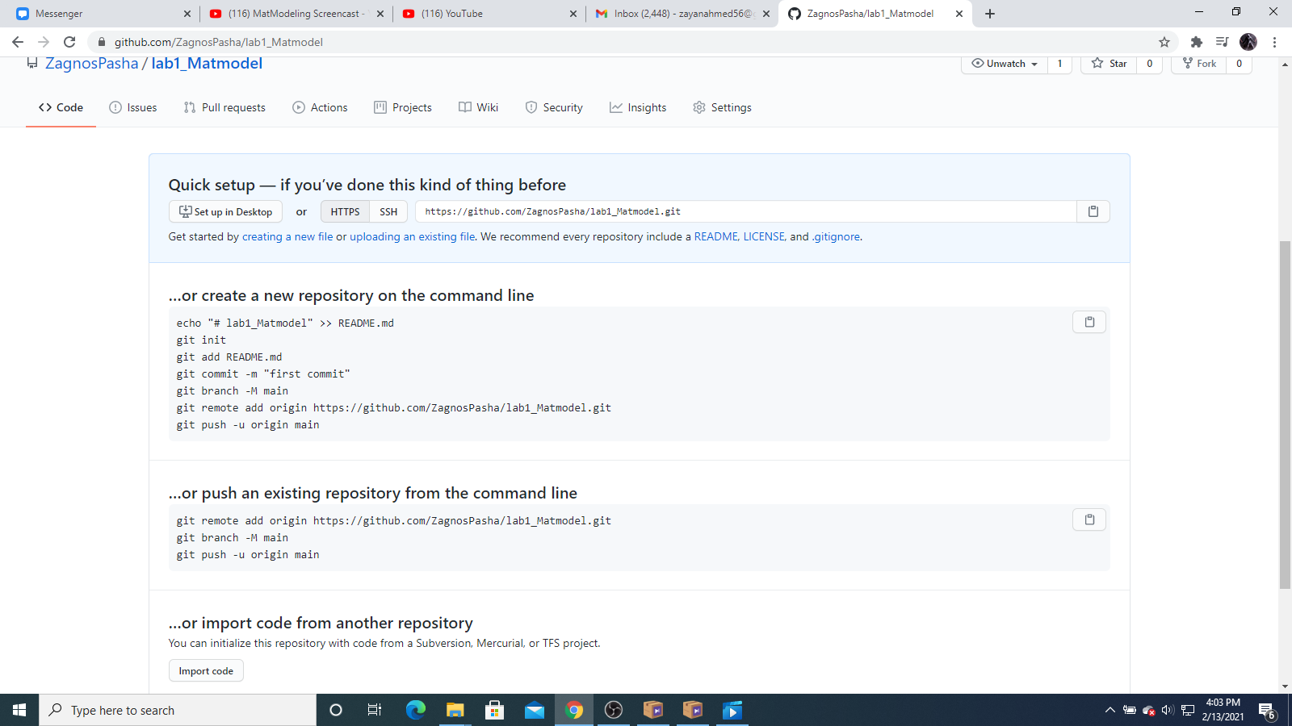{Image 1}

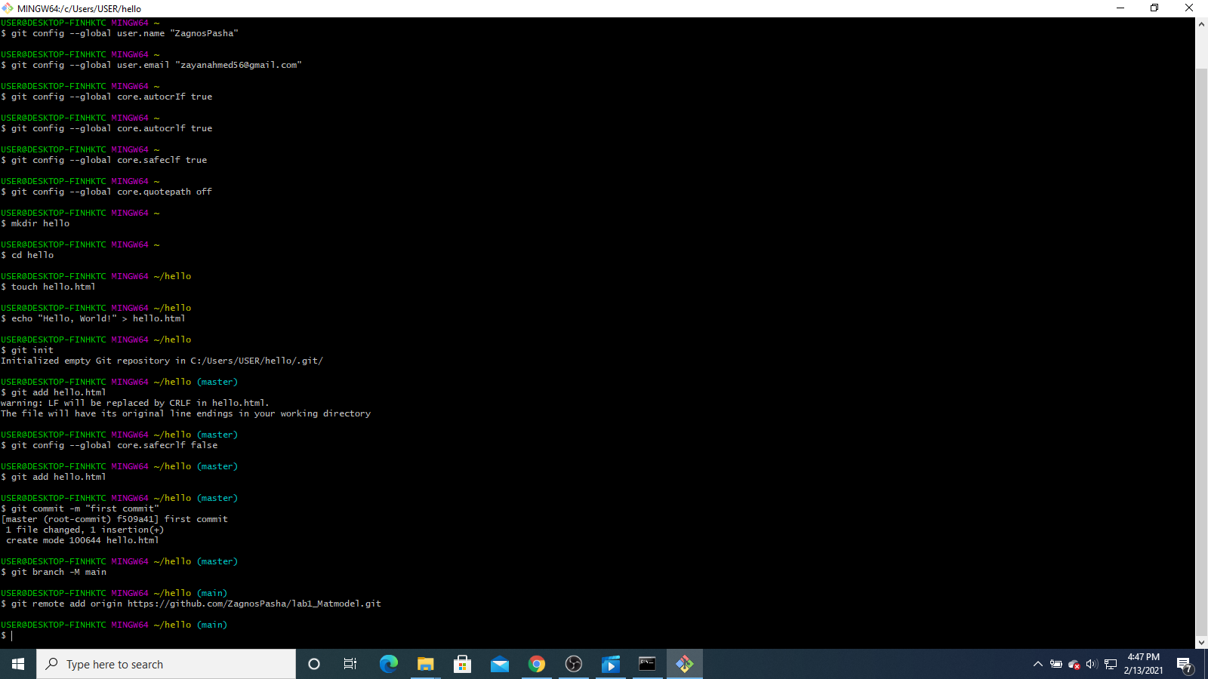{Image 2}

Downloaded and connected SSH keys (fig. 2)

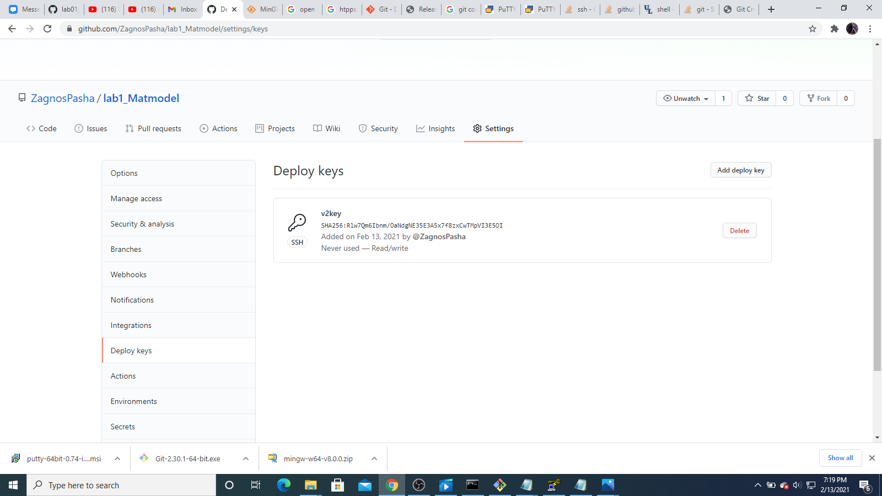{Image 3}

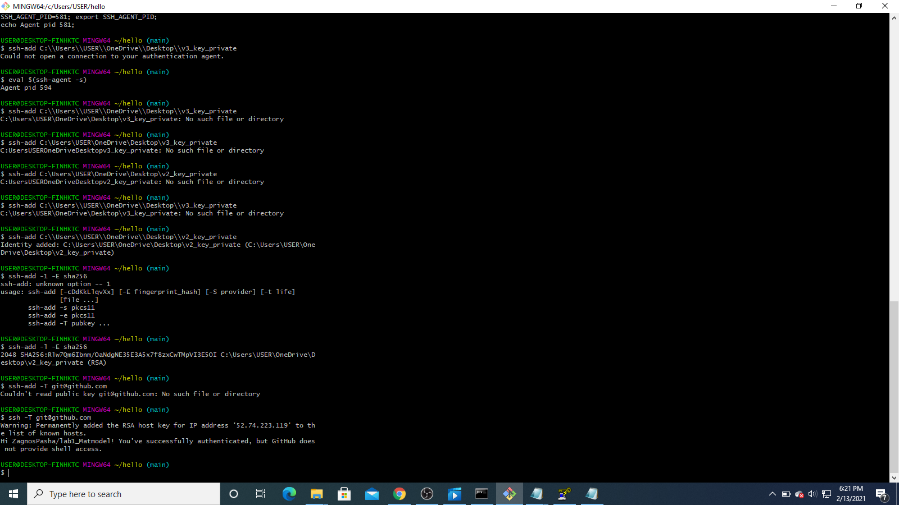{Image 4}

Created a hello.html file and started it (fig.3)

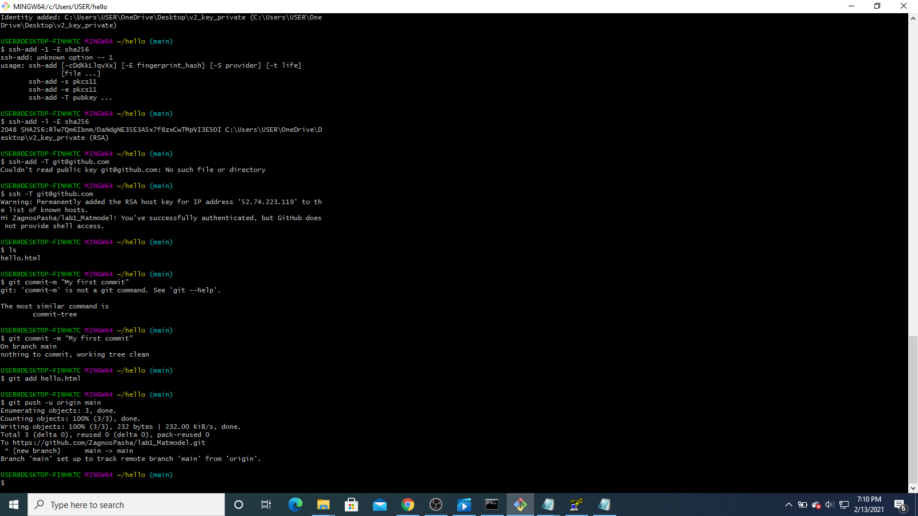{Image 5}

Made a release test on github (fig. 4)

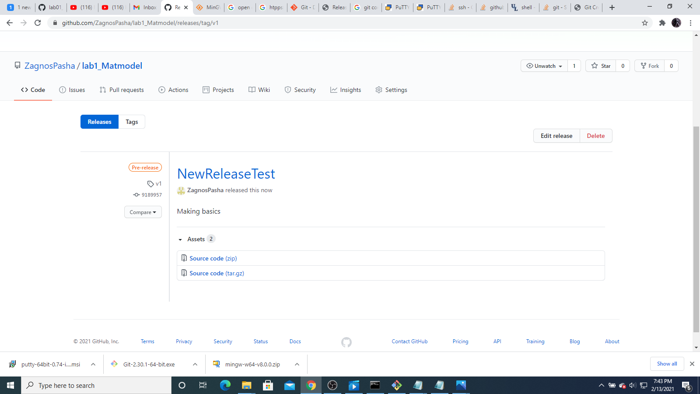{Image 6}

# Conclusions

Learned how to solve issues on github, how to make commits and push them.Learned how to mke releases and got accquainted with MarkDown