The Cost of the Prompt: Evaluating SAM 2 for Prompt-Free Agricultural Field Segmentation

Johanna Zagon¹, Andre Rubio², Pierre Lavergne³
¹Potsdam, Alemania | ²Lima, Perú | ³Saint-Étienne, France
Johanna Zagon: Johanna.zagon@pucp.edu.pe
Andre Rubio: andre.rubio@pucp.edu.pe
Pierre Lavergne: pierre.lavergne@etu.emse.fr

1. INTRODUCTION
Segment Anything (SAM) [2] and SAM 2 [1] segment natural images well when a user clicks on the object. Remote-sensing pipelines have no user, so the prompt must be generated automatically, usually as a regular grid of points. We ask what this prompt costs when a frozen SAM 2.1 segments agricultural parcels in Sentinel-2 images [4], and whether adapting the mask decoder can pay that cost. We find a weak frozen baseline, split the cost of the prompt into three measurable parts (prompt density, a quality filter tuned on another domain, and the mismatch between training and inference prompts), and show that a decoder fine-tune helps only once the last two are removed.
2. METHODOLOGY
Data. We use the Patches Assembled Dataset of Sen4AgriNet [3]: six Sentinel-2 tiles, three in Spain (ES) and three in France (FR), seeded random sampling, cloud-free May 2019 acquisitions [5]. This gives 888 RGB patches of 366 × 366 px (444 per country) with 211,375 parcels of at least 20 px (median 113 px, about 11 × 11 px). Split by patch, stratified by tile: 624 train / 132 validation / 132 test.
Model and metric. Frozen SAM 2.1 with a Hiera-Small encoder [6] and the automatic mask generator (16 × 16 point grid, predicted-IoU threshold 0.5, stability threshold 0.8). Each ground-truth parcel is scored by its best IoU over all generated masks; we report the mean over parcels (mean best IoU) and the fraction of parcels with IoU > 0.5.
Phase A: teardown. Forward hooks measure parameters and MACs. The image encoder holds 74.5 % of the parameters and the mask decoder 9.2 %. The encoder costs 133.6 GMACs once per image, the decoder 1.37 GMACs per prompt; at 16 × 16 points the decoder already costs 2.6× the encoder, at 32 × 32 10.5×. In prompt-free mode the prompt, not the backbone, dominates compute.
Phase B: decoder adaptation. We train only the second two-way transformer layer and the IoU head of the mask decoder (1.71 M parameters, 3.7 % of the model) with a Dice loss, encoder frozen. v1 trained on parcel-centroid prompts and selected the checkpoint by validation loss. v2 is a controlled ablation with expectations written before the results: training prompt (centroid, random point, generator grid point) × loss on token 0 or on tokens 1–3, selected by the generator's own validation IoU, plus a v1 replicate selected by loss.
Phase C: failure analysis. We overlay the generator grid on the true parcel masks and count the parcels that receive at least one point, by size and country; on the frozen model we sweep 16/32/64 points per side with runtime, and evaluate with both filters off.
3. RESULTS
Frozen baseline. On the 132 test patches the frozen generator reaches a mean best IoU of 0.156 (all 888 patches: 0.161; only 14.6 % of parcels exceed IoU 0.5). Spain is much worse than France (0.085 vs. 0.220).
Cost 1: prompt density. A 16 × 16 grid places a point every 22.9 px, so only 32 % of parcels receive any point (ES 24 %, FR 40 %; parcels of 20–49 px: 6 %). A 32 × 32 grid raises test IoU to 0.253 (Δ +0.096 [+0.088, +0.104]) at 5–9× the runtime; on 40 Spanish patches 64 × 64 gives 0.185 vs. 0.083.
Cost 2: a filter tuned on another domain. The generator keeps a mask only if predicted IoU ≥ 0.5 and stability ≥ 0.8, thresholds set on SA-1B. With both off, IoU rises to 0.262 (Δ +0.106 [+0.100, +0.112]) with 329 instead of 79 masks per patch, at lower precision (mask pixels on fields 0.58 → 0.47).
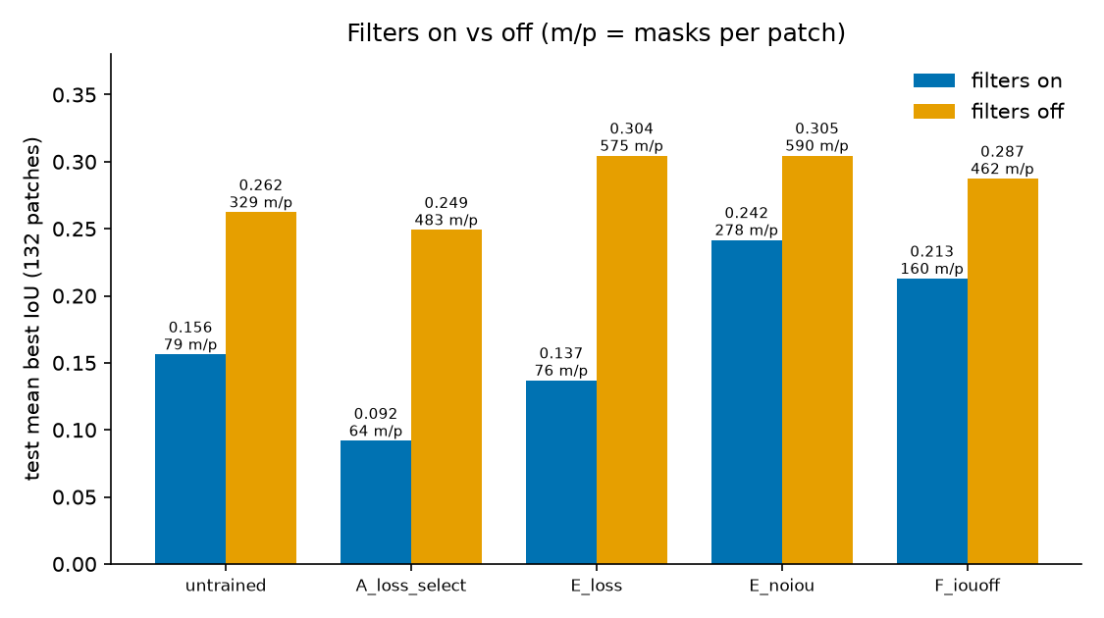
Fig. 1. Test mean best IoU with SAM's quality filters on and off (labels: masks per patch). Trained masks beat frozen ones once the filter stops discarding them.
Cost 3: training prompt ≠ inference prompt. v1 raised centroid-prompt validation IoU (0.312 → 0.530) but the generator fell to 0.064. In v2, every configuration that also trained the IoU head lowered the generator's validation IoU at all three learning rates, so selection kept epoch 0. With filters off, however, the loss-selected grid model (E_loss) beats the frozen masks (0.304 vs. 0.262): the masks get better, and the recalibrated IoU head under the fixed 0.5 threshold discards them. With the IoU-head loss off (grid prompts, tokens 1–3, E_noiou) the fine-tune beats the frozen model for the first time (Δ +0.085 [+0.080, +0.091]); negative clicks (F) reach 0.213. Expectations written before the results were refuted on: D best, trained masks equal with filters off (+0.042), F gain ≤ +0.02 (+0.057).
Table 1. Test results (132 patches). Δ: paired difference in mean best IoU to the frozen 16 × 16 generator, 95 % bootstrap CI. Trained rows use the 16 × 16 generator with filters on.
Model | Mean best IoU | Masks / patch | Δ [95 % CI]
Frozen, 16 × 16 (default) | 0.156 | 78.6 | —
Frozen, filters off | 0.262 | 329.2 | +0.106 [+0.100, +0.112]
Frozen, 32 × 32 | 0.253 | 165.5 | +0.096 [+0.088, +0.104]
v1: centroid, loss-selected | 0.064 | 41.1 | −0.092 [−0.103, −0.083]
E_loss: grid, IoU loss on | 0.137 | 76.0 | −0.019 [−0.024, −0.015]
E_noiou: grid, IoU loss off | 0.242 | 277.6 | +0.085 [+0.080, +0.091]
F: + negatives, IoU loss off | 0.213 | 160.0 | +0.057 [+0.052, +0.062]

4. CONCLUSIONS
Prompt-free SAM 2.1 transfers poorly to Sentinel-2 parcels (0.156). The cost of the prompt has three parts: prompt density, a quality filter calibrated on another domain, and a mismatch between training and inference prompts. With matched prompts and the IoU head left alone, adapting 3.7 % of the parameters gives +0.085, close to a 32 × 32 grid while keeping the 16 × 16 prompts. Each failure improved a proxy: validate on the deployment pipeline, not the proxy. Limitations: one seed; 150 training patches; 64 × 64 only on 40 patches; shared-GPU timings are noisy; RGB, one month.
REFERENCES
[1] N. Ravi et al., “SAM 2: Segment Anything in Images and Videos,” arXiv:2408.00714, 2024.
[2] A. Kirillov et al., “Segment Anything,” in Proc. IEEE/CVF ICCV, pp. 4015–4026, 2023.
[3] D. Sykas, M. Sdraka, D. Zografakis and I. Papoutsis, “A Sentinel-2 Multiyear, Multicountry Benchmark Dataset for Crop Classification and Segmentation With Deep Learning,” IEEE J. Sel. Topics Appl. Earth Observ. Remote Sens., vol. 15, pp. 2937–2953, 2022.
[4] M. Drusch et al., “Sentinel-2: ESA's Optical High-Resolution Mission for GMES Operational Services,” Remote Sens. Environ., vol. 120, pp. 25–36, 2012.
[5] A. Hollstein, K. Segl, L. Guanter, M. Brell and M. Enesco, “Ready-to-Use Methods for the Detection of Clouds, Cirrus, Snow, Shadow, Water and Clear Sky Pixels in Sentinel-2 MSI Images,” Remote Sens., vol. 8, no. 8, p. 666, 2016.
[6] C. Ryali et al., “Hiera: A Hierarchical Vision Transformer without the Bells-and-Whistles,” in Proc. ICML, 2023.

